Title
An initial psychometric assessment of an ICD-11 based measure of PTSD and Complex PTSD (ICD-TQ): Evidence of construct validity
Running head
PTSD and CPTSD self-report scale

Authors

Thanos Karatzias^{1,2}
Mark Shevlin³
Claire Fyvie²
Philip Hyland⁴
Erifili Efthymiadou²
Danielle Wilson²
Neil Roberts⁵
Jonathan I Bisson⁶
Chris R. Brewin⁷
Marylene Cloitre^{8,9}

Affiliations

¹Edinburgh Napier University, School of Health & Social Care, Edinburgh, UK
²NHS Lothian, Rivers Centre for Traumatic Stress, Edinburgh, UK
³Ulster University, School of Psychology, Derry, UK
⁴National College of Ireland, School of Business, Dublin, Ireland
⁵Psychology and Counselling Directorate, Cardiff and Vale University Health Board, Cardiff, UK.
⁶Cardiff University, School of Medicine, Cardiff, UK
⁷University College London, Clinical, Education & Health Psychology, London, UK
⁸New York University, School of Medicine, USA
⁹National Center for PTSD, Veterans Affairs Palo Alto Health Care System, Palo Alto, CA, USA

¹Address for Correspondence:

Prof. Thanos Karatzias, Edinburgh Napier University, Sighthill Campus, Sighthill Court, Edinburgh EH11 4BN, Scotland UK,Tel. (+44) (0) 131 455 5345, Email.t.karatzias@napier.ac.uk

Abstract
Among the conditions following exposure to traumatic life events proposed by ICD-11 are Posttraumatic Stress Disorder (PTSD) and Complex PTSD (CPTSD). The primary aim of this study was to provide an assessment of the reliability and validity of a newly developed self-report measure of ICD-11 PTSD and CPTSD: the ICD-11 Trauma Questionnaire (ICD-TQ). Participants in this study were a sample of individuals who were referred for psychological therapy to a National Health Service (NHS) trauma centre in Scotland (N = 193). Participants completed the ICD-TQ and measures of traumatic life events, DSM-5 PTSD, emotion dysregulation, self–esteem, and interpersonal difficulties. Confirmatory factor analysis results supported the factorial validity of the ICD-TQ with results in line with ICD-11 proposals. The ICD-TQ demonstrated satisfactory internal reliability, and correlation results indicated that the scale exhibited convergent and discriminant validity. Current results provide initial support for the psychometric properties of this initial version of the ICD-TQ. Future theoretical and empirical work will be required to generate a final version of the ICD-TQ that will match the diagnostic structure of PTSD and CPTSD when ICD-11 is published.

Keywords: PTSD, Complex PTSD, ICD-11 Trauma Questionnaire

Introduction
The upcoming 11th revision to the World Health Organization’s International Classification of Diseases (ICD-11) proposes two distinct sibling conditions, Posttraumatic Stress Disorder (PTSD) and Complex PTSD (CPTSD), under a general parent category of traumatic stress disorders (Maercker et al., 2013). The formulation of PTSD and CPTSD as two distinct disorders is supported by differences in risk factors (Hyland et al., 2016), proposed pathophysiology (Cloitre, Garvert, Brewin, Bryant, & Maercker, 2013), levels of functional impairment (Cloitre et al, 2013; Elklit, Hyland, & Shevlin, 2014), and, potentially, course and duration of treatment (Cloitre et al., 2011; Ford, 2015). Moreover, the ICD guidelines for the development of diagnoses indicate that they should have clinical utility, characteristics of which include that they be structured in a way consistent with clinicians’ mental taxonomies and demonstrate ease of use (Reed, 2010). A recent field study of 1,738 international mental health providers reported that clinicians readily discriminated between ICD-11 PTSD and CPTSD and that the addition of CPTSD increased overall diagnostic accuracy compared to other conditions (Keeley, Reed, Roberts, Evans, Robles, 2016). Thus, in addition to being motivated by traditional scientific reasons, the PTSD/CPTSD distinction appears to be readily comprehended and to improve overall differential diagnosis.
ICD requires that a traumatic stressor be present as a prerequisite for consideration of the diagnosis of either PTSD or CPTSD. Once this requirement is met, the differential diagnosis between PTSD and CPTSD is determined by assessment of symptoms. ICD-11 proposes that PTSD is comprised of three symptom clusters that result from stimuli related to the traumatic events (First et al., 2015). These symptoms clusters are: (1) re-experiencing of the trauma in the here and now (Re), (2) avoidance of traumatic reminders (Av), and (3) a persistent sense of current threat that is manifested by arousal and hypervigilance (Th). ICD-11 CPTSD includes the three PTSD clusters and an additional three clusters that reflect ‘disturbances in self-organization’ (DSO): (1) affective dysregulation (AD), (2) negative self-concept (NSC), and (3) disturbances in relationships (DR). These disturbances are proposed to be typically associated with sustained, repeated, or multiple forms of traumatic exposures (e.g., genocide campaigns, childhood sexual abuse, child soldiering, severe domestic violence, torture, or slavery), reflecting a loss of emotional, psychological, and social resources under conditions of prolonged adversity. However, type of traumatic stressor is considered a risk factor not a requirement in the differential diagnosis of PTSD versus CPTSD. This view, supported by recent data (Cloitre et al, 2013), recognizes and allows for the added potential influences of genetic load and environmental risk and resiliency factors. The diagnosis is ultimately determined by symptom profile not trauma history, and, based on symptoms, the individual is indicated to have one or the other disorder but not both. The decision to have CPTSD represented as a disorder distinct from PTSD rather than a subtype of PTSD is driven not only by conceptual and clinical reasons described above but also by the nature of the ICD taxonomic structure, which unlike the DSM, is strongly horizontal rather than vertical and does not readily support subtyping.
The qualitative distinction between PTSD and CPTSD symptomatology has been supported among different trauma samples including those experiencing a range of interpersonal violence events (Cloitre et al., 2013), rape victims, survivors of domestic violence, and traumatic bereavement (Elklit et al., 2014), victims of institutional abuse such as that occurring within foster care and religious organizations (Knefel, Garvert, Cloitre, & Lueger-Schuster, 2015), and young adults (Perkonigg, Höfler, Wittchen, Trautmann, & Maercker, 2014). The proposed three-factor structure of ICD-11 PTSD (Re, Av, Th) has been supported in numerous studies (Forbes et al., 2015; Gluck, Knefel, Tran, & Lueger-Schuster, 2016; Hansen, Hyland, Armour, Shevlin, & Elklit, 2015; Tay, Rees, Chen, Kareth, & Silove, 2015). In addition, the second-order factorial structure of CPTSD in which the disorder is comprised of both PTSD and DSO has also been supported (Hyland et al., 2016).
A salient limitation with all existing studies that have assessed the construct validity of ICD-11 proposals for PTSD and CPTSD has been the reliance on the use of archival data gathered using measures not specifically designed to capture the content of the ICD-11 diagnoses of PTSD and CPTSD. Consequently, it has been necessary to estimate the content of these diagnoses using measures that were generally designed to reflect the content of DSM-based models of PTSD. This is an important limitation as ICD-11 PTSD, and particularly ICD-11 CPTSD, do not merely reflect a subset of the DSM-5 PTSD symptoms. The ICD-11 proposals contain two logically distinct elements: a structural description of PTSD and CPTSD where PTSD is comprised of three factors and CPTSD involves two groups of three factors (see Figure 1, Model 4). The proposals also include new content concerning the key symptoms in the CPTSD diagnosis. Given the use of archival data, existing studies have supported the structural aspects of ICD-11 proposals but have not necessarily captured the content aspects precisely. This limitation has been the inevitable consequence of the absence of a measure that is specifically designed to capture the ICD-11 symptoms of PTSD and CPTSD.
The ICD-11 Trauma Questionnaire (ICD-TQ; Cloitre, Roberts, Bisson, & Brewin, under development) has been developed with these needs in mind and represents a preliminary-stage, self-report measure of the ICD-11 PTSD and CPTSD diagnoses. The goal of the ICD-11 proposals for PTSD and CPTSD is to include a limited number of symptoms for each disorder. However this first iteration of the ICD-TQ includes 23-items. These items reflect test items that may comprise the final composition of symptoms of ICD-11 PTSD and CPTSD when presented to the World Health Assembly in 2017 (First et al., 2015). In its current, preliminary form, seven items are included to represent the three clusters of PTSD: Re (items P1-P3), Av (items P4-P5), and Th (items P6-P7). Sixteen items are included to represent the three DSO clusters that make up the additional symptoms of CPTSD. Nine items are included to measure the AD cluster, and these items span hyper- and hypo-activation (items C1-C9), four-items to measure NSC (items C10-C13), and three items to measure DR (items C14-C16).
The primary aims of this study were to: (1) test the structural proposals of ICD-11 PTSD and CPTSD using a preliminary version of the ICD-TQ that contains a larger pool of items reflecting the CPTSD symptom clusters, (2) assess the internal reliability of the ICD-TQ, and (3) assess the convergent and discriminant validity of the ICD-TQ. A number of hypotheses were formulated based on these research aims. First, it was predicted that factorial models for CPTSD with two higher-order factors representing PTSD and DSO would perform better than models that do not differentiate between PTSD and DSO. Second, it was predicted that the ICD-TQ would demonstrate satisfactory internal reliability. Third, it was predicted that there would be evidence of convergent and discriminant validity. Convergent validity would be evidenced by the ICD-TQ PTSD (scale and sub-scales) factors correlating positively and strongly with three dimensions of another criterion measure of (DSM-5) PTSD (intrusions, avoidance, and alterations in arousal and reactivity subscales of the PCL-5), whereas discriminant validity would be indicated if the ICD-TQ PTSD (scale and sub-scales) factors correlated less strongly with other criterion measures of DSO (the negative alterations in cognition and mood scale of the PCL-5, the Difficulties in Emotional Regulation Scale, the Rosenberg Self-esteem Scale, and the Inventory of Interpersonal Problems). Similarly, it was also predicted that the scale and subscale scores for the DSO factors would correlate more strongly with other criterion measures of emotional regulation than the PTSD factors.
Method
Participants and procedure
Participants in this study were individuals who were referred by general practitioners, psychiatrists or psychologists for psychological therapy to a National Health Service (NHS) trauma centre in Scotland. Cases of childhood, adulthood and both child and adulthood traumatisation were referred to the service. All 230 new patients over the 18 month recruitment period were sent a letter and invited to complete a set of standardised measures. Twenty-two did not respond and 13 provided unusable data due to large amounts of missing responses, and 2 had missing scores on the ICD-TQ which resulted in a final sample size of 193.
The mean age of the sample was 40.7 years (SD = 12.4) and there were more females (65.1%) than males. Most of the sample were born in the United Kingdom (88.7%) and of these most were from Scotland (79%). The highest level of academic attainment was varied: school (38.5%), College (30.2%), and University (30.2%). Approximately a third of the sample was in employment (full-time 20.2%, part-time 13%), 38.9% were unemployed, 7.3% were retired, and 5.7% were in voluntary work (15% reported ‘None of these’). Almost half of the sample were single (48.2%), 22.3% were married, 12.4% were divorced, and 9.8% were co-habiting. Most participants were either living with partner or with their family (41%), 34.7% were living alone (and 24.4% reported ‘Other’). Psychotropic medication had been prescribed to 67.5% of the sample.
Measures
ICD-11 Trauma Questionnaire (ICD-TQ version 1.2; Cloitre et al., 2015)
The ICD-TQ is a 23-item self-report measure for ICD-11 PTSD and CPTSD diagnoses. Three items are used to measure Re (items P1-P3), two items to measure Av (items P4-P5), and two items to measure Th (items P6-P7). Although re-experiencing is generally measured with two symptoms, it can include a third item (P3) which references upset in response to internal or external cues that symbolize or resemble an aspect of the traumatic event. This item was designed to allow re-experiencing to be assessed among respondents with absent or unclear memories of the traumatic event, such as may occur with traumatic brain injury or childhood abuse. The P3 item was answered by all respondents in this survey whether they had a clear memory of the event or not. CPTSD includes PTSD as well as three clusters reflecting DSO. Sixteen items represent the three clusters of AD (items C1-C9), NSC (items C10-C13), and DR (items C14-C16). Symptom endorsement for all items is scored on a Likert scale ranging from 0 (“not at all”) to 4 (“extremely”) in response to the question “how much have you been bothered by that problem for the past month?” The scale can be used to generate a self-report ICD-11 PTSD or CPTSD diagnosis. A diagnosis of PTSD requires a score of > 2 (“moderately”) for at least one symptom in each of its three clusters. A diagnosis of CPTSD requires PTSD and the following scores for each of the three DSO clusters: AD requires a score > 10 on items 1-5 (hyper-activation) or a score of > 8 on items 6-9 (hypo-activation); NSC requires a score > 8, and DR requires a score > 10.
Childhood Trauma Questionnaire (CTQ: Bernstein & Fink, 1998).
The CTQ is a 28-item self-report questionnaire that assesses exposure to a range of different childhood traumas. It yields five subscales, each with five items: Emotional Abuse, Physical Abuse, Sexual Abuse, Emotional Neglect, and Physical Neglect. Items are responded to using a 5-point scale ranging from “never true” (1) to “very often true” (5) which produces possible scores of 5 to 25 for each trauma subscale. The reliability of the subscales was high in this sample; Emotional Abuse (.90), Physical Abuse (.85), Sexual Abuse (.97), Emotional Neglect (.92), Physical Neglect (.83).
The Life Events Checklist (LEC: Gray, Litz, Hsu, & Lombardo, 2004).
The LEC is a 17-item self-report measure designed to screen for potentially traumatic events in a respondent's lifetime. The LEC assesses life time exposure to 16 traumatic events (e.g. Natural disaster, Physical assault, Life threatening illness/injury) and the 17th item, “Any other very stressful event/experience”, can be used to indicate exposure to a trauma that is not listed. For each item, respondents check whether the event ‘Happened to me’ (1), ‘Witnessed it happening to somebody else’ (2), ‘Learned about it happening to someone close to me’ (3), ‘Part of my job’ (4), ‘Not sure it applies’ (5), ‘Doesn't apply to my experience’ (6). In order to create a summed total to represent the number of different life events that has been experienced the items were recoded into binary variables with ‘Happened to me’ responses being coded as 1 and all other responses coded as 0. This produced a single ‘Total traumas’ variable with possible scores ranging from 0 to 16; item 17 (“Any other very stressful event or experience”) was not included as the nature of the trauma could not be identified.
PTSD Checklist for DSM-5 (PCL-5: Weathers et al., 2013)
The PCL-5 is a 20-item self-report measure that assesses the 20 DSM-5 symptoms of PTSD. Participants respond using a 5 point scale, ranging from "Not at all" (0) to "Extremely" (4), indicating how much the specific symptom was a problem to them over the past month. Symptom cluster severity scores are calculated for intrusions (I: 5 items), avoidance (Av: 2 items), negative alterations in cognitions and mood (NACM: 7 items), and alterations in arousal and reactivity (Ar: 6 items). The scale can also be used to generate a self-report DSM-5 diagnosis using a cut-point of 38. PCL-5 has demonstrated acceptable reliability and validity in samples of college students (Blevins, Weathers, Davis, Witte, Domino, 2015) as well as veterans (Bovin, Marx, Weathers, Gallagher, Rodriguez, Schnurr, & Keane, 2015). The reliability of the total scale (α = .88) and the I (α = .80), NACM (α = .79), and Ar (α = .70) subscales were acceptable. The estimate of reliability for the Av items was low (α = .44) but is likely to be an under-estimate of the true reliability due to the small number of variables (Eisinga, Grotenhuis, & Pelzer, 2012).
Difficulties in Emotional Regulation Scale (DERS: Gratz & Roemer, 2004)
The DERS is a standardised 36-item measure of emotional dysregulation involving not just the modulation of emotional arousal, but also the awareness, understanding, and acceptance of emotions, and the ability to act in desired ways regardless of emotional state. It provides six subscales including ‘Non-acceptance of emotional responses’, ‘Difficulties in engaging in goal directed behaviour’, ‘Impulse control difficulties’, ‘Lack of emotional awareness’, ‘Limited access to emotional regulation strategies’ and ‘Lack of emotional clarity’. Participants are asked to indicate how often the items apply to themselves, with responses ranging from 1 to 5, where 1 is almost never and 5 is almost always. The total scale score was used in this study to reflect the overall degree of emotion dysregulation. The reliability of the total scale scores was high in this sample at .94.
Rosenberg Self-Esteem Scale (RSES: Rosenberg, 1965)
The RSES consists of 10 Likert-type scale items designed to assess positive and negative evaluations of self. Respondents indicate their level of agreement ranging from 1 (“strongly disagree”) to 4 (“strongly agree”). Thus, the possible total score can range from a minimum of 10 to a maximum of 40, with higher scores reflecting more positive evaluations of self. The reliability of the scale scores was high in this sample (.89).
Inventory of Interpersonal Problems - Short Circumplex Form (IIP: Soldz, Budman, Demby, & Merry,1995)
The IIP is a 32-item self-report measure of interpersonal difficulties and consists of 8 subscales (Domineering, Vindictive, Cold, Socially Avoidant, Non-assertive, Exploitable, Overly Nurturant, Intrusive) with responses based on a 5-point Likert scale ranging from “almost never” (1) to “almost always” (5). The total scale score was used in this study and the reliability of the scale scores was high in this sample at .84.
Statistical analysis
The latent structure of the ICD-TQ was tested using confirmatory factor analysis (CFA) based on responses to the full pool of 23 items. Seven alternative models were specified (see Figure 1) and tested as representative of PTSD and CPTSD, four of which (models 1, 2, 4 & 7 in this study) were previously investigated by Hyland et al. (2016). Overall the aim of testing alternative models was to determine if: (1) PTSD and DSO were distinct dimensions, (2) if PTSD was better represented as three correlated dimensions rather than one dimension, (3) if DSO was better represented as three correlated dimensions rather than one dimension, and (4) if there was a hierarchical structure (second-order factors) that explained the associations between the first-order PTSD and DSO dimensions. Model 1 is a one factor model where all symptoms load on the single latent variable CPTSD. Model 2 is a correlated six factor model (Re, Av, Th, AD, NSC, and DR). Model 3 replaced the factor correlations in Model 2 with a single second-order factor representing CPTSD. Model 4 (reflecting the ICD-11 proposals; Maercker et al., 2013) specified two correlated second-order factors (PTSD and DSO) to explain the covariation among the six first-order factors; Re, Av and Th loaded on the PTSD factor and AD, NSC and DR loaded on the DSO factor. Model 5 tested the hypothesis that there was no hierarchical structure for the PTSD items but a hierarchical structure for the DSO items, and Model 6 that there was no hierarchical structure for the DSO items but a hierarchical structure for the PTSD items. Model 7 proposed that all the PTSD and DSO items loaded on two correlated first-order factors. For all models the error variances were uncorrelated.
Each model was specified and estimated by Mplus 7.1 (Muthen & Muthen, 2013) using the robust weighted least squares estimator (WLSMV) based on the polychoric correlation matrix of latent continuous response variables. The WLSMV estimator is the most appropriate statistical treatment of ordinal indicators in a CFA context (Brown, 2006). Other methods of analysis, such as maximum likelihood estimation, tend to produce incorrect standard errors, attenuate the relationships between observed variables and produce possible pseudo-factors (Brown, 2006). The WLSMV estimator has been shown to produce correct parameter estimates, standard errors and test statistics (Flora & Curran, 2004). The amount of missing data for the ICD-TQ was low, with missing data on only 6 items ranging from .5 to 1.6%, and this was handled using pairwise present analysis which the default when the WLSMV estimator is used (Asparouhov & Muthѐn, 2010). Goodness of fit for each model was assessed with a range of fit indices including the chi-square, the comparative fit index (CFI; Bentler, 1990), and the Tucker-Lewis Index (TLI; Tucker & Lewis, 1973). A non-significant χ² and values greater than .90 for the CFI and TLI were considered to reflect acceptable model fit. Additionally, the Root Mean Square Error of Approximation (RMSEA; Steiger, 1990) was reported, where a value less than .05 indicated close fit and values up to .08 indicated reasonable errors of approximation (Jöreskog & Sörbom, 1993). When the best model was identified, factor scores were calculated and these were correlated with the summed scores from the criterion variables. Composite reliability for the preferred model was also calculated. Composite reliability estimates the internal consistency of a set of items without the strict assumptions of tau-equivalence (Raykov, 1997) and allows the reliability of a smaller set of variables to be estimated than is possible with Cronbach’s alpha.
Results
The prevalence of ICD-11 PTSD and CPTSD based on the ICD-TQ were 37% and 53.1% respectively, and based on a cut-off score over 38 on the PCL-5 the prevalence of DSM-5 PTSD was 88.2%. Based on Cohen’s kappa the level of agreement was low between DSM-5 PTSD and ICD-11 PTSD (k = .23, p < .05, 95% CI, .13 - .31), and between DSM-5 PTSD and ICD-11 CPTSD (k = .11, p <.05, 95% CI, .07 - .31). The participants also reported exposure to multiple traumatic events. The mean number of traumas reported using the Life Events Checklist was 5.00 (SD = 2.48), with only a small number (4.6%) reporting exposure to a single traumatic event. The most commonly reported events were “physical assault” (78.4%), “sexual assault (rape, attempted rape, made to perform any type of sexual act through force or threat of harm”: 57.9%), “assault with a weapon” (50.7%), “transportation accident” (49.2%), and “Other unwanted or uncomfortable sexual experience” (48.2%). Scores from the CTQ indicate that there were also high levels of childhood trauma, particularly emotional abuse and emotional neglect: Mean (SD): Emotional Abuse 14.20 (6.67), Physical Abuse 10.76 (5.89), Sexual Abuse 12.44 (8.07), Emotional Neglect 13.48 (6.22), and Physical Neglect.9.53 (5.01). Endorsement rates for any item (score > 1) from the CTQ subscales indicated that any experience of childhood trauma was also high: Emotional Abuse 84.6%, Physical Abuse 63.8%, Sexual Abuse 53.3%, Emotional Neglect 79.8%, and Physical Neglect 68.6%. The fit statistics for the seven models of the ICD-TQ are presented in Table 1.
Table 1 about here
Although the chi-square statistics were statistically significant this should not lead to the rejection of the models as the power of the chi-square is positively related to sample size (Tanaka, 1987). All models met the criteria for an acceptable model based on the CFI and TLI, but only Models 2, 3, 4 and 5 met the RMSEA criteria. Models 2 and 4 had the lowest RMSEA. These were the best fitting models and the chi-square difference test, using the DIFFTEST procedure, indicated that the models did not differ significantly in terms of fit (Δχ² = 10.602, Δdf = 8, p = .225). In addition Model 2 had fewer parameters and the difference between the RMSEA values was small, indeed the point estimate for each model was within the RMSEA 90% confidence intervals for the other model. Model 4, therefore, should be preferred on the basis of model fit, parsimony, and theoretical consistency. A post hoc power analysis was conducted using a Monte Carlo study (Muthén & Muthén, 2012). The estimates from Model 4 were used as population values, 1,000 replications were used, and the power of each parameter was estimated. All of the factor loading and factor correlation parameters had power greater than .90. The factor loadings for Model 4 are presented in Table 2.
Figure 1 about here
Table 2 about here
The second-order factor loadings for the PTSD factor (Re = .86, Av = .72, Th = .71) and the DSO factor (AD = .96, NSC = .80, DR = .88) were all positive, high and statistically significant (p < .05). The correlation between the PTSD and DSO factor was .75 (p < .05). The estimates of composite reliability derived from the model estimates indicated acceptable levels of internal reliability for all subscales: Re = .75, Av = .72, Th = .86, AD = .84, NSC = .95, and DR = .88.
The correlations between the factor scores derived from Model 4 and the criterion variables are presented in Table 3.
Table 3 about here
The correlations between the first order factor scores and the respective PCL subscales were all high, positive and statistically significant and larger than any other correlations among the variables (see Table 3). The correlations between the first order DSO factor scores and the criterion variables were as expected, with high and statistically significant correlations between the AD factor and scores on the Difficulties in Emotion Regulation Scale (r = .72), the NSC factor and the Rosenberg Self-esteem Scale (r = -.81), and the DR factor and the Inventory of Interpersonal Problems (r = .70). The second-order PTSD factor was positively correlated with the PCL-5 subscales of I (r = .71), Av (r = .53), and Ar (r = .74) and these correlations were higher than those observed for the second-order DSO factor. Likewise, the second-order DSO factor scores were more highly correlated with scores from the NACM cluster of the PCL-5 (r = .74), the Difficulties in Emotion Regulation Scale (r = .71), the Rosenberg Self-esteem Scale (r = -.72), and the Inventory of Interpersonal Problems (r = .73) than were the second-order PTSD factor scores.
Discussion
The primary aim of this study was to provide initial evidence regarding the factorial structure of the newly developed, and preliminary-stage ICD-TQ scale (Cloitre, Roberts, Bisson, & Brewin, under development). To test the factorial validity of the new scale, a series of alternative factor analytic models were specified and tested using a large pool of item indicators. In line with the ICD-11 proposals, it was predicted that a model for CPTSD with two second-order factors representing PTSD and DSO would provide the best model fit results. This was partially supported as Model 4, which specified two correlated second-order factors (PTSD and DSO) and was found to be the best fitting model, along with Model 2 which specified six correlated first-order factors. Model 4 was preferred given its theoretical consistency and it was more parsimonious than Model 2. Furthermore, the parameter estimates from Model 4 showed that all factor loadings were high, positive, and statistically significant and the correlation between the second-order factors was .75 which indicates an expected degree of conceptual overlap. Hyland et al. (2016) also found a high degree of similarity between the fit of first and second-order models, using a smaller number of items that were not designed specifically to measure CPTSD, and the second-order model was again judged to be superior based on parsimony. The consistency of these findings suggests that the conceptualisation of the correlations among the PTSD and DSO factors as second-order factors is possible and useful but not necessary.
The patterns of association between the PTSD and DSO first and second-order factors and their correlates provided support for the convergent and divergent validity of the ICD-TQ. Most notably the second-order DSO factor correlated more strongly with the measures of disturbed emotional regulation, negative self-esteem, and impaired relationship functioning than the second-order PTSD factor. A particularly interesting result was that the DSO factor was more strongly correlated with the NACM symptom cluster from the DSM-5 model of PTSD than was the second-order PTSD factor. This finding suggest that changes made to DSM-5, particularly with regards to the NACM cluster, mean that its symptom profile may be considered to reflect a complex psychological response to traumatic exposure. In contrast the second-order PTSD factor correlated more strongly with the intrusions, avoidance, and arousal clusters from the PCL-5 than did the DSO factor. Finally, the internal reliability of all the subscales was acceptable ranging from .72 to .95. Overall, current results suggest that this first iteration of the ICD-TQ with an expansive item set can adequately capture the structural features of PTSD and CPTSD, has satisfactory internal reliability, and possess good convergent and discriminant validity.
The ICD-TQ appears to be a promising self-report measure of the ICD-11 diagnoses of PTSD and CPTSD, however important developments for the ICD-TQ are required. Most notably, this involves a refinement of the current pool of symptoms that will ultimately reflect the final set of symptoms included within the published version of the ICD-11. The largest refinement will be associated with the AD symptom cluster as nine items were included in the initial version of the ICD-TQ. The large number of items reflected aspects of both hyper-activation and hypo-activation of emotional regulatory functions, as both forms of affective dysregulation are common following severe traumatic exposure (Dvir, Ford, Hill, & Frazier, 2014). The challenge facing the ICD-11 working group for trauma-related disorders is to determine the specific items that will constitute this symptom cluster. It was noticeable in the results of the current study that the nine items included in the AD clusters demonstrated the weakest factor loadings of the six first-order factors. Only two items possessed factor loadings greater than .70, one item measuring hyper-activation (difficulty calming down) and one-item measuring hypo-activation (difficult feeling pleasure or joy). It is not suggested that these findings point to the most suitable items for inclusion in the ICD-11 model of CPTSD. Such a conclusion would be misguided given the size and composition of the current clinical sample, however it does suggest that identification of two suitable items to capture the varied forms in which affective dysregulation can present following traumatic exposure may well be challenging. Such a decision therefore should be informed by significant theoretical consideration, and empirical data of extensive and varied nature.
Further research is now required to replicate and extend our findings. Our sample consisted predominantly of people who had experienced childhood psychological trauma or been multiply traumatised in childhood and adulthood. There is evidence to suggest that childhood and multiple traumatisation are most likely associated with CPTSD (Cloitre et al., 2013). Discriminant validity in distinguishing PTSD and CPTSD as per ICD-11 proposals was acceptable in the present study nevertheless the present study did not consider comorbidities such as depression, anxiety, or substance use, leaving the possibility of unrecognized comorbidity affecting the results. It will be important to explore whether the ICD-TQ can distinguish between PTSD or CPTSD and different conditions which are commonly co-morbid with PTSD and likely to occur independently following exposure to traumatic events (e.g. O’Donnell, Creamer, & Pattison, 2004). Reliability coefficients of the new scale were acceptable but test-retest reliability should also be investigated in future research using both correlation coefficients and mean change scores. Future research should also explore sensitivity in detecting change over time. This is essential to be able to use the scale in treatment outcome studies as well as epidemiological studies aiming to explore the prevalence of ICD-11 PTSD and CPTSD in the general and trauma specific populations. Finally, cut-offs for different trauma populations should be explored as well as the sensitivity of the new scale in detecting PTSD and CPTSD across different populations.
Notwithstanding the issues described above, these preliminary findings suggest that the ICD-TQ can adequately capture PTSD and CPTSD as per the ICD-11 proposals, and has the potential to be a useful clinical and research measure. Validation of an appropriate measure for the assessment of CPTSD is essential also considering that the new CPTSD disorder may require alternative clinical interventions other than the available evidence-based methods of treating PTSD (Ford, 2015). Although research is required on the treatment of CPTSD, the presence of a greater number and greater diversity of symptoms, along with greater functional impairment would suggest that relative to exposure alone treatments, the addition of treatment modules components that target the varied symptom clusters (e.g., interpersonal problems) might enhance treatment outcomes (Cloitre et al, 2011). ICD-TQ can be used to evaluate the effectiveness of appropriate interventions for the treatment of CPTSD. It can also be used as a tool for the assessment of CPTSD in routine clinical practice.

References
Asparouhov T, Muthén B. (2010) Weighted least squares estimation with missing data. MplusTechnical Appendix. 2010 Available at http://www.statmodel.com/download/GstrucMissingRevision.pdf (accessed 7 July 2016)
Bentler, P. M. (1990). Comparative fit indexes in structural models. Psychological Bulletin, 107(2), 238-246.
Bernstein, D. P., & Fink, L. (1998). Childhood Trauma Questionnaire: A retrospective self-report: Manual. San Antonio, TX: Psychological Corporation.
Blevins, C.A., Weathers, F.W., Davis, M.T., Witte, T.K., Domino, J.L. The Posttraumatic Stress Disorder Checklist for DSM-5 (PCL-5): Development and Initial Psychometric Evaluation. Journal of Traumatic Stress, 28, 489-498.
Bovin, M. J., Marx, B. P., Weathers, F. W., Gallagher, M. W., Rodriguez, P., Schnurr, P. P., & Keane, T. M. (in press). Psychometric Properties of the PTSD Checklist for Diagnostic and Statistical Manual of Mental Disorders–Fifth Edition (PCL-5) in Veterans. Psychological Assessment.
Briere, J. (2004). Psychological assessment of adult posttraumatic states: Phenomenology, diagnosis, and measurement. Washington, DC: American Psychological Association.
Brown, T. A. (2006). Confirmatory factor analysis for applied research. New York: The Guilford Press.
Cloitre, M., Courtois, C. A., Charuvastra, A., Carapezza, R., Stolbach, B. C., & Green, B. L. (2011). Treatment of complex PTSD: results of the ISTSS expert clinician survey on best practices. Journal of Traumatic Stress, 24(6), 615-27.
Cloitre, M., Garvert, D. W., Brewin, C. R., Bryant, R. A., & Maercker, A. (2013). Evidence for proposed ICD-11 PTSD and complex PTSD: A latent profile analysis. European Journal of Psychotraumatology, 4, 20706.
Cloitre, M., Roberts, N.P., Bisson, J. I., & Brewin, C. R. (under development). The ICD-11 Trauma Questionnaire (ICD-TQ). Unpublished Measure.
Dvir, Y., Ford, J. D., Hill, M., & Frazier, J. A. (2014). Childhood maltreatment, emotional dysregulation, and psychiatric comorbidities. Harvard Review of Psychiatry, 22, 149.
Eisinga, R., Grotenhuis, M. T., & Pelzer, B. (2012). The reliability of a two-item scale: Pearson, Cronbach, or Spearman-Brown? International Journal of Public Health, 58(4), 637-42. doi: 10.1007/s00038-012-0416-3.
Elklit, A., Hyland, P., & Shevlin, M. (2014). Evidence of symptom profiles consistent with posttraumatic stress disorder and complex posttraumatic stress disorder in different trauma samples. European Journal of Psychotraumatology, 5, 24221.
First, M. B., Reed, G. M., Hyman, S. E., & Saxena, S. (2015). The development of the ICD-11 clinical descriptions and diagnostic guideline for mental and behavioural disorders. World Psychiatry, 14, 82-90. Doi: 10.1002/wps.20189
Flora, D. B., & Curran, P. J. (2004). An empirical evaluation of alternative methods of estimation for confirmatory factor analysis with ordinal data. Psychological Methods, 9(4), 466-491.
Ford, J. D. (2015). Complex PTSD: research directions for nosology/assessment, treatment, and public health. European Journal of Psychotraumatology, 6: 27584. Doi: http://dx.doi.org/10.3402/ejpt.v6.27584
Frueh, B.C., Elhai, J.D., & Kaloupek, D.G. (2004). Unresolved issues in the assessment of trauma exposure and posttraumatic reactions. In G.M. Rosen (Ed.), Posttraumatic stress disorder: Issues and controversies (pp. 63–84). New York: Wiley.
Gluck, T. M., Knefel, M., Tran, U. S., & Lueger-Schuster, B. (2016). PTSD in ICD-10 and proposed ICD-11 in elderly with childhood trauma: prevalence, factor structure, and symptom profiles. European Journal of Psychotraumatology, 7: 29700. doi: 10.3402/ejpt.v7.29700
Gratz, K. L., & Roemer, L. (2004). Multidimensional assessment of emotion regulation and dysregulation: Development, factor structure, and initial validation of the difficulties in emotion regulation scale. Journal of Psychopathology and Behavioural Assessment, 26, 41-54.
Gray, M. J., Litz, B. T., Hsu, J.L., & Lombardo, T. W. (2014).The psychometric properties of the Life Events Checklist. Assessment, 11, 330-41.
Keeley, J. W., Reed, G. M., Roberts, M. C., Evans, S. C., Robles, R., Matsumoto, C., ... & Gureje, O. (2016). Disorders specifically associated with stress: A case-controlled field study for ICD-11 mental and behavioural disorders. International Journal of Clinical and Health Psychology, 16, 109-127.
Jöreskog, K.G. & Sörbom, D. (1993). LISREL 8: Structural Equation Modelling with the SIMPLIS Command Language. Chicago, Illinois: Scientific Software International.
Hansen, M., Hyland, P., Armour, C., Shevlin, M., & Elklit, A. (2015). Less is more? Assessing the validity of the ICD-11 model of PTSD across multiple trauma samples. European Journal of Psychotraumatology, 6, 28766 http://dx.doi.org/10.3402/ejpt.v6.28766.
Hyland, P., Shevlin, M., Elklit, A., Murphy, J., Vallières, F., Garvert, D. W., & Cloitre, M. (2016). An Assessment of the Construct Validity of the ICD-11 Proposal for Complex Posttraumatic Stress Disorder. Psychological Trauma: Theory, Research, Practice, and Policy. Advance online publication. http://dx.doi.org/10.1037/tra0000114

Kline, P. (2000). The Handbook of Psychological Testing (2nd Ed.) London: Routledge.
Knefel, M., Garvert, D. W., Cloitre, M.,& Lueger-Schuster, B. (2015). Update to an evaluation of ICD-11 PTSD and complex PTSD criteria in a sample of adult survivors of childhood institutional abuse by Knefel & Lueger-Schuster (2013): A latent profile analysis. European Journal of Psychotraumatology, 6, 25290.
Maercker, A., Brewin, C. R., Bryant, R. A., Cloitre, M., Reed, G. M., Van Ommeren, M. … Saxena, S. (2013). Proposals for mental disorders specifically associated with stress in the international classification of diseases. Lancet, 381 (9878), 1683-1685.
Muthén, L. K., & Muthén, B. O. (2013). MPlus user’s guide (7th ed.). Los Angeles, CA: Muthén & Muthén.
O’Donnell, M. L., Creamer, M., & Pattison, P. (2004). Posttraumatic stress disorder and depression following trauma: Understanding comorbidity. American Journal of Psychiatry, 161(8), 1390 – 1396.
Perkonigg, A., Hoffler, M., Wittchen, H. U., Trautmann, S., & Maercker, A. (2014, March). Evidence for the ICD-11 definitions of PTSD and complex PTSD among youth and young adults. In Symposium (Chairs: A. Maercker & B. Lueger-Schuster) PTSD and complex PTSD: Studies on the proposed new definitions of the disorders for ICD-11. The German Speaking Society on Psychotraumatology. Hamburg, Germany.
Raykov, T. (1997). Estimation of composite reliability for congeneric measures. Applied Psychological Measurement, 21(2), 173-184.
Rosenberg, M. (1965). Society and the Adolescent Image. Princeton: Princeton University Press.
Soldz, S., Budman, S., Demby, A., & Merry, J. (1995). A short form of the Inventory of Interpersonal Problems Circumplex scales. Assessment, 2, 53–63.
Steiger, J. H. (1990). Structural model evaluation and modification: An interval estimation approach. Multivariate Behavioural Research, 25(2), 173-180.
Tanaka, J. S. (1987). “How big is big enough?” Sample size and goodness of fit in structural equation models with latent variables. Child Development, 58(1), 134-146.
Tay, A. K, Rees, S., Steel, Z., Tam, N., Soares, Z., Soares, C., & Silove, D. M. (2016). Six-year trajectories of post-traumatic stress and severe psychological distress symptoms and associations with timing of trauma exposure, ongoing adversity and sense of injustice: a latent transition analysis of a community cohort in conflict-affected Timor-Leste. BMJ Open, Feb 23; 6(2) e010205. doi: 10.1136/bmjopen-2015-010205.
Tucker, L. R., & Lewis, C. (1973). The reliability coefficient for maximum likelihood factor analysis. Psychometrika, 38(1), 1-10.
Weathers, F. W., Litz, B. T., Keane, T. M., Palmieri, P. A., Marx, B. P., & Schnurr, P. P. (2013). The PTSD checklist for DSM-5 (PCL-5). National Center for PTSD www.ptsd.va.gov.
Wilson, J.P., & Keane, T.M. (Eds.). (2004). Assessing psychological trauma and PTSD (2nd ed.). New York: Guilford.
Wolf, E., Miller, M., Kilpatrick, D., Resnick, H., Badour, C. L…. Friedman, M. J. (2015). ICD–11 complex PTSD in U.S. national and veteran samples: Prevalence and structural associations with PTSD. Clinical Psychological Science, 3 (2), 215-229.
Yu, C. Y. (2002). Doctoral dissertation. Evaluating cut-off criteria of model fit indices for latent variable models with binary and continuous outcomes. Los Angeles: University of California.

Table 1. Fit Statistics for the Alternative Models of the ICD-11 PTSD and CPTSD Symptoms
Model | Chi-square (df) | RMSEA (90% CI) | CFI | TLI
1 | 867.10 (230)* | .119 (.111-.128) | .894 | .883
2 | 401.98 (215)* | .067 (.057-.077) | .969 | .963
3 | 452.53 (224)* | .073 (.063-.082) | .962 | .957
4 | 399.81 (223)* | .064 (.054-.074) | .970 | .967
5 | 458.63 (226)* | .073 (.063-.082) | .961 | .957
6 | 583.60 (224)* | .091 (.082-.100) | .940 | .932
7 | 629.42 (229)* | .095 (.086-.104) | .933 | .926

Note: * p < .05; df = degrees of freedom; CFI = Comparative Fit Index; TLI = Tucker Lewis Index; RMSEA = Root-Mean-Square Error of Approximation.
Table 2. First-order Factor Loadings for Model 4 of the ICD-11 PTSD and CPTSD Symptoms.
Item | RE | AV | TH | AD | NSC | DR
P1 | .74
P2 | .63
P3 | .75
P4 |  | .70
P5 |  | .79
P6 |  |  | .76
P7 |  |  | .97
C1 |  |  |  | .56
C2 |  |  |  | .70
C3 |  |  |  | .55
C4 |  |  |  | .48
C5 |  |  |  | .49
C6 |  |  |  | .68
C7 |  |  |  | .77
C8 |  |  |  | .63
C9 |  |  |  | .59
C10 |  |  |  |  | .95
C11 |  |  |  |  | .97
C12 |  |  |  |  | .88
C13 |  |  |  |  | .81
C14 |  |  |  |  |  | .84
C15 |  |  |  |  |  | .88
C16 |  |  |  |  |  | .80

Note: All loading statistically significant (p < .05). P1 to P7 are the PTSD items and C1 to C16 are the DSO items.

Table 3. Pearson Correlations between Model 4 Factor Scores and Criterion Variables
 | Model 4  Factor scores | PCL  I | PCL  Av | PCL NACM | PCL  Ar | DERS | RSES | IIP
1st order PTSD | RE | .81 | .45 | .56 | .65 | .50 | -.53 | .50
 | AV | .53 | .75 | .52 | .52 | .45 | -.39 | .42
 | TH | .44 | .33 | .45 | .73 | .46 | -.42 | .40
1st order DSO | AD | .50 | .39 | .74 | .69 | .72 | -.70 | .72
 | NSC | .36 | .28 | .64 | .56 | .65 | -.81 | .65
 | DR | .47 | .38 | .70 | .66 | .61 | -.63 | .70
2nd Order | PTSD | .71 | .53 | .64 | .74 | .60 | -.59 | .58
2nd Order | DSO | .52 | .41 | .74 | .71 | .71 | -.72 | .73
Note: All correlations significant (p < .05); PCL I = PCL Intrusion scores; PCL Av = PCL Avoidance scores; PCL NACM = PCL Negative alterations in cognitions and mood scores; PCL Ar = PCL Alterations in arousal and reactivity scores; DERS = Difficulties in Emotion Regulation Scale total scale score; RSES = Rosenberg Self-esteem Scale; IIP = Inventory of Interpersonal Problem.

Figure 1. Alternative Factor Models of the ICD-TQ.
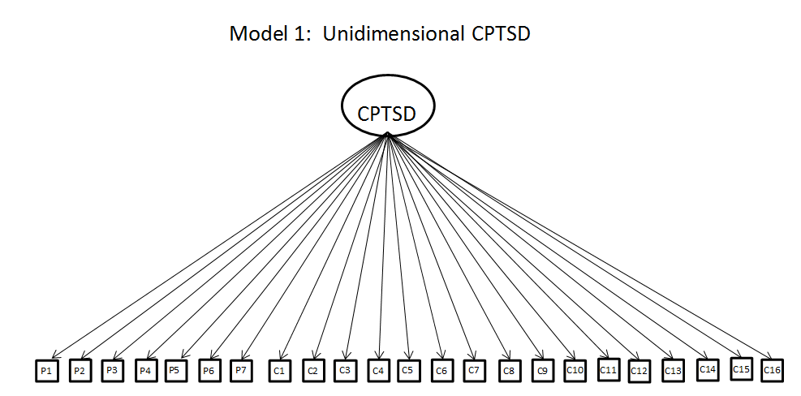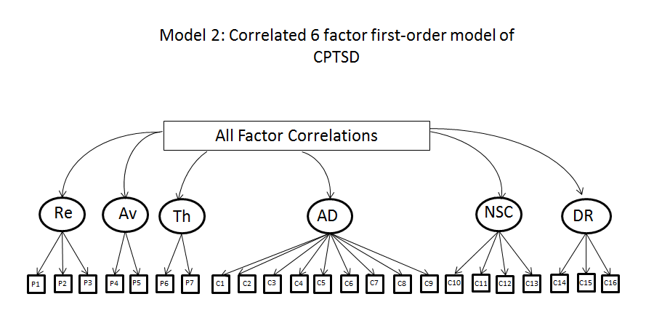

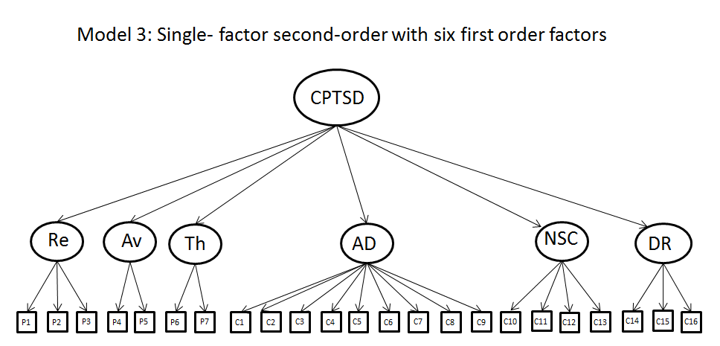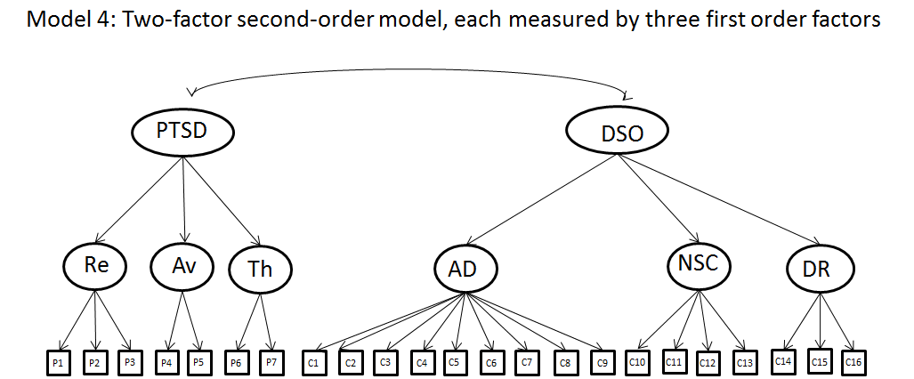
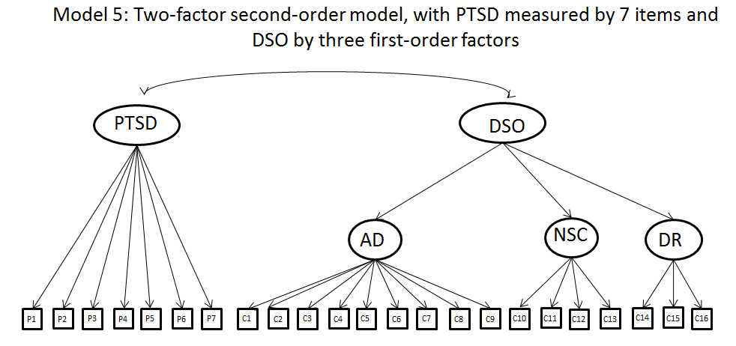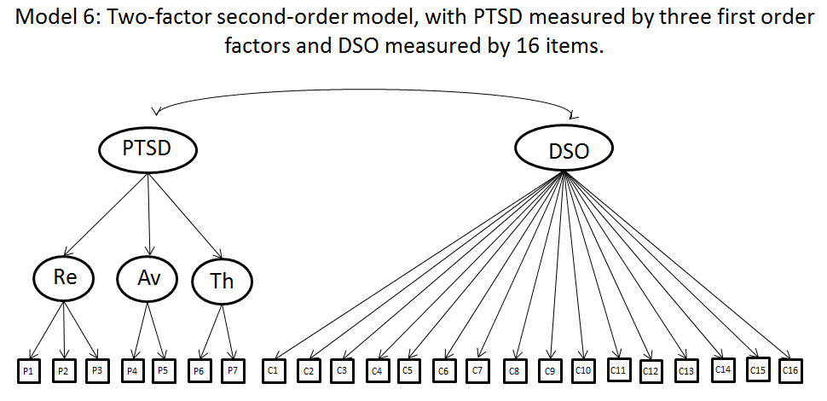

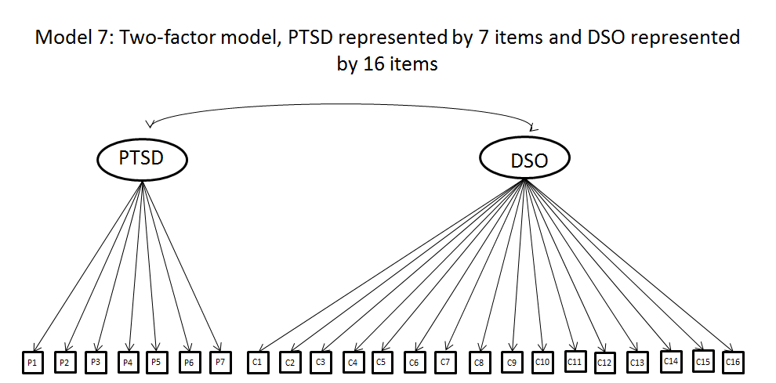
Note: All possible first-order correlations are represented as the box labelled ‘All Factor Correlations’ to avoid diagramic clutter.

