**The effect of confounding data features on a deep learning algorithm to predict complete coronary occlusion in a retrospective observational setting**

Rob Brisk1,2,*, Raymond Bond2, Dewar Finlay3, James McLaughlin3, Alicja Piadlo1, Stephen J Leslie4,5, David E Gossman6,7, Ian B Menown1,8, D J McEneaney1,9 and S Warren10

1 - *Cardiovascular Research Unit, Craigavon Hospital, 68 Lurgan Road, Portadown, BT63 5QQ, Northern Ireland, UK*

2 - *School of computer science, Ulster University, Shore Road, Jordanstown, BT37 0QB, Northern Ireland, UK*

3 - *Nanotechnology and Integrated Bioengineering Centre, Ulster University, Jordanstown, Northern Ireland, UK*

4 - *Cardiac Unit, Raigmore Hospital, Inverness, IV32 3UJ, Scotland, UK*

5 - *Division of Biomedical Sciences, University of the Highlands and Islands Institute of Health Research and Innovation, Old Perth Road, IV2 3JH, Inverness, Scotland, UK*

6 - *Tufts Medical School, 145 Harrison Avenue, Boston, MA 02111, USA*

7 - *Department of cardiology, St Elizabeth Medical Centre, 736 Cambridge Street, Boston, MA 02135, USA*

8 - *Queens University, University Road, Belfast, BT7 1NN, Northern Ireland, UK*

9 - *Centre for Advanced Cardiovascular Research, Ulster University, Jordanstown, Northern Ireland, UK*

*10 - Anne Arundel Medical Center, Department of Medicine, Cardiology Division, Annapolis, MD (S.W.).*

*\* - correspondence to* [*robbrisk@hotmail.com*](mailto:robbrisk@hotmail.com)

**Abstract**

*Background:* Deep learning (DL) has emerged in recent years as an effective technique in automated ECG analysis. *Methods:* A retrospective, observational study was design to assess the feasibility of detecting induced coronary artery occlusion in human subjects earlier than experienced cardiologists using a DL algorithm. A deep convolutional neural network (CNN) was trained using data from the STAFF III database. The task was to classify ECG samples as showing acute coronary artery occlusion, or no occlusion. Occluded samples were recorded after 60 seconds of balloon occlusion of a single coronary artery. For the first iteration of the experiment, non-occluded samples were taken from ECGs recorded in a rest room prior to entering theatres. For the second iteration of the experiment, non-occluded samples were taken in theatre prior to balloon inflation. Results were obtained using a cross-validation approach. *Results:* In the first iteration of the experiment, the DL model achieved an F1 score of 0.814, which was higher than any of three reviewing cardiologists or STEMI criteria. In the second iteration of the experiment, the DL model achieved an F1 score of 0.533, which is akin to the performance of a random chance classifier. *Conclusion:* The dataset was too small for the second model to achieve meaningful performance, despite the use of transfer learning. However, “data leakage” during the first iteration of the experiment led to falsely high results. This study highlights the risk of DL models leveraging data leaks to produce spurious results.

**Introduction**

Smith et al. noted ST segment elevation (STE) as an electrocardiogram (ECG) feature following the ligation of coronary arteries in canine models in 1918 [1]. Since then, it has become the gold standard bedside test for diagnosing transmural myocardial infarction (MI) caused by acute complete thrombotic coronary occlusion (ACTCO). The decision to activate the primary percutaneous coronary intervention (PPCI) pathway is generally contingent upon its presence [2]. The principal rationale for this practice can be summarised thus: (i) STE is known to be very specific for acute MI [3] and (ii) patients with STE, on average, benefit from primary PCI where patients with non-STEMI (NSTEMI) may not [4].

However, STE’s sensitivity for acute MI may be as low as 50% [5] and there have been few large-scale studies evaluating alternative models for predicting which patients will benefit from primary PCI [6]. Furthermore, such attempts have principally focussed on extending urgent revascularisation to “high risk” NSTEMIs, generally defined using a very small number of hand-crafted features (sometimes just two or three) and not incorporating ECG features [7, 8]. It could be argued that such low-dimensional feature representations poorly express the complex physiology of the patient with acute MI, and that an approach incorporating more relevant features might be more effective.

In the domain of atrial fibrillation (AF) detection, DL models have been shown to match “expert level” performance in the context of ambulatory recordings [9]. This is the highest possible performance one could expect for a task where the gold standard diagnostic criteria are based on expert interpretation of ECG data. In the domain of acute myocardial ischaemia, on the other hand, it is possible to use composite definitions that do not rely on ECG criteria but incorporate biochemical and angiographic data [3]. Therefore, it is plausible that a DL model could not only match, but also outperform, existing gold standard ECG criteria.

The aim of this study was to establish whether a DL algorithm can detect ACTCO, as defined by angiographically-proven acute coronary occlusion, by leveraging more complex ECG features than a manual approach would allow.

**Methods**

**Data acquisition**

ECG signals were downloaded from the STAFF III database (Physionet) [10-12]. This contains a collection of ECGs taken from 104 patients undergoing prolonged intracoronary balloon inflation. The records consist of nine lead ECGs at 1000Hz (investigators can calculate the three augmented limb leads if they wish). 76 records contain baseline ECGs obtained in a relaxing room prior to transfer to theatre. The inflations lasted an average of 262 seconds, with 84 lasting in excess of five minutes. Annotations contain the time of balloon inflations and deflations, contrast injection times and anatomical position of the balloons.

STAFF III remains one of the most valuable datasets for groups studying the early ECG effects of prolonged, total coronary occlusion in humans. It is the only publicly available dataset that contains angiographically-proven acute coronary artery occlusion without pre-selecting subjects based on ECG criteria nor chest pain.

Basic demographic information from the 76 STAFF III subjects included as per the original inclusion criteria (described below) are shown in table 1.

**Ethical considerations**

No ethical issues were identified with this study, as it involved open data from an anonymised, publicly-available database. This decision was ratified by the heads of research governance at two of the participating academic centres (Ulster University and Southern Health and Social Care Trust).

**Inclusion / exclusion criteria**

Initially, only records that included relaxing room ECGs were deemed eligible, as these were used as the non-ischaemic samples. Records where balloon inflations lasted less than 90 seconds were excluded as they contained insufficient ischaemic samples.

Several subjects underwent multiple inflations in different anatomical locations. Only data from the first inflation was used due to concerns that “hangover” electrical effects from previous inflations may confound results.

The study was executed and written up following completion of this initial protocol. However, following a conversation with a group who have worked extensively with the STAFF III database (including its creator), it was pointed out that the 28 patients excluded because they had no ECG from the relaxing room could be included if the beginning of their theatre ECG (taken prior to catheter insertion) was used as an alternative baseline.

It was decided that the experiment should be re-run with the inclusion criteria thus amended. It was also felt that standardising the baseline ECG acquisition by using pre-catheterisation theatre ECGs for all patients would be more methodologically sound.

**Algorithm design**

The model was a 34-layer convolutional neural network (CNN) with residual connections culminating in a fully connected layer with a single, sigmoid-activated output node. Researchers from the Stanford Machine Learning Group have identified this architecture as being particularly well-suited to processing ECG signal data [9], and our group has previously presented work using similar models for automated detection of atrial fibrillation (AF) [13]. The model was initiated using weights from the AF task, on the assumption that many ECG features learned during arrhythmia analysis would improve generalisation in the setting of ischaemia detection. This is known as “transfer learning” and can allow DL models to train for complex tasks on relatively small datasets [14].

During the training process, ECG signals were split into one second segments. Each ECG window was reshaped into a 9000 dimensional vector (9 leads x 1000Hz x 1 second). The loss was calculated using binary cross-entropy, where non-ischaemic samples were labelled 0, ischaemic traces 1.

**Model evaluation**

The model was evaluated using a 5-fold cross validation (CV) process, whereby each of 5 versions of the model were trained on data from 80% of the patients and tested on data from the remaining 20%. The experiment was subsequently repeated using a 10-fold CV process whereby data was split into 80% training, 10% validation and 10% test sets. This was to ensure the 5-fold CV process did not encourage overfitting.

Testing was undertaken using one 10 second trace for each patient taken from the baseline ECG (non-ischaemic examples) and one 10 second trace for each patient taken 60 seconds into balloon occlusion of a coronary artery (positive examples). 10 seconds was chosen because it is the standard length of printed 12 lead ECGs used to diagnose STEMI and would facilitate a fair comparison with cardiologist-labelled benchmarks.

The input vector for the model comprised a tensor of shape [batch size, 10, 9000]. The final dimension comprised one second of samples for each of nine leads at 1000Hz concatenated into a 9000-dimensional vector (the augmented limb leads were not explicitly calculated for the model). The penultimate dimension represented the 10 seconds of the ECG.

**Benchmarks**

Three consultant cardiologists were given all of the test traces in a random order and asked to label them as showing either no signs of ischaemia, non-specific ischaemic changes or STE. These results were used as a basis for comparison with the DL model performance as described below.

**Statistical analysis**

The accuracy of each classifier was calculated by dividing the number of correct labels with the total number of ECGs labelled. The consensus opinion of the three cardiologists regarding both non-specific ischaemic changes and STE was taken to be the current gold standard in clinical practice. This was evaluated against the DL model’s accuracy using the Chi-square test. For each classifier sensitivity, specificity, positive predictive value (PPV) and F1 score (see equation 1 below) were calculated.

$$2×\left(Sensitivity ×PPV\right)÷\left(Sensitivity+PPV\right)$$

*Equation 1 – the F1 score*

A receiver operating characteristic (ROC) curve was plotted for the DL model and area under the ROC (AUROC) calculated.

**Interrogating the model**

Attention heatmaps were generated using selective input masking. The fully trained model was shown each ECG in the test set with 50 millisecond (mS) segments “blanked out” (by substituting voltage values for zero). The greater the difference between the original prediction and the new prediction, the higher the value assigned to the masked part of the ECG on the heatmap. The process was repeated until a value had been assigned to each 50 mS window of each ECG.

**Results**

**First iteration of the study using original inclusion and exclusion criteria**

The results of ECG analysis by ST-elevation criteria (as defined by consensus opinion among the three cardiologists), individual analysis by each expert using a combination of both STEMI criteria and non-specific ischaemic changes, consensus opinion among the experts using both STEMI criteria and non-specific ischaemic changes, and analysis by the DL model are shown in figure 1. The DL model had both the highest accuracy (0.803) and the highest F1 score (0.814). Classification using the STEMI criteria produced the highest specificity (0.947). Cardiologist 3 achieved the highest sensitivity (0.842).

The confusion matrices used to calculate these results are included in appendix 1. As previously noted, the DL model’s results were calculated by taking the mean results of each cycle of the 5-fold CV process. Confidence intervals (95%) for these results are shown in figure 2.

Difference in accuracy between the DL model and the consensus cardiologist opinion for any type of ischaemic change was evaluated using the Chi-square test and found to be significant using a threshold of 0.05 (p=0.0469). Marginal homogeneity was evaluated using McNemar’s test. Results are shown in table 2.

Figure 3 shows the receiver operating characteristic (ROC) curve for the DL model. Area under the ROC (AUROC) was 0.860.

Results were reproducible using a 10-fold CV process as described in the methods section.

Attention heatmaps appeared to show that the model was primarily focussing on the latter part of the QRS complex or the ST-T segment. (See figure 4 for an example.)

**Second iteration of the study using amended inclusion and exclusion criteria**

Following amendment of the inclusion criteria so that baseline samples were obtained from theatre ECGs, 99 patients were included in the second run of the experiment. The model was retrained using the same 5-fold CV process, the same data sampling methods and the same hyperparameters as the first run.

Accuracy was 0.555 (standard deviation 0.08, 95% confidence interval 0.505 – 0.605). F1 score was 0.533 (standard deviation 0.17, 95% confidence interval 0.433 – 0.633). The experiment was repeated in case the stochastic nature of the DL approach has resulted in particularly poor results, but there was no change.

The results provide a case study that clearly demonstrates that a DL model that, under certain conditions, maya achieve high accuracy scores due to its ability to also exploit confounders and data leakages. This explains why the results in iteration 1 are superior to the results in iteration 2. The high performance in iteration 1 is likely due to the DL model detecting ‘noise’ as opposed to detecting ischaemia.

**Discussion**

This single centre, retrospective, observational study of 104 patients investigated the ability of a DL model to predict hyperacute myocardial ischaemia from ECG recordings. The first iteration, which obtained non-ischaemic samples from resting room ECGs, appeared to have an ability to detect ischaemia. The second iteration, which obtained non-ischaemic samples from inside theatres, was negative. In the first iteration, the model appeared to outperform a panel of three cardiologists with statistical significance. On the latter occasion, the model performed at the level of a random chance classifier. The likely explanation for the discrepancy in results is that the first model learned to associate background electrical noise in theatre with ischaemic samples during the first run of the experiment. Background electrical activity in cardiac theatres is known to manifest on ECGs (including noise in the 100Hz range from fluoroscopy) [15]. And given that the ‘ischaemic’ ECGs exhibited this noise, the algorithm was able to discriminate between ischaemia and non- ischaemia by simply detecting the noise in the ‘ischaemic’ ECGs. This is referred to as data leakage or a confounding factor.

During the second run, all samples were acquired in theatre and the model’s true ability to discern causative (as opposed to purely correlative) links within the data was revealed. The hypothesis had been that transfer learning from an arrythmia detection task may allow the model to glean generalisable insights from a small dataset [16], but the results demonstrate that this was not the case.

This experiment is not the first study showcasing how DL models can leverage confounding factors within the data to produce spuriously high performance: a number of similar occurrences have been described in healthcare and other domains [17-20]. Deep learning is currently receiving much attention in the domain of automated ECG interpretation, as it is in the fields of cardiac imaging, coronary evaluation and heart failure [21]. It is, therefore, particularly important that the cardiology community be aware of its pitfalls as well as its strengths.

We acknowledge that this was a highly speculative experiment at increased risk of spurious results due to a small study cohort and retrospective, observational setting [22]. We also recognise that neither cross-validation nor any other approach to validation guarantees against such an outcome, and agree with recent calls for more ML and DL applications to be in evaluated prospective, multi-centre clinical trials [23-25]. However, it must be noted that even DL algorithms trained on huge datasets and extensively validated by world-leading technical experts can behave in surprising, unacceptable and sometimes catastrophic ways [26, 27]. In addition, such tools may not integrate well into current clinical practice, where transparency is highly prized [28, 29].

It is our conclusion that AI in the medical domain must always retain a degree of “explainability” in order to facilitate human oversight and supervision. This does not necessarily require an exhaustive account of a DL model’s logic, which is encoded by the state of millions of coefficients within a complex computing graph [14] and may be impossible to explain in human terms. Rather, we propose that it falls to the clinical community to stipulate a set of minimum requirements for what we determine to be acceptable transparency in future cardiac DL applications.

In summary, DL continues to show significant promise and has many potential applications in modern medical practice [30]. However, it remains a nascent technology and further work is needed in the field. We particularly advocate future research that will support the development of standardised frameworks for acceptable transparency of these applications and we look forward to future discussions of this issue.

**Acknowledgements**

The corresponding author of this paper (Rob Brisk) holds a PhD scholarship from the Eastern Corridor Medical Engineering Centre that is supported by the European Union’s INTERREG VA Programme, managed by the Special EU Programmes Body (SEUPB). This research was also supported by the Craigavon Cardiac Care Association, whom we wish to thank for their active support of cardiovascular research in Northern Ireland over the last 50 years. We would also like to thank Physionet for providing the open-access ECG data used for this study.

**Author contributions**

Rob Brisk, Raymond Bond, David McEneaney, Alicja Piadlo, Dewar Finlay and James McLaughlin were responsible for the conception of this study. Rob Brisk wrote, executed and will be responsible for storing the source code and was the principle author of the paper. (The source code can be reviewed at <https://github.com/docbrisky/coronary-occlusion>.) David McEneaney, Stephen Leslie and David Gossman were the consultant cardiologists who labelled the ECGs. Along with Ian Menown, they also subsequently provided clinical insight on interpretation of the results, which formed the basis of substantive revisions. Raymond Bond oversaw the protocol and provided substantive revisions elsewhere in the paper. Stafford Warren reviewed the study, suggested the re-run that led to the discovery of the spurious results and provided substantive input into the re-write.

**Competing interests**

None of the authors have competing interests to declare.

**Tables and figures**

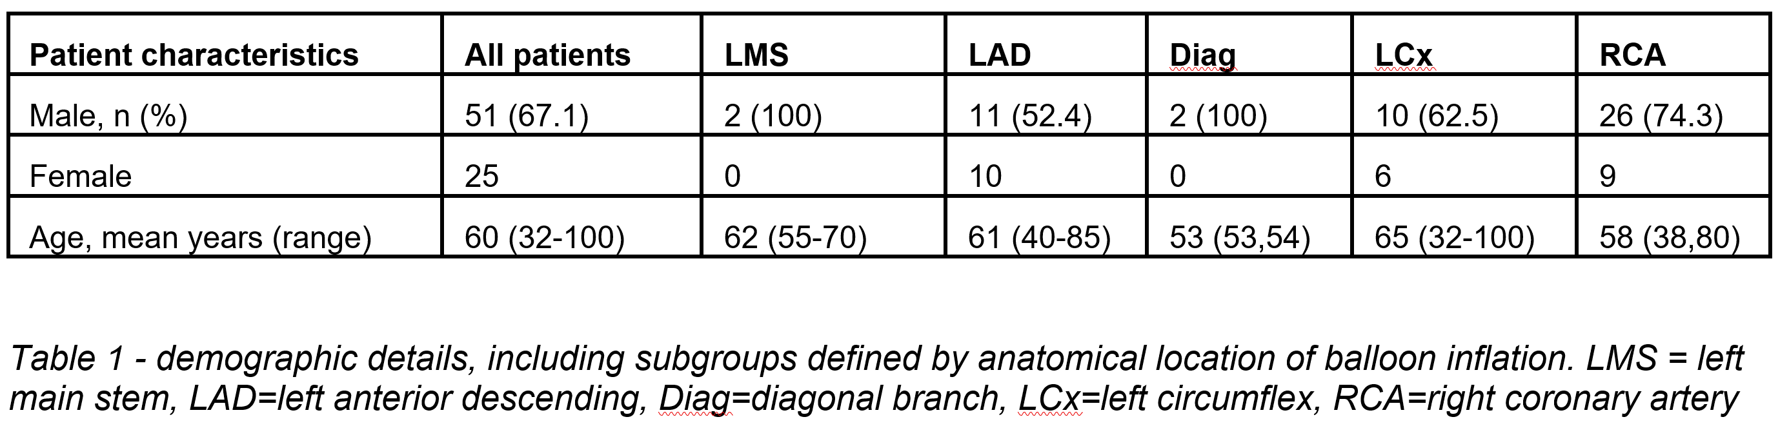

Figure 3 (first iteration) – ROC curve for the DL model (AUROC = 0.860). The dotted black line represents the ROC for a binary classifier based on random chance, where AUROC = 0.5

Table 1 (first iteration) – demographic details, including subgroups defined by anatomical location of balloon inflation. LMS = left main stem, LAD = left anterior descending, Diag = diagonal branch, LCx = left circumflex, RCA = right coronary artery

Figure 2 (first iteration) – results from the 5-fold cross validation process of the deep learning model across the whole dataset (averages and 95% confidence intervals)

Figure 1 (first iteration) – performance metrics of each classifier across the whole dataset

Figure 2 – results from the 5-fold cross validation process of the deep learning model across the whole dataset (averages and 95% confidence intervals)

Figure 1 - performance metrics of each classifier across the whole dataset

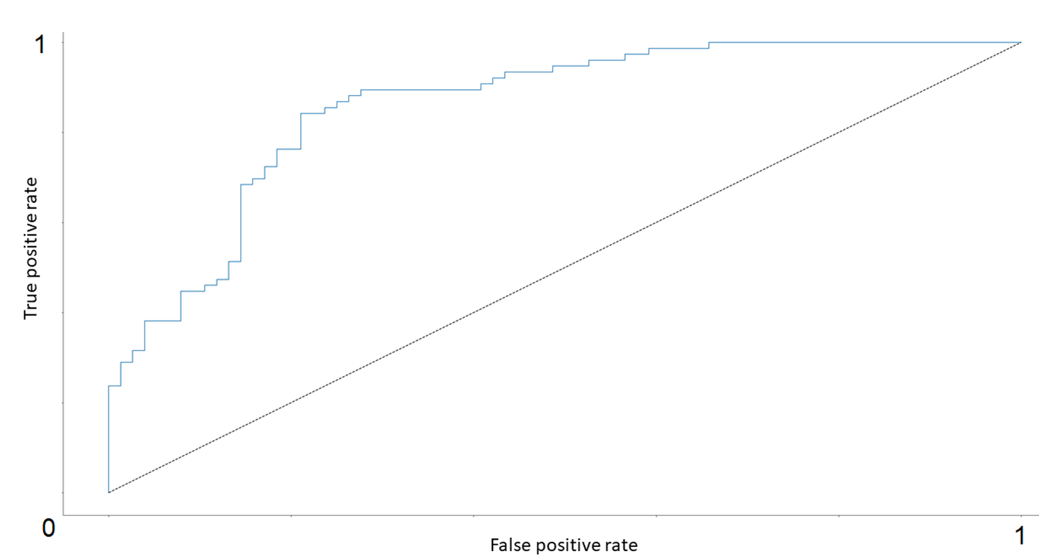

Figure 3 - ROC curve for the DL model (AUROC = 0.860). The dotted black line represents the ROC for a binary classifier based on random chance where AUROC = 0.5.

|  |  |  |  |  |  |
| --- | --- | --- | --- | --- | --- |
|  | **STEMI** | **Cardiologist 1** | **Cardiologist 2** | **Cardiologist 3** | **DL model** |
| **STEMI** | - | 0.193 | 0.126 | 0.699 | 0.177 |
| **Cardiologist 1** | 0.193 | - | 0.856 | 0.238 | **0.009** |
| **Cardiologist 2** | 0.126 | 0.856 | - | 0.201 | **0.004** |
| **Cardiologist 3** | 0.699 | 0.238 | 0.201 | - | 0.065 |
| **DL model** | 0.177 | **0.009** | **0.004** | 0.065 | - |

Table 2 - Classifier concordance calculated using McNemar's test. Statistically significant results (p<0.05) in bold.

Table 2 (first iterations) – classifier concordance calculated using McNemar’s test. Statistically significant results (p < 0.05) in bold.

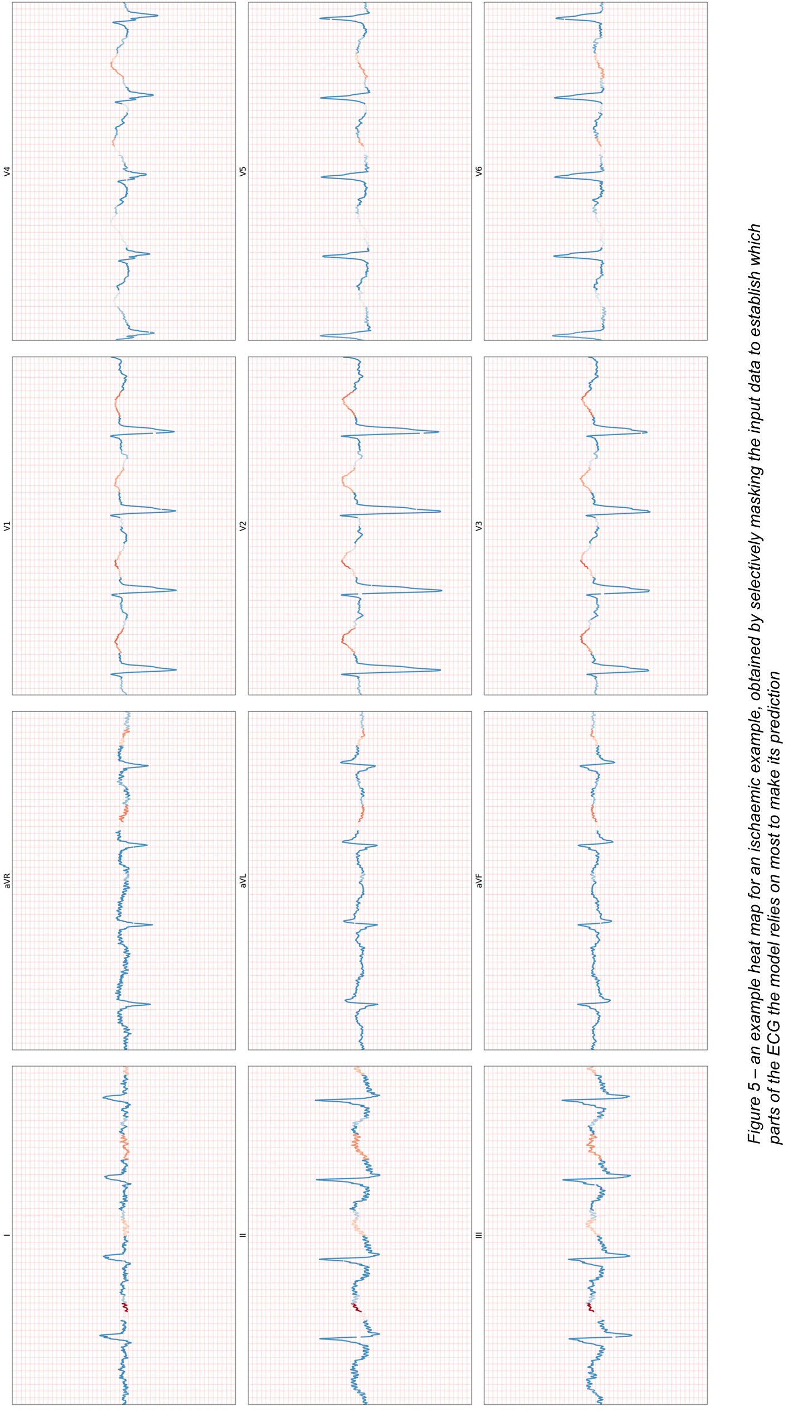

Figure 4 (first iteration) - an example heat map for an ischaemic example, obtained selectively masking input data to establish which parts of the ECG the model relies on most to make its prediction

**Appendices**

*Appendix 1 (first iteration)*: the confusion matrices from the overall classification task.

|  |  |  |
| --- | --- | --- |
| **STEMI** | Predicted: YES | Predicted: NO |
| Actual: YES | 39 | 37 |
| Actual: NO | 4 | 72 |
| **Cardiologist 1** |  |  |
| Actual: YES | 58 | 18 |
| Actual: NO | 33 | 43 |
| **Cardiologist 2** |  |  |
| Actual: YES | 59 | 17 |
| Actual: NO | 36 | 40 |
| **Cardiologist 3** |  |  |
| Actual: YES | 67 | 9 |
| Actual: NO | 35 | 41 |
| **DL model** |  |  |
| Actual: YES | 66 | 10 |
| Actual: NO | 20 | 56 |

**References**

1. SMITH, F.M., 1918. The ligation of coronary arteries with electrocardiographic study. *Archives of Internal Medicine,* **22**(1), pp. 8-27.
2. IBANEZ, B., JAMES, S., AGEWALL, S., ANTUNES, M.J., BUCCIARELLI-DUCCI, C., BUENO, H., CAFORIO, A.L., CREA, F., GOUDEVENOS, J.A. and HALVORSEN, S., 2017. 2017 ESC Guidelines for the management of acute myocardial infarction in patients presenting with ST-segment elevation: The Task Force for the management of acute myocardial infarction in patients presenting with ST-segment elevation of the European Society of Cardiology (ESC). *European heart journal,* **39**(2), pp. 119-177.
3. MENOWN, I., MACKENZIE, G. and ADGEY, A., 2000. Optimizing the initial 12-lead electrocardiographic diagnosis of acute myocardial infarction. *European heart journal,* **21**(4), pp. 275-283.
4. COX, D.A., STONE, G.W., GRINES, C.L., STUCKEY, T., ZIMETBAUM, P.J., TCHENG, J.E., TURCO, M., GARCIA, E., GUAGLIUMI, G. and IWAOKA, R.S., 2006. Comparative early and late outcomes after primary percutaneous coronary intervention in ST-segment elevation and nonâ€“ST-segment elevation acute myocardial infarction (from the CADILLAC trial). *The American Journal of Cardiology,* **98**(3), pp. 331-337.
5. POLLEHN, T., BRADY, W.J., PERRON, A.D. and MORRIS, F., 2002. The electrocardiographic differential diagnosis of ST segment depression. *Emergency medicine journal,* **19**(2), pp. 129-135.
6. BANNING, A.S. and GERSHLICK, A.H., 2018. Timing of intervention in non-ST segment elevation myocardial infarction. *European Heart Journal Supplements,* **20**(suppl_B), pp. B10-B20.
7. BADINGS, E.A., DAMBRINK, J.H., TJEERDSMA, G., RASOUL, S., TIMMER, J.R. and LOK, D.J., 2013. Early or late intervention in high-risk non-ST-elevation acute coronary syndromes: results of the ELISA-3 trial. *EuroIntervention: journal of EuroPCR in collaboration with the Working Group on Interventional Cardiology of the European Society of Cardiology,* **9**(1), pp. 54-61.
8. MEHTA, S.R., GRANGER, C.B., BODEN, W.E., STEG, P.G., BASSAND, J., FAXON, D.P., AFZAL, R., CHROLAVICIUS, S., JOLLY, S.S. and WIDIMSKY, P., 2009. Early versus delayed invasive intervention in acute coronary syndromes. *New England Journal of Medicine,* **360**(21), pp. 2165-2175.
9. HANNUN, A.Y., RAJPURKAR, P., HAGHPANAHI, M., TISON, G.H., BOURN, C., TURAKHIA, M.P. and NG, A.Y., 2019. Cardiologist-level arrhythmia detection and classification in ambulatory electrocardiograms using a deep neural network. *Nature medicine,* **25**(1), pp. 65.
10. MARTÍNEZ, J.P., PAHLM, O., RINGBORN, M., WARREN, S., LAGUNA, P. and SÖRNMO, L., 2017. The STAFF III database: ECGs recorded during acutely induced myocardial ischemia, *2017 Computing in Cardiology (CinC)* 2017, IEEE, pp. 1-4.
11. PETTERSSON, J., CARRO, E., EDENBRANDT, L., MAYNARD, C., PAHLM, O., RINGBORN, M., SÖRNMO, L., WARREN, S.G. and WAGNER, G.S., 2000. Spatial, individual, and temporal variation of the high-frequency QRS amplitudes in the 12 standard electrocardiographic leads. *American Heart Journal,* **139**(2), pp. 352-358.
12. GOLDBERGER, A.L., AMARAL, L.A., GLASS, L., HAUSDORFF, J.M., IVANOV, P.C., MARK, R.G., MIETUS, J.E., MOODY, G.B., PENG, C. and STANLEY, H.E., 2000. PhysioBank, PhysioToolkit, and PhysioNet: components of a new research resource for complex physiologic signals. *Circulation,* **101**(23), pp. e215-e220.
13. BRISK, R., BOND, R., BANKS, E., PIADLO, A., FINLAY, D., MCLAUGHLIN, J. and MCENEANEY, D., 2019. Deep learning to automatically interpret images of the electrocardiogram: Do we need the raw samples? *Journal of electrocardiology,* **57S**, pp. S65-S69.
14. GOODFELLOW, I., BENGIO, Y. and COURVILLE, A., 2016. *Deep learning.* MIT press.
15. HAAR, C.C.T., MAAN, A.C., SCHALIJ, M.J. and SWENNE, C.A., 2012. ST and ventricular gradient dynamics during percutaneous transluminal coronary angioplasty, *2012 Computing in Cardiology* 2012, IEEE, pp. 341-344.
16. YU, X. and ALOIMONOS, Y., 2010. Attribute-Based Transfer Learning for Object Categorization with Zero/One Training Example, K. DANIILIDIS, P. MARAGOS and N. PARAGIOS, eds. In: *Computer Vision – ECCV 20*, 10 2010, Springer Berlin Heidelberg, pp. 127-140.
17. CARUANA, R., LOU, Y., GEHRKE, J., KOCH, P., STURM, M. and ELHADAD, N., 2015. Intelligible models for healthcare: Predicting pneumonia risk and hospital 30-day readmission, *Proceedings of the 21th ACM SIGKDD International Conference on Knowledge Discovery and Data Mining* 2015, ACM, pp. 1721-1730.
18. BAROCAS, S. and SELBST, A.D., 2016. Big data's disparate impact. *Calif.L.Rev.,* **104**, pp. 671.
19. SWEENEY, L., 2013. Discrimination in online ad delivery. *arXiv preprint arXiv:1301.6822.*
20. SAUNDERS, J., HUNT, P. and HOLLYWOOD, J.S., 2016. Predictions put into practice: a quasi-experimental evaluation of Chicagoâ€™s predictive policing pilot. *Journal of Experimental Criminology,* **12**(3), pp. 347-371.
21. LOPEZ-JIMENEZ, F., ATTIA, Z., ARRUDA-OLSON, A.M., CARTER, R., CHAREONTHAITAWEE, P., JOUNI, H., KAPA, S., LERMAN, A., LUONG, C. and MEDINA-INOJOSA, J.R., 2020. Artificial intelligence in cardiology: present and future, *Mayo Clinic Proceedings* 2020, Elsevier, pp. 1015-1039.
22. BOLLEN, C.W., HOEKSTRA, M.O. and ARETS, H., 2006. Pooling of studies in meta-analysis of observational research leads to precise but spurious results. *Pediatrics,* **117**(1), pp. 261-262.
23. LIU, X., FAES, L., CALVERT, M.J. and DENNISTON, A.K., 2019. Extension of the CONSORT and SPIRIT statements. *The Lancet,* **394**(10205), pp. 1225.
24. LIU, X., RIVERA, S.C., FAES, L., RUFFANO, L.F.D., YAU, C., KEANE10, P.A., ASHRAFIAN11, H., DARZI11, A., VOLLMER, S.J. and DEEKS, J., 2019. Reporting guidelines for clinical trials evaluating artificial intelligence interventions are needed. *Nature Medicine* **25**, pp. 1467-1468
25. LUO, W., PHUNG, D., TRAN, T., GUPTA, S., RANA, S., KARMAKAR, C., SHILTON, A., YEARWOOD, J., DIMITROVA, N. and HO, T.B., 2016. Guidelines for developing and reporting machine learning predictive models in biomedical research: a multidisciplinary view. *Journal of medical Internet research,* **18**(12), pp. e323.
26. HOWARD, A. and BORENSTEIN, J., 2018. The ugly truth about ourselves and our robot creations: the problem of bias and social inequity. *Science and Engineering Ethics,***24**(5), pp. 1521-1536.
27. STILGOE, J., 2018. Machine learning, social learning and the governance of self-driving cars. *Social Studies of Science,***48**(1), pp. 25-56.
28. HIRSH, J. and GUYATT, G., 2009. Clinical experts or methodologists to write clinical guidelines? *The Lancet,* **374**(9686), pp. 273-275.
29. NORHEIM, O.F., 1999. Healthcare rationing—are additional criteria needed for assessing evidence based clinical practice guidelines? *Bmj,* **319**(7222), pp. 1426-1429.
30. ESTEVA, A., ROBICQUET, A., RAMSUNDAR, B., KULESHOV, V., DEPRISTO, M., CHOU, K., CUI, C., CORRADO, G., THRUN, S. and DEAN, J., 2019. A guide to deep learning in healthcare. *Nature medicine,* **25**(1), pp. 24-29.