Graphical Abstract
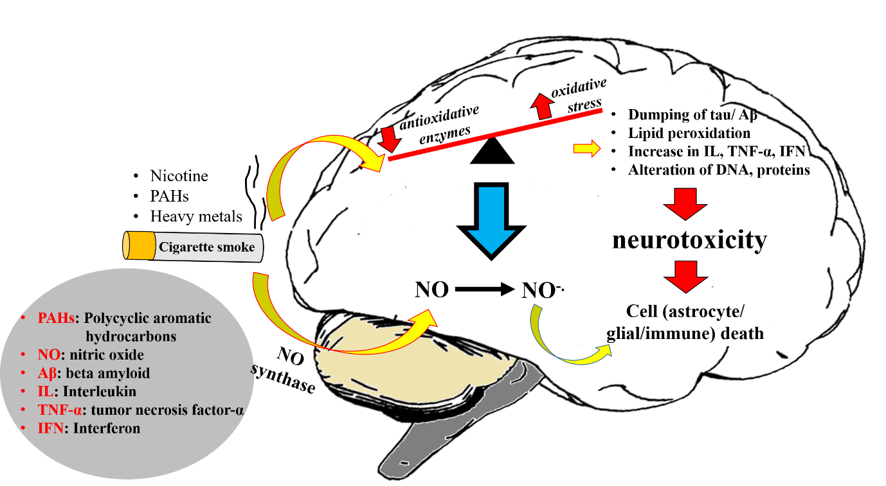

Beyond the obvious: Smoking and respiratory infection implications on Alzheimer's disease

Ridhima Wadhwa^{1,2#}, Keshav Raj Paudel^{2,3#}, Meenu Mehta^{1,2}, Shakti D Shukla⁴, Krishna Sunkara¹, Parteek Prasher⁵, Nisha Panth², Rohit Goyal⁶, Dinesh Kumar Chellappan⁷, Gaurav Gupta⁸, Philip M. Hansbro^{2,3,4}, Alaa AA. Aljabali⁹, Murtaza M. Tambuwala¹⁰, Kamal Dua^{1,2,4,6*}

¹Discipline of Pharmacy, Graduate School of Health, University of Technology Sydney, Ultimo NSW 2007, Australia
²Centre for Inflammation, Centenary Institute, Sydney, New South Wales, Australia
³School of Life Sciences, University of Technology Sydney, Sydney, NSW, Australia
⁴Priority Research Centre for Healthy Lungs, Hunter Medical Research Institute (HMRI) & School of Biomedical Sciences and Pharmacy, University of Newcastle, Callaghan,
NSW 2308, Australia
⁵Department of Chemistry, University of Petroleum & Energy Studies, Dehradun 248007, India
⁶School of Pharmaceutical Sciences, Shoolini University, Bajhol, Sultanpur, Solan, Himachal Pradesh, 173 229, India
⁷Department of Life Sciences, School of Pharmacy, International Medical University, Kuala Lumpur 57000, Malaysia
⁸School of Phamacy, Suresh Gyan Vihar University, Jagatpura, Mahal Road, Jaipur, India
⁹Yarmouk University, Irbid 21163, Jordan, Pharmaceutical Sciences
¹⁰School of Pharmacy and Pharmaceutical Sciences, Ulster University, Coleraine, County, Londonderry, BT52 1SA, Northern Ireland, United Kingdom

# Equal contribution

*Corresponding Author:
Dr Kamal Dua
Email: Kamal.Dua@uts.edu.au

⁷, Alaa AA. Aljabali⁸, Dinesh Kumar Chellapan⁹, Gaurav Gupta¹⁰, Philip M. Hansbro^{2,3,4*}, Kamal Dua^{1,2,4,6*}

¹Discipline of Pharmacy, Graduate School of Health, University of Technology Sydney, Ultimo NSW 2007, Australia
²Centre for Inflammation, Centenary Institute, Sydney, New South Wales, Australia
³School of Life Sciences, University of Technology Sydney, Sydney, NSW, Australia
⁴Priority Research Centre for Healthy Lungs, Hunter Medical Research Institute (HMRI) & School of Biomedical Sciences and Pharmacy, University of Newcastle, Callaghan,
NSW 2308, Australia
⁵Department of Chemistry, University of Petroleum & Energy Studies, Dehradun 248007, India
⁶School of Pharmaceutical Sciences, Shoolini University, Bajhol, Sultanpur, Solan, Himachal Pradesh, 173 229, India

Abstract

Background: Tobacco smoke is not only a leading cause for chronic obstructive pulmonary disease, cardiovascular disorders, lung and oral cancers but also causes neurological disorders such as Alzheimer’s disease. Tobacco smoke consists of more than 4500 toxic chemicals, which form free radicals and can cross blood brain barrier resulting in oxidative stress, an extracellular amyloid plaque from the aggregation of amyloid β (Aβ) peptide deposition in the brain. Further, respiratory infections such as Chlamydia pneumoniae, respiratory syncytial virus have also been involved in the induction and development of the disease.
Methods: The necessary information collated on this review has been gathered from various literature published from 1995 to 2019.
Findings: The review article sheds light on the role of smoking and respiratory infections in causing oxidative stress and neuroinflammation resulting in Alzheimer's disease (AD). This review will be of interest to scientists and researchers from biological and medical science disciplines including microbiology, pharmaceutical sciences and the translational researchers, etc.
Conclusion: The increasing understanding of the relationship between chronic lung disease and neurological disease are two-fold. First, this would help to identify the risk factors and possible therapeutic interventions to reduce the development and progression of both diseases. Second, this would help to reduce the probable risk of development of AD in the population prone to chronic lung diseases.

Keywords: Smoking; Pulmonary infections; Alzheimer’s disease; oxidative stress; infection

- Introduction
Dementia is a heterogeneous syndrome that is primarily characterised by marked reductions in an individual’s cognition levels which leads to impairments in social, professional or personal life [1]. A broad classification of dementia includes patients with dementia being either those who are “neurodegenerative” and non-neurodegenerative [1, 2]. Although simplistic in nature, this categorisation is increasingly being expanded to accommodate newly diagnosed traits associated with dementia [3]. Most common clinical symptoms of dementia include progressive memory impairment, gradual decline in cognition abilities, hallucinations, behavioural alterations (e.g., loss of empathy), aggression, and accidental falls leading to physical injury, headache and malaise [1]. Notably, one of the commonest forms of dementia is AD. This affects a majority of individuals (~70%) with dementia [4, 5].
The burden of dementia has doubled from 1990 (20.2 million) to 2016 globally (43.8 million) [6]. This is primarily due to increasing population growth and ageing. Moreover, the mortality attributed to dementia is now the fifth leading cause of deaths worldwide, accounting for approximately 2.4 million deaths annually [6]. Furthermore, a total of 28·8 million disability-adjusted life years (DALYs) corresponded to dementia. Around 6·4 million of these DALYs may be directly related to major modifiable risk factors. These may include elevated body mass index and smoking [6]. In addition, the economic costs associated with AD is enormous, with total direct expenditure of AD/dementia in USA estimated to be approximately $183 billion, which are predicted to increase to $1.1 trillion by 2050[7].
The key neuropathological biomarkers and/or effectors that are found in cerebrospinal fluid samples of the subjects having AD are outlined below; clumping of senile plaques that are made primarily of β-amyloid (i.e., Aβ42), and substances namely, neurofibrillary tangles (NFTs). These NFTs are primarily made up of a specific protein (tau (τ) protein). These proteins are generally hyperphosphorylated [8]. Novel potential biomarkers include amyloid β oligomers and other synaptic markers [9]. Age is one of the major non-modifiable risk factors in patients having AD. In addition, occurrence of genetic mutations, specifically, in the apolipoprotein E-4 allele (APOE4) is also a major risk factor [10]. In addition to the above, there are several important genetic risk factors that play a significant role. These are alterations within in the amyloid precursor proteins (APP) of the genes, PSEN1 and PSEN2 (presenilin 1 and presenilin 2, respectively). There are several other non-modifiable risk factors in individuals with AD. These constitute female gender, past incidence of head injury/trauma, hereditary incidence of Down syndrome, dementia and other risk factors arising from cerebrovascular issues. In addition, there are several modifiable risk factors attributed to AD, which primarily include lifestyle-related risk factors (i.e., cigarette smoking, stress, depression, inadequate sleep) [11] or acquired diseases that substantially increase the risk of AD, which include diabetes, hypertension, obesity and dyslipidemia [12].
Smoking of cigarettes is one of the significant and principal modifiable risk factors in the development of AD. Importantly, Cataldo et al., found that ever smoking, either active or former, was indeed one of the principal risk factors in the development of AD with a relative risk of 1.72 and a 95% CI (1.33–2.12) [13]. Moreover, a large study (n=21,123) reported that individuals who smoked >2packs/day were at increased risk of developing dementia, where the adjusted hazard ratio was 2.14 and a 95% CI, (1.65-2.78). The study also reported that AD had an adjusted HR of 2.57 at 95% CI, (1.63-4.03). Vascular dementia had an adjusted HR of 2.72 at 95% CI (1.20-6.18) [14]. The potential mechanisms by which former/active smoking may exert its effects on the initiation of AD are speculative and include generation of free radicals that could increase the oxidative stress burden in the host [15]. This leads to activation of immune system and more specifically activation of microglia, which then leads to increased production and release of inflammation triggering cytokines (e.g., tumour necrosis factor (TNF)-α, nitric oxide (NO), interleukin-6 (IL-6), and reactive oxygen species (ROS) [15, 16]. All these pro-inflammatory markers have been shown to be anti-neurogenic, potentially via inducing mitochondrial dysfunction [16]. Additionally, exposure to cigarette smoke is also associated with neuropathology characteristic of AD in both humans and animal models of AD [15].
Recently, emerging data also have outlined and summarised the crucial role of microbes in the development of AD. In particular, several neurotropic viruses, for instance, those related to the family of Herpesviridae namely, Human herpesvirus 1 [HHV-1], Cytomegalovirus (CMV), and Human herpesvirus 2 (HHV-2) are implicated in the neuropathological characteristics of AD [17]. Notably, increased HHV-6A and HHV-7 were detected in the brain sections of subjects having this condition (AD), when studied relatively with subjects who acted as controls [18]. Moreover, Eimer et al., have recently showed that amyloid-β peptides bind to the surface glycoproteins of herpesvirus, thereby, accelerating the deposition of β-amyloid in response to the viruses namely, herpes simplex virus 1 (HSV1) and HHV 6A and B [19]. Although this mechanism is presumably protective against the virus-induced damages in the brain, it also leads to increased amyloid-β amyloidosis [19]. Several bacteria, including, Fusobacterium nucleatum, Chlamydia pneumoniae [20], Prevotella intermedia, Helicobacter pylori, Porphyromonas gingivalis, Borelia burgdorferi, Treponema pallidum and other related bacteria of periodontal origin have also been associated with AD initiation and/or development [17]. The colonisation and/or infection with bacteria could lead to persistent inflammation within the host that could spill-over systemically and lead to damage to the neurons, i.e., neuro-inflammation [21]. This could then lead to hallmark features of AD. A potential role for gut microbiota, especially in the maturation of microglia and systemic immune cells, has been proposed and should be investigated further to tease out specific and most relevant mechanisms associated with infections and AD [22, 23].
- Effects of respiratory diseases in Alzheimer’s disease
Cognitive impairment in individuals with long term pathological lung conditions is continually shown to be more severe than without it (Figure 1).
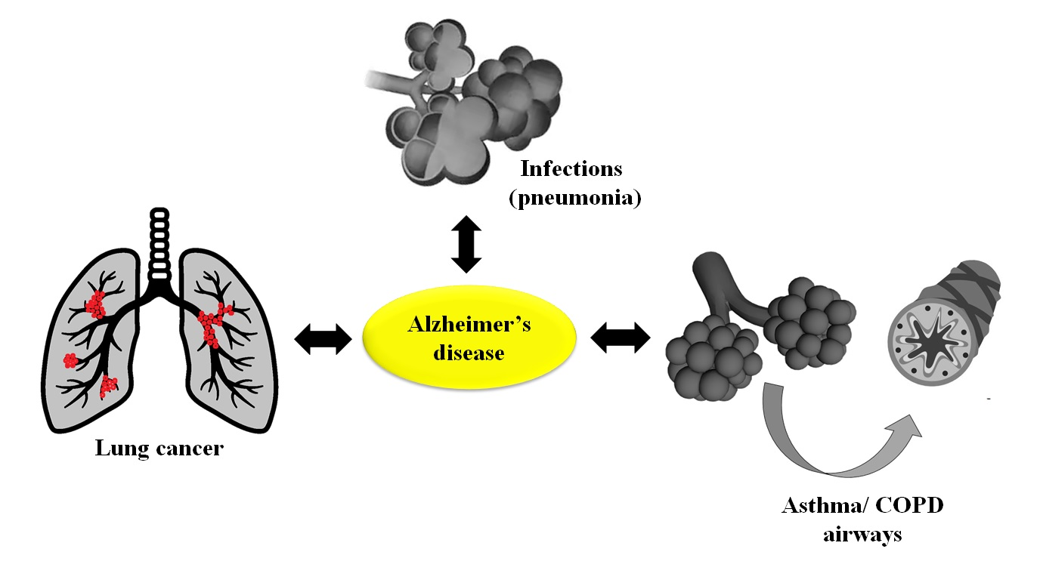
Figure 1: Inter-relationship of AD with respiratory diseases.
  - Chronic obstructive pulmonary disease (COPD)
The occurrence of cognitive disorders in COPD is between 10% and 61% based on population of the study and neuropsychological evaluation methodology. Chronic pulmonary obstructive disease has an effect on 210 million individuals, and 60 percent of certain groups have cognitive impairment [24-27]. A one year study involving 126,106 U.S. citizens in nursing homes found a combined diagnosis of COPD and dementia in mentally impaired health, showing substantial data to justify the link to poor quality of living standards, hospitalization and diminished survival. Moderate to severe cognitive dysfunction was reported to occur in around 61% of extremely hypoxaemic COPD individuals. Some studies show a global disability or lack of attention, memory and thinking and motor functions of COPD patients [28, 29]. A majority of the 42 percent of COPD patients showed severe dysfunction of cognition when compared to 22 percent for the patients who were in the group that was labelled as control as reported by the combined Nocturnal Oxygen Therapy and Intermittent Positive Pressure Breathing trials [30].
  - Asthma
The major clinically defined symptoms of asthma are breathlessness, wheezing, chest and throat tightness, repeated cough along with obstruction in the airflow [31-36]. The characteristics feature of asthma includes goblet cell hyperplasia, alterations in extracellular matrix component, denudation of epithelial lining, increased airway smooth muscle cell proliferation and angiogenesis [37]. Some studies suggest that neurocognitive dysfunction has an association with asthma, citing causes such as systemic inflammation, medication effects and sleep disorders [38, 39]. The incidences of cognitive dysfunction along with dementia were particularly related with mid-life asthma, and risks with exacerbations and hospitalization further increased. Cognitive function was assessed in baseline subjects, 6 weeks after administering inhaled bronchodilators and steroids. The sample size was 46, who were primarily atopic subjects suffering from asthma [40]. The intervention showed an enhancement in cognitive capacities, which is reported to have a connection with improved respiratory function variability. However, it is not evident that median effects have been fully taken into consideration in practice and regress [41].
  - Pneumonia
Pneumonia, in particular for older adults, is a main cause of hospitalization and mortality. The importance of the clinical management of pneumonia is growing with the rapid growth of the older population [42]. The aging phenomenon is followed by a growing number of Alzheimer's patients, a major challenge for healthcare. Previous research has shown that Alzheimer's is a risk factor for pneumonia in older adults. Several studies have also shown that people with Alzheimer's tend to die from pneumonia more often. A study reported on this has shown the risk of pneumonia-associated mortality is more than twice higher for Alzheimer's patients than for those without Alzheimer's. Nevertheless, the estimated rate of death from pneumonia among older adults with dementia ranges from 12% to 70% [43, 44].
  - Lung Cancer
Among cancer related death, lung cancer is the leading cause of mortality globally primarily due to lack of effective early diagnostic markers and treatments [45]. About 30 percent of small cell lung cancer (SCLC) patients suffer from a form of neurological disorder in course of the condition [46]. A majority of them are due to cerebral metastases. Some of these are metastases to locations other than the cerebrum. But, due to other factors there is a small percentage of them. These may result from comorbid conditions, chemical therapy and/or radiation, paraneoplastic neurological syndrome (PNS), aging, or immunological deterioration. A 59-year-old subject who was diagnosed with small-cell lung cancer (SCLC) received full response to chemoradiation in one case study in October 2008, which included a prophylactic cranial irradiation (PCI) with (25 Gy at 250 cGy per fraction). He was reported to have anorexia, weight loss, fatigue, and short-term loss of memory, and eventually developed Alzheimer's and weakness in his muscles, three months afterwards. Magnetic resonance imaging showed the progression of diffuse atrophy without evidence of metastasis of SCLC [47].
3. Role of nicotine in the pathology of Alzheimer’s disease
The hallmark features observed in AD pathology is the accumulation of two types of proteins, the naturally occurring Aβ peptide which accumulates as extracellular amyloid plaques and the intracellular hyperphosphorylated τ proteins aggregated as neurofibrillary tangles in various regions of the brain modulating the cholinergic system [48-50].
The Cholinergic system consists of the enzyme choline acetylcholine transferase (ChAT) that induces the production of the neurotransmitter acetylycholine (ACh) at the synaptic junction, the receptors nicotinic acetylcholine receptors (nAChRs) and muscarinic receptors which form a complex responsible for the neurotransmission, ACh esterase which metabolises the ACh after the signal transduction and the regulatory of ACh esterase and inhibitors [51-53]. The accumulation of amyloid plaques and τ proteins leads to decreased activity of ChATs that impairs the secretion of the neurotransmitters [53, 54], reduction in nACh receptors and increased stimulation of ACh esterases results in synaptic and neuronal loss causing brain atrophy and dementia observed in AD [55]. Thus, in AD the cholinergic and the synaptic mechanism are impaired affecting the nerve cell communication that results in the loss of cognitive and noncognitive functions such as memory, learning, attention, anxiety and balance and movement [56, 57].
Nicotine is the active component of tobacco, a natural product produced by plants of nightshade family and prepared synthetically as well. It is one of the commonly abused drugs and is highly addictive that augments individuals’ addiction to tobacco usage [58, 59]. Several studies proved the involvement of nicotine in AD pathogenesis and showed their protective and degenerative functions in the disease [59-62].
Homeostasis of metals in the body plays an important role in AD pathogenesis as it primarily affects the development of Aβ dimers and trimers [63]. Tobacco contains a high amount of other metals such as Al, As, Cd, Co, Cr, Cu, Hg, Mn, Ni, Pb, Se and Zn other than nicotine, at non-negligible amounts, out of which many are considered neurotoxic [64, 65]. Heavy metals such as Pb, Cd, As etc. increases the expression of amyloid precursor protein (APP) and β-secretase 1(BACE1) and interferes with the functioning of microglia and increases the accumulation of Aβ and plaque formation in hippocampus and cortex area [66, 67]. Moreover the exposure to heavy metals activates toll like receptors (TLR4) which induces rise in proinflammatory proteins such as Interleukins (IL)-1β, IL-8, tumor necrosis factor alpha (TNF-α), IL-6 and iNOS which intensifies the neuroinflammation [68].
Cadmium ions induce conformational changes (coil structure to α-helix structure) in the third repeat (R3) τ domain resulting in τ self-aggregation [69]. While aluminium improve the performance of τ kinases such as cyclin-dependent kinase 5 (CDK5), prevents dephosphorylation and enhances its aggregation [70]. Evidences showed that Alzheimer's disease (AD) pathology can be partly caused or worsened by inorganic mercury. Its strong affinity to selenium and selenoprotein indicates that inorganic mercury can promote neurodegenerative diseases through redox-regulation degradation. This can also enhance the effect of other metals on pathogenesis of AD [71].
Lovell et al. linked AD to the transition metals such as Cu, Fe, and Zn and showed that they are raised in phosphorylated τ tangles and in AD plaques (AD neuropil) as compared with adjacent nervous tissue [72]. In contrast to AD neuropil, copper was considerably higher (P<0.05) in the rim of senile plaques and Zn expedite the accumulation of amyloid beta peptide [73]. Another research revealed unique binding of these ions (Cu(II), Fe(II) and Zn(II)) to the Aβ peptide and modified its aggregation pathways [74]. Exposure to chronic copper worsened Aβ's accumulation and impair cognition ability [75]. Cu(II) and Fe(III) ions easily bound by Aβ peptide 64, produce harmful ROS which can potentially lead to neuroinflammatory symptoms correlated with AD [76, 77].

Nicotine is both a potent stimulant and relaxant, it activates the nAChRs of the parasympathetic nervous system and mimics the effects ACh [78]. However, there are a five nAChR subunits consisting of α (2-7, 9 and 10), β (2-4), γ, δ, and ε that form functional heteromeric and homomeric pentamers which modulate various functions of the nervous system [53, 78, 79]. Nicotine intake was first shown to be protective in an experimental rodent model of AD by Nordberg and his colleagues [80]. They observed that in transgenic mice with mutation in human amyloid precursor protein (APP) when supplied by adding nicotine in the drinking water, had 80% reduction in the Aβ peptide plaques compared with the controls [80].
Several other investigations also showed the decrease in Aβ peptide pathology with nicotine treatment through the activation of nAChRs, α 4 and 7, β 2 and more specifically via the stimulation of the nicotinic receptor α7 [62, 81-83]. Further, it was reported that in APP mutated transgenic mice, nicotine administration reduces the cellular concentration of the metal copper which decreases Aβ-mediated neurodegeneration and is independent of nChRs activation [84]. In AD, in addition to the dysfunctional cholinergic system, the Aβ plaques modulate the secretion of the neurotransmitter glutamate that overstimulates its receptor N-methyl-D-aspartate (NMDA) inducing neurotoxicity [85]. Moreover, various studies also showed that nicotine induced nAChRs stimulation attenuate glutamate mediated neurodegeneration as shown in figure 2 [86-88].
In contrast to Aβ aggregation, nicotine treatment showed increased hyperphosphorylation and aggregation of τ proteins in both in vitro and in vivo models [61, 89, 90]. Whereas, a recent study has reported that nicotine does not interact with Aβ and has no effect on Aβ accumulation in AD pathology [60]. The neurotoxic effects of nicotine may be mediated through the increased levels of oxygen free radicals which modulates the pro-inflamamtory transcription factor nuclear factor kappa-B [91]. Similarly, Das et al., performed in-vivo studies and demonstrated that intraperitoneal administration of nicotine for a week in rats resulted nitic oxide production that decreased the level of mitochondrial free radical scavenger levels in the brain [92].
The toxic effect of acute and chronic nicotine exposure was observed in adolescent female rats which showed significant brain damage compared with male rats [93]. Additionally, in a short randomized controlled clinical trial, high dosage of nicotine (16mg) was shown to impair sleep in healthy adults [94]. However, in other small clinical trials aimed at aged adults, nicotine therapy aided in improving their cognitive performance but not in other aspects of AD [95, 96]. Thus, understanding the effects of nicotine in alleviating AD pathologies is complex and further studies are required to bridge the gaps in the knowledge surrounding the mechanism of Aβ-mediated neurodegeneration to posit nicotine as a potential pharmacological target in the treatment of AD.
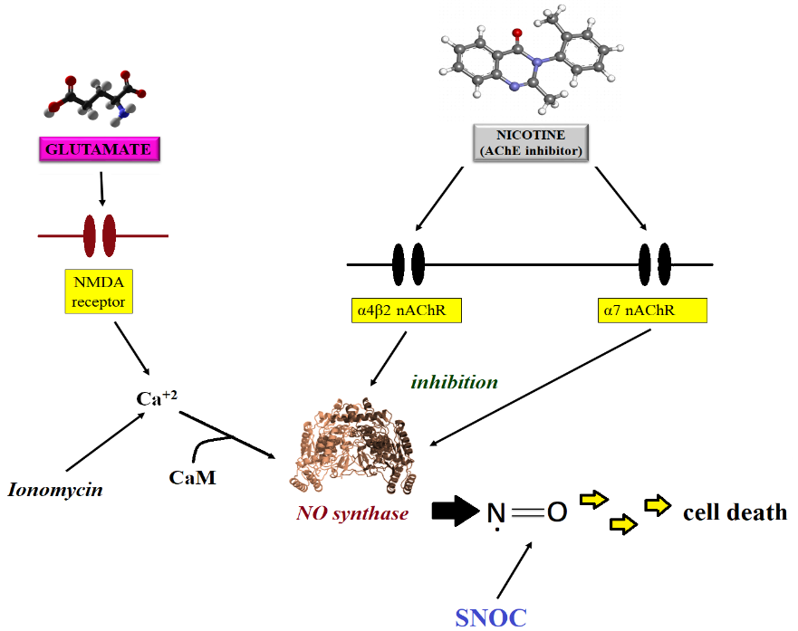
Figure 2: Role of nicotine in AD and cell death.

- Smoking and oxidative stress, a symbiotic association contributing Alzheimer disease
The abnormal dumping of both τ and Aβ protein is the important causative factors of Alzheimer's disease. These are primarily initiated and enhanced due to the oxidative stress (OxS) which is the imbalance between endogenous free radical production and antioxidant defences [32, 97, 98]. OxS produced by exogenous source such as smoking has been linked with peroxidation of membrane lipids, proteins DNA and RNA which impairs cellular function [99-103]. Along with more than 400 chemical compounds, cigarette smoke possesses elevated levels of free radical and several oxidising agents. Study have shown that cigarette smoking promotes the endogenous production of free radical species via activation of inflammatory cells as well as reducing antioxidant defence mechanism [104]. Cigarette smoking associated OxS promotes the amyloidogenic pathway resulting neurotoxic Aβ oligomers generation as well as the abnormal phosphorylation of τ, which is the aetiology of AD. Low level of serum enzymes functioning against oxidation (glutathione reductase, glutathione peroxidase) and antioxidants molecules (ascorbic acid, melatonin, β-carotene, α-carotene) as well as elevated level of malondialdehyde (oxidative stress markers) were observed in smokers [105-108]. In central and peripheral nervous systems, cytokines such as IL, TNF-α and interferons (IFN) influences the inflammatory and immune responses [109]. OxS mediated by free radical may activate inflammatory pathway through a cytokine induce immune response [16, 110] resulting in generation of proinflammatory and anti-inflammatory molecules, for example IL-6, IL-1 TNFα from brain cells [109]. High level of proinflammatory molecules are linked with cerebral OxS leading to cell apoptosis due to ROS and other mediator in brain by astrocytes, microglia and immune cells [48, 111, 112]. The brain cells are highly prone to oxidative damages induced by reactive free radicals because of enhanced metabolism and increased energy demand, as well as easy target of oxidizing agents to membrane phospholipids that are abundant with polyunsaturated fatty acids leading to lipid peroxidation by ROS as shown in figure 3 [113-117].
In vitro study has shown that condensate of cigarette smoke elevates the concentrations of Aβ_{1–40} along with the concentrations of Aβ_{1–42} with respect to various dose in human amyloid precursor protein (APP) transfected SweAPP N2a cells [118]. Wallin et al., 2017 used fluorescence, atomic force microscopy imaging, mass spectrometry, nuclear magnetic resonance techniques to record in vitro if Aβ accumulation is influenced by the chemicals present in cigarette such as polycyclic aromatic hydrocarbons (PAHs), nicotine, and metal ions Pb(II), Pb(IV), Cd(II), Cr(III). This study demonstrated that entire metal ions and PAHs modulated the Aβ accumulation process. Among metals ions, Pb(II) Cd(II) and Cr(III) showed common electrostatic associations with Aβ, whereas Pb(IV) displayed distinct temporary binding to N-end of Aβ. Therefore, Pb(IV) ions may be mostly liable to interact with dimer and trimer form of Aβ as well as influence its aggregation. In contrast, hydrophobic toluene mostly influences formation of bigger aggregates, for example tetramers. However, hydrophilic and uncharged molecule such as nicotine displayed no straight interactions with Aβ as well as no effect on its aggregation. This study provides a clear justification for the increased prevalence of AD among smokers highlighting the roles of Pb(IV) as a risk factor for AD [60].
Rat exposed to cigarette smoke increased β-soluble APP concentration in hippocampal tissue homogenate and Aβ accumulation in the cornu ammonis 3 region as well as dentate hippocampal subfield. Also, the rats exposed to smoke demonstrated remarkable upregulation in hyperphosphorylation of τ protein and OxS markers in hippocampal [119]. Exposure APP/presenilin1 transgenic mice (3 months old) to high dose of cigarette (one cigarette over 1 hour, 5 days/week for 4 months) showed an increased formation of fibrillar neuritic plaques and Aβ deposits. Mice also displayed a drastic increase in overall activated microglia density and reactive astrocytes, and τ hyperphosphorylation in the brain cerebral cortex and brain hippocampus compared to the low dosage group (half of cigarette given in 30 minutes) and controls [120].
Tyas et al., 2003 compared the level of neuritic plaque burden between never smoker and active, former smokers using autopsy sample of elderly patient with or without dementia. This study found that active and former smoker exhibit remarkably high burden in cerebral cortex as well as hippocampus. However, there were no significant differences between the samples with regard to hippocampal or cortical neurofibrillary tangle count [121]. In contrast, Ulrich et al., 1997 found that the level of neurotic plaques in autopsy sample was lower in entorhinal cortex, hippocampus and neocortex in female former/non-smoker compared to active smokers. However, the density of neurofibrillary tangles was higher. Likewise, among male non-smoker and active smokers, there was no significant difference in neurofibrillary tangle or plaque density. In either of the gender, smoking higher pack annually was closely related with increased density of neurofibrillary tangle, whilst not linked with the density of the neurotic plaque [122]. Furthermore, Sabbagh et al., 2005, in addition reported no significant alterations in neurofibrillary tangle density or neuritic plaques selectively in the mid-frontal cortex between active smokers, non-smokers and former smokers with AD [123]. These in vitro and in vivo (mice, rats and human) studies explain the clear symbiotic association of smoking and oxidative stress on progression of Alzheimer disease.
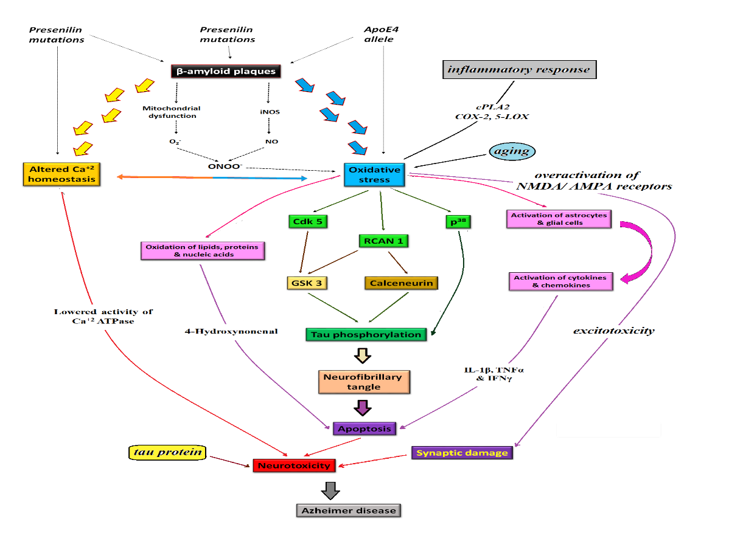
Figure:3 Smoking mediated OxS and inflammation resulting in neurotoxicity and AD
- Role of respiratory infection in AD
AD patients are highly susceptible to peripheral infections compared to healthy individuals of the same age. Different bacteria, virus, fungal infections are correlated to disease development, either by directly causing AD or through infiltration causing neuroinflammation [124, 125]. Chlaymdia pneumonia, intracellular gram negative bacteria has been widely reported to be associated with AD. It increases AD progression by five folds [126]. It has been reported that C.pneumonia crosses the blood brain barrier by infected monocytes or olfactory route and can infect astrocytes, microglia and neurons [127]. Further, it can inhibit neuronal apoptosis and facilitates persistence of chronic infection. Intranasal delivery of C. pneumonia in mice has shown to induce Aβ deposition in brain and its localisation in glia. C. pneumonia combines with factors like apolipoprotein E4 (APOE4) for the progression of AD [128]. It activates and stimulates the production of pro-inflammatory cytokines including TNF-β, IL-6, IL-1and IL-10 in the brain of AD patients [129-131]. Mahony [128]and co-workers studied the brain of AD patients via PCR screening technique and reported the correlation of AD with C.pneumonia [132]. Another study by Paradowski et al., performed ante-mortem screening of cerebrospinal fluid (CSF) of AD, which represents a positive correlation with C.pneumonia [133]. However, a little is known about the exact pathogenesis of C.pneumonia in AD. A well designed mice model may help to evaluate the colonisation of bacteria/ infection involved in AD.
- Conclusion
Smoking is associated with early onset of AD, reducing the life expectancy by atleast 10 years resulting in significant morbidity. Prolonged exposure to cigarette smoke and nicotine is associated with OxS which corresponds to cerebral cellular damage. OxS elevates proteolytic pathways resulting in Aβ isoforms and τ phosphorylation. These exogenous sources of OxS facilitate the pathophysiology of AD. Further, the available evidences in human show that respiratory infections may be cause direct β amyloidogenesis and indirectly contribute to pathogenesis of AD via microglial and inflammatory response in the brain. However, further studies using appropriate animal model are essential to decipher the mechanism of cigarette smoke and respiratory infection related progression of AD which can direct for potential prevention and treatment strategies.
Conflict of Interest
The authors have no conflict of interest to declare.
References:
[1] Gale SA, Acar D, Daffner KR. Dementia. Am J Med, 2018; 131: 1161-1169.
[2] Kumar R, Kumar R, Sharma N, Vyas M, Mahajan S, Satija S, Singh S, Mehta M, Khurana N. GENETICS OF PARKINSON'S DISEASE : HOW CLOSE AND HOW FAR WE ARE? Plant Archives, 2019; 19: 1017-1020.
[3] Raz L, Knoefel J, Bhaskar K. The neuropathology and cerebrovascular mechanisms of dementia. J Cereb Blood Flow Metab, 2016; 36: 172-86.
[4] 2016 Alzheimer's disease facts and figures. Alzheimers Dement, 2016; 12: 459-509.
[5] Brookmeyer R, Johnson E, Ziegler-Graham K, Arrighi HM. Forecasting the global burden of Alzheimer's disease. Alzheimers Dement, 2007; 3: 186-91.
[6] Global, regional, and national burden of Alzheimer's disease and other dementias, 1990-2016: a systematic analysis for the Global Burden of Disease Study 2016. Lancet Neurol, 2019; 18: 88-106.
[7] Stefanacci RG. The costs of Alzheimer's disease and the value of effective therapies. Am J Manag Care, 2011; 17 Suppl 13: S356-62.
[8] Ballard C, Gauthier S, Corbett A, Brayne C, Aarsland D, Jones E. Alzheimer's disease. Lancet, 2011; 377: 1019-31.
[9] Scheltens P, Blennow K, Breteler MM, de Strooper B, Frisoni GB, Salloway S, Van der Flier WM. Alzheimer's disease. Lancet, 2016; 388: 505-17.
[10] Genin E, Hannequin D, Wallon D, Sleegers K, Hiltunen M, Combarros O, Bullido MJ, Engelborghs S, De Deyn P, Berr C, Pasquier F, Dubois B, Tognoni G, Fievet N, Brouwers N, Bettens K, Arosio B, Coto E, Del Zompo M, Mateo I, Epelbaum J, Frank-Garcia A, Helisalmi S, Porcellini E, Pilotto A, Forti P, Ferri R, Scarpini E, Siciliano G, Solfrizzi V, Sorbi S, Spalletta G, Valdivieso F, Vepsalainen S, Alvarez V, Bosco P, Mancuso M, Panza F, Nacmias B, Bossu P, Hanon O, Piccardi P, Annoni G, Seripa D, Galimberti D, Licastro F, Soininen H, Dartigues JF, Kamboh MI, Van Broeckhoven C, Lambert JC, Amouyel P, Campion D. APOE and Alzheimer disease: a major gene with semi-dominant inheritance. Mol Psychiatry, 2011; 16: 903-7.
[11] Silva MVF, Loures CMG, Alves LCV, de Souza LC, Borges KBG, Carvalho MDG. Alzheimer's disease: risk factors and potentially protective measures. J Biomed Sci, 2019; 26: 33.
[12] Mayeux R, Stern Y. Epidemiology of Alzheimer disease. Cold Spring Harb Perspect Med, 2012; 2.
[13] Cataldo JK, Prochaska JJ, Glantz SA. Cigarette smoking is a risk factor for Alzheimer's Disease: an analysis controlling for tobacco industry affiliation. J Alzheimers Dis, 2010; 19: 465-80.
[14] Rusanen M, Kivipelto M, Quesenberry CP, Jr., Zhou J, Whitmer RA. Heavy smoking in midlife and long-term risk of Alzheimer disease and vascular dementia. Arch Intern Med, 2011; 171: 333-9.
[15] Durazzo TC, Mattsson N, Weiner MW. Smoking and increased Alzheimer's disease risk: a review of potential mechanisms. Alzheimers Dement, 2014; 10: S122-45.
[16] Voloboueva LA, Giffard RG. Inflammation, mitochondria, and the inhibition of adult neurogenesis. J Neurosci Res, 2011; 89: 1989-96.
[17] Sochocka M, Zwolińska K, Leszek J. The Infectious Etiology of Alzheimer's Disease. Curr Neuropharmacol, 2017; 15: 996-1009.
[18] Readhead B, Haure-Mirande JV, Funk CC, Richards MA, Shannon P, Haroutunian V, Sano M, Liang WS, Beckmann ND, Price ND, Reiman EM, Schadt EE, Ehrlich ME, Gandy S, Dudley JT. Multiscale Analysis of Independent Alzheimer's Cohorts Finds Disruption of Molecular, Genetic, and Clinical Networks by Human Herpesvirus. Neuron, 2018; 99: 64-82.e7.
[19] Eimer WA, Vijaya Kumar DK, Navalpur Shanmugam NK, Rodriguez AS, Mitchell T, Washicosky KJ, Gyorgy B, Breakefield XO, Tanzi RE, Moir RD. Alzheimer's Disease-Associated beta-Amyloid Is Rapidly Seeded by Herpesviridae to Protect against Brain Infection. Neuron, 2018; 99: 56-63.e3.
[20] Shima K, Kuhlenbaumer G, Rupp J. Chlamydia pneumoniae infection and Alzheimer's disease: a connection to remember? Med Microbiol Immunol, 2010; 199: 283-9.
[21] Lim C, Hammond CJ, Hingley ST, Balin BJ. Chlamydia pneumoniae infection of monocytes in vitro stimulates innate and adaptive immune responses relevant to those in Alzheimer's disease. J Neuroinflammation, 2014; 11: 217.
[22] Cerovic M, Forloni G, Balducci C. Neuroinflammation and the Gut Microbiota: Possible Alternative Therapeutic Targets to Counteract Alzheimer's Disease? Front Aging Neurosci, 2019; 11: 284.
[23] Budden KF, Shukla SD, Rehman SF, Bowerman KL, Keely S, Hugenholtz P, Armstrong-James DPH, Adcock IM, Chotirmall SH, Chung KF, Hansbro PM. Functional effects of the microbiota in chronic respiratory disease. The Lancet Respiratory Medicine, 2019; 7: 907-920.
[24] Ainslie N, Beisecker AE. Changes in decisions by elderly persons based on treatment description. Arch Intern Med, 1994; 154: 2225-33.
[25] Visser J, McLachlan MH, Maayan N, Garner P. Community-based supplementary feeding for food insecure, vulnerable and malnourished populations - an overview of systematic reviews. Cochrane Database Syst Rev, 2018; 11: Cd010578.
[26] Mehta M, Deeksha, Tewari D, Gupta G, Awasthi R, Singh H, Pandey P, Chellappan DK, Wadhwa R, Collet T, Hansbro PM, Kumar SR, Thangavelu L, Negi P, Dua K, Satija S. Oligonucleotide therapy: An emerging focus area for drug delivery in chronic inflammatory respiratory diseases. Chem Biol Interact, 2019; 308: 206-215.
[27] Mehta M, Dhanjal DS, Paudel KR, Singh B, Gupta G, Rajeshkumar S, Thangavelu L, Tambuwala MM, Bakshi HA, Chellappan DK, Pandey P, Dureja H, Charbe NB, Singh SK, Shukla SD, Nammi S, Aljabali AA, Wich PR, Hansbro PM, Satija S, Dua K. Cellular signalling pathways mediating the pathogenesis of chronic inflammatory respiratory diseases: an update. Inflammopharmacology, 2020.
[28] Drane JF, Coulehan JL. The best-interest standard: surrogate decision making and quality of life. J Clin Ethics, 1995; 6: 20-9.
[29] Relkin NR, Thomas RG, Rissman RA, Brewer JB, Rafii MS, van Dyck CH, Jack CR, Sano M, Knopman DS, Raman R, Szabo P, Gelmont DM, Fritsch S, Aisen PS. A phase 3 trial of IV immunoglobulin for Alzheimer disease. Neurology, 2017; 88: 1768-1775.
[30] Gold M, Alderton C, Zvartau-Hind M, Egginton S, Saunders AM, Irizarry M, Craft S, Landreth G, Linnamagi U, Sawchak S. Rosiglitazone monotherapy in mild-to-moderate Alzheimer's disease: results from a randomized, double-blind, placebo-controlled phase III study. Dement Geriatr Cogn Disord, 2010; 30: 131-46.
[31] Mehta M, Deeksha, Sharma N, Vyas M, Khurana N, Maurya PK, Singh H, Andreoli de Jesus TP, Dureja H, Chellappan DK, Gupta G, Wadhwa R, Collet T, Hansbro PM, Dua K, Satija S. Interactions with the macrophages: An emerging targeted approach using novel drug delivery systems in respiratory diseases. Chem Biol Interact, 2019; 304: 10-19.
[32] Dua K, Malyla V, Singhvi G, Wadhwa R, Krishna RV, Shukla SD, Shastri MD, Chellappan DK, Maurya PK, Satija S, Mehta M, Gulati M, Hansbro N, Collet T, Awasthi R, Gupta G, Hsu A, Hansbro PM. Increasing complexity and interactions of oxidative stress in chronic respiratory diseases: An emerging need for novel drug delivery systems. Chem Biol Interact, 2019; 299: 168-178.
[33] Dua K, Wadhwa R, Singhvi G, Rapalli V, Shukla SD, Shastri MD, Gupta G, Satija S, Mehta M, Khurana N, Awasthi R, Maurya PK, Thangavelu L, S R, Tambuwala MM, Collet T, Hansbro PM, Chellappan DK. The potential of siRNA based drug delivery in respiratory disorders: Recent advances and progress. Drug Dev Res, 2019; 80: 714-730.
[34] Chellappan DK, Yee LW, Xuan KY, Kunalan K, Rou LC, Jean LS, Ying LY, Wie LX, Chellian J, Mehta M, Satija S, Singh SK, Gulati M, Dureja H, Da Silva MW, Tambuwala MM, Gupta G, Paudel KR, Wadhwa R, Hansbro PM, Dua K. Targeting neutrophils using novel drug delivery systems in chronic respiratory diseases. Drug Dev Res, 2020.
[35] Ng ZY, Wong JY, Panneerselvam J, Madheswaran T, Kumar P, Pillay V, Hsu A, Hansbro N, Bebawy M, Wark P, Hansbro P, Dua K, Chellappan DK. Assessing the potential of liposomes loaded with curcumin as a therapeutic intervention in asthma. Colloids Surf B Biointerfaces, 2018; 172: 51-59.
[36] Mehta M, Chellappan DK, Wich PR, Hansbro NG, Hansbro PM, Dua K. miRNA nanotherapeutics: potential and challenges in respiratory disorders. In: ed.^eds. Future Science, 2020.
[37] Kim TM, Paudel KR, Kim DW. Eriobotrya japonica leaf extract attenuates airway inflammation in ovalbumin-induced mice model of asthma. J Ethnopharmacol, 2020; 253: 112082.
[38] Howe EG. Do we undervalue feelings in patients who are cognitively impaired? J Clin Ethics, 2006; 17: 291-301.
[39] Kukull WA, Brenner DE, Speck CE, Nochlin D, Bowen J, McCormick W, Teri L, Pfanschmidt ML, Larson EB. Causes of death associated with Alzheimer disease: variation by level of cognitive impairment before death. J Am Geriatr Soc, 1994; 42: 723-6.
[40] Manabe T, Mizukami K, Akatsu H, Teramoto S, Yamaoka K, Nakamura S, Ohkubo T, Kudo K, Hizawa N. Influence of pneumonia complications on the prognosis of patients with autopsy-confirmed Alzheimer's disease, dementia with Lewy bodies, and vascular dementia. Psychogeriatrics, 2016; 16: 305-14.
[41] McManus RM, Heneka MT. Role of neuroinflammation in neurodegeneration: new insights. Alzheimers Res Ther, 2017; 9: 14.
[42] Thakur AK, Chellappan DK, Dua K, Mehta M, Satija S, Singh I. Patented therapeutic drug delivery strategies for targeting pulmonary diseases. Expert Opin Ther Pat, 2020.
[43] Tsuda K, Higuchi A, Yokoyama E, Kosugi K, Komatsu T, Kami M, Tanimoto T. Physician Decision-Making Patterns and Family Presence: Cross-Sectional Online Survey Study in Japan. Interactive journal of medical research, 2019; 8: e12781.
[44] Yu N, Lin X-j, Zhang S-g, Di Q. Analysis of the reasons and costs of hospitalization for epilepsy patients in East China. Seizure, 2019; 72: 40-45.
[45] Malyla V, Paudel KR, Shukla SD, Donovan C, Wadhwa R, Pickles S, Chimankar V, Sahu P, Bielefeldt-Ohmann H, Bebawy M, Hansbro PM, Dua K. Recent advances in experimental animal models of lung cancer. Future Med Chem, 2020; 12: 567-570.
[46] Sharma P, Mehta M, Dhanjal DS, Kaur S, Gupta G, Singh H, Thangavelu L, Rajeshkumar S, Tambuwala M, Bakshi HA, Chellappan DK, Dua K, Satija S. Emerging trends in the novel drug delivery approaches for the treatment of lung cancer. Chem Biol Interact, 2019; 309: 108720.
[47] Asano M, Fujimoto N, Gemba K, Wada S, Ono K, Ozaki S, Adachi Y, Yamamoto H, Kishimoto T. Acute onset of brain atrophy and dementia in a patient with small cell lung cancer: A case report. Lung Cancer, 2011; 71: 367-369.
[48] Mattson MP. Pathways towards and away from Alzheimer's disease. Nature, 2004; 430: 631-9.
[49] Spires-Jones TL, Hyman BT. The intersection of amyloid beta and tau at synapses in Alzheimer's disease. Neuron, 2014; 82: 756-71.
[50] Selkoe DJ. The molecular pathology of Alzheimer's disease. Neuron, 1991; 6: 487-98.
[51] Dani JA, Bertrand D. Nicotinic acetylcholine receptors and nicotinic cholinergic mechanisms of the central nervous system. Annu Rev Pharmacol Toxicol, 2007; 47: 699-729.
[52] Giniatullin R, Nistri A, Yakel JL. Desensitization of nicotinic ACh receptors: shaping cholinergic signaling. Trends Neurosci, 2005; 28: 371-8.
[53] Gotti C, Clementi F. Neuronal nicotinic receptors: from structure to pathology. Prog Neurobiol, 2004; 74: 363-96.
[54] Guillem K, Bloem B, Poorthuis RB, Loos M, Smit AB, Maskos U, Spijker S, Mansvelder HD. Nicotinic acetylcholine receptor beta2 subunits in the medial prefrontal cortex control attention. Science, 2011; 333: 888-91.
[55] Knobloch M, Mansuy IM. Dendritic spine loss and synaptic alterations in Alzheimer's disease. Mol Neurobiol, 2008; 37: 73-82.
[56] Beeri R, Andres C, Lev-Lehman E, Timberg R, Huberman T, Shani M, Soreq H. Transgenic expression of human acetylcholinesterase induces progressive cognitive deterioration in mice. Curr Biol, 1995; 5: 1063-71.
[57] Sarter M, Bruno JP. Cognitive functions of cortical acetylcholine: toward a unifying hypothesis. Brain Res Brain Res Rev, 1997; 23: 28-46.
[58] Benowitz NL, Hukkanen J, Jacob P, 3rd. Nicotine chemistry, metabolism, kinetics and biomarkers. Handb Exp Pharmacol, 2009: 29-60.
[59] Swan GE, Lessov-Schlaggar CN. The effects of tobacco smoke and nicotine on cognition and the brain. Neuropsychol Rev, 2007; 17: 259-73.
[60] Wallin C, Sholts SB, Osterlund N, Luo J, Jarvet J, Roos PM, Ilag L, Graslund A, Warmlander S. Alzheimer's disease and cigarette smoke components: effects of nicotine, PAHs, and Cd(II), Cr(III), Pb(II), Pb(IV) ions on amyloid-beta peptide aggregation. Sci Rep, 2017; 7: 14423.
[61] Deng J, Shen C, Wang YJ, Zhang M, Li J, Xu ZQ, Gao CY, Fang CQ, Zhou HD. Nicotine exacerbates tau phosphorylation and cognitive impairment induced by amyloid-beta 25-35 in rats. Eur J Pharmacol, 2010; 637: 83-8.
[62] Wang HY, Lee DH, D'Andrea MR, Peterson PA, Shank RP, Reitz AB. beta-Amyloid(1-42) binds to alpha7 nicotinic acetylcholine receptor with high affinity. Implications for Alzheimer's disease pathology. J Biol Chem, 2000; 275: 5626-32.
[63] Atwood CS, Huang X, Moir RD, Tanzi RE, Bush AI. Role of free radicals and metal ions in the pathogenesis of Alzheimer's disease. Met Ions Biol Syst, 1999; 36: 309-64.
[64] Pappas RS, Polzin GM, Zhang L, Watson CH, Paschal DC, Ashley DL. Cadmium, lead, and thallium in mainstream tobacco smoke particulate. Food Chem Toxicol, 2006; 44: 714-23.
[65] Bernhard D, Rossmann A, Wick G. Metals in cigarette smoke. IUBMB Life, 2005; 57: 805-9.
[66] Zhou CC, Gao ZY, Wang J, Wu MQ, Hu S, Chen F, Liu JX, Pan H, Yan CH. Lead exposure induces Alzheimers's disease (AD)-like pathology and disturbes cholesterol metabolism in the young rat brain. Toxicol Lett, 2018; 296: 173-183.
[67] Ashok A, Rai NK, Tripathi S, Bandyopadhyay S. Exposure to As-, Cd-, and Pb-mixture induces Abeta, amyloidogenic APP processing and cognitive impairments via oxidative stress-dependent neuroinflammation in young rats. Toxicol Sci, 2015; 143: 64-80.
[68] Majewska M, Szczepanik M. [The role of Toll-like receptors (TLR) in innate and adaptive immune responses and their function in immune response regulation]. Postepy Hig Med Dosw (Online), 2006; 60: 52-63.
[69] Del Pino J, Zeballos G, Anadon MJ, Moyano P, Diaz MJ, Garcia JM, Frejo MT. Cadmium-induced cell death of basal forebrain cholinergic neurons mediated by muscarinic M1 receptor blockade, increase in GSK-3beta enzyme, beta-amyloid and tau protein levels. Arch Toxicol, 2016; 90: 1081-92.
[70] Yamamoto H, Saitoh Y, Yasugawa S, Miyamoto E. Dephosphorylation of tau factor by protein phosphatase 2A in synaptosomal cytosol fractions, and inhibition by aluminum. J Neurochem, 1990; 55: 683-90.
[71] Mutter J, Curth A, Naumann J, Deth R, Walach H. Does inorganic mercury play a role in Alzheimer's disease? A systematic review and an integrated molecular mechanism. J Alzheimers Dis, 2010; 22: 357-74.
[72] Sayre LM, Perry G, Harris PL, Liu Y, Schubert KA, Smith MA. In situ oxidative catalysis by neurofibrillary tangles and senile plaques in Alzheimer's disease: a central role for bound transition metals. J Neurochem, 2000; 74: 270-9.
[73] Lovell MA, Robertson JD, Teesdale WJ, Campbell JL, Markesbery WR. Copper, iron and zinc in Alzheimer's disease senile plaques. J Neurol Sci, 1998; 158: 47-52.
[74] Warmlander S, Tiiman A, Abelein A, Luo J, Jarvet J, Soderberg KL, Danielsson J, Graslund A. Biophysical studies of the amyloid beta-peptide: interactions with metal ions and small molecules. Chembiochem, 2013; 14: 1692-704.
[75] Kitazawa M, Cheng D, Laferla FM. Chronic copper exposure exacerbates both amyloid and tau pathology and selectively dysregulates cdk5 in a mouse model of AD. Journal of neurochemistry, 2009; 108: 1550-1560.
[76] Tiiman A, Luo J, Wallin C, Olsson L, Lindgren J, Jarvet J, Per R, Sholts SB, Rahimipour S, Abrahams JP, Karlstrom AE, Graslund A, Warmlander SK. Specific Binding of Cu(II) Ions to Amyloid-Beta Peptides Bound to Aggregation-Inhibiting Molecules or SDS Micelles Creates Complexes that Generate Radical Oxygen Species. J Alzheimers Dis, 2016; 54: 971-982.
[77] Heppner FL, Ransohoff RM, Becher B. Immune attack: the role of inflammation in Alzheimer disease. Nat Rev Neurosci, 2015; 16: 358-72.
[78] Jensen AA, Frolund B, Liljefors T, Krogsgaard-Larsen P. Neuronal nicotinic acetylcholine receptors: structural revelations, target identifications, and therapeutic inspirations. J Med Chem, 2005; 48: 4705-45.
[79] Buckingham SD, Jones AK, Brown LA, Sattelle DB. Nicotinic acetylcholine receptor signalling: roles in Alzheimer's disease and amyloid neuroprotection. Pharmacol Rev, 2009; 61: 39-61.
[80] Nordberg A, Hellstrom-Lindahl E, Lee M, Johnson M, Mousavi M, Hall R, Perry E, Bednar I, Court J. Chronic nicotine treatment reduces beta-amyloidosis in the brain of a mouse model of Alzheimer's disease (APPsw). J Neurochem, 2002; 81: 655-8.
[81] Inestrosa NC, Godoy JA, Vargas JY, Arrazola MS, Rios JA, Carvajal FJ, Serrano FG, Farias GG. Nicotine prevents synaptic impairment induced by amyloid-beta oligomers through alpha7-nicotinic acetylcholine receptor activation. Neuromolecular Med, 2013; 15: 549-69.
[82] Zeng H, Zhang Y, Peng L, Shao H, Menon NK, Yang J, Salomon AR, Freidland RP, Zagorski MG. Nicotine and amyloid formation. Biol Psychiatry, 2001; 49: 248-57.
[83] Svedberg MM, Svensson AL, Johnson M, Lee M, Cohen O, Court J, Soreq H, Perry E, Nordberg A. Upregulation of neuronal nicotinic receptor subunits alpha4, beta2, and alpha7 in transgenic mice overexpressing human acetylcholinesterase. J Mol Neurosci, 2002; 18: 211-22.
[84] Zhang J, Liu Q, Chen Q, Liu NQ, Li FL, Lu ZB, Qin C, Zhu H, Huang YY, He W, Zhao BL. Nicotine attenuates beta-amyloid-induced neurotoxicity by regulating metal homeostasis. Faseb j, 2006; 20: 1212-4.
[85] Talantova M, Sanz-Blasco S, Zhang X, Xia P, Akhtar MW, Okamoto S, Dziewczapolski G, Nakamura T, Cao G, Pratt AE, Kang YJ, Tu S, Molokanova E, McKercher SR, Hires SA, Sason H, Stouffer DG, Buczynski MW, Solomon JP, Michael S, Powers ET, Kelly JW, Roberts A, Tong G, Fang-Newmeyer T, Parker J, Holland EA, Zhang D, Nakanishi N, Chen HS, Wolosker H, Wang Y, Parsons LH, Ambasudhan R, Masliah E, Heinemann SF, Pina-Crespo JC, Lipton SA. Abeta induces astrocytic glutamate release, extrasynaptic NMDA receptor activation, and synaptic loss. Proc Natl Acad Sci U S A, 2013; 110: E2518-27.
[86] Shimohama S, Akaike A, Kimura J. Nicotine-induced protection against glutamate cytotoxicity. Nicotinic cholinergic receptor-mediated inhibition of nitric oxide formation. Ann N Y Acad Sci, 1996; 777: 356-61.
[87] Marchi M, Risso F, Viola C, Cavazzani P, Raiteri M. Direct evidence that release-stimulating alpha7* nicotinic cholinergic receptors are localized on human and rat brain glutamatergic axon terminals. J Neurochem, 2002; 80: 1071-8.
[88] Konradsson-Geuken A, Gash CR, Alexander K, Pomerleau F, Huettl P, Gerhardt GA, Bruno JP. Second-by-second analysis of alpha 7 nicotine receptor regulation of glutamate release in the prefrontal cortex of awake rats. Synapse, 2009; 63: 1069-82.
[89] de Oliveira AS, Santiago FE, Balioni LF, Ferrari Mde F, Almeida MC, Carrettiero DC. BAG2 expression dictates a functional intracellular switch between the p38-dependent effects of nicotine on tau phosphorylation levels via the alpha7 nicotinic receptor. Exp Neurol, 2016; 275 Pt 1: 69-77.
[90] Hellstrom-Lindahl E, Moore H, Nordberg A. Increased levels of tau protein in SH-SY5Y cells after treatment with cholinesterase inhibitors and nicotinic agonists. J Neurochem, 2000; 74: 777-84.
[91] Barr J, Sharma CS, Sarkar S, Wise K, Dong L, Periyakaruppan A, Ramesh GT. Nicotine induces oxidative stress and activates nuclear transcription factor kappa B in rat mesencephalic cells. Mol Cell Biochem, 2007; 297: 93-9.
[92] Das S, Gautam N, Dey SK, Maiti T, Roy S. Oxidative stress in the brain of nicotine-induced toxicity: protective role of Andrographis paniculata Nees and vitamin E. Appl Physiol Nutr Metab, 2009; 34: 124-35.
[93] Abreu-Villaca Y, Seidler FJ, Tate CA, Slotkin TA. Nicotine is a neurotoxin in the adolescent brain: critical periods, patterns of exposure, regional selectivity, and dose thresholds for macromolecular alterations. Brain Res, 2003; 979: 114-28.
[94] Jaehne A, Unbehaun T, Feige B, Herr S, Appel A, Riemann D. The influence of 8 and 16 mg nicotine patches on sleep in healthy non-smokers. Pharmacopsychiatry, 2014; 47: 73-8.
[95] White HK, Levin ED. Chronic transdermal nicotine patch treatment effects on cognitive performance in age-associated memory impairment. Psychopharmacology (Berl), 2004; 171: 465-71.
[96] Newhouse P, Kellar K, Aisen P, White H, Wesnes K, Coderre E, Pfaff A, Wilkins H, Howard D, Levin ED. Nicotine treatment of mild cognitive impairment: a 6-month double-blind pilot clinical trial. Neurology, 2012; 78: 91-101.
[97] Mondragón-Rodríguez S, Basurto-Islas G, Lee H-g, Perry G, Zhu X, Castellani RJ, Smith MA. Causes versus effects: the increasing complexities of Alzheimer’s disease pathogenesis. Expert review of neurotherapeutics, 2010; 10: 683-691.
[98] Panth N, Paudel KR, Parajuli K. Reactive oxygen species: a key hallmark of cardiovascular disease. Advances in medicine, 2016; 2016.
[99] Burke A, FitzGerald GA. Oxidative stress and smoking-induced vascular injury. Progress in cardiovascular diseases, 2003; 46: 79-90.
[100] Davies KJ. Oxidative stress, antioxidant defenses, and damage removal, repair, and replacement systems. IUBMB life, 2000; 50: 279-289.
[101] Aggarwal T, Wadhwa R, Thapliyal N, Sharma K, Rani V, Maurya PK. Oxidative, inflammatory, genetic, and epigenetic biomarkers associated with chronic obstructive pulmonary disorder. Journal of cellular physiology, 2019; 234: 2067-2082.
[102] Wadhwa R, Aggarwal T, Malyla V, Kumar N, Gupta G, Chellappan DK, Dureja H, Mehta M, Satija S, Gulati M. Identification of biomarkers and genetic approaches toward chronic obstructive pulmonary disease. Journal of cellular physiology, 2019.
[103] Shastri MD, Shukla SD, Chong WC, Dua K, Peterson GM, Patel RP, Hansbro PM, Eri R, O'Toole RF. Role of Oxidative Stress in the Pathology and Management of Human Tuberculosis. Oxid Med Cell Longev, 2018; 2018: 7695364.
[104] Isik B, Ceylan A, Isik R. Oxidative stress in smokers and non-smokers. Inhalation toxicology, 2007; 19: 767-769.
[105] Ozguner F, Koyu A, Cesur G. Active smoking causes oxidative stress and decreases blood melatonin levels. Toxicology and Industrial Health, 2005; 21: 21-26.
[106] Alberg AJ. The influence of cigarette smoking on circulating concentrations of antioxidant micronutrients. Toxicology, 2002; 180: 121-137.
[107] Kim SH, Kim JS, Shin HS, Keen CL. Influence of smoking on markers of oxidative stress and serum mineral concentrations in teenage girls in Korea. Nutrition, 2003; 19: 240-243.
[108] Wadhwa R, Gupta R, Maurya PK. Oxidative Stress and Accelerated Aging in Neurodegenerative and Neuropsychiatric Disorder. Current pharmaceutical design, 2018; 24: 4711-4725.
[109] Crews FT, Bechara R, Brown LA, Guidot DM, Mandrekar P, Oak S, Qin L, Szabo G, Wheeler M, Zou J. Cytokines and alcohol. Alcoholism: Clinical and Experimental Research, 2006; 30: 720-730.
[110] Dua K, Malyla V, Singhvi G, Wadhwa R, Krishna RV, Shukla SD, Shastri MD, Chellappan DK, Maurya PK, Satija S. Increasing complexity and interactions of oxidative stress in chronic respiratory diseases: An emerging need for novel drug delivery systems. Chemico-biological interactions, 2018.
[111] Guerri C, Pascual M. Mechanisms involved in the neurotoxic, cognitive, and neurobehavioral effects of alcohol consumption during adolescence. Alcohol, 2010; 44: 15-26.
[112] Perricone C, De Carolis C, Perricone R. Glutathione: a key player in autoimmunity. Autoimmunity reviews, 2009; 8: 697-701.
[113] Kovacic P. Unifying mechanism for addiction and toxicity of abused drugs with application to dopamine and glutamate mediators: electron transfer and reactive oxygen species. Medical hypotheses, 2005; 65: 90-96.
[114] Anbarasi K, Vani G, Balakrishna K, Devi CS. Effect of bacoside A on brain antioxidant status in cigarette smoke exposed rats. Life Sciences, 2006; 78: 1378-1384.
[115] Chalela JA, Wolf RL, Maldjian JA, Kasner SE. MRI identification of early white matter injury in anoxic–ischemic encephalopathy. Neurology, 2001; 56: 481-485.
[116] Mueller S, Trabesinger A, Boesiger P, Wieser H. Brain glutathione levels in patients with epilepsy measured by in vivo 1H-MRS. Neurology, 2001; 57: 1422-1427.
[117] Praticò D. The neurobiology of isoprostanes and Alzheimer's disease. Biochimica et Biophysica Acta (BBA)-Molecular and Cell Biology of Lipids, 2010; 1801: 930-933.
[118] Giunta B, Deng J, Jin J, Sadic E, Rum S, Zhou H, Sanberg P, Tan J. Evaluation of how cigarette smoke is a direct risk factor for Alzheimer's disease. Technology & Innovation, 2012; 14: 39-48.
[119] Ho Y-S, Yang X, Yeung S-C, Chiu K, Lau C-F, Tsang AW-T, Mak JC-W, Chang RC-C. Cigarette smoking accelerated brain aging and induced pre-Alzheimer-like neuropathology in rats. PloS one, 2012; 7: e36752.
[120] Moreno-Gonzalez I, Estrada LD, Sanchez-Mejias E, Soto C. Smoking exacerbates amyloid pathology in a mouse model of Alzheimer’s disease. Nature communications, 2013; 4: 1495.
[121] Tyas SL, White LR, Petrovitch H, Ross GW, Foley DJ, Heimovitz HK, Launer LJ. Mid-life smoking and late-life dementia: the Honolulu-Asia Aging Study. Neurobiology of aging, 2003; 24: 589-596.
[122] Ulrich J, Johannson-Locher G, Seiler WO, Stähelin HB. Does smoking protect from Alzheimer’s disease? Alzheimer-type changes in 301 unselected brains from patients with known smoking history. Acta neuropathologica, 1997; 94: 450-454.
[123] Sabbagh MN, Tyas S, Emery S, Hansen L, Alford M, Reid R, Tiraboschi P, Thal L. Smoking affects the phenotype of Alzheimer disease. Neurology, 2005; 64: 1301-1303.
[124] Chellappan DK, Ning QLS, Min SKS, Bin SY, Chern PJ, Shi TP, Mei SWE, Yee TH, Qi OJ, Thangavelu L. Interactions between microbiome and lungs: Paving new paths for microbiome based bio-engineered drug delivery systems in chronic respiratory diseases. Chemico-biological interactions, 2019: 108732.
[125] Aggarwal T, Wadhwa R, Thapliyal N, Gupta R, Hansbro PM, Dua K, Maurya PK. Recent Trends of Nano-material as Antimicrobial Agents. In: ed.^eds., Nanotechnology in modern animal biotechnology. Springer, 2019; pp. 173-193.
[126] Contini C, Seraceni S, Cultrera R, Castellazzi M, Granieri E, Fainardi E. Chlamydophila pneumoniae infection and its role in neurological disorders. Interdisciplinary perspectives on infectious diseases, 2010; 2010.
[127] Woods JJ, Skelding KA, Martin KL, Aryal R, Sontag E, Johnstone DM, Horvat JC, Hansbro PM, Milward EA. Assessment of evidence for or against contributions of Chlamydia pneumoniae infections to Alzheimer’s disease etiology. Brain, Behavior, and Immunity, 2019.
[128] Liu C-C, Kanekiyo T, Xu H, Bu G. Apolipoprotein E and Alzheimer disease: risk, mechanisms and therapy. Nature Reviews Neurology, 2013; 9: 106.
[129] Dua K, Hansbro NG, Hansbro PM. Steroid resistance and concomitant respiratory infections: A challenging battle in pulmonary clinic. EXCLI journal, 2017; 16: 981.
[130] Wadhwa R, Dua K, Adcock IM, Horvat JC, Kim RY, Hansbro PM. Cellular mechanisms underlying steroid-resistant asthma. European Respiratory Review, 2019; 28.
[131] Hansbro PM, Kim RY, Starkey MR, Donovan C, Dua K, Mayall JR, Liu G, Hansbro NG, Simpson JL, Wood LG. Mechanisms and treatments for severe, steroid‐resistant allergic airway disease and asthma. Immunological reviews, 2017; 278: 41-62.
[132] Mahony JB, Woulfe J, Munoz D, Browning D, Chong S, Smieja M. Identification of chlamydia pneumoniae in the Alzheimer's brain. Neurobiology of Aging, 2000: 245.
[133] Paradowski B, Jaremko M, Dobosz T, Leszek J, Noga L. Evaluation of CSF-Chlamydia pneumoniae, CSF-tau, and CSF-Abeta42 in Alzheimer’s disease and vascular dementia. Journal of neurology, 2007; 254: 154-159.

List of abbreviations
Abbreviation | Full form
Aβ | Amyloid β
AD | Alzheimer’s disease
DALYs | Disability-adjusted life years
NFTs | Neurofibrillary tangles
APOE4 | Apolipoprotein E-4 allele
APP | Amyloid precursor protein
PSEN1 | Presenilin 1
PSEN2 | Presenilin 2
TNF-α | Tumor necrosis factor alpha
HHV-1 | Human herpesvirus 1
CMV | Cytomegalovirus
HHV-2 | Human herpesvirus 2
HSV1 | Herpes simplex virus 1
COPD | Chronic obstructive pulmonary disease
SCLC | Small cell lung cancer
PNS | Paraneoplastic neurological syndrome
PCI | Prophylactic cranial irradiation
CHAT | Choline acetylcholine transferase
ACh | Acetylycholine
nAChRs | Nicotinic acetylcholine receptors
BACE1 | β-secretase 1
TLR4 | Toll like receptors
IL | Interleukins
TNF-α | Tumor necrosis factor alpha
CDK5 | cyclin-dependent kinase 5
ROS | reactive oxygen species
NMDA | N-methyl-D-aspartate
OxS | Oxidative stress
IFN | Interferons
PAH | Polycyclic aromatic hydrocarbons
CSF | Cerebrospinal fluid
τ | Tau

