DISCLAIMER
Thebelowarticlehasbeenprovisionallypublishedas“fulltextaheadofactualpublication”,onthebasisoftheinitialmaterialsprovidedbytheauthor.Oncethepaperisfinalizedandisreadytobepublished,thisversionwillberemoved.“FullTextAheadofPublication”isabenefitprovidedtoourauthors,togettheirresearchpublishedassoonaspossible.TheEditorialDepartmentreservestherighttomakemodificationsforfurtherimprovementofthemanuscriptinthefinalversion.

Coronaviruses
Year 2020
ISSN: 2666-7975 (Online)
ISSN: 2666-7967 (Print)
Impacts and Consequences of COVID-19 Epidemic on Global Economy
Pallavi Nayak¹, Vijay Mishra^{1*}, Manvendra Singh¹, Murtaza M. Tambuwala²
¹School of Pharmaceutical Sciences, Lovely Professional University, Phagwara (Punjab), 144411, India;²School of Pharmacy and Pharmaceutical Sciences, Ulster University, Coleraine, BT52 1SA,Northern Ireland, United Kingdom
Running title: Impacts of COVID-19 Epidemic on Global Economy
Abstract: Background:Since Coronavirus (COVID-19) is increasing its influence from China and spreading its reservoir to neighboring areas and other nations, expanded national and foreign efforts are being made to control this epidemic.
Methods: This review incorporated the information depicting the effect of COVID-19 on different industrial sectors.
Results: According to the World Health Organization, the outbreak was first identified in the Chinese city of Wuhan in December 2019 and has affected more than 17660523 people (confirmed cases) worldwide and more than 680894 people have died. In addition to its alarming impact on human health, the novel strain of COVID-19 has dramatically slowed down not just the Chinese economy but also the world economy. The increased uncertainty has led to financial market volatility.
Conclusion: Some firm decisions and policies must be framedout to stabilize the world economy so that threatening socio-economic impact cannot be sustained for a longer period of time for the welfare of humankind.
Keywords: Coronavirus, COVID-19, Economy, Trade, Financial crisis, Market volatility, Pharmaceutical industry
1. INTRODUCTION
World Health Organization (WHO) stated that Coronavirus (CoV), also known as COVID-19, belongs to a large virus family, which induces disease starting from the common cold to more serious diseases like severe acute respiratory syndrome (SARS-CoV) and middle east respiratory syndrome (MERS-CoV). This novel kind of virus has not beenpreviously found in humans. The CoV is zoonotic, which means it can be transmitted between animals and humans. Detailed researches showed that MERS-CoV and SARS-CoV were transmitted from dromedary camels and civet cats to humans, respectively. Primary symptoms of COVID-19 comprise cough, fever, shortness of breath, and respiratory disorders. More serious infections can induce SARS, kidney failure, pneumonia, and even death [1]. Governments of different countries cannot find themselves capable of reducing the death rate from COVID-19, which can hit the economy indirectly. Managing mortality as low as possible must be the greatest concern for individual people; therefore, governments ought to introduce measures for reducing the risk of the expected economic crisis.
On August 3, 2020, the 195th report of WHO revealed that No new country/territory/area reported cases of COVID-19 in the past 24 hours (Figure 1). Confirmed cases reached to 17660523 globally, 319462 in the Western Pacific Region, 3375535 in the European Region, 1554065 in the Eastern Mediterranean Region, 9476763 in Regions of the Americas, 2131165 in South-East Asia, and 802792 in the African Region whereas worldwide deaths touched to 680894 while 8415 in the Western Pacific Region, 213284 in the European Region, 40386 in the Eastern Mediterranean Region, 359180 in Regions of the Americas, 45837 in the South-East Asia and 13779 in the African Region (Figure 2) [2].
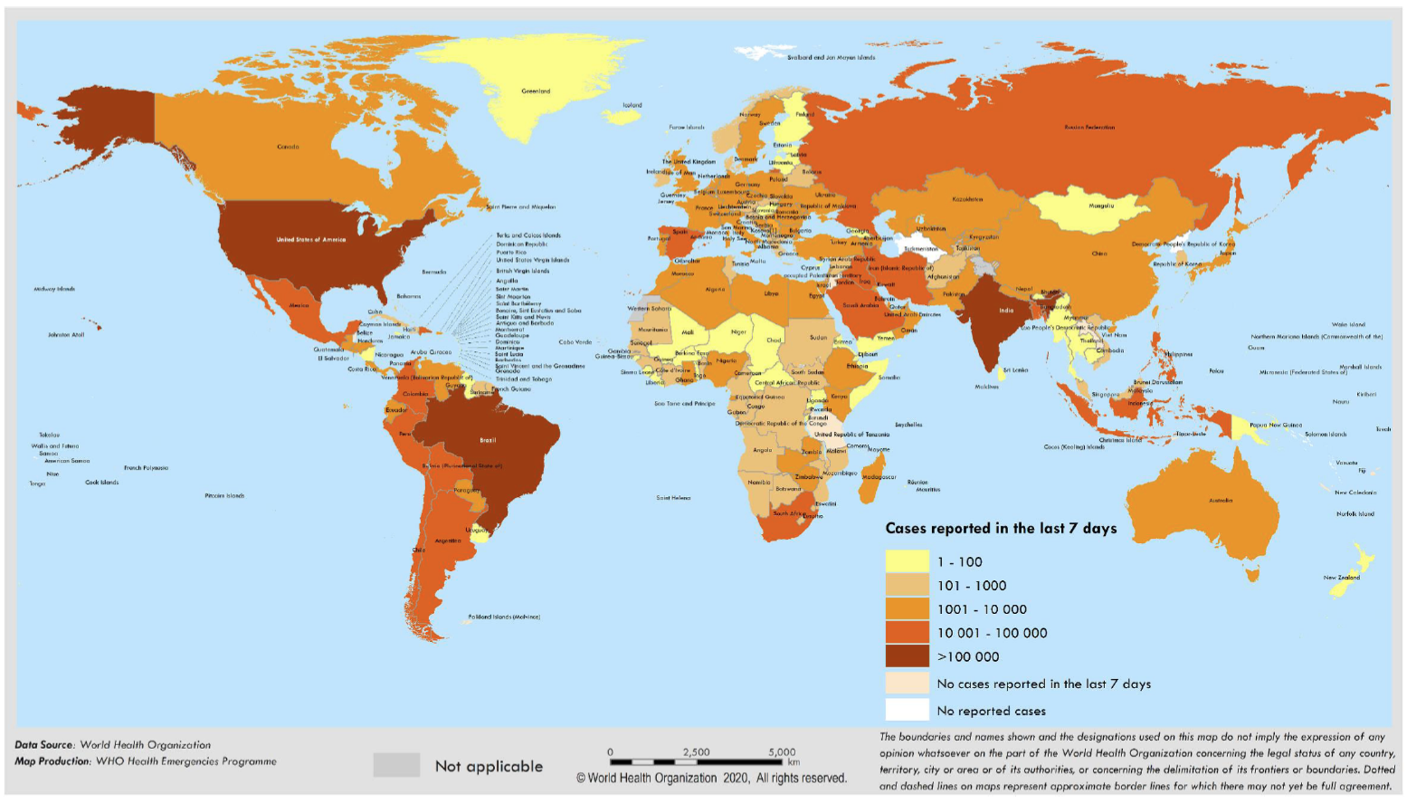
Figure 1. Worldwide new confirmed and death cases of COVID-19 as per WHO situation report 195 [2].

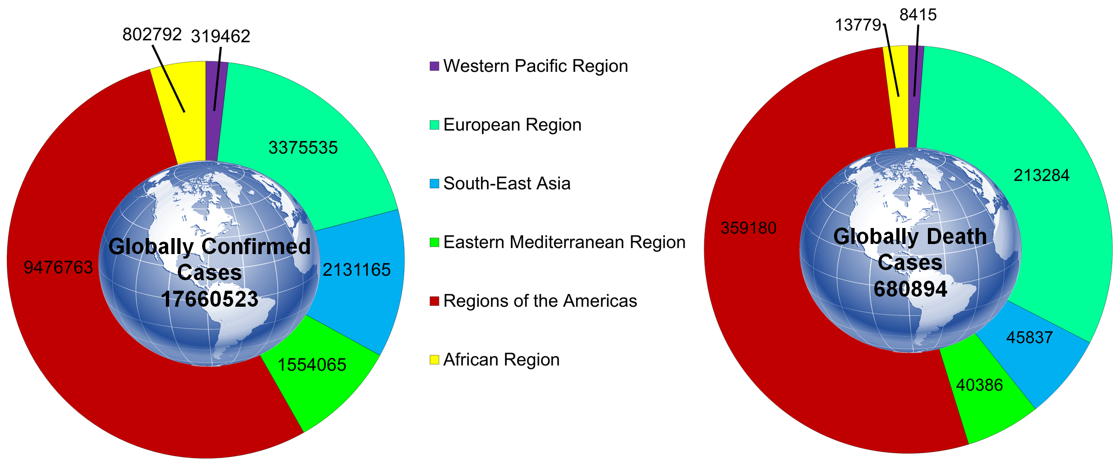
Figure 2. Globally confirmed cases of COVID-19 and Global death cases [2]

2. GLOBAL ECONOMY AND COVID-19
The spread of COVID-19 has triggered both production (demand) and consumption (supply) shocks that reverberate across the global financial system. As per the Organization for Economic Cooperation and Development (OECD) forecast among major economies other than China, the biggest downhill growth is observed in Japan, South Korea, and Australia [3].
Major European financial systems may suffer instabilities as the virus spreads and countries enact stringent solutions that control manufacturing activity at regional centres, including in Northern Italy. The United Nations (UN) project [4] that as a consequence of suppressed activity that direct foreign investment transactions can fall between 5-15% to their lowest rates since the 2008-2009 global economic crises. In addition to its threatening impact on human life, the COVID-19 has the ability to dramatically disrupt not only the Chinese economy but also the global economy. China has been the main production centre for various multinational business operations. It is anticipated that any disturbance of China's productivity would have consequences elsewhere through global and regional supply chains. Indeed, the latest data show a significant decline in production (output) in China [3].
Concerns of a larger outbreak and associated economic impacts spread to stock markets in February 2020, and several foreign indices are near to bear market territory (decreasing at least 20% from the 52-week high) as investors assess the lower company profits that would arise from the virus. The Standard & Poor's 500 Index (S&P 500), commonly referred to as the stock market index, dropped 7% to start the March 9, 2020 session, causing a "circuit breaker" the first halted trade since 1997 for the first time. Overall, the index is down around 17% from its record high on February 19, 2020. As a consequence of the equity routing, investors have migrated to safe-haven assets like the United States [3].
Economist Swaminathan Aiyar reported that India could be in deep trouble, if the condition of COVID-19 succeeds to circulate for more than a year. If it continues for nine months, it will be as long as the scenario of 1918-19 Spanish flu, which has affected 200 million people and resulted in 50 million deaths. With the current population levels, many billion people will be contaminated, tens of millions will die, and the financial loss will be very severe. The damage will be distinct from that perpetrated in 2008, which was a small economic crisis. In the worst situation, if the COVID-19 spreads for 12 months, then the companies will no longer have the resources to repay their debts [5].
While the world deals with the COVID-19 outbreak that threatens to impact a rising number of countries and people [6, 7], the responses to the recent McKinsey Global Economic Survey indicate raising hope [8]. Executives express ever more ambitious hopes for the competition and competitiveness of businesses, two months after expressing record pessimism on all fronts and for the economic prospects for their nations. Although the opinions of executives on profits of company remain more negative, the share projected to improve profit has increased. Across the industry, more than half of the retail and high-tech and telecom respondents predict a rise in demand. Retailers often have a far more positive perception of demand after the April 2020 report, as do those in infrastructure and capital projects (Figure 3) [8].
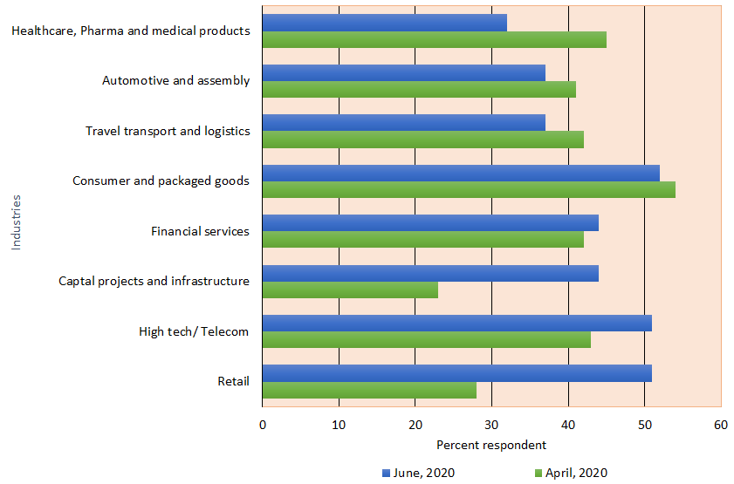
Figure 3. Share of respondents for various industries expecting customer demand will increase in the next 6 months
Once questioned regarding the prospects of the economy, respondents became highly skeptical yet hopeful. About 51% of respondents believe that six months from now, the global economy would be stronger, a share that has risen across 2020. Likewise, half of the respondents anticipate an improvement in their home economies; in May 43% of respondents said, up from 26% in March 2020 and 36% in April 2020. Except in Greater China, India, and Latin America-where, the perspective of respondents has stayed stable, executives in every area are more likely to expect an improvement than in May 2020 (Figure 4) [8].
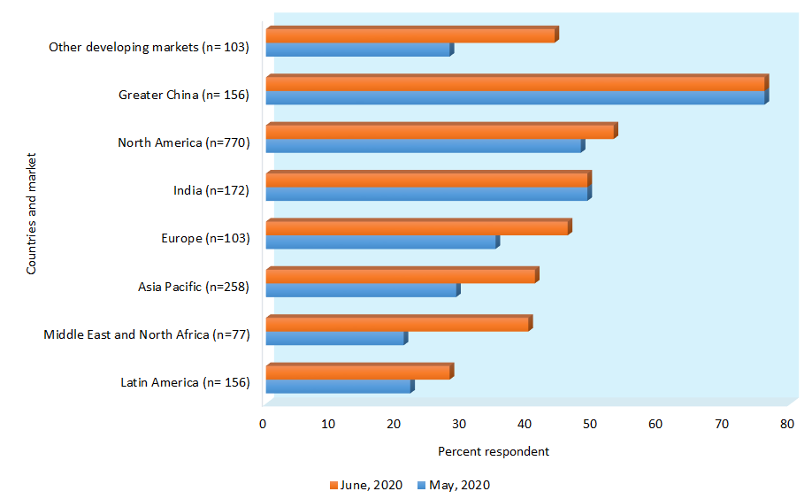
Figure 4. Share of respondents of different countries expecting economic conditions in the home country will be better in the next 6 months

3. CORONAVIRUS: HOW ARE NATIONS RESPOND TO THE FINANCIAL CRISIS?
COVID-19 exploits the world economy. The extremely infectious outbreak has brought the economy to the verge of a more serious collapse than the 2008 financial crash in only a couple of weeks. The severity and extent of the downturn would rely on several variables like the virus' own actions, economic interventions, and reactions to public health.
As per the International Monetary Fund (IMF), the world economy is projected to fall by more than 3% in 2020-the steepest downturn since the Great Depression of the 1930s. Presently, as some countries lift constraints and steadily reactivate their financial systems, here is another look at how they have been affected by the pandemic and how they have coped with it. The pandemic has driven the world economy into recession, implying that the economy begins to decline and growth stops. In the US, disruptions related to Covid-19 have led to millions of filing for unemployment benefits. The numbers were at 20.5 million in April 2020 alone, which are projected to increase as the effect of the pandemic on the US job sector deteriorates. As per a Reuters report, since March 21, 2020, more than 36 million have filed for unemployment benefits, which is almost a quarter of the working-age population. Furthermore, an early IMF study shows that production efficiency has gone down in several countries, showing a decline in export demand and increasing hopes of a decline in domestic demand. The world economy forecast of the IMF rising at -3% by 2020 is a "far worse" result than the global financial crisis of 2009. In the current year, economies including the US, Japan, UK, Germany, France, Italy, and Spain are projected to contract 5.9, 5.2, 6.5, 7, 7.2, 9.1, and 8%, respectively. Advanced economies have been struck harder and are projected to develop collectively by -6% in 2020. It is estimated that emerging markets and developing economies will contract by 1%. On the exclusion of China from this pool of countries, it is estimated that the growth rate for 2020 will be -2.2%. In Europe, the gross domestic products (GDPs) of France, Spain, and Italy fell by 21.3, 19.2, and 17.5%, respectively [9].

3.1. India
The financial impact of the COVID-19 outbreak in India from 2019 to 2020 has been tremendously destructive. World Bank and credit rating agencies downgraded the growth of India for the financial year 2021 with India's lowest estimates in three decades following the economy of India liberalization in the 1990s [10, 11]. However, the IMF projection for India for the financial year 2021-22 of 1.9% GDP growth is the highest among G-20 nations [12]. The financial status of India is estimated to lose more than US$4.5 billion per day during the first 21 days of full lockdown announced after the COVID-19 outbreak [13, 14]. Less than a quarter of India's US$2.8 trillion economy is functioning in full lockdown [15]. Up to 53% of businesses in the country will be significantly affected [16]. The most at risk are people in the informal industries and in regular pay categories [17]. There is also uncertainty among a huge number of farmers across the world who cultivate perishable food [18]. Multiple corporations, including hotels and airlines, are deducting salaries and laying off staff. An annual loss of US$ 420 million was reported in the live events industry [19]. The government of India has proposed a range of steps to resolve the crisis, ranging from food protection and special healthcare funding to sector-related benefits and extensions of the tax deadlines. On March 27, 2020, the Reserve Bank of India has declared a series of steps that will render accessible to the financial sector of the nation about US$ 52 billion. On March 29, 2020, the government permitted all necessary and non-essential items to be transported throughout the quarantine period [20]. World Bank funded US$ 1billion of funding to India on April 1, 2020, to combat the COVID-19 pandemic. The central government provided further funds to the states on April 3, 2020, to combat the overall COVID-19 to around US$ 4.0 billion. On April 6, 2020, a 30% salary cut for one year was announced for the President, Prime Minister, and Members of Parliament [21]. On April 14, 2020, the Prime Minister of India announced the extension of the lockdown period till May 3, 2020. A new set of regulations for the controlled opening of the economy and the relaxation of the lockdown has also been set up, which came into effect from April 20, 2020 [22].
Lockdown in India was implemented in late March 2020 and extended several times. Strict controls hindered most of the commercial practices and caused millions of citizens, many of them daily wage earners to lose their employment and income sources. Investment bank Goldman Sachs predicted a major economic downturn of 45% over the three months from April to June 2020. The rating agency Moody's slashed credit scores for India to the lowest point of investment grade. According to Priyanka Kishore, head of India and South East Asia economics at Oxford Economics, the recovery trajectory of India is going to be slow as the country is struggling to come out from this pandemic. She also said that the fiscal policy response of India has been “quite meagre” as compared to the strictness of the lockdown. To alleviate the economic downfall, the government of Prime Minister Narendra Modi unveiled a $266 billion assistance package worth around 10% GDP of India that involved both fiscal and monetary initiatives. But economists have said that the package will do little to boost economic growth since it contains relatively less projected policy expenditure [23].
3.2. United States
Since mid-March, about 17 million Americans have applied for unemployment as an indication of the drastic effect that the outbreak has been having on the US economy. Before the 1982 epidemic, 695,000 was the maximum number filing in a single week. As per the prediction of different experts the unemployment rate of the US may hit more than 40% in the second quarter of the year, even higher than the 25% average in the Great Depression. Although, Washington has been accused of poor management of the public health response to the pandemic, but effective initiatives to regulate the financial system have also been recognized. The Federal Reserve System stated in March 2020 that the bank will manage everything as per their capacity to boost the financial status of the country and have stability.
The Fed's historic interventions included the quick purchase of hundreds of billion-dollars in treasury bond and mortgage-backed securities, decreasing the reserve requirements of bank to zero, deducting interest rates close to zero, buying municipal debt, and corporate and extending emergency credit to a nonbank. Moreover, on the economic side, policymakers have introduced a US$ 2 trillion spending plan, some analysts have viewed it as a bridge fund to get the US financial status across the outbreak. It offers hundreds of billion dollars in loans, reduces disability insurance, funding for health care services, provides incentives to companies, and cash subsidies to families up to US$ 1200 [23].
On June 29, 2020, the Congressional Budget Office estimated that the coronavirus pandemic would cost the US economy US$16 trillion over the next 10 years. After adjustment for inflation, the pandemic is estimated to trigger a loss of US$7.9 trillion or 3% of "actual" GDP by 2030. The forecasts illustrate the significant long-term cost that the pandemic is expected to impose on the economy, which will see dampened consumer demand and business expenditure in the years ahead [24].
3.3. China
China is the second-largest economy in the world revived at the beginning of April, after enduring a wrenching blow from the COVID-19 that developed at the end of 2019 in Wuhan Town, Hubei Region. The government imposed lockdowns on hundreds of communities for many weeks, which have culminated in double-digit percentage decreases in manufacturing production, retail prices, development, and other financial action. In February, the rate of urban unemployment hit a record high of over 6%. This time, China's government is less likely to instigate a global financial recovery than it did before the 2008 economic crisis when it liberally spent more than half a trillion dollars in the stimulus plan. China has almost increased its government debt throughout the years as of about 60% of GDP, and several experts say it can't continue to invest that heavily again. To date, the Central Bank of China has taken some steps including lowering reserve requirements of banks, facilitating them to fund an additional US$ 80 billion to help businesses, and suggesting that interest rates would be reduced in the coming months. Analysts believe the announcement of Beijing regarding the annual growth plan was delayed because of a virus and it would be a major indicator to monitor. An optimistic objective of about 6% could signal that a bigger stimulus plan is arriving, whereas a more conservative figure, similar to 3%, is likely to imply a continuity of the status quo [25].
3.4. United Kingdom
The epidemic of COVID-19 paralyzes the financial status of the UK even as its politicians are seeking a post-Brexit partnership with the European Union (EU). There had also been worries of a slowdown from a so-called hard Brexit previous to the outbreak. Economists estimate that a 5-10 % share of the COVID-19 pandemic may be taken out of the population by 2020. The UK Government is prepared to allow policies that will be "unprecedented in the history of the British State" to boost the economy at the beginning of March. In the emergency initiatives, the government also agreed to compensate 80% of salaries of employees for six months to prevent businesses from resorting to major redundancies, promised to repay self-employed staff for missed income, postponed tax payments, expanded unemployment insurance, created a lending scheme for small to medium-sized firms, and to supported organizations with rescue assistance. The Bank of England has reduced its target interest rate to 0.5% and lowered bank capital specifications. Through an unprecedented development through the beginning of April, the central bank decided to finance the expenses of government through the recession directly, saving it from debt issuance on the bond sector. The relief initiatives might see Britain investing more than 400 billion pounds or about 15% of GDP [25].
3.5. Germany
The financial status of German is predicted to collapse for the very first time since 2009, it may reduce up to 3-10% depending on the lockdown period of the country. Nearly a half-million German corporations registered in March to make their workers enter a temporary government job scheme planned to avoid more numbers of unemployment. To tackle the financial impact of COVID-19, Berlin is taking drastic steps, quitting its determined assurance to stable budgets, acknowledged as Schwarze Null or “black zero”. It assigns a minimum of EUR 350 billion or around 10% of its GDP to finance the largest economy of the Eurozone. Funds may be invested in loaning out struggling companies, possibly by allowing unrestricted lending and even acquiring equity shares [25].
3.6. Japan
Financial export predicted that the export-led economy of Japan would collapse by about 3% this year, it will be the poorest output since 2008. The significant effect of the virus outbreak derives from a global financial crisis after a sales tax increase last fall. The government is bound to postpone the Summer Olympics till next year due to the COVID-19 outbreak. Like some of its Western counterparts, the government of Japan replied with a huge stimulus program worth approximately US$ 1 trillion to aid the nation to navigate one of the most difficult times in current history. The headline statistic is around 20% GDP of Japan, but analysts estimate that the real budget effect would be far lower. In the middle of March, the Central Bank of Japan reported that it will increase its annual acquisition of securities, shares, and other reserves to more than US$ 100 billion. Moreover, some analysts argue that the move has revealed the Bank of Japan's restricted choices to hold interest rates below zero for years [25].
4. FINANCIAL CRISIS IN DIFFERENT SECTORS
While shareholders across the globe begin to worry regarding the economy of China as well as the world due to the current effect of the quick spreading of the COVID-19 epidemic, analysts predict that global economic growth will be dropped by 0.2-0.3% in 2020 while in USA first-quarter output will take a hit of 0.2-0.4% [26]. Due to the COVID-19 outbreak, assessments for the first-quarter Gross Domestic Product (GDP) of China range from 0-5.5% drop from 5.9% current year estimated growth rate [27]. Moody’s Analytics and Barclays predict that the COVID-19 is likely to decrease world GDP by 0.3% by 2020, whereas Oxford Economics estimates a decrease by 0.2% for the year [27, 28]. According to the Washington Post forecast, White House economists analyze just a restricted financial effect as a consequence of the COVID-19 outbreak, with an estimated 0.2% drop of economic growth in the first-quarter. JP Morgan has dropped US first-quarter GDP forecast by 0.25%, similarly 0.45% by Moody’s and 0.40% by Goldman Sachs [29].
The crisis impacted all manufacturing sectors over the period March 2019-April 2020. The share of countries reporting a decline in manufacturing ranges from 55% (pharma) to 94% (motor vehicles). In a previous UNIDO COVID-19 economic impact analysis, pharma sector was identified as one of the very few “winners”, while motor vehicles were (and continues to be) one of the biggest “losers”. It suggests that the downward pattern persisted in all sectors into April 2020, while certain sectors, such as pharmaceuticals, tend to be significantly less impacted than other more vulnerable industries [30].
4.1. Pharmaceutical sector
As markets around the world are struggling from the effects of the COVID-19 outbreak, companies are facing setbacks, workers are jobless and many face the prospect of a total lifestyle change. However, pharmaceutical companies, like Gilead and Eli Lilly, taking centre stage in the COVID-19 battle, are seeing strong stock price gains and a fresh explosion of innovation in the infectious disease world as the battle for COVID-19 therapy approval begins [31].
AstraZeneca (AZ) estimates a decline in revenue due to the current economic situation in China, which was seen as a region of high development for AZ, rendering it more vulnerable to a slowdown in sales relative to other major pharma companies. Therefore, the epidemic would hamper this development, and much more so when it begins to impede economies in other parts of the world including Europe and the US regions where AZ makes certain significant fractions of its overall revenue. But in the face of this possible impact, AZ has confirmed a donation of 9 million face masks to different countries experiencing extreme virus challenges and has ramped up research on diagnostic measures. Global data predict that, with the possibility of an effective drug agent against COVID-19, like their cancer therapy Calquence (acalabrutinib), AZ may offset this lack of sales. The organization is actively conducting a clinical trial of the medication in patients with COVID-19. In fact, AZ also partnered up with Sanofi in the goal of making a vaccine, another effort, which will help to restore lost sales [31].
After the COVID-19 pandemic, many pharmaceutical industries follow up to utilize their own technologies to lighten a load of coronavirus on their patients. Eli Lilly has provided a large amount of support to her diabetic patients with full-page advertisements in various US papers outlining how they can seek funding in such a financially unstable time. To certain insulin-dependent diabetics, their unparalleled financial distress may render them unwilling to afford life-saving medications, something that Eli Lilly is well conscious of. This has also given more assistance to others who have lost their work or health policies due to the outbreak. Patients are advised to contact the Lilly Diabetes Treatment Center where they will speak to clinicians about a range of choices, such as moving to the right alternative or reducing monthly drug prices, to ensure that there is no delay in the distribution of diabetes medicines. Global Data predicts that the growing pharmaceutical industry should develop its own particular customer care approach, because not doing so may have adverse consequences on credibility. Pfizer has also suffered unexpectedly from the coronavirus pandemic. The pneumonia vaccine of Pfizer has witnessed an unprecedented rise in demand, most likely attributed to the presence of coronavirus, which in extreme situations triggers pneumonia with elevated mortality rates. This improved income for Pfizer would be met and surpassed if its partnership with BioNTech on the COVID-19 vaccine is effective. It would be established for pandemic areas beyond China, as BioNTech has partnered with the Shanghai Fosun Pharmaceutical Group in China. While the vaccine must face a long path towards acceptance, COVID-19's unexplained recurrence alongside the immense economic and social damage it has generated internationally must guarantee universal vaccine adoption. Global Data claims the partnership of Pfizer and BioNTech would encounter stiff pressure from other pharmaceutical industries like Johnson & Johnson, Gilead, and Amgen. There are also new competitors, such as Kentucky Bioprocessing, a parent company of British American Tobacco, who are in pre-clinical stages with a non-profit plant-based vaccine [31].
The Indian pharma sector, the third-largest in the world, provides almost 60% of the vaccines used worldwide, including those that are essential, like diphtheria, tetanus, and pertussis vaccinations needed by the WHO. The nation reaches 90% of the worldwide market for a measles vaccine. Millions of patients worldwide use generic medicines manufactured by Indian drug makers. The US Food and Drug Administration (USFDA) as well as the UK Medicine and Healthcare Products Regulatory Agency (MHRA) have licensed more than 250 factories in the world. They produce drugs for foreign customers, including the US and the UK. The active pharmaceutical ingredient (API) sector of India is expected to produce sales of US$6 billion by the end of 2020. Generic medicines already perform a key function in fighting COVID-19. India has reached more than 20% of the world, and almost 50% of the generic medicine requirements of the US. Unfortunately, Indian producers depend heavily on China to fulfill approximately 70% of the demands of Indian pharmaceutical companies for key starting materials (KSMs), intermediates and APIs. The Indian pharmaceutical industry is a significant part of the global health sector and is influential every year in saving millions of lives. For all other markets, though, COVID-19 has influenced it too and has brought in opportunities to improve further [32]. India is one of the leading drug exporters in the world. Domestic pharmaceutical companies depend profoundly on imports of bulk products such as API and intermediates with therapeutic values. The import of bulk drugs in India was nearly of Rs 24,900 crore in the financial year 2019 (FY19), reflecting roughly 40% of total domestic use. Since the API imported from China to India represents about 70% of its value intake, importers remain at danger of market (supply) disruption and unpredictable price fluctuations. Dependence on imports from China is near to 100% for certain essential antipyretics and antibiotics. Distribution and monitoring of products inside China are also unclear if they are inward or outward [33].
Glenmark Pharmaceuticals was the biggest loser in the healthcare ranking, displaying a decline in shares of almost 23% followed by RPG Lifesciences, Aurobindo Pharma, and Wockhardt [15]. India rating indicated that this fall emerged because the credit outlook for Indian pharmaceutical companies remains progressive in the near-term despite the heavy dependence of the industry on Chinese APIs and intermediates. All India Chemists and Druggists Association reported a 12% rise in domestic growth of the pharma industry in February 2020 as compared to 7% in the preceding month. The healthcare rate decreased by 8.3%, whereas the Sensex decreased by 8.2% after India introduced restrictions on international arrivals by restricting most visas until April 15, 2020 [34].
On March 3, 2020, the World Bank promised up to US$ 12 billion, including US$ 8 billion in new funding to help other countries dealing with the COVID-19. This fast-tracked funding includes grants and low-interest loans, as well as technological services. Many of the programs are meant to augment community health services and their easy access. The World Bank will offer priority to support the countries at high risk and with limited ability to respond with the outbreak. Half of the proposed funding is from the International Finance Corporation, which is expected to improve global supply chains and support critical sectors including pharmaceuticals [35].
4.2. Stock market
On June 8, 2020, WHO declared that the COVID-19 pandemic was escalating across the world and cautioned against complacency. More than six months into this pandemic, this is not the time for any country to take its foot off the pedal. The US stock market launched its fourth consecutive week of a rally on the very same day. The S&P 500 index is back to where it was at the beginning of 2020, erasing the unprecedented fall (one-third of its value) that took place between February 20 and March 23, 2020 [36]. Currently, the world is suffering from the worst economic crisis since the Great Depression. The stock market avoided the pandemic at first and then screamed when Europe became the epicentre [37- 40].
In one of his influential New York Times columns, Paul Krugman (2020) said out loud what many people were thinking: “Whenever you consider the economic implications of stock prices, you want to remember three rules. First, the stock market is not the economy. Second, the stock market is not the economy.
The United Nations Conference on Trade and Development (UNCTAD) reported that the resonance behind the downturn in production in China related to the outbreak of COVID-19 is affecting world trade and may result in a US$ 50 billion decline in exports across global supply chains. According to a UN report, the trade effects of the COVID-19 outbreak on India are projected to be around US$ 348 million, and the country stands among the top 15 countries, which are most affected by the downturn in manufacturing in China affected global trade. The most affected sectors comprise communication equipment, automotive, precision instruments, and machinery. The most affected economies are Vietnam (US$ 2.3 billion), Taiwan Province of China (US$ 2.6 billion), South Korea (US$ 3.8 billion), Japan (US$ 5.2 billion), the United States (US$ 5.8 billion), and the European Union (US$ 15.6 billion).
India is one of the 15 most-affected economies owing to the COVID-19 (Figure 5) and production stagnation in China, with a trade cost of US$ 348 million. The trade effects in India are lower than in other countries like South Korea, USA, Japan, and the EU. For India, the trade impact is estimated to be the most for the electrical machinery at US$ 12 million, leather products at US$ 13 million, wood products and furniture at US$ 15 million, metals and metal products at US$ 27 million, the automotive sector at US$ 34 million, textiles and apparel at US$ 64 million, and chemicals sector at US$ 129 million[41, 42].
Figure 5. Impact of COVID-19 on Indian market (1) Various sectors; (2A-2C) Various large, mid and small-caps [43]

4.3. Oil market sector
Over dramatic one-month duration, the initial estimation of the effect of COVID-19 on oil consumption has changed from preliminary forecasts. The oil demand of China has largely affected due to the virus and the estimation of using more quantity of jet fuel will impacts much more on the growth of the world economy for the rest of the year. An early report by Barclays stated that the oil consumption at the end of January 2020 will decrease by around 600 to 800,000 barrels per day (BPD) over the first-quarter of the year and 200,000 BPD over the year, the International Energy Agency (IEA) updated annual oil demand by 365,000 BPD.The discussion on the consumption of oil for the rest of the year is still driven by the growing possibility of a recession. The impact in the price of oil has been significant. The Brent oil crude price graph attained a twelve-month low value and the prediction even worse for the rest of the year. Since that time the forward curve shows predicted price per-barrel for the rest year has collapsed in the past week, suggesting that traders of oil may not exhibit much interest in selling or keeping off their stocks. At the weekend, Brent traded at just above US$ 50 per barrel with West Texas Intermediate (WTI) prices remaining at US$ 45.26 [43].
Indian state fuel retailers take a 15-day moving average of international fuel rates and factor in the exchange rate to estimate the daily domestic price of diesel and petrol. Fuel costs generally track the crude oil trajectory. Crude oil dropped by 12% with many incidents of COVID-19 reported in several countries. Oil has been down a quarter since the starting of the year 2020. Fall in oil costs is positive for heavy energy users like India, who imports 85% of their oil needs. Lower cost of oil tends to hold inflation in check, decrease oil subsidy, reduce the current account deficit, and put more public funding money to the states [44].
The Indian Oil & Gas (O&G) industry is noteworthy in the global sense. It contributes to 5.2% of world oil production, ranked in the top three regional markets for consumption growth, and ranks 4th in the world for refining capability (about 249 MTPA). India is still very contingent on imports, with oil imports at 84% and gas imports at 53% of their respective annual requirements. The O&G imports, make up about 25% of the import bill of India in FY 19. Therefore, the effect of COVID-19, either due to the widespread devastation of demand, or the downward fall of crude prices, is of considerable concern to all participants in the Indian O&G industry. The Indian O&G industry is typically experienced in responding to a crisis and its success has been shown in the past across several crises. The industry has also done relatively well so far with COVID-19, as demonstrated by the near-continuous operations and availability of numerous fuels, almost throughout the world. However, most of the O&G CXOs believe that the recovery for the sector is likely to be longer, and more protracted than anticipated [45].
According to IEA on 10 July, the worst impacts of COVID-19 on international oil demand have ended but will begin to circulate while the sector gradually expands in the second half of 2020. In its widely followed monthly survey, the IEA stated that global oil demand dropped by 10.75 million barrels a day in the first half of 2020, down around 11% from last year. The oil production estimate is predicted to decline by 5.1 million barrels per day in the second half of the year [46].
4.4. Automobile sector
Manufacturing sectors of China are predicted to contract by about 2% as of February 2020 because of the COVID-19 outbreak. Reduction in the export of automobiles and parts from China can affect the automobile industry in the EU with an expected decline of US$ 2.5 billion (Figure 6) [47].
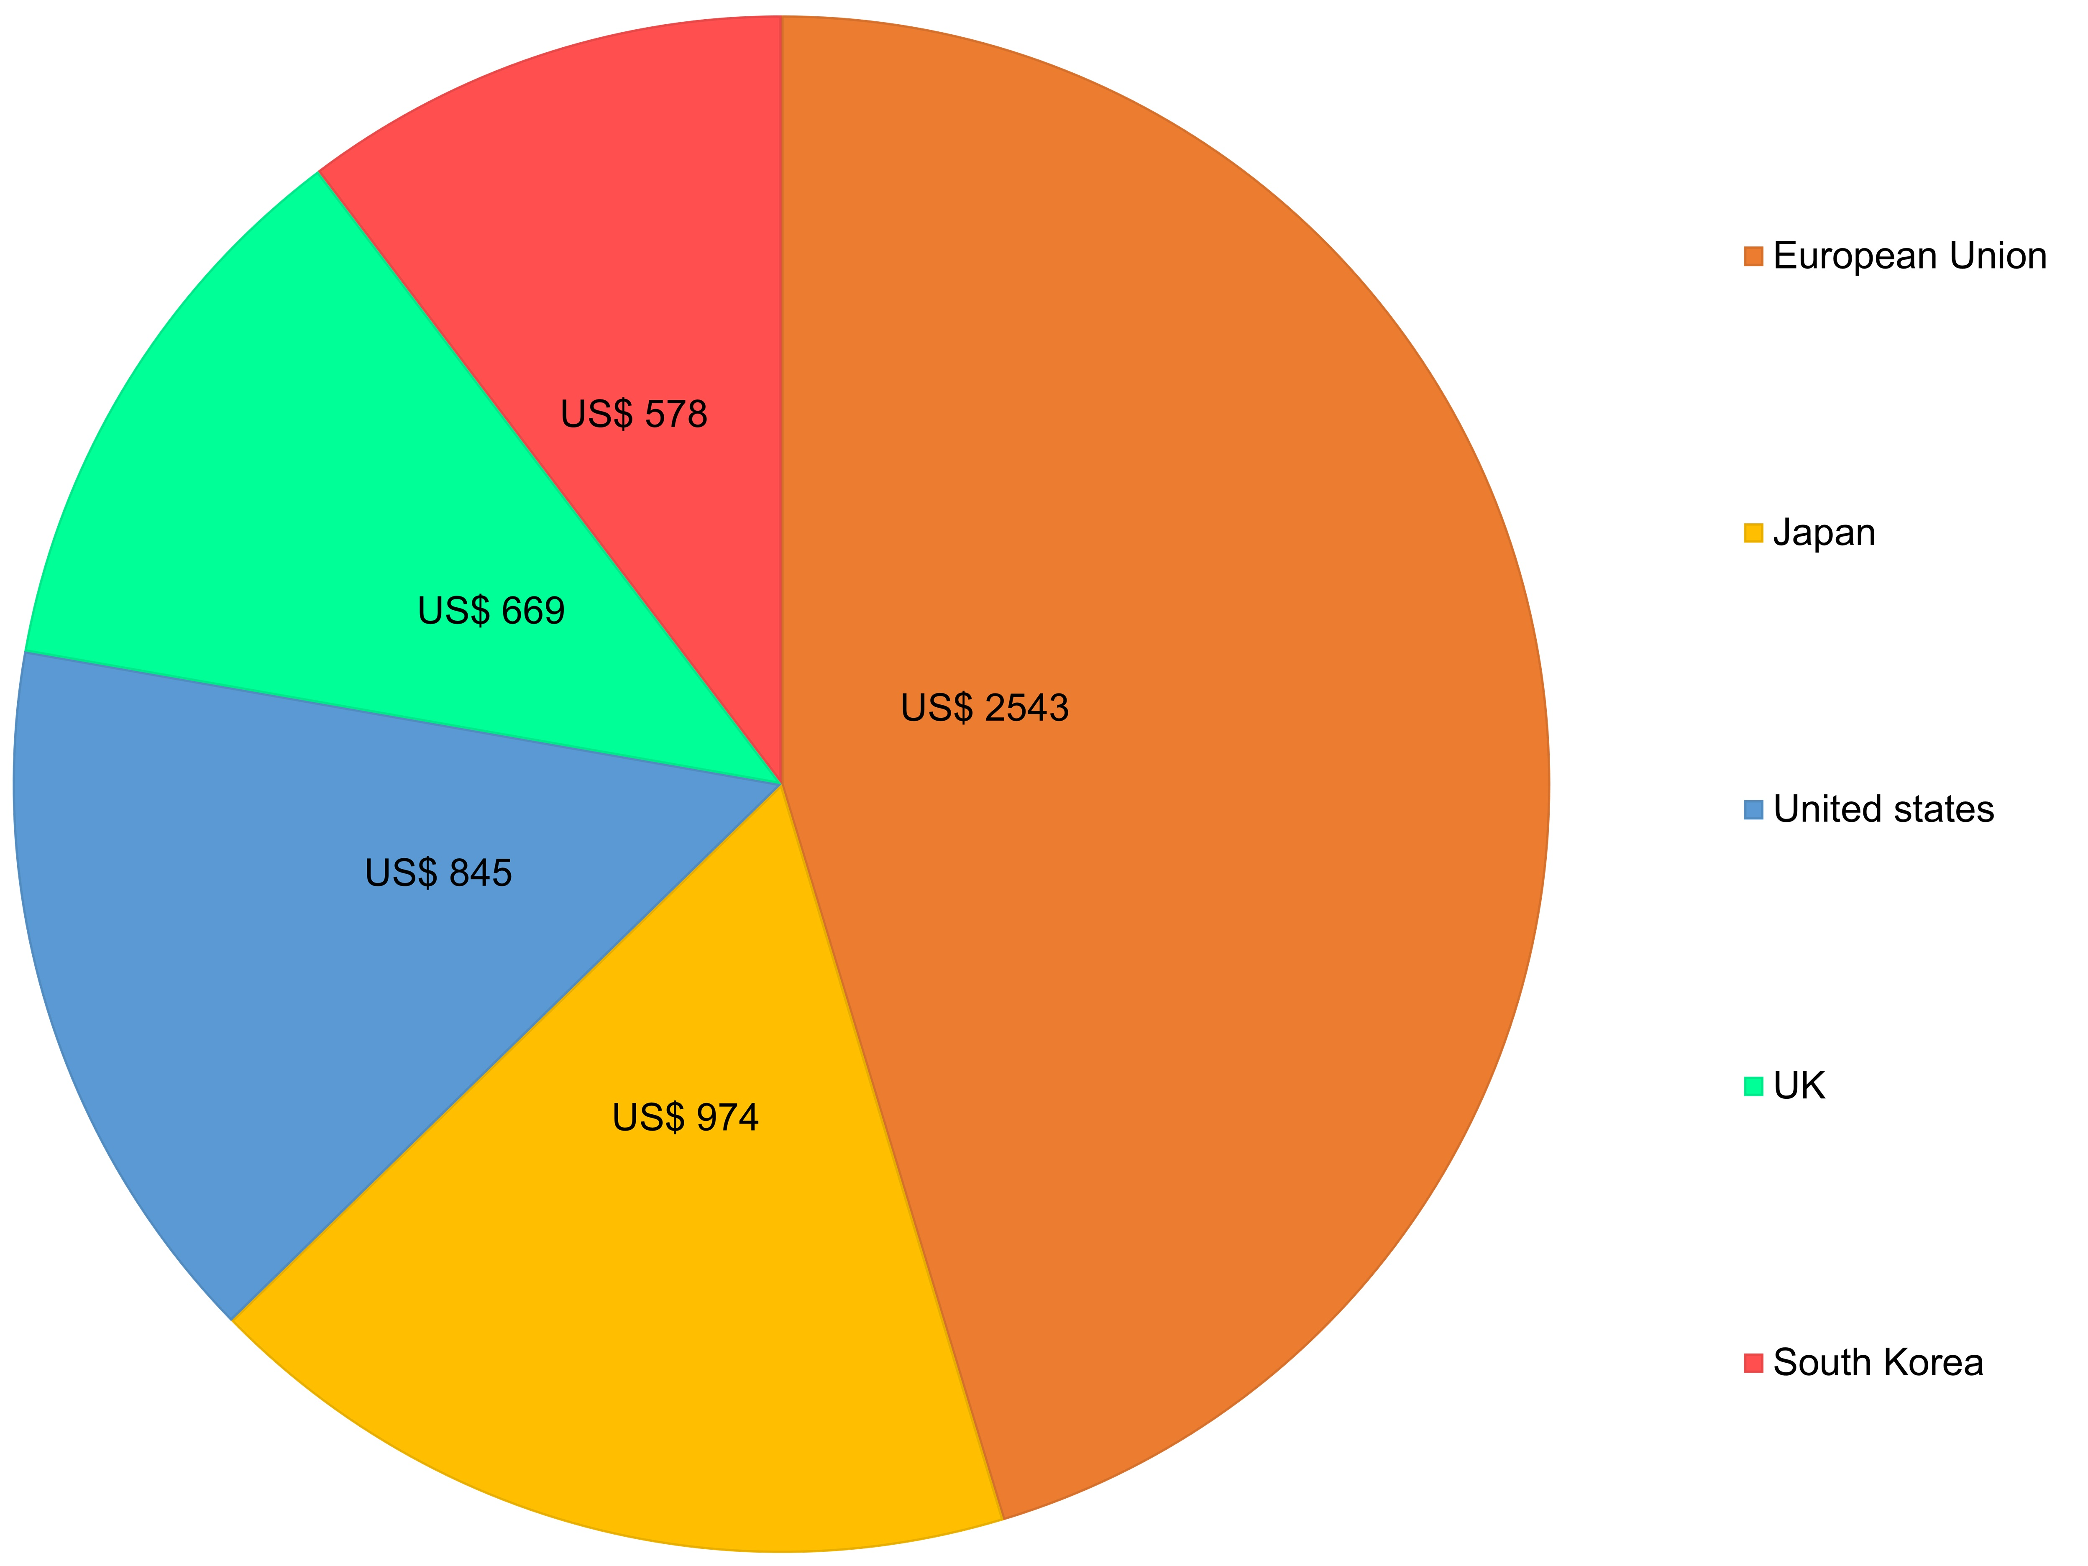
Figure 6. Estimated trade impact of COVID-19 epidemic on the automotive sector as of February 2020 (in million US$) [48]

Fitch Solution recently reported that the production of vehicles in India is expected to fall by 8.3% in 2020 following an approximate decline of 13.2% in 2019.The agency also listed production shortages due to the outbreak of the virus as one of the causes of the contraction. Crisil also reported that the domestic industry has records for up to 30-60 days, which may help tidethe crisis in the short term, any shortage of essential products such as printed circuit boards could hinder the potential of manufacturers to produce automobiles [48].
Society of Indian Automobile Manufacturers (SIAM) reported that wholesale volumes of commercial vehicles dropped 32.9% to 58,670 units and sales of passenger vehicles dropped 7.61% to 251,516 units and in February 2020. The demand for scooters declined 14.27% to 422,310 units last month, those of two-wheelers decreased 19.82% to 1,294,791 units, that for motorcycles by 22% to 816,679 units (Table 1) [49].
Table 1. Comparative wholesale dispatches from factories and not retail sales in February 2019 and 2020 [49].
Category | February 2019 | February 2020 | % Decline
 | (Domestic sale only)
Passenger vehicles | 272,243 | 251,516 | -7.16
Commercial vehicles | 87,436 | 58,670 | -32.90
Three-wheelers | 59,875 | 41,300 | -31.02
Two-wheelers | 1,614,941 | 1,294,791 | -19.82
Overall | 2,034,597 | 1,646,332 | -19.08

BCG's Vehicles and Center for Macroeconomics departments expect that automobiles demand will most likely plunge by 14-22% across the Chinese, US, and European markets in 2020. In the face of this complexity, businesses must adopt a comprehensive view to establish a variety of options to detailed contingency strategies to handle such challenging times [50].
The automobile industry focuses on the use of energy-efficient, stiff, and compact materials to lower adverse environmental impacts. As a consequence, the global automobile market is making a growing application of specialized vehicle components, including titanium, carbon fiber, and magnesium. Carbon fibers are widely favored fabrics for automobile applications thanks to their excellent strength-to-weight ratio. The global automotive industry is now seeing the introduction of stringent rules and regulations, under which the Automotive Boards and Agencies have already developed their legislative mechanisms for automobiles. The developed automotive markets, such as the EU, North America, and Japan, have the most stringent fuel emission norms in the world. The decrease of automotive pollution and fuel use is the primary objective of maintaining stringent emission limits. The European Union introduced Euro VI norms in 2014. Nitrogen oxide emissions shall stay below 0.4 g/KWh, and particulate emissions shall stay below 0.01 g/KWh, in compliance with the regulation. Japan is seeking to update the emission requirements to levels that are similar to Euro VI requirements. Over the projected era, these pollution and economy requirements would boost the global demand for automotive carbon fiber products, as such products deliver advantages such as weight loss, improved fuel output, and decreased carbon emissions [51].
4.5.Travel and Tourism sector
Consumer News and Business Channel (CNBC) reported that as per data generated by Tourism Economics, the US travel and tourism market could lose at least US$ 24 billion in international investment this year as a consequence of the quickly spreading COVID-19. As per the report, COVID-19 would be about seven times more than the industry lost during the 2003 SARS outbreak. Tourism Economics monitors all travel costs including lodging, restaurants, amusement parks, and attractions. Foreigners usually invest around US$ 256 billion a year on US travel and tourism [52].
As per the Confederation of Indian Industry (CII), it is one of the toughest crises ever to strike the Indian tourism sector that affects all its geographical segments-inbound, outbound, and domestic, almost all tourism verticals like adventure, leisure, cruise, heritage, and corporate. In an effect assessment of the COVID-19 epidemic, the CII Tourism Committee stated that inbound international tourism accounted for an average of 60-65%, which is over US$28 billion in value terms between October and March. When the virus news began to pick up from November, the percentage of cancellations began to rise steadily in this sector and is now hitting a peak of nearly 80% in several Indian locations in March 2020. The risk estimate of this segment will be in multiples of tens of thousands of crores [53].
The tremendous toll of COVID-19 on foreign tourism has now become apparent, with statistics from the World Tourism Organization ( UNWTO) showing the cost up to maybe three times that of the 2009 Global Economic Crisis. As the condition begins to shift, the United Nations specialist received the first detailed insight into the effects of the pandemic, both in terms of visitor figures and missed sales, ahead of the upcoming publication of up-to-date statistics on travel restrictions worldwide. The new version of the UNWTO World Tourism Barometer reveals that the near-complete shutdown placed in reaction to the pandemic contributed to a 98% decrease in foreign tourist numbers in May 2020 relative to 2019. The Barometer also indicates a 56% year-on-year decline in tourist arrivals between January and May 2020. It translates into a decrease of 300 million visitors and a reduction of US$ 320 billion in foreign tourism sales-more than three times the shortfall since the 2009 Global Economic Crisis [54].
CONCLUSION
The spreading of COVID-19 is a public health issue that may present a significant danger to the global economy by slowing manufacturing processes, interrupting people's movements, and disrupting supply chains. Fear about the effect of COVID-19 on the world economy has harmed the interest of investors and raising equity values in international markets. Industry shutdowns, travel restrictions, and supply-chain delays are disruptions to the development that limits the capacity of the economy to generate services and products. Major falls in the stock market are also driving lower demand by reducing household capital. Since COVID-19 has evolved as a global pandemic, various findings indicate that prices will increase rapidly. The combined efforts of developed nations and organizations across the world to stabilize the world economy are the need of the time. Firm decisions and policies are warranted to stabilize the world economy for normalizing any possible untoward socio-economic impact.
CONSENT FOR PUBLICATION
Not applicable.
FUNDING
None.
CONFLICT OF INTEREST
The authors declare no conflict of interest, financial or otherwise.
ACKNOWLEDGEMENTS
The author extends their appreciation to the reviewer.
REFERENCES
- Coronavirus, World Health Organisation https://www.who.int/health-topics/coronavirus2020.
- Coronavirus Disease (COVID-2019) Situation Reports 1-195; World Health Organization https://www.who.int/docs/default-source/coronaviruse/situation-reports/20200802-covid-19-sitrep-195.pdf?sfvrsn=5e5da0c5_22020.
- The Global Economic Impacts of COVID-19, Center for Strategic and International Studies https://www.csis.org/analysis/global-economic-impacts-covid-192020.
- Coronavirus outbreak has cost global value chains $50 billion in exports https://unctad.org/en/pages/newsdetails.aspx?OriginalVersionID=2297&Sitemap_x0020_Taxonomy=UNCTAD%20Home;#13852020.
- Economy's fate now depends on coronavirus, not govt policies: SwaminathanAiyar https://economictimes.indiatimes.com/news/economy/indicators/economys-fate-now-depends-on-coronavirus-not-govt-policies-swaminathan-aiyar/articleshow/746119082020.
- WHO Coronavirus Disease (COVID-19) Dashboard, WHO covid19.who.int2020.
- Khan Z, Muhammad K, Ahmed A, Rahman H. Coronavirus outbreaks: prevention and management recommendations. Drugs TherPerspect 2020; •••: 1-3.
PMID: 32218651
- The coronavirus effect on global economic sentiment, McKinsey and Company https://www.mckinsey.com/business-functions/strategy-and-corporate-finance/our-insights/the-coronavirus-effect-on-global-economic-sentiment2020.
- Explained: How Covid-19 has affected the global economy, The Indian Express https://indianexpress.com/article/explained/explained-how-has-covid-19-affected-the-global-economy-6410494/2020.
- World Bank sees FY21 India growth at 15-28%, slowest since economic reforms 30 years ago, The Hindu PTI https://www.thehindu.com/business/world-bank-sees-fy21-india-growth-at-15-28-slowest-since-economic-reforms-30-years-ago/article31322011.ece2020.
- World Bank sees FY21 India growth at 15-28%- slowest since economic reforms three decades ago, The Times of India https://timesofindia.indiatimes.com/business/india-business/covid-19-causes-severe-disruption-to-indian-economy-says-world-bank/articleshow/75104070.cms2020.
- IMF projection for India’s GDP growth highest in G-20, says RBI Governor Shaktikanta Das https://www.indiatoday.in/business/story/rbi-governor-shaktikanta-das-indian-economy-covid19-imf-projection-gdp-growth-1667889-2020-04-172020.
- Covid-19 lockdown estimated to cost India $45 billion a day: Acuité Ratings, The Hindu Business Line https://www.thehindubusinessline.com/economy/covid-19-lockdown-estimated-to-cost-india-45-billion-a-day-acuit-ratings/article31235264.ece2020.
- Experts peg India’s cost of coronavirus lockdown at USD 120 bn, The Hindu Business Line https://www.thehindubusinessline.com/economy/experts-peg-indias-cost-of-coronavirus-lockdown-at-usd-120-bn/article31160115.ece2020.
- Lockdown relaxation⁠- more than half of India's economy may reopen from Monday, says Nomura, Business Insider https://www.businessinsider.in/policy/economy/news/lockdown-relaxation-more-than-half-of-indian-economy-may-reopen-from-monday-april-20/articleshow/2020.
- Coronavirus impact: Indian industry seeks relief measures to aid economy, Livemint https://www.livemint.com/companies/news/coronavirus-impact-indian-industry-seeks-relief-measures-to-aid-economy-11584904435575.html2020.
- 136 million jobs at risk in post-corona India, Livemint https://www.livemint.com/news/india/136-million-jobs-at-risk-in-post-corona-india-11585584169192.html2020.
- Covid-19 puts India’s food supply chain to a stress-test, The Hindu Business Line https://www.thehindubusinessline.com/economy/agri-business/covid-19-puts-indias-food-supply-chain-to-a-stress-test/article31173973.ece2020.
- Covid-19: How the deadly virus hints at a looming financial crisis, The Economic Times https://economictimes.indiatimes.com/news/economy/ finance/covid-19-crisis-how-the-deadly-virus-hints-at-a-looming-financial-crisis/articleshow/74752200.cms2020.
- Covid-19: Govt allows transportation of all essential, non-essential goods, Business Standard India PTI https://www.business-standard.com/article/current-affairs/covid-19-govt-allows-transportation-of-all-essential-non-essential-goods-120033000055_1.html2020.
- President, MPs, ministers take a pay cut for 1 year, say it is a message, Hindustan Times https://www.hindustantimes.com/india-news/ordinance-passed-to-cut-salaries-of-mps-ministers-by-30-to-fund-covid-19-battle/story-2x9a6obfOxHc 5HQ8rhS7FP.html2020.
- India’s economy was hit by the coronavirus lockdown These charts show how, CNBC MARKETS https://www.cnbc.com/2020/06/22/economic-impact-of-indias-coronavirus-lockdown-in-four-charts.html2020.
- India evolves world’s largest smart model of lockdown: Officials, The Economic Times https://economictimes.indiatimes.com/news/politics-and-nation/india-evolves-worlds-largest-smart-model-0f-lockdown-officials/ articleshow/75169336.cms2020.
- U.S. Economy Faces Long-Term Recovery. https://www.nytimes.com/2020/06/01/business/stock-market.html2020.
- Coronavirus: How Are Countries Responding to the Economic Crisis? Council on Foreign Relations https://www.cfr.org/backgrounder/coronavirus-how-are-countries-responding-economic-crisis2020.
- Coronavirus is now expected to curb global economic growth by 03% https://www.forbes.com/sites/sergeiklebnikov/2020/02/11/coronavirus-is-now-expected-to-curb-global-economic-growth-by-03-in-2020/#203f23e716da2020.
- The Effect of the COVID-19 Virus Outbreak. https://www.moodysanalytics.com/2020.
- Will the coronavirus outbreak derail the global economy? https://www.theguardian.com/news/2020/feb/10/will-the-coronavirus-outbreak-derail-the-global-economy2020.
- SARS Stung the Global Economy The Coronavirus Is a Greater Menace https://www.nytimes.com/2020/02/03/business/economy/SARS-coronavirus-economic-impact-china.html2020.
- Coronavirus: the economic impact, United Natuons Industrial Development Organization https://www.unido.org/stories/coronavirus-economic-impact-10-july-20202020.
- The impact of big pharma on Covid-19, Global Data Healthcare https://www.pharmaceutical-technology.com/comment/covid-19-pharmaceutical-companies-impact/2020.
- COVID–19 and its impact on India Pharma Inc, EP News Bureau https://www.expresspharma.in/latest-updates/covid-19-and-its-impact-on-india-pharma-inc/2020.
- Coronavirus its impact on various sectors, ETMarketscom https://economictimes.indiatimes.com/markets/stocks/news/coronavirus-its-impact-on-various-sectors/pharma/slideshow/74490810.cms2020.
- Covid-19 Impact: Fears of Chinese API shortage hurt pharma players https://economictimes.indiatimes.com/markets/stocks/news/covid-19-impact-fears-of-chinese-api-shortage-hurt-pharma-players/articleshow/74%E2%80%A62020.
- GMT- World Bank pledges US$12 billion for coronavirus response https://www.nature.com/articles/d41586-020-00154-w2020.
- The stock market and the economy: Insights from the COVID-19 crisis, Gunther Capelle-Blancard, Adrien Desroziers https://voxeu.org/article/stock-market-and-economy-insights-covid-19-crisis2020.
- Baldwin R, Weder di Mauro B. Economics in the time of COVID-19, VoxEU eBook. CEPR Press 2020.
- Baldwin R, Weder di Mauro B. Mitigating the COVID Economic Crisis: Act Fast and Do Whatever It Takes, VoxEU eBook. CEPR Press 2020.
- Bénassy-Quéré A, Weder di Mauro B. Europe in the time of COVID-19, VoxEU eBook. CEPR Press 2020.
- Coibion O, Gorodnichenko Y, Weber M. The Cost of the COVID-19 Crisis: Lockdowns, Macroeconomic Expectations, and Consumer Spending BFI Working Paper 2020.
- Trade impact of Coronavirus epidemic for India estimated at 348 million dollars: UN report https://economictimes.indiatimes.com/news/ economy/foreign-trade/trade-impact-of-coronavirus-epidemic-for-india-estimated-at-348-million-dollars-un-report/article show/74487020.cms?from=mdr2020.
- Coronavirus impact on Indian market: Numbers say it all, ETMarketscom https://economictimes.indiatimes.com/markets/stocks/news/coronavirus-impact-on-indian-markets-in-5-pictures/deep-in-the-red/slideshow/74591296.cms2020.
- Coronavirus and the oil market: The effects thus far and what to expect next https://www.atlanticcouncil.org/blogs/new-atlanticist/coronavirus-and-the-oil-market-the-effects-thus-far-and-what-to-expect-next/2020.
- Coronavirus outbreak: Petrol, diesel set to get cheaper as crude oil hits 13-month low https://economictimes.indiatimes.com/industry/energy/oil-gas/coronavirus-outbreak-petrol-diesel-set-to-get-cheaper-as-crude-oil-hits-13-month-low/articleshow/74362021.cms?from=mdr2020.
- Opinion: COVID-19 impact on the Oil Gas industry - A perspective, ET Energy World https://energy.economictimes.indiatimes.com/news/oil-and-gas/opinion-covid-19-impact-on-the-oil-gas-industry-a-perspective/757268822020.
- Coronavirus’s worst impact on oil demand has passed, IEA Says, The Wall Street Journal https://www.wsj.com/articles/coronaviruss-worst-impact-on-oil-demand-has-passed-iea-says-115943694122020.
- COVID-19 - trade impact on the automotive sector by market 2020, Statista Research Department https://www.statista.com/statistics/1103657/economic-trade-impact-of-covid-19-on-the-auto-industry-by-market/2020.
- Another blow to India's auto sector! This time due to coronavirus, Business Today https://www.businesstoday.in/sectors/auto/another-blow-to-indias-auto-sector-this-time-due-to-coronavirus/story/397125.html2020.
- Automobile sales down ahead of BS-VI transition, virus woes, ET Bureau https://economictimes.indiatimes.com/industry/auto/auto-news/automobile-sales-down-ahead-of-bs-vi-transition-virus-woes/articleshow/74621136.cms?from=2020.
- COVID-19’s Impact on the Automotive Industry https://www.bcg.com/en-in/publications/2020/covid-automotive-industry-forecasting-scenarios2020.
- COVID-19 Impact Recovery Analysis, Global Automotive Carbon Fiber Components Market 2020-2024, Growing Use of Carbon Fiber Materials In Automotive Industry to Boost Market Growth, Technavio https://www.businesswire.com/news/home/20200729005344/en/COVID-19-Impact-Recovery-Analysis-Global-Automotive-Carbon2020.
- Travel industry could lose $24 billion as coronavirus cripples tourism from outside US https://www.cnbc.com/2020/03/11/coronavirus-travel-industry-could-lose-24-billion-in-tourism-from-outside-us.html2020.
- Impact of coronavirus on Indian tourism could run into thousands of crores of rupees https://economictimes.indiatimes.com/industry/services/travel/ impact-of-coronavirus-on-indian-tourism-could-run-into-thousands-of-crores-of-rupees/articleshow/2020.
- Impact of Covid-19 on Global Tourism Made Clear As Unwto Counts The Cost Of Standstill, July 28, 2020, World Tourism Organization A United Nations Specialized Agency https://www.unwto.org/news/impact-of-covid-19-on-global-tourism-made-clear-as-unwto-counts-the-cost-of-standstill2020.

