Widening Participation in Higher Education through Community Youth Work Training

[Please insert University of Ulster Logo, YouthAction NI and WELB Youth Service]

In June 2013 the community youth work team at University of Ulster was successful in securing funding to offer flexible learning solutions with employers within the community. The purpose of the project was to make Higher Education visible and accessible within communities. To do this the community youth work team partnered with YouthAction NI in two areas, Newry and Mourne and Fermanagh and with the WELB Youth Service, in Derry and Limavady. In each of the areas a module from the Certificate in Community Youth Studies was offered, the costs of training and students fee bursaries were funded by the University of Ulster as part of its widening access and participation strategy.

The project was informed by the Higher Education Strategy for Northern Ireland Graduating to Success (DEL, 2012) which highlights the need for: (1) A more accessible higher education sector; (2) A more flexible lifelong learning environment; (3) Community engagement to be embedded within Higher Education Institutions. The funding is targeted at increasing participation in areas of Northern Ireland were Higher Education study is low, particularly targeting identified communities within the top 20% of the most deprived wards according to the 2010 Multiple Deprivation Measures.

When considering these priorities a decision was taken to partner with community youth work employers in local communities in order offer a higher education experience within community. A total of 42 students completed a level 4 module of 10 credits. For 67% of participants being able to study in their local community was a significant factor, in addition to the subject of study and because of the link to an agency working in their community.

In Derry we linked with the WELB Youth Service ‘InTurn’ apprenticeship project, twelve students studied the module ‘Perspectives on Young People.’ Exploring aspects of youth culture and examined the concept of anti-social behaviour when used in connection with young people.

In Derry and Limivady we linked with the WELB Youth Service, Foyle Youth Forum, welve students studied the module ‘Applied Physical Theatre’ Students were introduced to using physical theatre methods with young people to foster the participation and creative expression of young people.

And in Fermangh, Newry and Mourne linked with Youth Action NI, twenty three students completed the module ‘Diversity and Young People.’ Students completed sessions on gender awareness and have linked with Belong NI to consider how they can be welcoming of people from other countries coming to love in Northern Ireland, for example, ensuring that they have materials in other languages, of by celebrating festivals or days important to those from other cultures. One student commented “doing this module and getting support from the tutors allowed me to come out to the rest of the group whilst we were doing LGB&T training. Because of the support it's allowed me to take control of who I am and I've now realized I want to go on and work with the LGB&T community within youth work.”

Photo: Fermanagh Students at the presentation event
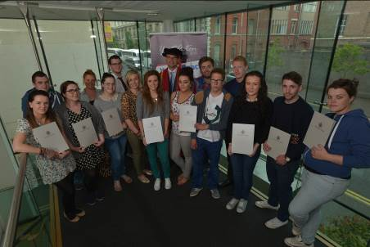

Photo: Fermanagh Students at the presentation event

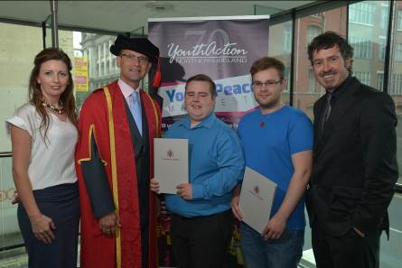
Photo: Two of the successful Newry students at the Certificate Presentation in June 2014, pictured with tutors and the Dean of Social Sciences.

For many of the participants being able to participate in these modules has increased their motivation to study in Higher Education, 82% reported increased motivation and 68% indicated they were now very likely to undertake a Certificate or Degree in Higher Education.

Participants can use the completed modules against the Certificate in Community Youth Studies if they choose further study in community youth work. In addition, students can also undertake further study in a range of diverse subjects offered throughout the University of Ulster, from computing, finance, marketing and foreign languages to name a few. Students can study these modules over a number of years as part of the Certificate of Personal & Professional Development (CPPD). When students have 60 credits accumulated they are presented with the Certificate. Participants from last year’s programme will be presented in November 2014.

We are now working hard in the current academic year (2014-15) as we have been successful in securing further funding. With this funding we will partner with YouthAction NI and Belfast Unemployed Centre with the intention of offering around 200 bursaries for students to study community youth work modules in the community.

