BLAST WAVE FROM A HYDROGEN TANK RUPTURE IN A FIRE IN THE OPEN: HAZARD DISTANCE NOMOGRAMS

Sergii Kashkarova, *, Zhiyong Lib, Vladimir Molkova

* Corresponding author; e-mail: [s.kashkarov@ulster.ac.uk](mailto:s.kashkarov@ulster.ac.uk); tel.: +442890368668

a Hydrogen Safety Engineering and Research Centre (HySAFER), Block 27, Ulster University, Shore Road, Newtownabbey, BT37 0QB, United Kingdom

b Institute for Built Environment and Energy Engineering, Jiaxing University, No.56 South Yuexiu Road, Jiaxing City, P.R. China

ABSTRACT

The nomograms for graphical calculation of hazard distances and zones from a blast wave generated by a stand-alone (stationary) and an onboard (under-vehicle) high-pressure hydrogen tank ruptures in a fire are presented. The nomograms can be used by first responders, hydrogen safety engineers and other stakeholders to determine hazard distances and zones based on a blast wave strength characterised by both overpressure and impulse. The nomograms were built using the validated physical model of a blast wave decay published by the authors and accounting for the contribution of combustion into the blast wave strength. Two types of nomograms are developed: one for on-site use by the first responders, and another for design of hydrogen systems and infrastructure by hydrogen safety engineers. The paper underlines the importance of international regulatory activities to unify harm to people and damage to buildings criteria across different countries.

# INTRODUCTION

The assessment of risk associated with hydrogen storage for hydrogen-fuelled vehicles is required by the regulations, e.g. United Nations Global Technical Regulation No. 13 [1]. Risk, as combination of the event probability and severity [1] involves an understanding of different hazards including hydrogen tank rupture. The hazard distances and zones from a hydrogen system like a vehicle or an infrastructure element like a stationary storage tank at refuelling station must be calculated to carry out the quantitative risk assessment (QRA). The QRA study at Ulster University on accidents related to hydrogen-powered vehicles (HPV) in London [2] showed the risk of HPVs (together with published elsewhere information on failure probability of thermally activated pressure relief devices (TPRD)) is only satisfactory when the time to storage tank rupture in a fire is over 45 min. This is much longer than times to rupture of different tanks obtained in experimental studies in different laboratories.

There is non-zero failure probability of a high-pressure storage tank rupture in a fire, e.g. due to TPRD activation failure or its blockage in a car accident. Another possible scenario in which the TPRD may fail to operate due to exposure to insufficient heat is the smoldering fire. The recent accident of the compressed natural gas (CNG) truck explosion in the USA blasted a hole in the front of a nearby house”. “A total of four houses were damaged in the explosion” [3], [4]. There is a lack of safety technologies for hydrogen storage that are capable to fully exclude tank rupture, except TPRDs. The safety technology developed at Ulster University safety technology [5] eliminates tank rupture in a fire. Instead, a small hydrogen leak though the wall occurs. This leak size is equivalent a hole size of about $D$ =0.2~0.3 mm. Such a small leak also eliminates long jet fires and pressure peaking phenomenon (for confined spaces) [6]–[8].

The high-pressure hydrogen tank rupture in a fire in the open atmosphere is followed by the devastating blast wave and fireball, which diameter may reach tens of meters for cars, and projectiles [9]–[13].

These pressure (blast wave) and thermal (fireball) effects may cause fatalities and injuries of people as well as damaging buildings, even severe enough to fully demolish them, leaving no possibility for evacuation or rescue in the least case.

Moreover, it is unclear what hydrogen inventory, in case of a tank rupture in a fire, would be allowed for fuel cell vehicles passing a tunnel. This topic is out of the scope of this study and is being investigated in the HyTunnel-CS project funded by FCH JU and coordinated by Ulster University.

Through the theoretical analysis of experimental data it was demonstrated by the authors [11] that combustion of cooled during expansion hydrogen, i.e. comparatively “slow” release of chemical energy, at the contact surface with compressed and thus heated by the shock air, contributes to the strength of the blast initiated by a physical explosion, i.e. rupture and practically instantaneous release of mechanical energy of compressed gas.

Stand-alone cylinder for hydrogen storage, e.g. a cylinder at a refuelling station, and under-vehicle onboard hydrogen storage cylinders are two typical examples. There is an essential difference in calculation of blast wave strength after ruptures of such two types of tanks. This is due to the fact that under-vehicle tank rupture is accompanied by a significant loss of released mechanical energy directed to destroy a vehicle and to displace its body from its original location by tens of meters as observed in the experiment [11]. It should be noted that from the blast strength calculation point of view, an under-vehicle cylinder rupture may be considered to some extent as a “stand-alone” application in some scenarios. For instance, this can be applied to cases when a vehicle is overturned in an accident or in a case of tank storage on a vehicle roof, e.g. like in buses, or on a vehicle side. Yet, this is a conservative approach as the loss of energy to damage a vehicle body would be neglected.

The methodology [11] is applied in this work to develop nomograms convenient for use as engineering tools. The two categories of nomograms are developed: one for use by first responders at an accident scene to quickly define hazard zones, in particular, the evacuation perimeter. Another category is for the use by safety engineers when they design hydrogen systems and infrastructure for different applications and location, including the user’s choice of harm criteria, which could vary depending on the national regulation.

The first category of nomograms, i.e. for first responders, is extremely easy to use graphical tools due to pre-selected harm criteria for people and damage criteria for buildings. They are needed to promptly act at an accident scene. These nomograms define three hazard distances to three harm thresholds based on overpressure, i.e. “no-harm” (1.35 kPa) [12], “injury” (16.5 kPa) [14], [15] and “fatality” (100 kPa) [14], [15]. The hazard distance will vary depending on hydrogen cylinder volume and storage pressure. These three distances define four hazard zones. The “no-harm” zone is the zone with distances where blast overpressure is below 1.35 kPa (the evacuation perimeter), “slight injury” is the zone where blast overpressures are in the range 1.35-16.5 kPa, “serious injury” is the zone where overpressures are 16.5-100 kPa, and “fatality” is the zone spreading from the cylinder location to the distance from the tank where overpressure drops to 100 kPa.

The second category of the nomograms has a higher level of flexibility in the choice of harm criteria and was developed for the use by hydrogen safety engineers and other qualified stakeholders. Such nomograms are used to calculate the hazard distances using a deeper knowledge of overpressure and impulse in the blast wave. They allow hydrogen safety engineers to apply their national or international harm and damage criteria to assess hazard distances. These nomograms can be also used as hydrogen safety engineering tools to predict an overpressure and impulse in a blast wave at different distances from the high-pressure vessel location. The opportunity to choose national harm criteria to people (including indoor occupants, people outdoors and indirect effects, such as fragments scatter due to blast) and damage criteria to structures are available to these nomograms’ user.

# HARM TO people and damage TO buildings CRITERIA

## Harm effects on people

Humans can be strongly affected by a blast wave directly through injuring human organs sensitive to pressure, e.g. eardrum rupture and lung haemorrhage. Indirect effects on a human involve body displacement with possible fatal injuries, e.g. a human may hit the head or receive lethal fractures, e.g. if the body is projected against obstacles. The people are more vulnerable to harm when being indoors. This is due to fragment effect, e.g. skin lacerations by flying glass, injuries from falling building parts, e.g. shattered walls and brickworks. Harm criteria which are given in this study were gathered from different national and international sources, including codes, guidelines and best practices. The harm effects to people due to blast wave overpressure, $∆P$, and impulse, $I$, are shown in Table 1.

Table 1. Effects on people from blast waves.

|  |  |  |
| --- | --- | --- |
| **Effects on people** | $∆P$**, kPa** | $I$**, Pa·s** |
| **People (unprotected) outdoors** | | |
| 50% blowdown [16] | - | 60 |
| Lung haemorrhage threshold [16] | - | 180 |
| Severe lung haemorrhage [16] | - | 360 |
| 1% serious injury from displacement [16] | - | 370 |
| 1% fatality probability [16] | - | 590 |
| 50% fatality probability [16] | - | 900 |
| Irreversible effects from “grave” danger threshold [17] | 5 | - |
| People are knocked down [18] | 10.3-20 | - |
| Fatality effects threshold from “grave danger” [17] | 14 | - |
| Eardrum rupture threshold [18] | 13.8 | - |
| Possible fatality by projection against obstacles [18] | 13.8 | - |
| 1% eardrum rupture probability [14], [15] 1 | 16.5 | - |
| Maximum survivable blast overpressure [19] | 17-21 | - |
| Fatal effects from “very grave” danger threshold [17] | 20 | - |
| 1% eardrum rupture [16] | 23 | - |
| 1% fatality probability [19] | 25-35 | - |
| Eardrum rupture [20]–[22] | 34.47 | - |
| 50% eardrum rupture probability [18] | 34.5-48.3 | - |
| 15% fatality probability [19] | 35 | - |
| 50% eardrum rupture probability [5], [6] | 43.5 | - |
| Internal injuries threshold [18] | 48.3 | - |
| 50% fatality probability [19] | 50-100 | - |
| Lethal head injury [20]–[22] | 55.16 | - |
| Standing people are thrown by distance [18] | 55.2-110.3 | - |
| 90% eardrum rupture probability [18] | 68.9-103.4 | - |
| Severe lung damage [20]–[22] | 68.95 | - |
| Lethal injury to the body [20]–[22] | 75.84 | - |
| Lung haemorrhage threshold [18] | 82.7-103.4 | - |
| 90% eardrum rupture probability [14], [15] | 84 | - |
| 1% fatality probability (lung haemorrhage) [14], [15] 2 | 100 | - |
| 50% eardrum rupture probability [16] | 110 | - |
| 50% fatality probability (lung haemorrhage) [18] | 137.9-172.4 | - |
| 50% fatality probability (lung haemorrhage) [14], [15] | 140 | - |
| 99% fatality probability (lung haemorrhage) [14], [15] | 200 | - |
| 90% fatality probability (lung haemorrhage) [18] | 206.8-241.3 | - |
| Instant fatalities [18] | 482.6-1379 | - |
| **People indoors** | | |
| 10% occupant vulnerability (probability of serious injury/death) - wood-frame and non-reinforced masonry bldg.) [23] | 6.9 | - |
| Injuries likely from broken glass and structure debris, personnel are highly protected from fatality and serious injury [23] | 8.27 | - |
| 20% occupant vulnerability (non-reinforced masonry) [23] | 8.62 | - |
| 40% occupant vulnerability (steel-frame bldg.) [23] | 10.34-17.24 | - |
| Injuries from secondary blast effect (e.g. debris) [23] | 11.72 | - |
| Temporal loss of hearing/injury from secondary blast effect (structure debris/body translation); no fatality or serious injury; injuries from fragments to personnel in open [23] | 15.86 | - |
| 100% vulnerability (non-reinforced masonry) [23] | 20.68 | - |
| 20% fatality probability [19] | 21 | - |
| Personnel serious injury (fragments/firebrands) [23] | 24.13 | - |
| 100% vulnerability (wood- & steel-frame bldg.) [23] | 34.47 | - |
| Serious injury is likely to be brought by the blast, missiles, debris and translation of a body [23] | 55.16 | - |
| 100% fatality probability (unprotected structures) [19] | 70 | - |

Notes: 1 – the value of 16.5 kPa is selected in this study as the “Serious injury” threshold following [14], [15]. 2 – 100 kPa is selected in this study as the “Fatality” threshold with 1% fatality probability due to lung haemorrhage [14], [15].

The “No-harm” distance or the evacuation perimeter is defined here as the distance to pressure effects with “temporary threshold shift” (TTS), i.e. temporal loss of hearing. This corresponds to overpressure threshold 1.35 kPa and the impulse above 1 Pa·s following Baker et al. [24]. However, in this work, we shall use only the overpressure criterion for the reason of conservatism. This approach is used because, according to the overpressure-impulse diagram for TTS (Figure 10, left [24]) at values of impulse below 1 Pa⋅s, the overpressure values become higher which shorten hazard distances.

Three harm thresholds divide the area around the tank into four hazard zones of exposure by a decaying blast wave after hydrogen tank rupture in a fire. The blast wave travels outwards and creates four zones: “Fatality”, “Serious injury”, “Slight injury”, and “No-harm” (see Figure 1).

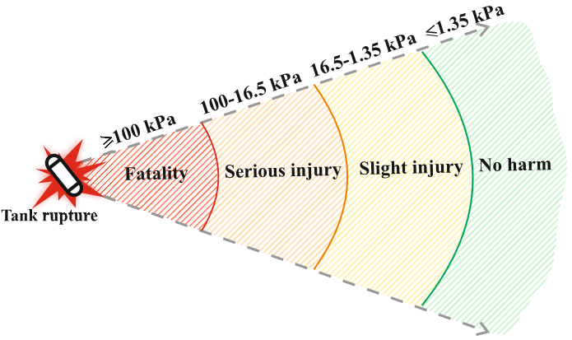

Figure 1. Hazard zones for people based on selected thresholds.

The overpressures 100 kPa and higher are covered by “Fatality zone” (see harm effects in Table 1). People within this zone would get fatal injuries, including lung haemorrhage [14], [15]. The blast wave overpressures in the range from 100 kPa down to 16.5 kPa (1% eardrum rupture [14], [15], as per Table 1) are covered by “Serious injury” zone. The “Slight injury” zone is the zone covering the blast overpressures in the range 1.35-16.5 kPa. The “No-harm” zone or the evacuation perimeter covers overpressures below 1.35 kPa.

## Damage effects on buildings and structures

Three thresholds for building damage were selected based on the criteria described in [5]: “Minor damage” to house structures (4.8 kPa); “Partial demolition” of a house, which turns inhabitable (6.9 kPa); almost “Total destruction” of house (lower overpressure value selected, i.e. 34.5 kPa). Table 2 shows the variety of published damage criteria to structures.

Table 2. Effects on buildings and structures from blast waves.

|  |  |  |  |
| --- | --- | --- | --- |
| **Building/ structure/ element** | **Effects** | $∆P$**, kPa** | $I$**, Pa·s** |
| General structures | Limited minor damage to structures [14], [25] | 2.8 | - |
| Slight damage to structures threshold [17] | 5 | - |
| Repairable damage to structures and facades of dwellings [26], [27] | 6.9-16.55 | - |
| Serious damage to structures [17] | 14 | - |
| Essential damage to structures and processing equipment [26], [27] | 17.24-34.47 | - |
| Domino effect threshold [17] | 20 | - |
| Very serious damage to structures threshold [17] | 30 | - |
| Possible total destruction of building [5] | 69 | - |
| House  [14], [25], [28] | Minor damage to house structures 1 | 4.8 | - |
| Partial demolition of house, turns non-habitable 2 | 6.9 | - |
| Partial collapse of walls and roof of the house | 13.8 | - |
| 50% destruction of brickwork of the house | 17.3 | - |
| Almost total destruction of house 3 | 34.5-48.3 | - |
| Industrial building [5] | Break of the cladding of light industrial building | 27.6 | - |
| Window/ glass | 5% of window frame broken [5] | 0.69-1.0 | - |
| Damage to glass, 10% of panes [26], [27] | 1.03-2.07 | - |
| 50% of window frame broken [5] | 1.45-2.5 | - |
| Damage to glass [26], [27] | 3.45-6.9 | - |
| 90% of window frame broken [5] | 3.7-6.0 | - |
| 50% big windows (from 1.5 m2 to 2.3 m2) breakage [16] | - | 21 |
| 50% small windows (from 0.12 m2 to 0.56 m2) breakage [16] | - | 55 |

Notes: 1 – 4.8 kPa are selected in this study as the “Minor damage” threshold [5]. 2 – 6.9 kPa is selected as the “Partial demolition” threshold [5]. 3 – 34.5 kPa is selected as the lower value for the almost “Total destruction” threshold [5].

The hazard zones for structure damage are shown in Figure 2. It is worth noting that “No damage” zone does not fully exclude damage of building parts. Indeed, there will be no significant building destruction when exposed to overpressures below 4.8 kPa, but slight damage may occur, e.g. glass or window frames breakage [5].

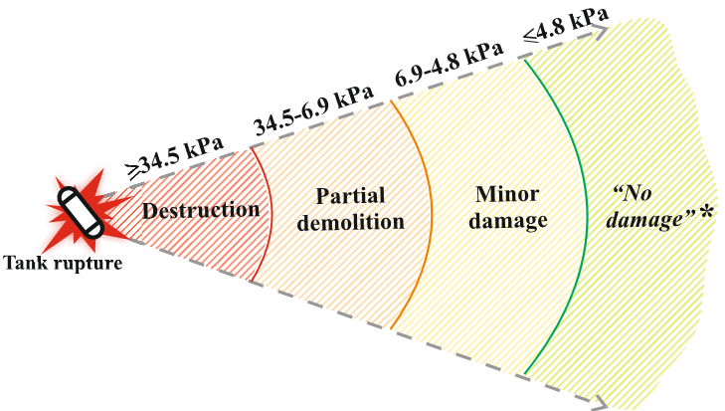

Figure 2. Hazard zones for buildings based on the selected thresholds.   
* - “No damage” zone means no substantial building damage.

# Nomograms

## Model assumptions

The nomograms are built using the blast wave decay model [11]. The model was validated against experiments with rupture of 350 bar under-vehicle tank and 350 bar stand-alone tank in a fire. The mechanical energy of the compressed hydrogen gas is calculated using the Abel-Noble real gas equation of state. The model implies that in the event of tank rupture the wall instantaneously disappears and the starting shock, which represents the highest overpressure in a blast wave, starts to propagate outwardly and heats air by the rapid compression. The blast wave overpressure decays with distance. The non-premixed turbulent combustion of cooled by expansion hydrogen at the contact surface with ambient air, heated by the shock, releases with time the chemical energy that contributes to the blast wave strength (this is slower process compared to the instantaneous release of mechanical energy in the moment of tank rupture). The initial ambient air pressure is atmospheric and the initial temperatures of both, the ambient air and the compressed hydrogen in the vessel are assumed to be 293 K.

Hydrogen will burn in the fireball in a couple of seconds, but only small fraction contributes to the blast wave strength. This is due to the much shorter time of the blast wave decay compared to the fireball existence time. The users of nomograms for stand-alone tank should be informed that nomograms were designed based on the model validated here against tests with 700 bar tanks rupture in a fire (previous study [11] involved validation against tests with 350 bar only). Figure 3 below demonstrates how the blast energy from tank rupture decreases with the presence of vehicle, specifically in the near-field, as compared to the stand-alone tank rupture.



Figure 3. Experiments with 350 bar stand-alone and under-vehicle tanks and predictions by Ulster model obtained in previous study [11].

The vast amount of the blast energy generated after the under-vehicle tank rupture, i.e. predominantly mechanical portion of total energy, is spent to destroy the vehicle and translate its body frame by more than 20 m [13]. This is indiced by decrease of mechanical energy by 15 (!) times. However, the portion of the chemical energy in such case increased from 5.2% to 9% [11].

Table 3 below shows the details of the two experiments [29] that will be used in this study for further validation and implementation in the nomograms.

Table 3. Tests with 700 bar stand-alone tanks’ ruptures [29].

|  |  |  |  |  |
| --- | --- | --- | --- | --- |
| Test, tank type | Tank , bar1 | Tank , L | Hydrogen , K2 | Air , K |
| Test A, Type IV tank | 945.4 | 35 | 379.8 | 282.15 |
| Test B, Type III tank | 994.7 | 36 | 394.2 | 280.15 |

Notes: 1 – the pressure in the tank before rupture increased due to heat transfer from a fire. 2 – the temperature in the tank before rupture increased due to heat transfer from a fire.

The experimental decay of blast wave pressure for these two test and comparison with calculated data with different coefficients for mechanical (a) and chemical energy (b) are shown in Fig.3.

In Test A the measured overpressure at 5 m ($∆P$ =110.5 kPa) is higher than that at 5 m in Test B ($∆P$ =74.3 kPa) by nearly 33%. The far-field overpressures at 10 m in both tests are the same, i.e. $∆P$ =23.4 kPa. It is deemed that such a difference in the first sensor occurred due to the way of tanks’ opening at the moments of rupture. This may have caused directing of the blast towards the sensors and leading to higher overpressure at the first sensor in Test A. The numerical study by Molkov et al. [29] explained the effect of tank opening mode at the moment of rupture. Firstly, in the numerical Test A the tank rupture was represented through instantaneous wall removal, which caused an overpressure of $∆P$ =67.13 kPa at 5 m distance. This is by 39% below the experimental value ($∆P$ =110.5 kPa). Secondly, half of the tank wall in the direction of the sensors was removed from the start of simulation and the other half was removed in 0.7 ms. This initial opening of one half of the tank increased the overpressure by 40%, i.e. $∆P$ =112.64 kPa. The study concluded the importance opening mode effect on the overpressure in the near-field.

To “reproduce” this opening mode effect in the model, the mechanical energy coefficient was doubled from the value characteristic for surface explosion (α=2) to value characteristic for explosion between two adjacent walls located at angle 90o one to another (α=4). With this increased due to boundary conditions (explosion at the surface to explosion between two surfaces) mechanical energy, the contribution of chemical energy to the blast wave strength was sought by inverse problem method through turning calculated pressure decay to experimental one. Figure 4 shows the effect of the chemical energy coefficient on the model reproducibility of Test A pressures (black curves) and Test B pressures (grey curve).

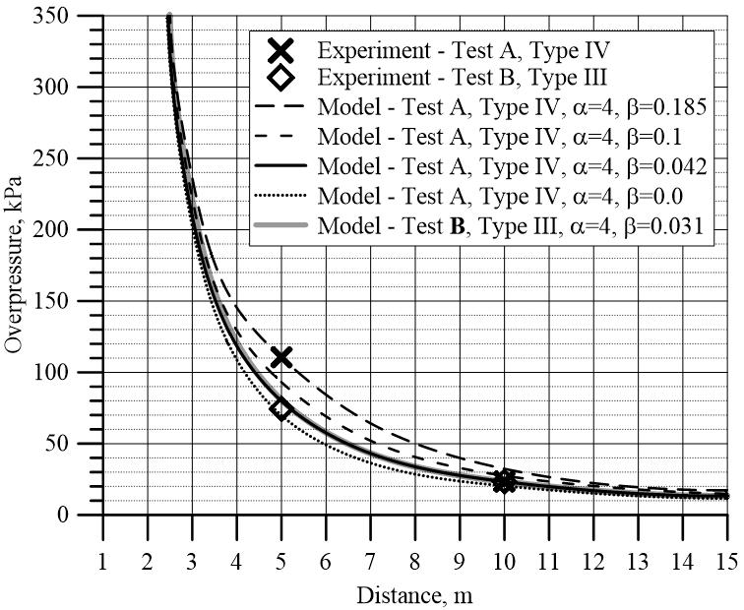

Figure 4. Experimental measurements of blast wave overpressures in Test A and B (symbols) and model predictions of Test A and Test B with $α$ =4 and different coefficients for chemical energy $β$ (curves).

Table 4 shows the model predictions for Test A and deviation from the experiment.

Table 4. Test A (Type IV tank): experiment versus model calculations.

|  |  |  |
| --- | --- | --- |
| Tests details | Overpressures at different distances, kPa | |
| $r$ =5 m | $r$ =10 m |
| Experiment, Test A | 110.5 | 23.4 |
| Model, Test A: $α$ =4, $β$ =0.185 | 110.5 (0%) | 32.58 (+39%) |
| Model, Test A: $α$ =4, $β$ =0.1 | 93.02 (-16%) | 27.36 (+17%) |
| Model, Test A: $α$ =4, $β$ =0.042 * | 79.84 (-28%) | 23.4 (0%) |
| Model, Test A: $α$ =4, $β$ =0.0 | 69.71 (-37%) | 20.29 (-13%) |
| Experiment, Test B | 74.3 | 23.4 |
| Model, Test B: $α$ =4, $β$ =0.031 | 80.55 (+8.4%) | 23.4 (0%) |

Note: * these model coefficients were chosen for the nomograms; symbols (-) and (+) denote the model’s under- and over-prediction compared to the experiment.

To investigate the contribution of the chemical energy for the reproducibility of the highest overpressure in the first experimental point at 5 m (Test A) we implemented the coefficient $β$ =0.185. It gives the exact prediction of the first point, but high over-prediction in the second point at 10 m (39%). Such portion of chemical energy (18.5%) is somewhat below the total amount of burnt hydrogen in the numerical study by Molkov et al [29] (which is about 20%). Although, the amount of burnt hydrogen that actually contributed to the blast wave strength in the numerical study should have been less and its fraction is unknown. In the previous study on the blast wave decay [11] the chemical energy contribution for the stand-alone tank was 5.2% for 350 bar tank, giving the best reproducibility for near- and far-field experimental points.

The authors focus on the reproducibility of rather the second experimental point, i.e. 10 m, as the tank opening mode brings a big uncertainty at the first sensor (5 m) in both tests, A and B. Opening mode vastly affects overpressures at 5 m, as confirmed by numerical study [29]. The far-field sensor at 10 m, however, is much more valuable especially for firefighters and first responders. This is where overpressures for determining the hazard distances are typically assessed, including evacuation perimeter. The far-field overpressures are also very important in context of confined spaces like tunnels. The recent numerical study [30] demonstrated that rupture of a hydrogen tank in a tunnel has a significant overpressure drop (several times) only before the distances of 10-20 m. The overpressure decreases monotonically and is much less steep after these distances, i.e. by the end of the tunnel.

The exact prediction of Test A for the second experimental point at 10 m is for the model coefficients $α$ =4, $β$ =0.042. This chemical energy amount contributing to the blast strength, i.e. 4.2%, is close to the aforementioned 5.2% [11]. The exact prediction of the Test B pressure at location of sensor 10 m is with the close model coefficients, i.e. $α$ =4, $β$ =0.031.

To build the nomograms for first responders and hydrogen safety engineers in this study the authors shall implement the model coefficients with the higher combustion contribution fraction, i.e. $α$ =4, $β$ =0.042, for the reason of conservatism.

It is worth mentioning that the determined by inverse problem method the coefficients for Tests A and B both with tanks at nominal working pressure (NWP) 700 bar, i.e. $α$ =4, $β$ =0.042, are somewhat different from the coefficients for stand-alone tanks with NWP 350 bar, i.e. $α$ =1.8, $β$ =0.052 [1]. The coefficients determined for 700 bar tanks are conservative if applied to 350 bar tanks (see Figure 5).

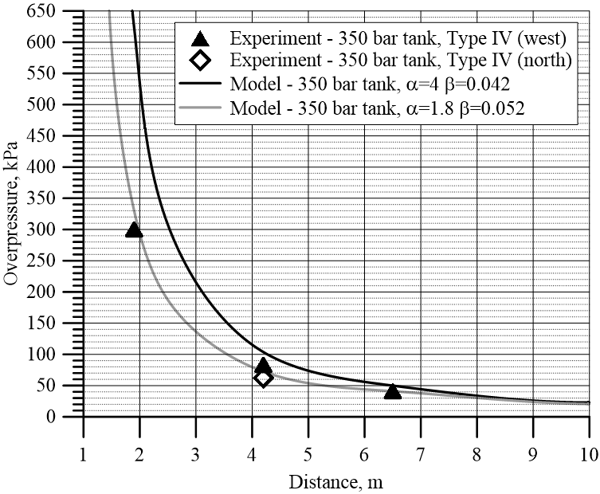

Figure 5. Experimental blast wave pressure decay for stand-alone fire test with 350 bar tank against model predictions with $α$ =4, $β$ =0.042 (for stand-alone tanks with NWP 700 bar, this study) and coefficients $α$ =1.8, $β$ =0.052 (study [11]).

Figure 5 shows that despite of the difference in blast wave peak pressure prediction the near field the difference in the far-field (beyond 8 m) is negligible.

Table 5 shows the model predictions for Test A and deviation from the experiment.

Table 5. Test A (Type IV tank): experiment versus model calculations.

|  |  |  |  |  |
| --- | --- | --- | --- | --- |
| Tests details | Overpressures at different distances, kPa | | | |
| $r$ =1.9 m | $r$ =4.2 m | $r$ =6.5 m | $r$ =10 m |
| Experiment, 350 bar | 300 | 62-83 | 41 | - |
| Model, 350 bar: $α$ =4, $β$ =0.042 | 620.6 (+107%) | 103.3515 (+66.7%; +24.5%) | 49.45 (+17) | 23.30 |
| Model, 350 bar: $α$ =1.8, $β$ =0.052 | 332.3 (+10.8%) | 72.9 (+17.6%;  -12.2%) | 41 (0%) | 20.8 |
| Model predictions’ differences | 288.3 (96%) | 20.35 (37%) | 8.45 (17%) | 2.53 (11%) |

It is shown in Table 5 how the difference between predictions by the model with different coefficients decreases at the far field. The far-field hazard distances are of most importance for estimation of evacuation perimeter, especially in structures like tunnels.

## Nomograms for first responders: stand-alone tank

The nomograms for first responders were built to enable prompt calculation of hazard distances on an accident scene by using the information on a hydrogen storage tank volume and pressure, e.g. by recognition of a vehicle make or records in fire safety plan for storage vessels at refuelling station. Both nomograms, i.e. for hazard distances for humans and hazard distances for structures, are designed for hydrogen storage tank volumes in the range from 10 L (characteristic for bike storage tanks) to 10,000 L (perspective hydrogen refuelling station tanks) and pressures 200 bar, 350 bar, 700 bar and 1000 bar. When hazard distances, e.g. evacuation perimeter, are defined, no other actions with these nomograms are required. The conservative case with NWP 700 bar of a stand-alone tank rupture in a fire is selected to build the nomograms for first responders.

The harm criteria to people and damage criteria to structures are selected by the authors from the reviewed variety of overpressure/impulse thresholds across the literature sources from different countries. The harm criteria to people are selected from the thresholds in the UK and the USA sources. The damage criteria to buildings are mainly adopted from the thresholds of the UK sources. It should be noted that harm criteria in Japan are also adopted from the USA and the UK [15] sources.

The selected overpressure/impulse thresholds and associated harm/damage criteria are used in this study for assessment of hazard distances for humans and buildings for the first responders' nomograms. These nomograms, therefore, were built to find hazard distances to the pre-defined by the authors harm and damage criteria. The authors do not take any responsibility for the choice of harm and damage criteria and its use in safety engineering of hydrogen systems and infrastructure and in actions by first responders.

For the reader’s remark, overpressures and/or impulses of “equivalent” harm effects collected from different sources from a number of countries diverge significantly. It shall be further highlighted that criteria for harm to people and damage to structures across different countries are highly desirable to be more consistent.

A hydrogen refuelling station may host several hydrogen storage vessels, the volume of which may be for example 300 L each, and the storage pressure may be as high as 1000 bar. This example is graphically presented in the nomograms below for the stand-alone tank (see Figure 6 and Figure 7). Figure 6 shows the nomogram for the stand-alone tank rupture to graphically identify the hazard distances for the selected harm criteria to people. Figure 7 shows the nomogram to identify hazard distances for buildings.

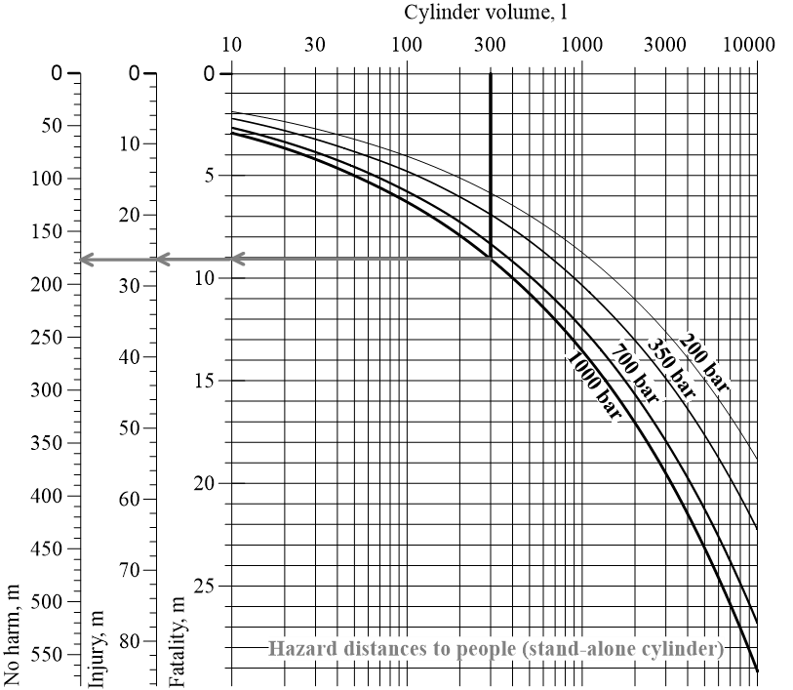

Figure 6. Hazard distances for people nomogram for first responders (stand-alone tank rupture).

The nomograms must be used as follows. First select cylinder volume on upper horizontal axis and then draw a vertical line downwards to the relevant hydrogen storage pressure curve (shown in Figure 6 and Figure 7 by the black bold vertical lines for the selected example of cylinder volume 300 L and pressure 1000 bar). Then, from that intersection with storage pressure curve draw a horizontal line to the left (examples are shown as the grey bold arrows) towards three hazard distances axes that define “Fatality”, “Injury” and “No harm” thresholds in Figure 6, and for “Total destruction”, “Partial demolition” and “Minor damage” thresholds in Figure 7. The intersection with each axis on the left provides the corresponding hazard distance in meters. Figure 6 shows that for the 300 L and 1000 bar tank the “Fatality” zone is up to 9 m (the first grey arrow drawn from the intersection with the pressure curve); the “Injury” distance is nearly 26.2 m (thus, the “Serious injury” zone is from 9 m to 26.2 m); the “No-harm” distance is about 167 m, i.e. “Slight injury” zone extends in the range 26.2-176 m, and the peoples’ no harm zone, i.e. zone beyond the “No-harm” threshold or evacuation perimeter is outside 176 m radius from the cylinder.

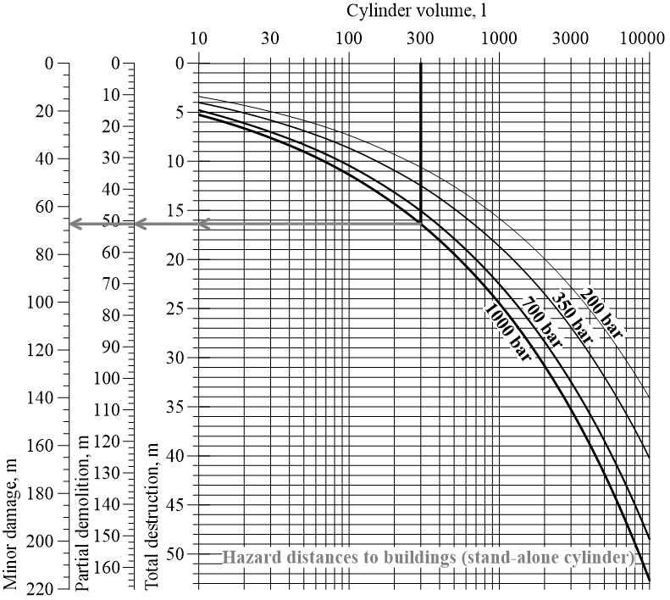

Figure 7. Hazard distances for damage to buildings nomogram for first responders (stand-alone tank rupture).

Similarly, in Figure 7 we obtain the “Total destruction” of buildings within about 16.4 m, partial demolition in the zone from 16.4 m to 51.3 m, minor damage in the range of distances 51.3-67.3 m, and “No damage” beyond the radius of 67.3 m.

## Nomograms for safety engineers: stand-alone tank

The nomograms for hydrogen safety engineers are designed using the pressure-impulse diagrams [24]. Blast overpressure and impulse are used as input values in the direct problem of hazard distance estimation, where particular overpressure or impulse are reached for selected tank volume and pressure. These nomograms provide flexibility for assessment of storage parameters based on a required distance to harm for people or damage to buildings in the inverse problem. Hazard distance from the tank, e.g. “No harm” distance or evacuation perimeter, can be defined by threshold pressure and impulse in national or international regulations, codes and standards (RCS). In the inverse problem the nomograms can be used for defining the harm and damage effects at pre-defined by RCS distances, substantiation of which is not known in most of the cases or untrackable.

The nomograms for hydrogen safety engineering in the case of stand-alone tank rupture in a fire are shown in Figure 8 and Figure 9. One way to use them (direct problem) is to select the overpressure and impulse of interest (as per harm and damage criteria adopted from [24] or other sources) and then define a hazard distance for a tank of particular volume and storage pressure. Another way (inverse problem) is to select the distance from the tank position and then to find the corresponding overpressure and impulse values. The nomograms are shown in Figure 8 and Figure 9 (grey arrowed lines for the direct problem and black lines for the inverse problem are shown).

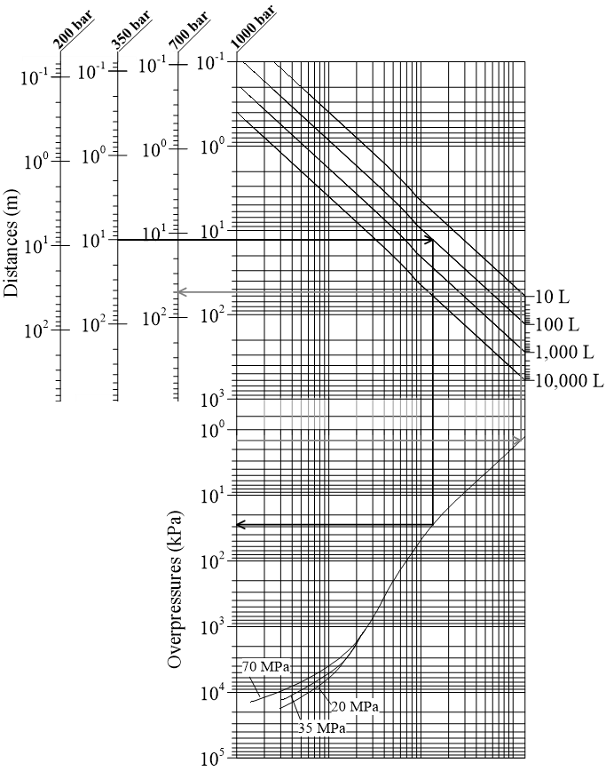

Figure 8. Overpressure-distance nomogram for blast wave from a stand-alone hydrogen tank rupture in a fire for hydrogen safety engineers.

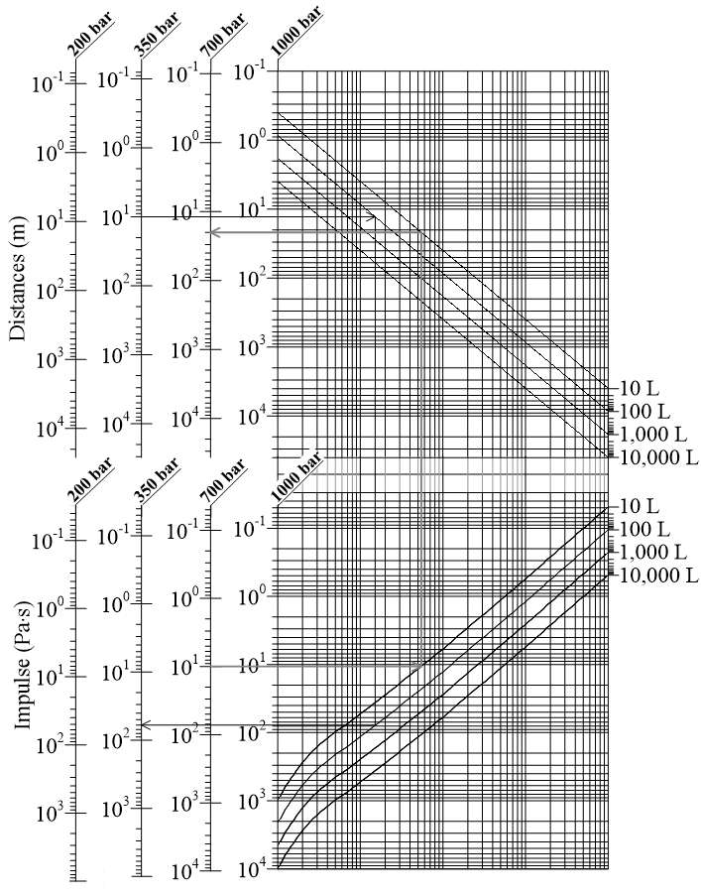

Figure 9. Impulse-distance nomogram for blast wave from a stand-alone hydrogen tank rupture in a fire for hydrogen safety engineers.

Let us consider blast wave from rupture of a stand-alone tank of 10 L volume and 700 bar pressure (typical parameters for a motorbike storage tank). To find out the evacuation perimeter, i.e. “No harm” distance, let us first select an overpressure harm threshold in a blast wave for “No harm” distance, i.e. 1.35 kPa [16], and draw a line from the “Overpressure” axis (horizontal grey arrowed line directed right in Figure 8) until a storage pressure black curve. Then, the vertical line is drawn upwards until the volume curve of interest (volume 10 L is taken for this example). Shall the volume be selected, the final horizontal line must be drawn to the left until the “Distance” axes with assigned needed storage pressure (read the labels on the top). The grey arrow in the example shows the distance identified that is about 50 m. For any intermediate volume value, such as for instance 30 L, an additional curve parallel to the closest existing volume curve in upper part of the nomogram (Figure 8) must be plotted by the user using the scale divisions between volume curves on the right-hand side of the nomogram.

The nomograms can be used to determine an overpressure and impulse at a distance of interest, as per the example of 10 m distance and the 100 L and 350 bar pressure tank shown with black arrows in Figure 8 and Figure 9. The user should define the tank pressure by selecting the assigned to this pressure vertical left upper axis (350 bar in this case) and draw a horizontal line from mark 10 m to the right till the volume curve. Once the volume is chosen (100 L in our example), the line is drawn downwards till the pressure curve (Figure 8) or volume curve (Figure 9) – depending on which nomogram is used. From intersection with that curve, another horizontal line is drawn to the left axis defining “Overpressure” (Figure 8) or “Impulse” (the axis assigned to the same tank pressure is selected in Figure 9). The identified value of blast wave overpressure at 10 m after tank rupture in a fire is about 28 kPa and the impulse is about 62 Pa.s. Figure 10 (left) shows the point with the same overpressure and impulse, which is in the serious injury zone for the selected in this study harm criteria for outdoor person location (above 16.5 kPa). This overpressure is also above a harm for indoor people, i.e. 100% vulnerability for wood and steel-frame buildings [23]. Figure 10 (right) shows that a civil structure located at 10 m from the ruptured tank is beyond the “Total destruction” threshold [5] (vertical dash lines).

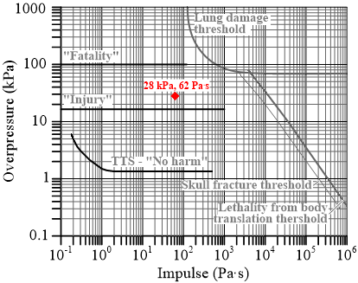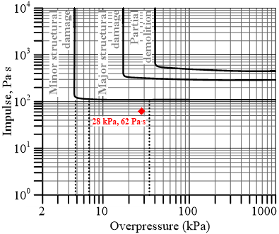

Figure 10. Overpressure-impulse thresholds of: left - harm criteria for humans, and right – damage for buildings [14], [15], [24].

It should be noted that the distances obtained by using the overpressure-distance nomogram only or by impulse-distance nomogram only may differ. If the applied harm criterion includes overpressure and impulse combination, the user should exploit both nomograms, i.e. shown in Figure 8 and Figure 9. When two distances are found using the overpressure-distance and impulse-distance nomograms, the user should pick the distance that will include both, minimum required overpressure and impulse. For the reason of conservatism in safety provisions, the longer distance can be considered as acceptable in safety design.

## Nomograms for first responders: under-vehicle tank rupture in a fire

The rupture of an onboard hydrogen tank located under-vehicle produces lower overpressures in a blast wave in the near field compared to the case of rupture of stand-alone tank of the same volume and pressure. Unfortunately, there is no experimental data for a far-field, which are needed for the model validation and firm recommendations for safety engineers. This difference in the near field is due to losses of a significant part of the compressed hydrogen mechanical energy in the onboard tank on the vehicle destruction and its translation, e.g. by 22 meters in the USA test with 350 bar tank. The estimated difference in fractions of mechanical energy contributed to the blast wave strength for stand-alone and onboard tanks is 1.8/0.12=15 times [1]. At the same time, this reduction of the mechanical energy is practically “compensated” in a far-field by nearly doubling of the fraction of chemical energy, which is released during combustion (350 bar tanks) slower compared to instantaneous release of mechanical energy at the moment of tank rupture [11].

The nomograms in Figure 11 and Figure 12 allow calculation of hazard distances from a blast wave generated by the under-vehicle onboard tank rupture in a fire. For the under-vehicle 350 bar tank rupture case, the fractions of total mechanical and chemical energy that contribute to the blast wave are $α$ =0.12 and $β$ =0.09 respectively, i.e. significantly different compared to the stand-alone tank case when $α$ =1.8 and $β$ =0.052 [11] and coefficients used in this study, i.e. $α$ =4 and $β$ =0.042. It should be noted, that these fractions can differ depending on a tank size and internal pressure as well as vehicle weight, size and safety design. More experimental data and their analysis are needed to improve the nomograms’ predictive capability. The nomograms demonstrate the calculation of hazard distances to people (Figure 11) and buildings (Figure 12) for under-vehicle storage tank of volume 60 L and pressure 700 bar [31].

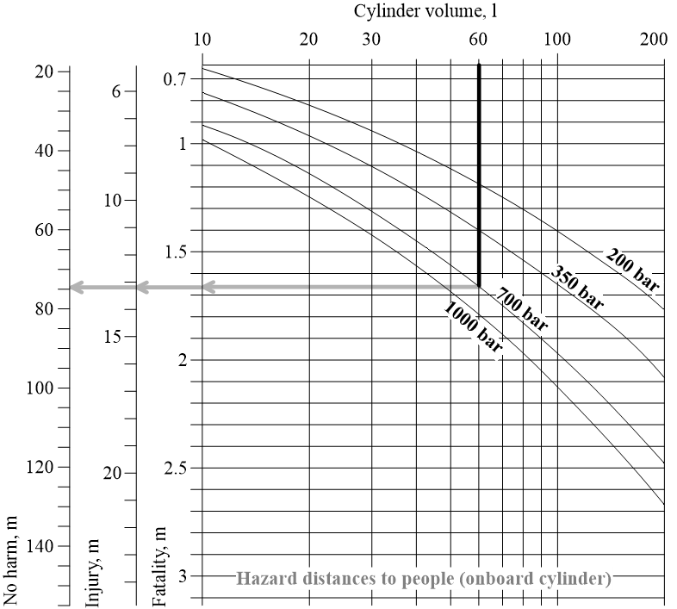

Figure 11. Nomograms for hazard distances to people from a blast wave after onboard (under-vehicle) tank rupture in a fire (example of tank 60 L, 700 bar) for first responders.

When using the nomogram in Figure 11, the “Fatality“ distance can be calculated as almost 1.7 m (conservative estimate); the “Injury” distance as 13.2 m; the “No harm” distance as about 75 m.

Figure 12 gives the distance to the total building destruction criterion 8.2 m, partial demolition distance 24.8 m and minor damage distance 31 m for the same application (60 L and 700 bar pressure under-vehicle tank).

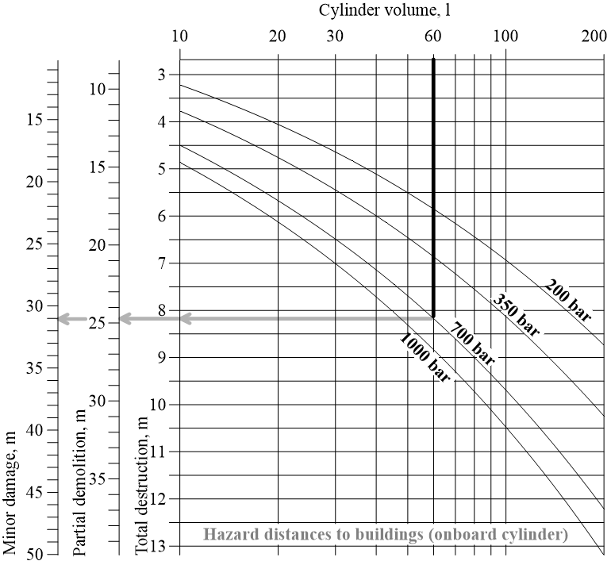

Figure 12. Nomograms for hazard distances to buildings from a blast wave after onboard (under-vehicle) tank rupture in a fire (example of tank 60 L, 700 bar) for first responders.

## Nomograms for safety engineers: under-vehicle tank rupture in a fire

Figure 13 and Figure 14 represent two nomograms for determination of hazard distances and blast wave characteristics from onboard tank rupture. The selected example of hydrogen storage application of 60 L volume and 700 bar storage pressure [31] is shown with arrowed lines.

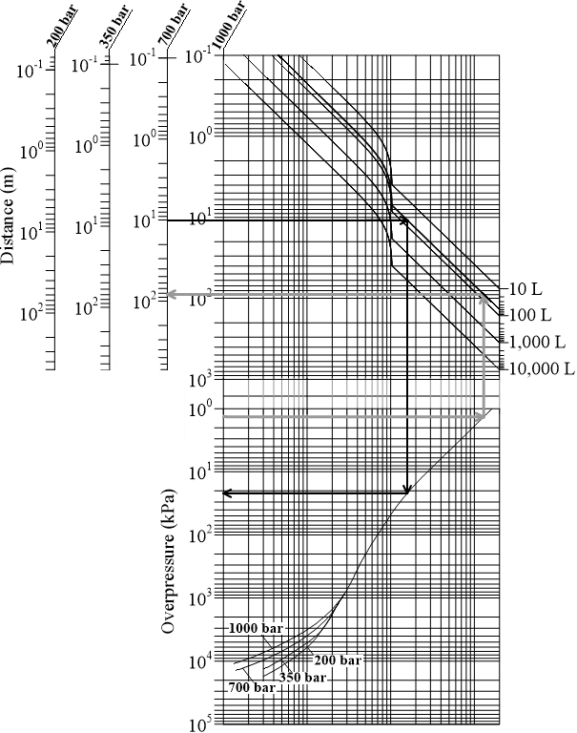

Figure 13. Nomogram for overpressure in a blast wave from an onboard (under-vehicle) tank rupture in a fire for hydrogen safety engineers.

An example of using the nomogram in Figure 13 is as follows. To find an overpressure from the application under consideration, i.e. 60 L and 700 bar under-vehicle tank, the “additional” volume curve for 60 L is drawn (parallel to 100 L curve) in Figure 13. It is deduced in the graph with the black arrowed lines that the overpressure at the distance of 10 m is 22 kPa.

Let us find the evacuation perimeter (“No harm” hazard distance threshold, or temporary shift threshold for hearing [24]), i.e. distance where the blast wave overpressure drops to 1.35 kPa. First, we have to draw an arrowed grey line from 1.35 kPa to the right until intersection with the pressure curve. Then, the line is continued upwards till intersection with the new-built 60 L volume curve in the upper part of the nomogram. Afterwards we draw the horizontal line to the left until intersection with the axis “700 bar”. Hence, we obtain the evacuation perimeter of 82 m. This value somewhat (by 9%) differs from the value 75 m obtained for the same tank using the nomogram in Figure 14. The difference is within acceptable 10% error, which is characteristic for graphical engineering tools. The similar procedure and example are applied to the impulse nomogram (see Figure 14).

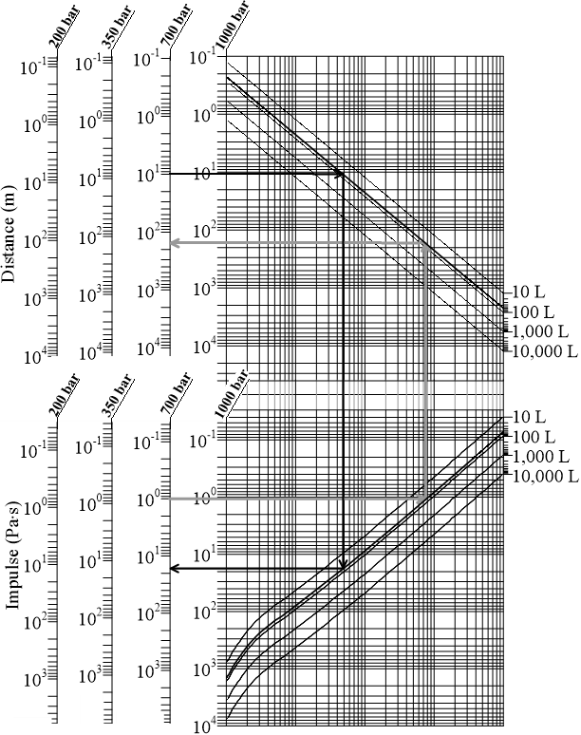

Figure 14. Nomogram for impulse in a blast wave from an onboard (under-vehicle) tank rupture in a fire for hydrogen safety engineers.

# HAZARD DISTANCES: effect of national harm criteria

Hazard distances for people and buildings depend on harm or damage criteria and these criteria vary across countries. Table 6 shows the difference in hazard distances from rupture of a stand-alone 300 L and 1000 bar tank at refuelling station due to the difference in harm criteria.

Table 6. Hazard distances to people from blast wave after the rupture in a fire of 300 L and 1000 bar stand-alone hydrogen tank.

|  |  |  |  |
| --- | --- | --- | --- |
| **Country** | **Effects** | $∆P$***,* kPa** | **Distance, m** |
| **Eardrum rupture** | | | |
| UK [18] | Eardrum rupture threshold | 13.8 | 29.8 |
| UK [14], [15] | 1% eardrum rupture probability | 16.5 | 26 |
| USA [16] | 1% eardrum rupture probability | 23 | 21 |
| USA [20]–[22] | Eardrum rupture | 34.47 | 16.4 |
| **Fatality** | | | |
| UK | Possible fatality by projection against obstacles [18] | 13.8 | 29.8 |
| 1% fatality [19] | 25-35 | 16.3-20 |
| France [17] | Fatality threshold from “grave danger” | 14 | 29.4 |
| USA | Fatal head injury [20]–[22] | 55.16 | 12.8 |
| 1% fatality probability due to lung haemorrhage [14], [15] | 100 | 9 |

The evaluation was performed using the harm criteria from the UK, France, and the USA. It can be seen from Table 6 that UK and USA sources gave different values of “Eardrum rupture” distances, e.g. the UK’s “1% eardrum rupture probability” and USA’s “1% eardrum rupture probability” thresholds were selected by the authors for the comparison. The obtained hazard distances are 26 m and 21 m respectively. If comparing the UK’s “Eardrum rupture threshold” with USA’s “Eardrum rupture” criterion, the difference in hazard distances increases - 29.8 m and 16.4 m respectively.

The “Fatality” thresholds from the UK, France and the USA are quite different and can hardly be accepted as are comparable due to the impact type, e.g. projection of body against obstacles, head injury, lung haemorrhage, etc. However, Table 6 demonstrates that such criteria as in the UK (projection against obstacles) [18] and in France (fatality from “grave danger”) [17] provide very similar hazard distances, i.e. 29.8 m and 29.4 m with just 1% difference. The higher overpressure range for 1% fatality for people outdoors defined by the UK Health and Safety Executive gives the hazard distances 16.3-20 m which are about 1.5-1.8 times shorter than those in the UK defined by the projection against obstacles, and in France. The USA criteria have also several natures for “Fatality” threshold, e.g. head injury [20]–[22] and lung haemorrhage [14], [15] giving the distances that differ drastically, especially if compared to the UK distance defined by the projection against obstacles.

The damage criteria to structures in different countries were also gathered and applied to compare hazard distances. The British and French damage criteria together with calculated using them hazard distances are presented in Table 7.

Table 7. Damage criteria and hazard distances to buildings from a blast wave after tank rupture in a fire: 300 L, 1000 bar stand-alone hydrogen tank example.

|  |  |  |  |
| --- | --- | --- | --- |
| **Country** | **Effects** | $∆P$**, kPa** | **Distance, m** |
| **Minor damage to structures** | | | |
| UK [25], [28] | Minor damage to house structures | 4.8 | 64 |
| France [17] | Slight damage to structures | 5 | 65 |
| **Total destruction** | | | |
| France [17] | Very serious damage to structures | 30 | 17.8 |
| UK [25], [28] | Almost total destruction of house | 34.5-48.3 | 13.7-16.4 |

The difference in hazard distances for structures is not as large as it was observed for people. The “Minor damage” distances differ by about 2% (see Table 7). The hazard distance according to the criteria in France is 65 m following the “Slight damage to structures threshold” [17], and the UK is nearly 64 m following “Minor damage to house structures” criterion [25], [28].

The “Total destruction” hazard distance following the “Very serious damage to structures” threshold [17] accepted in France is 17.8 m. This is somewhat longer than the range of distances 13.7-16.4 m by nearly a quarter, as assessed using the UK criterion “Almost total destruction of house” [25], [28].

# CONCLUSIONS

The paper presents the contemporary engineering tools for determination of hazard distances by the strength of a blast wave decaying after a high-pressure hydrogen storage tank rupture in a fire. The tools are presented in the form of two types of nomograms for graphical estimation of hazard distances. The first type is for prompt estimation of hazard distances by first responders at an accident scene. The second type of nomograms is for hydrogen safety engineers with the flexibility to choose criteria defining harm for people and damage for buildings, based on the national regulation, codes and standards. The availability of the nomograms to different groups of stakeholders underpins development and deployment of inherently safer hydrogen systems and infrastructure around the globe. These engineering tools will provide the wider use of safety engineering design within hydrogen and fuel cells community, especially hydrogen systems and storage solution developers. This defines the significance of this work.

The originality of this study is in the derivation of easy to use hydrogen safety engineering tools from the validated further theory of blast wave accounting for the contribution of hydrogen combustion at contact surface with air into the blast wave strength [1]. The Ulster’s model, which has been expanded by the validated new experiments with 700 bar stand-alone hydrogen storage tanks, is used in this work to build the engineering nomograms. The nomograms can easily provide an overpressure and an impulse in a blast wave at different locations from an accident epicentre. Based on our previous work [1] and this study it can be concluded the coefficients for calculation of blast wave decay after tank rupture in a fire are $α$ =4, $β$ =0.042 for composite tanks with NWP 700 bar, and $α$ =1.8, $β$ =0.052 for tanks with NWP 350 bar. The coefficients determined here for 700 bar tanks are conservative if applied to 350 bar tanks in the near field and define the same blast wave overpressure in a far-field.

The rigour of this study is in the provision of the nomograms covering all typical scenarios of hydrogen tank rupture in a fire, i.e. stand-alone (e.g. at a refuelling station, bus with tanks located on roof, or turned over at the accident vehicle) and onboard (under-vehicle), e.g. fuel cell car. The nomograms for safety engineers allow choosing harm and damage criteria following national RCS and include all features of the model [11]. The tools’ users must be aware of the environment around accident scene, e.g. confined space or any obstructions nearby that could affect human, to properly apply harm to people or damage to buildings criteria.

The added value of this study is paving the way for international harmonisation of harm to people and damage to buildings criteria for pressure effects from high-pressure storage tank rupture in a fire.

# acknowledgements

The work was supported by the Project “HYLANTIC”–EAPA_204/2016 which is co-financed by the European Regional Development Fund in the framework of the Interreg Atlantic programme. The work was also supported by Zhejiang Provincial Natural Science Foundation of China under (Grant No. LY18G030024), and Ministry of Education of the People’s Republic of China (Foundation for Humanities and Social Science under Grant No. 17YJCZH099).

# REFERENCES:

[1] United Nations Economic Commission for Europe, “Global Registry. Addendum 13: Global technical regulation No. 13. Global technical regulation on hydrogen and fuel cell vehicles.,” UNECE, 2013.

[2] M. Dadashzadeh, S. Kashkarov, D. Makarov, and V. Molkov, “Risk assessment methodology for onboard hydrogen storage,” *Int. J. Hydrog. Energy*, vol. 43, no. 12, pp. 6462–6475, Mar. 2018.

[3] Today, “Caught on Camera: Natural-gas powered garbage truck explodes,” *Today*, 2016. [Online]. Available: https://www.today.com/video/caught-on-camera-natural-gas-powered-garbage-truck-explodes-609780803613. [Accessed: 01-Jun-2019].

[4] NJ, “WATCH: Garbage truck explodes in fireball, rips hole in nearby house,” *NJ.com*, 2019. [Online]. Available: https://www.nj.com/mercer/2016/01/garbage_truck_explosion_damages_hamilton_house.html. [Accessed: 01-Jun-2019].

[5] V. Molkov, D. Makarov, and S. Kashkarov, “Composite Pressure Vessel for Hydrogen Storage,” PCT International Application P119851PC00, 2017.

[6] S. Brennan and V. Molkov, “Safety assessment of unignited hydrogen discharge from onboard storage in garages with low levels of natural ventilation,” *Int. J. Hydrog. Energy*, vol. 38, no. 19, pp. 8159–8166, 27 2013.

[7] H. G. Hussein, S. Brennan, V. Shentsov, D. Makarov, and V. Molkov, “Numerical validation of pressure peaking from an ignited hydrogen release in a laboratory-scale enclosure and application to a garage scenario,” *Int. J. Hydrog. Energy*, vol. 43, no. 37, pp. 17954–17968, Sep. 2018.

[8] D. Makarov, V. Shentsov, M. Kuznetsov, and V. Molkov, “Pressure peaking phenomenon: Model validation against unignited release and jet fire experiments,” *Int. J. Hydrog. Energy*, vol. 43, no. 19, pp. 9454–9469, May 2018.

[9] V. Shentsov, W. Kim, D. Makarov, and V. Molkov, “Numerical simulations of experimental fireball and blast wave from a high-pressure tank rupture in a fire,” presented at the Proc. of the Eighth International Seminar on Fire & Explosion Hazards (ISFEH8), Hefei, China, 2016.

[10] V. Shentsov, D. M. C. Cirrone, D. Makarov, and V. Molkov, “Simulation of fireball and blast wave from a hydrogen tank rupture in a fire,” in *7th International Symposium on Non-equilibrium Processes, Plasma, Combustion, and Atmospheric Phenomena*, Sochi, Russia, 2016.

[11] V. Molkov and S. Kashkarov, “Blast wave from a high-pressure gas tank rupture in a fire: Stand-alone and under-vehicle hydrogen tanks,” *Int. J. Hydrog. Energy*, vol. 40, no. 36, pp. 12581–12603, Sep. 2015.

[12] N. Weyandt, “Analysis of Induced Catastrophic Failure Of A 5000 psig Type IV Hydrogen Cylinder,” Southwest Research Institute report for the Motor Vehicle Fire Research Institute, 01.06939.01.001, 2005.

[13] N. Weyandt, “Vehicle bonfire to induce catastrophic failure of a 5,000-psig hydrogen cylinder installed on a typical SUV,” Southwest Research Institute report for the Motor Vehicle Fire Research Institute, 2006.

[14] S. Mannan, *Lees’ Loss Prevention in the Process Industries*, 3rd ed., vol. 1. Elsevier Butterworth-Heinemann, 2005.

[15] L. E. Fugelso, L. M. Weiner, and T. H. Schiffman, “Explosion effects computation aids,” Gen. Am. Div., Gen. Am. Transportation Co., Niles, Illinois, US, GARD Prog. 1540, 1972.

[16] NFPA, “NFPA® 2, Hydrogen Technologies Code,” Batterymarch Park, Quincy, MA 02169-7471, NFPA® 2, 2011.

[17] Ministère de l’Interieur, “NIO Risque hydrogène,” *interieur.gouv.fr*, 2013. [Online]. Available: http://www.interieur.gouv.fr/Le-ministere/Securite-civile/Documentation-technique/Les-sapeurs-pompiers/Doctrines-et-techniques-professionnelles/Notes-operationnelles. [Accessed: 10-Dec-2015].

[18] R. M. Jeffries, S. J. Hunt, and L. Gould, “Derivation of fatality probability function for occupants buildings subject to blast loads,” WS Atkins Science & Technology, Contract research report for HSE 147/1997, 1997.

[19] Health and Safety Executive, “Methods of approximation and determination of human vulnerability for offshore major accident hazard assessment.” Supporting document to SPC (SPC/Tech/OSD/30, version 3), 2010.

[20] AIChE Center for Chemical Process Safety, “Guidance for Consequence Analysis of Chemical Releases,” Center for Chemical Process Safety, American Institute of Chemical Engineers, New York: American institute of Chemical Engineers, 1999.

[21] CCPS, “Guidelines for Evaluating the Characteristics of Vapour Cloud Explosions, Flash Fires and BLEVEs,” New York: American institute of Chemical Engineering, 1994.

[22] Federal Emergency Management Agency, “Handbook of Chemical Hazard Analysis Procedures,” Washington, D.C., 1987.

[23] API, “Management of hazards associated with location of process plant buildings,” American Petroleum Institute, Washington D.C., API Recommended Practice 752, 1995.

[24] W. E. Baker, P. A. Cox, P. S. Westine, J. J. Kulesz, and R. A. Strehlow, *Explosion hazards and evaluation*. Elsevier Scientific Publishing Company, 1983.

[25] V. J. Clancey, “Diagnostic features of explosion damage,” presented at the Sixth Int. Mtg of Forensic Sciences, Edinburgh, UK, 1972.

[26] T. F. Barry, *Risk-Informed, Performance-Based Industrial Fire Protection*, 1st ed. USA: Tennessee Valley Publishing, 2002.

[27] Technica Ltd., “Techniques for assessing industrial hazards,” Washington, D.C., World Bank Technical Paper Number 55, 1988.

[28] Health and Safety Executive, “The Peterborough Explosion. A report of the investigation by the Health and Safety Executive into the explosion of a vehicle carrying explosives at Fengate Industrial Estate, Peterborough on 22 March 1989.,” 1990.

[29] V. Molkov, D. Cirrone, V. Shentsov, W. Dery, W. Kim, and D. Makarov, “Blast wave and fireball after hydrogen tank rupture in a fire,” in *Advances in pulsed and continuous detonations*, 2018.

[30] V. Shentsov, D. Makarov, and W. Dery, “Stand-Alone Hemisphere-Tank Rupture in Tunnel Fire: Effect of Hydrogen Inventory on Blast Wave Strength in Far Field,” in *Proc. of the Ninth International Seminar on Fire & Explosion Hazards (ISFEH9)*, St. Petersburg, Russia, 2019.

[31] A. Yamashita, M. Kondo, S. Goto, and N. Ogami, “Development of High-Pressure Hydrogen Storage System for the Toyota ‘Mirai,’” *SAE Tech. Pap.*, 2015.