Manuscript Details

Manuscript number JTV_2019_87_R1

Title Seated Buttocks Anatomy and its Impact on Biomechanical Risk

Article type Research Paper

Abstract
Aim: The objective of this study was to describe the amount, types, and shapes of tissue present in the buttocks during sitting (i.e., seated buttocks soft tissue anatomy), and the impact of seated buttocks soft tissue anatomy on biomechanical risk. Materials and Methods: The buttocks of 35 people, including 29 full-time wheelchair users with and without a history of pelvic pressure ulcers were scanned sitting on flat foam in a FONAR Upright MRI. Multi-planar scans were analyzed to calculate bulk tissue thickness, tissue composition, gluteus maximus coverage at the ischium, the contour of the skin, and pelvic tilt. Results: Bulk tissue thickness varied from 5.6 to 32.1 mm, was composed mostly of adipose, and was greatest in the able-bodied cohort. Skin contours varied significantly across status group, with wheelchair users with a history of pressure ulcers having tissue with a peaked contour that wrapped more closely to the ischium. Finally, the majority of participants presented with little to no gluteus coverage over their ischial tuberosity, regardless of status group. Conclusions: This study provides quantitative evidence that Biomechanical Risk, or the intrinsic characteristic of an individual's soft tissues to deform in response to extrinsic applied forces, is greater in individuals at greater risk for pressure ulcers.

Keywords Pressure ulcer MRI Buttocks Tissue deformation Biomechanical Risk Contour

Corresponding Author Sharon Sonenblum

Corresponding Author's Institution
Georgia Institute of Technology

Order of Authors:Sharon Sonenblum, Davin Seol, Stephen Sprigle, John Cathcart

Highlights
  - Bulk tissue thickness under the seated ischium varied from 5.6-32.1mm.
  - Wheelchair users with a pressure ulcer history have more peaked buttocks contours
  - Most people do not have gluteus maximus covering their ischial tuberosity

Title: Seated Buttocks Anatomy and its Impact on Biomechanical Risk

Authors:
Sharon E. Sonenblum
Corresponding Author

Rehabilitation Engineering and Applied Research Laboratory The George W. Woodruff School of Mechanical Engineering Georgia Institute of Technology
801 Atlantic Dr.
Office 026
Atlanta, Georgia 30332-0280
404-385-0633
ss427@gatech.edu

Davin Seol
dseol7@gatech.edu

Stephen H. Sprigle
Rehabilitation Engineering and Applied Research Laboratory
College of Design and The George W. Woodruff School of Mechanical Engineering Georgia Institute of Technology
801 Atlantic Dr.
Lab 027
Atlanta, Georgia 30332-0280 stephen.sprigle@design.gatech.edu

John McKay Cathcart DMed.Sc, MSc, PgD, DCR(R)

Lecturer in Diagnostic Radiography Room 17J10
School of Health Sciences Ulster University
Shore Road Jordanstown Newtownabbey County Antrim Northern Ireland BT38 0QB
+44(0)2890368192
j.cathcart@ulster.ac.uk

Funding

This study was completed as part of the Mobility RERC (grant H133E080003) and a Field Initiated Project (grant 90IF0120-01-00), which were funded by the National Institute on Disability, Independent Living, and Rehabilitation Research (NIDILRR). This work was also supported by donations from Ride Designs and the Robert H. Graebe Foundation.

Acknowledgements:
The authors acknowledge and thank the clinical team, Kelly Waugh, PT, MAPT, ATP, Mary Shea, MA, OTR, ATP, and Trevor Dyson-Hudson, PhD for their efforts collecting high quality data for this study. The authors also acknowledge the contributions of John Greenhalgh, PhD from Fonar, Corp. for his contributions of time and effort with MRI protocol development and data collection. Finally, the authors also acknowledge our research participants, who contributed their time, along with patience and enthusiasm, and without whom this work could not have been completed.

Seated Buttocks Anatomy and its Impact on Biomechanical Risk of Pressure Ulcers

Abstract
Aim: The objective of this study was to describe the amount, types, and shapes of tissue present in the buttocks during sitting (i.e., seated buttocks soft tissue anatomy), and the impact of seated buttocks soft tissue anatomy on biomechanical risk.
Materials and Methods: The buttocks of 35 people, including 29 full-time wheelchair users with and without a history of pelvic pressure ulcers were scanned sitting upright on 3” of flat HR45 foam in a FONAR Upright MRI. Multi-planar scans were analyzed to calculate bulk tissue thickness, tissue composition, gluteus maximus coverage at the ischium, the contour of the skin, and pelvic tilt.
Results: Bulk tissue thickness varied from 5.6 to 32.1 mm, was composed mostly of adipose tissue, and was greatest in the able-bodied cohort. Skin contours varied significantly across status group, with wheelchair users with a history of pressure ulcers having tissue with a peaked contour with a radius of curvature of 65.9mm that wrapped more closely to the ischium (thickness at the apex = 8.2mm) as compared to wheelchair users with no pressure ulcer history (radius of curvature = 91.5 mm and apex thickness = 14.5 mm). Finally, the majority of participants presented with little to no gluteus coverage over their ischial tuberosity, regardless of status group.
Conclusions: This study provides quantitative evidence that Biomechanical Risk, or the intrinsic characteristic of an individual's soft tissues to deform in response to extrinsic applied forces, is greater in individuals at greater risk for pressure ulcers.

Introduction
Wheelchair users at risk of pressure ulcers include a disparate list of medical diagnoses such as spinal cord injury and disease (SCI/D), multiple sclerosis, cerebral palsy, spina bifida, and other neurological and orthopedic conditions that impact mobility and sensation (1). For example, more than 50% of people with SCI/D develop a pressure ulcer during their lifetimes (2, 3). A pressure ulcer cannot occur in the absence of pressure, but many risk factors including heat, humidity and shearing, to name a few, significantly add to a person’s risk profile. This combination of extrinsic risk factors is transmitted inside the body in order to damaged internal tissue and lead to the development of a pressure ulcer. When external pressure is translated to muscle, adipose tissue, and connective tissues, those tissues deform, or change shape, which brings about pathophysiologic responses including reduced blood flow, impaired lymphatic drainage, and mechanical cell damage (4, 5). Each of these potential mechanisms of damage involve tissue deformation (6-8). Therefore, understanding what tissues are present and how individuals’ tissues deform is key to identifying high-risk patients and informing personalized interventions.

To date, limited work has been done investigating the seated buttocks anatomy. Back in 1985, Dhami and colleagues immersed participants in clay to study the contour and immersion of participants’ ischial region and determined that participants with paraplegia and a history of pressure ulcers had a sharper prominence and a greater impression depth in the clay than those without a history of pressure ulcers. Studies by Brienza, et al., and Call, et al., and Sonenblum, et al. investigated tissue under the ischium in small cohorts and provided measurements of tissue thickness that begin to frame a picture of how individuals sit (9-11), while recent ultrasound studies look into a modified seated posture using a different tool (12-14). Along with Wu 2013, these imaging studies capture insight to how reduced muscular activity and paralysis in wheelchair users lead to tissue atrophy(15). Wu et al. (15) compared muscle between able- bodied individuals and those with SCI to explore muscle quantity and quality, demonstrating fatty infiltration in the gluteus maximus. However, by studying individuals while they were supine, Wu et al. could not translate their results about muscle quantity to the seated posture.
There is limited information in the literature about the composition of tissue beneath the ischium in a seated posture, yet pressure ulcer researchers maintain a belief that muscle dominates that region.
Deep tissue injury (DTI) is an injury that begins beneath intact skin, and is not visible until the damage has propagated through the layers of tissue and opened the skin (8). Because of their presentation, there is limited information available about the details of where and how these problematic PrUs begin. Although the definition of a DTI by the NPUAP refers to the “underlying soft tissue” and contains no mention of muscle, researchers have begun to define a DTI as damage to the muscle overlying the bone (e.g. (16, 17)). As far back as 1959, Kosiak described ulceration “over weight-bearing bony prominences covered only by skin and small amounts of muscle and subcutaneous tissue.” (18).
None of the studies to date has compared a sufficiently large cohort of individuals with and without a history of pressure ulcers to investigate internal seated anatomy and tissue response to loading. That comparison is needed to address the impact of anatomy on biomechanical risk, or the intrinsic characteristic of an individual's soft tissues to deform in response to extrinsic applied forces (11, 19).
Therefore, the objective of this study was to describe the seated buttocks soft tissue anatomy by measuring the amount, types, and shapes of tissue present in the buttocks during sitting and the impact of seated buttocks soft tissue anatomy on biomechanical risk. This study also sought to investigate the influence of pelvic tilt on seated buttocks soft tissue shape.

Methods

Participants
Thirty-five individuals were enrolled in this study after providing informed consent. Institutional Review Board approval was received from the three participating institutions. Participants included able-bodied individuals (n=6) and wheelchair users (n=29). Wheelchair users had to use a wheelchair as their primary means of mobility, have been using a wheelchair for at least 3 years prior to participation in the study, had to be able to remain stable while seated on flat foam in the MRI environment, and if they had a current pressure ulcer, they could not be on restricted sitting time or in a situation where sitting on the test cushions or the additional transfers would put them at additional risk for tissue damage. Wheelchair users were further classified by whether or not they had ever experienced a pressure ulcer at the ischium or sacral/coccyx region (n=14 No PrU, n=15 PrU Hx).

MRI Study Protocol
One side of participants’ buttocks were scanned sitting in a FONAR Upright MRI. Expert seating clinicians with decades of experience worked to seat participants in an erect posture with as neutral of a pelvic posture as possible. The scan environment has been described previously (11), but briefly it included a 96⁰ seat to back angle and a Java seat back insert with integrated abdominal support (Ride Designs). The sitting surface was a 3” piece of 18”x18” flat HR45 foam. The footrest was adjusted to properly load the thighs and to keep the knees and hips close to 90° of flexion. Because the goal of the study was to describe anatomy, decisions were made to use a single cushion and to control posture. Use of a homogeneous and flat surface provides a more consistent loading surface that is not beholden to positioning on the cushion; seeking the most neutral pelvis helps control for differences in hip flexion angle and presentation of the ischia relative to gravity.

Data Processing
Multiplanar analysis and segmentation of the pelvis, gluteus maximus and adipose tissue was conducted using AnalyzePro 1.0. Point clouds of the segmented tissue regions underwent further analysis using MATLAB 2017b.

Data Analysis
The following measurements of tissue were calculated.
Bulk Tissue Thickness included all tissue types under the ischium and was defined as the average tissue thickness under the ischial tuberosity measured in an oblique plane in a region 50 mm long (Figure 1A). The oblique plane is the plane that runs parallel to the ischium and is depicted in Figure 1. It was chosen such that the 50 mm region of interest was primarily tissue beneath the ischium. Bulk tissue includes any tissue present such as skin, connective tissue, adipose tissue, and muscle (11). Within this region, bulk tissue thickness was also split into the % Adipose Thickness, defined as the percentage of combined adipose tissue and skin thickness and % Other Tissue Thickness. Other tissue thickness was composed of all tissue beneath the ischium that was neither adipose tissue nor skin (for example, this might include the tendon insertion of the hamstrings, ligament insertion of the sacrotuberous ligament, or muscle when present).
Percent gluteus coverage was defined as the percent of tissue under the ischial tuberosity within a region of interest 50 mm long (measured in the oblique plane) that includes gluteus maximus, with a minimum thickness of 2 mm (Figure 1B). Unlike the tissue measured above, which represents the percent of the total tissue thickness, percent gluteus coverage is the percent of the 50 mm ROI containing any thickness of gluteus maximus greater than 2mm.

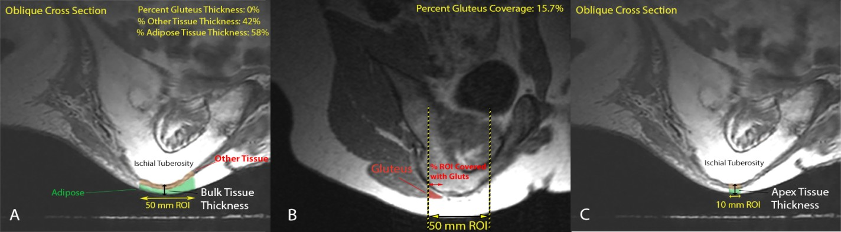

Figure 1. Measurements of tissue are described graphically, including A) Bulk tissue thickness and % adipose and other tissue, and B) % gluteus coverage, C) Apex Tissue Thickness

Two metrics were used to describe tissue shape. 1) Apex Tissue Thickness - localized tissue thickness averaged over a 10 mm region of interest under the most inferior point (“apex”) of the ischium in the oblique cross-section. Apex tissue thickness describes the distance of the skin contour from the apex (Figure 1C), and 2) Radius of Curvature - the radius of curvature of the contour in both coronal and sagittal planes computed in a 50 mm region of interest (11). Together, these metrics present information about how far the contour is from the pelvis and how sharp the peak is on the contour. In addition to these metrics, tissue shape based on the segmentation of the skin in the coronal and sagittal planes at the apex of the ischial tuberosity is presented graphically. All subjects were aligned according to the apex of their ischial tuberosity. The average of all subjects’ contours was taken at each point along the medial-lateral or anterior-posterior axis to present a population average.
Sagittal Pelvic Angle was defined in the MRI scan by the angle formed between the line connecting the Anterior Superior Iliac Spine (ASIS) and the Posterior Superior Iliac Spine (PSIS) and the horizontal (20). The ASIS and PSIS were identified in the MRI scans by a radiographer.
    - Statistical Analysis
Comparison of metrics of tissue and pelvic tilt across PrU risk status were tested using Kruskal-Wallis tests, and results are presented adjusted for ties. Kruskal-Wallis was used to assess main effects only, and p-values less than 0.1 were discussed. Effect sizes were used to report the magnitude of differences (small (0.2), medium (0.5), or large (0.8)) compared to the able-bodied status, and to compare between the two groups of wheelchair users (21).

Results

Participants
There were no significant differences between the height, weight, BMI or race of participant groups. Wheelchair users with and without a history of pressure ulcers did not have a difference in terms of years using a wheelchair. The breakdown of women versus men did differ between groups, but there were only 6 women in the entire study, split between the able-bodied group and wheelchair users with no history of pressure ulcers.
Table 1. Description of n=35 study participants.

 | All |  | Able-Bodied  (n=6) |  | WC User No Hx  (n=14) |  | WC User PrU Hx  (n=15)
 | Mean (SD) | Median  [min – max] | Mean (SD) | Median  [min – max] | Mean (SD) | Median  [min – max] | Mean (SD) | Median  [min – max]
Height (inches,  n=32) | 70 (4) | 71 [62 –  79] | 68 (5) | 69 (62  – 74) | 69 (4) | 71 (62  – 76) | 71 (4) | 71 (63  – 79)
Weight (lbs, n=34) | 172  (41) | 172 [105 –  260] | 158  (42) | 165  (112 –  209) | 178  (46) | 171  (105 –  260) | 171  (38) | 180  (110 –  254)
BMI (n=30) | 24.8  (4.7) | 23.9 [14.6  – 34.5] | 25.0  (3.7) | 25.2  (20.5 –  29.1) | 25.9  (5.3) | 24.8  (14.6 –  34.5) | 23.4  (4.4) | 22.8  (14.9-  33.5)
Years Using  Wheelchair (n=29) | 15 (11) | 10 [3 – 41] | n/a | n/a | 13  (10) | 10 (3-  37) | 17  (13) | 15 (3 –  41)
Sex | N | % | N | % | N | % | N | %
Female | 6 | 17% | 3 | 50% | 3 | 21% | 0 | 0%
Male | 29 | 83% | 3 | 50% | 11 | 79% | 15 | 100%
Diagnosis
Able-Bodied | 6 | 17% | 6 | 100% | 0 | 0% | 0 | 0%
SCI | 25 | 71% | 0 | 0% | 11 | 78% | 14 | 93%
Spina Bifida | 1 | 3% | 0 | 0% | 0 | 0% | 1 | 7%
Multiple Sclerosis | 1 | 3% | 0 | 0% | 1 | 7% | 0 | 0%
Spinal Cord Stroke | 1 | 3% | 0 | 0% | 1 | 7% | 0 | 0%
Frontotemporal  Degeneration | 1 | 3% | 0 | 0% | 1 | 7% | 0 | 0%
Race/Ethnicity
Other (Asian American, Hispanic or Latino, Self-  Reported Other) | 8 | 23% | 2 | 33% | 3 | 21% | 3 | 20%
Black/African  American | 1 | 3% | 0 | 0% | 1 | 7% | 0 | 0%

White | 26 | 74% | 4 | 67% | 10 | 71% | 12 | 80%

4.2 Seated Buttocks Anatomy
There was a wide range of bulk tissue thicknesses across participants when seated on flat foam, with thicknesses ranging from 5.6 to 32.1 mm. (Table 2, Figure 2). The tissue under the ischium was composed primarily of adipose tissue for most participants (mean (SD) % Adipose Thickness 80.5% (16.1%), Table 2, Figure 3). Other tissue, including tendon and ligament insertions and muscles, etc., composed an average of 19.5% of the tissue thickness covering the ischium.

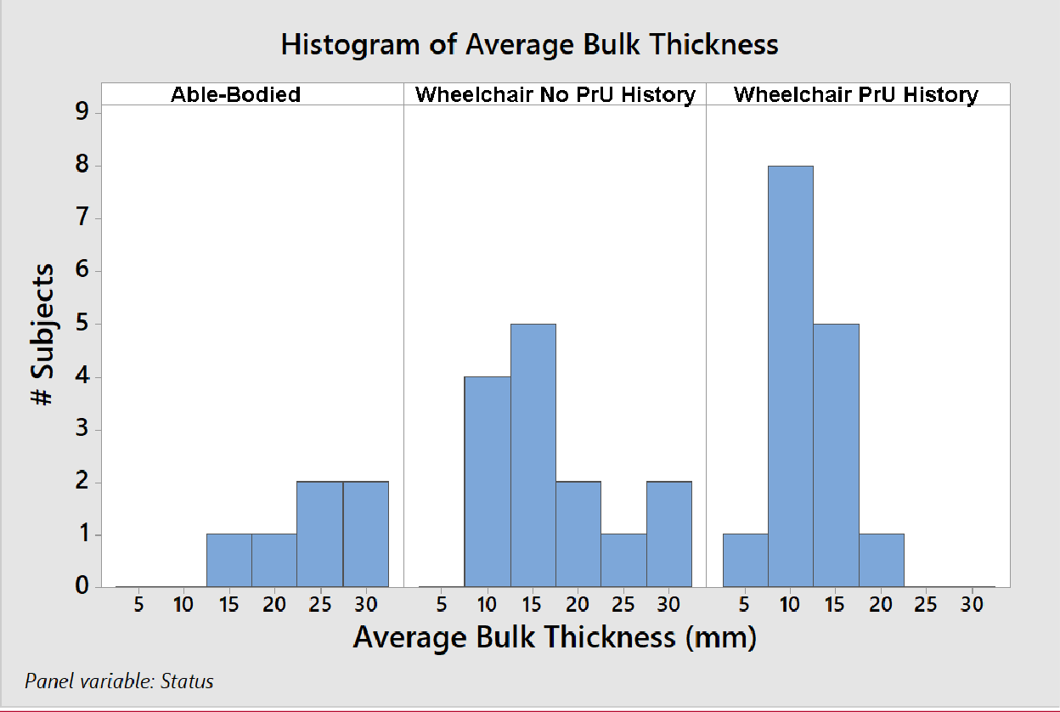
Figure 2. Histogram of Average Bulk Thickness.

Table 2. Tissue characteristics.

 | Overall population  (n = 35) |  | Able-Bodied (n=6) |  | Wheelchair No PrU History  (n=14) |  |  | Wheelchair PrU History (n=15) |  |  |  | Kruskal- Wallis
Variables | Mean (SD) | Median [Min- Max] | Mean (SD) | Median [Min- Max] | Mean (SD) | Median [Min- Max] | Effect Size vs. Able- Bodie  d | Mean (SD) | Median [Min-Max] | Effect Size vs. Able- Bodie  d | Effect Size vs. Wheelc hair No PrU  History | p-value
Average Bulk Thickness (mm) | 16.2  (7.1) | 15.6  [5.6 - 32.1] | 24.2  (4.6) | 25.3  [16.2 - 28.8] | 17.7  (7.3) | 16.3  [10.0 - 32.1] | 0.91 | 11.5  (3.7) | 10.3  [5.6 - 17.8] | 1.78 | 0.87 | 0.001
Adipose Thickness (%) | 80.5  (16.1) | 82.6  [34.8 - 100.0] | 73.8  (20.7) | 80.8  [34.8 - 92.3] | 82.6  (11.8) | 79.6  [67.9 - 100.0] | 0.55 | 81.2  (18.1) | 85.3  [44.9 - 100.0] | 0.46 | 0.09 | 0.661
Other Tissue Thickness (%) | 19.5  (16.1) | 17.4  [0.0 - 65.2] | 26.2  (20.7) | 19.2  [7.7 - 65.2] | 17.4  (11.8) | 20.4  [0.0 - 32.1] | 0.55 | 18.8  (18.1) | 14.7  [0.0 - 55.1] | 0.46 | 0.09 | 0.661
Percent Gluteus Coverage (%) | 8.9  (18.9) | 0.0  [0.0 - 80.4] | 21.9  (28.5) | 12.7  [0.0 - 78.2] | 4.7  (7.6) | 0.0  [0.0 - 23.4] | 0.91 | 7.6  (20.7) | 0.0  [0.0 - 80.4] | 0.76 | 0.15 | 0.054
Pelvic Tilt Angle (°) | 0.6  (13.3) | 1.5  [-38.0 - 24.7] | 3.2  (5.9) | 6.0  [-7.3 - 6.0] | 2.1  (10.2) | 0.9  [-12.3 - 24.7] | 0.08 | -1.8  (17.4) | 1.5  [-38.0 - 21.7] | 0.38 | 0.29 | 0.889
Apex Tissue Thickness | 13.8  (6.8) | 13.4  [2.8 - 27.6] | 21.3  (5.1) | 23.4  [13.4 - 26.0] | 15.3  (6.7) | 14.5  [7.7 - 27.6] | 0.88 | 9.5 (3.9) | 8.2  [2.8 - 16.5] | 1.74 | 0.86 | 0.001
Coronal Radius of Curvature | 85.4  (58.9) | 73.3  [34.6 - 363.5] | 103.2  (31.9) | 99.4  [57.0 - 143.5] | 104.3  (82.9) | 82.1  [34.6 - 363.5] | 0.02 | 60.8  (23.1) | 51.2  [34.7 - 114.7] | 0.72 | 0.74 | 0.022
Sagittal Radius  of Curvature | 91.8  (47.2) | 78.7  [32.4 - 258.3] | 135.0  (65.4) | 107.4  [84.3 - 258.3] | 99.2  (45.0) | 91.5  [41.7 - 188.8] | 0.76 | 67.7  (22.9) | 65.9  [32.4 - 122.0] | 1.43 | 0.67 | 0.013

Table 3. Percent gluteus coverage under a 50mm region of interest of the ischium.

% Gluteus Coverage | A B | WC-  NoHx | WC-  PrU_Hx | Tot al
0% | 1 | 9 | 11 | 21
1-25% | 4 | 5 | 3 | 12
25-50% | 0 | 0 | 0 | 0
50-75% | 0 | 0 | 0 | 0
75-100% | 1 | 0 | 1 | 2

Bulk tissue thickness differed across status groups, with able-bodied participants having the most tissue underneath their ischium (Table 2, Figure 3). The percent of bulk thickness comprised of adipose tissue did not differ according to status group, but a moderate effect size existed between the able-bodied subjects and both other groups. All three contour parameters, Apex Tissue Thickness, Coronal and Sagittal Radius of curvatures, differed across the three groups. Large effect sizes existed between the able-bodied subjects and the other two groups for Apex Tissue Thickness and Sagittal Radius of Curvature. For Coronal Radius of curvature, no effect size existed between able-bodied and wheelchair users with no pressure ulcer history, but a large effect size existed with wheelchair users with a pressure ulcer history.
The majority of participants presented with little to no gluteus coverage over their ischial tuberosity. (Mean (SD) 8.9% (18.9%)),Table 2). More than 90% of subjects had less than 25% of their ischial tuberosity covered with gluteus maximus (Table 3). Instead of being present beneath the ischial tuberosity, the gluteus maximus was typically posterior and lateral to the peak of the ischial tuberosity. Kruskall-Wallace analysis reported p=0.054 for Percent of Gluteal Coverage but had large effect size differences between able-bodied and wheelchair subjects.

Thickness (mm)

Figure 3. Tissue thickness under the ischium differed by pressure ulcer risk status and was predominantly composed of adipose tissue.
30

25

20

15

10

5

0
Subject
W/C User
PrU History
W/C User
No PrU History
A/B
35
Tissue Thickness Under the Ischium
Tissue Type Other Adipose
3 7
2
8
2 31
34
352
4 7
10
136
1 17
190
2 21
22 6
229
33 1
56
89
11
124
115
18 3
224
25 0
3 32

The shape of the skin when seated on flat foam is illustrated in Figure 4 and Figure 5, as compared with the average contour of the overall population. Able-bodied participants demonstrated a much rounder contour, farther from the ischium. This is consistent with the greater Apex Tissue Thickness and radius of curvature parameters (Table 2), while wheelchair users with a history of pressure ulcers had a much sharper contour, wrapping closer to the ischium.

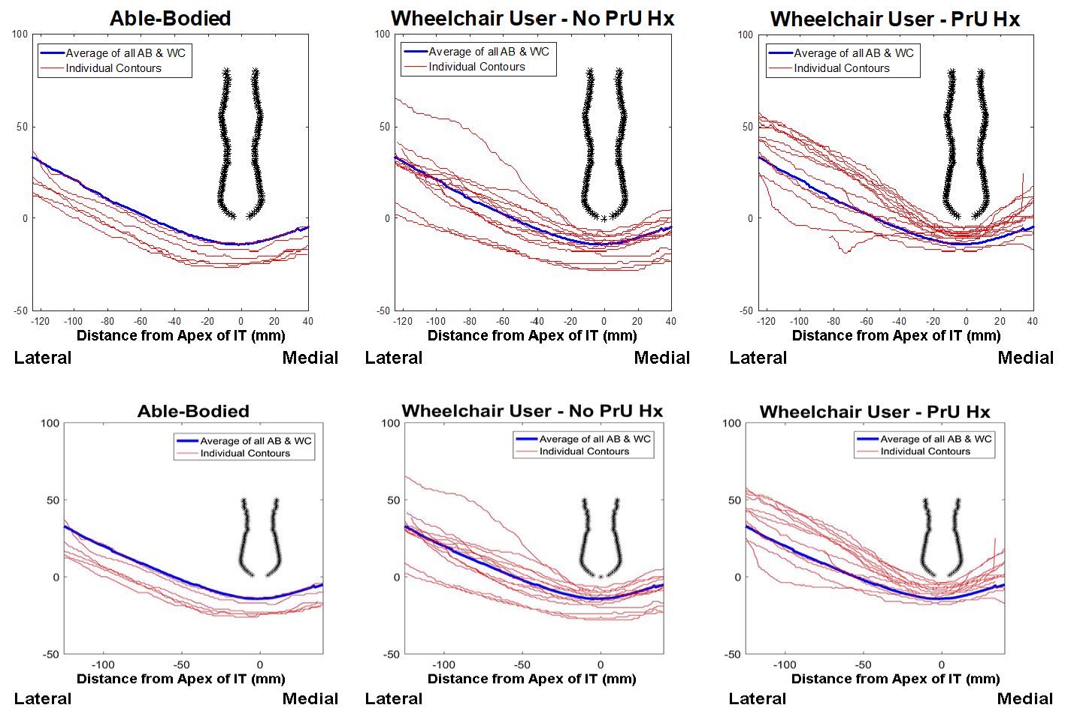
Figure 4. Coronal skin contour at the apex of the ischial tuberosity depicts the variability of shape characteristics within and across status groups. An average coronal profile of an ischial tuberosity is shown in black and the average contour across all participants (from all status groups) is shown in blue.
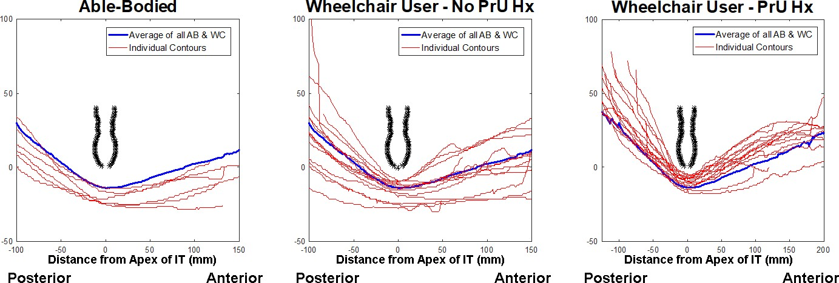

Figure 5. Sagittal skin contour at the apex of the ischial tuberosity depicts the variability of shape characteristics within and across status. An average sagittal profile of an ischial tuberosity is shown in black and the average contour across all participants (from all status groups) is shown in blue.

4.3 Pelvic Tilt
The MRI for one participant did not include sufficient image quality to measure the PSIS, therefore, pelvic tilt results are reported for 34 participants. On average, participants were seated in a neutral posture, with a sagittal pelvic angle of 0.6⁰ (13.3⁰) (Figure 6). Within all 3 groups, pelvic tilt ranged from anterior to posterior pelvic tilt, with the variance in the able-bodied group being markedly lower than that in both wheelchair user groups. The median pelvic tilt did not differ between status group, as presented in Table 2.
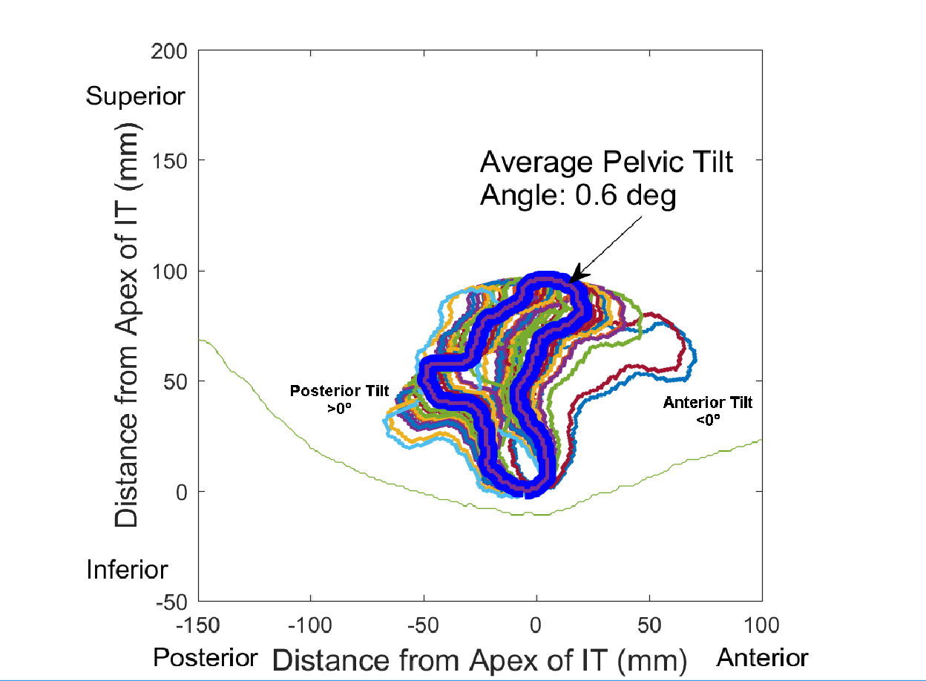

Discussion
Figure 6. Distribution of pelvic tilt angles across participants.

Comparison with previous literature
This is the first study to investigate the seated buttocks soft tissue anatomy on a large population. Results of this study, however, were comparable to previously published pilot studies. For example, tissue thicknesses under load varied from approximately 5-30 mm. Previous studies of participants seated on commercially available wheelchair cushions of varying materials and designs reported approximately 7-25mm in 4 wheelchair users (11), <30 mm in 6 participants including 4 wheelchair users (9), and 8-16mm across 11 participants, most of whom were wheelchair users (10). The slightly thicker values when seated on flat foam in this study as compared to some previous work may be the result of a

larger region of interest, including 50mm under the ischium, as opposed to smaller regions just under the apex of the ischium in (9) and (10). Tissue composition surrounding the ischia was also similar to previous MRI studies, in that (11) reported <17% gluteus maximus coverage across subjects, (9) reported half of their participants had <5% gluteus and only 2 of 6 participants had more than 25% gluteus coverage. Call et al. reported that no muscle was visible in 4/11 participants, and another 2 participants had less than 25% coverage (10). Recent ultrasound studies measure significantly more muscle under the ischium than MRI studies have. Swaine et. al found that less than 75% of tissue was composed of adipose and skin, while Gabison et al found approximately 40% of tissue was adipose and skin. (12, 13). Identification of the loaded peak of the ischium in a simulated seated posture is challenging, as is identification of a bony peak using ultrasound. Furthermore, the muscle is used as an identifying landmark in the ultrasound procedure. Therefore, it is possible that the location selection is biased towards a location on the ischium that is more posterior or lateral that includes gluteus maximus and might explain this discrepancy.

Tissue Composition Under Load
With 35 participants in this study, of whom 21 had no gluteus maximus coverage under a 50mm region of their ischium, and only 2 had more than 50% of their ischium covered with gluteus, there is strong evidence to say that people do not sit on their gluteus maximus. As described above, this is consistent with previous MRI literature, but conflicts with current assumptions within the field of pressure ulcer research (e.g. (16, 17)). Despite the representation of muscle coverage as small, common thinking has overly emphasized the role of muscle. For example, finite element models of the buttocks, used to evaluate wheelchair cushions and pressure ulcer risk, often depict gluteus maximus coverage under the ischium as more than 50% of the tissue thickness (22-25). Furthermore, research into pressure ulcer etiology has focused mostly on skeletal muscle damage, as exemplified by the extensive research program in Eindhoven, described in (5). The results presented above, that most individuals do not present with any muscle in the at-risk region of the pelvis, suggests that increased effort should be made to study the potential role of adipose tissue, tendons and ligaments in deep tissue injury. Tendons exposed to paralysis have been shown to become less stiff (26), and clinical experience suggests there may be differences in the mechanical properties of adipose tissue according to clinical presentation.

Pelvic Tilt
A wide variability in pelvic tilt occurred even when manual positioning targeted an erect, neutral posture. This may have been the result of anatomic variability in the pelvis, which is to say that perfectly erect is not always measured at 0 degrees. At the same time, many people cannot achieve and maintain a perfectly erect posture, despite the best efforts of an expert clinician trying to position the individual. However, the average sagittal pelvic tilt angle was 0.6°, suggesting that on average, an erect, neutral posture was achieved across the study.

Differences across status group
The most significant finding of this study was the differences in tissue shape and size across status group. Individuals who used a wheelchair had significantly thinner tissue under the ischium than able- bodied individuals. The composition of the tissue (percent adipose tissue, percent other tissue) was similar between the wheelchair user groups, and not much different in the able-bodied cohort. The shape of that tissue was also significantly different. Individuals who have had a history of pelvic pressure ulcers had tissue with a more peaked contour that is closer to the ischial apex, and wraps closer to the ischium at all sides. This thin, highly curved tissue under load may be comparable to the highly deformed tissue described previously as having an increased Biomechanical Risk (11, 19). Individuals in this group were already considered at increased risk because of their history of having a previous pressure ulcer (27), but the increased Biomechanical Risk may be the root cause for that initial risk. It is worth asking whether individuals in this group demonstrated a different tissue shape and thickness as a result of having had a previous pressure ulcer, perhaps due to scar tissue. While this is certainly a possibility, only 7 of the 15 participants with a history of pressure ulcers had an ischial ulcer – the remaining participants had a history of ulcers in the coccyx region. This suggests a systemic increased biomechanical risk that is not necessarily localized to the ischium.
The contours presented in the present study show a very similar pattern to those studied when participants were measured in clay in (28), despite the very different support surface. This supports the idea that there is a fundamental difference in tissue characteristics in individuals with high biomechanical risk that is also independent of the supporting surface.
The overall difference in biomechanical risk has two important clinical implications. First is whether it can be used for identifying increased risk in an already high risk population. All full-time wheelchair users are at high risk for pressure ulcer development due to their lack of mobility and frequently their reduced sensation (29). The cohort in this population with a history of ulcers was at a further increased risk (27). If a clinical tool can be identified based on seated tissue thickness and contour, this might provide increased opportunity to personalize interventions. Second, this provides an opportunity to look at wheelchair cushions and support surfaces. Differences in tissue shape and thickness in this cohort may necessitate different product design. There is an ongoing effort to investigate how individuals respond to different materials construction and designs of wheelchair cushions, according to their biomechanical risk.

Study Limitations
The primary limitations in this study relate to the limited seating configurations in which people were studied. That is, people were studied in a static, erect neutral pelvic posture on a single surface. How their loaded tissue conditions might change when they adopt a more posterior pelvic angle (slouching) would be important, as few people can maintain an erect neutral posture continuously throughout the day. At the same time, for those subjects who could not achieve a neutral posture, it is possible that their seated contour was impacted by their pelvic posture, although the relationship was not systematic. Additionally, the differences in individuals’ tissue responses to dynamic loading, and the shear strains experienced under such conditions would be important to study as well. Different wheelchair cushions would no doubt impact the tissue shape and thickness of the buttocks (9, 11). Another significant limitation is that the group of wheelchair users with a history of pressure ulcers have potentially experienced tissue changes secondary to their pressure ulcer history, meaning their tissue shape and

thickness may not have differed prior to their pressure ulcer. However, the inclusion of 8 individuals with sacral ulcers in that group suggests that biomechanical risk may in fact be systemic, rather than a localized response, even if it is a response to pressure ulcer history. Finally, a more thorough analysis of the impact of the three-dimensional pelvic shape and structure on loading would be a beneficial addition to this study.

Conclusions
This study demonstrated two significant conclusions. First, the overwhelming majority of individuals do not sit with their gluteus maximus loaded by their ischial tuberosity. Second, that individuals at greater risk for pressure ulcer development, defined by a history of pelvic pressure ulcers (ischial or coccyx) demonstrate a greater Biomechanical Risk. That is, their tissue is thinner and has a sharper peak under load.

- Local Coverage Determination (LCD): Wheelchair Seating (L15887). Centers for Medicare & Medicaid Services; 2013.
- Krause JS, Broderick L. Patterns of recurrent pressure ulcers after spinal cord injury: identification of risk and protective factors 5 or more years after onset. Arch Phys Med Rehabil. 2004;85(8):1257-64.
- Saunders LL, Krause JS, Acuna J. Association of race, socioeconomic status, and health care access with pressure ulcers after spinal cord injury. Arch Phys Med Rehabil. 2012;93(6):972-7.
- Bouten CV, Oomens CW, Baaijens FP, Bader DL. The etiology of pressure ulcers: skin deep or muscle bound? Arch Phys Med Rehabil. 2003;84(4):616-9.
- Oomens CW, Bader DL, Loerakker S, Baaijens F. Pressure induced deep tissue injury explained. Annals of biomedical engineering. 2015;43(2):297-305.
- Oomens CW, Bressers OF, Bosboom EM, Bouten CV, Blader DL. Can loaded interface characteristics influence strain distributions in muscle adjacent to bony prominences? Comput Methods Biomech Biomed Engin. 2003;6(3):171-80.
- Krouskop TA. A synthesis of the factors that contribute to pressure sore formation. Medical hypotheses. 1983;11(2):255-67.
- Stekelenburg A, Gawlitta D, Bader DL, Oomens CW. Deep tissue injury: how deep is our understanding? Arch Phys Med Rehabil. 2008;89(7):1410-3.
- Brienza D, Vallely J, Karg P, Akins J, Gefen A. An MRI investigation of the effects of user anatomy and wheelchair cushion type on tissue deformation. Journal of tissue viability. 2017.
- Call E, Hetzel T, McLean C, Burton JN, Oberg C. Off loading wheelchair cushion provides best case reduction in tissue deformation as indicated by MRI. Journal of tissue viability. 2017;26(3):172-9.
- Sonenblum SE, Ma J, Sprigle SH, Hetzel TR, McKay Cathcart J. Measuring the impact of cushion design on buttocks tissue deformation: An MRI approach. Journal of tissue viability. 2018;27(3):162-72.
- Swaine JM, Moe A, Breidahl W, Bader DL, Oomens CWJ, Lester L, et al. Adaptation of a MR imaging protocol into a real-time clinical biometric ultrasound protocol for persons with spinal cord injury at risk for deep tissue injury: A reliability study. Journal of tissue viability. 2018;27(1):32-41.
- Gabison S, Mathur S, Verrier MC, Nussbaum E, Popovic MR, Gagnon DH. Quantitative ultrasound imaging over the ischial tuberosity: An exploratory study to inform tissue health. Journal of tissue viability. 2018;27(3):173-80.

- Akins JS, Vallely JJ, Karg PE, Kopplin K, Gefen A, Poojary-Mazzotta P, et al. Feasibility of freehand ultrasound to measure anatomical features associated with deep tissue injury risk. Medical engineering & physics. 2016;38(9):839-44.
- Wu GA, Bogie KM. Not just quantity: gluteus maximus muscle characteristics in able-bodied and SCI individuals--implications for tissue viability. Journal of tissue viability. 2013;22(3):74-82.
- Solis LR, Twist E, Seres P, Thompson RB, Mushahwar VK. Prevention of deep tissue injury through muscle contractions induced by intermittent electrical stimulation after spinal cord injury in pigs. Journal of applied physiology. 2013;114(2):286-96.
- Xiao DZ, Wu SY, Mak AF. Accumulation of loading damage and unloading reperfusion injury-- modeling of the propagation of deep tissue ulcers. J Biomech. 2014;47(7):1658-64.
- Kosiak M. Etiology and pathology of ischemic ulcers. Arch Phys Med Rehabil. 1959;40(2):62-9.
- Sonenblum SE, Sprigle SH. Buttock tissue response to loading in men with spinal cord injury. PLoS One. 2018;13(2):e0191868.
- Waugh K, Crane B. A Clinical Application Guide to Standardized Wheelchair Seating Measures of the Body and Seating Support Surfaces Rev. ed. Denver, CO: University of Colorado Denver; 2013. 363 p.
- Cohen J. Statistical Power Analysis for the Behavioral Sciences. Hillsdale, NJ: Lawrence Erlbaum Associates, Inc., Publishers; 1988.
- Linder-Ganz E, Shabshin N, Itzchak Y, Gefen A. Assessment of mechanical conditions in sub- dermal tissues during sitting: a combined experimental-MRI and finite element approach. J Biomech. 2007;40(7):1443-54.
- Levy A, Kopplin K, Gefen A. An air-cell-based cushion for pressure ulcer protection remarkably reduces tissue stresses in the seated buttocks with respect to foams: finite element studies. Journal of tissue viability. 2014;23(1):13-23.
- Shoham N, Levy A, Kopplin K, Gefen A. Contoured Foam Cushions Cannot Provide Long-term Protection Against Pressure-Ulcers for Individuals with a Spinal Cord Injury: Modeling Studies. Advances in skin & wound care. 2015;28(7):303-16.
- LI S, ZHANG Z, WANG J. A NEW CUSTOM-CONTOURED CUSHION SYSTEM BASED ON FINITE ELEMENT MODELING PREDICTION. Journal of Mechanics in Medicine and Biology. 2013;13(04):1350051.
- Maganaris CN, Reeves ND, Rittweger J, Sargeant AJ, Jones DA, Gerrits K, et al. Adaptive response of human tendon to paralysis. Muscle Nerve. 2006;33(1):85-92.
- Marin J, Nixon J, Gorecki C. A systematic review of risk factors for the development and recurrence of pressure ulcers in people with spinal cord injuries. Spinal Cord. 2013;51(7):522-7.
- Dhami LD, Gopalakrishna A, Thatte RL. An objective study of the dimensions of the ischial pressure point and its correlation to the occurrence of a pressure sore. Br J Plast Surg. 1985;38(2):243- 51.
- Mortenson WB, Miller WC, Team SR. A review of scales for assessing the risk of developing a pressure ulcer in individuals with SCI. Spinal Cord. 2008;46(3):168-75.

Acknowledgements
Blinded for review

We confirm that the manuscript has been read and approved by all named authors and that there are no other persons who satisfied the criteria for authorship but are not listed.

We further confirm that any aspect of the work covered in this manuscript that has involved either experimental animals or human patients has been conducted with the ethical approval of all relevant bodies and that such approvals are acknowledged within the manuscript

