ATLAS II SIG meeting: Space, Place, Mobilities in Tourism
Seminar Programme
Spaces of nature, places of nature: Exploring the tourism encounter with nature
3rd June 2019, University of Derby, Buxton, UK

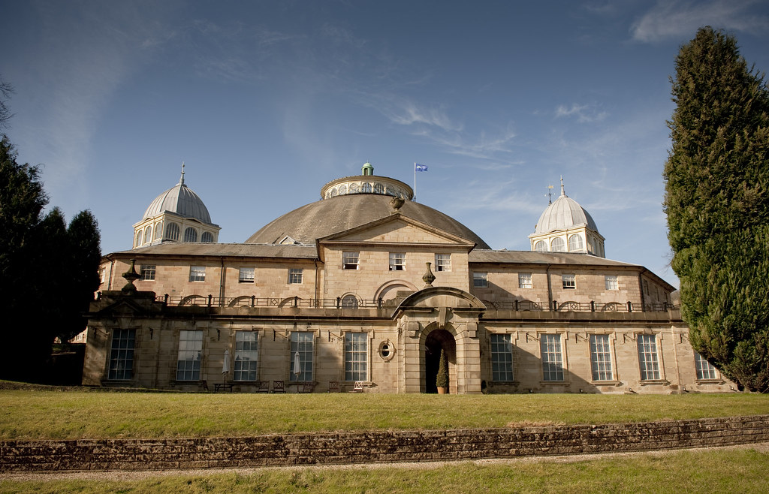

@ATLAS, #ATLAS
http://www.atlas-euro.org/Default.aspx?TabID=318

Conference Organisers - Contact us:
Dr. Iride Azara: i.e.azara@derby.ac.uk
Prof. Antonio Paolo Russo: antonio.russo@urv.cat
Sarah Jones: s.jones@derby.ac.uk
Loretta Waterhouse: l.waterhouse@derby.ac.uk
Jantien Veldman, jantien.veldman@atlas-euro.org
Leontine Onderwater, leontine.onderwater@atlas-euro.org

Monday 3rd June 2019
8:30- 9:30 | Registration
09:00-9:30 | Lecture Theatre: DOG/04  Welcome to SIG meeting Space, Place, Mobilities in Tourism: “Spaces of nature, places of nature: Exploring the Tourism Encounter with nature: Prof. Antonio Paolo Russo, ATLAS SIG Co-ordinator  Welcome to the University of Derby: Ass. Prof. Eleni Michopoulou, Chair of the Scientific Committee and Dr. Iride Azara, Chair of Organising Committee
9:30-11:00 | Chair: Peter Wiltshier Room: 116C
Chiara Rabbiosi
Body moving and nature encounters: An autobiographic insight of a walking holiday

Chantal Laws
“Dirt under my fingernails”: performing serious leisure identities at garden attractions/events

Maarja Kaaristo
Spaces of (constructed?) nature: Canal tourism in the UK
11:00-11:30 | Coffee break
11:30-12.30 | Chair: Iride Azara Room: 116C
Xavier Michel
Specifying the spatialities of the tourists’ and organizers’ anthropocentric and ecocentric stances

Niina Moilanen, Antti Petteri Kurhinen
Student Journey from Nature Tourism Enthusiast to Nature Tourism Professional
12:30-13:30 | Lunch
13.30-14.30 | Lecture Theatre: DOG/04  Keynote: Dr. Hazel Andrews, Liverpool John Moores, ‘Finding a Way to Tourism Encounters with Nature’.
14:30-15:30 | Chair: Alan Clarke Room: 116C
Sian Newsome Magadza
Wildlife: tourist snapshots, local values

Emma Pope
Nature-Based Tourism: Connection and Co-Transformation

Peter Gilliver
The walk
15:30-16:00 | Coffee break
16.00-17.00 | Chair: Eleni Michopoulou Room: 116a
Nicola Allen
Toward partnership and conflict resolution in UK national parks

Lisa Lakdja
Using natural settings to transform one’s wellbeing
17.00-17:30 | SIG meeting:  Open debate: key insights from the sessions and advances in research on tourism mobilities, place and performance, introduced and moderated by Dr. Iride Azara and Prof. Alan Clarke
18.00- 20:00 | Cocktail Reception  Location: Pump Room (Buxton SK17 6BQ – opposite The Crescent)
20:00 till late | Dinner  Location: Buxton Brewery Tap House, Address: Old Court House, George St, Buxton SK17 6AY

