Insights toward Efficient Angle Design of Pedestrian Crowd Egress Point Bottlenecks
Hossein Tavana, Kayvan Aghabayk
Hossein Tavana, Research Scholar, School of Civil Engineering, College of Engineering, University of Tehran, Tehran, Iran
Kayvan Aghabayk, PhD, Assistant Professor, School of Civil Engineering, College of Engineering, University of Tehran, Tehran, Iran (Corresponding author)
Kayvan.Aghabayk@ut.ac.ir

Insights toward Efficient Angle Design of Pedestrian Crowd Egress Point Bottlenecks
Understanding the impact of geometrical characteristics of bottlenecks in pedestrian egress behaviour is ubiquitous in safe and effective crowd management. This paper aims to study how funnel-shaped bottlenecks with different angles affect the microscopic and macroscopic properties of pedestrian egress flow. Hence, funnel-shaped bottlenecks were designed and experimented in this study. The minimum width of the bottleneck in all experiments was one meter and the egress point was exactly in the middle. With this width and egress point, two scenarios were designed to investigate the bottlenecks. In the first scenario, the large width of the bottleneck was constant and the length and subsequently the slope was varied. In the second scenario, the length of the bottleneck was constant and the large width, and subsequently the slope was varied. As a result, the impact of length, large width, and slope of the bottleneck were examined. Considering the first scenario for each bottleneck, the microscopic and macroscopic properties of flow were extracted and compared. New controlled experimental data suggest that the best-performing bottleneck with regard to angle follows a certain trend, with 26.6 degrees being the most efficient. In the second scenario, it was observed that upon increasing the large width the flow increases.
Keywords: Pedestrian bottleneck, Egress point, Exit layout

1. Introduction
Nowadays with the increase in population and development of cities, the need for bigger residential and public buildings and facilities has emerged which leads to crowdedness in limited space. Therefore, understanding of pedestrian movement is imperative in designing safe and more efficient pedestrian facilities which is why optimal conditions regarding the movement of the crowd have been explored. To this end, numerous studies regarding pedestrian evacuation have been carried out in the past 15 years.
Aforementioned studies have been performed in well-controlled environments (Liddle et al., 2009; Muir et al., 1996; Daamen and Hoogendoorn, 2012; Nagai et al., 2006; Daamen and Hoogendoorn, 2003; Liao et al., 2014; Garcimartín et al., 2016; Rupprecht et al., 2011; Shiwakoti et al., 2016; Aghabayk et al., 2014), using virtual reality (Moussaïd et al., 2016), by analysing real footage of crowds (Zhang et al., 2013; Shiwakoti, 2016; Gu et al., 2016), through observation of flow properties of non-human organisms especially under panic conditions (Sobhani et al., 2014; Garcimartín et al., 2015; Shiwakoti et al., 2014; Dias et al., 2013), and by means of modelling and simulation (Cornes et al., 2017; Chen et al., 2018; Johansson and Helbing, 2007; Bode and Codling, 2016; Duives et al., 2016; Kirchner et al., 2003; Pereira et al., 2013; Handel and Borrmann, 2018).
Among the mentioned methods, performing experiments under well-controlled conditions is of high value, as it allows us to analyse different shapes and observe true behaviour of pedestrians. One of the first studies on pedestrian flow in bottlenecks was performed by Muir et al. (1996), who examined pedestrians evacuating an airplane. Liddle et al. (2009) examined the impact of bottleneck width with a constant corridor length and also the impact of corridor length with a constant bottleneck width. Liao et al. (2014) studied wide bottlenecks with numerous participants and found a linear dependency between flow and bottleneck width. Rupprecht et al. (2011) used 20 to 30-year-old soldiers to examine the impact of bottleneck width on flow and concluded that pedestrian behaviour varies with different widths but did not find any relation between flow and distance of waiting area to bottleneck, and between flow and width of the waiting area. All these bottlenecks were merely doors which led to an open area or simple bottleneck corridors. Seyfried et al. (2009) compared the previous studies and also experimented and found a linear relation between flow and bottleneck width. Guo et al. (2017) examined the evacuation time of people who were dispersed uniformly in an artificial room and calculated the evacuation time in two sets of experiments. They found out that mean of evacuation time in each set is almost equal. However, all of these studies considered only narrow bottlenecks and no other shape were examined. Through these studies, other researchers examined other factors such as individual or group egress (Bode et al., 2015), selfish behaviour in normal walking speed or in a hurry (Nicolas et al., 2017), the impact of desire to overtake and push other pedestrians on travel time (Bukáček et al., 2018) and impact of stress level on pedestrian behaviour (Sobhani et al., 2014), which contributed to better understanding of flow in narrow bottlenecks. However, other types of bottleneck except narrow bottlenecks with right angle egress points were not studied. Recall that egress point is a point in a building or facility which provides a way out of that area (i.e. doors).
By performing such experiments, in addition to extracting flow and examining the impact of different factors on it, trajectories of pedestrians could be extracted and their formation be observed (Liddle et al., 2011). By experimenting, important microscopic and macroscopic properties of flow could be manually or with the help of software calculated (Steffen and Seyfried, 2010). Therefore, by studying extracted trajectories and microscopic properties of flow in previous works and experiments, different phenomena in flow were observed (Hoogendoorn and Daamen, 2005). It was concluded that overcrowding in bottlenecks happens not only as a result of a decrease in capacity but also due to a lack of time for the flow to get organized (Cepolina and Tyler, 2005). As narrow bottlenecks get overcrowded, decisions and personalities of pedestrians could influence the flow and evacuation time (Garcimartín et al., 2016; Heliövaara et al., 2012). In addition to this, Nicolas and Touloupas (2018) studied the evacuation time of people in a bottleneck and concluded that evacuation happens both in shorter and longer timeframes. Previous experiments have not been limited to examining microscopic properties of flow with regard to different bottleneck length and width and pedestrian behaviour. Different factors, different design and having multiple exit options have also been studied and it has been shown that these items also could influence the flow (Haghani and Sarvi, 2017; Wagoum et al., 2017; Liu et al., 2016). In this regard, Jiang et al. (2014) found out placing pillars near bottlenecks might increase escape efficiency and with installing two pillars on both sides of an egress point, they reached the maximum amount of the exiting efficiency.
Parallel to experiments with numerous human participants, other methods have been used to extract microscopic and macroscopic features, because in many cases such as panic, it is not ethically possible to experiment with human subjects. Moreover, studying different scenarios with a great number of participants is a very difficult task. Following are a number of studies which have been carried out using such methods. Moussaïd et al. (2016) studied evacuation under emergency conditions in a virtual environment. In another study, woodlice were utilized to measure outflow to density ratio in a panic situation (Sobhani et al., 2014). A flock of sheep was used to study flow and measure headway between consequent sheep exiting the bottleneck. They also were used to examine the impact of width and the existence of an obstacle before the egress point and exponential behaviour was observed (Garcimartín et al., 2015). In another experiment, the influence of funnel-shaped bottlenecks was investigated on a group of mice and it was found out with increasing of angle, evacuation time decreases (Oh and Park, 2017). In a different scenario, evacuation of ants from an enclosed area was studied, where the exit was a door-like opening and funnel-shaped bottlenecks were not examined in this study. After calibration and simulation for the pedestrian flow, the impact of placement of bottleneck, its funnel shape, and existence of an obstacle in the exit were studied using this simulation. In spite of its high value, the result of this study may not be as reliable since no human subjects were examined (Shiwakoti et al., 2014).
Efficiency and pedestrian behaviour in bottlenecks have also been studied through modelling and simulation. Cornes et al. (2017) used social force model to simulate evacuation through a door under panic conditions, where some pedestrians had fallen to the ground, and the others were trying to push them away or trample them. Additionally, the social force model was adjusted by Yuen and Lee (2012) to consider overtaking effect and hence was able to model uni-directional overtaking behaviour. In another study, Cellular Automata was used to show collision avoidance behaviour during evacuation by modelling a classroom with benches (Chen et al., 2018). However, collaboration behaviours should be considered to avoid gridlock effect in the model (Xue et al., 2017). Kirchner et al. (2003) used Cellular Automata to prove that if the width of the bottleneck is less than the critical width, the conflict at the exit point will result in higher evacuation times and vice-versa. With the help of genetic algorithm, it was shown that the existence of an obstacle or channel before the bottleneck could improve the flow (Johansson and Helbing, 2007). Finite Automata is among other models used for evacuation scenarios for pedestrian behaviour, in which total evacuation time follows an extreme value distribution (Pereira et al., 2013). Duives et al. (2013) investigated different simulation methods and compared their speed and accuracy in modelling.
Even though many methods for predicting pedestrian movement and flow in bottlenecks have been invented, all of them need to be ultimately calibrated and validated with human subjects (Boltes and Seyfried, 2013; Porter et al., 2018). To this end, experimentation and questionnaires are the most reliable method to study pedestrian flow (Shiwakoti et al., 2017). Hence it is imperative to examine pedestrian behaviour in different bottleneck shapes, placements, gender and age combinations through designing and performing numerous experiments so that the best design for safe and efficient evacuation of pedestrians under panic and overcrowding conditions is found. However, in many experiments lack of age diversity, a disproportionate number of males and females and a small number of participants undermine the validity of the experiments. As a result, only a few numbers of experiments are carried out under controlled conditions and with many participants with enough diversity in age and gender. Therefore, it is paramount to perform experiments in aforementioned conditions in order to achieve a better understanding of bottlenecks, be able to determine the best design of a bottleneck, and study pedestrian behaviour in different bottleneck designs.
Among the best models regarding efficient evacuation of the bottleneck is the funnel-shaped bottleneck. This subject has been studied in the past in designing silos for discharging granular materials and it has been shown that in funnel shapes and in optimal angles, the layers move smoothly and maximum outflow is achieved (Buzek and Epstein, 1988; Nedderman et al., 1982; Oldal and Safranyik, 2015). Using this design has been recommended by Helbing et al. (2005) to improve bottlenecks with regard to pedestrian evacuation, but experiments have yet to be performed on this design and analyse the impact of such design on flow properties. This article aims to study pedestrian behaviour and microscopic properties of flow in a funnel-shaped bottleneck through an experiment under controlled conditions and compares it with narrow bottlenecks. In addition to utilizing this new design, wide age range and well-balanced combination of male and female participants are key points in this study. Next section discusses details regarding performing the experiment and data collection. The third section presents the analyses and discussion of their results and the fourth section summarizes this article and its findings.

2. Data and Methodology
The experiment was performed on Thursday 26th of October 2017 at 10 am in the campus of University of Tehran, faculty of engineering. The weather was sunny and the temperature was 24 degrees Celsius. The number of participants was 94 (consisting of 43 males and 51 females) and they were aged between 10 and 70 years old. Figure 1 shows the age distribution of participants in the experiment. In order to control and help to manage the experiments, a professor, a graduate student, and three technical staff were present.
The pedestrians waited inside a holding area of about 30 m^2 located 3 meters before the bottleneck and started walking with a crowded density of roughly 3.1 person/m^2. This was close to the pedestrian density in an experiment conducted by Seyfried et al. (2009). The goal of this experiment was to measure the impact of funnel-shaped bottleneck on pedestrian flow, which had not yet been studied with human subjects.
The experiment was recorded in HD quality in 60 frames per second. The camera was mounted on an 8-meter-high crane. To extract the data from the recordings, the Tracker software was used. The parameters in the software were calibrated with the predesignated points on the ground and the videos were converted to 30 frames per second. Using the Tracker software, each individual was tracked and the coordinates and the timeframes were extracted and stored in an excel file. The data were analysed using MATLAB R2015b and the required parameters were extracted.
Before starting the experiment, each participant was given a hat with indicators to facilitate better tracking. The participants were asked to walk normally as if they are walking to work or school, and after the instructions and the preparation, they were guided to the waiting area.
The participants started moving in the predetermined path upon hearing the starting signal. The path was built in the campus using 1.6-meter-tall stands which were taped at 0.6, 1.1, and 1.6 meters to prevent anyone from going outside the path. The perimeter of the place where the experiment was performed, was defined with tables and chairs and the ground was completely flat.
Overall 8 different shapes were considered for experimentation, with the first one being a 1-meter-wide narrow bottleneck, the second a 3-meter-wide bottleneck. And the third, fourth, fifth and sixth shapes funnel-shaped bottlenecks having a constant large-width of 3 meters and a constant small-width of 1 meter and variable length of 1, 2, 3 and 4 meters that change the slope and hence yield different angles (α=45°, 26.6°, 18.4°, 14°), respectively. The seventh and eighth bottlenecks had a small-width of 1 meter and large-width of 2 and 4 meters with the length of 4 meters, making a different degree of 7.1°, and 20.6°, respectively. All the bottlenecks were located in the middle of the area and the corridor continued for 10 meters after the bottleneck. The width of corridor was 1 meter, the same as the width of egress point, which allowed two pedestrians to easily walk side-by-side. The 1-meter-wide bottleneck was used to examine the impact of funnel-shaped compared to narrow bottleneck and the 3-meter-wide bottleneck that was used to extract the free flow speed of pedestrians. The experiment was repeated three times for each shape, making the total number of runs 24.
Before performing the main experiment, the participants walked the 1-meter-wide bottleneck three times to get familiar with the experiment. The experiment paths and the screenshot of the experiment are shown in Figure 2, and Figure 3, respectively.

3. Analysis and Results

3.1. Flow
One of the most important macroscopic properties in studies on pedestrians is flow. To calculate flow, a hypothetical line at the end of the funnel where the width is 1 meter was considered. This line represents the end of the bottleneck and after that pedestrians move in one direction in the corridor. Therefore, using equation (1), flow is calculated in every angle.
$$J=\frac{N}{Δt} =\frac{N}{t_{n}-t_{1}} (1)$$

3.1.1. Flow for bottlenecks with constant widths and variable length (Scenario 1)
Using equation (1) flow was calculated for each shape and it was observed that upon changing the shape from narrow bottleneck to funnel-shaped bottleneck, flow increases considerably. Table 1 represents the flow for bottlenecks with variable length. This table also shows the standard deviation of the flow. Based on this table, it can be concluded that the flow increases when bottleneck changes to funnel-shaped bottleneck. This increase in flow continues until the length of the bottleneck reaches 2 meters, then it decreases as the length increases to 4 meters, or in other words, the angle decreases.
The ANOVA test is used to investigate whether the difference between pedestrian flows in funnel-shaped bottlenecks with variable length is statistically significant. To conduct this test, the null hypothesis (H₀) is considered as the equality of flows and the alternative hypothesis is that the flows are unequal. As F>F_{cr}, the null hypothesis is rejected with a 95% level of confidence and shows the efficiency of the optimal angle. The results of the ANOVA test are presented in Table 2.
Figure 5 depicts the flow vs. bottleneck length diagram with constant entry and exit widths. Table 2 and Figure 4 indicate that the flow peaks between the funnel-shaped bottlenecks with 2 meters’ length and 3 meters’ length (26.6 degrees and 18.4 degrees). This may seem unusual, as it is expected that the flow increases with increasing length. But the recordings in 1 meter of length (45 degrees) show that there is not enough time for people to organize, therefore some conflicts happen. As a result, collisions happen which hinder the movement and passing the bottleneck. After reaching the optimal angle, the trajectories and flow organization start to disrupt, in which the number of pedestrians 2 meters before the egress point varies constantly and placement in further layers and organization are impeded. Therefore, in the right angle people not only have enough time and space to be organized, but further collisions could be prevented.

3.1.2. Flow for bottlenecks with constant small-width, constant length and variable large-width (Scenario 2)
For bottlenecks, in which the slopes changed with changing the large-width, the flow was calculated and it is presented in Table 3. This table also shows the standard deviation of the flow for this scenario. The results indicate that increasing the large-width of the bottleneck, which implies augmenting the angle of the trapezoid, leads to an increase of the flow. If 20.6 degrees are exceeded, the large-width would be larger than 4 meters which isn’t practically possible, therefore only these three shapes were investigated. The data was tested using ANOVA, which yielded a P value of 0.077, is accepted with a 90% level of confidence. Figure 5 depicts the diagram of flow vs. large-width which indicates that upon reaching the optimal angle, the flow increases more rapidly.

3.2. Evacuation time
This parameter is of high value in designing paths and exit facilities. Evacuation time is the time it takes for a person to successfully exit the bottleneck. This property is especially important in critical situations, in which quick evacuation of a pedestrian could be the difference between life and death. To calculate evacuation time, similar to flow, a hypothetical line was considered at the end of the funnel where the width is 1 meter. Then, the time that individuals started to walk is considered as t₀ and t_{p} is the time that pedestrians passed the hypothetical line at the end of the funnel. Finally, using equation (2) the evacuation time is calculated. This time is calculated person by person which results in 282 times for each shape. In the following, some diagrams are plotted.
Evacuation time = t_{p} – t₀ (2)
Figure 6 depicts different exit times for different scenarios using box and whisker plots. Even though comparing the exit flow shows in which shape the last person has the least exit time, the box and whisker plots could provide additional useful information, as it shows both the mean and quartiles. In this regard, the box and whisker plots are built by almost 300 points for each experimental condition and readily convey the differences between each shapes’ evacuation time.
Figure 6-a depicts exit time in bottlenecks with different lengths and Table 4 also depicts mean evacuation time in those bottlenecks. This figure shows that when narrow bottleneck changes to funnel-shaped bottleneck, the evacuation time and also the difference between first and third quartiles decreases. And this difference reaches its minimum in length of 2 meters (26.6-degree angle) and the pedestrians evacuate the bottleneck in the least amount of time possible. Mean evacuation time (marked with an x in Figure and presented in Table 4) decreases when the narrow bottleneck changes to funnel-shaped bottleneck and this decrease continues as the length increases to 2 meters (26.6-degree angle) but the evacuation time decreases beyond 2 meters. Improvement of evacuation time when changing from narrow to funnel-shaped bottleneck was tested with T-test and it was confirmed with a 95% level of confidence, and the P value of 0.002. Another T-test also verified the improvement of evacuation time in 26.6 degrees compared to that of the 45 degrees.
Figure 6-b and Table 5 depict evacuation time for funnel-shaped bottlenecks with variable large-widths. It is worth mentioning that when the slope in funnel-shaped bottleneck decreases, the mean evacuation time resembles the evacuation time of pedestrians in narrow bottlenecks and the funnel shape does not particularly help with decreasing the evacuation time. But in the shape, in which the large-width was 4 meters, mean evacuation time decreases more. This difference was tested for 4:1 bottleneck compared to 2:1 with T-test and it was confirmed with a 95% level of confidence and a P value of 0.02.
The findings presented here confirm the trend noticed in the previous section indicating that evacuation time correlates inversely with flow. In other words, the evacuation time decreases as the flow increases. In fact, the best design with the optimal flow would also have the optimal evacuation time.

3.3. Time Headway
Time headway is another microscopic property of flow. The importance of this parameter is that it can indicate clearly whether the evacuation in the bottleneck happens efficiently (Shiwakoti et al., 2014). Furthermore, the time headway can affect the level of service. The time headway in this study is the time it takes for two consecutive pedestrians to cross the same line, as shown in equation (3). This hypothetical line is considered the line at the end of the funnel, where the width is 1 meter.
$$t_{headway}=t_{i+1}-t_{i} (3)$$
Aghabayk et al. fitted a lognormal distribution on time headway (Aghabayk et al., 2015). Considering this, the same distribution was fitted on time headway in this study, where Figure 7 shows the comparison of lognormal distributions for bottlenecks with constant widths and variable length. Similarly, the comparison between bottlenecks with constant small-widths and length and variable large-width are shown in Figure 8.
In figures 7 & 8, mode is the point of global maximum of the probability density function. Upon examining these figures, we conclude that the mode of the time headway, the average time headway, and its variance decrease when the narrow bottleneck changes to funnel-shaped bottleneck. Close inspection of Figure 7 shows that in funnel-shaped bottlenecks, the mean and the median decrease with the increase of bottleneck length to 2 meters (decreasing the angle to 26 degrees), which means that the average time headway of pedestrians decreases. Based on the videos, this may be due to the conflicts between pedestrians at the egress point. These conflicts and collisions force the pedestrians to stop and go. As a result, these stops increase the time headway. In other words, with changing narrow bottlenecks to funnel-shaped bottlenecks, these conflicts decrease and time headway decreases too. The time headway decreases with the increase of bottleneck length to 2 meters and beyond that, it increases. This means that in high density, less time headway could result in more people passing. The differences between the time headways of people in each shape are clearly seen in Figure 7.
Figure 8 shows that headways have a higher mean and variance in 3:1 bottlenecks, whereas in 4:1 bottlenecks the mean headway and the variance are smaller.
Larger headways could happen because of two reasons: the first reason is that less density which leads to higher speed and more distance between pedestrians who pass one after each other. Low density also leads to a higher level of service in traffic flow. The second reason, which was mentioned before, is the extremely high density which leads to low flow and small space between participants. Considering the fact that the density was extremely high in all scenarios, the pedestrians must have been very close to one another. These conditions are at worst in the narrow bottleneck and result in difficulty of crossing the bottleneck for pedestrians, and because of this, the time headway would be higher in narrow bottleneck compared with the funnel-shaped bottleneck. For the funnel-shaped bottleneck, headway analysis in comparison with the analysis of the flow indicated that the average time headway decreases with the increase of flow up to 2 meters in the funnel length. At funnel length of greater than 2 meters, the average headway starts to increase again. In light of these results, it can be concluded that using the headway is an appropriate measure for examining the performance of the bottleneck. However, it shall not be neglected that in some case, some factors such as vision impairment could lead to discrepancies in such a way that this correlation does not happen (Dias et al., 2013), but in most cases, this correlation exists.
Figure 9 depicts the headway vs. flow diagram for bottlenecks with different lengths which indicates that funnel-shaped bottleneck and 26-degree angle result in better performance. This diagram confirms that bottlenecks with high density which are passed with more time headway have less flow which is a surprising result. The reason for this phenomenon is the conflicts between pedestrians which leads to many stops in their path. In other words, in the high-density condition, the time headway decreases as the flow increases.

3.4. Trajectories
Each participant had a hat with indicators to facilitate the tracking process. After extraction, the trajectories were then smoothed out to omit errors and the excessive movements like head movement. For smoothing, moving average method was used (Steffen and Seyfried, 2010). The trajectories were plotted in MATLAB where the velocity of each person is shown on its corresponding colour map. In the first scenario (Fig. 10) it is observed that upon changing the narrow bottleneck to funnel-shaped bottleneck, the velocity before the bottleneck increases. When the length of the funnel increases to 2 meters, the velocity increases, but it decreases in 3 and 4 meters of length. The next scenario is changing the large-width with a constant length (length= 4m). In this scenario with large-widths of 2, 3 and 4 meters, it was observed that with the increase of large-width, the velocity increases. Moreover, with increasing the area of the funnel, no flow back in bottleneck happens and lines are organized more efficiently. Recall that flow back is the phenomenon which long queues and disorder in queue happen when a bottleneck affects the flow. The plotted trajectories are shown in figures 10 and 11.

3.5. Velocity
Among important microscopic features is velocity, which was represented earlier in Figure 10 and Figure 11. The free movement velocity of participants was calculated in the shape with the 3-meter width which was 1.5 m/s. At the egress point, this velocity decreased in the narrow bottleneck to less than 0.5 m/s which correlates with a considerable decrease of flow. As with flow, the velocity at the egress point increases substantially when the bottleneck design changes to funnel shape. This increase, which is more than 20%, contributes to less agitation of participants upon crossing the bottleneck. Before the bottleneck, the pedestrians move more easily and the level of service of the facility is improved. Figure 12 depicts the diagram of velocity vs. walking direction (X values). Figure 12-a shows the 3 to 1 funnel-shaped bottleneck with a length of 2 m where x=0 is the point that people enter the funnel and x=2 corresponds to the egress point. In Figure 12-b, the narrow bottleneck is shown where x= 0 corresponds to true exit and it is the egress point of narrow bottleneck. Comparing these two, it is obvious that not only the velocity increases in the funnel-shaped bottleneck, but it is also more consistent.
Additionally, in narrow bottlenecks, the velocity wavers more, which indicates more stop and go incidents. In the diagram for the narrow bottleneck, the lines sometimes reach negative values, which is due to stops and backward head movement. Although in some cases backward motion is also observed, the negative velocities do not necessarily indicate a backward motion. Furthermore, in the funnel-shaped diagram, the velocity increases more slowly downstream from the bottleneck, whereas in narrow bottlenecks there is a jump in velocity downstream from the bottleneck. As a result, the velocity downstream the narrow bottleneck is higher than the velocity at the same spot in the funnel-shaped bottleneck. The reason might be that the pedestrians getting agitated before the narrow bottleneck and after this sudden jump in velocity, the velocity slightly decreases. Additionally, the number of pedestrians crossing the funnel-shaped bottleneck with high velocity has increased compared with narrow bottlenecks.
To sum up, the mean velocity at the egress point increases when the bottleneck design changes to funnel-shaped bottleneck which shows the velocity correlates inversely with the evacuation time. However, with the increase of velocity at the egress point, flow increases and the best design with the highest flow has the highest speed.

4. Conclusion
As human evacuation from a closed space is highly important, bottleneck design was the main focus of this study. A new bottleneck design was experimented under well-controlled conditions and compared with the narrow bottleneck. The experiments were carried out with 94 volunteer participants consisting of 43 males and 51 females aged between 10 to 70 at the campus of University of Tehran. The experiments were recorded by a camera mounted on a sufficiently high crane. To validate the data collection, each scenario was repeated three times. During the experiment, the learning effect may happen. However, this is unavoidable as could happen in other researcher’s experiments. Further, due the people experience in their daily life, they have gone through different egress points and have experienced different situations. By looking at the results, it may be concluded that the learning effect may not be very significant as no trend is not found in any of the experiments.
First, the flow was examined and the optimal shape was found among experimented layouts. It was observed that with the optimization of the design of the bottleneck, the flow could be increased by 20 percent. Then, the evacuation time of the participants was extracted, which also showed considerable improvement compared to that of the usual design. The results agree with the results obtained from flow analysis which the optimal layout found through flow analysis was confirmed. The headway was also examined and it was observed that when the bottleneck shape changes from narrow to optimized design, the mean time headway at exit point decreases and more pedestrians cross with less time headway. Then the trajectories were extracted and the heat maps were used to display the velocities visually. It was shown velocity increases when changing from the narrow bottleneck to the optimal shape. Finally, the velocity was examined and the velocity vs. walking direction plot was presented. This plot showed that when the bottleneck shape changes from narrow to funnel, not only the velocity at the egress point of the bottleneck increases, but also the stop and go motion of pedestrians decreases and the pedestrians have a more stable velocity.
The findings in this article could help urban designers, designers for public places, and architects designing buildings and large spaces with high pedestrian density achieve the proper design. Appropriate designs will help speed up the evacuation in case of a disaster and reduce the injuries and fatalities.
Finally, further studies are recommended to investigate the impact of group movement of friends or colleagues or selfish movement of pedestrians in future research work. The impact of a column and its placement on flow in funnel-shaped bottlenecks is also suggested for future studies.

5. References
AGHABAYK, K., EJTEMAI, O., SARVI, M. & SOBHANI, A. 2014. Understanding pedestrian crowd merging behavior. Transportation Research Procedia, 2, 768-773.
AGHABAYK, K., SARVI, M., EJTEMAI, O. & SOBHANI, A. 2015. Impacts of different angles and speeds on behavior of pedestrian crowd merging. Transportation Research Record: Journal of the Transportation Research Board, 76-83.
BODE, N. W. & CODLING, E. A. 2016. Statistical models for pedestrian behaviour in front of bottlenecks. Traffic and Granular Flow'15. Springer.
BODE, N. W., HOLL, S., MEHNER, W. & SEYFRIED, A. 2015. Disentangling the impact of social groups on response times and movement dynamics in evacuations. PloS one, 10, e0121227.
BOLTES, M. & SEYFRIED, A. 2013. Collecting pedestrian trajectories. Neurocomputing, 100, 127-133.
BUKÁČEK, M., HRABÁK, P. & KRBÁLEK, M. 2018. Microscopic travel-time analysis of bottleneck experiments. Transportmetrica A: transport science, 14, 375-391.
BUZEK, J. & EPSTEIN, H. 1988. Preventing buckling in grain storage silos. Journal of pressure vessel technology, 110, 457-460.
CEPOLINA, E. & TYLER, N. Understanding capacity drop for designing pedestrian environments. 2005. Walk21.
CHEN, L., TANG, T.-Q., HUANG, H.-J., WU, J.-J. & SONG, Z. 2018. Modeling pedestrian flow accounting for collision avoidance during evacuation. Simulation Modelling Practice and Theory, 82, 1-11.
CORNES, F., FRANK, G. & DORSO, C. 2017. High pressures in room evacuation processes and a first approach to the dynamics around unconscious pedestrians. Physica A: Statistical Mechanics and its Applications, 484, 282-298.
DAAMEN, W. & HOOGENDOORN, S. 2003. Experimental research of pedestrian walking behavior. Transportation Research Record: Journal of the Transportation Research Board, 20-30.
DAAMEN, W. & HOOGENDOORN, S. 2012. Emergency door capacity: influence of door width, population composition and stress level. Fire technology, 48, 55-71.
DIAS, C., SARVI, M., SHIWAKOTI, N., EJTEMAI, O. & BURD, M. 2013. Investigating collective escape behaviours in complex situations. Safety science, 60, 87-94.
DUIVES, D. C., DAAMEN, W. & HOOGENDOORN, S. P. 2013. State-of-the-art crowd motion simulation models. Transportation research part C: emerging technologies, 37, 193-209.
DUIVES, D. C., DAAMEN, W. & HOOGENDOORN, S. P. 2016. Sensitivity Analysis of the Local Route Choice Parameters of the Continuum Model Regarding Pedestrian Movement Phenomena. Traffic and Granular Flow'15. Springer.
GARCIMARTÍN, A., PARISI, D., PASTOR, J., MARTÍN-GÓMEZ, C. & ZURIGUEL, I. 2016. Flow of pedestrians through narrow doors with different competitiveness. Journal of Statistical Mechanics: Theory and Experiment, 2016, 043402.
GARCIMARTÍN, A., PASTOR, J., FERRER, L., RAMOS, J., MARTÍN-GÓMEZ, C. & ZURIGUEL, I. 2015. Flow and clogging of a sheep herd passing through a bottleneck. Physical Review E, 91, 022808.
GU, Z., LIU, Z., SHIWAKOTI, N. & YANG, M. 2016. Video-based analysis of school students’ emergency evacuation behavior in earthquakes. International journal of disaster risk reduction, 18, 1-11.
GUO, N., JIANG, R., HU, M.-B. & DING, J.-X. 2017. Constant evacuation time gap: Experimental study and modeling. Chinese Physics B, 26, 120506.
HAGHANI, M. & SARVI, M. 2017. Social dynamics in emergency evacuations: Disentangling crowd’s attraction and repulsion effects. Physica A: Statistical Mechanics and its Applications, 475, 24-34.
HANDEL, O. & BORRMANN, A. 2018. Service bottlenecks in pedestrian dynamics. Transportmetrica A: transport science, 14, 392-405.
HELBING, D., BUZNA, L., JOHANSSON, A. & WERNER, T. 2005. Self-organized pedestrian crowd dynamics: Experiments, simulations, and design solutions. Transportation science, 39, 1-24.
HELIÖVAARA, S., KUUSINEN, J.-M., RINNE, T., KORHONEN, T. & EHTAMO, H. 2012. Pedestrian behavior and exit selection in evacuation of a corridor–An experimental study. Safety science, 50, 221-227.
HOOGENDOORN, S. P. & DAAMEN, W. 2005. Pedestrian behavior at bottlenecks. Transportation science, 39, 147-159.
JIANG, L., LI, J., SHEN, C., YANG, S. & HAN, Z. 2014. Obstacle optimization for panic flow-reducing the tangential momentum increases the escape speed. PloS one, 9, e115463.
JOHANSSON, A. & HELBING, D. 2007. Pedestrian flow optimization with a genetic algorithm based on boolean grids. Pedestrian and evacuation dynamics 2005. Springer.
KIRCHNER, A., KLÜPFEL, H., NISHINARI, K., SCHADSCHNEIDER, A. & SCHRECKENBERG, M. 2003. Simulation of competitive egress behavior: comparison with aircraft evacuation data. Physica A: Statistical Mechanics and its Applications, 324, 689-697.
LIAO, W., SEYFRIED, A., ZHANG, J., BOLTES, M., ZHENG, X. & ZHAO, Y. 2014. Experimental study on pedestrian flow through wide bottleneck. Transportation Research Procedia, 2, 26-33.
LIDDLE, J., SEYFRIED, A., KLINGSCH, W., RUPPRECHT, T., SCHADSCHNEIDER, A. & WINKENS, A. 2009. An experimental study of pedestrian congestions: influence of bottleneck width and length. arXiv preprint arXiv:0911.4350.
LIDDLE, J., SEYFRIED, A. & STEFFEN, B. 2011. Analysis of bottleneck motion using Voronoi diagrams. Pedestrian and evacuation dynamics. Springer.
LIU, Y., SHI, X., YE, Z., SHIWAKOTI, N. & LIN, J. 2016. Controlled experiments to examine different exit designs on crowd evacuation dynamics. CICTP 2016.
MOUSSAÏD, M., KAPADIA, M., THRASH, T., SUMNER, R. W., GROSS, M., HELBING, D. & HÖLSCHER, C. 2016. Crowd behaviour during high-stress evacuations in an immersive virtual environment. Journal of The Royal Society Interface, 13, 20160414.
MUIR, H. C., BOTTOMLEY, D. M. & MARRISON, C. 1996. Effects of motivation and cabin configuration on emergency aircraft evacuation behavior and rates of egress. The International Journal of Aviation Psychology, 6, 57-77.
NAGAI, R., FUKAMACHI, M. & NAGATANI, T. 2006. Evacuation of crawlers and walkers from corridor through an exit. Physica A: Statistical Mechanics and its Applications, 367, 449-460.
NEDDERMAN, R., TÜZÜN, U., SAVAGE, S. & HOULSBY, G. 1982. The flow of granular materials—I: Discharge rates from hoppers. Chemical Engineering Science, 37, 1597-1609.
NICOLAS, A., BOUZAT, S. & KUPERMAN, M. N. 2017. Pedestrian flows through a narrow doorway: Effect of individual behaviours on the global flow and microscopic dynamics. Transportation Research Part B: Methodological, 99, 30-43.
NICOLAS, A. & TOULOUPAS, I. 2018. Origin of the correlations between exit times in pedestrian flows through a bottleneck. Journal of Statistical Mechanics: Theory and Experiment, 2018, 013402.
OH, H. & PARK, J. 2017. Main factor causing “faster-is-slower” phenomenon during evacuation: rodent experiment and simulation. Scientific reports, 7, 13724.
OLDAL, I. & SAFRANYIK, F. 2015. Extension of silo discharge model based on discrete element method. Journal of Mechanical Science and Technology, 29, 3789-3796.
PEREIRA, L., DUCZMAL, L. & CRUZ, F. 2013. Congested emergency evacuation of a population using a finite automata approach. Safety science, 51, 267-272.
PORTER, E., HAMDAR, S. H. & DAAMEN, W. 2018. Pedestrian dynamics at transit stations: an integrated pedestrian flow modeling approach. Transportmetrica A: transport science, 14, 468-483.
RUPPRECHT, T., KLINGSCH, W. & SEYFRIED, A. 2011. Influence of geometry parameters on pedestrian flow through bottleneck. Pedestrian and Evacuation Dynamics. Springer.
SEYFRIED, A., PASSON, O., STEFFEN, B., BOLTES, M., RUPPRECHT, T. & KLINGSCH, W. 2009. New insights into pedestrian flow through bottlenecks. Transportation Science, 43, 395-406.
SHIWAKOTI, N. 2016. Understanding differences in emergency escape and experimental pedestrian crowd egress through quantitative comparison. International Journal of Disaster Risk Reduction, 20, 129-137.
SHIWAKOTI, N., SARVI, M. & BURD, M. 2014. Using non-human biological entities to understand pedestrian crowd behaviour under emergency conditions. Safety Science, 66, 1-8.
SHIWAKOTI, N., SHI, X., YE, Z., LIU, Y. & LIN, J. A comparative study of pedestrian crowd flow at middle and corner exits. The 38th Australasian Transport Research Forum (ATRF 2016): The Australasian Transport Research Forum, 2016. Australasian Transport Research Forum, 1-10.
SHIWAKOTI, N., TAY, R., STASINOPOULOS, P. & WOOLLEY, P. J. 2017. Likely behaviours of passengers under emergency evacuation in train station. Safety science, 91, 40-48.
SOBHANI, A., SARVI, M., DUIVES, D., EJTEMAI, O., AGHABAYK, K. & HOOGENDOORN, S. 2014. Exploring the relationship of exit flow and jam density in panic scenarios using animal dynamics. Transportation Research Procedia, 2, 745-751.
STEFFEN, B. & SEYFRIED, A. 2010. Methods for measuring pedestrian density, flow, speed and direction with minimal scatter. Physica A: Statistical mechanics and its applications, 389, 1902-1910.
WAGOUM, A. K., TORDEUX, A. & LIAO, W. 2017. Understanding human queuing behaviour at exits: an empirical study. Royal Society open science, 4, 160896.
XUE, S., JIANG, R., JIA, B., WANG, Z. & ZHANG, X. 2017. Pedestrian counter flow in discrete space and time: experiment and its implication for CA modelling. Transportmetrica B: Transport Dynamics, 1-16.
YUEN, J. & LEE, E. 2012. The effect of overtaking behavior on unidirectional pedestrian flow. Safety science, 50, 1704-1714.
ZHANG, X., WENG, W., YUAN, H. & CHEN, J. 2013. Empirical study of a unidirectional dense crowd during a real mass event. Physica A: Statistical Mechanics and its Applications, 392, 2781-2791.

Table 1 – Average flow and standard for bottlenecks with different lengths
4 | 3 | 2 | 1 | 0 | Length of funnel (m)
14 | 18.4 | 26.6 | 45 | none | Angle (degree)
2.02 | 2.21 | 2.28 | 2.13 | 1.87 | Flow (Person/m/s)
0.052 | 0.062 | 0.07 | 0.069 | 0.054 | Standard Deviation
Table 2- Analysis of Variance (ANOVA)
F crit | P-value | F | MS | Df | SS | Source of Variation
4.066181 | 0.017689 | 6.180009 | 0.037956 | 3 | 0.11386 | Between Groups
 |  |  | 0.006142 | 8 | 0.04913 | Within Groups
Table 3- Average flow for bottlenecks with different large-widths
4 | 3 | 2 | Large width of funnel (m)
20.6 | 14 | 7.1 | Angle (degree)
2.13 | 2.02 | 1.98 | Flow (Person/m/s)
0.057 | 0.053 | 0.057 | Standard Deviation
Table 4 – Mean evacuation time for bottlenecks with different lengths
4 | 3 | 2 | 1 | 0 | Length of funnel (m)
14 | 18.4 | 26.6 | 45 | none | Angle (degree)
21.8 | 21 | 18.4 | 18.9 | 22.2 | Mean Evacuation Time (s)
13.15 | 12.51 | 11 | 12.06 | 13.47 | Standard Deviation
Table 5- Mean evacuation time for bottlenecks with different large-widths
4 | 3 | 2 | Large width of funnel (m)
20.6 | 14 | 7.1 | Angle (degree)
19.8 | 21.8 | 22 | Mean Evacuation Time (s)
11.96 | 13.15 | 13.37 | Standard Deviation

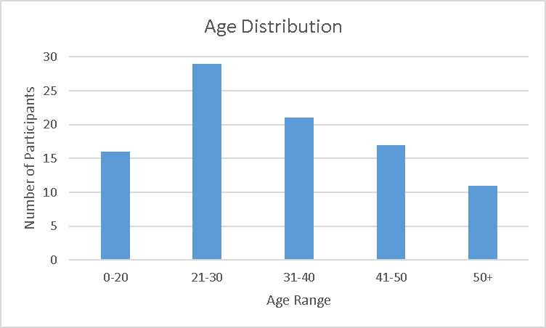
Figure 1- Age Distribution of Participants

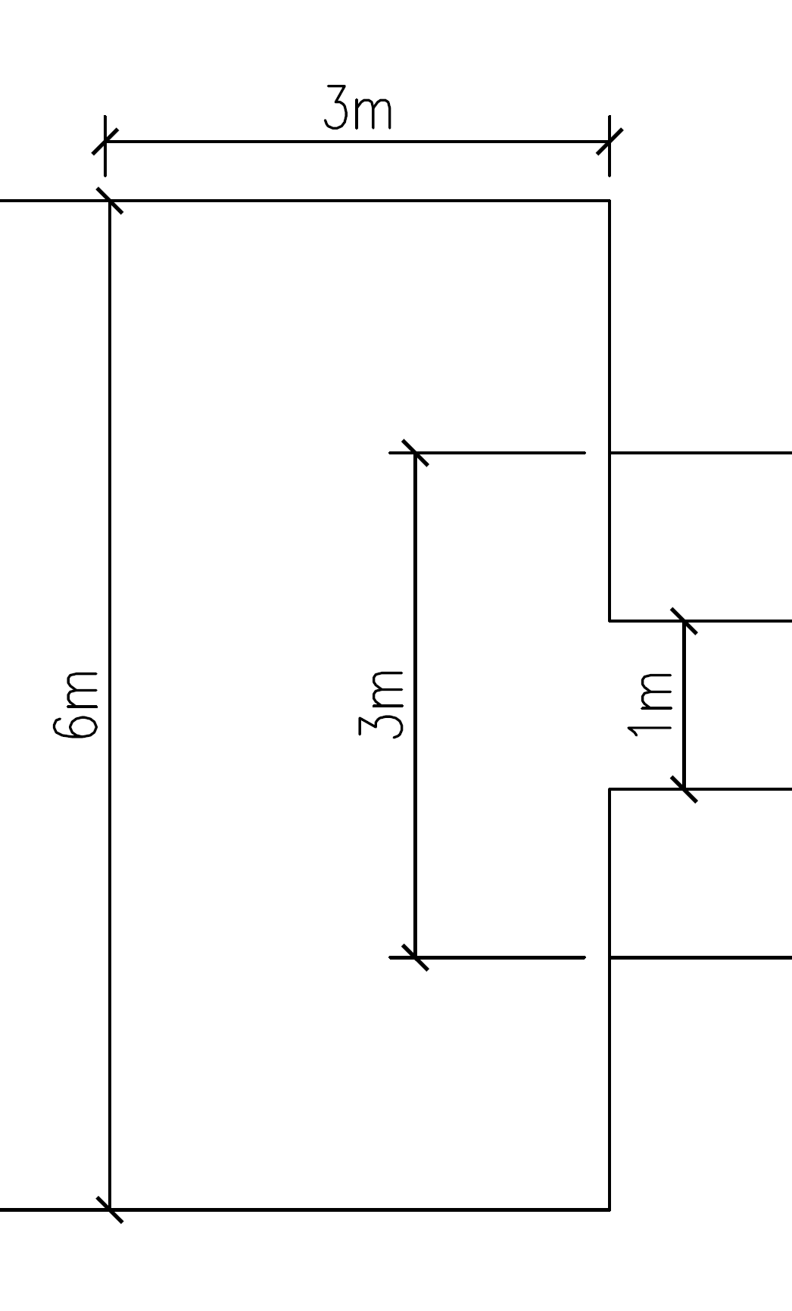 | 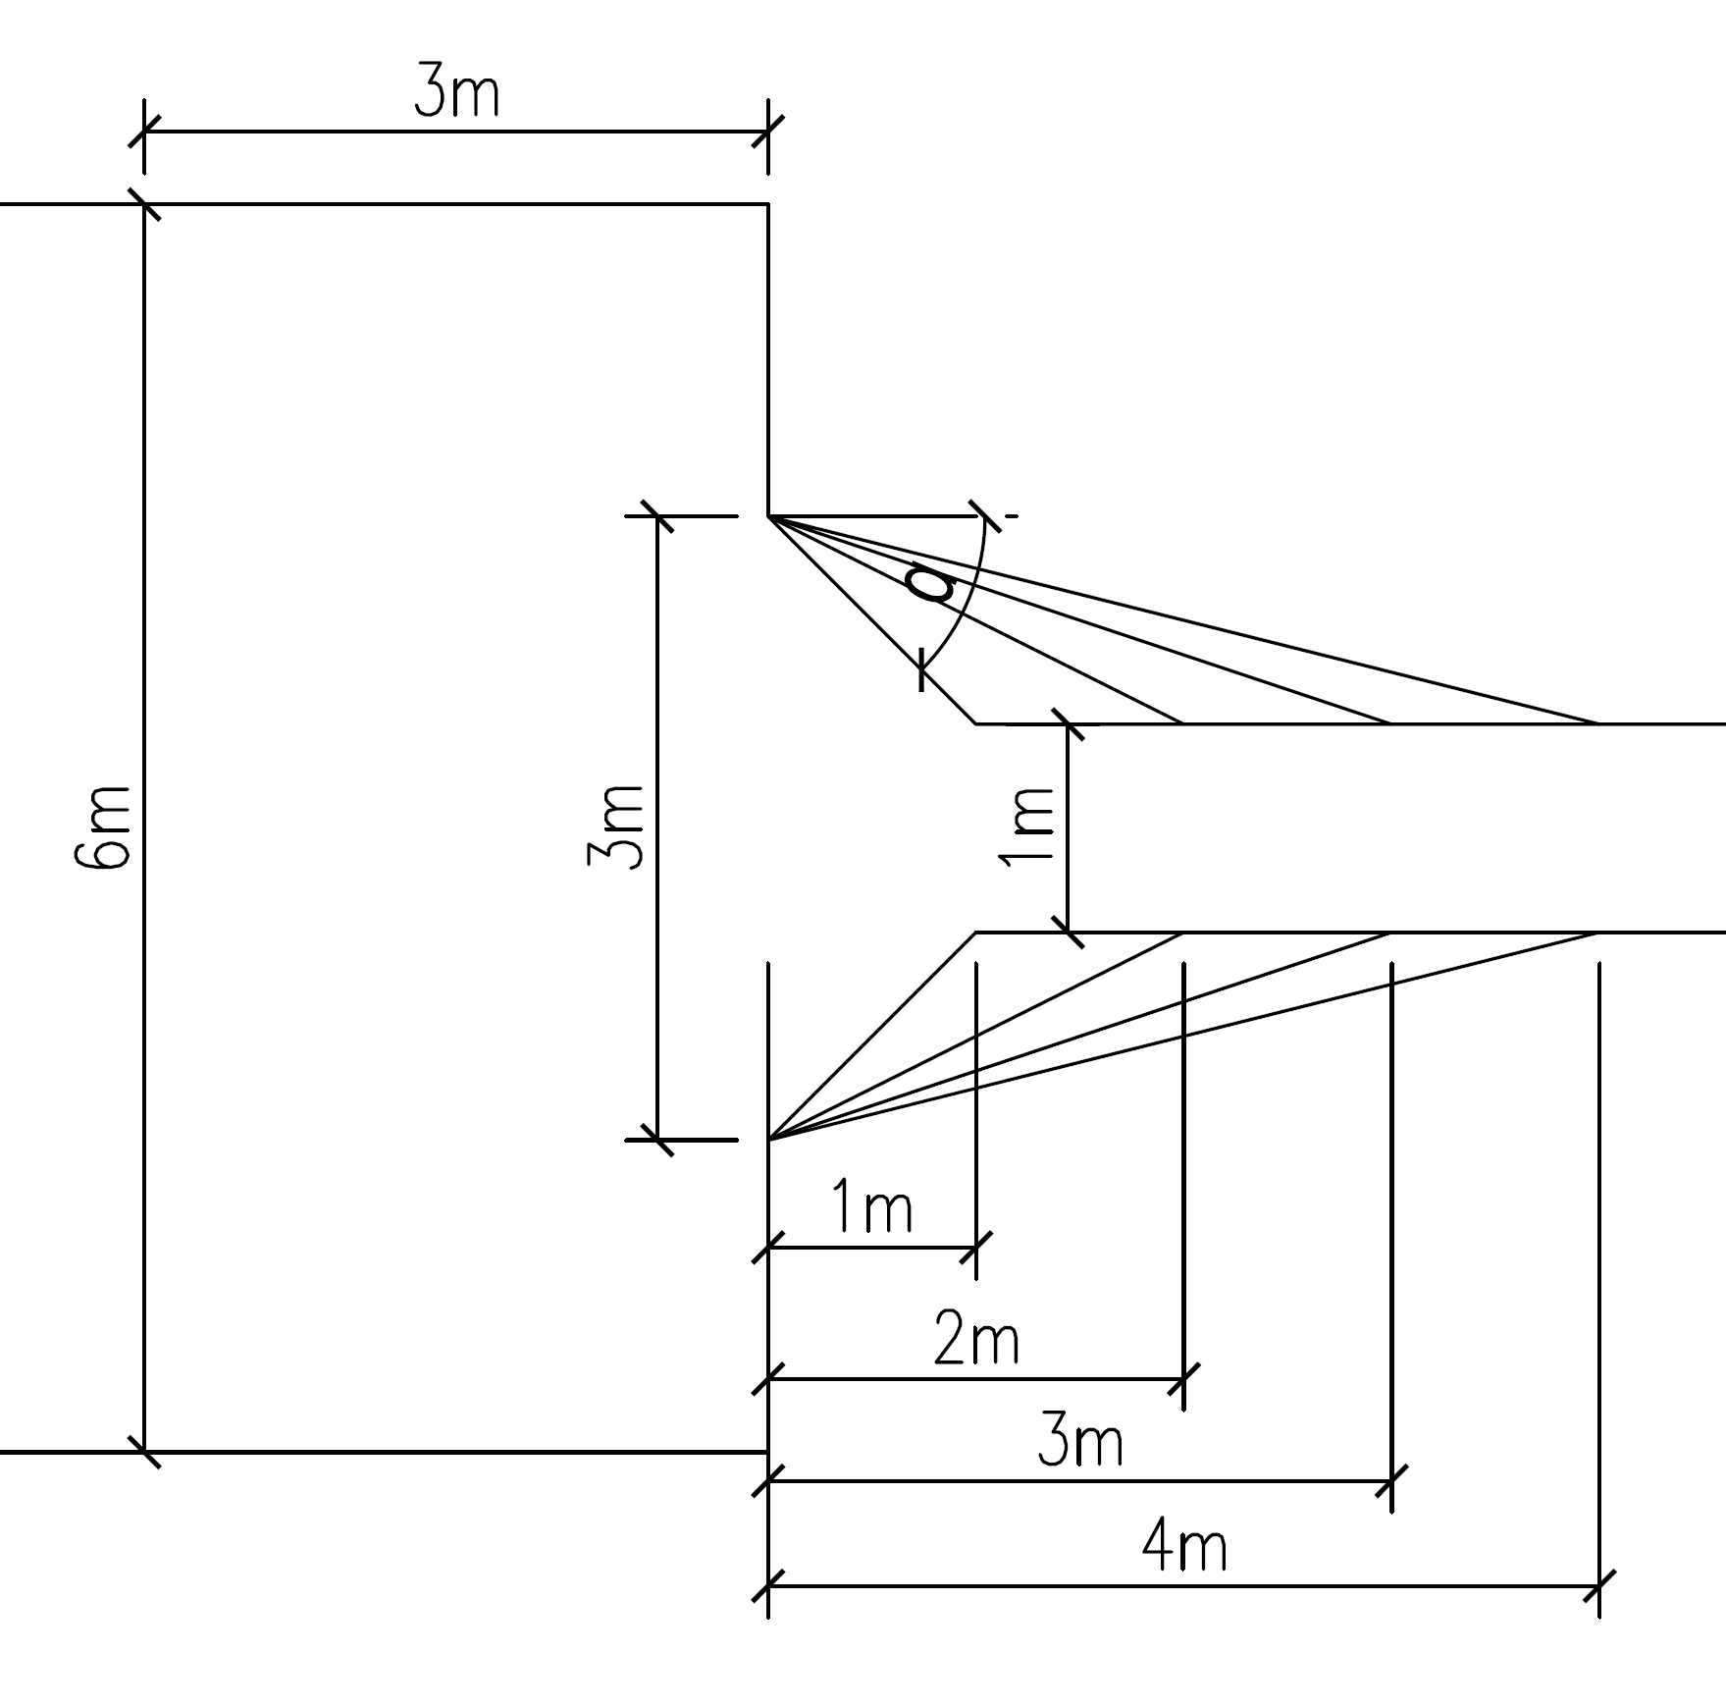 | 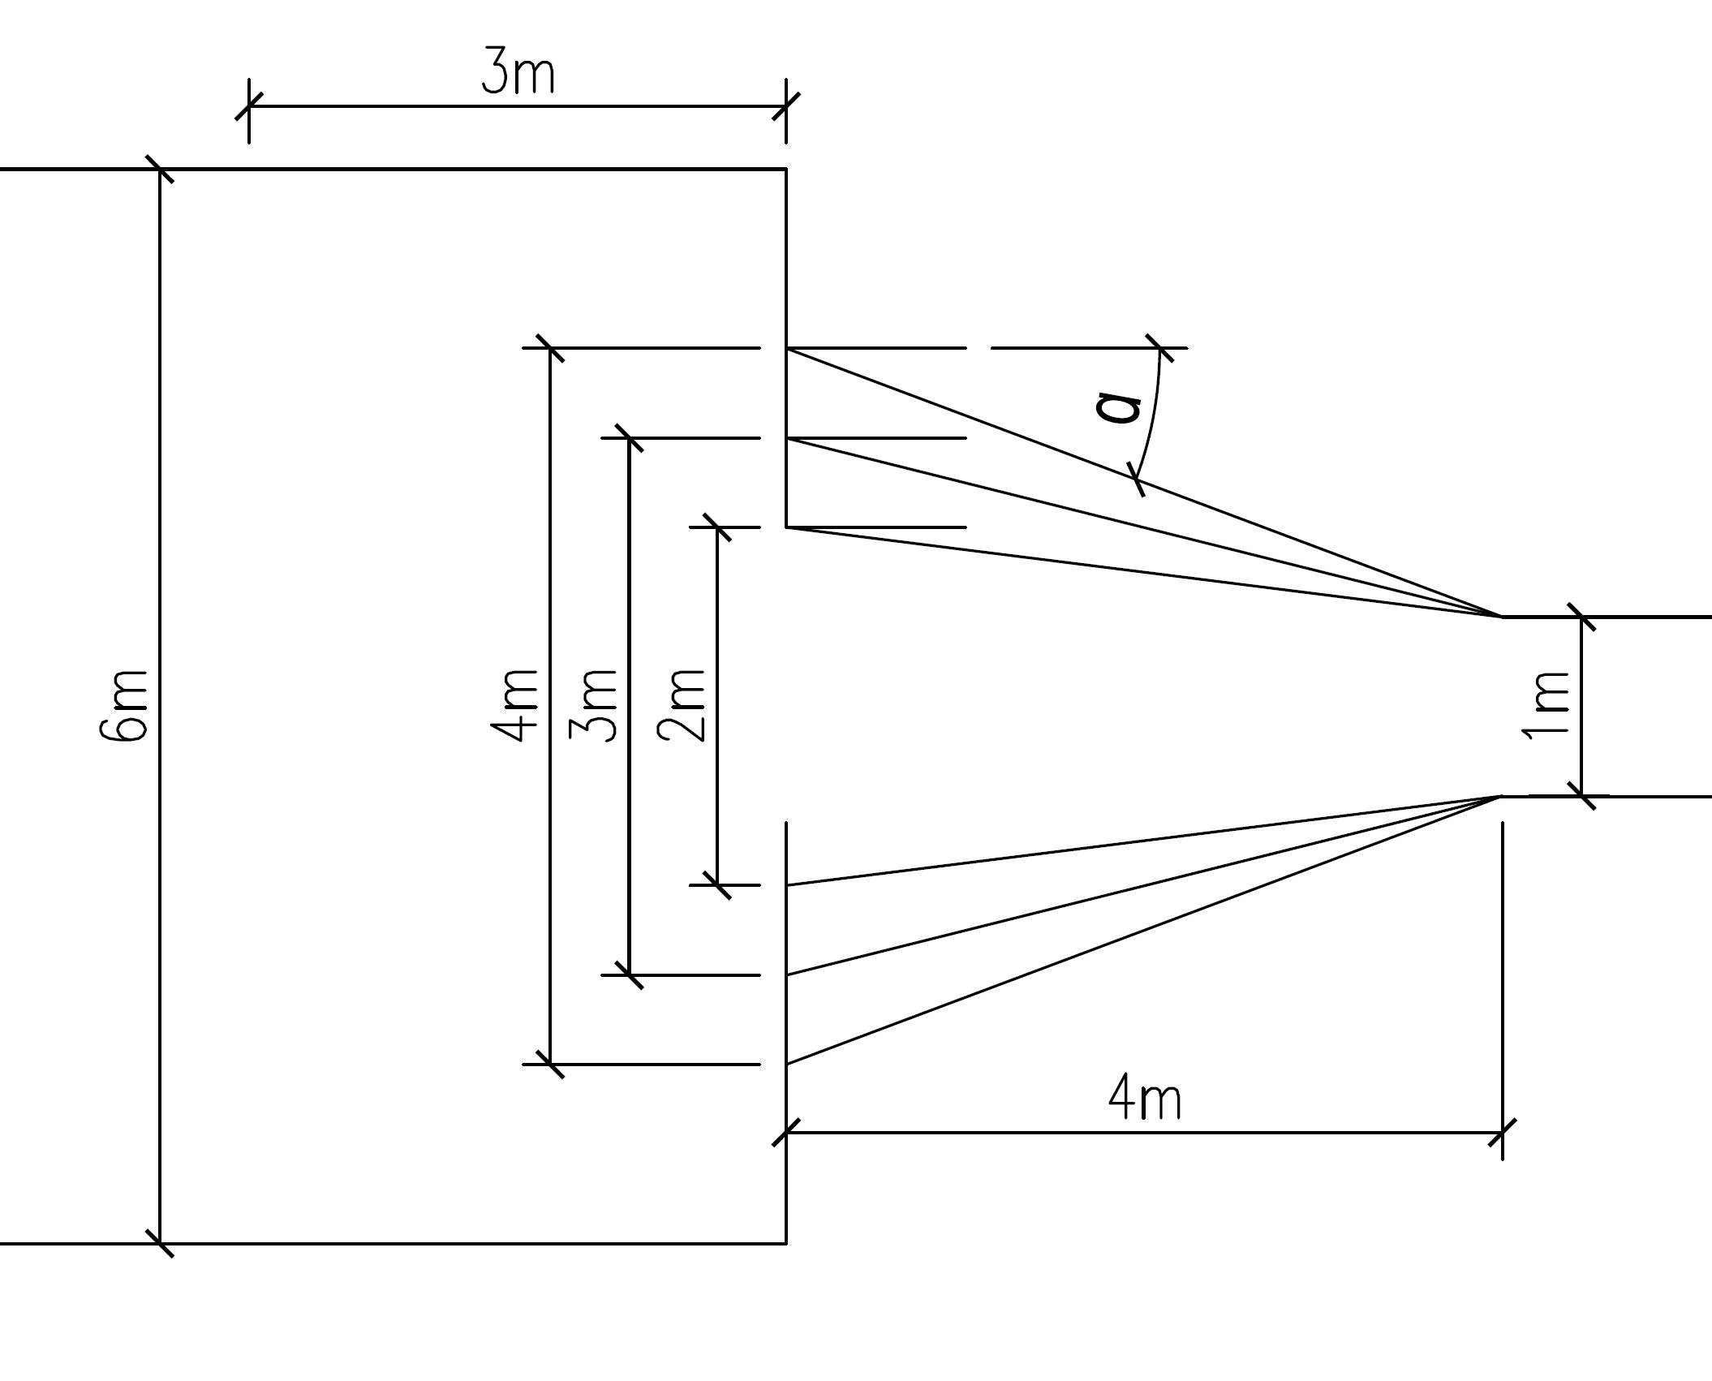
a | b | c
Figure 2-a) narrow 1-meter-wide bottleneck and 3-meter corridor b) first scenario, changing the funnel-shaped bottleneck with changing the length c) second scenario, changing the funnel-shaped bottleneck with changing the large-width

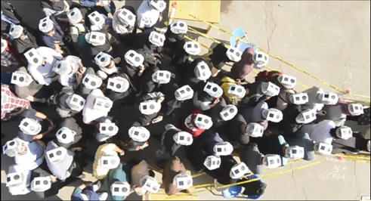
Figure 3- Screenshot of the experiment
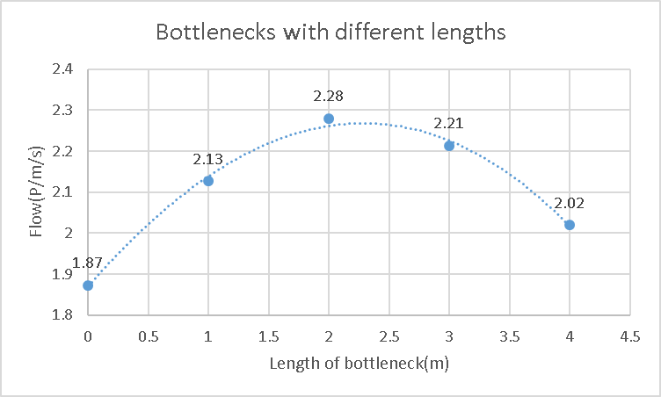
Figure 4- Diagram of flow vs. length of bottleneck for bottlenecks with different lengths (Large Width=3m, Small Width=1m)

Figure 5- Diagram of flow vs. large-width of bottleneck (Length=4m)
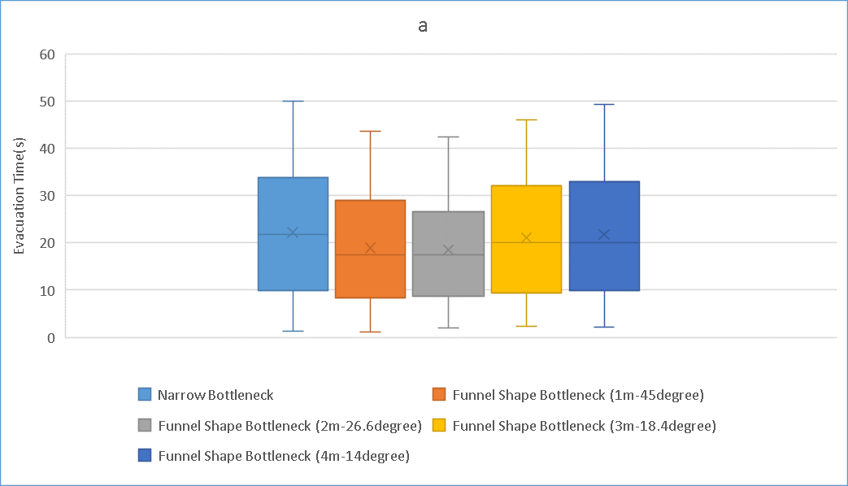
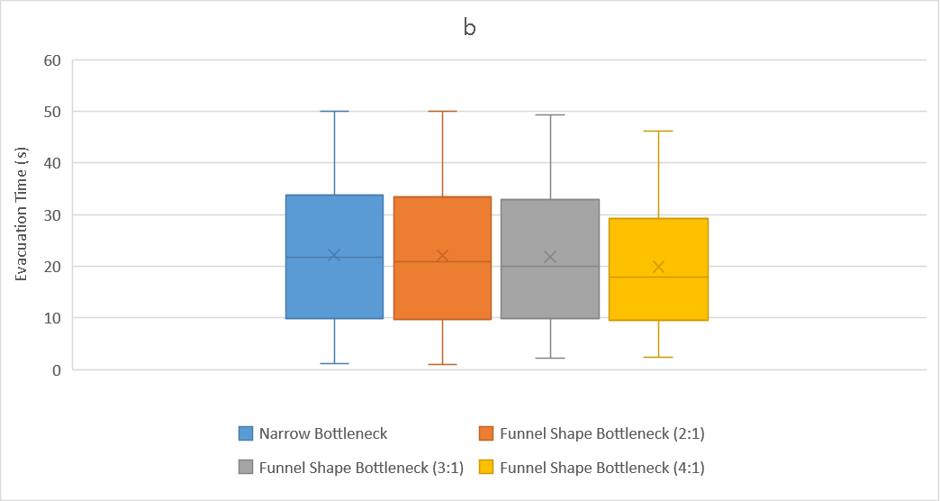
Figure 6- Box and whisker diagram for evacuation time in a) bottlenecks with variable lengths, b) bottlenecks with variable large-width
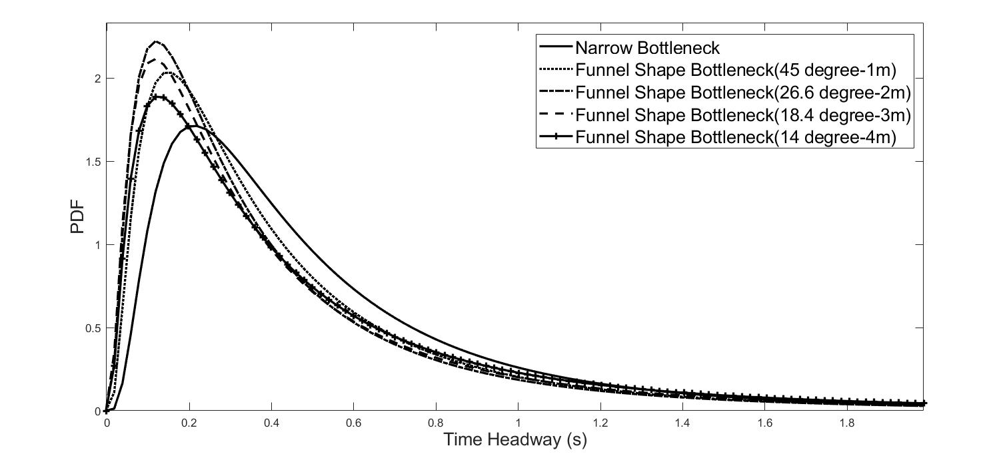
Figure 7- Comparison between lognormal distributions for bottlenecks with variable lengths
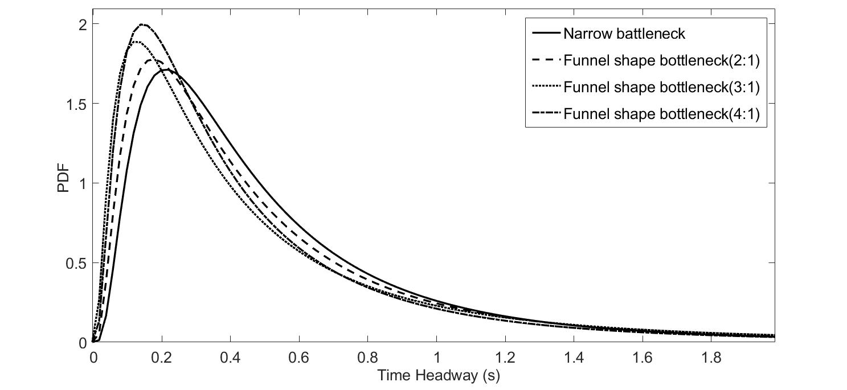Figure 8- comparison between bottlenecks with variable large-widths
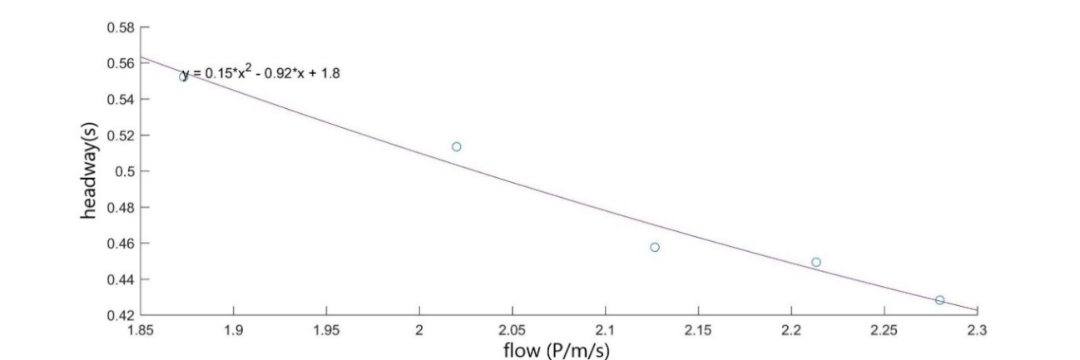
Figure 9- Diagram of headway vs. flow for scenario 1
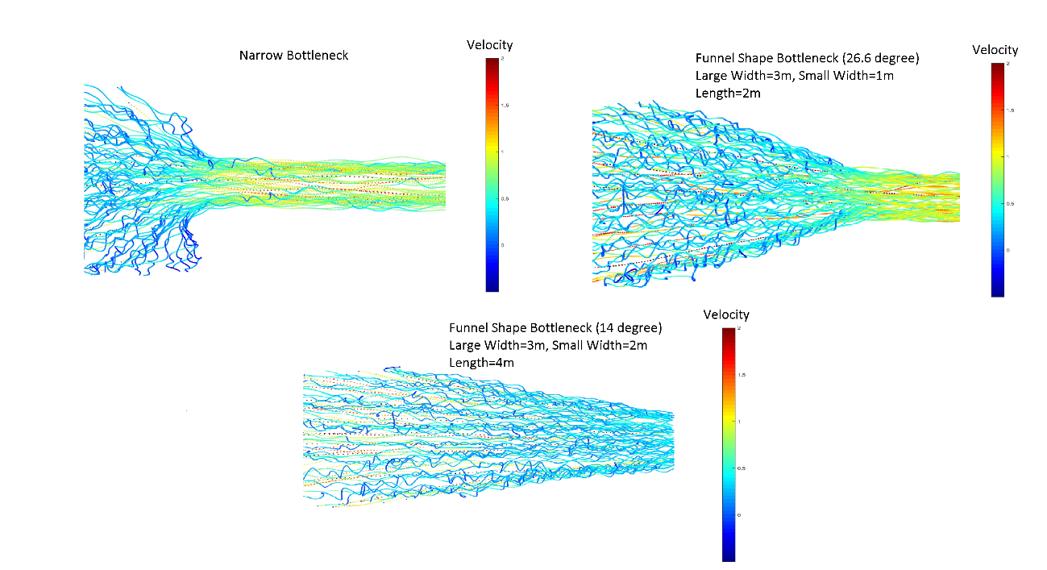
Figure 10- Trajectories of narrow and funnel-shape bottlenecks with different length (In all shapes Large Width= 3m, Small Width= 1m)
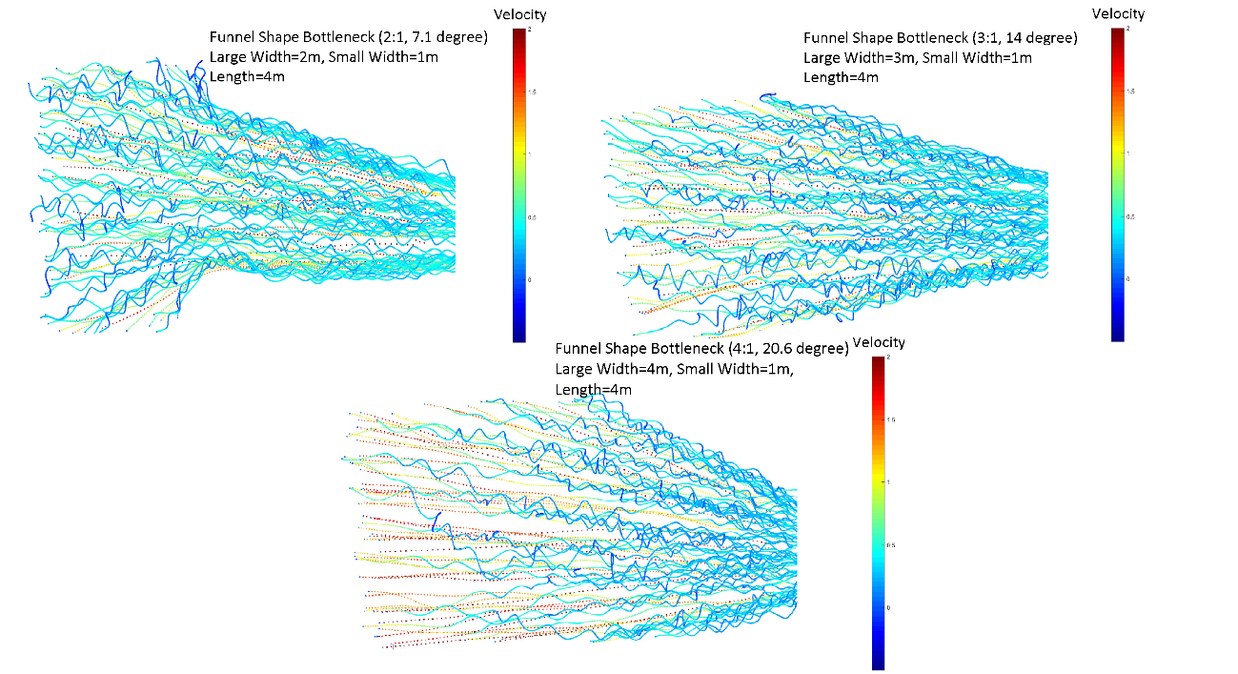
Figure 11- Trajectories of bottlenecks with different large-widths (Length= 4m in all shapes)
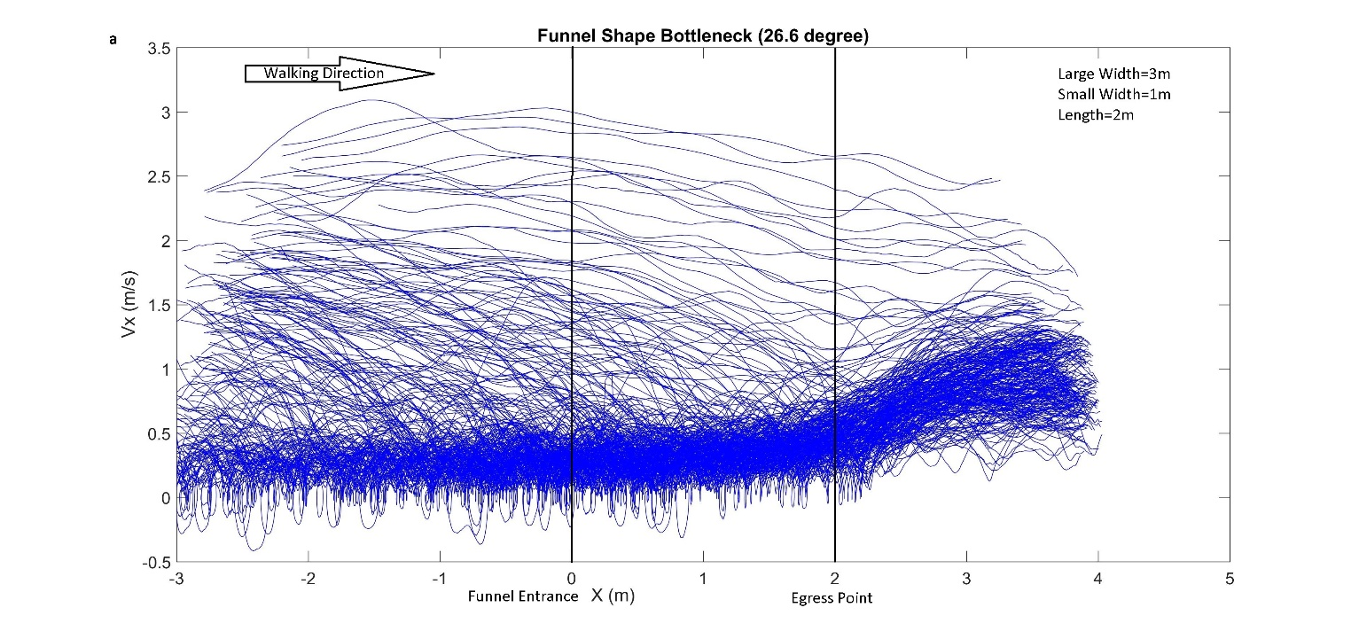
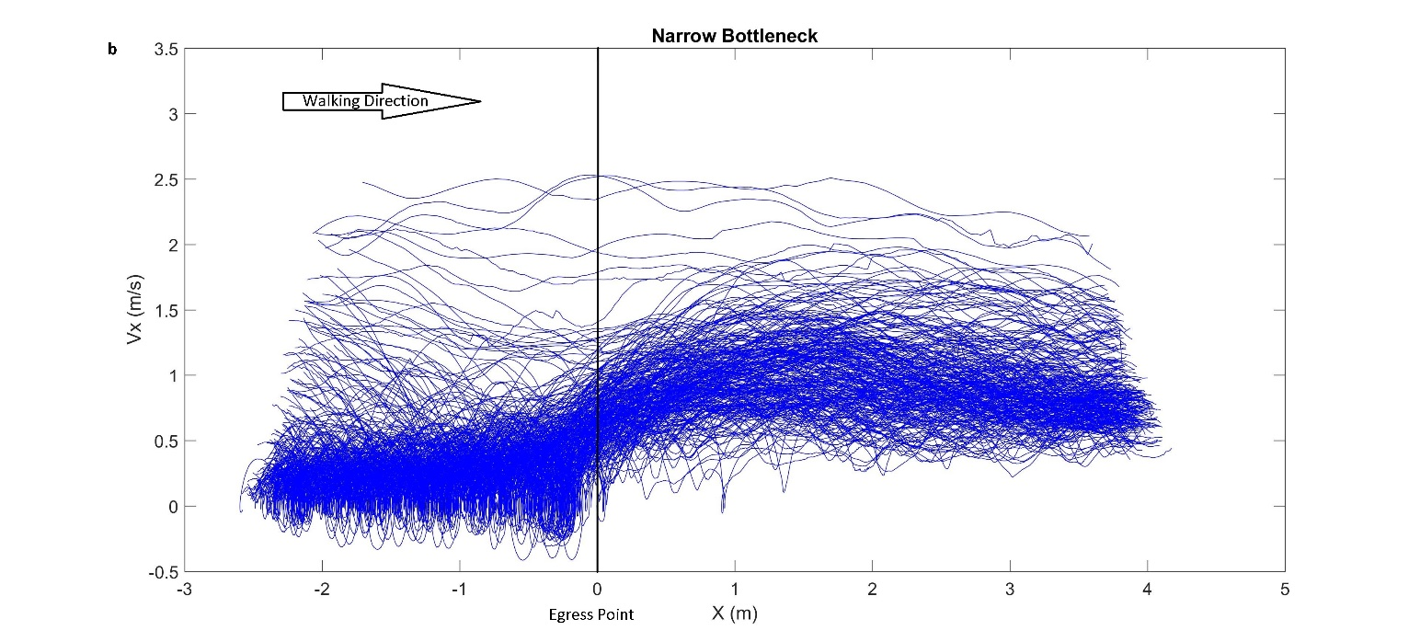

Figure 12- Diagram of velocity vs. walking direction (X)
a- funnel-shaped bottleneck with length of 2 meters b- narrow bottleneck

