TRIP : An international symposium exploring the role and relevance of traditional ‘hand skills’ in contemporary textiles, and the value and status of craft process.

Experimental archaeology meets textile design: the rediscovery of shadow tissues.

Introduction:

This Leverhume research award is investigating the lost textile technique known as ‘shadow tissue’. It is an exciting collaborative project bringing together expertise from different design sectors:
- Trish Belford, the Principal Applicant, textile designer of international standing, active in creative practice-based research and design education.
- Dr Philip Sykas, Co-applicant a design historian known for his work in bringing together textile manufacturers’ design archives, the history of technology and company history;
- Paul Turnbull, Managing Director of Turnbull Prints Limited, a firm printing textiles for the high-end furnishing market, and holder of the Turnbull and Stockdale archive
- Postgraduate Research Assistant: Beth Milligan, specializing in weave.

Ultimately the research is practice based, but the initial strengths and depth rely on the gathering of evidence led by Dr Sykas, this is not only as a historical and theoretical exercise but utilizing archaeological techniques, working with original samples produced by Turnbull and Stockdale in the 1920’s and 1930’s, now preserved in the privately owned Company archive. The initial research aims to recover technical information about Turnbull and Stockdale’s developmental contribution to the ‘shadow tissue’ printing methods, and then to apply this knowledge to creating trial-stage contemporary textiles. The intention is not to learn how to mimic old techniques using new technology. Instead, a multi-faceted historical and artefactual analysis, creative practice, and entrepreneurial skills will be harnessed together to generate new textile products suited to current use. Nevertheless, the end products are to be reflective of a thorough understanding
of past design knowledge.

RE-Discovery: Aims and Methodology
The initial investigation by Sykas is multi disciplinary in nature, drawing from design and business history, material culture and history of technology. A secondary and no less important aim is to reclaim technical information about the shadow tissue process. When things are made in an industrial context, there is much tacit knowledge that never gets written down. Thus the artifact exploration being carried out is to delve into the realm of experimental archaeology in order to recover some of the lost ‘know-how’.

It is the knowledge of process and construction that is sought. This is not a new notion and perhaps in this digital era, as designers, we should reflect on the designers McLeish’s words (1920) ‘ We are so made that nothing but using brain and hand together, in some way or other, enables us to grasp facts.”
In this spirit, we see that experimental archaeology allies well with the designer’s native way of gaining technical understanding.

The latter part of the research and probably the most challenging and interesting is to apply the historical and practical knowledge to the creation of textile samples in tune with current trends. Bringing into play new technologies and materials to create innovative fabrics, but inspired by the research and the discovery of unrecorded methods of process.

RE-Invention: Research Plan

The research is being undertaken in stages whereby the historical and practical aspects of the project are able to inform each other. Currently the research is in early stages and this paper will chart the research process and challenges in understanding traditional and unrecorded methods in line with positioning this knowledge in the current climate of research and industrial importance.

Historical Stage 1
The paper archive housed in a private residence on The Isle of Man, was first visited during the period from February to April 2011. This was a time for exploration, illustrated by an eloquently written report. Sykas painstakingly sifted through elegant mahogany plans chests, plus many boxes to uncover and attempt to bring order to numerous manuscripts, designs, photographic documents and pattern books. The process of digging through densely piled artifacts has lent vitality to the archaeological metaphor of the project, but unfortunately the archive was found to be in such a state of dishevelment that dating and structure will require further work ‘Survival of documents is uneven, with the most notable groups being documentation of shares upon the decease of shareholders, monthly / annual sales figures, records of the 1921 Glasgow exhibition. The monthly sales figures are especially relevant to this project as sales are broken down into categories, with shadow tissues itemized separately. Figures are available from December 1928 to August 1942. Shadow tissues begin at a peak in 1928 representing nearly a 1/5th of total sales (19%) and show a slow and steady decline to 5% in 1935/36 and down to 1% in 1939/40’. However the determination to keep shadow tissues alive was commented on by Captain William Turnbull in the Cabinet Maker in 1932 when he foresaw the continuing development of the technique:
“Every new season continues to be marked by new ideas, either of designs or yarns – or both.” This clearly illustrates the company’s interest in design and innovation.

IMAGES FROM 1ST STAGE REPORT BY DR PHILIP SYKAS

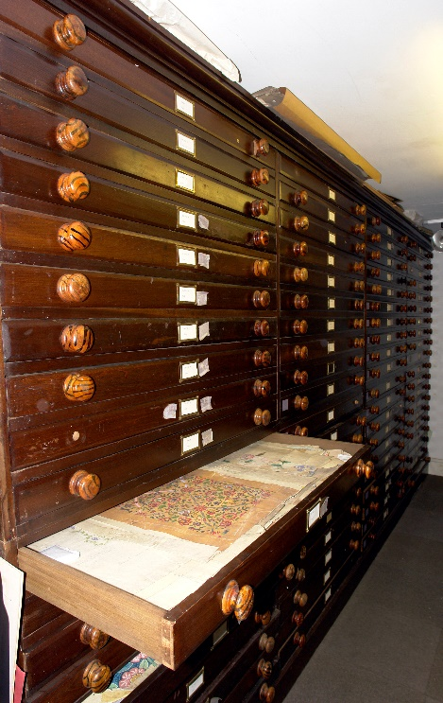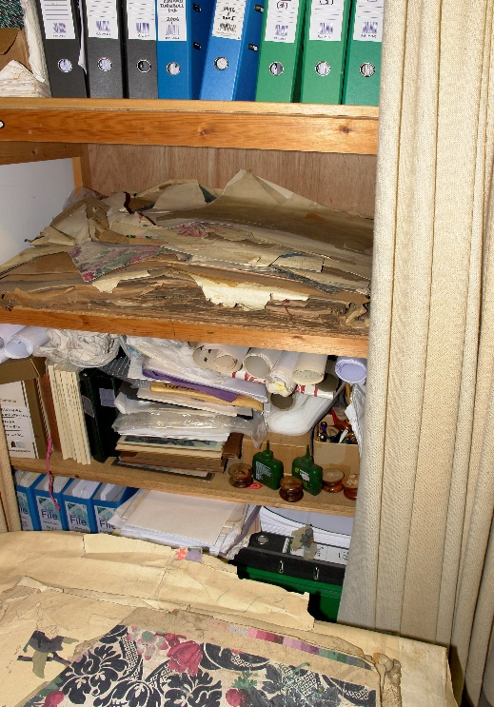

Turnbull & Stockdale archive – Isle of Man – Apparent order and chaos

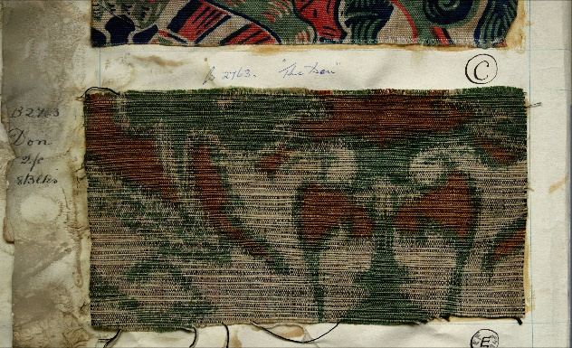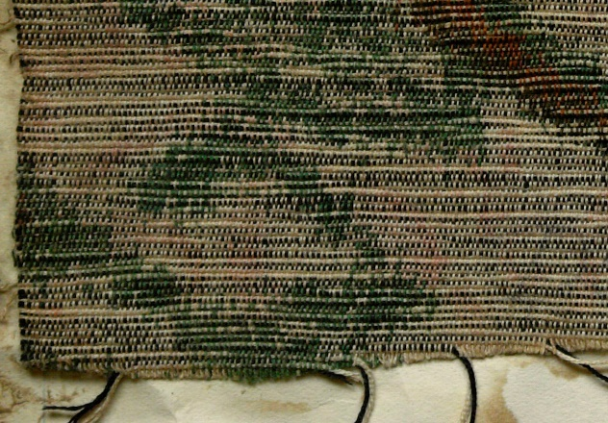

Rosebank Cretonnes 46. Sample from 1912 showering a jaspered ground; this effect is produced by variegated dyeing of yarn while in skein form before weaving.

The knowledge gained will be applied through creative practice to evolve new ways of exploiting the technique introducing current materials and technologies. Ultimately, a series of sample-stage products will be developed that which are capable of being taken into commercial production.

PRACTICAL STAGE 1
For a textile designer interested in the process of making, this stage is the most exciting, but also challenging as we are bound by the historical findings to understand and feel the technique, before embarking on any new constructions.
Working with Research Assistant Beth Milligan, we began by digesting the report sent by Sykas. This presented itself with the vastness of the archive still not uncovered. Inspecting some of the original samples, their beauty and integrity has most possibly come about from their age. However in this fast moving and digital textile era I began to think that we were also responding to the fact that there was an evident understanding of process and skills, this is emphasized by our desire to ‘get back’ to the non generic aesthetic.
Practical research began with investigation and experimentation of the ancient printing/colouring techniques of Ikat and Katsuri. From the information we gathered, we began to gain an understanding of the process.

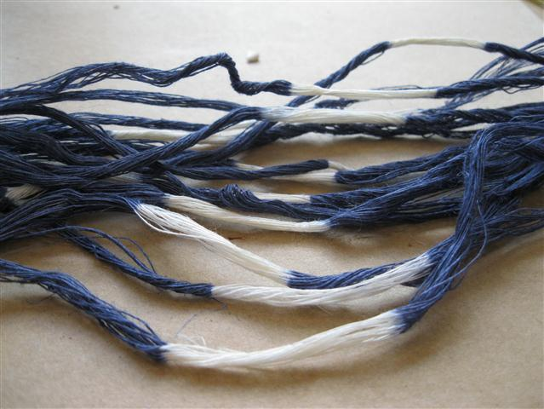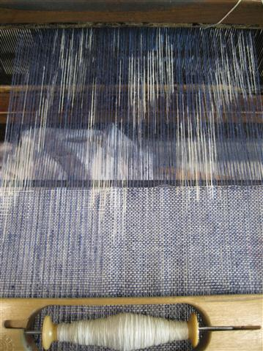
IKAT TECHNIQUES

The next step was to apply basic screen and digital printing techniques; this was to determine the extent of warp slippage and factors that affected this problem.

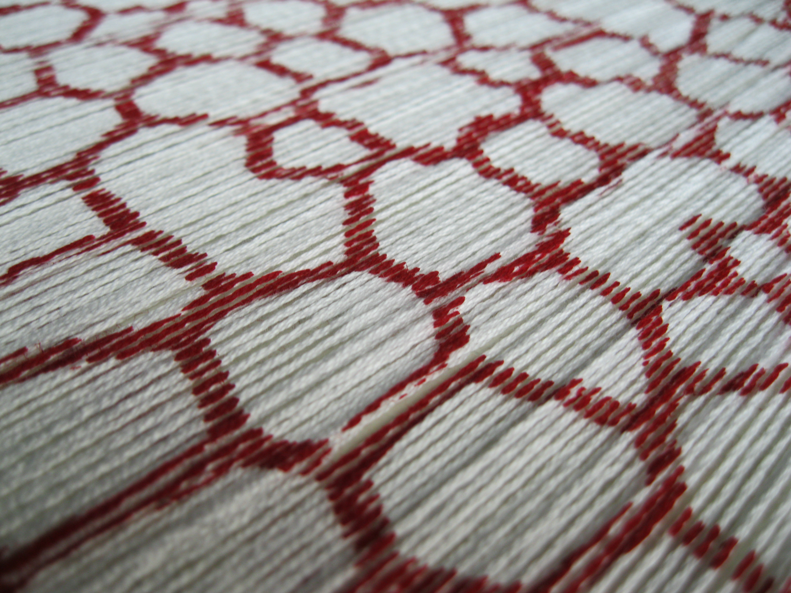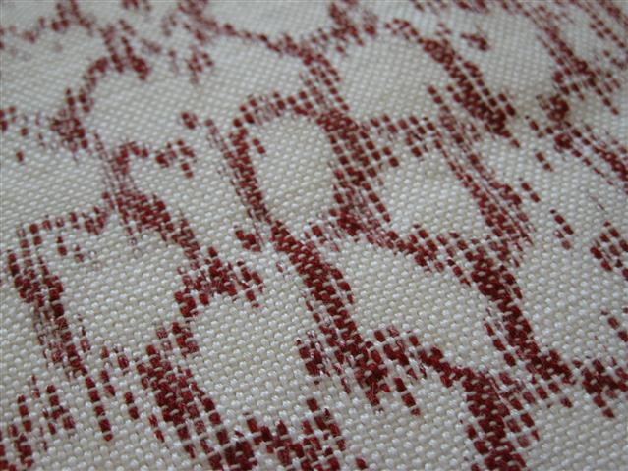
PRINTED WARP THREADS AFTER WEFT INSERTION

- Following these trials we selected a suitable design from the archive, Abbotsford, is made of 14 screen separations and challenging in the colourmatching and overprint methods. The design will be printed by screen and digital, initially matching in character and yarn of the original but swiftly moving on to generate new constructions. Relevant information gleaned from the report will be utilized to produce samples, in particular the reference to two of the pattern books from the 1920’s noting that the constructional technique of using wefts of two contrasting colours thrown in the same shed, was widely used to create a random effect, interacting to give a rich visual textural quality. In the shadow tissues, the randoimised texture of the weft effect complements the uneven slippage of printed warps, further breaking up the edges of the design and making it more ‘shadowy’. However as we have progressed, it is apparent there is a fine line between acceptable ‘shadowy’ effects and obvious slippage

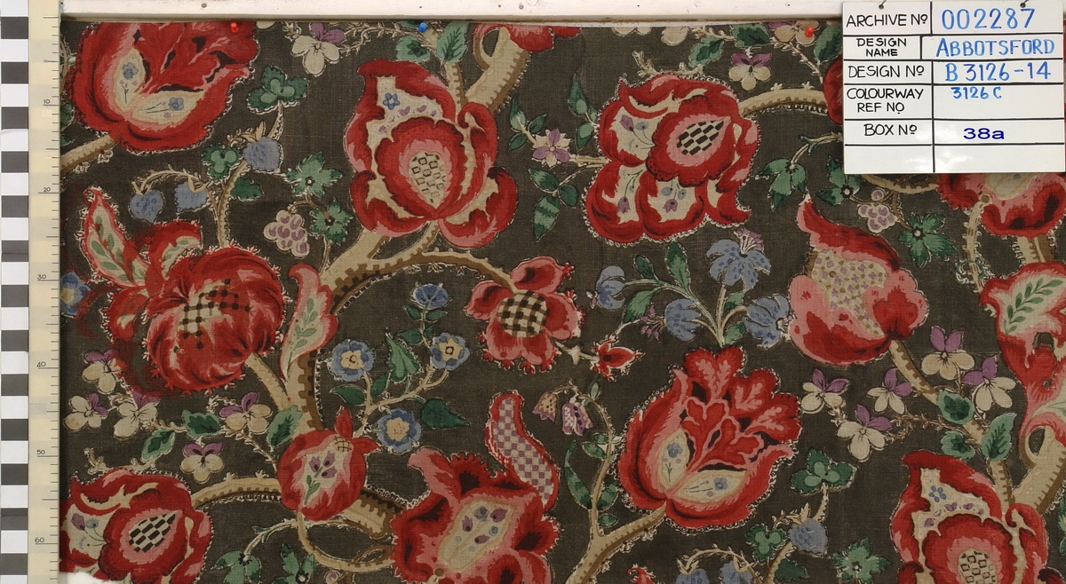

During this period of replication and understanding the techniques employed in the past, we will in parallel be researching and experimenting with alternative weft insertions and yarn constructions. This will not necessarily be an arbitrary selection but will be based on historic observations of contrasting yarns. Contemporary yarns will be researched but we will retain the contrast of:
- Colour (dark and light)
- Texture (smooth and slubby, or thick and thin)
- Lustre (matte and bright)

From an initial practical perspective one of the problems to overcome has been prevention of warp slippage, and from initial trials, even with the greatest of care, a slight slip or area of uneven tension could ruin a design. The days to create the warps is and was extensive, illustrating the time and care taken during the archive years to perfect this process. Developing the depth of colour on the warp has also been extremely difficult, and as each part of the process is related to the next, the full effect is not understood until the end of the process, an indication of the huge amount of development and attention to detail at each stage. This illustrates the crafted and precise approach of all parts, building up to the final outcome, something in this digital age, we overlook by just trying to achieve a mimicked effect. Individual threads can twist and move, making the image distorted. However in the past, many 100’s of metres of fabric were commercially produced making this look seamless.

CONCLUSION

This research will open up an important private design archive to academic study for the first time. It examines a very particular process in the history of textiles, but is one with great potential for exploration and exploitation. It allows for close collaboration of historical, creative and commercial exponents, and will provide a potential model for future research. Textile designer and art educator Minnie McLeish proclaimed in the 1920’s, ‟There is a whole vast world of knowledge wrapped up in a piece of patterned cloth.” This research sets out to unpack some of that knowledge, to demonstrate the rich inheritance untapped in our archives, and how this still continues to resonate in the world of design today.
The project is still in its early stages and will have several outcomes:
- Archival recording of designs and samples relating to shadow tissues in the Turnbull and Stockdale archive.
- A group of textile samples illustrating historical technique, with written explanation of methods, and the insights gained in their practical execution.
- A Limited edition of pattern books containing samples to touch, and an explanation of the historical and contemporary route taken to achieve the end results. These will be offered to appropriate academic, museum and educational libraries.

During this project experimentation, questioning, and mechanical practice are all engaged in pursuit of the end product, harnessing and understanding traditional methods and applying the knowledge to lead to innovative and current end products.

Patricia Belford 7th October 2011

McLeish, M. (1920) “Colour and form”, Cabinet Maker, 8 May & 12 June 1920, pp.277&560.
Sykas, P.A (23rd May 2011)

