a ligno-cellulosic bio-adsorbent derived from sawdust waste for the removal of meropeneM antibiotic dissolved in water
Tretsiakova-McNally, S.¹, Solan, B.¹, Currie, R.¹, Akinsanmi, O.², Arnscheidt, J.², McDermott, R.¹ and Coleman, H.M.³
¹Belfast School of Architecture and the Built Environment, Ulster University, UK,
² School of Environmental Sciences, Ulster University, UK,
³School of Pharmacy and Pharmaceutical Sciences, Ulster University, UK

Corresponding Author Email s.tretsiakova-mcnally@ulster.ac.uk

Abstract
The discharge of antibiotics into the aquatic environment is a serious concern for scientists and engineers around the world, due to the development of antimicrobial resistance. The situation is complicated by the dwindling supply of effective antibiotic treatments for so called superbug infections. Therefore, an effective method for the removal of these contaminants from wastewaters is imperative. This study explores the possibility of using ligno-cellulosic substrates derived from sawdust waste as bio-adsorbents of meropenem antibiotic dissolved in water. These bio-adsorbents can be readily incorporated within existing tertiary treatment filters at wastewater treatment works. The sawdust was used in two forms: untreated fibres and the substrate obtained following a treatment of the raw sawdust with 2M sulfuric acid. The high level of meropenem removal from contaminated water was comparable with current industry standard treatment (activated carbon), which is expensive. For example, the adsorption of meropenem on raw sawdust packed in a fixed filtration bed resulted in a 92% removal, while the use of treated sawdust had led to a 96% removal of meropenem from its aqueous solutions. Thus, the ligno-cellulosic substrate from raw and acid-treated sawdust waste has the potential to be an effective low-cost bio-adsorbent of meropenem dissolved in water.
Keywords
Adsorption, antibiotics, antimicrobial resistance, ligno-cellulosic substrate, meropenem, sawdust, wastewater treatment
Introduction
The use of antibiotics and the associated discharge of these substances into the environment is a serious concern for governments, scientists and wastewater engineers around the world. According to a recent report, almost 100,000 antibiotics prescriptions are issued by GPs in England every day (Fernandez 2018). The research carried out by Public Health England estimates that one in five of these prescriptions are not necessary (Fernandez 2018). With an ever-growing population, this trend is likely to increase in the near future. The varying amounts of antibiotics and their metabolites end up in wastewaters. Bienkowski (2013) suggests that almost a half of the drugs that are present in raw wastewaters are not eliminated by Wastewater Treatment Works (WWTWs) and simply pass through to the water courses. Consequently, this negatively affects aquatic life, soils and eco-systems (Baquero et al. 2008; Larsson 2014). The alarming phenomenon of antimicrobial resistance (AMR) occurs when microorganisms and bacteria, due to the prolonged exposure, become resistant to the actions of antibiotics. AMR is considered to be one of the greatest global public health challenges of the modern world (WHO 2014). For example, the World Health Organisation demonstrated that AMR has created a two-fold risk of mortalities and intensive care unit admissions in regards to E.coli, K.pneumoniae and S.aureus infections (WHO 2014). Three main issues caused by AMR include a reduced ability to cure common diseases, a backtracking of current medical advances, and a reduced potential to reach further medical goals (ReAct 2017). It is estimated that by 2050, the number of fatalities attributed to AMR will be around 10 million per year (The Review on Antimicrobial Resistance 2014; WHO 2014). Recently, the WHO commenced a surveillance into the impact of AMR and also compiled a list of antibiotics, which are at risk of losing their therapeutic efficacies due to the spread of resistance among priority pathogens (WHO 2017). This document includes meropenem (MER), the antibiotic belonging to the class of β-lactams, commonly used to treat medical conditions caused by gram positive and gram negative bacteria such as pneumonia, meningitis and urinary tract infections.
Although the awareness of AMR threats is growing (Daily Mail 2019), currently there are no regulations in place that control the concentration levels on antibiotics in wastewater discharges (Sayen et al. 2018). The information on the levels of wastewater pollution with MER is limited and is estimated to be in the region of 10⁻⁹ – 10⁻⁶ g/L (Hrenovic et al. 2017). The conventional methods of wastewater treatment (e.g. biological degradation, reverse osmosis and membrane filtration) are found to be only partially effective with regards to the removal of antibiotics (Metcalf et al. 2014; Sayen et al. 2018). Other treatment techniques including chlorination and ozonation may result in the formation of the unknown and even more harmful antimicrobial entities, thus contributing to AMR (Neth et al. 2017; Sayen et al. 2018).
Adsorption seems to be a promising wastewater treatment process alternative to the current direct intervention technologies. Owing to its versatility, it offers higher efficiency in relation to various contaminants, simplicity of the application and operation. Most importantly, it can deal with very low concentrations of antibiotics present in wastewater, from nanograms to micrograms per litre (Sayen et al. 2018). However, activated carbon, which is most frequently used at WWTWs, is an expensive material. Thus, research focusing on efficient and cheaper adsorbents that could replace activated carbon is becoming increasingly important. Ligno-cellulosic substrates derived from sawdust waste may hold the answer to solving this complicated problem. Nuamah et al. (2012) estimate that approximately 10 Mt of wood residue, including sawdust, is produced annually, thus making this by-product inexpensive, readily available and a sustainable alternative technology. This material is highly porous, with a high surface area and contain functional groups that can boost the adsorption of some organic molecular species dissolved in water. There are reports on the use of ligno-cellulosic materials to remove heavy metals (Zhang & Wang 2015), dyes (Suteu et al. 2008) and pharmaceuticals (Ribiero et al. 2011) from industrially polluted waters. Nevertheless, there have been only few studies which focus on the removal of antibiotics and the mechanisms behind their adsorption (Qureshi et al. 2015; Alidadi et al. 2018; Sayen et al. 2018).
The aim of the present study was to assess the potential of sawdust as an adsorbent within existing WWTWs to deal with antibiotic pollution. This paper reports on preliminary results obtained from the adsorption of MER on ligno-cellulosic substrates derived from the fibres of untreated and acid-treated sawdust. The degree of MER removal by these substrates was compared to its adsorption on the common industrial adsorbent – activated carbon.

Materials and Methodology

Materials and Reagents
All chemicals, reagents and solvents were purchased from Sigma Aldrich (UK) and used without any further purification. Meropenem, MER, (molecular formula: C₁₇H₂₅N₃O₅S; ionisation constants: pK_{a1} 2.9 and pK_{a2} 7.4; molecular weight: 383.46 g/mol) is a white crystalline powder that was stored in the dark at 4-8 ºC. In the present study, a pharmaceutical secondary standard (certified reference material) of meropenem trihydrate MER·3H₂O (molecular weight: 437.51 g/mol) was used. Aqueous stock solutions of MER were prepared by dissolving the pre-weighed powders of MER·3H₂O in both distilled and stream water at room temperature.
The sawdust was supplied by Diamond and Son Timber Company (Coleraine, Northern Ireland). The sawdust was sourced from Sitka spruce tree (Picea sitchensis), which is a coniferous and evergreen species dominant in Northern Ireland forest plantations. Activated carbon (Carbsorb 30) in its granular form (GAC) was purchased from Calgon Carbon Corporation (USA) and was used as a reference adsorbent.

Adsorption and Filtration Experiments
The adsorption experiments were carried out on sawdust or GAC (ca. 2 g) packed in a fixed filtration bed inside a glass column (internal diameter 22 mm) equipped with a PTFE stopcock. A pea-sized ball of glass wool was placed inside, at the bottom, of the column to prevent a possible loss of the adsorbent. A dropping funnel filled with aqueous MER solution (100 ml) was set up above the column containing the adsorbent in question. The solution was slowly added from the dropping funnel to the adsorbent inside the column. The stopcock was used to control the addition rate with the view to keep a constant level of liquid above the filtration bed. A funnel lined with a Whatman filter paper was positioned directly under the column to collect any solid particles suspended in an effluent. The filtrate was collected portion-wise into glass or plastic universal containers with screw caps. They were labelled and stored in a fridge until needed for testing. The first and the last portions of the filtrate (approx. 10 ml) were discarded. All the experiments were carried out at room temperature, in triplicates. The average contact time between MER solution and the particles of sawdust was between 29 and 32 s, while for GAC it was around 5 s.

Instrumentation Techniques
The particles size distribution (PSD) of the raw sawdust was carried out on a Malvern Mastersizer 2000. The moisture content of the adsorbents was evaluated gravimetrically, according to CEN/TS 14774-1:2004 by oven drying all the materials at 105±2 ºC until the constant weight is reached.
The Fourier Transform Infrared (FT-IR) spectra were recorded on a Thermo-Nicolet FT-IR, Nexus model 470 spectrometer, for the samples of raw and acid-treated sawdust. The spectra were obtained over a frequency range of 4000 – 500 cm⁻¹ in the attenuated total reflectance (ATR) mode with a resolution set at 4 cm⁻¹ and 64 scans. Each sample was air-dried in a fume hood, ground using a pestle and mortar to ensure homogeneity before recording the spectra.
The elemental compositions of raw and acid-treated sawdust was performed on a Perkin Elmer PE2400CHNS elemental analyser.
The morphology of raw and acid-treated sawdust particles was characterised using Scanning Electron Microscopy (SEM) with the aid of a JEOL JSM-6010 equipment operated at 15kV. The Brunauer-Emmett-Teller (BET) method was used to determine the surface areas of sawdust (both virgin and untreated materials) with the aid of a Micromeritics Tristar 3020 instrument. The measurements were based on the adsorption of nitrogen at -196 ºC (77 K).
The extent of MER adsorption on both types of sawdust and GAC was monitored by measuring the concentration of the antibiotic in corresponding solutions using High Performance Liquid Chromatography (HPLC). The samples of initial solutions and of collected filtrates were analysed on a Shimadzu HLPC instrument (CBM-20A model) fitted with a photo-diode array (PDA) detector operating at 299 nm. A reverse-phase HPLC was adopted here due to a poor solubility of MER in organic solvents by employing a reverse phase C-18 column (250 × 4.60 mm × 5 µm). The mobile phase for detection of MER was composed of ammonium acetate (12 mmol, 92 vol. %) and acetonitrile (8 vol. %) for the isocratic elution. All samples were analysed in duplicates, at a flow rate of 1 mL/min, at an injection volume of 20 μL. The level of MER adsorption was deduced from the concentration difference between the initial solution and the collected filtrate. The percentage of MER removal from water was calculated from the following expression:
$Removal \left(\%\right)=\frac{c_{i}-c_{f}}{c_{i}}×100\%$ (1)
where $c_{i}$ is the initial concentration of MER (mg/L); $c_{f}$ is the concentration of MER in the filtrate (mg/L).
The pH levels in MER aqueous solutions were measured using a Mettler Toledo SevenEasy pH meter.

Results and Discussion

Preparation and Characterisation of a Ligno-Cellulosic Substrate
The raw sawdust (RSD) was washed several times with hot distilled water and then dried in a fan-assisted oven at 100±2 ºC for 15 hours. The dried sawdust was ground using a Waring HGB55E blender and sorted to particle sizes between 46 and 460 µm with the aid of a Retsch AS 200 automatic sieve shaker on a set of standard sieves. The RSD particles that remained on the 250 µm sieve were collected to be used in the adsorption and filtration experiments. The particle size distribution pattern for RSD is shown in Figure 1. The D-values obtained for this adsorbent are: D₁₀ = 46.230 µm; D₅₀ = 231.290 µm; and D₉₀ = 455.039 µm.
Figure 1. Particle size distribution curve of RSD adsorbent.
The treatment of RSD with sulfuric acid (2M solution) was conducted with the intention of removing some lipids, proteins, polysaccharides and extractives from the material. The washed and dried RSD was mixed with 2M aqueous solution of sulfuric acid in a conical flask at 25 ºC. This suspension was stirred with an overhead stirrer at 900 rpm overnight to ensure the mixture uniformity. Then, the suspension was kept in the oven for 2 hours at 60 ºC to trigger an acid-catalysed hydrolysis of sawdust fibres and their associates. After that, the mixture was filtered under vacuum and washed with distilled water continuously on a filter paper until the pH of the washings reached neutral values. A pH paper was used to check the pH levels of the washing process. The acid-treated sawdust (TSD) was dried in a vacuum oven at 40 ºC for 12 hours and stored in a desiccator at room temperature. This treatment of sawdust not only improves the accessibility/reactivity of functional groups on the surface of the adsorbent but also increases the BET surface area of the adsorbent (Table 1). The RSD, TSD and GAC adsorbents were dried off, in an oven for 12 hours, prior to their use in adsorption and filtration experiments. The values of moisture content, surface area and elemental composition are detailed in Table 1.
Table 1: Characteristics of the adsorbents used in the current study.
Type of adsorbent | Moisture content, wt. % | BET surface area, m²/g | Elemental composition
 |  |  | C, % |  | H, % | N, % |  | S, % |  | O, %
RSD | 4.73 | 0.8261 | 47.06 | 5.96 |  |  | <0.30 |  | <0.30 |  | 46.98
TSD | 2.02 | 2.1827 | 47.17 | 5.89 |  |  | <0.30 |  | <0.30 |  | 46.94
GAC* | 0.49
* BET and CHNS analyses were not carried out

The main components of sawdust are cellulose, hemicellulose and lignin. Cellulose has a 3D structure stabilised by different types of bonding (hydrogen, van der Waals or hydrophobic interactions) between the so called macro- and micro-fibrils. The process of sawdust hydrolysis, catalysed by sulfuric acid, leads to a destruction of these intermolecular bonds within the cellulose fibres and results in the production of individual cellulosic fibres, which are clearly visible from the SEM images (Figure 2). This treatment was responsible for an almost 3-fold increase in the TSD surface area compared to RSD.
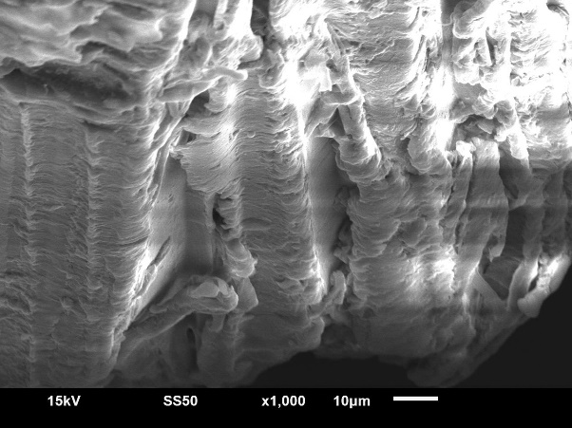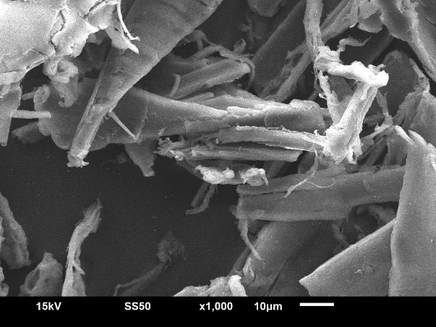
(a) (b)
Figure 2. SEM images of RSD (a) and TSD (b).
The FT-IR spectra of RSD and TSD (Figure 3) were characterised by the following features: the broad bands at 3,300 cm⁻¹ corresponding to the stretching of hydrogen bonded hydroxyl (-OH) groups; the peaks at 2,900 cm⁻¹, which can be assigned to C-H stretching in methylene (CH₂) groups; the bands at 1,730 and 1,620 cm⁻¹ attributed to carboxylic groups (-COOH); a set of signals in the region from 1,500 to 1,000 cm⁻¹ assigned to various lignin constituents such as guaiacyl and syringil units; the peaks at 890 cm⁻¹ indicative of a β-glycoside linkage between elementary glucose units of cellulose (Sayen et al. 2018). The FT-IR spectra of RSD and TSD with adsorbed MER revealed similar features, although with a slight shift in the peaks locations. This may indicate that some surface functional groups of RSD and TSD interact with those of MER and thus improve the extent of the antibiotic removal from water.

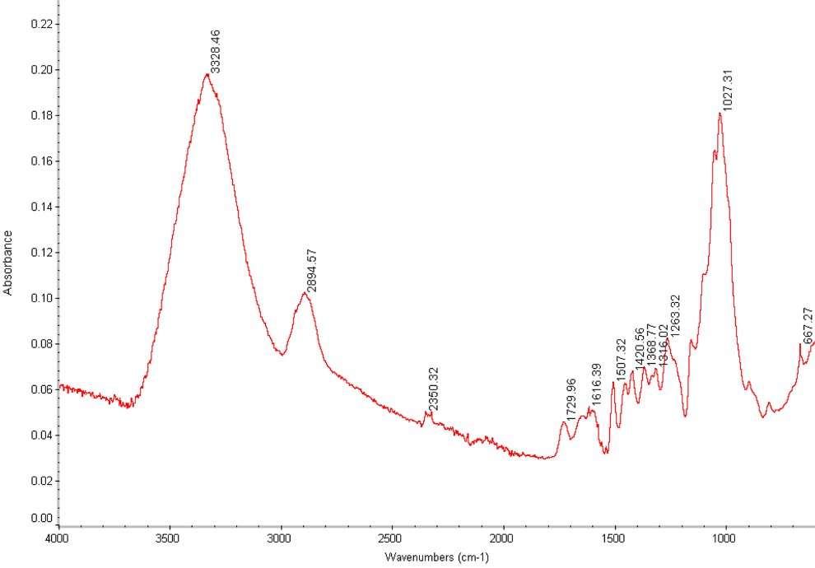
(a)
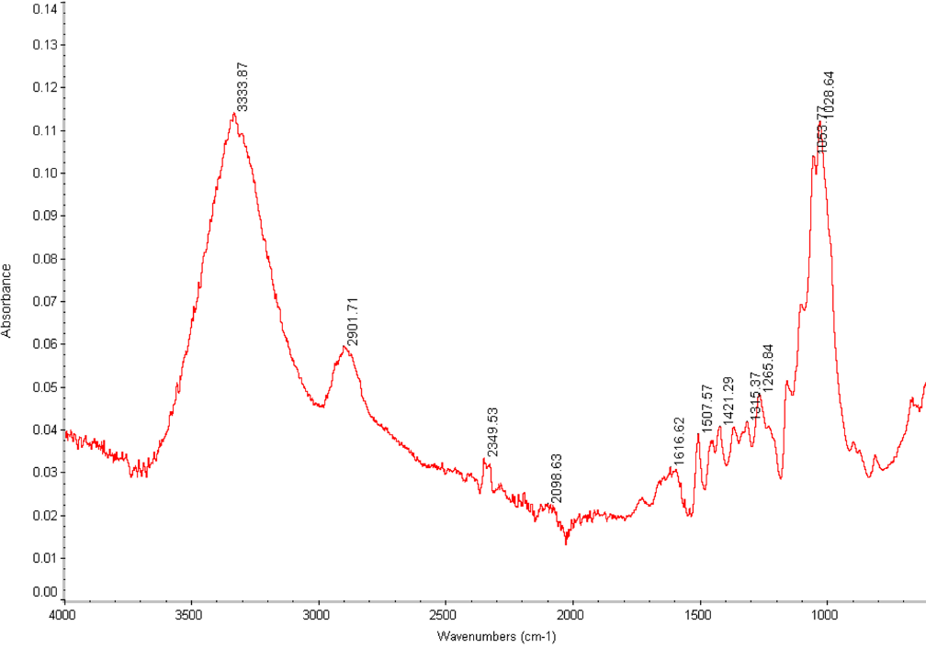
(b)
Figure 3. FT-IR spectra of RSD (a) and TSD (b).

Adsorption of Meropenem from Waters
The molecular structure of MER is given in Figure 4.
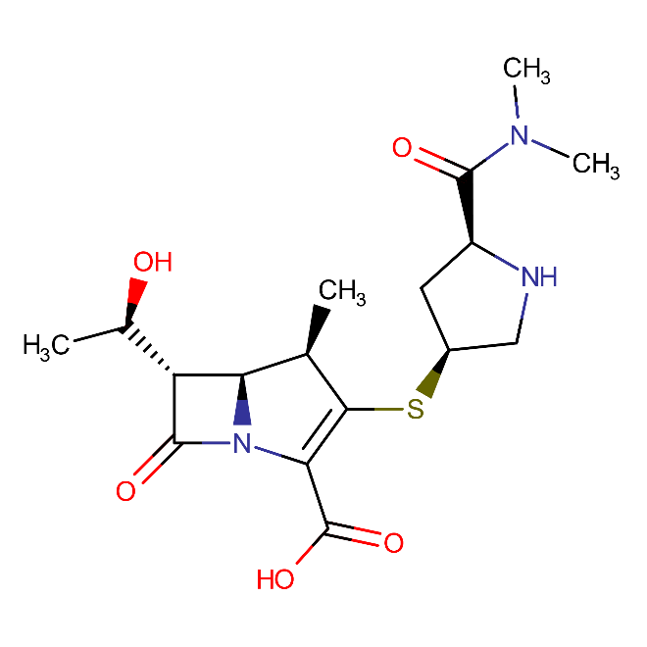
pK_{a2}=7.4
pK_{ap1}=2.9 2.9
pK_{a2} 7.4
Figure 4. Chemical structure of meropenem.
MER contains carboxylic and a pyrrolidinylamino groups (Figure 4). In the event of protonation the cationic form (MER⁺) is formed when pH value is below pK_{a1}. At pH above the value of pK_{a2} deprotonation of MER occurs and the anionic form (MER⁻) prevails in the solution. Due to the ionisation of carboxylic group MER can exist in zwitter-ionic form (MER±) that is predominant when the pH of the solution is in the region between pK_{a1} and pK_{a2}.
The point of zero charge pH_{zpc}, defined as the pH value, at which the surface of an adsorbent is neutral. It is a significant parameter used in predicting the behaviour and interaction of the adsorbent with molecular species dissolved in water. When the pH < pH_{zpc}, the surface of the adsorbent becomes positively charged, favouring the interaction with anionic moieties MER⁻. Conversely, when the pH > pH_{pzc}, the adsorbent has a negatively charged surface, thus capable of attracting cationic species MER⁺. The pH_{pzc} of RSD was found to be 4.0. Thus, it is evident that the adsorption of MER on sawdust adsorbent is highly pH-dependent. For example, it was found that the lower levels of pH = 2 in aqueous solution (i.e. pH < pH_{zpc}) provided almost 100% removal of MER. The positive surface charge of the sawdust and the electrostatic forces between the adsorbent and the MER⁻ in acidic conditions may be responsible for the higher adsorption efficiency. This work is currently ongoing and will be reported at a later date.
The bar chart on Figure 5 shows the values of MER removal (in %) from distilled and stream waters spiked with this antibiotic. The pH of MER solution in distilled water was 4.10 and in stream water – 6.84. It can be seen that TSD had yielded the highest level of MER removal: 95.9% for the solution in distilled water and 98.6% for MER dissolved in stream water. The corresponding values for a filter bed containing RSD are 92.4% and 86.6%. As for the industry standard adsorbent GAC, a 100% removal of MER from the solution in distilled water was achieved. With the exception of TSD, the level of MER removal from the stream water is lower than that from the solution in distilled water. This is possibly due to the presence of other pollutants in the stream water, which are also adsorbed by the active surface sites of RSD and GAC.

Figure 5. The percentage of MER removed from its solutions in distilled and stream waters by filtration through RSD, TSD and GAC beds.

Conclusions
- The preliminary results of this study indicate that a ligno-cellulosic substrate derived from sawdust can serve as an effective adsorbent for treatment of wastewaters contaminated with antibiotics.
- The treatment of RSD with 2M sulfuric acid generates the TSD adsorbent with improved ability to remove antibiotics from water, owing to higher surface areas and better accessibility of the surface sites. This adsorbent potentially can be used within WWTWs.
- The levels of MER removal by adsorption and filtration through a fixed filtration bed containing TSD was at 95.9% for its solution in distilled water and at 98.6% for the solution in stream water. These values are comparable to those obtained for the industry standard GAC adsorbent, commonly used in tertiary treatment of wastewaters. This is a significant result taking into account the cost difference, the availability and the nature of the materials being considered. The filtration through RSD also demonstrated high levels of MER removal from water: its concentration in distilled water was reduced by 92.4%. These high levels of the antibiotic removal from aqueous media were achieved by implementing only adsorption processes during filtration (no other steps such as disinfection were needed to achieve this result).
- The electrostatic forces between cations and zwitter-ions of MER and negatively charged surface of sawdust are mainly responsible for the adsorption mechanism. However, the role of hydrogen bonding, hydrophobic and π-π interactions cannot be ruled out. The optimisation of MER removal can be achieved by lowering the pH of the solution. This is an important parameter influencing the adsorption of MER and its effects should be studied further in detail.

Acknowledgements
The authors wish thank Dr Patrick Lemoine (NIBEC, Ulster University) for conducting SEM analysis. The authors also want to thank the Research Director Dr Jayanta Mondol (Ulster University, Belfast School of Architecture and the Built Environment) for sponsoring this submission to the 13th European Waste Water Management Conference in Birmingham.

References
Alidadi, H., Dolatabadi, M., Davoudi, M., Barjasteh-Askari, F., Jamali-Behnam, F. and Hosseinzadehb, A. (2018) Enhanced Removal of Tetracycline Using Modified Sawdust: Optimization, Isotherm, Kinetics, and Regeneration Studies. Process Saf. Environ. Prot., 117, 51–60.
Antimicrobial resistance: tackling a crisis for the health and wealth of the nations (2014) The review on antimicrobial resistance. Chaired by O’Neill, J.
Baquero, F., Martínez, J.L. and Cantón, R. (2008) Antibiotics and Antibiotic Resistance in Water Environments, Curr. Opin. Biotechnol., 19(3), 260–265.
Bostock, N (2018) GPs write 20,000 unnecessary antibiotic prescriptions per day, officials suggest [online]. GP online. https://www.gponline.com/gps-write-20000-unnecessary-antibiotic-prescriptions-per-day-officials-suggest/article/1458080 [accessed 12 June 2019].
Bukowski, B. (2013) Only half of drugs removed by sewage treatment [online]. Scientific American. https://www.scientificamerican.com/article/only-half-of-drugs-removed-by-sewage-treatment/ [accessed 12 June 2019].
Fernandez, C. (2019) Fish in British rivers contain traces of cocaine, ketamine, pesticides and pharmaceutical drugs [online]. Daily Mail. https://www.dailymail.co.uk/sciencetech/article-6977239/Shrimps-British-waterways-contain-COCAINE-ketamine-pesticides-pharmaceutical-drugs.html [accessed 12 June 2019].
Hrenovic, J., Ivankovic, T., Ivekovic, D., Repec, S., Stipanicev, D. and Ganjto, M. (2017) The fate of carbapenem-resistant bacteria in wastewater treatment plant. Water Res, 126, 232-239.
Larsson, D.G.J. (2014) Antibiotics in the Environment, Ups. J. Med. Sci., 119(2), 108-112.
Metcalf & Eddy/AECOM (2014) Wastewater engineering treatment and resource recovery, 5th International ed-n. McGraw-Hill Education, New York, USA.
Neth, N.K., Carlin, C.M. and Keen O.S. (2017) Doxycycline Transformation and Emergence of Antibacterially Active Products During Water Disinfection with Chlorine. Environ. Sci: Water Res. Technol. 3, 1086-1094.
Nuamah, A., Malmgren, A., Riley, G. and Lester, E. (2012) Biomass co-firing. In Sayigh: A (ed) Comprehensive Renewable Energy. Elsevier, Amsterdam, The Netherlands, 55-73.
Qureshi, T., Memon, N., Memon, S.Q. and Ashraf, M.A. (2016) Decontamination of Ofloxacin: Optimization of Removal Process onto Sawdust Using Response Surface Methodology. Desalin. Water Treat. 57, 221-229.
ReAct (2017) The global threat of antibiotic resistance [online]. ReAct. https://www.reactgroup.org/antibiotic-resistance/the-threat/ [accessed 12 June 2019].
Ribeiro, A.V., Belisário, M., Galazzi, M.R., Balthazar, D.C., Pereira, M.D.G. and Ribeiro, J.D (2011) Evaluation of Two Bioadsorbents for Removing Paracetamol from Aqueous Media. Electron. J. Biotechnol., 14(6).
Sayen, S., Ortenbach-Lopez, M, and Guillon, E (2011) Sorptive Removal of Enrofloxacin Antibiotic from Aqueous Solution Using a Ligno-cellulosic Substrate from Wheat Bran. J. Environ. Chem. Eng., 6, 5820-5829.
Suteu, D., Bilba, D., Zaharia, C. and Popescu, A. (2008) Removal of Dyes from Textile Wastewater by Sorption onto Ligno-cellulosic Materials. Sci Study Res. 9(3), 293-302.
The Review on Antimicrobial Resistance. (2014). Antimicrobial Resistance: Tackling a crisis for the health and wealth of nations.
WHO (2014) Antimicrobial Resistance. Global report on surveillance [online]. World Health Organisation. https://apps.who.int/iris/bitstream/handle/10665/112642/9789241564748_eng.pdf;jsessionid=9CBB641A1605EDF9E83F2589A64BFB58?sequence=1 [accessed 12 June 2019].
WHO (2017) WHO publishes list of bacteria for which new antibiotics are urgently needed [online]. World Health Organisation. https://www.who.int/en/news-room/detail/27-02-2017-who-publishes-list-of-bacteria-for-which-new-antibiotics-are-urgently-needed [accessed 12 June 2019].
Zhang, X. and Wang, X. (2015) Adsorption and Desorption of Nickel (II) Ions from Aqueous Solution by a Lignocellulose/Montmorillonite Nanocomposite [online]. Plos One. 10(2). https://journals.plos.org/plosone/article?id=10.1371/journal.pone.0117077 [accessed 12 June 2019].

