Electricity autoproduction, storage and billing: A case study at Dundalk Institute of Technology, Ireland

Conall E. Ruth^{a,1}, Paul MacArtain^{a,2}, Raymond Byrne^{a,3}, and Neil J. Hewitt^{b,4}

ªCentre for Renewables and Energy, School of Engineering, Dundalk Institute of Technology, Dundalk, Ireland
¹corresponding author: conall.ruth@dkit.ie; +353 42 937 04 74
²paul.macartain@dkit.ie
³raymond.byrne@dkit.ie

^{b}Centre for Sustainable Technologies, School of Built Environment, Ulster University, Belfast, Northern Ireland, UK
⁴nj.hewitt@ulster.ac.uk

Declaration of interest
This study was conducted in part by employees of Dundalk Institute of Technology with the support of the INTERREG VA SPIRE2 project. This project is supported by the European Union’s INTERREG VA Programme, managed by the Special EU Programmes Body (SEUPB).

Abstract

Dundalk Institute of Technology (DkIT) is a third-level college in the east of Ireland with approximately 5,000 registered students. The college is an autoproducer with an 850-kW wind turbine installed on campus. In this study, the half-hourly electricity usage of DkIT over the 2017/18 academic year was measured and the benefit of the wind turbine was assessed in terms of energy, cost and carbon savings. In the period studied, the college imported electricity at fixed time-of-use (TOU) rates, although an alternative billing approach that was analysed is half-hourly pricing (HHP) based on the system marginal price (SMP). Furthermore, after a sizing study, the operation of a modular 777-kW, 1,554-kWh battery to be used for time-shifting was modelled. Over the year, the wind turbine was found to reduce the college’s required import by a net amount of 1,057 MWh (29.0%), while also creating 261 MWh of export. This decreased the net electricity costs by €83,107 (21.0%), and the net carbon emissions by 445 t (31.0%). Switching to HHP would have provided further estimated savings of €110,385 (35.4%). The modelled time-shifting of costs using the battery would have generated an estimated €22,506 for the year, although with an expected lifespan of 15 years and estimated lifetime costs of €928,019, this is far from economically viable. Additionally, operating the battery in this way was found to increase the college’s net carbon emissions slightly. On the other hand, reserving the battery for use in the Irish grid-response markets appears to be a more economically favourable option.

Keywords
Autoproduction, electricity billing, electricity storage, time-shifting, economics, carbon emissions

Abbreviations
DkIT Dundalk Institute of Technology
ESBN Electricity Supply Board Networks
HHP half-hourly pricing
MEC maximum export capacity
MIC maximum import capacity
SMP system marginal price
TOU time of use

1. Introduction

1.1 Background
For all types of electricity consumer, reducing both the cost and carbon impact of one’s electricity usage is a challenge worth addressing. The most straightforward ways of achieving this are to reduce consumption (either through behavioural changes or by improving the efficiency of the loads), or, in the case of economic savings specifically, to switch to a more favourable price plan. Electricity can be billed in a multitude of ways [1-3]. This includes fixed unit rates agreed with the supplier, which can depend on the time of day/week/year, and real-time unit rates dependent on the SMP, i.e. the price that national generator units receive for providing the electricity. While fixed rates offer more certainty and less risk for consumers [3,4], some studies have indicated that switching to billing at the market price can lead to substantial economic savings on final bills [5-8]. These, however, have mainly focused on residential consumers in only a small number of countries. The benefit of switching for other types of consumer and in additional markets therefore warrants further assessment.
Besides these changes, another approach to reduce one’s electricity costs and carbon impact is through autoproduction. By operating on-site generators behind the meter, consumers can reduce their requirement to import electricity from the grid while potentially allowing any surplus energy generated to be sold. Depending on the capital and operation costs of the generator, and on the import and export unit prices being offered, this can be a viable investment in many cases. Over the three-year period 2015-2017, fossil fuels provided 73.0% of the electricity consumed in Ireland [9], resulting in an average electrical carbon intensity of 460.6 gCO₂/kWh [9,10]. If non-fossil-fuel on-site generators such as wind turbines or PV systems are installed, this can have the additional benefit of reducing consumers’ carbon impact by reducing the demand on national generators and potentially supplying the grid with any surplus zero-carbon energy. Accurately assessing the impact that various autoproduction technologies have is therefore very important for making informed decisions on future installations and refurbishments.
The other important technological approach for consumers to reduce electricity costs and carbon emissions is the use of on-site electricity storage. A plethora of electricity storage technologies exist, each with their respective strengths and weaknesses [11-14]. Depending on the size and the desired outcome, storage technologies can be used for many purposes [15-19]. One of the simplest applications of on-site electricity storage is time-shifting (also referred to as arbitrage), whereby the device is charged at times of low import prices, low carbon intensity, or surplus autoproduction, and discharged at more expensive or carbon-intensive times to reduce the consumer’s net costs or carbon emissions. Another common application is peak-lopping, whereby the device is discharged during times of high electricity demand on site, as this can reduce any costs associated with consumers’ maximum allowable and observed import powers. For high-power fast-response devices, other applications include grid-support services, whereby the grid operator pays to be able to take control of the device to ensure adequate supply of power on the grid or to make necessary corrections to the grid frequency. As it is desirable for consumers to reduce their carbon emissions as well as their costs, this study focuses on the application of time-shifting, as this can theoretically be used for either purpose.

1.2 Study overview
DkIT is a third level college in the east of Ireland with approximately 5,000 registered students. The college is already an autoproducer, with a Vestas V52 850-kW wind turbine in operation since 2005. The main campus, which is the focus in this study, is connected to the grid via a 10-kV power line, stepped down on site as needed. The college’s maximum import capacity (MIC) agreed with the electricity supplier is set at 1,322 kW, while the maximum export capacity (MEC) is set at 500 kW. For this study, the electricity usage of DkIT over the 2017/18 academic year (Sep to Aug) was measured and analysed. The benefit of the wind turbine over this period was assessed in terms of energy, cost and carbon savings. Furthermore, the value of switching the college to HHP was examined. Lastly, the potential impact of installing on-site electricity storage for time-shifting was investigated.

2. Data and methods

2.1 Electricity metering
The electricity imported and exported through the college’s main incomer is officially metered by the Electricity Supply Board Networks (ESBN), with the data available as either 15- or 30-min average import and export powers. In addition to this, the college operates two Schneider Electric ION7600 electricity meters (henceforth referred to as “ionmeters”) on campus, which are programmed to record bidirectional cumulative energy flows at a 1-min resolution. These are located on the college’s 10-kV main incomer (consumer-side of the ESBN meter) and on the 10-kV line from the main incomer to the turbine, respectively. For this study, each set of electricity meter data was aggregated into 30-min energy totals, with any data gaps of 1 h or less interpolated using a piecewise cubic Hermitian spline. This interpolation method was chosen so as to provide accurate estimates while ensuring only positive changes to the cumulative recordings. While the ESBN-metered data were virtually gap-free, the main-incomer and turbine ionmeter records had post-interpolation availabilities of just 81.2% and 79.9%, respectively, over the study year.

2.2 Estimating electricity consumption
Using the metered data, the college’s electricity consumption within a given half-hour time interval can be estimated as:

C_{IT} = I + W⁺ – E, (1)

where C_{IT} [kWh] is the energy consumed (including the small amount consumed by the wind turbine itself), I [kWh] is the energy imported from the grid, W⁺ [kWh] is the energy generated by the turbine (positive component only), and E [kWh] is the energy exported to the grid. Alternatively, if we consider a scenario where the turbine is removed, the college’s estimated electricity consumption then becomes:

C_{ET} = C_{IT} – W–, (2)

where C_{ET} [kWh] is the energy that would be consumed with no turbine, and W– [kWh] is the energy that the turbine itself was observed to consume in reality. Without the turbine, all of this consumption would need to be imported, with no immediate source of export. While W⁺ and W– can only be measured using the turbine ionmeter, I and E can be measured using the main-incomer ionmeter and the ESBN’s meter. In cases where both sets of data are available, the consumption was estimated using the ESBN data, as their meter is assumed to be more accurate than the ionmeter.
Because of the aforementioned data gaps in the turbine ionmeter record, only 79.9% of the half-hourly consumption for the 2017/18 academic year could be estimated directly. For the remaining 20.1%, the consumption values instead had to be taken from similar times recorded within the previous three years. These were defined as comprising the same half-hour of the day, on the same day of the week, having the same assignment of “regular day” or “holiday”, and with as similar a day of the year as possible (out by seven days at most). This substitution approach was assumed to be reasonably accurate, as there has not been any substantial growth or decline in DkIT in terms of buildings or number of students over this period. To validate this, a reference month outside of the study year was selected whose complete half-hourly consumption could be estimated without any substitution required. The consumption in this month was then re-estimated purely by substitution and the two records were compared. The month selected was November 2018. During this month the turbine ionmeter was, in fact, unable to record any data, although a mechanical issue meant that the turbine itself had to remain in idle mode for this entire period. The turbine therefore still consumed a small amount of electricity, but generated nothing. As a result, the half-hourly import recorded by the ESBN over this month represented the college’s consumption directly. The comparison of the two consumption records yielded an R² of 0.983 and a root mean square error of 21.2 kWh per half-hour, with the substituted total of 370,490 kWh just 1.0% off the measured total of 374,386 kWh. This similarity indicates that the substitution method is indeed suitable for filling the missing values in the college’s consumption record.

2.3 National grid data
Several records related to the Irish electricity grid can be found on EirGrid’s Smart Grid Dashboard [20]. From here, the half-hourly SMP, as well as the 15-min national electrical carbon intensity, total system generation, and system wind generation were obtained for this study. Of these, only the carbon-intensity record contained missing values within the study year. As with the metered data, the records were aggregated into 30-min resolutions, with any gaps of 1 h or less interpolated as before. The resulting carbon intensity, however, still comprised 17.1% missing values. Unlike with DkIT’s electricity consumption, it was not possible to estimate these values simply by substituting from similar times of day and year, since carbon intensity is primarily dependent on the concurrent fuel mix, especially the wind penetration. This, in turn, can vary substantially from hour to hour with varying wind resource, as well as over longer timescales as the national demand and the selection of national generator units evolves. For estimating the missing values in the carbon-intensity record, it was therefore important to use recent observations from times with similar grid conditions. The approach implemented was thus to take the median observed value within 90 days, 2.5% wind penetration, and 500 MW system generation, as this was found to provide reasonably accurate estimates in a separate test sample. Over the study year, the resulting carbon-intensity record ranged from 202.5 gCO₂/kWh to 651.0 gCO₂/kWh, with an average of 394.2 gCO₂/kWh.

Time-of-use category | Average unit price [€/kWh]
summer weekday daytime | 0.0934
summer weekend daytime | 0.0800
summer nighttime | 0.0508
winter weekday peak daytime | 0.1640
winter weekday off-peak daytime | 0.0968
winter weekend daytime | 0.0937
winter nighttime | 0.0521
Table 1 Dundalk Institute of Technology’s import time-of-use categories and average unit prices over the study year. Here “daytime” is defined as 08:00 to 23:00 UTC, “peak daytime” is defined as 17:00 to 19:00 UTC, and “nighttime” is defined as 23:00 to 08:00 UTC. “Summer” is defined as March to October, and “winter” is defined as November to February.
[single-column image]

2.4 Electricity billing
Over the study year, DkIT’s actual billing of electricity imports was based on TOU, with unit rates and additional charges fixed on a monthly basis. The TOU categories and corresponding average unit prices over the period examined are given in Table 1. Note that all prices given in this study exclude value added tax (VAT). In addition to these energy charges the bills comprised a standing charge averaging €147 per month, an MIC-dependent capacity charge averaging €2,583 per month, and an MIC-dependent public service obligation (PSO) levy averaging €4,778 per month. One month (April 2018) also included a low power factor surcharge of €11. The final (separately billed) electricity-related charge is the maintenance cost of the wind turbine, which averages €19,019 per year, based on the years 2009 to 2017.
While the college’s imports are billed at fixed rates, exports are already billed through HHP. Over the study year, the half-hourly credit received for exporting was:

EC = 0.92 * E * LAF * (SMP + CP), (3)

where EC [€] is the export credit; E [kWh] is the energy exported in the half-hour; LAF is the time-dependent distribution loss-adjustment factor set once a year by the ESBN, and provided on the college’s export bills; SMP [€/kWh] is the half-hourly system marginal price available from [20]; and CP [€/kWh] is the half-hourly capacity price, also provided on the export bills. Over the study year, the SMP ranged from –€0.1000 per kWh to €1.0000 per kWh, with a mean of €0.0565 per kWh. Likewise, the capacity price ranged from €0.0000 per kWh to €0.0345 per kWh, with a mean of €0.0141 per kWh.
To assess the economic benefit of switching from fixed TOU billing of imports to full HHP, the college’s net electricity cost for the study year under each tariff structure was considered, using the measured or estimated half-hourly usage profiles with and without the turbine present. As with [8], we assumed no change in consumption pattern related to this switch. The half-hourly price of imports under HHP was set as:

IP = I * (SMP + CP), (4)

where IP [€] is the import price, I [kWh] is the energy imported in the half-hour, and SMP and CP are the system marginal price and the capacity price, as above. No additional charges were assumed. HHP thus represents a purely energy-dependent tariff structure.

2.5 Electrical carbon impact
For each scenario of having or not having a wind turbine, DkIT’s electrical CO₂ emissions were estimated by multiplying the half-hourly record of carbon intensity by the given set of imports. Similarly, the half-hourly grid emissions prevented through exporting were estimated as the product of the half-hourly carbon intensity and the given exports. Electricity generation with the wind turbine was assumed to have zero emissions. The net electrical carbon impact of the college is thus given as the sum of the emissions caused by importing minus the emissions offset by exporting.

2.6 Electricity storage selection
As stated in Section 1, this study, in part, examines the potential benefits of on-site electricity storage to be used for time-shifting. While several studies have proposed storage sizing procedures based on expected costs and revenue [21-23], we sought a more generally applicable approach by sizing based on electricity usage only. The first approach considered was to size the storage such that all export could be eliminated. To do this, the college’s “export events” over the 2017/18 academic year were quantified, defined as periods of continuous greater-than-zero half-hourly export. This yielded a total of 571 export events, ranging greatly in magnitude from 0.25 kWh to 18,902 kWh (Fig. 1a). Smaller events occurred much more frequently than larger events, with a median size of just 16.5 kWh, compared to the mean of 456.3 kWh. As the largest export events are thus outliers, storage of this size would seldom be needed for eliminating export. As a general approach, this method of sizing would therefore be unwise.

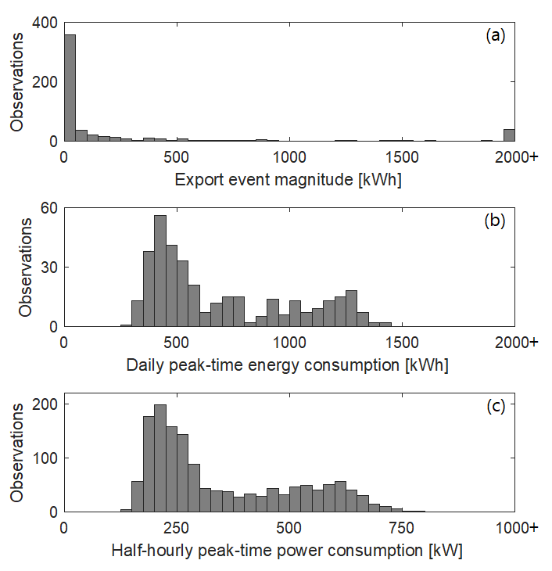

Fig. 1 Distributions examined for sizing Dundalk Institute of Technology’s electricity storage over the study year: a) “export events” (n=571); b) daily peak-time (17:00 to 19:00 UTC) electrical energy consumption (n=365); and c) half-hourly peak-time power consumption (n=1460). Observations beyond the plotted range are included in the highest plotted bar.
[single-column image]

The next approach considered was to size the storage such that all of the daily peak-time (17:00 to 19:00 UTC) electricity consumption could be satisfied without any need to import from the grid, since this is overall the most expensive time of day. Figure 1b shows the distribution of the daily peak-time electrical energy totals over the study year. These values ranged from 275.0 kWh to 1,408.5 kWh, with a mean of 694.9 kWh. As this distribution is relatively narrow, the maximum value of 1,408.5 kWh was deemed to be a suitable size for the storage capacity. The corresponding distribution of the half-hourly peak-time average consumption powers is shown in Fig. 1c. This has a similar shape to that of the daily peak-time energy totals, with a range of 136.0 kW to 786.0 kW, and a mean of 347.4 kW. As a result, the maximum value of 786.0 kW was likewise deemed to be a suitable maximum size for the storage power.
Based on this sizing, a commercially available, modular 777-kW, 1,554-kWh Li-ion battery was modelled for this study. This type of battery is characterised by a high degree of efficiency and a long lifespan, albeit at a high capital cost [24,25]. Because of the high cost, some studies have found Li-ion batteries to be uneconomical for consumer-end time-shifting [26-28]. As the price, performance, and lifespan of these batteries is continuously improving [29-31], however, new case studies are nevertheless worth analysing. For the specific battery model considered, the manufacturers report a depth of discharge of 100%, and a charging/discharging efficiency of 92.46% (85.5% round trip), which is assumed here to be constant across all powers. They also recommend a minimum operating power of 100 kW, which is adhered to in this study. Furthermore, [32] reports that the battery comes with a 10-year warranty, but has a 15-year life expectancy. In all other respects, the battery in this study is assumed to have no limitations, i.e. it is assumed to be free from self-discharge and in-life degradation, with an instantaneous response time and an unlimited ramp rate, and unaffected by external variables such as temperature. While the manufacturer did not provide a quote for the battery, by scaling the acquired costs of other commercially available models, we have estimated the capital cost to be €705,399. On top of this, we estimate an installation cost of €11,000, and annual operation and maintenance costs of 2% of the capital investment, as per [29], amounting to €14,108 per year or €211,620 over the expected 15 years. The total lifetime costs for the battery are therefore estimated to be €928,019.

2.7 Battery usage
The battery modelled in this study was primarily operated for maximum potential economic rewards given a cycling limit of once per day and without any forecasting of market prices, wind generation, or demand. To determine a usage approach that would be consistent over the whole year, the 2017/18 TOU import rates were averaged across all days of the week and all times of year. The resulting categories were thus peak daytime (17:00 to 19:00 UTC; averaging €0.1075 per kWh), off-peak daytime (08:00 to 17:00 UTC and 19:00 to 23:00 UTC; averaging €0.0916 per kWh) and nighttime (23:00 to 08:00 UTC; averaging €0.0512 per kWh). These prices are shown in Fig. 2 along with the average half-hourly export unit prices based on Eq. 3. Charging of the battery was prioritised for times when the average import and export unit prices are lowest, so as to minimise the cost of charging from the grid (when necessary) and avoid exporting for low gains. Conversely, discharging was prioritised for times when the average import and export unit prices are highest so as to avoid expensive import and avail of valuable export. The charging was therefore carried out between 02:30 and 06:30 UTC, with the exact half-hourly amount dependent on the unit prices, the initial state of charge, and the amount of surplus wind generation in the half-hour. As this is a low-demand time of day for the college, the associated increase in import from grid-charging never caused the MIC to be reached. Conversely, the discharging of the battery, which was carried out between 17:00 and 23:00 UTC, frequently had to be curtailed so as not to exceed the MEC. The exact half-hourly discharge therefore depended on the unit prices, the initial state of charge, the import demand, and the surplus wind generation in the half-hour. The battery usage was simulated in this manner for each scenario of having or not having a turbine. The college’s electrical carbon impact and the economic benefit of switching to HHP were then reassessed with the simulated battery present.

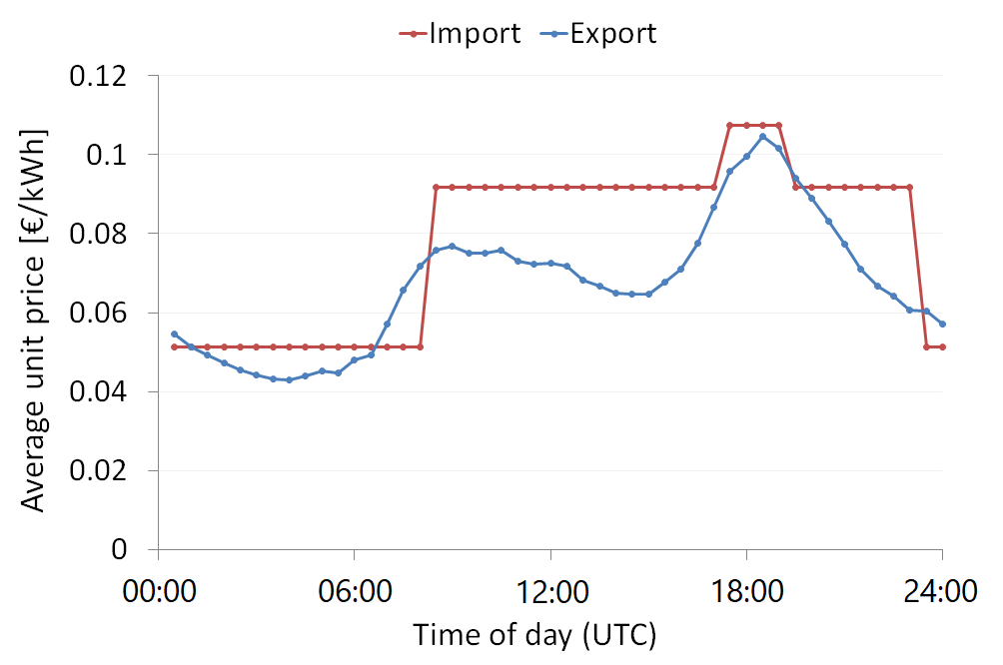

Fig. 2 Average daily profile of the half-hourly electricity import and export unit prices for Dundalk Institute of Technology over the 2017/18 academic year (Sep to Aug).
[single-column image; requires colour in print]

3. Results and discussion

3.1 Energy impact of the wind turbine
The college’s monthly electricity consumption, import, wind generation, and export over the 2017/18 academic year are shown in Fig. 3. Consumption, which totalled 3,660 MWh for the year, was generally high during term time (September to May) and low over the summer holidays (June to August). Generation followed a broadly similar pattern, totalling 1,327 MWh. Of this, 1,067 MWh (80.4%) was consumed, reducing the required import to 2,593 MWh, with the remaining 261 MWh exported. Over the study year, the turbine itself consumed a total of 10 MWh. If the turbine were removed, the overall consumption (all of which would have to be imported) would therefore decrease to 3,650 MWh. The turbine’s net energy impact over the study year was therefore a 29.0% reduction in required import from 3,650 MWh to 2593 MWh, with 261 MWh of export created.

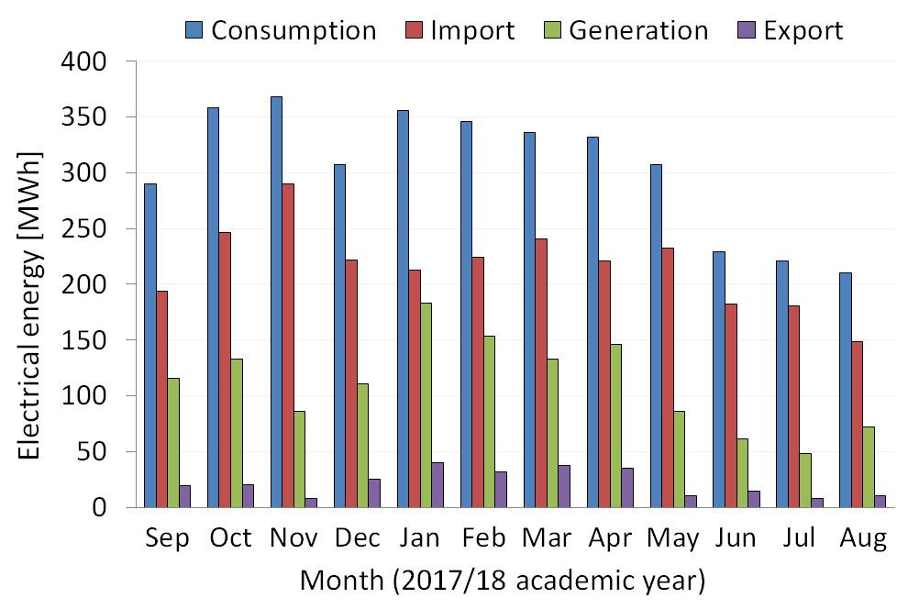

Fig. 3 Monthly electricity consumption, import, wind generation, and export for Dundalk Institute of Technology over the 2017/18 academic year.
[single-column image; requires colour in print]

3.2 Carbon impact of the wind turbine
As per Section 2.5, DkIT’s net electrical CO₂ emissions were estimated for the study year with and without the turbine present. This amounted to 990 t and 1,435 t, respectively, indicating that the turbine reduced the college’s electrical carbon impact in that year by 445 t (31.0%).
Rather than using dynamic carbon intensities, some studies such as [33,34] have estimated consumers’ carbon impact using the average intensity over a year or more. If DkIT’s net emissions for the 2017/18 academic year were simply estimated using the average intensity over this period (394.2 gCO₂/kWh), this would yield a result of 920 t – 7.1% less than the 990 t estimated using the half-hourly intensities. Averaging the carbon intensity over long periods can thus lead to discrepancy in estimating emissions. On this basis we would suggest using the highest-resolution data available.

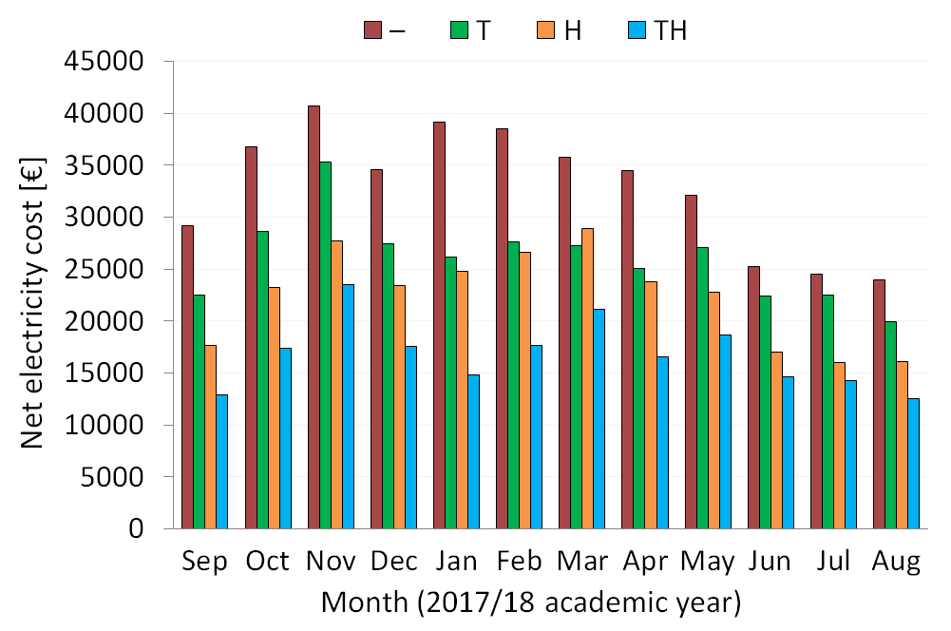

Fig. 4 Monthly net electricity costs for Dundalk Institute of Technology over the 2017/18 academic year for various scenarios: “T” indicates the presence of the wind turbine, and “H” indicates that the college has switched to half-hourly billing.
[single-column image; requires colour in print]

3.3 Economic impact of the wind turbine and HHP
DkIT’s estimated monthly net electricity costs over the study year are displayed in Fig. 4 for each scenario of having or not having a wind turbine and being on fixed TOU or half-hourly billing. For the baseline scenario of having a turbine and paying fixed TOU rates, the monthly net costs display a similar pattern to the import energies in Fig. 3, totalling €311,956 for the year. Removing the turbine increases the total to €395,063, with the pattern again resembling the would-be imports, in this case the overall consumption. The net amount saved by the turbine over they study year is therefore estimated to be €83,107 or 21.0% of the no-turbine total. With the turbine in place, switching to HHP further reduces the net cost in every month, yielding a yearly total of just €201,571. Making this switch would therefore provide a saving of €110,385 or 35.4%. Finally, if both the turbine is removed and the college switches to HHP, the net costs decrease relative to the baseline in all months except March 2018, bringing the yearly total to €268,319, thus representing a saving of €43,637 or 14.0%. These results indicate that operating the turbine and – to an even greater extent – switching to HHP each offer substantial economic savings for the college, regardless of the initial set-up. Making the switch to HHP would therefore be strongly advisable for DkIT.

3.4 Battery performance and energy impact
The battery selected in Section 2.6 was then modelled as described in Section 2.7. The battery’s half-hourly state of charge over study year with and without the turbine present is illustrated in Fig. 5. In the no-turbine scenario (Fig. 5a), the battery completes the intended one full cycle per day, charging (by import only) between 04:00 and 06:30 UTC and discharging between 17:00 and 19:30 UTC. The total throughput for the year is thus 567,210 kWh, of which 50.8% is discharged to reduce import, with the remaining 49.2% discharged to create export. The college’s overall consumption for this scenario amounts to 3,739 MWh, with 3,997 MWh of import and 258 MWh of export.

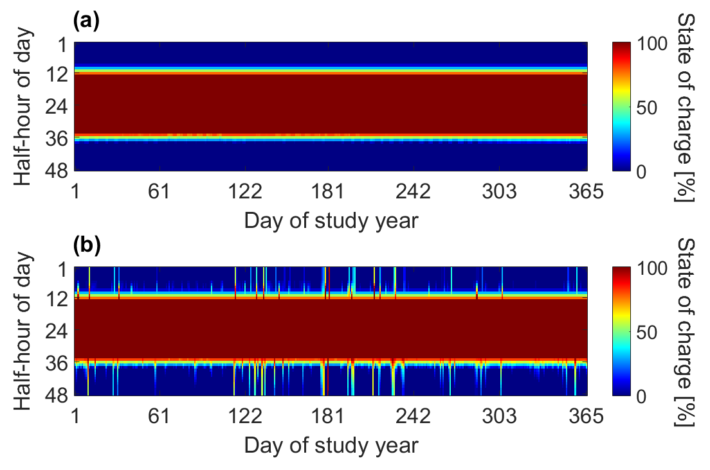

Fig. 5 Simulated half-hourly state of charge of the battery over the study year with the wind turbine absent (a) and present (b).
[single-column image; requires colour in print]

With the turbine present (Fig. 5b), the rate of discharge is generally reduced, as much of the import demand is already satisfied by wind generation, and less export can be added before reaching the MEC. As a result, the battery generally takes longer to discharge, failing to do so fully on a total of 39 days. In these cases, whatever charge remains in the battery at the end of the day is simply carried forward into the next. Because of these failures to discharge fully, the total throughput for the year is reduced by 2.9% to 550,558 kWh. Of this, 36.4% is discharged to reduce import, with the remaining 63.6% discharged to increase export. When there is surplus wind generation, charging of the battery can begin as early as 02:30 UTC, although grid-charging never begins before 04:00 UTC, as in the no-turbine case. Overall, just 7.4% of the total charge comes from surplus generation, with the grid supplying the remaining 92.6%. The yearly consumption for this scenario amounts to 3,746 MWh, with 2,959 MWh of import and 540 MWh of export.

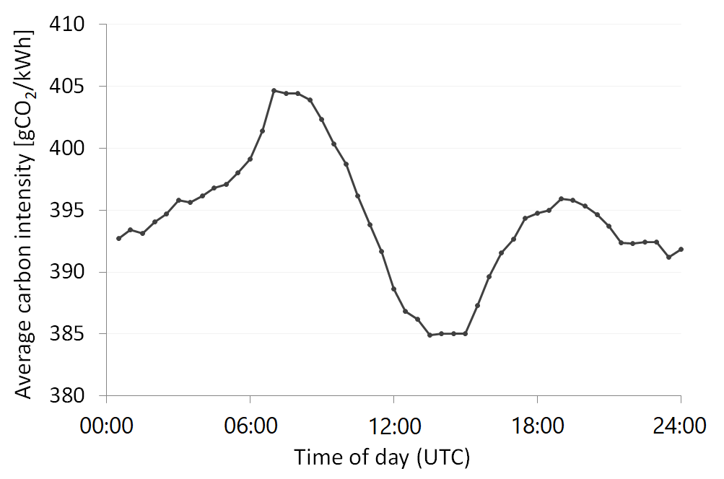

Fig 6. Average daily profile of the half-hourly electrical carbon intensity in Ireland over the study year.
[single-column image]

3.5 Carbon impact of the battery
With the turbine present, modelling the battery operation for the maximum potential economic results was unexpectedly found to raise DkIT’s net CO₂ emissions for the study year slightly, from 990 t to 1,026 t – an increase of 36 t or 3.6%. Similarly, with the turbine removed, operating the battery was found to raise emissions from 1,435 t to 1,472 t – an increase of 37 t or 2.6%. These increases were found to arise primarily from the inefficiency of the battery, which causes 243.7 kWh to be electrically lost in each full cycle. This accounted for an increase of 33 t with the turbine present and 35 t with the turbine absent. To explain the remaining difference, Fig. 6 shows the average daily profile of carbon intensity in Ireland over the study year. From this, the intensity over the grid-charging times of 04:00 to 06:30 UTC is generally slightly higher than over the discharging times of 17:00 to 23:00 UTC. Therefore, even with a perfectly efficient battery, time-shifting for the maximum potential economic outcome would nevertheless add to the college’s carbon impact unless a substantial amount of the charge can be autoproduced.

3.6 Economic impact of the battery
DkIT’s net electricity cost for the study year under each of the analysed scenarios is shown in Fig. 7. As there is some uncertainty in the capital and maintenance costs of the battery, these have been excluded from the plotted totals. For the baseline scenario of having a turbine and paying fixed TOU rates, introducing the battery reduces the net electricity cost from €311,956 to €289,450 – saving €22,506 or 7.2%. While this saving is sufficient to cover the battery’s estimated yearly operation and maintenance costs, multiplying it by the 15-year life expectancy gives a lifetime revenue of €337,590, equating to just 36.4% of the estimated lifetime costs of €928,019. For the other scenarios, introducing the battery offers similar results. From a starting point of having fixed TOU billing and no turbine, the net costs decrease from €395,063 to €370,751, saving €24,311. Alternatively, with the college on HHP, operating the battery decreases the net costs from €201,571 to €178,654 with the turbine present, saving €22,917, or from €268,319 to €244,440 with the turbine removed, saving €23,879. The specific battery model and usage considered is therefore far from economically viable for DkIT for any of the analysed scenarios. For a full summary of the college’s electricity usage, costs, and carbon impact for each scenario over the study year see Table 2.

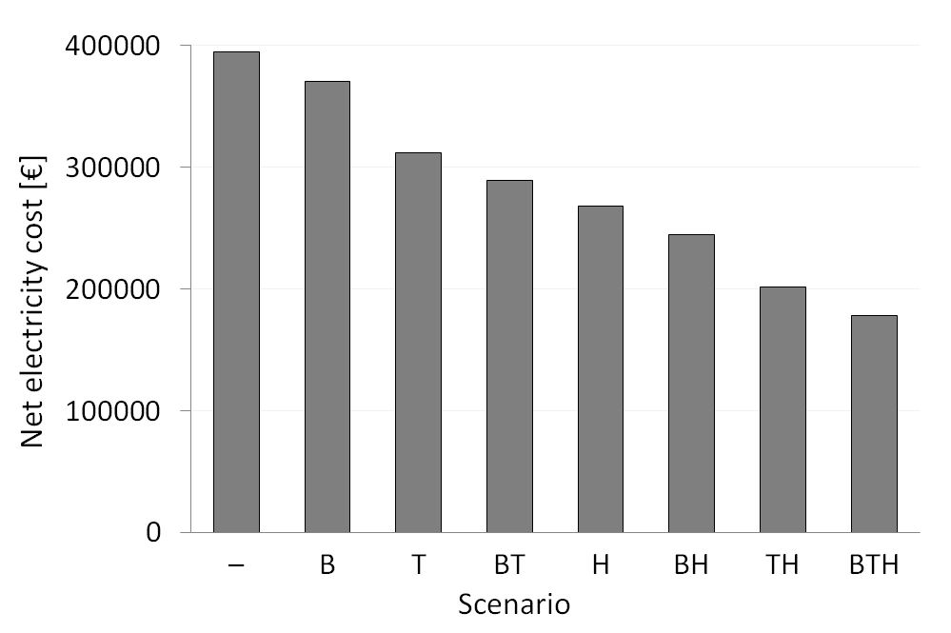

Fig. 7 Net electricity cost for Dundalk Institute of Technology for the 2017/18 academic year (Sep to Aug) for each scenario investigated: “T” indicates the presence of the wind turbine, “H” indicates that the college has switched to half-hourly billing, and “B” indicates the presence of the battery for time-shifting (with capital and maintenance costs excluded).
[single-column image]

Despite the battery’s poor economic results described above, there are a number of changes that could be made to increase its revenue. Firstly, by forecasting the market prices, wind generation, and demand on campus, the charging and discharging times on a given day could be adjusted to increase the effectiveness of time-shifting, particularly in the case of HHP. In terms of the impact this might have, [35] estimated that arbitrage in the real-time UK market provides 75% to 88% of the potential earnings (assuming storage efficiencies of 80% and 100%, respectively) when no foresight is considered. On this basis, forecasting might increase the revenue here somewhat, although it alone would not be sufficient to make the battery economically viable. A more promising way to increase revenue would be to consider applications other than time-shifting. If the given battery were reserved for the various grid-support markets offered in Ireland [18,36], it is estimated that it would generate up to €102,952 annually [37-39]. With this revenue, the lifetime costs would be covered in just over 9 years, generating a lifetime profit of €616,261. On this basis, the battery would, in fact, be a worthwhile investment for the college. Further research into acquiring a battery for this purpose is therefore warranted.

 |  | Scenario
 |  | – | B | T | BT | H | BH | TH | BTH
Energy  [MWh] | Import | 3650 | 3997 | 2593 | 2959 | 3650 | 3997 | 2593 | 2959
 | Export | 0 | 258 | 261 | 540 | 0 | 258 | 261 | 540
 | Generation | 0 | 0 | 1327 | 1327 | 0 | 0 | 1327 | 1327
 | Consumption | 3650 | 3739 | 3660 | 3746 | 3650 | 3739 | 3660 | 3746
CO₂  [t] | Emission | 1435 | 1575 | 1072 | 1219 | 1435 | 1575 | 1072 | 1219
 | Offset | 0 | 102 | 81 | 193 | 0 | 102 | 81 | 193
 | Net | 1435 | 1472 | 990 | 1026 | 1435 | 1472 | 990 | 1026
Costs [€] | Expenditure | 395063 | 395767 | 326336 | 333321 | 268319 | 269455 | 215951 | 222526
 | Revenue | 0 | 25016 | 14380 | 43872 | 0 | 25016 | 14380 | 43872
 | Net | 395063 | 370751 | 311956 | 289450 | 268319 | 244440 | 201571 | 178654
Table 2 Summary of Dundalk Institute of Technology’s electrical energy, CO₂, and cost totals for the 2017/18 academic year (Sep to Aug) for each scenario investigated: “T” indicates the presence of the wind turbine, “H” indicates that the college has switched to half-hourly pricing, and “B” indicates the presence of the battery for time-shifting (with capital and maintenance costs excluded).
[2-column image]

4. Conclusions

In this study DkIT’s electricity usage, carbon impact, and costs over the 2017/18 academic year were analysed. The college’s half-hourly imports, exports, and wind generation were measured, and from this, the overall consumption was estimated. By comparing these records, the impact of the college’s wind turbine was assessed in terms of energy, cost, and carbon savings. Over the study year, the turbine was found to reduce the college’s required import of electricity by a net amount of 1,057 MWh or 29.0%, while also creating 261 MWh of export. Given the actual tariff structure of fixed TOU rates, this decreased the net electricity cost by €83,107 or 21.0%, while the net CO₂ emissions were likewise reduced by 445 t or 31.0%. Varying the initial conditions by changing the tariff structure or introducing on-site electricity storage did not alter these results qualitatively. The turbine is therefore clearly beneficial to the college in each of these respects.
If the college had switched to HHP, the net cost for the study year would have been further reduced to €201,571, saving €110,385 or 35.4%. This represents the single biggest source of economic savings for the college out of all the changes investigated. Again, this result did not change qualitatively through removing the turbine or introducing on-site storage. Making the switch to HHP would therefore be a strongly advisable course of action for DkIT.
Lastly, the use of a 777-kW, 1,554-kWh Li-ion battery for time-shifting was simulated. The battery was sized to approximate the largest observed daily peak-time (17:00 to 19:00 UTC) consumption, as this is the most expensive time of day to import from the grid. For the baseline set-up of having a turbine and paying fixed TOU rates, time-shifting of costs with the battery would have generated an estimated €22,506 over the study year, equivalent to €337,590 over its expected lifetime. This, however, is far from sufficient to cover the battery’s lifetime costs, estimated as €928,019, making the given battery very much uneconomically viable for time-shifting. Additionally, time-shifting from an economic point of view was found to add to the college’s net carbon emissions. On the other hand, using the battery purely for grid-support services would generate an estimated €102,952 annually [37-39], indicating that the battery would, in that case, be a worthwhile investment for DkIT.

Acknowledgments
The authors acknowledge the valuable input from Kris Perry and Michael Jackson of Energy Trading Ireland.

The views and opinions expressed in this document do not necessarily reflect those of the European Commission or the SEUPB.

Funding: This work was supported by the INTERREG VA SPIRE2 project. This project is supported by the European Union’s INTERREG VA Programme, managed by the SEUPB.

References

[1] Commission for Energy Regulation. Electricity tariff structure review: Alternative tariff structures, http://regulationbodyofknowledge.org/wp-content/uploads/2013/03/NERA_Electricity_Tariff_Structure.pdf; 2004 [accessed 26 February 2019].

[2] Faruqui A, Hledik R, Tsoukalis J. The power of dynamic pricing. Electr J 2009;22(3):42-56. https://doi.org/10.1016/j.tej.2009.02.011.

[3] Faruqui A, Hledik R, Palmer J. Time-varying and dynamic rate design, https://www.raponline.org/wp-content/uploads/2016/05/rap-faruquihledikpalmer-timevaryingdynamicratedesign-2012-jul-23.pdf; 2012 [accessed 8 February 2019].

[4] Dutta G, Mitra K. A literature review on dynamic pricing of electricity. J Oper Res Soc 2017;68(10):1131-45. https://doi.org/10.1057/s41274-016-0149-4.

[5] Taylor TN, Schwarz PM, Cochell JE. 24/7 hourly response to electricity real-time pricing with up to eight summers of experience. J Regul Econ 2005;27(3):235-62.

[6] Campillo J, Dahlquist E, Wallin F, Vassileva I. Is real-time electricity pricing suitable for residential users without demand-side management? Energy 2016;109:310-25. https://doi.org/10.1016/j.energy.2016.04.105.

[7] Gambardella C, Pahle M. Time-varying electricity pricing and consumer heterogeneity: Welfare and distributional effects with variable renewable supply. Energy Econ 2018;76:257-73. https://doi.org/10.1016/j.eneco.2018.08.020.

[8] Zethmayr J, Kolata D. The costs and benefits of real-time pricing: An empirical investigation into consumer bills using hourly energy data and prices. Electr J 2018;31:50-7. https://doi.org/10.1016/j.tej.2018.02.006.

[9] EirGrid Group. System and renewable data summary report, www.eirgridgroup.com/site-files/library/EirGrid/System-and-Renewable-Data-Summary-Report.xlsx; 2019 [accessed 8 February 2019].

[10] Sustainable Energy Authority of Ireland. Energy-related CO₂ emissions in Ireland 2005-2016: 2018 report, https://www.seai.ie/resources/publications/Energy-Emissions-2017-Final.pdf; 2018 [accessed 8 February 2019].

[11] Akinyele DO, Rayudu RK. Review of energy storage technologies for sustainable power networks. Sustain Energy Technol Assess 2014;8:74-91. https://doi.org/10.1016/j.seta.2014.07.004.

[12] Luo X, Wang J, Dooner M, Clarke J. Overview of current development in electrical energy storage technologies and the application potential in power system operation. Appl Energy 2015;137:511-36. https://doi.org/10.1016/j.apenergy.2014.09.081.

[13] Guney MS, Tepe Y. Classification and assessment of energy storage systems. Renew Sustain Energy Rev 2017;75:1187-97. https://doi.org/10.1016/j.rser.2016.11.102.

[14] Zhang C, Wei Y-L, Cao P-F, Lin M-C. Energy storage system: Current studies on batteries and power condition system. Renew Sustain Energy Rev 2018;82:3091-106. https://doi.org/10.1016/j.rser.2017.10.030.

[15] Pearre NS, Swan LG. Technoeconomic feasibility of grid storage: Mapping electrical services and energy storage technologies. Appl Energy 2015;137:501-11. https://doi.org/10.1016/j.apenergy.2014.04.050.

[16] Zhao H, Wu Q, Hu S, Xu H, Rasmussen CN. Review of energy storage system for wind power integration support. Appl Energy 2015;137:545-53. https://doi.org/10.1016/j.apenergy.2014.04.103.

[17] Günter N, Marinopoulos A. Energy storage for grid services and applications: Classification, market review, metrics, and methodology for evaluation of deployment cases. J Energy Storage 2016;8:226-34. https://doi.org/10.1016/j.est.2016.08.011.

[18] EirGrid Group. DS3 system services: Quantification trials process outcomes and learnings 2017, http://www.eirgridgroup.com/site-files/library/EirGrid/DS3-System-Services-Qualification-Trials-Process-Outcomes-and-Learnings-2017.pdf; 2017 [accessed 1 March 2019].

[19] Rohit AK, Rangnekar S. An overview of energy storage and its importance in Indian renewable energy sector: Part II – energy storage applications, benefits and market potential. J Energy Storage 2017;13:447-56. https://doi.org/10.1016/j.est.2017.07.012.

[20] EirGrid Group. Smart grid dashboard, http://smartgriddashboard.eirgrid.com/; 2019 [accessed 14 February 2019].

[21] Weniger J, Tjaden T, Quaschning V. Sizing of residential PV battery systems. Energy Procedia 2014;46:78-87. https://doi.org/10.1016/j.egypro.2014.01.160.

[22] Wu D, Kinter-Meyer M, Yang T, Balducci P. Analytical sizing methods for behind-the-meter battery storage. J Energy Storage 2017;12:297-304. https://doi.org/10.1016/j.est.2017.04.009.

[23] Frate GF, Carro PP, Ferrari L, Desideri U. Techno-economic sizing of a battery energy storage coupled to a wind farm: An Italian case study. Energy Procedia 2018;148:447-54. https://doi.org/10.1016/j.egypro.2018.08.119.

[24] Chen H, Cong TN, Yang W, Tan C, Li Y, Ding Y. Progress in electrical energy storage system: A critical review. Prog Nat Sci 2009;19:291-312. https://doi.org/10.1016/j.pnsc.2008.07.014.

[25] Leadbetter J, Swan LG. Selection of battery technology to support grid-integrated renewable electricity. J Power Sources 2012;216:376-86. https://doi.org/10.1016/j.jpowsour.2012.05.081.

[26] Zheng M, Meinrenken CJ, Lackner K. Agent-based model for electricity consumption and storage to evaluate economic viability of tariff arbitrage for residential sector demand response. Appl Energy 2014;126:297-306. https://doi.org/10.1016/j.apenergy.2014.04.022.

[27] Graditi G, Ippolito MG, Telaretti E, Zizzo G. Technical and economical assessment of distributed electrochemical storages for load shifting applications: An Italian case study. Renew Sustain Energy Rev 2016;57:515-23. https://doi.org/10.1016/j.rser.2015.12.195.

[28] Metz D, Saraiva JT. Use of battery storage systems for price arbitrage operations in the 15- and 60-min German intraday markets. Electr Power Syst Res 2018;160:27-36. https://doi.org/10.1016/j.epsr.2018.01.020.

[29] Fleer J, Zurmühlen S, Badeda J, Stenzel P, Hake J-F, Sauer DU. Model-based economic assessment of stationary battery systems providing primary control reserve. Energy Procedia 2016;99:11-24. https://doi.org/10.1016/j.egypro.2016.10.093.

[30] Kairies K-P. Battery storage technology improvements and cost reductions to 2030: A deep dive, https://www.irena.org/-/media/Files/IRENA/Agency/Events/2017/Mar/15/2017_Kairies_Battery_Cost_and_Performance_01.pdf?la=en&hash=773552B364273E0C3DB588912F234E02679CD0C2; 2017 [accessed 1 March 2019].

[31] Few S, Schmidt O, Offer GJ, Brandon N, Nelson J, Gambhir A. Prospective improvements in cost and cycle life of off-grid lithium-ion battery packs: An analysis informed by expert elicitations. Energy Policy 2018;114:578-90. https://doi.org/10.1016/j.enpol.2017.12.033.

[32] Shahan Z. Tesla Powerwall and Powerpacks per-kWh lifetime prices vs Aquion Energy, Eos Energy, & Imergy, https://cleantechnica.com/2015/05/09/tesla-powerwall-powerblocks-per-kwh-lifetime-prices-vs-aquion-energy-eos-energy-imergy/; 2015 [accessed 13 February 2019].

[33] Louis J-N, Caló A, Leiviskä K, Pongrácz E. Environmental impacts and benefits of smart home automation: Life cycle assessment of home energy management system. Int Fed Autom Control Pap Online 2015;48(1):880-5. https://doi.org/10.1016/j.ifacol.2015.05.158.

[34] Kealy T. Stakeholder outcomes in a wind turbine investment; is the Irish energy policy effective in reducing GHG emissions by promoting small-scale embedded turbines in SME’s? Renew Energy 2017;101:1157-68. https://doi.org/10.1016/j.renene.2016.10.007.

[35] Staffell I, Rustomji M. Maximising the value of electricity storage. J Energy Storage 2016;8:212-25. https://doi.org/10.1016/j.est.2016.08.010.

[36] Single Electricity Market Committee. Capacity remuneration mechanism, https://www.semcommittee.com/capacity-remuneration-mechanism; 2016 [accessed 3 March 2019].

[37] EirGrid Group. System services industry forum, http://www.eirgridgroup.com/site-files/library/EirGrid/DS3SystemServices_Industry-Forum-Slide-Deck-Oct-12-v2.pdf; 2017 [accessed 4 April 2019].

[38] EirGrid Group. DS3 system services agreement, http://www.eirgridgroup.com/site-files/library/EirGrid/Ire-DS3-System-Services-Regulated-Arrangements_final.pdf; 2018 [accessed 9 April 2019].

[39] Perry K. Energy Trading Ireland. Personal communication [27 February 2019].

