SENDoc - to export wearable sensors in rehabilitation practice for the elderly
Writers: Elina Nevala¹*, Antti Alamäki¹, Karla Muñoz Esquivel², Joan Condell², Daniel Kelly², Richard Davies³, David Heaney², Anna Nordström⁴, Markus Åkerlund Larsson⁴, John Barton⁵ and Salvatore Tedesco⁵
¹ Research, Development and Innovation activities (RDI) & Physiotherapy Education, Karelia University of Applied Sciences, Finland
² Magee Campus, Ulster University, Derry/Londonderry, Northern Ireland, UK
³ Jordanstown Campus, Ulster University, Northern Ireland, UK
⁴ Department of Public Health and Clinical Medicine, Umeå University, Sweden and School of Sport Sciences, The Arctic University of Norway, Tromsø, Norway
⁵ Tyndall National Institute, University College Cork, Ireland
* corresponding author: Elina Nevala, Karelia University of Applied Sciences, Joensuu, Finland, Tel: +358503568868

Elina Nevala, MSc, Pt, Karelia University of Applied Sciences, Joensuu, Finland
Antti Alamäki, MSc, Pt, Senior Lecturer, Karelia University of Applied Sciences, Joensuu, Finland
Juha Jalovaara, Pt, Coordinator, Karelia University of Applied Sciences, Joensuu, Finland
Dr. Karla Muñoz Esquivel, AFHEA, Magee Campus, Ulster University, UK
Dr. Joan Condell, FHEA FCHERP, Senior Lecturer, Distinguished Teaching and Learning Support Fellowship, Magee Campus, Ulster University, UK
John Barton, Industry Projects Team Leader, Wireless Sensor Network Group, Tyndall National Institute, University College Cork, Ireland

Wearable sensors are the most promising technology for the automatic, continuous and long-term evaluation in areas of functional capacity. In the SENDoc project, we test different kinds of wearable sensors and implement them into rehabilitation practice for the elderly in co-operation with Siun sote (North Karelia´s Joint municipal Authority, Social and Healthcare (link to Siun sote´s website?). Wearable sensors can be integrated into both acute and chronic situations and may provide the necessary information for managing health disorders and rehabilitation, to both patients and healthcare personnel (Appelboom et al., 2014).

What is the SENDoc project?
SENDoc project (Smart Sensor Devices fOr rehabilitation and Connected health link to: www.sendocnpa.com ) is an international project, where Karelia UAS is one of the partners. The other partners are Ulster University (Northern Ireland, UK), Tyndall Institute/ University College Cork (Ireland) and Umeå University (Sweden). The SENDoc project aims to introduce the use of wearable sensor systems in ageing communities in northern remote areas. SENDoc will assess monitoring sensors technical, clinical and social acceptability aspects and their impact on patients, on health and care delivery, and on rural communities (SENDoc, 2018). The associate partner of Karelia UAS is Siun sote (North Karelia´s Joint municipal Authority, Social and Healthcare). This project is funded by the Northern Periphery and Arctic Programme (NPA 2018 Iink to: http://www.interreg-npa.eu/)

What are the wearable sensors?
There are different kinds of wearable sensors. They can be integrated into textile fibers, clothes or elastic bands. Also, there are “patch type” sensors which can be placed directly onto the skin. These sensor systems consist of many parts; sensor system unit/units, communication modules and signal processing units. The sensor/sensors measures/measure activities and this data is transmitted to a nearby processing unit using a suitable connection (for example Bluetooth). The processing unit (for example a smartphone, tablet computer, computer) contains this sensor systems software, which translates the algorithms into clinically sensible information. (Majumder 2017, 2-3). For example, picture 1 introduces one sensor system called G-WALK. In this system, there´s one sensor, which is attached to a waist with a belt. This sensor is able to establish a connection via Bluetooth to a tablet computer. The computer is running a software, which performs the data processing and translates data into understandable measurements, information, and graphics to be displayed to the end-users.

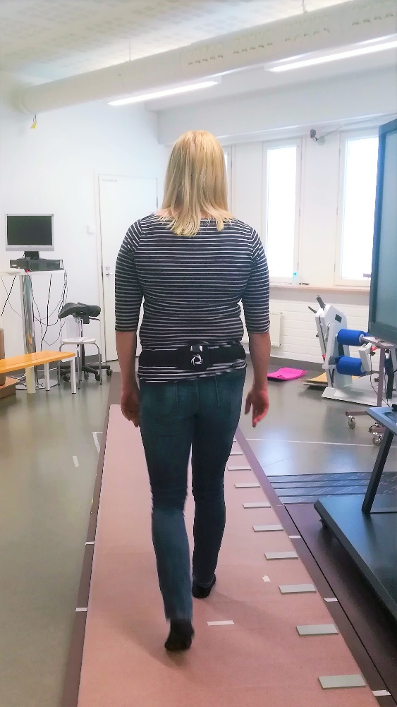
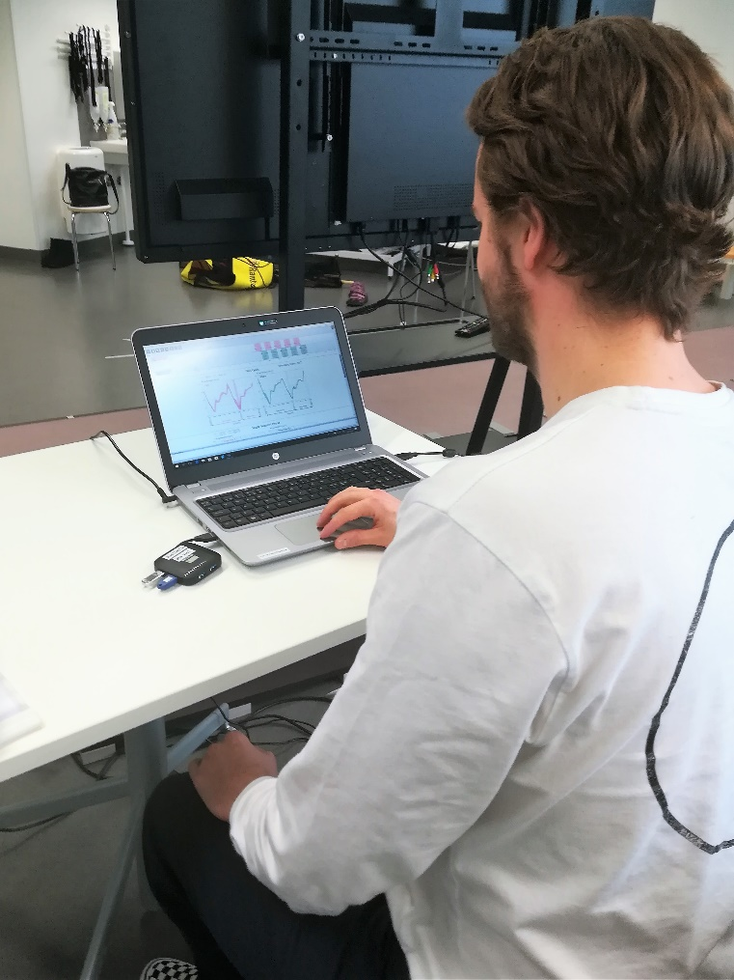

Picture1. Voiko nämä kuvat “yhdistää” yhdeksi? On the right picture is shown a physiotherapy student comparing G-WALK sensor systems and GAITRite®´s gait parameters with each other (Nevala, 2018).

The usability research at Karelia UAS

Our aim is to implement different sensor systems into elderly´s rehabilitation processes. The end users are rehabilitation staff and the elderly. Our goal is to figure out whether there is any added value in using these sensor systems in rehabilitation practice at this point? And what´s the actual usability of these wearable monitoring sensors? Usability is a very important quality attribute and we´ve had to consider it carefully while evaluating and testing wearable sensors. Usability refers to how easy and pleasant it is to use. Another key attribute is utility, which refers to the device´s functionality, does it give the features the user needs? Together the usability and the utility defines the usefulness of the device (Nielsen 1993, 26-27). So, the question arises of whether or not the wearable sensor system was successful given both usability and utility. The usability from a health practitioner’s perspective, such as a physiotherapist, is that these wearable sensors must work in the hospital environment, and also in clients´ homes. So, if these systems work in clinical or laboratory environments, but not in real rehabilitation environments, it´s not actually useful. The structure of our usability research, shown in Picture2, is assembled on these ladders (picture 1) and is based on evidence-based medicine and the concepts of efficiency, effectiveness, and cost-effectiveness (Stavrou et al. 2014, 123).

Phase 1. Efficiency – can it work? Testing and evaluating sensor systems among project staff and Karelia Voimala-Hub and FysioTikka service unit elderly clients: Usability aspects and relevant & accurate measures. Comparing with each other measurements of the same area (e.g. GAITRite® & Kistler®).
Phase 2. Effectiveness – Does it work in practice? Testing and evaluating wearable sensors in Siun Sote´s rehabilitation hospital and in home rehabilitation. Usability, relevant & accurate measures, added value, need of education, implementing in rehabilitation processes. etc.
Phase 3. Cost-effectiveness – Is it worth? What can be done with the data? Testing on and evaluating elderly on large scale in co-operation with Siun Sote´s rehabilitation staff. Introducing sensor systems into rehabilitation processes – What are the results of rehab? Does it give added value to organization and end-users?

Picture 2. Structure for evaluating the use of wearable sensors in rehabilitation processes.

Phase 1. Efficiency - can it work?
Last spring, we tested 12 commercially available sensor systems, which measure functional capacity (e.g. gait and balance). We tested and evaluated their usability and accuracy by comparing the reported measurements (numerical quantities with units) with the ones provided by the “golden standards” e.g. GAITRite® and Kistler® (picture 1). The tested sensor systems, some in the form of insoles, included e.g. accelerometers, gyroscopes, and magnetometers. Sensor unit/units were attached in different parts of the body, depending on what they measured. One example of tested sensor systems is shown in Picture 4. During this evaluation period, we attained meaningful knowledge in this area. We realized that most of these commercially available devices are not remarkably reliable and usable, so they they can be used into rehabilitation practice. They must be further developed in their simple and easy to use features, so they are able to serve end-users appropriately. However, these factors must not affect the accuracy of sensor systems.

Focusing on achieving our main goal of using sensor systems to employ them in the hospital and home environments, we identified and observed the following problems when testing the usability and accuracy of the sensor systems:
- Excessively time-consuming to use, will not be used in practice
- Connection and repeatability problems
- Extremely complicated to use, e.g. excessive number of sensors and each sensor had to search for a connection one by one
- Software/application was especially complicated and unclear
- Several distractions from other connections
- The introduction and installation of the sensor system/software may require IT expert assistance
After this evaluation period, we decided which sensor systems would suit best our purpose of implementing them into real rehabilitation processes for the elderly in collaboration with Siun sote´s rehabilitation staff.

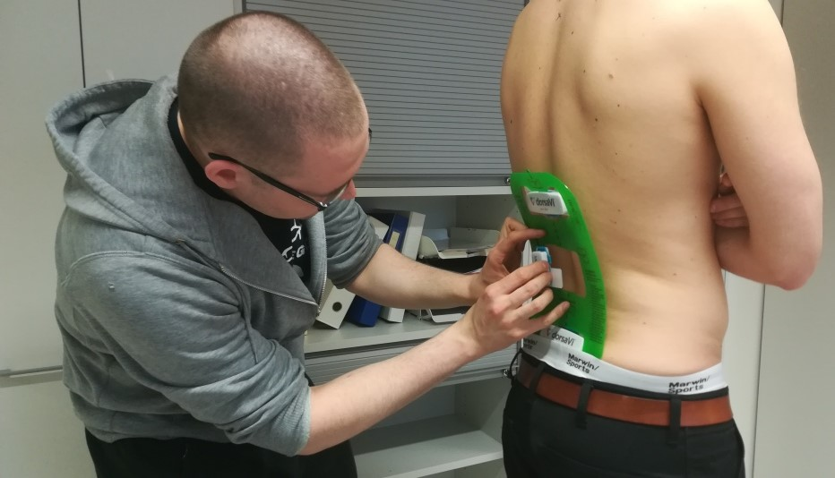
Picture 4. Physiotherapy student testing ViMove2™ (DorsaVi™, 2018), which is used to measure the range of movement from the lumbar spine and muscle activation (Nevala, 2018).

Phase 2. Does it work in practice?
In spring 2018, we had several meetings with Siun sote´s therapists who work in home rehabilitation and rehabilitation hospital. In these meetings, they got a chance to get acquainted with sensor systems. Together with rehabilitation staff, we tested two specific sensor systems G-WALK and MoveSole smart insoles in the rehabilitation hospital and in home rehabilitation. The attitude towards these sensor systems was very positive both from physiotherapists and the elderly. It can be very motivating from a client´s point of view to see objective numbers, for example, how your gait develops overtime as more symmetrical. Rehabilitation staff was surprised about the G-WALK, how much information can be obtained with only one sensor and how easy it is to use. The main goals for this evaluation phase were to find out what kind of reactions and feedback we can obtain from rehabilitation staff and patients and whether these sensor systems work in this kind of environments, e.g. in the hospital and in clients´ home?

The next part of this phase 2 is that two G-WALK systems and MoveSole smart insoles are going to be left available for independent use for physiotherapists in neurological and surgical wards and home rehabilitation. The main goal is that these physiotherapists start to use these sensor systems independently and after this period, we will be able to obtain real information about their usefulness in rehabilitation practice. We are doing theme interviews in groups to find out the usability aspects of these sensor systems. For example, what were the positive and negative considerations in their use? Was any added value to customer/rehabilitation staff/organization from using these systems? This theme interview is going to be based on five quality components of usability: Learnability, efficiency, memorability, errors, and satisfaction (Nielsen 1993, 26).

Phase 3. Cost-effectiveness
The third phase of our usability research will be based on the results of earlier phases and we will plan the research structure together with physiotherapists and their supervisors. We are going to evaluate these sensor systems in large scale on elderly and in rehabilitation processes and we are also considering distant areas of Siun sote (North Karelia). However, the purpose is to exploit more specifically and accurately the information that wearable sensors are producing. For example, Siun sote has developed a structured rehabilitation process for patient´s after hip replacement surgery, so it would be fairly easy to put sensor system in this process and to attain objective and accurate information about the results of rehabilitation. We can also find out the benefits of its use in large scale, e.g. in an organization.

Lessons learned to date
In the future, wearable sensors and other new technologies will save money from individuals, organizations, and societies because with them we can predict and prevent health problems and disorders (e.g. frailty, falling injuries, etc.) more effectively. According to Lankila et al. (2016, 4) these new technologies, logistics, digital and other new service processes will decrease place tied services like the number of hospitals and health stations from 5 to 40% until 2025.
Based on our expertise as physiotherapists and experiences with “off the shelf” wearable sensors, only a few of them have been developed until now that could actually be used in practice. One of the most important ways to develop these devices - from the perspective of the companies that design and produce them - is to increase co-operation with rehabilitation experts because they know their practice.

References:

Appelboom, G., Camacho, E., Abraham, M., Bruce, S., Dumont, E., Zacharia, B., D’Amico, R., Slomian, J., Reginster, J., Bruyère, O. & Connolly, ES. 2014. Smart wearable body sensors for patient self-assessment and monitoring. Archives of Public health. http://www.archpublichealth.com/content/72/1/28. 2.10.2018.

DorsaVi. 2016. http://www.dorsavi.com/uk/en/vimove/. 2.10.2018.

Lankila, T., Kotavaara, O., Antikainen, H., Hakkarainen, T. & Rusanen, J. 2016. Sosiaali- ja terveyspalveluverkon kehityskuva 2025 – Paikkatieto- ja saavutettavuusperusteinen tarkastelu. Inspection of social and health care services progression picture 2025 – position knowledge and availability –based retrospect. Oulun Yliopisto / University of Oulu. https://media.sitra.fi/julkaisut/Muut/Sosiaali_ja_terveyspalveluverkon_kehityskuva_2025.pdf. 5.10.2018.

Majumder, S., Mondal, T. & Deen, M.J. 2017. Wearable sensors for remote health monitoring. Sensor 2017, 17, 130.
https://www.ncbi.nlm.nih.gov/pmc/articles/PMC5298703/pdf/sensors-17-00130.pdf. 1.10.2018.

Nevala, E. 2018. Photos taken during the SENDoc project.

Nielsen, J. 1993. Usability Engineering. Boston: Academic Press.

Northern Periphery and Arctic Programme 2014 – 2020. 2018. http://www.interreg-npa.eu/. 8.10.2018.

Stavrou, A., Challoumas, D. & Dimitrakakis. 2014. Archibald Cochrane (1909-1988): the father of evidence-based medicine. Interactive Cardiovascular and Thoracic Surgery; 18(1)_121-124. https://www.ncbi.nlm.nih.gov/pmc/articles/PMC3867052/. 4.10.2018.
SENDoc. 2018. SENDoc project´s website. http://www.sendocnpa.com/. 5.10.2018.
http://www.siunsote.fi/

