Trial of a digital training tool to support chest image interpretation in radiography

Aims and objectives:
The purpose of this study was to determine the impact and effectiveness of the digital training platform on participant performance.
The objectives were to determine;
- performance levels pre and post implementation of the platform;
- confidence levels for each group of participants pre and post study;
- any variation in eye tracking metrics between the two groups and pre and post time points.

Methods and materials:
Materials:
A digital training platform was developed to include: A) a search strategy training tool to assist reporters during their interpretation of images, and B) an educational tool to communicate the search strategies to trainees using eye tracking technology.
- The search strategy comprises of a series of questions and prompts to guide the user to exclude pathologies, systematically search the image and form a diagnosis (Fig. 1).
- The educational tool consists of videos comprising expert eye gazes and scan paths recorded during chest image interpretation and collected whilst the expert used the search strategy training tool. Trainees can see where an expert fixates on the image and the areas experts gave greater visual and cognitive attention to (Fig. 2).
(Information on the development of the training platform was presented at ECR 2017).
Methods:
Participants were reporting radiographers beginning their training in chest image interpretation.
Pre and post intervention, the control group (n=7) and the intervention group (n=5) interpreted 20 chest images (n=480) whilst thinking aloud and using eye tracking technology.
Eye tracking data, a questionnaire, an image diagnosis were collected along with self-rated confidence levels for each image provided.
Follow up measurements were carried out at approximately 9 months post initial assessment.

Results:
Table 1: False Positives (FP) of reporting radiographers’ training in chest image interpretation pre and post study
 | Control (n=7) | Intervention (n=5)
FP Pre | 3.29 ± 1.11 | 5.20 ± 0.84
FP Post | 3.57 ± 3.05 | 2.80 ± 1.30*
Mean FP scores of reporting radiographers training in chest image interpretation. *significant difference within group
The identification of false positives (FP) by the intervention group decreased from 47.3% in the initial assessment to 28.0% in the follow up assessment (p=0.024).
Table 2: True Positives (TP) of reporting radiographers’ training in chest image interpretation pre and post study
 | Control (n=7) | Intervention (n=5)
TP Pre | 3.71 ±1.50# | 2.60 ± 0.89#
TP Post | 5.29 ± 1.38~ | 3.80 ± 0.48*~
Mean TP scores of reporting radiographers training in chest image interpretation. # significant difference between groups at baseline *significant difference within group ~significant difference between groups post intervention (P<0.05)
The True Positive (TP) scores of both groups increased following the intervention period. Control group participants had a greater TP score than the intervention group at baseline and follow up. The intervention group identified more true positives (p=0.033) following the intervention, increasing from 28.9% in the initial assessment to a mean of 38.0% in the follow up assessment.
Table 3: Confidence in diagnosis of reporting radiographers’ training in chest image interpretation pre and post study
 | Control (n=7) | Intervention (n=5)
Confidence Pre | 7.18 ± 0.95 # | 4.78 ± 1.91 #
Confidence Post | 7.52 ± 0.42 # | 6.41 ± 1.05 #
Mean confidence scores of reporting radiographers training in chest image interpretation. All values are means + SD # significant difference between groups at baseline
No significant change in confidence levels identified in either group. However, confidence of both groups increased in the follow up assessment.

Table 4: Eye tracking data for each participant group which was collected from the AOP
 | Control (n=7) | Intervention (n=5)
Mean fixation duration Pre (secs) | 11.69 ± 8.12 | 7.93 ± 4.24
Mean fixation duration Post  (secs) | 7.33 ± 3.36 | 5.16 ± 6.70
Mean time to first fixate Pre  (secs) | 8.32 ± 5.61 | 13.28 ± 6.62
Mean time to first fixate Post (secs) | 11.15 ± 10.17 | 11.44 ± 9.14
Mean fixation count Pre  (n) | 35.38 ± 20.13 | 24.74 ± 13.02
Mean fixation count Post  (n) | 25.08 ± 8.85 | 23.95 ± 22.91
Mean decision time Pre  (secs) | 58.80 ± 16.77 | 67.72 ± 17.12
Mean decision time Post  (secs) | 65.81 ± 28.09 | 76.71 ± 18.86*
Data is presented in mean ± standard deviation. All values are means + SD. *indicates post score of group is significantly different to pre score of the same group
Decision time increased from approximately 67.7 secs per image at the initial testing period to 76.7 secs per image at the follow up testing period for the intervention group participants (p<0.05).
Although no other significant differences were noted in the Areas of Pathology (AOP) eye gaze metrics, in general the eye gaze metrics tended to decrease at the follow up testing period compared to the initial testing period. However, one increase was recognized, control group participants took longer to fixate on the pathology (approximately 11.2 secs) at the follow up testing period.
Limitations
All participants were being trained in reporting of chest imaging. Both groups demonstrated improved TP rates by the end of the study. It would be useful to investigate this tool within a group of clinicians who were not trained in chest image interpretation.

Conclusion:
The training tool reduced FP rates and increased TP rates indicating that it is likely the tool has some effect on performance. This tool, which was developed to aid chest image interpretation, could be a valuable addition in the training of reporting clinicians.

Personal information
References:

Key words: Thorax, Digital radiography, Observer performance
Affirmations
Images:
Fig. 1: An example of the layout of the search strategy training tool, which comprises questions, diagrams and text to help guide the user to systematically search the image
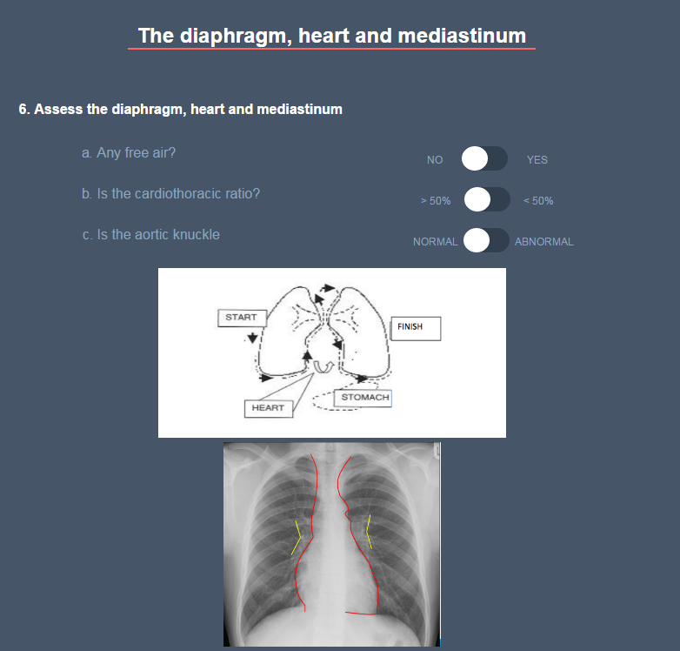
Fig. 2: A chest radiograph image overlaid with the eye gaze and scan path of the expert, as recorded by the eye tracking technology
