ICD-11 PTSD and Complex PTSD among Syrian Refugees in Lebanon: The factor structure and the clinical utility of the International Trauma Questionnaire

Vallières, F.¹, Ceannt, R.¹, Daccache, F.³, Abou Daher, R.³, Sleiman, J.³, Gilmore, B.¹, Byrne, S.², Shevlin, M.⁴, Murphy, J.⁴, and Hyland, P.^{1,5}

¹Centre for Global Health, University of Dublin, Trinity College, 7-9 South Leinster Street, Dublin 2, Ireland.
²School of Psychology, University of Dublin, Trinity College, Ireland.
³International Medical Corps Lebanon, Beirut, Lebanon
⁴Psychology Research Institute, Ulster University, Londonderry, Northern Ireland.
⁵School of Business, National College of Ireland, Mayor Street, International Financial Services Centre, Dublin 1, Ireland

Corresponding author: Dr. Frédérique Vallieres, Centre for Global Health, University of Dublin, Trinity College, 7-9 South Leinster Street, Dublin 2, Ireland

Email: fvallier@tcd.ie

Phone: +353 (0)1 896 2130

Abstract
Objective: Support for ICD-11 posttraumatic stress disorder (PTSD) and Complex PTSD (CPTSD) is growing, however few studies include refugees or examine the clinical utility of PTSD/CPTSD classifications. This study sought to provide the first evaluations of (1) the factor structure of ICD-11 PTSD/CPTSD amongst refugees in the Middle East; and (2) the clinical utility of the International Trauma Questionnaire (ITQ) to identify PTSD/CPTSD in a humanitarian context.
Method: Participants were 112 treatment-seeking Syrian refugees living in Lebanon. Factorial validity was assessed using confirmatory factor analysis (CFA) based on responses to the ITQ. Clinical utility of the ITQ was assessed through semi-structured interviews with six Lebanese psychotherapists.
Results: CPTSD (36.1%) was more common than PTSD (25.2%), and no sex or age differences were observed at the prevalence or symptomatic levels. CFA results supported a two-factor higher-order model consistent with ICD-11 PTSD/CPTSD. Qualitative findings indicated that the ITQ is generally positively regarded, with some limitations and suggested modifications noted.
Conclusion: This is the first study to support the ICD-11 PTSD/CPTSD amongst refugees in the Middle East, and the clinical utility of the ITQ in a humanitarian context. Findings support the growing evidence for the cross-cultural applicability of ICD-11 PTSD/CPTSD.
Keywords: PTSD, Complex PTSD, Syrian Conflict, Lebanon, Refugees, International Trauma Questionnaire (ITQ)

Significant Outcomes
- PTSD (25.2%) and Complex PTSD (36.1%) were common amongst a treatment-seeking sample of Syrian refugees in Lebanon.
- CFA results favoured a two-factor second-order model that distinguished between the symptoms of PTSD and CPTSD.
- Psychotherapists working in a low-resourced, humanitarian context reported that the ITQ, as a tool to identify ICD-11 PTSD and CPTSD, was clinically useful.

Limitations
- Results are based on a small, treatment-seeking, sample limiting the generalisability of the findings.
- Psychotherapists noted problems with the ITQ’s use of formal Arabic when assessing ill-to-low literate clients.
- Some symptom indicators of PTSD/CPTSD in the ITQ may require re-wording to ensure maximum cultural applicability.
ICD-11 PTSD and Complex PTSD among Syrian Refugees in Lebanon: The factor structure and the clinical utility of the International Trauma Questionnaire

Introduction
In 2016, the World Bank and the World Health Organization (WHO) issued a joint call for a collaborative response to mental health, including greater investment, awareness, and prioritisation of mental health, as a key component of the global health agenda (1). In the same year, the United Nations High Commission for Refugees (UNHCR) estimated the daily rate of people fleeing their homes due to conflict at nearly 34,000 (2). There are currently 65.6 million forcibly displaced persons worldwide; 22.5 million of whom are refugees (3).
Refugees are of particular concern to global mental health practitioners as they are more likely to be trauma-exposed (4), and are 10 times more likely to experience posttraumatic stress disorder (PTSD) compared to the general population (5-7). In their analysis of data from 90 refugee camps across 15 countries, Kane et al. (8) noted a large discrepancy between the high prevalence of psychiatric disorders amongst refugees and the proportion who received treatment; highlighting an important gap in the level of mental health care for refugees. Today, the largest number of refugees come from Syria, with over 5.5 million people having fled the country (UNHCR, 2017). Of these, 1.5 million have taken refuge in Lebanon, a country of only 6.2 million people. Adding to the pre-existing refugee communities, mostly from Palestine and Iraq, Lebanon now accounts for the country with the highest number of refugees per capita (9). The most recent lifetime prevalence estimate of PTSD among Syrian refugees living in camps in Lebanon is estimated at 35.4% (10), substantially higher than recent general population estimate of 8.8% (11).
In 2018, the WHO published the 11th version of the International Classification of Diseases (ICD-11). The ICD-11 includes a new model of psychotraumatology that is distinct from both ICD-10 and the American Psychiatric Association’s fifth edition of the Diagnostic and Statistical Manual of Mental Disorders (DSM-5) (12). Specifically, ICD-11 will include two stress-related disorders: a simplified description of PTSD and a new diagnosis termed ‘Complex PTSD’ (CPTSD) (12). The refined description of ICD-11 PTSD includes six symptoms, reflecting three symptom groups: (i) Re-experiencing of the trauma in the here and now, (ii) deliberate avoidance of traumatic reminders, and (iii) a sense of current threat. CPTSD is a broader diagnosis, more likely to occur following exposure to severe traumatic events from which escape is difficult or impossible (e.g., childhood abuse, captivity, torture). CPTSD includes the core PTSD symptoms and three additional symptom clusters of (i) affective dysregulation, both ‘hyperactivity’ and ‘hypoactivity’ (ii) negative self-concepts, and (iii) disturbed relationships. These three symptom clusters are collectively referred to as ‘Disturbances in Self-Organization’ and serve to define CPTSD as a discrete disorder from PTSD.
A substantial number of studies utilising clinical and community samples from multiple nations have been undertaken since the initial publication of the proposals for ICD-11 PTSD and CPTSD. A recent review of these studies suggest strong empirical support for the construct validity of PTSD and CPTSD (13). However, a number of important limitations still remain, requiring greater investigation prior to the official release of ICD-11 in 2018. For example, few studies to date have evaluated the factor structure of these diagnoses among refugee and displaced populations, and no studies have been performed with refugees residing in the Middle East. Furthermore, no studies have empirically evaluated the perceived utility of the ICD-11 diagnoses amongst clinicians working in humanitarian settings. Given that the primary rationale for the ICD-11 revisions of PTSD and CPTSD was that these diagnoses should maximise clinically utility, especially within low-resourced, humanitarian settings (12), the lack of such data represents an important gap in the trauma literature.
To date, only four studies have investigated the nature of ICD-11 PTSD/CPTSD amongst refugee and internally displaced samples. The factorial validity of ICD-11 PTSD and CPTSD has been supported in two studies (14, 15) with West Papuan refugees resettled in Papa New Guinea (N = 230, and N = 250). Nickerson et al. (16) also found evidence to support the factor structure of CPTSD amongst a nationally-diverse, treatment-seeking sample of refugees (N = 134) resettled in Switzerland. Prevalence estimates of PTSD and CPTSD amongst these samples varied widely. Tay et al. (2015) reported prevalence rates of 6% and 3% for PTSD and CPTSD, respectively, while Nickerson et al. (2016) reported prevalence rates of 19.7% and 32.8% for PTSD and CPTSD, respectively. The variation in prevalence rates across these studies is likely attributable to the nature of the respective samples. Whereas the study of Tay et al. included a sample of refugees from the general population, the study of Nickerson et al. was based on a sample of treatment-seeking refugees. An important limitation associated with each of these studies is that the symptoms of PTSD/CPTSD were derived from scales that were not designed to represent the specific ICD-11 symptoms. Recently however, the International Trauma Questionnaire (ITQ) (17) has been developed and validated (18, 19) to capture the precise symptoms outlined in ICD-11. Using the ITQ, Shevlin et al., (20) reported a prevalence rate of 21% for ICD-11 PTSD amongst a nationally representative sample of adult, internally displaced people in Ukraine (N = 2,203). The authors also reported that ICD-11 PTSD was associated with high levels of impairment in day-to-day living. Importantly however, this study did not assess the prevalence or nature of CPTSD.

Aims of the study
The current study, based on a treatment-seeking sample of Arabic-speaking, Syrian refugees living in Lebanon, was performed to redress a number of important gaps in the existing literature. Using the ITQ, the first aim of the study was to evaluate the prevalence rates of ICD-11 PTSD and CPTSD, and whether PTSD and CPTSD varied according to sex and age. The second aim was to assess the factor structure of ICD-11 PTSD and CPTSD amongst this sample. The third aim was to provide the first evaluation of the clinical utility of the ITQ, as a tool to identify PTSD and CPTSD, as assessed by psychotherapists responsible for treating Syrian refugees in Lebanon.

Methods

Participants and Procedures
Participants were 112 Syrian refugees living in Lebanon (80.2% female, mean age = 33.02, SD = 8.94, Range = 18-60 years old). The majority were unemployed (75.5%, n = 80), with a mean of 5.71 years of education (SD = 4.39, Range = 0-18 years), and 31.25% (n = 35) received less than 4 years of education. Most participants were registered with the UNHCR (90.1%, n = 100), and had spent an average of 37.45 months (SD = 14.62, Range = 1-60 months) in Lebanon. Few individuals resided in a refugee camp (12.7%, n = 14), with most residing with family members (96.4%, n = 107). Respondents were asked to identify the most traumatizing event that they had experienced before being administered the ITQ.
Refugees were recruited through International Medical Corps (IMC) Lebanon’s Mental Health Program, which consists of providing mental health and psychosocial support (MHPSS) consultations across a number of IMC-affiliated primary health care centres (PHCs) and community centres throughout the country. Refugees often first learn of MHPSS services through community mental health education initiatives. Potential participants were identified through IMC’s case managers, based in 11 mental health supported PHCs across seven (Beqaa, Beirut, Mount Lebanon, North Lebanon, South Lebanon, Akkar, Baalbeck) of the country’s eight provinces (muhafazah). Where a potential participant presented to the PHC to seek MHPSS services, case-managers informed them of the study, and gave them the option of participation, before referring them to one of eight IMC psychotherapists. Where a participant consented to taking part in the study, the ITQ was administered as an additional component of the consultation with the psychotherapist. In the instance where the client did not consent, the appointment with the psychotherapist took place as usual. To participate, individuals had to be over the age of 18 and forcibly displaced to Lebanon from Syria within the last five years.
Given the expected low rates of literacy, psychotherapists were trained and instructed to administer the scale to those who had provided consent. All scales were administered face-to-face. All psychotherapists were of Lebanese origin, were fluent in Arabic, held a Bachelor degree in Psychology, and either held a Masters degree or were in the process of obtaining one. Hours of psychotherapy training among the psychotherapists ranged from 400-1100 hours and followed the World Council for Psychotherapy (WCP), or comparable, international council standards. Training of the psychotherapists on the ITQ took place over the course of a one-day workshop held in Beirut in November 2015, during which case managers were also trained on how to obtain informed consent from participants. Six of the eight IMC psychotherapists were subsequently interviewed on their experience of using the ITQ to assess ICD-11 PTSD and CPTSD.
Ethical approval was obtained from the Health Policy & Management/Centre for Global Health Research Ethics Committee, Trinity College Dublin and from the Comité d’Éthique, Université Saint Joseph, Beirut, Lebanon. Written or verbal consent was obtained, depending on the literacy of the participant. In the case of an illiterate participant, verbal consent was obtained and signatures were given in the form of a right thumbprint.

Materials and Methods

Assessment of Traumatic Exposure
Traumatic exposure was assessed by asking respondents to indicate the nature of their most distressing traumatic experience. Types of traumatic events included the 21 events listed in the Traumatic Life Events Questionnaire (TLEQ) (21), in addition to 12 other events (i.e. bombing, forced displacement, torture, missing family member, war-related injury, arrest). We then cross-referenced these events with those listed in the TLEQ to ensure that the identified events met the traumatic exposure criterion. All events identified by participants were consistent with standard definitions of traumatic events.
Assessment of CPTSD
PTSD and CPTSD were assessed using the ITQ (17). A preliminary-stage version of the ITQ was used in the current study and multiple studies support its validity and reliability (18, 22, 23). The ITQ was professionally translated into Arabic and was subsequently back-translated into English to ensure consistency and that nothing was lost to translation. This version of the ITQ includes six items to measure the three PTSD symptom clusters of (i) re-experiencing in the here and now (Re1, Re2); (ii) avoidance (internal or external) (Av1, Av2); and (iii) a sense of current threat (Th1, Th2). Sixteen items measure three symptom clusters of Disturbances in Self-Organization: (i) Affective dysregulation, both hyper-activation (C1-C5) and hypo-activation (C6-C9); (ii) negative self-concept (C10-C13); and (iii) disturbances in relationships (C14-C16). The ITQ also includes three items that measure functional impairment associated with PTSD and a further three items that measure impairment associated with Disturbances in Self-Organization symptoms.
All items are answered on a five-point Likert scale anchored by “Not at all” (0) and “Extremely” (4). Diagnostic criteria for PTSD requires a score of ≥ 2 (“Moderately”) for at least one of two symptoms in each cluster, along with endorsement of at least one functional impairment item. CPTSD diagnosis requires that the PTSD criteria are met, and the following scores for each of the Disturbances in Self-Organization clusters: A score of ≥ 10 for Affective Dysregulation-Hyperactivity (C1-C5) or a score of ≥ 8 for Affective Dysregulation-Hypoactivity (C6-C9); a score ≥ 8 for Negative Self-Concept (C10-C13); and a score ≥ 6 for Disturbances in Relationships (C14-C16). Additionally, endorsement of at least one functional impairment item associated with these Disturbances in Self-Organization symptoms is required.
Semi-structured interviews with psychotherapists consisted of a number of questions pertaining to the therapist’s general experience of working with the ITQ, how participants reacted to the scale, the appropriate phrasing of the ITQ’s items and whether any of the items were problematic or difficult for their clients to understand, whether they felt the items in the ITQ were an adequate reflection of trauma-related psychological distress as they would typically manifest in this particular context, and how, if at all, the ITQ was used to inform their therapeutic approach.

Analysis
The current study employed a mixed-methods approach and included three components. First, prevalence rates for PTSD and CPTSD were calculated and associations between diagnostic status and sex were assessed using a Pearson chi-square test. Mean levels of PTSD and CPTSD symptoms were determined and compared across males and females using an independent samples t-test. Additionally, associations between PTSD and CPTSD symptom levels and age were assessed using a Pearson correlation test.
Second, the factor structure of the PTSD/CPTSD symptoms was assessed using confirmatory factor analysis (CFA). Six factor analytic models were compared (see Figure 1). Model 1 was a unidimensional model. Model 2 was a correlated six-factor model (re-experiencing, avoidance, threat, affective dysregulation, negative self-concept, and disturbed relationships). Model 3 is similar to Model 2 but separates the Affective Dysregulation latent variable in terms of its ‘hyperactivity’ (C1-C5) and ‘hypoactivity’ (C6-C9) symptoms. Model 4 is a second-order variant of Model 2 and assumes that the correlations between the six first-order factors can be explained in terms of a single ‘CPTSD’ second-order factor. Model 5 is also a second-order model but includes two second-order latent factors of ‘PTSD’ (explaining covariation between re-experiencing, avoidance, threat) and ‘Disturbances in Self-organisation’ (DSO) (explaining covariation between affective dysregulation, negative self-concept, and disturbed relationships). Finally, Model 6 is similar to Model 5, but separates the Affective Dysregulation factor into its ‘hyperactivity’ and ‘hypoactivity’ component parts. All models were tested in Mplus 7.4 (24) using the mean and variance-adjusted weighted least squares estimator (WLSMV). The WLSMV process of estimation was used as it has been shown to be the optimal method of estimating models based on ordered categorical data, particularly with skewed data (25). Most PTSD/CPTSD indicators showed modest levels of negative skew (no values exceeded -1.15), with only one item (C5, ‘reckless behaviour’) demonstrating evidence of positive skew (1.06). Missing data were managed using the default pairwise present analysis method. Model fit was determined using standard recommendations (26) whereby acceptable model fit is indicated by: A chi-square-to-degree of freedom ratio (χ²:df) less than 3:1; Comparative Fit Index (CFI) and Tucker-Lewis Index (TLI) values > .90; and a Root Mean Square Error of Approximation (RMSEA) value < .08. Additionally, the Bayesian Information Criterion (BIC) was used to evaluate alternative models, where a comparatively smaller value indicates better model fit (the BIC value was calculated using the robust maximum likelihood estimator). Reliability was assessed using a composite reliability score, as is commonly used in conjunction with measurement modeling (i.e. latent variable modeling) procedures (27).

FIGURE 1 HERE
Qualitative interviews with the six IMC psychotherapists were conducted face-to-face in English, recorded, and transcribed verbatim by the research team. The interviews were conducted across the four study provinces between June 15-17, 2016 and lasted between 20-50 minutes. Interviews were subjected to thematic analysis following Strauss and Corbin’s (28) guidelines for open coding. First, we identified phenomena from line-by-line open coding analysis. Second, we labelled these phenomena into concepts at a higher level of abstraction. Third, these concepts were grouped into categories which sought to organise the findings based on repetition and their relation to the process. Two researchers independently conducted the analysis with a subsequent comparison to propose the findings presented below.

Results

Diagnostic rates and descriptive statistics
The most commonly reported ‘most distressing’ traumatic events were forced displacement (17.9%, n = 20), exposure to bombing (11.0%, n = 12), unexpected death of a loved one (10.0%, n = 11), and forced separation from family members (8.3%, n = 9). The most frequent timeframe of exposure was between 1-5 years prior to assessment (76.4%, n 84).
More refugees met the criteria for CPTSD (36.1% [95% CI = 27% - 46%], n = 39) than PTSD (25.2% [95% CI = 17% - 34%], n = 27). There were no sex differences in rates for PTSD (χ² = .60, df = 1, p = .437, OR = .63 [95% CI = .19 – 2.05]) or CPTSD (χ² = .24, df = 1, p = .626, OR = 1.27 [.49 – 3.31]). On average, levels of PTSD symptoms (M = 14.77, Mdn = 16.00, SD = 6.03, Range = 0-24) and CPTSD symptoms (M = 51.10, Mdn = 53.00, SD = 19.03, Range = 4-88) were high. Males and females did not significantly differ in their mean levels of PTSD (t(107) = .35, p = .726, Cohen’s d = .08) or CPTSD (t(106) = .32, p = .750, Cohen’s d = .08) symptoms. Additionally, age was not significantly associated with PTSD (r = -.15, p = .125) or CPTSD (r = -.13, p = .19) symptom levels.

Factor structure and internal reliability
The CFA results are provided in full in Table 1. All models terminated normally with the exception of Models 2 and 3 which were rejected based on the occurrence of a factor correlation greater than 1.0 between the Re-experiencing and Sense of Threat factors. Of the remaining models, Model 1 was rejected as an unsatisfactory representation of the sample data. Models 4, 5, and 6 all produced satisfactory fit, however Model 6 was the only model which demonstrated good model fit for each fit index. Moreover, Model 6 possessed the lowest BIC value and was therefore determined to be the best fitting model.
The parameters of Model 6 were satisfactory as all factor loadings were greater than .50 (p’s < .001). The correlation between the two second-order PTSD and DSO factors was high (r = .88, p < .001). Composite reliability analysis indicated that the PTSD (.80) and DSO (.94) items possessed excellent internal reliability. Taken together, these results support the factorial validity and internal reliability of the ITQ within the current sample of Syrian refugees.

TABLE 1 HERE

Qualitative Interviews

Positive Attributes of the ITQ
The majority of psychotherapists indicated that the items used to capture the constructs of ICD-11 PTSD and CPTSD within the ITQ were comprehensive, helpful in their practice, and that they had positive experiences using the scale. As one psychotherapist explained:
‘...some of [the Syrian refugees] were interacting with me as if “yeah you understand, you understand what I’m…” So it was good to know that these questions might be helpful too… when some questions were asked, they really said “yeah that’s exactly how I’ve been feeling”... I feel that they become more interested in the sessions because they think that somehow we know what’s going on and we can help them... they were really engaged in the questionnaire, they felt that this questionnaire understands them’. (Psychotherapist 1, Northern Region).
They also noted that the ITQ was helpful for initiating discussion, assisting individuals to express their feelings, and was relevant to many of the refugees’ lived experiences. Overall, psychotherapists reported that the ITQ was useful to instigate in-depth discussions on specific topics, lending itself as both a useful screening tool and as a tool to facilitate a therapy session.

Negative Attributes of the ITQ
Psychotherapists identified some limitations of the ITQ, and these were categorised into three sub-themes: scale content, fit-for-purpose, and refugee understanding.

Scale Content
Complications arising from the inherent differences between the more formal, written form of Arabic, and the vernacular used by most of the participants were noted. One psychotherapist remarked on the absence of symptoms they had noted in clients, which are not captured in the revised models of PTSD and CPTSD: “In this population, amnesia and lack of concentration are common – but not adequately addressed in the [ITQ]” (Psychotherapist 2, Southern Province). Also, some of the examples used within the scale were not considered relevant to Syrian refugees living in Lebanon (e.g. ‘reckless driving’ as an example of risky behaviour as measured by item AD5). To suit the context, one of the psychotherapists instead gave the example of “going out at night…because in their region, both men and women are at risk of sexual assault, and all are warned of that” (Psychotherapist 5, South and Beirut Regions). These latter points highlight the importance of adapting the ITQ to suit the local cultural context.

Fit for Purpose
All but one psychotherapist noted that they had to administer the scale or assist the refugees through its completion. While the administration of the ITQ by the psychotherapist resulted in a more in-depth engagement with the items, it also meant that the questionnaire took longer to administer; lasting between 25-45 minutes, depending on the client’s level of literacy. The time it took to administer the scale, together with the psychotherapist’s preference for treating symptoms rather than diagnoses, were both mentioned as barriers to the uptake of the scale. That said, only one psychotherapist reported that they would not use the scale, and another had already started to use the ITQ as part of their own practice.

Refugee Understanding and Concern
Psychotherapists noted that many refugees were unfamiliar with the use of tools and questionnaires. As such, the psychotherapists reported frequent challenges related to item/topic repetition and the use of Likert scales. As one psychotherapist explained, their level of understanding often came down to the refugee’s level of education:
‘If they are educated it’s easier for them to catch the idea, but for non-educated people it was hard. I needed to explain more and so they were tired sometimes and I had to give them time. I was patient, I had no problem myself, but felt that it was too long for them.’ (Psychotherapist 2, Southern Province)
Several psychotherapists also had concerns regarding certain subgroups of refugees, such as prisoners, and their distrust of using classifying scales. When it came to such subgroups, many psychotherapists suggested that the scale be administered after the psychotherapist had established a strong therapeutic rapport with the beneficiary.

Discussion
The current study was undertaken in order to provide (1) the first assessment of the factorial validity of the ITQ amongst an Arabic-speaking sample of refugees from the Middle East, and (2) the first assessment of the clinical utility of the ITQ within a low-resourced, humanitarian setting. Building on previous studies which estimated the prevalence rates of PTSD and CPTSD amongst refugees and internally displaced persons (14-16, 20), the current study represents the first assessment of the prevalence rates of ICD-11 PTSD and CPTSD using a disorder-specific measure (ITQ). Prevalence rates of PTSD (25.2%) and CPTSD (36.1%) in this group of treatment-seeking Syrian refugees were similar to those observed within another treatment-seeking refugee sample resettled in Switzerland (PTSD = 19.7%, CPTSD = 32.8%) (16). Current rates of ICD-11 PTSD and CPTSD (61.3%) were also higher than recent assessments of PTSD, as measured in accordance with ICD-10/DSM-IV criteria amongst Syrian refugees living in camps in Lebanon (35.4%) (10). Furthermore, the current and prior estimates of ICD-11 PTSD and CPTSD prevalence amongst refugees in the Middle East and Europe, respectively, are consistent with prevalence rates reported amongst non-refugee clinical samples in the UK (see (19)). The consistency in prevalence estimates of PTSD and CPTSD within different refugee-based studies, and across refugee and non-refugee based studies, is suggestive of PTSD and CPTSD classifications being similarly meaningful for individuals characterised by different traumatic histories, and that these classifications may possess satisfactory cross-cultural applicability.
It was notable that there were no sex differences for PTSD or CPTSD at either the prevalence or symptomatic level. While the interpretation of current findings are limited by virtue of the small and predominately female composition of the sample, possible sex differences in ICD-11 PTSD and CPTSD remains a debate within the extant literature. The evidence thus far accumulated is contradictory, with some studies reporting sex differences in PTSD and/or CPTSD (e.g. (20, 29, 30)) and others reporting no such differences (e.g., (22, 31)). Moreover, possible sex differences for both PTSD and CPTSD have been found to remain even after controlling for the nature of one’s traumatic exposure, many of which can be highly sex-specific (i.e. sexual violence, childhood sexual abuse) (32).
The results of the CFA analysis provide novel empirical support for ICD-11 PTSD/CPTSD. The current study evaluated a larger number of models than all previous studies with refugee samples (14-16), and also tested the hypothesis that the Affective Dysregulation latent variable might be better conceptualised in terms of two factors that reflect ‘hyperactivation’ and ‘hypoactivation’ of emotional regulation functions. Previous studies have modeled this dimension as a single factor despite the fact that the diagnostic algorithm recognises a distinction between the hyper- and hypo-activation symptoms of the Affective Dysregulation cluster. Current results suggest that recognition of the distinctiveness of the Affective Dysregulation symptoms led to an improved model fit. These findings have important implications for the ongoing process of finalizing the diagnostic profile of CPTSD, and highlight the need to represent the Affective Dysregulation cluster with indicators of both hyper- and hypo-activation indicators. This higher-order dimensional representation of the PTSD and Disturbances in Self-Organisation symptoms is consistent with the theoretical predictions of ICD-11 that CPTSD is represented by these two sets of symptoms. Current results therefore add further evidence to support the factorial validity of the ICD-11 model of PTSD and CPTSD, and provide the first piece of empirical evidence to support the ICD-11 model amongst a refugee sample drawn from the Middle East.
Evidence in support of the factorial validity of ICD-11 PTSD and CPTSD is however, arguably moot if not accepted amongst those most likely to utilise them. Currently, only one study has assessed the clinical utility of ICD-11 PTSD and CPTSD among clinicians (33), however this study was conducted prior to the development of a precise measure of these disorders and did not include clinicians who were working in low-resourced humanitarian settings. The results of the qualitative interviews with Lebanese psychotherapists suggests that the ITQ is best administered with the assistance of a trained professional within this context. Notably, a trained administrator is necessary to communicate the formal Arabic version of the ITQ in vernacular form, especially for use with ill-to-low-literate individuals. Though our findings were generally highly supportive of the clinical utility of the ITQ amongst psychotherapists, future research should also explore the acceptability of the ITQ amongst refugees themselves. In addition, revisions of the Arabic version of the ITQ should include terms and examples familiar to clients, to ensure the cultural validity of the scale. One psychotherapist noted that the ITQ did not measure psychological symptoms (e.g., difficulty with concentration) that are commonly observed among refugees. This highlights the importance using a battery of assessments that capture the entire breath of psychologically distressing experiences that are clinically relevant within different contexts. The nature of the ITQ as a short, simply-worded, and valid and reliable measure of trauma-related psychopathology makes it ideally suited for inclusion within more comprehensive measure of psychological distress experienced by refugees in humanitarian settings.
Mental healthcare in emergencies requires a structured, streamlined approach to assessment and treatment, which can be challenging due to several factors including the crisis itself, the complexity of psychological distress, and the myriad actors and agencies involved. More efficient referral systems are particularly important given the current dearth of human resources for mental health and the fraction of funding attributed to mental health, compared to other global health priorities (34). With plans for further refinement (35) the ITQ has the potential to be used for more efficient treatment and referral of refugees experiencing trauma-related psychological distress within in humanitarian settings, where, given the time they take to administer and the requirement that they be administered by a clinician (36), diagnostic interviews are considered rather impractical. Future research should explore the possibility of task-shifting/task-sharing the administration of the ITQ to lower cadre health workers, including community health volunteers and mental health and psychosocial support (MHPSS) workers, as a useful screening tool within primary care and in humanitarian responses. Future research should also explore the validity of ICD-11 PTSD and CPTSD among children and adolescents, who are among the most vulnerable members of communities affected by humanitarian emergencies (37). Moreover, consideration should be given to how ICD-11 PTSD and CPTSD will be incorporated within common international mental health guidelines, including the World Health Organization’s Mental Health Gap Action Programme (mhGAP) (38). Specifically, which evidence-based guidelines, protocols and tools are best suited to incorporate within these guidelines for clinical decision-making in emergency contexts.
Findings of the current study should be interpreted in relation to several important limitations. First, the small, predominately female, treatment-seeking nature of the sample limits the generalisability of these findings. Second, and while the clinical utility of the ITQ in its current form was supported, the ITQ will eventually be streamlined, with the number of DSO symptoms decreased from 16 to 6 in the near future (39). Therefore, current findings will require replication once the final iteration of the scale is published. However, given that one of the concerns raised by the psychotherapists was the considerable time needed to administer the scale among highly distressed, and low literate clients, a reduction of items should help to mitigate these concerns. Thirdly, recruiting participants from a naturalistic setting meant that we were unable to account for potential differences between those identified as potential participants by case-managers who consented to taking part in the study and those who declined to participate. Finally, working with a treatment-seeking refugee sample imposed a number of ethical, time, and resource constrains and we were unable to measure additional constructs that would have permitted evaluations of concurrent or discriminant validity. Demonstrating that the observed factor structure of PTSD and CPTSD is meaningfully associated with external correlates is a critical component of the validation process and such work should be undertaken in the future.
In conclusion, the current study provides additional support for the reliability and factor structure of ICD-11 PTSD and CPTSD amongst refugee populations and suggests that the ITQ is a useful and acceptable tool among psychotherapists to identify these classifications. Furthermore, the current study provides initial empirical evidence of the factorial validity of these classifications amongst Arabic-speaking individuals from the Middle East. Establishing the cross-cultural validity of these disorders is imperative given the WHO’s emphasis that diagnoses should be meaningful internationally, and that they should offer clinical utility in humanitarian contexts. Finally, the current study suggests that CPTSD is a meaningful clinical construct in individuals who have been affected by the on-going humanitarian crisis in Syria. The development of treatment guidelines for CPTSD is currently on-going (40) and consideration of the optimal way in which to treat CPTSD amongst refugees in low-resourced, humanitarian setting should be carefully considered.

Declaration of Interest
The authors declare that they have no competing interests.

Acknowledgements
This research was made possible thanks to the support of Trinity College Dublin through the Pathfinder programme.

Author Contributions
FV, together with BG and RC, designed research. FV, RC, RD, FD and JS coordinated the data collection in Lebanon. RD conducted assessments and together with FD and JS ensured the accurate back-translation of the ITQ (Arabic Version). PH, MS and FV conducted the quantitative data analysis and SB and BG led the qualitative analysis. FV, JM, PH, BG and RC contributed equally to the manuscript writing. All authors contributed to the critical interpretation of the results and approved the final version. FV is the final guarantor of the manuscript.

Table 1. Model fit statistics for the alternative models of CPTSD symptoms based on the ITQ.
Models | χ² | df | P | CFI | TLI | RMSEA (90% CI) | BIC
Model 1 | 327 | 209 | <.001 | .907 | .897 | .072 (.056-.086) | 8422
Model 2* | - | - | - | - | - | - | -
Model 3* | - | - | - | - | - | - | -
Model 4 | 271 | 203 | .001 | .946 | .938 | .056 (.037-.072) | 8395
Model 5 | 265 | 202 | .002 | .950 | .943 | .054 (.034-.070) | 8389
Model 6 | 256 | 201 | .001 | .957 | .950 | .050 (.029-.067) | 8381
Note: N = 110; χ2 = chi-square; df = degree of freedom; P = statistical significance; CFI = Comparative Fit Index; TLI = Tucker Lewis Index; RMSEA (90% CI) = Root Mean Square Error of Approximation with 90% Confidence Intervals; BIC = Bayesian Information Criterion. Estimator = WLSMV.
* Models rejected due to factor correlations > 1.0 between Re-experiencing and Sense of Threat.

Figure 1. Alternative CFA models
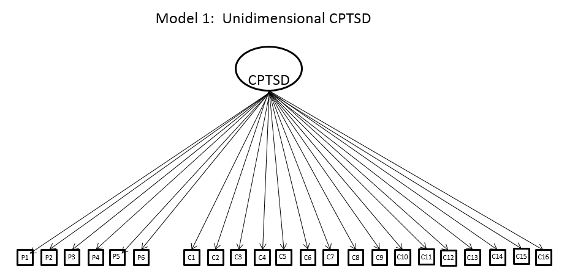
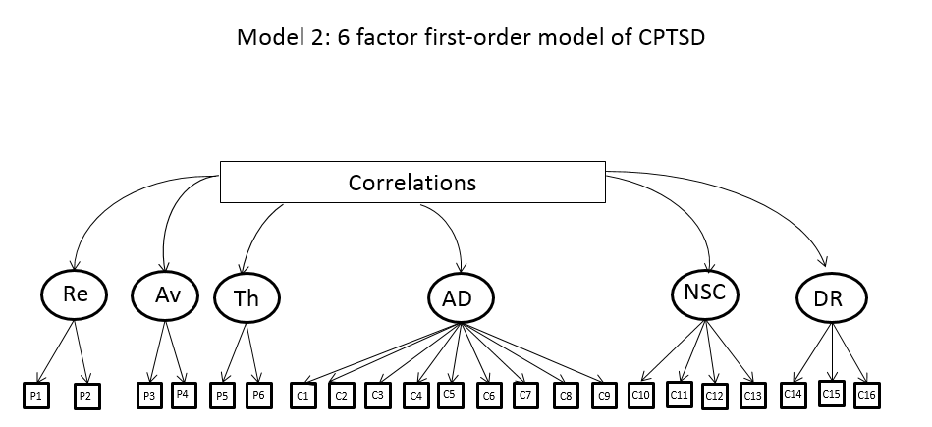
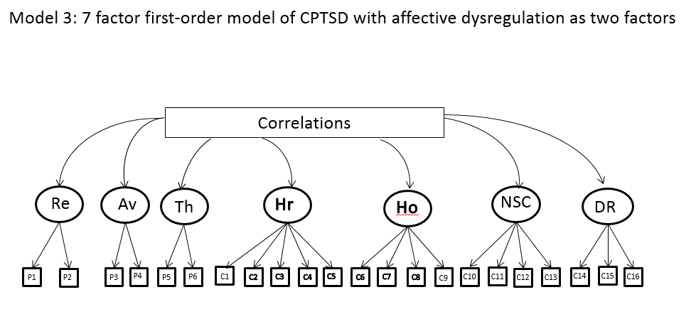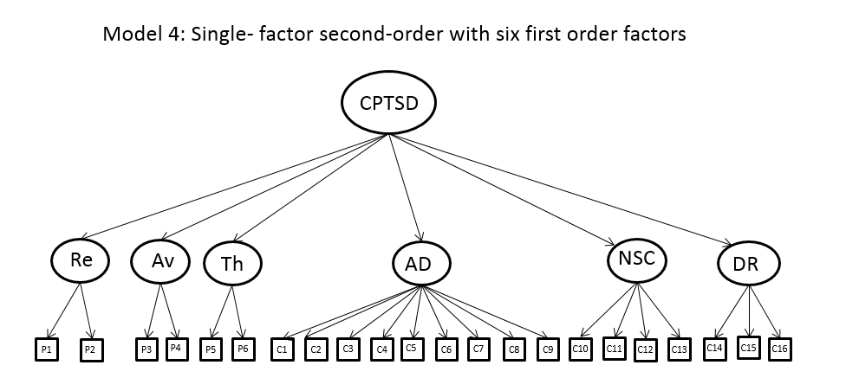
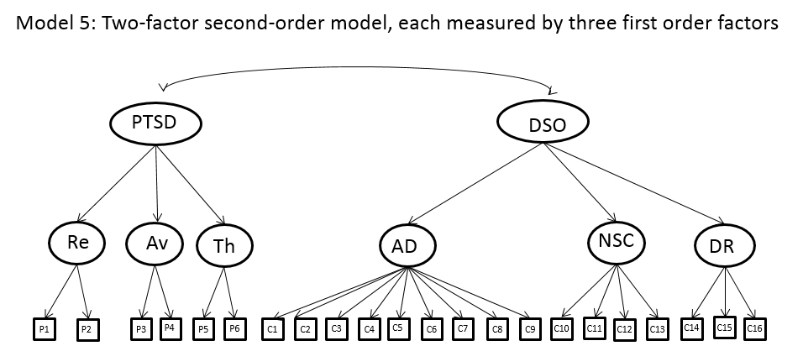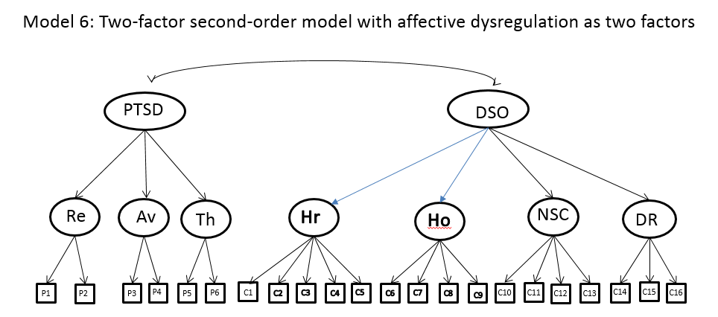
Figure 1: Model 1 depicts a unidimensional model where all items load onto a single latent variable, Complex PTSD (CPTSD). Model 2 is a six-factor correlated model consisting of re-experiencing (Re), avoidance (Av), threat (Th), affective dysregulation (AD), negative self-concept (NSC), and disturbed relationships (DR). Model 3 is a seven-factor model, further separating the Affective Dysregulation latent variable in terms of ‘hyperactivity’ (Hr) (C1-C5) and ‘hypoactivity’ (Ho) (C6-C9) symptoms. Model 4 is a second-order variant of Model 2, which assumes that the correlations between the six first-order factors can be explained in terms of a single ‘CPTSD’ second-order factor. Model 5 is a second-order model including two second-order latent factors of ‘PTSD’ (explaining covariation between re-experiencing, avoidance, threat) and ‘Disturbances in Self-organisation’ (DSO) (explaining covariation between affective dysregulation, negative self-concept, and disturbed relationships). Model 6 is similar to Model 5, but further separates the Affective Dysregulation factor into its ‘hyperactivity’ (Hr) and ‘hypoactivity’ (Ho) component parts.

References
1. World Bank Group, WHO, editors. Report of Proceedings of Event "Out of the Shadows: Making Mental Health a Global Development Priority."2016; Washington, DC: World Bank Group.
2. UNHCR. Figures at a Glance 2016 [Available from: http://www.unhcr.org/en-ie/figures-at-a-glance.html.
3. UNHCR. Global Focus: Lebanon 2017 [
4. Hollifield M, Warner TD, Lian N, Krakow B, Jenkins JH, Kesler J, et al. Measuring trauma and health status in refugees: a critical review. JAMA. 2002;288(5):611-21.
5. Bogic M, Njoku A, Priebe S. Long-term mental health of war-refugees: a systematic literature review. BMC Int Health Hum Rights. 2015;15:29.
6. Fazel M, Wheeler J, Danesh J. Prevalence of serious mental disorder in 7000 refugees resettled in western countries: a systematic review. Lancet. 2005;365(9467):1309-14.
7. Slewa-Younan S, Uribe Guajardo MG, Heriseanu A, Hasan T. A Systematic Review of Post-traumatic Stress Disorder and Depression Amongst Iraqi Refugees Located in Western Countries. J Immigr Minor Health. 2015;17(4):1231-9.
8. Kane JC, Ventevogel P, Spiegel P, Bass JK, van Ommeren M, Tol WA. Mental, neurological, and substance use problems among refugees in primary health care: analysis of the Health Information System in 90 refugee camps. BMC Med. 2014;12.
9. European Commission. Lebanon: Syria Crisis https://ec.europa.eu/echo/files/aid/countries/factsheets/lebanon_syrian_crisis_en.pdf2017 [
10. Kazour F, Zahreddine NR, Maragel MG, Almustafa MA, Soufia M, Haddad R, et al. Post-traumatic stress disorder in a sample of Syrian refugees in Lebanon. Compr Psychiatry. 2017;72:41-7.
11. Farhood LF, Fares S, Sabbagh R, Hamady C. PTSD and depression construct: prevalence and predictors of co-occurrence in a South Lebanese civilian sample. European Journal of Psychotraumatology. 2016;7(1):31509.
12. Maercker A, Brewin CR, Bryant RA, Cloitre M, van Ommeren M, Jones LM, et al. Diagnosis and classification of disorders specifically associated with stress: proposals for ICD-11. World Psychiatry. 2013;12(3):198-206.
13. Brewin CR, Cloitre M, Hyland P, Shevlin M, Maercker A, Bryant RA, et al. A review of current evidence regarding the ICD-11 proposals for diagnosing PTSD and complex PTSD. Clin Psychol Rev. 2017;58(Supplement C):1-15.
14. Tay AK, Rees S, Chen J, Kareth M, Silove D. The structure of post-traumatic stress disorder and complex post-traumatic stress disorder amongst West Papuan refugees. BMC Psychiatry. 2015;15:111.
15. Silove D, Tay AK, Kareth M, Rees S. The Relationship of Complex Post-traumatic Stress Disorder and Post-traumatic Stress Disorder in a Culturally Distinct, Conflict-Affected Population: A Study among West Papuan Refugees Displaced to Papua New Guinea. Frontiers in Psychiatry. 2017;8:73.
16. Nickerson A, Cloitre M, Bryant RA, Schnyder U, Morina N, Schick M. The factor structure of complex posttraumatic stress disorder in traumatized refugees. Eur J Psychotraumatol. 2016;7:33253.
17. Cloitre M, Roberts NP, Bisson JI, Brewin CR. The ICD-11 Trauma Questionnaire (ICD-TQ).
18. Karatzias T, Shevlin M, Fyvie C, Hyland P, Efthymiadou E, Wilson D, et al. An initial psychometric assessment of an ICD-11 based measure of PTSD and complex PTSD (ICD-TQ): Evidence of construct validity. J Anxiety Disord. 2016;44:73-9.
19. Hyland P, Shevlin M, Brewin CR, Cloitre M, Downes AJ, Jumbe S, et al. Validation of post-traumatic stress disorder (PTSD) and complex PTSD using the International Trauma Questionnaire. Acta Psychiatr Scand. 2017;136(3):313-22.
20. Shevlin M, Hyland P, Vallieres F, Bisson J, Makhashvili N, Javakhishvili J, et al. A comparison of DSM-5 and ICD-11 Posttraumatic Stress Disorder rates and comorbidity: An analysis of the Ukrainian Internally Displaced Person’s Mental Health Survey. . Acta Psychiatr Scand. in press.
21. Kubany ES, Haynes SN, Leisen MB, Owens JA, Kaplan AS, Watson SB, et al. Development and preliminary validation of a brief broad-spectrum measure of trauma exposure: the Traumatic Life Events Questionnaire. Psychol Assess. 2000;12(2):210-24.
22. Karatzias T, Shevlin M, Fyvie C, Hyland P, Efthymiadou E, Wilson D, et al. Evidence of distinct profiles of Posttraumatic Stress Disorder (PTSD) and Complex Posttraumatic Stress Disorder (CPTSD) based on the new ICD-11 Trauma Questionnaire (ICD-TQ). J Affect Disord. 2017;207:181-7.
23. Murphy S, Elklit A, Dokkedahl S, Shevlin M. Testing the validity of the proposed ICD-11 PTSD and complex PTSD criteria using a sample from Northern Uganda. Eur J Psychotraumatol. 2016;7:32678.
24. Muthen LK, Muthen BO. MPlus Statistical Analysis with Latent Variables. 7.4 ed. Los Angeles: Muthen and Muthen; 2013.
25. Flora DB, Curran PJ. An empirical evaluation of alternative methods of estimation for confirmatory factor analysis with ordinal data. Psychol Methods. 2004;9(4):466-91.
26. Hu L, Bentler PM. Cutoff criteria for fit indices in covariance structure analysis: Conventional criteria versus new alternatives. Structural Equation Modeling. 1999;6:1-55.
27. Peterson RA, Kim Y. On the relationship between coefficient alpha and composite reliability. J Appl Psychol. 2013;98(1):194-8.
28. Strauss AL, Corbin J. Basics of Qualitative Research: Grounded Theory Procedures and Techniques (2nd). Thousand Oaks Sage; 1998.
29. Perkonigg A, Hofler M, Cloitre M, Wittchen HU, Trautmann S, Maercker A. Evidence for two different ICD-11 posttraumatic stress disorders in a community sample of adolescents and young adults. Eur Arch Psychiatry Clin Neurosci. 2016;266(4):317-28.
30. Hyland P, Shevlin M, Elklit A, Murphy J, Vallieres F, Garvert DW, et al. An assessment of the construct validity of the ICD-11 proposal for complex posttraumatic stress disorder. Psychol Trauma. 2017;9(1):1-9.
31. Cloitre M, Garvert DW, Brewin CR, Bryant RA, Maercker A. Evidence for proposed ICD-11 PTSD and complex PTSD: a latent profile analysis. European Journal of Psychotraumatology. 2013;4:10.3402/ejpt.v4i0.20706.
32. Hyland P, Murphy J, Shevlin M, Vallieres F, McElroy E, Elklit A, et al. Variation in post-traumatic response: the role of trauma type in predicting ICD-11 PTSD and CPTSD symptoms. Soc Psychiatry Psychiatr Epidemiol. 2017.
33. Keeley JW, Reed GM, Roberts MC, Evans SC, Robles R, Matsumoto C, et al. Disorders specifically associated with stress: A case-controlled field study for ICD-11 mental and behavioural disorders. Int J Clin Health Psychol. 2016;16(2):109-27.
34. Mackenzie J, Kesner C. Mental health funding and the SDGs: What now and who pays? London, UK.; 2016 May 2016.
35. Shevlin M, Hyland P, Roberts N, Bisson J, Brewin C, Cloitre M. A psychometric assessment of disturbances in self-organization symptom indicators for ICD-11 Complex PTSD. . European Journal of Psychotraumatology. in press.
36. Bovin MJ, Marx BP, Schnurr PP. Evolving DSM Diagnostic Criteria for PTSD: Relevance for Assessment and Treatment. Current Treatment Options in Psychiatry. 2015;2(1):86-98.
37. Peek L, Abramson DM, Cox RS, Fothergill A, Tobin J. Children and Disasters. In: Rodrígues H, Donner W, Trainor J, editors. Handbook of Disaster Research. Handbooks of Sociology and Social Research: Springer, Cham; 2018. p. 243-62.
38. World Health Organization. mhGAP Intervention Guide: for mental, neurological and substance use disorders in non-specialized health settings (version 2.0). Geneva: World Health Organization; 2016.
39. Shevlin M, Hyland P, Roberts NP, Bisson JI, Brewin CR, Cloitre M. A psychometric assessment of Disturbances in Self-Organization symptom indicators for ICD-11 Complex PTSD using the International Trauma Questionnaire. Eur J Psychotraumatol. 2018;9(1):1419749.
40. Cloitre M, Courtois CA, Ford JD, Green BL, Alexander P, Briere J, et al. The ISTSS Expert Consensus Treatment Guidelines for Complex PTSD in Adults. 2012.

Case managers are close-to-community care providers affiliated with primary health care centres, working to bridge Syrian refugees requiring mental and physical health service with the formal health system.
All model parameter results are available, upon request, from the corresponding author.

