Effect of curing temperature on the behaviour of UHPFRC at elevated temperatures

Charles Kahanji^{a*}, Faris Ali^{b}, Ali Nadjai^{b} and Naveed Alam^{b}
ª Department of Civil Engineering, Stellenbosch University, Stellenbosch, 7602, South Africa
^{b} FireSERT, Built Environment Research Institute, School of the Built Environment, Ulster University, Shore Road, BT37 0QB, United Kingdom
*Corresponding author. Email address: ckahanji@sun.ac.za

ABSTRACT
Ultra high performance fibre reinforced concrete is one of the construction materials that is still in need of more research to evaluate its performance under fire, particularly regarding explosive spalling. In this study, the effect of curing temperature on the fire resilience of ultra-high performance fibre reinforced concrete (UHPFRC) has been tested. In particular, the influence of cold (20 °C) and hot (90 °C) water curing temperatures on the performance of UHPFRC exposed to elevated temperatures has been investigated. Beams, cured in cold water and in hot water were tested under the standard ISO 834 heating regime. The test results showed that the beam cured in hot water spalled significantly more than the beam cured in cold water. The study further investigated the influence of curing temperature on the residual strength of UHPFRC (containing both steel and polypropylene fibres). The cube elements were heated at eight selected temperatures between 200 °C and 900 °C. The cold-cured concrete exhibited higher relative residual strength at all temperatures. The results further showed that UHPFRC have high strength retention up to 600 °C. The residual peak strength for both the cold and the hot-cured occurred at 400 °C.
Keywords – Ultra-high performance fibre reinforced concrete; ISO 834; fire resistance; concrete beams; steel fibres; polypropylene fibres; spalling; curing; residual strength

INTRODUCTION
High performance concrete (HPC) cured in elevated temperature conditions are reported to have a much denser matrix due to improved hydration process compared to the cold-cured [1–3]. Additional calcium silicate hydrates (C-S-H) are formed when concrete is cured at elevated temperatures. As a result, thermally treated concrete possess enhanced mechanical properties like higher compressive strength, higher bond strength, tensile strength and improved durability attributes arising from the lower permeability and lower porosity [4,5]. This is more pronounced in ultra-high performance fibre reinforced concrete (UHPFRC) whose constituent materials are typically fine granular particles. In UHPFRC, the curing mode tends to have an influence on the mechanical properties of hardened concrete. For instance, UHPFRC elements cured in hot water are reported to attain higher early-age compressive strength than the corresponding specimens cured in cold water [6,7]. Richard and Cheyrezy [1] report that pozzolanic activity is slower in concrete cured at 20 °C. However, curing of concrete at elevated temperatures (at 90 °C) leads to accelerated pozzolanic reaction. Thermal curing results in longer chains of C-S-H hydrates being formed which modify the microstructure of the concrete, thus leading to a more compact matrix. The influence of curing temperature on the fire performance and spalling of UHPFRC has not been sufficiently tackled. Previous research work on different curing modes of UHPFRC have largely focussed on the assessment of the ambient mechanical properties of concrete [5–11].
Research conducted by Behloul et al. [12] and Pimienta et al. [13] suggests that curing temperature has no influence on the spalling behaviour of smaller elements (cubes, prisms and slabs) and large scale elements (columns and beams). These tests were based on the spalling resistant commercial UHPFRC formula (Ductal-AF) which contains polypropylene fibres. Comparative tests to highlight the contrasting performance behaviour of the cold-cured and the heat-treated elements exclusively reinforced with metallic (steel) fibres were not performed.
Lee et al. [14] also performed a series of fire tests on small UHPFRC element as well as large-scale columns under a standard fire. However, all the elements tested had undergone a single curing mode (heat-treatment).
Kahanji et al. [15,16] carried out fire tests on seven UHPFRC beams in a furnace under the ISO 834 heating regime. All the beams tested were cured in cold water. Three variables were investigated in this study; i.e. the steel fibre dosage (2 and 4 vol. %), polypropylene fibres, and the influence of an externally applied constant load (with load ratios of 0.2, 0.4 and 0.6). The fire resistance and the spalling patterns were studied and compared. The beams with 2 vol. % fibres were more susceptible to spalling and therefore had lower fire resistance ratings compared to those with 4 vol. %. The beams under the action of the 0.6 load ratio had the least spalling. No spalling was recorded in the beam which contained polypropylene fibres.
The explosive spalling phenomenon inherent in UHPFRC hampers efforts of successfully determining their residual strength [17]. UHPFRC specimens usually explode when heated beyond 400 °C [18]. One of the viable ways of determining the residual strength at higher temperatures is by adding polypropylene fibres [18,19]. The residual strength of normal strength concrete (NSC) and high strength concrete (HSC) is widely reported to deteriorate with temperature [20–22]. In their investigations, Chan et al. [23] exposed NSC and HSC to temperatures of up to 1200 °C. The specimens retained their ambient strength between 0 to 400 °C. Severe strength deterioration was observed between 400 °C and 800 °C. Beyond 800 °C, only a tiny fraction of their original strength was retained. Chen and Liu [24] also observed similar trends in the residual strength of HSC reinforced with steel, carbon and polypropylene fibres. Residual strength tests carried out by Xiao and Falkner [25] on high performance concrete also recorded strength degradation at temperatures between 100 and 900 °C.
Concrete containing steel fibres, however, is said to exhibit a different characteristic in the range of up to 400 °C. Purkiss [26] recorded gains in the residual strength of concrete with steel fibres when heated up to 400 °C. The concrete specimens without steel fibres on the other hand recorded losses in strength.
Only a few residual strength tests have been carried out on UHPFRC. Burke [19] performed residual strength tests on UHPC Ductal FM (steel fibres only) and Ductal AF (steel and polypropylene fibres) between 200 °C and 600 °C. The specimens made from Ductal FM spalled at higher temperatures. The residual strength was only analysed for Ductal AF specimens as they did not spall. The residual strength of samples that were heated for 1 hour was lower than the ambient temperature strength for all temperatures. However, for the specimens with a soak time of 3 hours, their residual strength was only higher than the ambient compressive strength at 300 °C. Xiong and Liew [18] also assessed the residual strength of UHPFRC at 200 °C, 400 °C, 600 °C and 800 °C. Sample specimens contained both polypropylene and steel fibres. A slight increase in residual strength was achieved at 200 °C but strength reduction was reported at 400 °C and above.
There is need for further investigations into the residual strength of UHPFRC especially those which are resistant to spalling. Investigations that delve into the influence of the curing temperatures would add another dimension to understanding the behaviour and performance of UHPFRC at elevated temperatures.

Research significance
The favourable mechanical properties of UHPFRC inevitably makes the material ideally suited for use in high strength applications such as tunnels. The performance of most building materials deteriorate in fire. Thus, elements of building construction need to be thoroughly tested to determine their performance and usability on exposure to elevated temperatures. The findings from tests like the ones performed in the current study could provide insights into the performance and usability of UHPFRC in applications such as tunnels where fire (like the Channel tunnel fire [27]) could have a profound effect on the structural integrity. From the literature reviewed, most tests on UHPFRC at elevated temperatures have been done on smaller elements e.g. cubes and cylinders. Few of the tests that have been done on large scale beams have looked at variables such as loading, steel fibre dosage, spalling resistant fibres. There is little research study that has attempted to compare the fire resistance and performance of beams cured in different modes. It is, therefore, imperative to compare the influence of curing temperatures on the performance of beams vis-à-vis fire resistance, spalling behaviour and residual strength. To achieve this, two beams cured in different conditions were tested under the ISO 834 fire curve. For residual strength tests, UHPFRC are highly susceptible to spalling but the inclusion of polypropylene fibres can eliminate the phenomenon, thus enabling researchers to assess the residual strength of spalling resistant UHPFRC. The data obtained can be useful in the post-fire analysis of UHPFRC structures. In this paper, the residual strength of UHPFRC with a dosage of 2 vol. % of steel fibres and 4 kg/m³ of polypropylene fibre was determined at temperatures ranging between 20 °C and 900 °C. One stream of cube specimens underwent cold water curing and another was hot-cured. The study analysed the strength gains/losses of specimens from the two curing conditions.

THE EXPERIMENTAL PROGRAMME

Materials
The mix proportion of the constituent materials used is shown in Table 1. The material composition for the beams and cubes (for residual strength tests) were the same except for the former where polypropylene fibres were not added. The fibres used were steel fibres (Dramix® fibres manufactured by Bekaert) and the monofilament polypropylene fibres. The steel fibres were straight and measured 13 mm long and 0.2 mm in diameter. For residual strength testing, the cube elements were reinforced with both steel and polypropylene fibres.
Table 1: Constituent Materials
Constituent | Type | Specific Mass (kg/m³)
Cement | CEM I 52.5N | 967
Silica fume | Larsen 60%<1μm | 251
Sand | ≤0.6mm | 675
HRWR | Larsen Chemcrete HP3 | 77
Steel fibres | Dramix® OL 13/.02 | 2 vol. % = 158
Polypropylene | Larsen Monofilament | 4
Water | w/b ≈ 0.20 | 244

Casting and curing
Casting was done in a 150-litre concrete pan mixer. A summarised sequence of the casting process is shown in Figure 1. The detailed procedure can be found in [7,28]. Two curing processes were adopted: cold curing and hot curing. The cold curing involved immersing the elements in a water tank with temperature kept at ambient levels for a continuous period of 28 days. The hot cured elements were submerged in a hot water tank for 7 days with temperature kept constant at 90 °C. After the curing process, the two beams were stored in the conditioning room in conformity with the BS EN 1363-1 [29] until the test day.
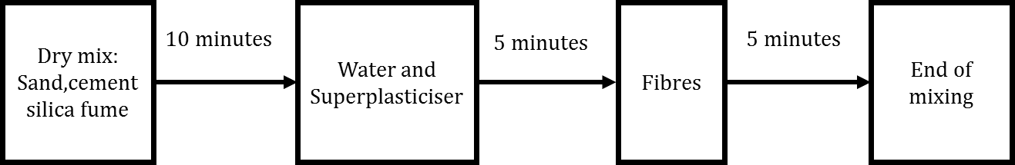
Figure 1: Sequence of mixing during casting

Design and details of test specimens
The experimental programme in this study is divided into two parts. The first involves testing of beams in the furnace under an ISO 834 fire curve [30]. The second part deals with residual strength testing of concrete. The latter involved heating cube elements up to a maximum temperature of 900 °C and subsequently testing for their residual strength.

Beam specimens
The two beams were 1300 mm long and had a cross-section of 100 mm x 150 mm. They were designated as USCF2-0 and USHF2-0. The specific details for the beams are shown in Table 2. Both beams contained steel fibres with a dosage of 2 vol. %, however, they did not contain steel reinforcement bars. The USCF2-0 beam was cured in cold water (with the letter “C” denoting cold curing) while the USHF2-0 was cured in hot water (the letter “H” denoting hot curing). In the earlier phase of this project, the beams were tested with an applied external load. The results from the previous investigations can be found in [16,28]. In this current study, no external load was imposed on both beams. The tests in the current paper were aimed at investigating the influence of the curing temperatures (20 °C and 90 °C) on the behaviour and performance of beams on exposure to elevated temperatures.
Table 2: Details of the beam specimens
Beam ID | Cross-section [mm] | Length [mm] | Curing mode | Steel fibre dosage [vol %]
USCF2-0 | 100x150 | 1300 | Cold (20 °C) | 2
USHF2-0 | 100x150 | 1300 | Hot (90 °C) | 2

Residual strength specimens
The second part of the experimental programme involved determining the residual strength of UHPFRC specimens containing both steel and polypropylene fibres. These tests were performed on 100 mm cubes at temperatures ranging from room temperature to 900 °C. The tests sought to investigate the influence of curing temperature on the residual strength of concrete. Owing to the explosive spalling nature of UHPFRC containing only steel fibres, only elements that are resistant to spalling were investigated for residual strength. Polypropylene fibres with a dosage of 4 kg/m³ were added to the mix. This amount was based on the previous study where spalling was successfully eliminated [16]. A total of fifty-four cubes were cast from the same batch; half of which were cured in hot water (90 °C) and another half in cold water (20 °C). Table 3 presents the number of cube specimens and the temperatures at which the residual compressive strength was determined.
Table 3: Residual strength test specimens
Temperature  [°C] | No. of cube specimens
 | Cold-cured | Hot-cured
20 | 3 | 3
200 | 3 | 3
300 | 3 | 3
400 | 3 | 3
500 | 3 | 3
600 | 3 | 3
700 | 3 | 3
800 | 3 | 3
900 | 3 | 3

THE TEST PROCEDURES

The test of beams in the furnace
The two beams were tested in an indicative fire resistance test furnace which had an internal chamber measuring 1.5 m x 1.5 m x 1.5 m. The furnace was designed to test material's ability to withstand exposure to high temperatures. The three vertical walls and floor surface of the furnace were lined with special high temperature insulating fire bricks while its front was fitted with a shutter sliding door made from alumina fibreboard. The furnace top was covered with two custom made concrete slabs with provision to accommodate the test sample beam between them and ensuring that the heat flow was unhindered. The beam specimen and slab interface and the slab-wall interface were lined with ceramic fibre blanket insulation. The fibre blanket used had the ability to withstand temperatures of up to 1260°C. The test beam was supported on specially made steel brackets. Figure shows the beam inside the furnace supported on the brackets at the ends. The furnace chamber was heated by 4 burners that were fired by liquefied petroleum gases. The heat output of the burners was controlled from the control room to ensure that it conformed to the ISO 834 curve. The inner chamber had five thermocouples placed at different positions and were used to determine the average furnace gas temperature. Each beam was tested separately without an applied load by exposing its bottom half section to the ISO 834 heating regime. The test duration for each beam was 60 minutes.
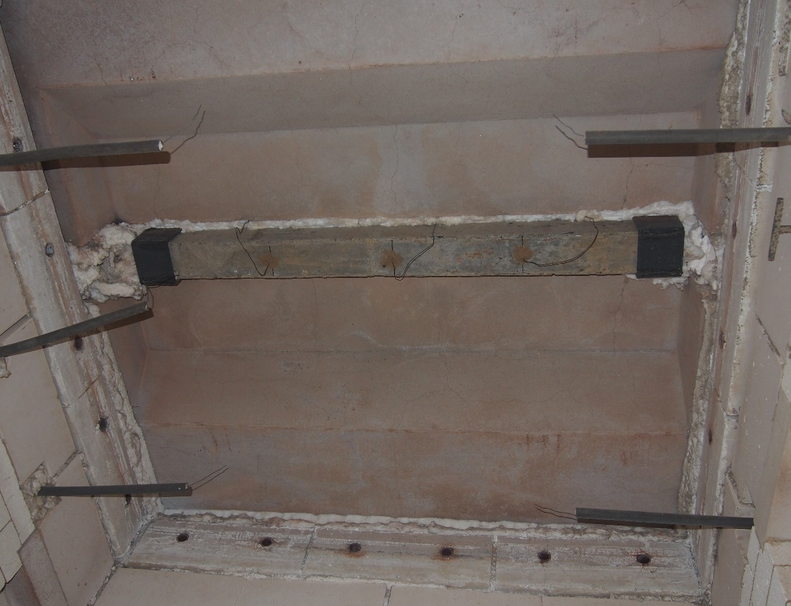
Figure 2: The position of the beam inside the furnace

Test instrumentation
The temperature history of the beams was measured by thermocouples. Five type K-310 thermocouples with stainless steel sheath material were fixed at five locations of the beams shown in Figure 3. The temperature was measured and recorded at intervals of 33 seconds throughout the entire test duration. The five different locations are marked TC-BL, TC-BC, TC-BR, TC-MID, and TC-TOP. These locations include the bottom surface, the mid depth and the top surface. The bottom surface, which was exposed to direct heat had three thermocouples. These were labelled TC-BL, TC-BC and TC-BR. The TC-MID thermocouple was placed at the mid-depth (75 mm depth) and the fifth (TC-TOP) was fixed at the unexposed top surface of the beam.
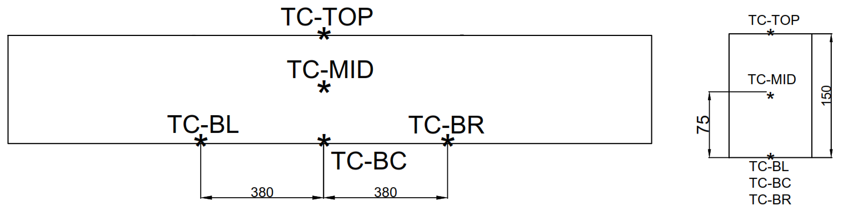
Figure 3: Thermocouple locations on the beams

Residual strength tests
The 100 mm cubes were heated in an ELF Carbolite Furnace, shown in Figure 4. The furnace had an internal chamber measuring 200 mm high, 220 mm wide and 315 mm in depth. The chamber was well insulated with ceramic fibre boards which had exceptionally low heat of conductivity. The furnace could accommodate a maximum of three 100 mm cubes. The furnace had a maximum operating temperature of 1100 °C and a maximum heating rate of about 25 °C/min. The specimens from both curing streams were heated at eight different temperatures (200, 300, 400, 500, 600, 700, 800 and 900°C) at about 10 °C/min heating rate. In both curing streams, a set of three cubes were tested at each of the eight temperatures in addition to those tested at ambient temperature. The specimens were placed in the furnace chamber and heated to the target temperature. Once the target temperature was attained, it was kept constant for 1 hour for purposes of achieving thermal stability. After being soaked for one hour, the cubes were removed and placed outside to cool in natural air. The test cubes were then tested in a standard compression machine to determine the residual compressive strength. The residual strength tests were performed within 24 hours of heating the cubes. Experimental results carried out by Phan et.al [31] reveal that it takes approximately 20 hours for the concrete core of cylindrical specimens to cool down to room temperature levels. Thus, the 24-hour period of cooling was a reasonable period for the cube elements to attain the ambient temperature.
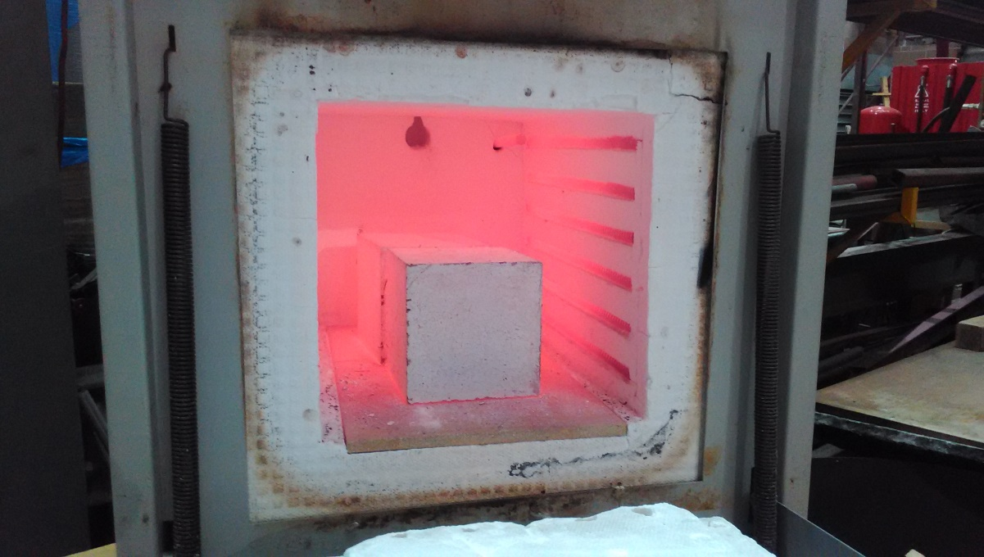
Figure 4: Cubes inside the Carbolite Furnace

RESULTS AND DISCUSSION

INFLUENCE OF CURING ON FIRE BEHAVIOUR OF UHPFRC BEAMS
The results of the two beams tested in the furnace are presented in this section. As already pointed out, the microstructure of concrete is affected by the curing temperature. Curing at elevated temperatures activates pozzolanic reaction, which generates additional hydrates in the concrete matrix. These additional hydrates fill up the existing voids thereby creating a denser matrix with stronger bonds. The difference in microstructure makeup may result in concrete having different responses when exposed to fire. To investigate the influence of the two phenomena, two beams without steel reinforcement bars were tested under the standard fire curve. They both contained steel fibres with 2 vol. % dosage. The USCF2-0 was cured in ambient water while the USHF2-0 was cured in hot water (90 °C). Subsequent sections discuss the findings of the two beams which were tested at elevated temperatures for a duration of one hour. Table 4 presents the 28 and the test-day compressive strengths, age and test duration of the two beams.
Table 4: Results summary of the two beams
Beam | Curing Temp | 28-day f_{ck} [MPa] | Test-day f_{ck} [MPa] | Age [days] | Test duration [min]
USCF2-0 | 20 °C | 128.8 | 154.4 | 509 | 60
USHF2-0 | 90 °C | 172.7 | 180.7 | 529 | 60

Cold-cured beam: USCF2-0
The beam was tested for one hour in the furnace without an external load. Five thermocouples were attached to this beam to record the temperature history. It had 28-day and test-day compressive strength of 128.8 MPa and 154.4 MPa respectively.

Test observations
The audible sounds of explosive spalling commenced in the 12th minute of the test. The sounds intensified around the 15th minute but lessened significantly in the final ten minutes of the test, with only occasional loud bangs. White steam presumably from the beam’s moisture could be seen billowing above the furnace. The temperature history at five locations of the beam are presented in Figure 5. Also included on the graph is the furnace gas temperature (Mean Furn) which compared well with the ISO 834 fire curve. The graphical data shows that the unexposed surface of the beam had attained a maximum temperature of 110 °C (from the 11 °C initial temperature), which is less than the 180 °C stipulated in the design code [29]. The temperature profile at the top surface (TC-TOP) shows a time delay of 15 minutes as the top surface temperature approached 100 °C (44th minute). This time delay was due to the latent heat of vaporisation of the moisture which drifted from the heated zone (bottom half of the beam) and accumulated on the top surface. As clearly marked out in Figure 5, all the three thermocouples attached to the bottom surface (TC-BL, TC-BC and TCBR) were expunged from the concrete surface between the 13th and 15th minute. This period coincided with the phase of intense spalling. The temperature at mid-depth (TC-MID) remained below 100 °C in the first 30 minutes, but it reached a maximum of 255 °C at the end of the test. A closer analysis of the damaged beam in Figure 6 and Figure 7 show that a small portion of the beam around the midspan, where the TC-MID was positioned, was not severely affected by spalling compared to the outward regions of the beam towards the end supports. Since there was no external load applied on the beam, it was largely under the action of its weight. The self-weight load is assumed to act at midspan. This might have induced cracks around that region. These cracks could have been used as pathways for trapped gaseous vapour to escape, thereby reducing pore pressure and minimising the severity of spalling around the midspan region.
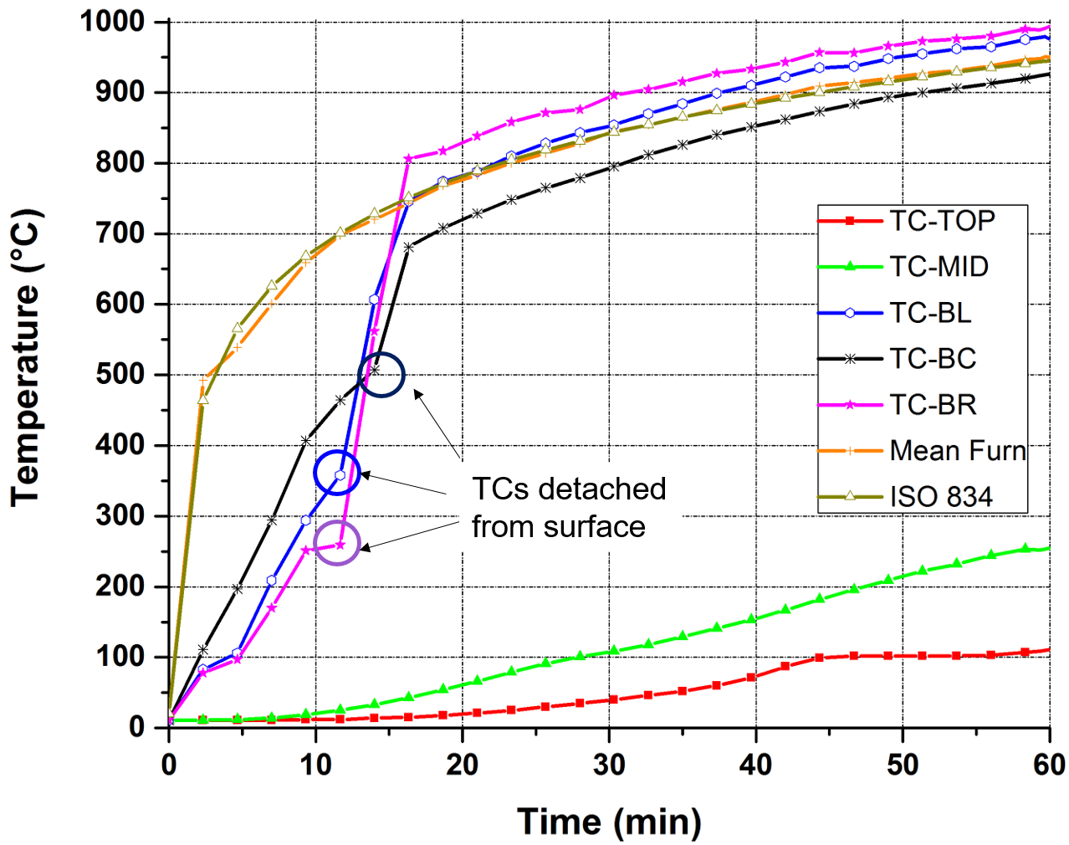
Figure 5: Temperature distribution of the cold-cured beam – USCF2-0

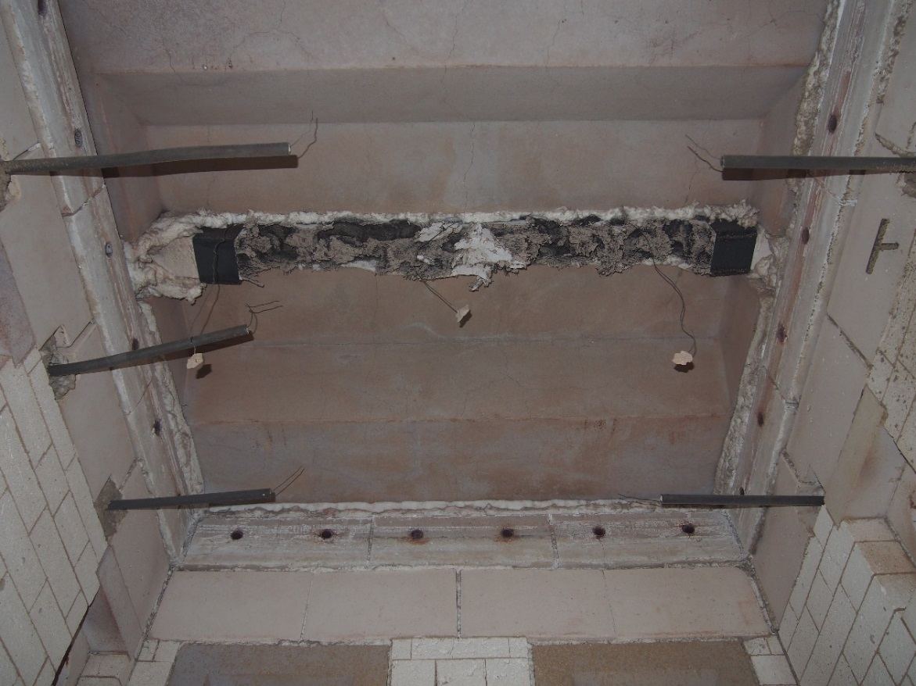
Figure 6: USCF-2 beam after fire test inside the furnace

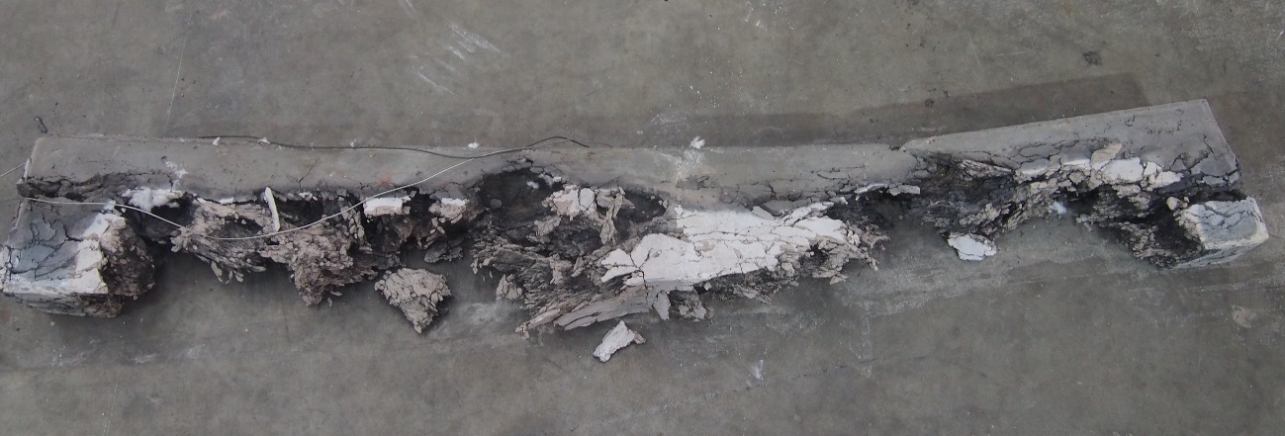
Figure 7: USCF-2 beam outside the furnace after test

Hot-cured beam: USHF2-0
The USHF2-0 was cured in hot water at 90 °C for a continuous period of 7 days. The beam was kept in the conditioning room until a few days before the tests for test preparations. Its 28-day and test-day compressive strengths were 172.7 MPa and 180.7 MPa respectively. Other parameters, instrumentation and test procedures were the same as the cold-cured USHCF2-0 beam.

Test observations
The beam was heated under the ISO 834 fire curve, in the furnace, for one hour. The explosive sounds of spalling commenced in the eighth minute. Figure 8 shows the temperature history across the beam section. Three thermocouples (TC-BR, TC-BC and TC-BL) were attached to the bottom surface at different locations to measure the temperature along the length of the beam. It can be seen from the graph that the temperatures were virtually the same up to the 12th minute. It can also be observed that they were all hauled off from the bottom surface at the small time (12th minute) at which point the surface temperature of the beam was 350 °C. This was the period when spalling had intensified. The temperature suddenly increased to over 600 °C in less than 3 minutes, and after that, the temperature profile for the three followed the pattern of the ISO 834 fire curve.
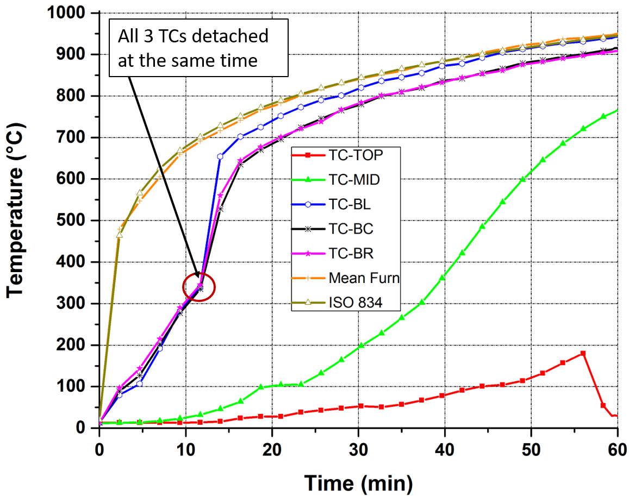
Figure 8: Temperature distribution of the hot-cured beam –USHF2-0

The temperature at the mid-depth was monitored by the TC-MID thermocouple. Note from Figure 8 that the mid-depth attained a temperature of nearly 100 °C after 18 minutes of fire exposure and this temperature remained constant for about 5 minutes implying the existence of a liquid/vapour phase change. Most of the lower section of the beam was “eaten up” by spalling as can be seen from Figure 9 and Figure 10. This can be observed from the temperature of the mid-depth, which was almost 750 °C at the end of the test. The temperature of the top surface was nearly 200°C in the 57th minute but decreased suddenly to less than 30 °C at the end of the test. At that instance, the beam had lost its bottom half because of excessive spalling. Spalling begun to affect the top surface; flakes of concrete could be seen being ejected from the top surface at high velocities. The sudden drop in temperature indicates that the thermocouple was detached from the top surface and left hanging in the air outside of the furnace thereby reading the room temperature. Upon inspection after the test, it was confirmed that the TC-TOP was detached from the beam and it was hanging in mid-air.
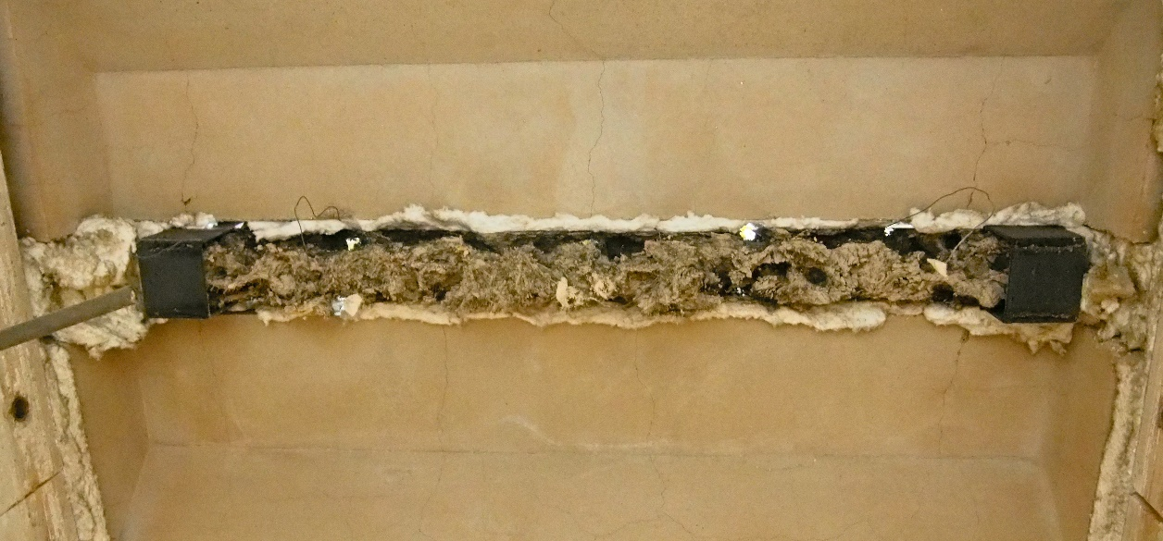
Figure 9: USHF-2 beam after fire test inside the furnace

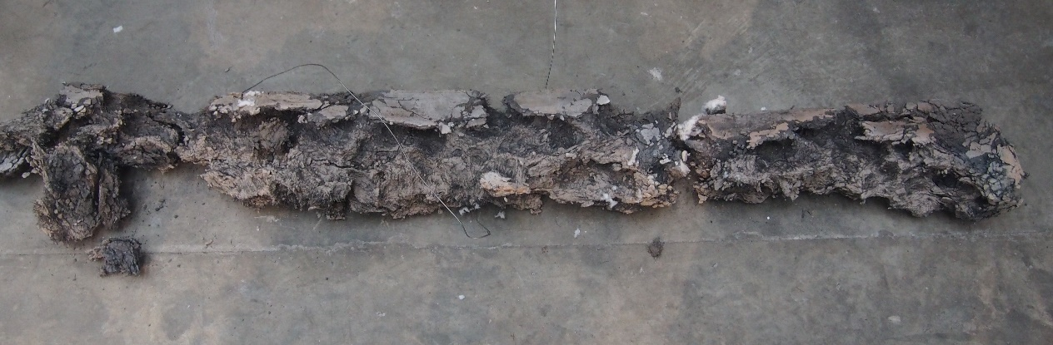
Figure 10: Remains of the hot cured, USHF2-0 beam after fire test

Comparisons between the hot and the cold cured beams
A number of contrasting observations were noted when the two beams that were cured in different conditions were exposed to elevated temperatures.

Onset of spalling
The explosive sounds that signalled the onset of spalling commenced four minutes early in the hot-cured beam. These results are an indication that the onset of spalling is influenced by the compactness of the concrete matrix. The thermally treated beam had higher compressive strength, denser matrix and therefore smaller capillary pores. The smaller pores are filled with higher vapour pressure much quicker than the relatively larger pores present in the cold-treated beam. Consequently, these factors result in spalling being triggered a few minutes early in thermally treated UHPFRC.

Size of flakes and explosive sounds
The spalling sounds were not the same in the two beams. In addition to the explosive bangs, which were common to both beams, the hot-cured was characterised with continuous firecracker-like sounds, especially in the first 30 minutes. The different sounds reported could be used to predict the size of spall fragments coming off the element. The firecracker-like sound, in this case, could be an indication that the fragments were tiny pieces. This was confirmed by analysing the size of fragments from each beam. Figure 11 shows the furnace floors with fragments from each test. The fragments in the hot-cured (right) were much smaller compared to those from the cold-cured beam (on the left). This supports the findings by Jansson [32] where the spalling behaviour of self-compacting concrete made from HSC and NSC was compared. The thickness of spall fragments from HSC (higher paste density) were much thinner compared to those from the NSC (less closely packed) elements. At a microstructure level, the hot-cured concrete has a more closely packed matrix and going by the findings of Jansson [32]; they are expected to have much finer spall flakes than the cold-cured UHPFRC. Towards the end, the hot-cured beam had louder and more violent sporadic bangs (in addition to the continuous cracker-like sounds). Overall, the sounds were much more violent in the hot-cured beams.
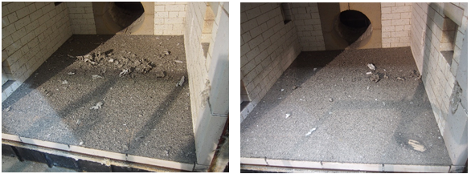
Figure 11: The furnace surface with spall fragments; the USCF2-0 beam on the left and USHF2-0 on the right

The extent of spalling
In the cold-cured beam spalling was only restricted to the exposed portion of beams. However, in the hot-cured beam, the unexposed top surface was also affected by spalling. Some flakes of concrete pieces could be seen coming off from the unexposed top surface of the beam. The flakes were scattered at high speeds away from the furnace and were accompanied by massive explosions. The explosive bangs in the hot-cured continued long after the furnace had been switched off. This is in contrast to all the cold-cured beams (including beams from previous tests [16]) where spalling sounds stopped immediately the furnace was switched off. Spall fragments continued to be ejected from the top surface of the hot-cured beam long after the furnace had been switched off. The portions of the top surface of the USHF2-0 beam affected by spalling are clearly marked out in Figure 12. The spalling at the top surface of the hot-cured beam could be explained in terms of the degree of material loss caused by the difference in microstructure. It can be observed from Figure 7 that the upper portion of the cold-cured beam was nearly intact, whereas in the hot-cured beam (Figure 10), only a small section had remained. The reduced thickness of the beam probably made it easier for the moisture in the remaining portion to be driven to the top (cold) surface by the heat from below. This probable scenario could have caused the pressure in the capillary pores around the top surface to build-up thereby triggering explosive spalling at the top surface.
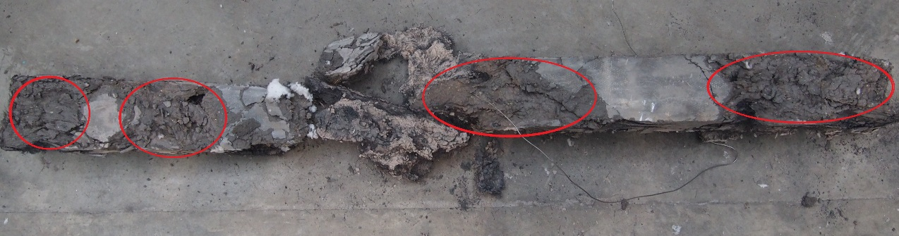
Figure 12: USHF2-0 beam showing material loss on portions of the top surface
The hot-cured beam lost more mass as a result of spalling. Table 5 shows the initial mass of both beams including the masses of the remnant beams and the spall fragments. The USCF2-0 remained as a single piece after the fire test but the USHF2-0 beam was only kept together as it was sandwiched between the two top slab covers. It disintegrated into smaller stumps on the furnace floor as attempts were made to bring it down.
Table 5: Spalling comparisons in terms of mass loss
Beam ID | Mass before test  [kg] | Spall fragments [kg] | Mass of beam after test  [kg] | Total (fragments + beam mass after test)  [kg]
USHF2-0 | 45.0 | 18.3 | 20.0 | 38.3
USCF2-0 | 45.2 | 14.7 | 25.2 | 39.9

Time-temperature history
Figure 13 compares the temperature history of both beams at the two locations; the top surface and the mid-depth. The beams had almost similar temperature profiles at the top surface for about 45 minutes. Thereafter, the top surface temperature of the cold-cured beam remained nearly constant (about 100 °C) until the end. The peak temperature at the top surface of the hot-cured beam, on the other hand, was twice the peak value of the cold-cured (200 °C) before the thermocouple got detached from the surface at 57 minutes. The mid-depth temperature (TC-MID) in both beams show similar trends up to the 10th minute, but the temperature of the hot-cured started to increase rapidly after that. The temperature increase coincided with the onset of spalling. The hot-cured beam lost almost the entire section and the TC-MID thermocouple was left exposed to direct heat, hence the spike in temperature.
Figure 13: Temperature distribution profiles of both USHF2-0 and USCF2-0 at the top surface and mid-depth

INFLUENCE OF AN EXTERNAL LOAD
In earlier studies by these authors [16], seven beam specimens were tested in the furnace while loaded under three load ratios. The loads were applied prior to the fire test. Comparing the performance of the loaded and unloaded beams, the current study has shown that the elements without an externally imposed load are much more susceptible to spalling. Depending on the load magnitude, imposing a load on a flexural element results in the formation of cracks in the tension region of the member. In earlier studies, the beams imposed with the highest load ratio (0.6) spalled the least. This was attributed to severe cracking of the beams prior to the fire test. These cracks could have acted as channels through which gaseous vapour and chemically-bound water were expelled when the elements were heated. The expulsion of vapour would mean having reduced pore pressure around the heated regions, thereby reducing the severity of explosive spalling. This reinforces the theory postulated by Khoury [33] regarding the relationship between spalling and the porosity of concrete.

RESIDUAL STRENGTH OF CONCRETE CUBES RESULTS
Analysing the residual strength behaviour of concrete helps engineers in post-fire assessments. It enables structural engineers to make an informed decision on the suitability of a structure to perform its structural function and to prescribe repair works if necessary. The residual strength of concrete was determined by heating the specimens to a target temperature (between 200 – 900 °C) and soak at that temperature for 1 hour and then allowed to cool. Figure 14 shows the cubes inside the furnace just after they were heated at 900 °C. Some of the cube samples are shown in Figure 15 after undergoing heating at various temperatures. The colour change at different temperatures at which the cubes were heated, is quite distinct from the photo.
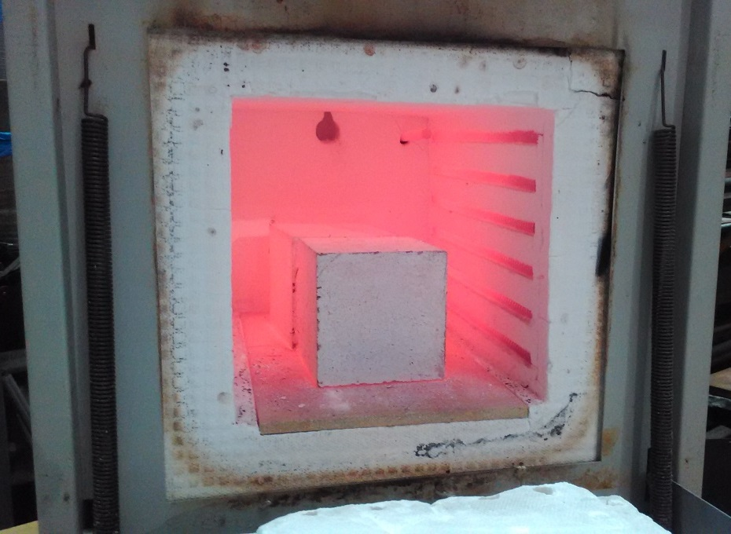
Figure 14: Cubes inside furnace at 900 °C temperature

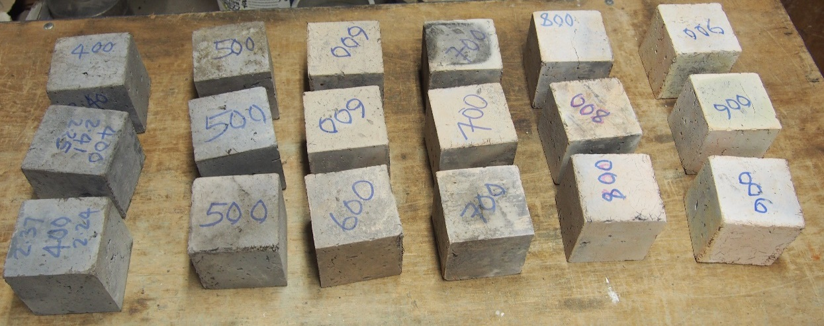
Figure 15: Some of the cubes after heating before testing
At each target temperature, two sets of results are presented; the first set being the residual strength of cubes cured in 20 °C water and the other set for specimens cured in hot water (90 °C). The residual compressive strength at each target temperature is then analysed by comparing them with the ambient compressive strength. These results are presented in Table 6. Also included in the table is the relative residual strength that is taken as a ratio of room temperature compressive strength to the residual strength at a target temperature. The next sections analyse the residual strength results of the cold and the hot-cured cubes.
Table 6: Residual strength of test specimens
Temperature  [℃] | Compressive strength  [MPa] |  | Relative residual strength $\left[\frac{f_{ck-T}}{f_{ck-20}}\right]$
 | Cold-cured | Hot-cured | Cold-cured | Hot-cured
Room Temp | 100.0 | 150.6 | 1.0 | 1.0
200 | 111.2 | 152.8 | 1.11 | 1.01
300 | 120.6 | 161.5 | 1.21 | 1.07
400 | 130.7 | 171.6 | 1.31 | 1.14
500 | 104.8 | 163.6 | 1.05 | 1.09
600 | 101.5 | 136.2 | 1.02 | 0.90
700 | 87.9 | 110.7 | 0.88 | 0.74
800 | 52.5 | 65.9 | 0.53 | 0.44
900 | 28.8 | 20.1 | 0.29 | 0.13

Cold-cured cubes
The ambient temperature compressive strength of the cold-cured cubes was 100 MPa. This value was taken as the reference compressive strength value. The residual compressive strength of cold-cured specimens increased progressively and reached the peak at 400 °C (130.7 MPa). The strength at 400 °C was 30 % higher than the ambient temperature value. At 500 °C, the residual strength dropped from 130.7 MPa (at 400 °C) to 104.8 MPa, although it was still about 5 % higher than the ambient strength. At 600 °C, the residual strength was nearly the same as the ambient compressive strength. It was only at 700 °C that the residual strength first became lower than the ambient compressive strength value (12 % lower) and at 800 °C, the residual strength deteriorated by about 50 %. At 900 °C, the residual strength degenerated to about 30 % of the ambient temperature strength.

Hot-cured cubes
The hot-cured specimens had a higher ambient temperature compressive strength (150.6 MPa) than the cold-cured (100 MPa). Just like the cold-cured specimens, the residual strength of the hot-cured elements also increased progressively from 150.6 MPa at 200 °C, to a peak strength of 171.6 MPa at 400 °C. This peak residual strength was 14% higher than the reference value. After attaining the peak residual, the strength dropped slightly to 163.6 MPa at 500 °C, but this was still 9 % higher than the ambient strength. It was only at 600 °C that the residual strength first went below the ambient strength value, (10 % lower than the 20 °C compressive strength). The strength deteriorated further at 700 °C, but the worst deterioration in strength was recorded at 900 °C, where only 13 % of the strength was retained. Figure 16 shows a close-up of two specimens after being heated at 800 and 900 °C respectively. The extent of cracking on both specimens is clearly visible. The formation of cracks at the two temperatures affected specimens from both curing modes.
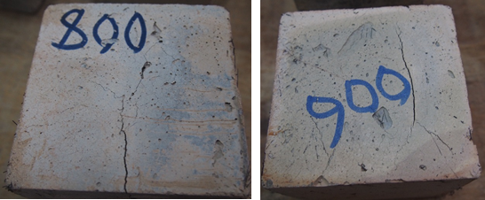
Figure 16: Some specimen after being heated at 800 °C (left) and 900 °C (right) with cracks

Influence of curing temperature
The residual strength for both the cold and hot-cured specimens is plotted in Figure 17. The results show that the rate of increase in residual strength between 200 and 400 °C was much greater in the cold-cured specimens. The results further indicate that from 500 °C, the rate of strength degradation was higher in hot-cured specimens.
Relative residual strength is a much better parameter for purposes of analysing and comparing changes in strength. The relative residual strength at a given temperature (T) is the ratio of the residual strength (fck-T) to the ambient temperature compressive strength (fck-20). The relative residual strengths are expressed in graphical form in Figure 18. The relative residual strength for the cold-cured specimens was higher than that of the hot-cured up to 400 °C.
The disparities can be explained in terms of the hydration process. In hot-cured specimens, there is a near complete hydration process due to the activation of pozzolanic reactions. For the concrete cured in ambient temperature water, the hydration process at 28 days is normally not fully complete; the bulk of silica fume added at the mixing stage is normally present in its raw form as a filler. The cold-cured specimens also possess relatively higher levels of moisture content than the hot-cured elements. The heating of the cube elements in the oven led to a resumption of the hydration process. After being heated, the unreacted silica fume and the cement paste in the elements went on to react, forming new C-S-H binders. This process would result in concrete having stronger bonds and higher compressive strength between 200 and 400 °C. The strength degradation recorded beyond 600 °C (which is regarded as the critical temperature), could be attributed to the dehydration of the C-S-H gel due to excessive heat [23].
Figure 17: Graphical representation of the residual strengths

Figure 18: The relative residual strength for both cold and hot-cured specimens

Comparisons with existing models
Xiao and Falkner [25] formulated a third order polynomial model for the relative residual strength relationship based on the HPC with polypropylene fibres. This is presented in Equation (1). The equation was decomposed into Equations (2) and (3).
$$\frac{f_{cu}^{T}}{f_{cu}^{20}}=0.002{\left(\frac{T}{100}\right)}^{3}-0.04{\left(\frac{T}{100}\right)}^{2}+0.11\left(\frac{T}{100}\right)+0.9638$$ |  |  | (1)
$$\frac{f_{cu}^{T}}{f_{cu}^{20}}=1.011-\frac{T}{1900}; T≤400 ℃$$ |  |  | (2)
$$\frac{f_{cu}^{T}}{f_{cu}^{20}}=1.440-\frac{T}{625}; 400℃≤T≤900 ℃$$ |  |  | (3)
where | $$T$$ | Exposure temperature of HPC [°C ]
 | $$f_{cu}^{T}$$ | Residual compressive strength at temperature T
 | $$f_{cu}^{20}$$ | Compressive strength of HPC at 20 °C

An attempt to use the Xiao-Falkner model on the residual strength results has been made in Figure 19. However, it can be observed that this model is not compatible with the UHPFRC results. Whereas the obtained residual strength for both cold and hot-cured specimens increased up to 500 °C, the results obtained by Xiao and Falkner [25] on HPC showed a decrease in residual strength at all temperatures, relative to the ambient temperature strength. A new model that works with UHPFRC is therefore needed. Since the strength degradation or gain for specimens that have undergone cold curing and hot curing is not the same, there is need to formulate two separate models. It is hoped, these models can be used to predict the strength gains/degradations of specimens with similar constituent materials and cured in similar temperature conditions.
Figure 19: The Xiao-Falkner model

The model for specimens
The regression curves for both the hot and the cold cured specimens are presented in Figure 20. These were derived from the best fitting curves which were obtained from the 3rd order polynomials and expressed in terms of the relative residual strength.
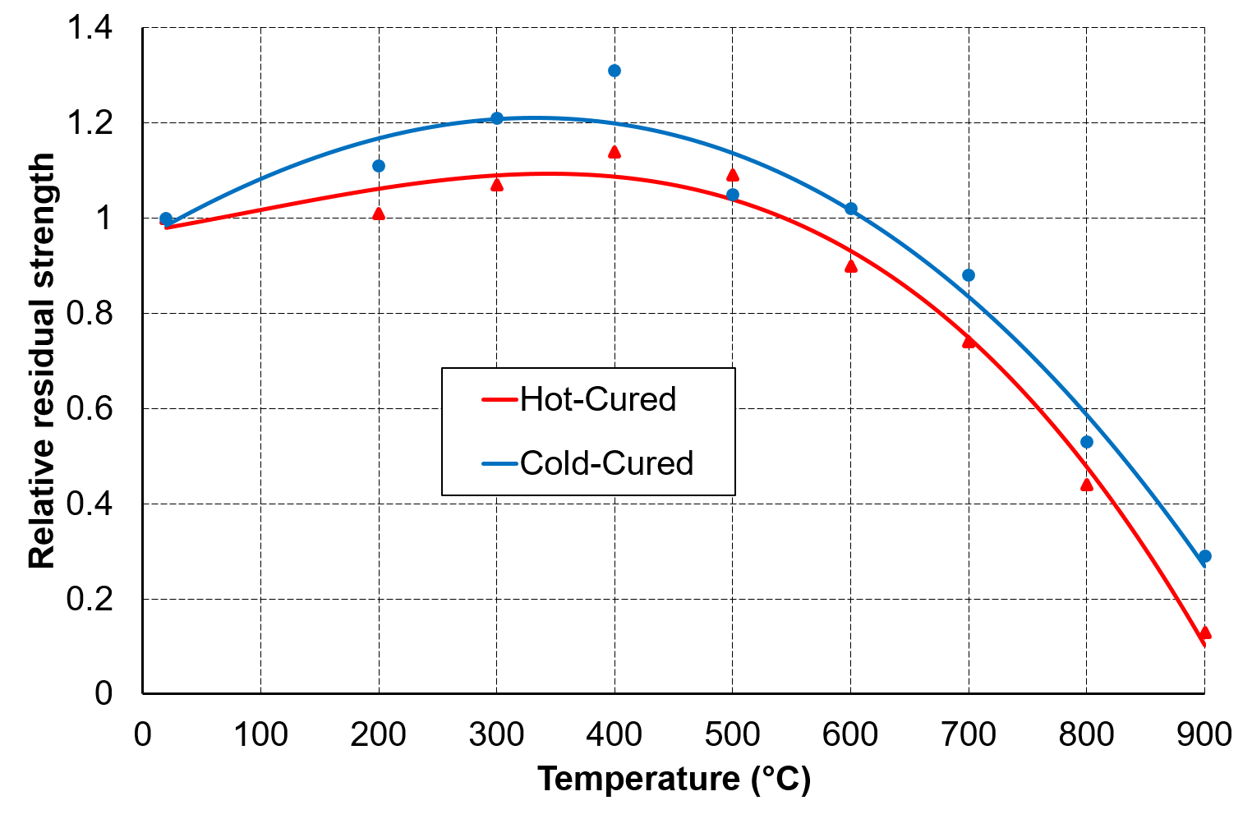
Figure 20: Residual strength regression for both the cold and the hot-cured cubes

Model for hot-cured elements
Equation (4) shows the polynomial for the hot-cured specimens.
$$\frac{f_{ck-T}}{f_{ck-20}}=-0.00242{\left(\frac{T}{100}\right)}^{3}+0.00638{\left(\frac{T}{100}\right)}^{2}+0.0423\left(\frac{T}{100}\right)+0.97147$$ |  |  | (4)
Adjusted R-square = 0.97942
where | $$T$$ | Exposure temperature of test specimen [°C]
 | $$f_{ck-T}$$ | Residual compressive strength at temperature T
 | $$f_{ck-20}$$ | Compressive strength of specimen at 20 °C

From Figure 20, the residual strength increased gradually and reached its peak at 400 °C before reducing drastically up to 900 °C. Two distinct regions of the curve can be observed from the graph, i.e. positive and negative gradients regions. The third order polynomial equation can be transformed into two linear equations. Equation (5) can be used to approximate the relative residual strength between 0 and 400 °C while Equation (6) is more suited for temperatures above 400 °C.
 | $$\frac{f_{ck-T}}{f_{ck-20}}=0.03604+\left(\frac{T}{100}\right)+0.97211; ≤400°C$$ | (5)
 | $$\frac{f_{ck-T}}{f_{ck-20}}=-0.238+\left(\frac{T}{100}\right)+2.326; >400°C$$ | (6)

The model for cold-cured elements
Similarly, the regression curve for the cold-cured follows Equation (7) which was obtained from the best fitting curves are shown in Figure 20.
$$\frac{f_{ck-T}}{f_{ck-20}}=-0.000702{\left(\frac{T}{100}\right)}^{3}-0.018326{\left(\frac{T}{100}\right)}^{2}+0.145\left(\frac{T}{100}\right)+0.95609$$ | (7)
Adjusted R-square = 0.94545

From Figure 20, the residual strength pattern shows an increase in strength up to 400 °C, then the strength can be seen to decrease gradually from 400 to 900 °C. From these two distinct regions, simplified linear relationships can be developed. The first one relates to temperatures between 20 - 400 °C and the second for 400 - 900 °C. These two expressions are presented in Equations (8) and (9).
 | $$\frac{f_{ck-T}}{f_{ck-20}}=0.081345+\left(\frac{T}{100}\right)+0.97041; ≤400°C$$ | (8)
 | $$\frac{f_{ck-T}}{f_{ck-20}}=-0.194+\left(\frac{T}{100}\right)+2.10952; >400°C$$ | (9)

RECOMMENDATIONS
The results of this study have clearly shown that spalling is more ferocious in the thermally cured elements. Comparisons drawn between the concrete elements tested in a previous study ([16]) with an externally applied load and the current study with no load have shown that spalling is more prevalent in the latter scenario. The results from the current study plausibly imply that non-structural elements made from thermally treated UHPFRC could be unsuitable in certain building applications. One such area where they may be deemed unsafe is in tunnel applications. Spalling is usually initiated when concrete is exposed to rapidly rising temperatures. Tunnel fires are typically propelled by petrochemical fuels found in automobiles. These fires (hydrocarbon) are more severe than the cellulosic ones upon which this study was based. UHPFRC structural elements in such an environment could suffer severe damage from explosive spalling owing to the ferocious nature of such fires. In such applications, it is strongly recommended that polypropylene fibres be added to UHPFRC elements.

CONCLUSIONS
This study has presented results of two UHPFRC beams tested at elevated temperatures in a furnace under a standard temperature heating profile. The study has also explored the residual strength behaviour of UHPFRC containing both steel and polypropylene fibres. The residual strength tests were performed on cube elements that were heated between 200 and 900 °C. The following conclusions were drawn from this study:
- The performance of the UHPFRC beams was highly influenced by the curing regime. The hot-cured beam spalled significantly more than the cold-cured.

- The explosive sounds were also influenced by the curing temperature. They were much louder and produced “fire-cracker” like sounds in the hot-cured beam.

- The time spalling starts is influenced by the curing method. Spalling started four minutes early in the hot-cured elements as these elements have smaller pores (denser matrix) which are filled with high vapour pressure a lot quicker than the relatively larger pores typically present in the elements cured in cold water.

- The curing temperature has an influence of the size of spalling flakes. The spall fragments in the hot-cured beam were much smaller and refined compared to the cold-cured beam which were much bigger.

- The marked contrast in the spalling behaviour of the two beams was attributed to their microstructure. Hot-cured UHPFRC have a much denser matrix and thus, fewer capillary pores and cavities brought about by the additional binders produced from pozzolanic reactions.

- In comparisons with loaded beams conducted in previous study, the unloaded beams had a higher degree of spalling. The unloaded beams were almost in an unrecognisable state after the fire test. Thus, imposing an external load on a flexural member could minimise spalling due to the stresses induced in a member. The thermo-mechanical stresses create cracks, which eventually serve as escape routes for vapour and chemically bound water.

- Based on the ferocity of spalling prevalent in the hot-cured elements, their use in applications such as tunnels, where fires could have devastating effects, is not recommended. UHPFRC used in such applications must contain polypropylene fibres.
- In general, UHPFRC have higher residual compressive strength with respect to their ambient compressive strength up to the temperature of 600 °C. This is in contrast to the well-known documented behaviour of NSC and HSC which normally record losses in strength at elevated temperatures.

- The residual strength peaked at 400 °C, which was higher than the corresponding ambient strength by 31 % and 14 % for the cold-cured and hot-cured elements respectively.

- The residual strength tests have showed that the cold-cured specimens have higher strength retention than the hot-cured specimens. This is attributed to the resumption of the hydration process in the cold-cured elements on exposure to elevated temperatures.
References
[1] P. Richard, M. Cheyrezy, Composition of reactive powder concretes, Cem. Concr. Res. 25 (1995) 1501–1511. doi:10.1016/0008-8846(95)00144-2.
[2] H. Zanni, M. Cheyrezy, V. Maret, S. Philippot, P. Nieto, Investigation of hydration and pozzolanic reaction in Reactive Powder Concrete (RPC) using 29Si NMR, Cem. Concr. Res. 26 (1996) 93–100. doi:http://dx.doi.org/10.1016/0008-8846(95)00197-2.
[3] M. Cheyrezy, V. Maret, L. Frouin, Microstructural analysis of RPC (Reactive Powder Concrete), Cem. Concr. Res. 25 (1995) 1491–1500. doi:10.1016/0008-8846(95)00143-Z.
[4] J. Yuan, B. Graybeal, Bond of reinforcement in ultra-high-performance concrete, ACI Struct. J. 112 (2015) 851–860. doi:10.14359/51687912.
[5] A. Kamen, E. Denarie, E. Bruhwiler, Thermal Effects on Physico-Mechanical Properties of Ultra-High-Performance Fiber-Reinforced Concrete, ACI Mater. J. 104 (2007). doi:10.14359/18832.
[6] C. Kahanji, F. Ali, A. Nadjai, Influence of curing regimes on flexural behaviour of ultra-high performance concrete beams, in: Response Struct. Under Extrem. Load., DEStech Publication, Inc, East Lansing, Miami, USA, 2015: pp. 730–737.
[7] C. Kahanji, F. Ali, A. Nadjai, Structural performance of ultra-high-performance fiber-reinforced concrete beams, Struct. Concr. 18 (2017) 249–258. doi:10.1002/suco.201600006.
[8] B.A. Graybeal, Material Property Characterization of Ultra-High Performance Concrete., (2007).
[9] P.R. Prem, A.R. Murthy, B.H. Bharatkumar, Influence of curing regime and steel fibres on the mechanical properties of UHPC, Mag. Concr. Res. 67 (2015) 988–1002. doi:10.1680/macr.14.00333.
[10] S.L. Yang, S.G. Millard, M.N. Soutsos, S.J. Barnett, T.T. Le, Influence of aggregate and curing regime on the mechanical properties of ultra-high performance fibre reinforced concrete (UHPFRC), Constr. Build. Mater. 23 (2009) 2291–2298. doi:http://dx.doi.org/10.1016/j.conbuildmat.2008.11.012.
[11] T.M. Ahlborn, D.L. Misson, E.J. Peuse, C.G. Gilbertson, E. Fehling, Durability and Strength Characterization of Ultra-High Performance Concrete under Variable Curing Regimes, in: 2nd Int. Symp. Ultra High Perform. Concr., 2008: pp. 197–204.
[12] M. Behloul, G. Chanvillard, Fire resistance of Ductal® ultra high performance concrete, in: First Fib Congr., 2002: pp. 421–430. http://www.ductal-lafarge.com/06_2002_fire_resistance_fr.pdf.
[13] P. Pimienta, J.-C. Mindeguia, A. Simon, M. Behloul, Behavior of UHPFRC at High Temperatures, in: F. Toutlemonde, J. Resplendino (Eds.), Des. Build. with UHPFRC, John Wiley & Sons, Inc., Hoboken, NJ USA, 2011: pp. 579–600. doi:10.1002/9781118557839.ch40.
[14] Y.-S. Sohn, J.-H. Lee, S.-H. Lee, Fire resistance of hybrid fibre-reinforced, ultra-high-strength concrete columns with compressive strength from 120 to 200 MPa, Mag. Concr. Res. 64 (2012) 539–550. doi:10.1680/macr.11.00034.
[15] C. Kahanji, F. Ali, A. Nadjai, Experimental study of ultra-high performance fibre reinforced concrete under ISO 834 fire, in: V.K.R. Kodur, M.E.M. Garlock (Eds.), Struct. Fire - Proceeding Ninth Int. Conf., Destech Publications, Inc, Princeton, NJ, USA, 2016: p. 165.
[16] C. Kahanji, F. Ali, A. Nadjai, Explosive spalling of ultra-high performance fibre reinforced concrete beams under fire, J. Struct. Fire Eng. 7 (2016) 328–348. doi:10.1108/JSFE-12-2016-023.
[17] D. Heinz, L. Urbonas, F. Dehn, Fire resistance of ultra high performance concrete (UHPC) - Testing of laboratory samples and columns under load, in: Int. Symp. Ultra High Perform. Concr., 2004: pp. 703–715.
[18] M. Xiong, J.Y.R. Liew, Spalling behavior and residual resistance of fibre reinforced Ultra-High performance concrete after exposure to high temperatures, Mater. Construcción. 65 (2015). http://materconstrucc.revistas.csic.es/index.php/materconstrucc/article/view/1972/2398.
[19] B.T. Burke, Residual Strength of Ultra-High Performance Concrete After Exposure to Elevated Temperatures, University of Connecticut, 2011.
[20] A.N. Noumowe, P. Clastres, G. Debicki, M. Boivin, High Temperature Effect on High Performance Concrete ( 70-600 C ) Strength and Porosity, Spec. Publ. 145 (1994) 157–172. doi:10.14359/4546.
[21] X. Luo, W. Sun, Y.N. Chan, Residual compressive strength and microstructure of high performance concrete after exposure to high temperature, Mater. Struct. 33 (2000) 294–298. doi:10.1007/BF02479699.
[22] C.-S. Poon, S. Azhar, M. Anson, Y.-L. Wong, Comparison of the strength and durability performance of normal- and high-strength pozzolanic concretes at elevated temperatures, Cem. Concr. Res. 31 (2001) 1291–1300. doi:http://dx.doi.org/10.1016/S0008-8846(01)00580-4.
[23] Y.N. Chan, G.F. Peng, M. Anson, Residual strength and pore structure of high-strength concrete and normal strength concrete after exposure to high temperatures, Cem. Concr. Compos. 21 (1999) 23–27. doi:http://dx.doi.org/10.1016/S0958-9465(98)00034-1.
[24] B. Chen, J. Liu, Residual strength of hybrid-fiber-reinforced high-strength concrete after exposure to high temperatures, Cem. Concr. Res. 34 (2004) 1065–1069. doi:10.1016/j.cemconres.2003.11.010.
[25] J. Xiao, H. Falkner, On residual strength of high-performance concrete with and without polypropylene fibres at elevated temperatures, Fire Saf. J. 41 (2006) 115–121. doi:http://dx.doi.org/10.1016/j.firesaf.2005.11.004.
[26] J.A. Purkiss, Steel fibre reinforced concrete at elevated temperatures, Int. J. Cem. Compos. Light. Concr. 6 (1984) 179–184. doi:10.1016/0262-5075(84)90006-X.
[27] E. Comeau, A. Wolf, Fire in the Chunnel!, NFPA J. 2 (1997) 58–64.
[28] C. Kahanji, Fire performance of ultra-high performance fibre reinforced concrete beams, PhD thesis, Ulster University, Belfast, UK, 2017.
[29] B.S. Institution, BS EN 1363-1:2012: Fire resistance tests. General requirements, BSI, London, 2012.
[30] ISO, Fire-resistance tests - Elements of building construction - Part 1: General requirements, International Organization for Standardization, Geneva, 1999.
[31] L.T. Phan, J.R. Lawson, F.L. Davis, Effects of elevated temperature exposure on heating characteristics, spalling, and residual properties of high performance concrete, Mater. Struct. 34 (2001) 83–91.
[32] R. Jansson, Fire spalling of concrete: theoretical and experimental studies, (2013).
[33] G.A. Khoury, Effect of fire on concrete and concrete structures, Prog. Struct. Eng. Mater. 2 (2000) 429–447. doi:10.1061/41016(314)299.

