“There is still so much inside”: The impact of personalised reminiscence, facilitated by a tablet device, on people living with mild to moderate dementia and their family carers.

Abstract
The aim of this qualitative study was to explore the impact of a home-based, personalised reminiscence programme facilitated through an iPad app on people living with dementia and their family carers. Semi-structured interviews were used to collect data from 15 people living with dementia and 17 family carers from a region of the United Kingdom. The interviews were recorded, transcribed and analysed using thematic analysis. Six key themes emerged related to usability (“It’s part of my life now”); revisiting the past (“Memories that are important to me”); home use (“It was homely”); impact on the person living with dementia (“It helped me find myself again”); gains and abilities (“There is still so much inside”) and impact on relationships (“It’s become very close”). These themes highlighted the impact of the reminiscence experience at an individual and relationship level for people living with dementia and their carers. The reminiscence experience also appeared to facilitate the development of new insights among participants that emphasised abilities and gains rather than disabilities and losses. The significance of personal memories was a core theme although this was not without its challenges, particularly if memories were distressing. The reminiscence experience was differentiated by individual roles. Carers tended to become more relationship-focused, whereas people living with dementia highlighted the significance of learning new skills. The study concluded that individual specific reminiscence supported by an iPad app can have a positive impact on people living with dementia and their carers at an individual and relationship level.

Keywords
reminiscence, dementia, family carer, personalised, iPad, technology, home

Introduction
There is an increasing body of international evidence to suggest that non-pharmacological interventions in dementia care can have commensurate effectiveness to pharmacological treatment and may, in fact, be preferable where medication can cause negative side-effects (Lawrence, Fossey, Ballard, Moniz-Cook & Murray,2012; Woods, Bruce, Edwards, Elvish & Hoare, 2012; Gonzalez, Mayordomo, Torres, Sales & Melendez, 2015). While reminiscence remains one of the most popular psychosocial interventions for people living with dementia and their families (Cotelli, Manenti & Zanetti, 2012), the delivery of such an intervention is not without its challenges.

Reminiscence involves “using tangible prompts or memory triggers to stimulate discussion and recall of past activities and experiences” (Subramaniam & Woods, 2016, p1263). It therefore draws on a person's strengths and preserved abilities, rather than accentuating their impairments (Woods, Orrell, Bruce, Edwards & Hoare, 2016). Prior evaluations of reminiscence have typically relied on static material such as photographs and personal items (O Rourke, Tobin, O Callaghan, Sowman & Collins, 2011). It is now recognised that technology-based applications have the potential to provide a more dynamic reminiscence experience (Lazar, Thompson & Demiris, 2014) as they can be rapidly downloaded or quickly personalised to the individual and family. Smaller mobile devices and a wider availability of mobile and wireless networks have also increased portability (Berge & Muilenberg, 2013).
The use of multimedia in reminiscence was arguably the first stage in the growth of technology in reminiscence systems and there are a significant number of research projects and publications highlighting such work (Astell et al., 2010; Hamel, Sims, Klassen, Harvey & Gaugler, 2016; Subramaniam & Woods, 2016). It is understandable that the reminiscence process, which uses visual and hearing senses (as well as others), could be enriched with multimedia material encompassing photographs, videos, audio recordings and music as well as historical material such as newspapers. The multimedia paradigm also lends itself to extending the concept of memory books, used in traditional reminiscence activities, where a carer or family member compiles a personal storybook, providing a dynamic capability in which personal memories can be elicited, accessed and stored (Critten & Kucirkiova, 2017)
Lazar et al. (2014) carried out a systematic review of literature surrounding the use of technology in reminiscence therapy using the ACM Guide to Computing Literature, PubMed and PsychINFO databases. Forty-four papers were selected for review and, although limited by the small sample size of some of the selected papers, the authors concluded that there are benefits to using ICT for reminiscence interventions. Some of these benefits have been reported elsewhere and include; access to rich and engaging multimedia reminiscence materials (Astell, Ellis, Bernardi, Alm & Dye, 2010; Critten & Kucirkiova, 2017; Elfrink, Zuidema, Kunz & Westerhof, 2017), opportunities for people with dementia to participate in social interactions and take ownership of conversations (Hamel, Sims, Klassen, Harvey & Gaugler, 2016; Kerssens, Kumar, Adams, Knott & Matalenas, 2015) and a reduction in travel and time commitments for carers (Lazar et al., 2014).

Kerssens et al. (2015) tested the usability, feasibility and adoption of the ‘Companion’ in a study involving seven people living with dementia and their carers. The Companion, designed to mitigate neuropsychological symptoms and cue daily health and wellness routines, is a touch screen computer that delivers psychosocial interventions such as reminiscence, stimulated presence and orientation to place and person. Interventions were personalised and delivered in the home for a minimum of three weeks. Post-intervention measures indicated the technology was easy to use, significantly facilitated meaningful and positive engagement and simplified carers’ daily lives.

Using a parallel convergent mixed methods design, the feasibility of ‘Memory Matters’ (MM), a mobile device application to promote reminiscence, was evaluated by Hamel et al. (2016). Eighteen people living with dementia and eight family carers were asked to use Memory Matters for four weeks. Consistent with the findings of other studies (Haesner, Steinert, O Sullivan &, Weichenberger, 2015; Lazar et al., 2014), Hamel et al. reported positive user experiences of MM. Family participants enjoyed discussing the early years with their relatives who, on several occasions, shared memories in a direct response to prompts provided by MM. The authors concluded that these findings support the social engagement potential of mobile devices that include stimulating interactive content (Bleakely, Charles, Porter-Armstrong, McNeill & McDonagh, 2015; DeLello & McWhorter, 2015). However, Mulvenna, Doyle, Wright, Zheng & Topping, 2011) caution that the risk in adapting such technologies is that the richness inherent in such a human activity as reminiscing are lost in translation and that older people may be expected to use technology as a proxy for interaction with other people.

In an Irish study, McHugh, Wherton, Prendergast & Lawlor (2012) explored the role of Information and Communication Technology (ICT) in supporting caregivers of people living with dementia. Interviews were conducted with 14 spousal caregivers and analysed using a grounded theory approach. Findings revealed specific areas in which technology could alleviate caregiver burden based around three key themes; support needed, social isolation and the relationship between the person living with dementia and their caregiver. The study concluded that ICT can facilitate communication between people living with dementia and their carers while also supporting connectivity between carers and their family and friends.

Despite developments in technology facilitated reminiscence, there is a dearth of research on the role of technology in supporting home-based, personalised reminiscence. In addition, the importance of reminiscence and information technology (IT) training for people living with dementia and their carers has been under-reported in the literature. This novel study with its focus on technology facilitated, home-based, personalised reminiscence sought to address this issue and in doing so contribute to the international debate on reminiscence as a psychosocial intervention in dementia care.

Aim
The aim of this qualitative study was to explore the impact of a home-based, personalised reminiscence programme facilitated through an iPad app (InspireD) on people living with dementia and their family carers. For ease of reference, an acronym ‘InspireD’ (Individual Specific Reminiscence in Dementia) will be used to refer to the reminiscence app used in this study.

Objectives:
- To explore issues relating to the acceptability, usability and practicality of the InspireD app
- To explore the impact of home-based, personalised reminiscence on people living with dementia and their carers
- To explore the impact of joint reminiscence on relationships between people living with dementia and their carers.
- To explore challenges and opportunities associated with the use of technology in personalised reminiscence.

Method
The theoretical model that underpinned this study was the person-centred care approach proposed by Kitwood (1997) which involves recognising a person living with dementia as a unique individual by personalising care, promoting freedom of choice, engaging in effective communication, building good relationships and working together. Kitwood’s approach recognises the importance of focusing on a person’s strengths and the importance of their biography in sharing and influencing their current presentation.

The InspireD App
A User Development Group, consisting of 6 people living with dementia worked with the research team to co-create the InspireD app. This group advised that a limited number of apps should be present on the home screen of the iPad to avoid confusion. Therefore, in addition to the InspireD app, each iPad was also configured with Safari as the internet source and YouTube. These additional apps were mainly used to support the gathering of individual specific memorabilia. In recognition of the personalised nature of this intervention, the iPads became the property of participating dyads after the study was completed. See Figure 1 for various screen shots of the InspireD app.

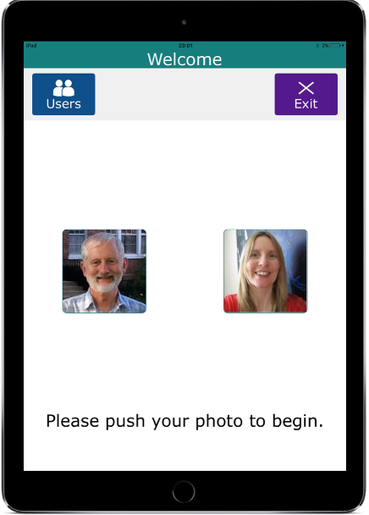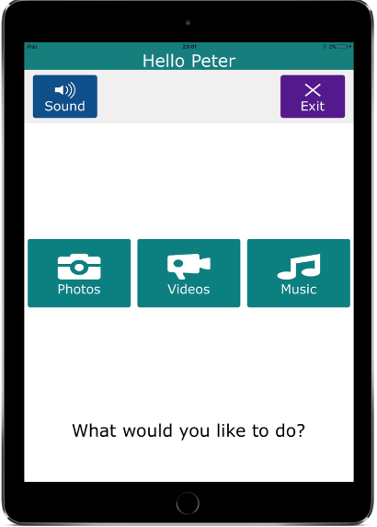
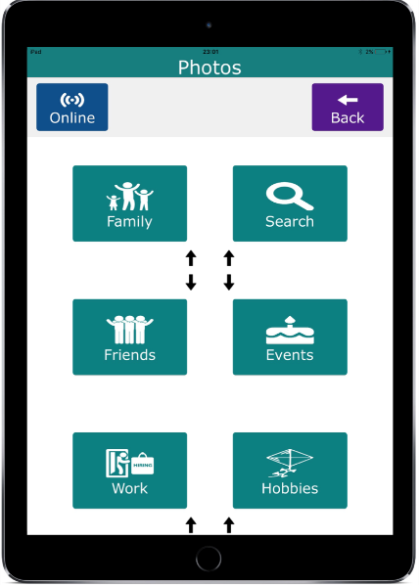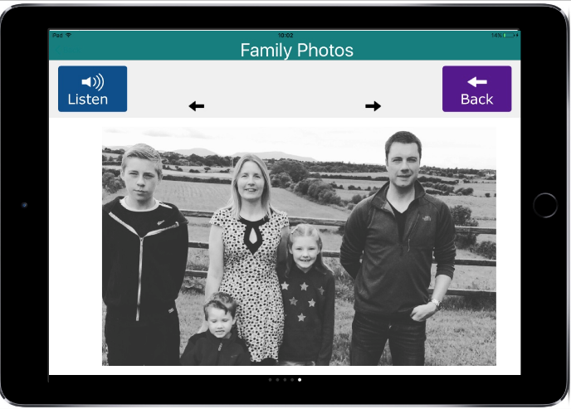
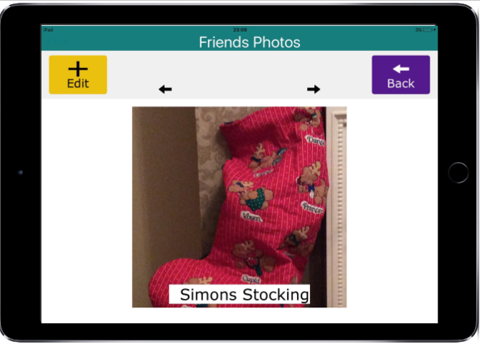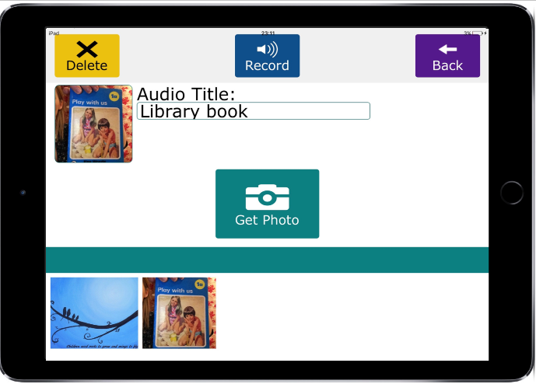
Figure 1: Various Screen Shots of the InspireD app

Data collection
A semi-structured topic guide was used to guide the interview process. This included participants’ views on the use of the app, impact of the reminiscence on individuals and relationships, challenges and opportunities associated with the app and recommendations for improvements. Separate interviews were conducted for both groups. This strategy was employed as it recognised the individuality of participants while also enabling all interviewees to be frank and honest in their responses without having to worry about upsetting the other person. Recruitment was not contingent on the willingness of both dyad members to be involved and as a result, a slightly higher number of carers completed interviews. One dyad requested a joint interview due to personal reasons and this was accommodated by the research team. In general, the interviews with carers lasted approximately 60 minutes and the interviews with people living with dementia were of a shorter duration (Ryan, McCauley, Laird, Gibson & Mulvenna, 2018).

The sample
The study was based in the geographical area of a large health and social care trust in the United Kingdom. Potential participants were referred to the study by the Trust’s Community Mental Health Team for Older People. Further support was provided by a Specialist Dementia Nurse and by engagement with the local Alzheimer’s Society Dementia Cafes.

The study received ethical approval from the Office for Research Ethics Committees Northern Ireland in February 2016 (16/NI/0035). After obtaining consent, all interviews were conducted at a time and place suitable for participants and digitally recorded. Recruitment continued until saturation was reached. To maximise the quality of data collected, most of the interviews were conducted no later than two weeks after the 12-week period of home-based reminiscence. The final sample comprised 15 participants living with dementia and 17 carers (Table 1). There was a higher number of women interviewed than men, 19 to 13 respectively. The youngest interviewee was 31 years and the oldest was 94 years.

Table 1: Interview Participants
Interview  No. | Name | Participant | Age | Relationship | Co-habiting
1 | Christine | Person living with dementia (PWD) | 82 | Mother | No
1 | Amanda | Carer | 57 | Daughter | No
2 | Joe | PWD | 80 | Husband | Yes
2 | Karen | Carer | 80 | Wife | Yes
3 | Margaret | PWD | 75 | Mother | Yes
3 | Janet | Carer | 31 | Granddaughter | Yes
4 | Rita | Carer | 66 | Wife | Yes
5 | Peter | PWD | 63 | Husband | Yes
5 | Rose | Carer | 60 | Wife | Yes
6 | Geraldine | PWD | 75 | Wife | Yes
6 | James | Carer | 80 | Husband | Yes
7 | Pierce | PWD | 85 | Husband | Yes
7 | Maura | Carer | 85 | Wife | Yes
8 | Ron | PWD | 83 | Husband | Yes
8 | Joanne | Carer | 82 | Wife | Yes
9 | Angela | PWD | 78 | Wife | Yes
9 | Frank | Carer | 78 | Husband | Yes
10 | Arlene | PWD | 85 | Mother | No
10 | Trevor | Carer | 61 | Son | No
11 | Jerome | PWD | 61 | Husband | Yes
11 | Barbara | Carer | 61 | Wife | Yes
12 | Neil | PWD | 85 | Husband | Yes
12 | Angela | Carer | 78 | Wife | Yes
13 | Alice | PWD | 76 | Mother | Yes
13 | Matthew | Carer | 50 | Son | Yes
14 | Wesley | PWD | 94 | Husband | Yes
14 | Molly | Carer | 91 | Wife | Yes
15 | Alan | PWD | 80 | Husband | Yes
15 | Mary | Carer | 78 | Wife | Yes
16 | Maureen | Carer | 81 | Wife | Yes
17 | Tim | PWD | 69 | Husband | Yes
17 | Valerie | Carer | 55 | Wife | Yes
Data Analysis
Braun and Clarke’s (2006) method of thematic analysis was used as it provided the flexibility and responsiveness needed for a rich and dynamic approach to qualitative data analysis, while also giving the researchers “theoretical freedom” to provide thematic clarity on complex data. Braun and Clarke’s (2006, p.87) 6 phased method of analysis comprises the following steps:

1. Familiarising yourself with your data
2. Generating initial codes: Coding interesting features of data
3. Searching for themes: Collating codes into potential themes
4. Reviewing themes: Generating a thematic ‘map’ of analysis
5. Defining and naming themes: Ongoing analysis to refine
6. Producing the report

Rigour and Credibility of Findings
All recorded interviews were read several times to facilitate data familiarisation. Non-verbal observations and researcher comments were also noted to further inform the analysis process. The trustworthiness of qualitative research can be assured by using Lincoln and Guba’s (1985) criteria of credibility, dependability, transferability and confirmability. The credibility of analysis was enhanced by frequent peer debriefing sessions and the random selection of interview transcripts which were read by other research team members to independently identify emerging themes. These were then re-read by the researcher who conducted the interview to cross compare their own field notes with the transcription. The rigour of analysis was also enhanced by the three members of the research team who conducted the interviews (CMcC, AR, EL) discussing and agreeing a consensus on the emergent themes. The dependability of the analysis was demonstrated by interviewees maintaining a diary throughout the entire study. This enabled the analysis to be conducted from a position of reflexivity (Polit & Beck, 2012). The transferability of the qualitative phase of the study was demonstrated by the transparent presentation of the process of recruitment, data collection methods and ethical considerations. The confirmability of the analysis was evidenced by providing a visual audit of the analytical processes to the research team.

Findings
The six key themes that emerged from the thematic analysis are presented under the following ‘in vivo’ themes: “It’s Part of My Life Now” (Usability), “Memories that are important to me” (Revisiting the past); “It was Homely” (Home use); “It helped me find myself again” (Impact on the person living with dementia), “There is still so much inside’ (Gains and abilities) and “It’s become very close” (Impact on relationships). Pseudonyms are used to protect participant anonymity.

“It’s Part of My Life Now” (Usability)
Most of the carers interviewed attributed the ease of app usage to one of the reasons they remained engaged with the study. They also considered the app an immediate tool which could be used to support their loved one. As a result, it became integrated into their lives despite a lack of confidence at the outset.

“It’s a part of my life now. It was something that I never thought that I could use. I didn’t think that I could use that…” (Karen, wife)

“It was simple. It was nice and easy……… the wee app and the photographs, it was easy to do. You know, I think that, because the programme was so simple, do you know what I mean, if it had’ve been something more complicated I think we would’ve lost interest.” (Valerie, wife)

The ease of use was very much influenced by the compact nature of the iPad which participants felt they could carry with them throughout their day and use at their own convenience. A secure and protected virtual storage space which could be kept clean and protected was particularly important to participants.

“Well, the thing about it, you have it on your knee, and you can sit and just go through it, you know… Whereas, if it’s an album, usually they’re stuck in a drawer or something, and you wouldn’t be bothered going to look for them.” (Margaret, person living with dementia)

“I think it’s wonderful because it’s so small and so compact. It’s something that you can give a little wipe and clean and it looks good and everything is stored in there, all that information that you want about your family history from when you were growing up, right through to now.…... .” (Peter, person living with dementia)

A significant factor which impacted the convenient use of the iPad app was its mobility. The InspireD app offered a different way of capturing their day-to-day life and that of their families. It became a travel companion and even a dinner guest on family occasions that were special and significant to the dyad.

“And when we go away for a drive in the car…that there goes with us… It goes everywhere with us…. “So, it brings the trips alive.” (Joe, person living with dementia)

“When she gets visitors, aye, she just loves it, or when something happens, like, when my brother was back, we took the iPad out for dinner... usually mobile phones are banned at the table, and all this, but we were allowed the iPad out for photos and all, and she was trying to take some herself.” (Janet, grand-daughter)

In the case of participants who struggled to use the app, carers acknowledged they had not adapted well to this type of technology or felt this type of medium was not appropriate for their relative.

“Well definitely for some people who are not au fait with computers or…it was a very difficult mountain to climb…I am neither a TV fan or a radio fan or any…I have no interest in any of them things at all…not at all.” (Joanne, wife)

“I would put the whole thing down to me. I’m not accepting of it. I wasn’t maybe doing as much as I should have been doing.” (Maura, wife)

“Memories that are important to me” (Revisiting the past)
Participants enjoyed all the functions of the app. Viewing photographs was the most popular activity followed by music and video. Photographs of family members, family holidays and of
their early life together were particularly special to them.

“Photographs, photographs definitely…. because it’s visual, its’ visual, you know….and I think you need that, you know, visual side of it to keep the memories going” (James, husband)

“Why I’ll use it most of all, if I’m doing something which is interesting I keep it and I if I go back to the photograph, if I’m having problems, it would sort of make it easier for me to think.” (Tim, person living with dementia)

“Memories that are important to me. Oh, I think family, friends, what we’ve done, where we’ve been, where we’ve lived… Well, it’s nice to think that he could remember them.” (Molly, wife)

However, some carers acknowledged that not all memories were happy and spoke of the challenges they encountered revisiting such memories and understanding the significance they held for their loved ones. Although distressing at the time, this process appeared to be crucial to reconnecting with their relative living with dementia and this, in turn, enabled them to address the feelings behind painful memories while preserving them on the app.

“At the start, I was a bit emotional, because all the photos, like, my mum, and my granda and my brothers, and all is on it. But, no, it’s nice now. I think you get over that wee hurdle. Then something always comes back to her every time you use it.” (Janet, grand-daughter)
“He picked out lots of photographs and he picked out a few of my daughter’s funeral. I didn’t like that. They were hard, but they were what he picked and there was nothing I could do about it. They were his memories; they were what he wanted for the iPad.” (Rose, wife)

“Even when the, well I say when the children were growing up and, you know, memories we’ve had of them and, you know, even the two wee boys that died, you know, things like that, you know, we can talk about it. I would say maybe even more now than we could at the time, you know, so I would say it’s been good, you know, even.” (Alan, husband)

Perhaps not surprisingly, some carers found it difficult to engage with memories that did not include them. This indicated that shared memories, regardless of their nature, were particularly impactful for connection and closeness.

“He’s been married before and I was married before so, I don’t really feel that we’ve probably benefitted as much as some couples may have, we haven't got that memory together” (Maureen, wife)

“I would like to sit and share memories with Pierce all the time, but as I say, he has a one-track mind as regards things to do. Those things to do are mainly to do with cars. That was part and parcel of his whole life and you can’t weed that out. I would like to be able to share a whole lot of things with him, but I know I won’t get a good response sometimes and then I don’t bother.” (Maura, wife)

“It was Homely” (Home Use)
A key aspect of this study was the home-based nature of its delivery. All the interviewees found this especially appealing, as it enabled them to feel safe and secure which was integral to their involvement in the study.

“I never would have gone anywhere. I just wouldn’t have gone out of the door. I wouldn’t have gone anywhere…I’m in my own atmosphere. You don’t feel as if it is…it’s just like somebody you’re chatting to… probably more confident. That’s probably what you feel more…more secure…in your own house”. (Jerome, person living with dementia)

“Oh, it was brilliant. You didn’t have to go out. The people come to you, and it was great. You were in your own home, that you didn’t have to, oh, my god, I don’t feel like going out today…It was brilliant. I think it’s really brilliant in your own home.” (Karen, wife)

“The fact that you’re just being where you normally are… In surroundings which was totally familiar to you” (Wesley, person living with dementia)

Participants further articulated that the home-based nature of this intervention enabled the person living with dementia to feel more relaxed. This in turn facilitated the sharing of more personal and intimate memories in private rather than having to navigate the challenges of a group-based activity. This was considered key to their continued engagement with the reminiscence process.

“You would be withdrawn if it was any other place, if that would be the right word to use? “I probably wouldn’t have been as open…I feel more relaxed, would be the main thing I think, your home environment.” (Christina, person living with dementia)

“I think it was more personal and easier. You’re in your own space and you feel calmer and, I suppose, more truthful. If you were in a group in a centre, you’d probably be saying things to please people. When you’re in your own home, you think, ‘This is the truth’. I think in the centre, where you would be with other people, you’d be very wary of what you said. I certainly wouldn’t say that I get a bit of peace at night. They’d probably think, ‘Oh my goodness, listen to her!’.” (Rose, wife)

“Well, I think you can express yourself better in your own home…Not so much, I just think it’s just nicer to talk face to face with somebody rather than in another room with other people… Because everybody’s thoughts are different.” (Matthew, son)

“It helped me find myself again” (Impact on the individual)
For people living with dementia, learning to use the app to connect to memories, and the feelings that underpinned these memories, appeared to have had a major impact on how they felt about and within themselves.

“Yeah, it helped me find myself again, so it did.” (Tim person living with dementia)

It makes me feel that I have everything on it that I really need, and it makes me feel better in myself that I can lift it, and use…But since taking part in that there now, it has, kind of, levelled everything out, you know” (Margaret, person living with dementia)

“It’s just wonderful to have people like you who care about people like me and want to do something wonderful for me, like giving me the iPad, which I really appreciate. It’s certainly changed my life and I love it to bits” (Peter, person living with dementia)

From the perspective of participating carers, usage of the InspireD app was also impactful. However, the degree of impact experienced by carers appeared to be directly related to the positivity demonstrated by their relative living with dementia and the way in which the use of the app triggered connections for them. Usage of the app also highlighted to carers that they were not alone in their journey and the intervention, by its very design, made them feel they were enabling their loved one to find comfort and self-esteem.

“I could see him lighten up, do you know what I mean, when he’d see pictures or music or something that he knew, do you know what I mean. I could see him interested in it which I felt was, he doesn’t have much interest in anything really” (Rita, wife)

“It makes you kind of aware as well how many people out there, the same way and you know something like this programme here would help, might give him a wee bit of self-worth or comfort, do you know?” (Valerie, wife)

“There is still so much inside” (Gains and abilities)
By engaging in a process of joint reminiscence, participants were able to focus on what still remained and what they could still gain rather than a continued focus on the losses associated with a dementia diagnosis.

“You feel you’re losing her completely and then during the project thinking my God, you know, there's still so much inside that head still, so and we need to get it out before, you know” (James, husband)

“Doing the project is I think a lot of respect has to be given to my mummy for the memories she has about this which has helped me to realise that there's still a lot there, do you know what I mean?” (Amanda, daughter)

For participants living with dementia, mastery of modern technology and learning a new skill was a significant personal achievement for them at this stage in their dementia journey. “The training on the app was the turning point for me. That was the turning point for me” (Joe, person living with dementia). Some participants also became more conscious of the importance of keeping their mind active.

“I would be more conscious now to keep my mind more active, you know, too.” (Peter, person living with dementia)

“The wee iPad definitely. The iPad and getting on to it. There’s a lot to learn on it yet. I’ve plenty of time to do it. It’s keeping the head thinking.” (Jerome, person living with dementia)

Participants also discussed the way in which the iPad impacted the wider family circle and in particular, younger family members. This trans-generational impact was attributed to the use of modern technology as it made their loved one, and the memories significant to their life story, have contemporary relevance.

“Well, the children would come up and show Mary how to work it and it was one of the children who showed her how to go on the YouTube first and then she asked me how to do it, so she’s learning from them as well … They’re amazed at her.” (Alan, husband)

“They would actually relate more to it through the technology in this way than if you said, oh, here’s the photos, do you want to see some of the old photos, no say here, do you want to look through this and see do you like any of them, they’d engage much more” (Amanda, daughter)

“It’s become very close” (Impact on relationships)
As a result of sharing personalised and significant memories, participants reflected that they felt closer to their loved one. Carers highlighted that having an aid for communication and a stimulus to share memories was a significant factor in this.

“I would say I would be closer to my mother, not to be so anxious in some ways that you can actually stop and do a different type of thing instead of thinking of all the things like medication, what’s going to happen and whatever, that it’s more an in the moment type of experience” (Amanda, daughter)

“it’s become very, very close because you don’t have to try and bring a subject up on your own, you just open the iPad and things happen and I find that great.” (Angela, wife)

This increased sense of closeness was experienced and articulated differently dependent on participants’ roles as caregiver or care-recipient. Some of the people living with dementia highlighted an increased level of openness and understanding in their relationship with their carer whereas other felt that their carer had become more protective of them.

“We were always comfortable but no barriers at all, no hidden barriers, if there’s such a thing…. Really is more open I think now, I use the word open.” (Christina, person living with dementia)

“X (carer) is more protective now and all that, now, so she is, and she’s always asking me am I all right, or getting up in the morning she’s always shouting to me, are you all right granny, and, you know, and things like that. You know, she’s more protective of me now.” (Margaret, person living with dementia)

“I think he's more understanding… Well, I think it’s talking about it and accepting the way that I am, you know, but trying not to think about it. I don’t let it be the main thing in my mind that my memories not good.” (Arlene, person living with dementia)

Carers talked about the way in which they had developed a richer perspective of their loved one as an individual with memories and a story of a life lived. As a result, they felt that they had more patience, respect and understanding in their caring role.

“I’m a bit more patient or maybe it’s just the time I’m actually taking to do it is a big thing, especially in today’s world. So, if you’re sitting and you’re actually looking and choosing and talking then that’s something that mightn’t otherwise have happened. You know, so closer in some ways and I suppose when your mammy’s your mammy you don’t look at your mammy as sneaking out the window to the dance or you know whatever, you know that type of thing” (Amanda, daughter)

Carers described how this change in their loved one directly impacted the dynamic of their relationship. While the benefit may not have been immediate, they began to notice this change in mood and self-perception in their loved one over time. This created the opportunity to relieve and create new memories but ultimately to celebrate the life they had lived and continued to live. Carers also noticed a change in themselves as they had access to a new of caring for their loved one which was enjoyable for the dyad.

“You don’t realise the benefit. You don’t notice it right away, but, maybe, over three weeks, four weeks, you do notice it, you know, the change in the people.” (Janet, grand-daughter)

“And just capturing huge enthusiasm about the life she led” (Trevor, son)

“it’s a different way of caring than we think, see it as more person centred caring, a holistic way of caring and looking at them as the person, as I say it’s all new to me and I would have thought I’m a very patient person but I would have found myself snapping at the seventh time and then feeling really terrible and feeling oh god that’s terrible, it’s terrible doing this but then like you’re not taught…this project actually works very well… I think presenting it maybe as an, as an enjoyable way to care” (Amanda, daughter)

Discussion
The aim of this study was to explore the impact of a home-based, personalised reminiscence programme facilitated through an iPad app on people living with mild to moderate dementia and their family carers. This novel approach which also included IT and reminiscence training has not been reported in the literature to date. Thematic analysis of data from individual interviews with 15 people living with dementia and 17 family carers highlighted the impact of the reminiscence experience on participants as individuals and on their relationships with their carers.

Dempsey, Murphy, Cooney, Casey and O’Shea (2012, p.12) described reminiscence as an intervention which “permits intrapersonal evaluation and fosters interpersonal relationships and self-esteem, while additionally reinforcing one’s own sense of competence and well-being”. This was evident in the interviews as participants living with dementia described how the experience created a space to focus on their memories and in doing so, enabled them to concentrate on significant aspects of their life. Participants living with dementia articulated that the intervention revealed how much they could still remember about their lives which had considerable impact, bringing joy, insight and a good feeling about, and within, themselves. As reported elsewhere (Lazar et al, 2914: Critten & Kucirkiova, 2017), having access to rich and stimulating multimedia was of significant benefit to the reminiscence process.

Hamel et al. (2016) described how carers in their study enjoyed hearing previously untold memories about their loved whereas Cooney, Hunter, Murphy, Casey and Devane (2014, p. 3568) used the term “seeing me through my memories” to describe the way in which a process of joint reminiscence revealed the person living with dementia as a unique human being. Carers in our study described how the process helped them to learn things about their relative that they had not previously known. Consistent with Kitwood’s person-centred approach to dementia care, it appears that the joint reminiscence experience enabled carers to see the person within the dementia rather than the dementia within the person.

For most participants, the usability of the app was a significant reason why they remained engaged in the study. Carers highlighted that the convenience of the app provided a means of interaction with their relative and their wider social circle. All participants availed of the mobility and convenience of the app, thus it became a social companion which accompanied them for family meals, holidays or day trips. In keeping with the findings of Hamel et al. (2016) our findings suggest that the mobility of the app was a key factor in on-going usage as it became an important way to sustain and in some cases, renew social connectivity. The app also appeared to represent a virtual space in which precious memories could be preserved and protected. According to Lorenz, Freddolino, Comas-Herrera, Knapp and Damant (2017, p. 10), technology can “support safety and security” through monitoring and assisted living devices. However, our findings tentatively suggest that the physical safety and security afforded by modern technology can also be extended to emotional safety and security achieved through the protection of precious memories and life stories.

Contrary to the National Institute for Health and Care Excellence Guidelines (NICE, 2018) which recommends group reminiscence therapy for people living with mild to moderate dementia, the individualised and home-based reminiscence experienced by our participants was, in their view, central to their initial and continued engagement with the study. Without exception, they all indicated a strong preference for the home-based nature of this intervention. They described how it created feelings of privacy and safety which would not have been possible if they had to navigate the challenges of a group-based activity (Melunsky, Crellin, Dudzinski, Orrell & Wenborn, 2015; Subramanian & Woods, 2012). It is also possible that the home-based nature of the intervention enabled the meaning connected to a specific memory to be positively integrated within their own life story (Cosley, Akey, Alson, Baxter & Broomfield, 2009; Westerhof & Bohlmejer, 2014). This resonates with Kerssens et al. (2015) who reported that their home-based approach simplified carer involvement and in doing so, enabled meaningful engagement.

One of the largest studies on reminiscence in dementia (Woods et al. 2012) was a multicentre, pragmatic, randomised controlled trial (n=488). The intervention consisted of joint reminiscence groups held weekly for 12 consecutive weeks, followed by monthly maintenance sessions for a further 7 months. The results showed no differences in outcome between the intervention and control conditions on primary or secondary outcomes (self-reported quality of life in Alzheimer’s disease). Significantly, carers of people living with dementia allocated to the reminiscence intervention reported a significant increase in anxiety at the end of the study. The authors concluded that the beneficial effects for people living with dementia who attend reminiscence sessions must be viewed in the context of raised anxiety and stress in their carers. Our study, with its personalised and home-based reminiscence intervention, was specifically designed to address the limitations and build on the work of previous studies including that of Woods et al. (2012). Its findings therefore have the potential to enhance our conceptual understanding of the impact of shared reminiscence and this merit further consideration in a future randomised controlled trial.

Acknowledging the significant contribution of person-centred models in enhancing quality of care (Kitwood, 1997; McCormack & McCance, 2017) our findings challenge the meaning of person-centred care in dyadic relationships where there is a danger that meeting the needs of one person (the person with dementia) may be achieved at the expense of another person (the carer). In this context, it may be the case that a theoretical framework which recognises a more relationship-centred approach to care (Nolan, Brown, Davies, Nolan & Keady, 2006) may be a better fit when balancing the support needs of people living with dementia and their carers. It is possible that explicating the dimensions of relationship-centred care may challenge conventional markers of success in terms of interventions in dementia care. In doing so, successful outcomes may need to be re-defined as those which show moderate improvement for both the person living with dementia and their carers rather than a significant improvement for one at the expense of the other.

The person living with dementia identified that the vivid recollection of memories significantly impacted their self-esteem and self-perception (Dempsey et al., 2012). From the carers’ perspectives, seeing such a positive response in their loved one was not only very encouraging but also caused them to value the life that they relative had lived and continued to live. Melunksy et al. (2015) argued that while a personalised approach to reminiscence may yield positive outcomes for carers, such was seen in this study, it is also possible that carers may miss the supportive network associated with a group setting. Our study findings concur with Kerssens’s et al. (2015) view that delivering the intervention in the home of participants enabled the process of carer engagement to be facilitated and, ultimately, to become a positive experience. Therefore, it is our contention that the individualised approach used in this study nurtured the relationship between people living with dementia and their carers by focusing on what still remained and what they had gained rather than a continued focus on loss and what McHugh et al. (2012, p.227) described as the “disappearance of the relationship”. A transgenerational impact was also evident as people living with dementia indicated that engagement with the iPad enhanced their contemporary relevance to younger generations within their wider family (Mulvenna et al. 2011).

While significant memories for participants included families, holidays and their early life together, not all defining memories were happy. As reported elsewhere, (Astell, Purves & Phinney, 2011; Lazar et al., 2014), this was particularly challenging for carers as the nature of the memory, for example the loss of a child, although painful for them, was not always significant for the person living with dementia. How the memory of the event is recalled can often differ in the event details or the emphasis placed on a specific aspect of memory. According to Condon, Ritchie and Igou (2015), this lack of memory conformity is not related to how much trust or familiarity exists between the couple but is more reflective of the context in which the memory is recalled. While dyadic reminiscence through verbal discussion, may impact memory conformity, it could be argued that painful memories do not need to be recalled identically but rather, the meaning attached to the memory can be integrated into the dyads life story (Westerhof & Bohlmejer, 2014).

The desire for some participants in our study to recollect painful memories resonates with the final stage of Erikson’s (1959) theory of psychosocial development, ego integrity versus despair, which begins at approximately 65 years of age and ends at death. Erikson described ego integrity as “the acceptance of one’s one and only life cycle as something that had to be” (1950, p. 268) and later as “a sense of coherence and wholeness” (1982, p. 65). Success in this stage will lead to the virtue of wisdom which enables a person to look back on their life with a sense of closure and completeness, and also accept death without fear. Wise people are not characterized by a continuous state of ego integrity, but they experience both ego integrity and despair. Thus, late life is characterized by both integrity and despair as alternating states that need to be balanced.

This has implications for the integration of the app into the lives of participants who acknowledged that the recall of painful memories facilitated a discussion around past events which had not taken place at the time of the trauma. Whether this led to a corrective process on perceived distorted memories (Condon et al., 2015) was not explored and did not emerge from our findings, but instead, the recollection appeared to provide the opportunity for internal reflection and reconciliation with the experience. For a minority of carers, the memories of the person living with dementia were not shared as they did not involve them, or they belonged to an earlier part of the life of their relative. This corresponds to Astell et al’s. (2011) view that when asked to recall memories, people living with dementia will often cite ‘bump’ memories, those experienced between the ages of 10-30 years old. This suggests that shared memories, regardless of their nature, are essential for connection and closeness to be established or enhanced through individual and specific reminiscence. The implications of this in the context of societal trends relating to marriage, divorce and longevity of relationships warrant further consideration in interventions of this kind.

The interviews revealed that for the person living with dementia, involvement in the study had a significant impact on self and their relationship with their carer as they felt more content, more in control of their memories and more confident in their ability to learn new skills. For the carers, this created an opportunity to celebrate the life they had lived, accessing a way for caring for their loved one which was relationship-focused. This was significant as Quinn, Clare and Woods (2009) found that caregivers often experience the loss of a reciprocal relationship and consequently redefine their relationship within the context of their caregiving role. To minimise the likelihood of this, Vernooij-Dassen, Draskovic, McCleery and Downs (2011) suggested that carers need to cognitively reframe their caregiving role and responsibilities to alleviate stress and minimise the adverse consequences on their relationships.

Community care policies across Europe and beyond emphasise the importance of supporting people living with dementia to remain at home for as long as possible (Ryan & McKenna, 2013). As reminiscence interventions, such as that used in this study, rely on the involvement of family members, more research is warranted to explore the outcomes of such involvement on their health and wellbeing. Larger scale studies are required to strengthen the evidence for the use of psychological interventions in dementia care. While there is evidence to suggest that reminiscence can be used to enhance quality of life in dementia, there is a need to address the challenges posed by a lack of standardisation in research in the context of different types of reminiscence, diverse care environments and varying stages of dementia.

Study limitations
Participants had a diagnosis of mild to moderate dementia and, with the support of their carer, were able to use the iPad to reminiscence. This approach may not have worked as well for participants with more advanced dementia. It is also acknowledged that the type of dementia and other factors such as health or sensory impairments and caregiver stress, may have had a bearing on the findings.
Over the course of the study, the research team formed a relationship with participants and this may have influenced the findings. A marginally higher number of carers participated in the interviews and while this could be perceived as a limitation, the team believe that this was more likely attributable to awareness on the part of people living with dementia of their cognitive and communication challenges. However, all efforts were made by the research team to ensure that such challenges were addressed which may be reflected in the considerable number of people living with dementia who took part in the interviews.

Conclusions
Reminiscence has been promoted internationally as a means of enhancing standards of care and quality of life for people living with dementia. The findings of this study indicate that a more individualised approach to reminiscence, facilitated by the use of a tablet device and preceded by a period of reminiscence and IT training, has the potential to generate a positive impact on people living with dementia without negative consequences for family caregivers. These findings support an emerging body of evidence that purports that individual specific psychosocial interventions have efficacy in the context of dementia care.

Acknowledgements.
We acknowledge the families living with dementia who participated in the study. We also acknowledge the support of the Reminiscence Network for Northern Ireland, the Alzheimer’s Society and the Community Mental Health Team for Older People in the study site.
Declaration of Conflicting Interests
The authors declare that there is no conflict of interest.
Funding
This work was supported by the Northern Ireland, Public Health Agency, Research and Development Division and The Atlantic Philanthropies [COM /5016/14].

References
Astell, A., Ellis, M., Bernardi, L., Alm, N., Dye, R., Gowans, G., & Campbell, J. (2010) Using a touch screen computer to support relationships between people with dementia and caregivers. Interacting with Computers, 22, 267-275.
Astell, A.J., Purves, B. & Phinney, A. (2011) ‘Story of my life?’ The contents and functions of reminiscing. CHI. ACM 978-1-4503-0268-5/11/05.

Berge, Z., Muilenberg, L. (2013) Handbook of Mobile Learning. Routledge, New York & London
Bleakley, C.M., Charles, D., Porter-Armstrong, A., McNeill, M.D.J., McDonagh, S.M. & McCormack, B, (2015) Gaming for health: A systematic review of the physical and cognitive effects of interactive computer games in older adults. Journal of Applied Gerontology, 34, NP166-NP189.
Braun V. & Clarke V. (2006) Using thematic analysis in psychology. Qualitative Research in Psychology, 3, 77-101
Condon, C.E., Ritchie, T.D. & Igou, E.R. (2015) How dyads reminiscence moderates the relations between familiarity, trust, and memory conformity. Social Psychology, 46(2), 65-75.
Cooney, A., Hunter, A., Murphy, K., Casey, D., Devane, D., Smyth, S., Dempsey, L., Murphy, E., Jordan, F. & O'Shea E. (2014) 'Seeing me through my memories': a grounded theory study on using reminiscence with people with dementia living in long-term care. Journal of Clinical Nursing, 23,3564 3574.
Cosley, D., Akey, K., Alson, B., Baxter, J., Broomfield, M., Lee, S., Sarabu, C. (2009) Using technologies to support reminiscence. Proceedings of the 23rd British HCl Group Annual Conference on People and Computers: Celebrating People and Technology, Pages 480-484.
Cotelli M, Manenti R, Zanetti O (2012) Reminiscence therapy in dementia: A review. Journal of Maturitas. 72 (1) pp 203-205.
Critten, V. & Kucirkova, N. 2017. ‘It brings it all back, all those good times; it makes me go close to tears’. Dementia, 1-18, DOI: 10.1177/1471301217691162
DeLello, J.A. & McWhorter, R.R (2015) Reducing the digital divide: Connecting older adults to iPad technology. Journal of Applied Gerontology. DOI 10.1177/0733464815589985.
Dempsey, L., Murphy, K., Cooney, A., Casey, D., O’Shea, E., Devane, D., Jordan, F. & Hunter, A. (2012) Reminiscence in dementia: a concept analysis. Dementia, 0 (0), 1-17.
Elfrink, T.R., Zuidema, S.U., Kunz, M. & Westerhof, G. (2017) The effectiveness of creating an online life story book on persons with early dementia and their informal caregivers: a protocol of a randomized controlled trial. BMC Geriatrics. 17, 95 DOI: 10.1186/S12877-017-0471-Y.
Erikson, E. H. (1950) Childhood and Society. New York: W.W Norton and Company, Inc.
Erikson, E. H. (1959) Identity and the Life Cycle. New York: International University Press, Inc.
Erikson, E. H. (1982) The Life Cycle Completed. New York: Rikan Enterprise Limited.
Gonzalez J, Mayordomo T, Torres M, Sales A, Melendez C. (2015). Reminiscence and dementia: A therapeutic intervention. Journal of International Psychogeriatric, 27(10), 1731-1737.
Haesner, M., Steinert, A., O Sullivan, J.L. & Weichenberger, M (2015) Evaluating an online cognitive training platform for older adults: User experience and implementation requirements. Journal of Gerontological Nursing, 41 (8), 22-31.
Hamel, A.V., Sims, T.L., Klassen, D., Harvey, T. & Gaugler, J.E. (2016) Memory Matters. A mixed methods feasibility study of a mobile aid to stimulate reminiscence in individuals with memory loss. Journal of Gerontological Nursing, 42(7), 15-24.
Kerssens, C., Kumar, R., Adams, A., Knott, C., Matalenas, L., Sanford, J.A. & Rogers, A. (2015) Personalized technology to support older adults with and without cognitive impairment living at home. American Journal of Alzheimer’s Disease & Other Dementias, 30(1), 85-97.
Kitwood T (1997) Dementia Reconsidered: The Person Comes First. Open University Press, Buckingham, UK.
Lawrence V, Fossey J, Ballard C, Moniz-Cook E, Murray J (2012) Improving quality of life for people with dementia in care homes: making psychosocial interventions work. British Journal of Psychiatry, 201 (5), 344-51.
Lazar, A., Thompson, H. & Demiris, G (2014). A systematic review of the use of technology for reminiscence therapy. Health Education and Behaviour, 41 (15) 515-615.
Lincoln, Y.S. & Guba, E.G (1985) Naturalistic Inquiry. Beverly Hills, CA: Sage Publications.
Lorenz, K., Freddolino, P., Comas-Herrera, A., Knapp, M. & Damant, J. (2017) Technology- based tools and services for people with dementia and carers: Mapping technology onto the dementia care pathway. Dementia 0(0) 1-17
McCormack B & McCance T (2017) Person-Centred Practice in Nursing and Health Care: Theory and Practice, 2nd Ed. Wiley-Blackwell, Oxford.

McHugh, J.E., Wherton, J.P., Prendergast, D.K. & Lawlor, B.A. (2012) Identifying opportunities for supporting caregivers of persons with dementia through information and communication technology. Gerontechnology, 10(4), 220-230.
Melunsky, N., Crellin, N., Dudzinski, E., Orrell, M., Wenborn, J., Poland, F., Woods, B. & Charlesworth, G. (2015) The experience of family carers attending a joint reminiscence group with people with dementia: A thematic analysis. Dementia, 14(6), 842-859.
Mulvenna, M.D., Doyle, L., Wright, T., Zheng, H., Topping, P., Boyle, K. & Martin, S. (2011) Evaluation of card-based versus device-based reminiscing using photographic images. Journal of CyberTherapy and Rehabilitation, 4(1), 57-66.
National Institute for Health and Care Excellence (2018) Dementia: Assessment, management and support for people living with dementia and their carers. UK: National Institute for Health and Care Excellence.
Nolan, MR., Brown, J., Davies, S., Nolan, J., & Keady, J. (2006). The Senses Framework: improving care for older people through a relationship-centred approach. Getting Research into Practice (GRiP) Report No 2. Project Report. University of Sheffield.
O'Rourke, J., Tobin, F., O'Callaghan, S., Sowman, R. & Collins, D.R. (2011) "YouTube": a useful tool for reminiscence therapy in dementia? Age and Ageing, 40(6), 742-744.
Polit, D.F & Beck, C.T. (2012) Nursing Research: Generating and Assessing Evidence for Nursing Practice. 9th Edition, Lippincott, Williams & Wilkins, Philadelphia.
Quinn, C., Clare. L. & Woods, B. (2009). The impact of the quality of relationship on the experiences and wellbeing of caregivers of people with dementia: A systematic review. Aging and Mental Health, 13 (2), 143-154.

Ryan A & McKenna H. (2013) Familiarity as a key factor influencing rural family carers experience of the nursing home placement of an older relative: a qualitative study. BMC Health Services Research, 13:252. DOI: 10.1186/1472-6963-13-252

Ryan, A. McCauley, C., Laird, E.A., Gibson, A., Mulvenna, M.D., Bond, R., Bunting, B., Curran, K., & Ferry, F. (2018) A feasibility study of facilitated reminiscence for people living with dementia. Unpublished Report, Ulster University, Belfast.
Subramaniam, P. & Woods, B. (2012) The impact of individual reminiscence therapy for people with dementia: systematic review. Expert Rev. Neurother, 12(5), 545-555.
Subramaniam, P. & Woods, B. (2016). Digital life storybooks for people with dementia living in care homes. Clinical Interventions in Aging, 11, 1263-1276.
Vernooij-Dassen, M., Draskovic, I., Mc Cleery, J & Downs, M. (2011) Cognitive reframing for carers of people with dementia. The Cochrane Database of Systematic Reviews. Issue 11.
Westerhof, G.J. & Bohlmeijer, E.T. (2014) Celebrating fifty years of research and applications in reminiscence and life review: State of the art and new directions. Journal of Aging Studies, 29, 107-114.
Woods R, Bruce E, Edwards R, Elvish R, Hoare Z, Hounsome B, Keady, J., Moniz-Cook, E.D., Orgeta V., Orrell, M., Rees, J., Russell, I.T. (2012). REMCARE: Reminiscence Groups for People with dementia and their family caregivers- effectiveness and cost-effectiveness pragmatic multicentre randomised trial. Health Technology Assessment. 16 (46) 1-116.
Woods, R.T., Orrell, M., Bruce, E., Edwards, R.T., Hoare, Z., Hounsome, B., Keady, J., Moniz-Cook, E., Orgeta, V., Rees, J. & Russell, I. (2016) REMCARE: Pragmatic Multi-Centre Randomised Trial of Reminiscence Groups for People with Dementia and their Family Carers: Effectiveness and Economic Analysis. PLoS ONE [Electronfo Resource}, 11(4) pp 1-19.

