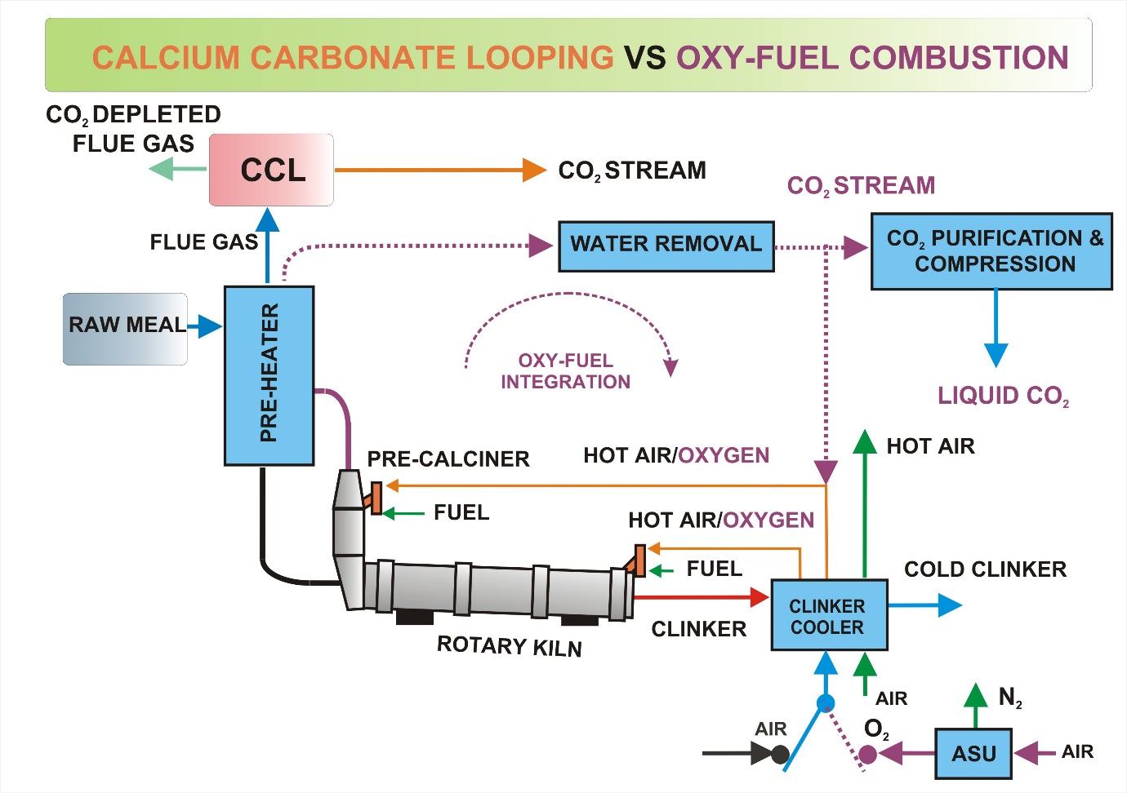

**HIGHLIGHTS**

* The CCL CO2 capture process and oxy-fuel cement plant were modelled and analysed.
* LCA had been conducted to determine the environmental impact.
* CCL and oxy-fuel CO2 capture rates of 94% and 100% were found, respectively.
* The specific CO2 avoided in the CCL is higher than in the oxy-fuel cement plant.
* The grid electricity CO2 emission factor affects the CCL and oxy-fuel performance.

**Technical and Environmental Study of Calcium Carbonate Looping versus Oxy-fuel Options for Low CO2 Emission Cement Plants**

A. Rolfe 1, Y. Huang 1*, M. Haaf 2, A Pita 3, S. Rezvani 1, A. Dave 1 and N.J. Hewitt 1

1 CST, Ulster University, Northern Ireland, UK

2 Institute for Energy Systems and Technology, Technische Universität Darmstadt, Germany

3 Cemex Research Group AG (CEMEX), Switzerland

Abstract

The process of cement production emits large amounts of CO2 through both chemical reactions and fossil fuel combustion. Reducing CO2 emissions from the cement industry is becoming a global imperative. This work focuses on the technical and environmental evaluation for the integration of calcium carbonate looping (CCL) and oxy-fuel combustion processes into a cement plant for carbon capture and storage. Three scenarios have been established: 1. the base case cement plant without CO2 capture, 2. Cement plant with integrated CCL and 3. oxy-fuel cement plant. The process models of the CCL capture plant and the oxy-fuel cement plant are developed. To better understand the technical parameters and benefits of each scenario, the ECLIPSE modelling software is used to a technical analysis. Life cycle analysis (LCA) has been conducted using the SimaPro software to determine the environmental impact of the capture technologies.

Technical results showed that the cement plant equipped with the CCL illustrated better performance with specific CO2 emissions avoided of 1.21t CO2/tClinker and the specific primary energy consumption of 2.39 GJ/t CO2 compared with the oxy-fuel cement plant with 0.71t CO2/tClinker and 3.31 GJ/t CO2. The main conclusion indicated that the CCL unit had a lesser environmental impact than the oxy-fuel combustion because of the additional benefit of electricity generation through the heat recovery system.

Keywords: calcium carbonate looping, oxy-fuel combustion, carbon capture, cement plant, technical and life cycle analysis

*Corresponding author email address: [y.huang@ulster.ac.uk](mailto:y.huang@ulster.ac.uk)

# Introduction

Man-made climate change is a major threat both economically and environmentally. It is caused by greenhouse gas (GHG) emissions connected to human activities. Carbon dioxide (CO2) the most important gas among the GHGs and thus has the highest contribution to man-made climate change [1]. The Paris Agreement is the latest agreement within the UN Framework Convention on Climate Change. It is an international agreement that aims to tackle climate change and maintain global average temperatures well below 2oC above pre-industrial levels [2]. To achieve the aims of the Paris Agreement, a vast implementation of low CO2 emission technologies, including carbon capture and storage (CCS) is required [3].

Approximately 60% of global CO2 emissions can be attributed to industrial activities such as heat and power generation, and the production of cement and steel. While a large proportion of the CO2 emissions are due to the combustion of fossil fuels, some industries such as in the cement industry have process reactions that produce CO2 as a waste gas inherently linked to the raw materials [1]. The Cement industry is one of the largest emitters of CO2; accounting for approximately 5% of anthropogenic GHG emissions [4].

Cement is a fundamental building material used as a component in mortar, grout, and concrete. Its production is linked to the economic growth and to the levels of industrialisation and infrastructure development [5, 6]. In terms of volume consumed, cement is second only to water. Cement production is both resource and energy intensive. Producing one tonne of Portland cement consumes approximately 1.5 tonnes of raw material, 2.93 – 6.28 GJ of thermal energy and 65 – 141 kWh of electrical energy [5]. Within a typical cement plant, 50% of the CO2 emissions are related to the raw materials used in the process, whereas 40% are formed during the combustion of fossil fuels. The supply of electricity accounts for nearly 5% and another 5% of the total CO2 emissions is released during the transportation of the raw materials and the product [7]. It has been estimated that the cement industry could reduce its CO2 emissions from current levels by 18% by 2050 [6]. There are four areas of concern for reducing the climate footprint of cement production; thermal and electric efficiency, alternative fuels, clinker substitution and carbon capture and storage (CCS) [6, 8]. Whereas the first three means can help towards the attainment of the CO2 emission targets only partially, the implementation of CCS could provide a more significant approach for the reduction of the carbon footprint [4, 9].

Interest in CCS has increased given the pressure to reduce CO2 emissions [10, 11, 12]. A review of the evolution of CCS technology over the last 10 years can be found in [13]. A lot of this effort has been directed to power generation applications [14, 15, 16]. Whereas, Other works have considered CCS for industrial applications [17, 18]. For example, in [19], an oxy-fuel combustion power plant has been considered as an alternative for the utility boilers at an oil refinery. Life cycle assessment (LCA) studies have been conducted on power [20, 21] and industrial plants [22, 23] as well as a range of CCS technologies [24] with some including calcium carbonate looping (CCL) [25]. As an example, Clarens et al, [26] compared the LCA of CCL capture with two established amine capture technologies for a sub-critical coal power plant.

This work has been done in conjunction with the FP7 SCARLET (Scale-up of Calcium Carbonate Looping Technology for Efficient CO2 Capture from Power and Industrial Plants) funded by the European Union [27]. The aim of the SCARLET project is to bring the CCL technology closer to full scale commercialisation, by experimental investigation in a 1MWth scale and upscaling and engineering to a 20MWth pilot plant. Other strands have included the long-term pilot testing of the CCL plant at 1MWth scale, the results proved the performance of the process in steady state operation under varying operating parameters. The CO2 absorption rates in the carbonator were higher than 90% and the overall capture rates higher than 95% [28]. Process models have been developed and validated against the 1MWth pilot plant [29]. The accumulation of impurities such as ash and CaSO4 cause performance losses by requiring heating and cooling along with the circulation of the solids stream in the system. The influence of fuel type and particle size on the sorbent is observed in [30]. Other works include the simulation of a 1 MWth pilot plant CFB carbonator unit with the coarse grain DEM model [31] and the 3-D CFD simulation of the reacting flow inside the 1 MWth calciner [32].

This work builds on and uses previously validated data with the aim to consider the technical and environmental performance of CCL when integrated into a conventional cement plant. Oxy-fuel combustion and the cement plant without capture are also analysed for comparison. This study will be of interest to those working in the cement industry, those responsible for carbon reduction policies and other academics with similar interests. The results will allow decision makers to examine and weigh the potential benefits and penalties of the two carbon capture technologies and compare them to the base cement plant.

The following elements of the paper delves further into the background of the study and describes the scenarios of the current work. This is followed by description of the methods used for the technical and environmental assessment. Finally, the results and conclusions are presented and discussed.

# Carbon Capture and Storage

The aim of CCS is not to reduce the formation of CO2, but to separate it from emissions and store it under the earth’s surface. Suitable locations for the storage of captured CO2 are porous geological formations, which are usually several kilometres below the earth’s surface, such as disused oil and gas fields, and deep saline formations [33]. Another option for the storage of the capture CO2 is in maturing oil fields, whereby the CO2 is injected into the subsurface of an oil field. The CO2 mixes with the oil causing it to swell and reduce its viscosity. This makes the oil flow easier within the reservoir [34]. Some of the injected CO2 surfaces with the oil is separated and reinjected. However, a significant fraction of the injected CO2 is trapped in the reservoir, requiring additional CO2 to continue the process [35]. This process increases the oil output and the profits can be used to offset the cost of CCS and it infrastructure [36].

In general, CCS comprises of a range of technologies that can be sub-divided further into pre-combustion, post-combustion and oxy-fuel combustion. Pre-combustion capture uses the process of gasification and syngas reforming to remove CO2 from fuels before combustion is completed. Post-combustion capture uses a suitable solvent to capture CO2 from exhaust gases. In an oxy-fuel combustion process, fuel is burnt with almost pure oxygen diluted by recirculated flue gases rather than air. This results in flue gases that mainly consist of CO2 and water which produces exhaust gas with higher CO2 concentrations and enables easier purification [6].

There are barriers to large-scale deployment of CCS. These range from high energy penalties and costs for the capture and compression of CO2, to a lack of suitable long-term storage sites. A full discussion of barriers to CCS can be found in [1]. The CCS in the industrial sector is not as developed as in the power sector due to the lack of the incentive and the scale [37]. However, the industrial sector may have a benefit over the power sector because industrial facilities tend to form clusters such as in Teesside UK, whereby several large plants operate closely enough to develop interlinked network for CO2 transport and storage [38].

As stated previously, a large portion of CO2 formed in a cement plant is directly linked to the calcination of limestone in the raw meal and therefore can only be reduced by a reduction in clinker production [38]. For this reason, pre-combustion CO2 capture is not considered to be viable in cement plants as the CO2 emissions in the calcination step would never be captured [6]. CCL and oxy-fuel combustion systems are suitable options as they can capture both the CO2 emissions linked to fossil fuel combustion as well as those caused by the calcination of limestone.

## Calcium carbonate looping CO2 capture

The CCL process is a second-generation post combustion carbon capture technology that employs solid CaO based sorbents to separate CO2 from flue gases coming from either electricity generation or an industrial plant, producing a concentrated CO2 stream. The CCL process consisting of two interconnected circulating fluidised bed reactors, involves two chemical reactions as shown in Equation 1, continuously in reactors.

$CaO+{CO}_{2} ⇔Ca{CO}_{3}+∆H, ∆H_{{25}^{o}C}=±178.2kJ/mol$ (1)

The CCL process is carried out in two main steps, i.e. carbonation and calcination. Carbonation is based on the reversible, exothermic reaction that occurs in the carbonator in a temperature range between 600 and 750 oC where CO2 in the flue gases is absorbed by CaO forming solid CaCO3. Depending on the CO2 partial pressure and equilibrium conditions, CO2 absorption rates up to 90% for the carbonator are feasible. The resulting CaCO3 is directed to a second reactor which is called calciner, where it is decomposed at a temperature of approximately 900 °C, producing a highly concentrated CO2 stream and burnt lime. Due to the endothermic calcination reaction in the calciner the additional heat input is required for the reaction. The combustion is carried out in an O2/CO2 atmosphere, similar to oxy-fuel combustion applications. After regeneration, the sorbent is transferred back to the carbonator to start the new cycle. The captured CO2 is then dried and purified, so that it is ready for sequestration and storage. The CO2-depleted flue gases are emitted to atmosphere [39].

## Oxy-fuel combustion CO2 capture

During the oxy-fuel combustion process, the combustion air is replaced by a mixture of oxygen supplied by an air separation unit (ASU), and the recycled flue gas. The resulting exhaust gas is therefore composed mainly of CO2 and water vapour [40, 41]. This eliminates nitrogen from the flue gas stream and thus produces a CO2 rich stream that requires water vapour condensation and impurity removal before compression and storage. An added value of oxy-fuel combustion is that NOx emissions are lowered. This occurs in three ways. Firstly, low N2 concentrations in oxy-fuel combustion impedes NOx formation. Secondly, NOx reduction is aided via the reburning of the flue gas. Thirdly, the high CO2 and CO concentrations in oxy-fuel combustion suppresses fuel NO formation [42].

## Studied scenarios

For the purposes of this study to provide cement plants with the option to capture and export carbon dioxide and to maximize CO2 emission reductions relative to the selected reference plant, three cases are considered; the cement plant without CCS, CCL integrated into the cement plant and oxy-fuel cement plant.

### Scenario 1 – base case cement plant

Cement production involves the process of selected mineral raw materials to produce a synthetic mineral mixture (clinker) that can be ground to powder having the specified chemical composition and physical properties of cement.

The four main processes in the selected cement plant are shown in Figure 1. The gas and solid streams within the plant have a counter-current movement. The milled raw meal is fed to the cyclone preheater section. Within this system the solid feed is heated and subsequently dried by means of direct heat transfer between the hot flue gas from the pre-calciner and the raw meal particles. The number of cyclones is determined by the moisture content of the raw feed. In this case, a five-staged double lined preheating section is applied. In the preheating system the solids stream reaches the required temperatures for calcination (~800 oC). After preheating, the hot raw feed is inserted into the directly attached pre-calciner, where the temperature is further increased, the calcination is finalised, and the carbon dioxide is driven off from the limestone. The clinkerisation of the hot feed takes place in the rotary kiln unit. To finalise the clinker phase formation and sintering of the particles, the solid temperature is further increased up to a maximum of 1450°C by means of the combustion of fossil fuel. To reduce the complexity of the process modelling, some simplifications need to be made in comparison to the selected cement plant layout:

• Ideal gas-solid separation within each cyclone

• Reference hard coal as fuel for pre-calciner and rotary kiln

After passing the kiln, the hot clinker is cooled in the air blown clinker cooler, where heat is recovered from the hot clinker product. The resulting hot air is split into three parts. Two parts are used as primary / secondary combustion air inside the kiln and the pre-calciner, the heat contained in the third part is used in other sections of the cement plant (e.g. raw meal milling). The cement plant described thus, will constitute Scenario 1 – the base case. The modelling for clinker production is based on the following main chemical reactions which take place during a rotary kiln at different reaction zones [43].

${CaCO}_{3}→CaO+{CO}_{2}+∆H, ∆H_{{25}^{o}C}=+178.2kJ/mol$ (2)

$2CaO+SiO_{2}→C_{2}S+∆H ∆H_{{25}^{o}C}=-126.4kJ/mol$ (3)

$3CaO+SiO_{2}→C_{3}S+∆H ∆H_{{25}^{o}C}=-113.0kJ/mol$ (4)

$3CaO+{Al}_{2}O_{3}→C_{3}A+∆H ∆H_{{25}^{o}C}=-7.3kJ/mol$ (5)

${Al}_{2}O_{3}+4SiO_{2}+H_{2}O→AS_{4}H+∆H ∆H_{{25}^{o}C}=-80.7kJ/mol$ (6)

${Al}_{2}O_{3}+2SiO_{2}+2H_{2}O→AS_{2}H_{2}+∆H ∆H_{{25}^{o}C}=-7.3kJ/mol$ (7)

Where C2S, C3S, C3A, AS4H and AS2H2 are Dicalcium Silicate, Tricalcium Silicate, Tricalcium Aluminate, Pyrophyllite and Kaolinite, respectively.

2.3.2 Scenario 2 – CCL Integration

In Scenario 2, a CCL unit is integrated at the back-end of the cement plant. The flue gas is extracted directly after the first stage of the cyclone preheating tower. This minimises the adaption to the cement plant in the case of a retrofit. The purge material extracted from the calciner is directly fed to the rotary kiln for the final clinker formation. Sensible heat from the CO2 rich stream and the CO2 depleted flue gas stream is recuperated for the steam generation of the water-steam cycle, as well as the heat recovered carbonator reactor. The cooled CO2-rich stream is then sent to the CO2 purification and compression unit for further treatment. A schematic diagram is shown in Figure 2.

### Scenario 3 – Oxy-fuel integration

In Scenario 3, the base-case cement process is modified towards an oxy-fuel sustained process. Replacing air with oxygen can increase the CO2 concentration since little nitrogen is introduced into the system. Hereby, an ASU supplies oxygen of approximately 95 % purity. The oxygen is heated by the first stage of the clinker cooler. Fuel is combusted with the preheated oxygen and flue gas mixture. The standard counter-current heat exchange takes place and the flue gas is extracted from the first stage of the cyclone preheater. Within the recirculation, this flue gas undergoes dedusting and dehydration. The proportion of the flue gas processed is recycled to keep the temperature profile in the combustion process. The rest of the CO2 rich flue gas is then purified, compressed and liquefied for safe disposal. Figure 3 shows the schematic diagram.

## CO2 purification and compression process

As mentioned, the captured CO2 stream consists essentially of CO2 and water vapour, plus some quantities of nitrogen, oxygen, argon, acidic gases and various other trace impurities. Before the CO2 stream is introduced into transportation process, it will be purified to the levels required to avoid a negative impact on pipeline transportation and geological storage, such as corrosion and two-phase flow [44, 45]. The CO2 separation and liquefaction with a cryogenic purification unit are based on the physics of condensation through a series of compression and cooling steps, as illustrated in Figure 4 [46]. The first step of this technique consists of drying the flue gas by simple condensation, where the water content, ash and dissolved gases are removed from the flue gas stream. Thereafter, the flue gas is compressed to a dual bed desiccant drier to reduce the moisture content. The dried gas is then passed to a cryogenic distillation unit, where most of inert gases from the CO2 are removed using CO2 refrigeration. At the final stage the purified CO2 product is further compressed to a pressure of about 110 bars in the liquid form for transport through pipelines.

## Modelling boundary conditions

In order to compare the CCL technology with other CO2 capture solutions, European best practice guidelines will be followed [47].

2.5.1 Feedstock

The feedstock chosen will be used in the pre-calciner, the rotary cement kiln, the calciner of the CCL unit and the oxyfuel combustion cement process. Table 1 contains the basic properties of this coal type.

2.5.2 Air separation unit

The ASU simulation is not performed in the model and electricity consumption for oxygen production is assumed to be 200 kWh/t O2 at atmospheric pressure [48]. This information serves as a basis for estimating the energy requirement for the ASU [49]. It is also assumed that the ASU oxygen output has a constant oxygen purity of 95 vol.% with 1.7% N2 and 3.4% Argon.

2.5.3 Indirect heat consumption and CO2 emissions

Indirect heat consumption which is derived from the consumption of purchased or sold electricity, indicates the primary energy consumed in the cement production process. To convert imported or exported electricity to the primary energy source, a reference power plant fuelled by pulverised coal needs to be defined. Therefore we assume that the electricity efficiency on average with which the thermal energy is converted to electricity for the UK power generation is 42 percent using gross calorific values. As indicated by the UK Electricity National Grid current coal fired power plants in the UK have an average CO2 emissions rate of 0.870 kg CO2/kWh [50]. Thus, for calculating the amount of CO2 emissions from electricity, the above conversion factor is considered.

2.5.4 CCL unit operating conditions

The sorbent looping ratio (i.e. the amount of CaO circulating in relation to CO2 that is contained in flue gas and fed to the carbonator) which is one of key operating parameters within the CCL process, influences the heat required for sorbent regeneration in the calciner and carbonator capture efficiency. In order to obtain optimal results for a long-term operation the molar looping ratio is assumed to be eight [28, 43]. The oxygen concentration is assumed to be around 38 vol.% at the calciner inlet and 2% at the calciner outlet. To keep the system inventory constant and maintain a certain activity of the circulating sorbent, fresh limestone is added to the calciner. The molar make-up ratio (the ratio of fresh CaCO3 to the CO2 to be captured) of 0.14 is proposed [28]. Taking high sorbent circulating and the make-up ratios into account the carbonator CO2 absorption efficiency of 88.6% is also defined. Air leakage which occurs in the carbonator and calciner is neglected.

2.5.5 Steam cycle plant operating conditions

Within the CCL system, a large amount of high grade heat is available and can be recovered from the carbonator reactor, and from the gaseous streams leaving carbonator and calciner to generate additional electricity through a steam cycle plant. However, the steam generated by waste heat recovery units is significantly reduced for the cement case, compared to large scale applications in the field of the CCL technology. The steam cycle modelling is assumed to use sub-critical steam cycle conditions with steam parameters of 130/35 bar and 540/540 oC and a condenser pressure of 0.05 bar. The temperatures of the gaseous streams that exits the CCL unit (i.e. CO2 rich stream / CO2 depleted flue gas) are set to 120 oC, respectively.

2.5.6 Oxy-fuel cement plant operating conditions

Within the oxy-fuel system operation excess oxygen is assumed to be around 10% at the pre-calciner and 6% at the kiln. Air leakage which occurs in preheater and kiln, has a negative impact on the performance of oxy-fuel operations, i.e. increasing the volume flow rate of the flue gas and reducing the CO2 concentration. Due to the lack of the experimental results it is simply assumed that air in-leaks are 0.33 kg air/kg clinker produced in pre-heater and kiln [51].

# Methods

## Technical method

To ensure that the investigation and comparisons were performed on a consistent and reliable basis, all three scenarios were modelled and simulated using the ECLIPSE personal computer-based process simulation package. ECLIPSE was developed by the Energy Research Centre of Ulster University for the European Commission over the period since 1986 [52]. A technical and environmental assessment study is performed in logical stages, as shown in Figure 5. At the initial stage, process flow diagrams composed of modules and streams are generated within ECLIPSE. After specifying the stream inputs and technical features of individual modules, the mass and energy balance is determined via enthalpy calculations for each stream. The information gained during this second stage of simulation forms the base for identifying critical components within the plants that may be subjected to extreme physical and chemical exposure conditions. In the third stage, the package computes the amount of energy consumed by individual utilities and compounds and provides the plant output. When the mass and energy balance has been completed, the next stage involves the environmental impact analysis. These analyses provide all the data required to complete the assessment study.

To evaluate the energy performance and avoided CO2 emissions of CCL and oxy-fuel CO2 capture options for cement plants, the specific CO2 emissions avoided and specific primary energy consumption for CO2 avoided (SPECCA) relative to the same cement plant without CO2 capture, as shown in Equations (8) and (9) is also calculated [53].

$Specific {CO}_{2} emissions avoided\left({tCO}_{2}/tClinker\right)={Eco}_{2 CCL/Oxy}-{Eco}_{2 Ref.}$ (8)

## $SPECCA (GJ/t {CO}_{2} Avoided)=\frac{Q_{CCL/Oxy}-Q_{Ref.}}{{Eco}_{2 CCL/Oxy}-{Eco}_{2 Ref.}}$ (9)

Where Q and ECO2 are the specific energy consumption (GJ/t Clinker) and the specific CO2 emissions (t CO2/t Clinker). Ref. is the selected reference cement plant without CO2 capture.

## Life cycle analysis method

LCA is a methodology used to evaluate the environmental impacts associated with a product or service during its entire life i.e. cradle-to-grave. However, cradle-to-gate studies are common. Capital goods are buildings and machinery that are used in the production are often not part of the study although for certain studies such as accounting LCAs they should be included. There are four parts to a LCA; (i) goal and scope, (ii) life cycle inventory (LCI), (iii) life cycle impact assessment (LCIA) and (iv) interpretation. Often, dedicated LCA software is used to perform the LCIA. The ISO 14040 series is specific to LCA. ISO 14000 series is a set voluntary environmental management standards, guides, and technical reports, in which ISO14040 sits [54].

i) Goal and scope

The goal and scope section outlines the study. It describes the system boundaries, study rules and methodologies.

(ii) Inventory analysis

In the LCI input, output, product and waste data for the system is collected. The LCI is a flow model of the technical system. It constitutes an incomplete mass and energy balance of the system, where, only environmentally relevant flows are considered. LCI models are generally static and linear, whereby, time is not a variable and relationships are simplified to linear ones [55].

(iii) Life cycle impact assessment

In the LCIA the results of the LCI are sorted and assigned to the various impact categories. This is known as classification. The relationship between an environmental event and its potential effect is determined via a cause-effect pathway. There are two stages in the pathway; endpoint and midpoint. Endpoint methods look at the environmental impacts at the end of the cause-effect pathway, while the midpoint method does the same at an earlier point in the pathway. This stage is often carried out by dedicated LCA Software.

(iv) Interpretation

The final stage is the interpretation stage, here, the results are analysed and are related back to the goal and scope definition.

### Goal and Scope of this Study

The goal of this work is to evaluate the environmental impact of producing clinker at an existing cement plant, while simultaneously capturing carbon dioxide. The scenarios outlined in section 2.4 will be compared. The intended application is to appraise whether the studied captured technologies could lower the environmental burden i.e. climate change impact, of clinker production without introducing adverse environmental impacts. The function of the process is to produce clinker product. In agreement with other similar studies, the functional unit is the production of 1 tonne of clinker product produced [5, 8]. The reference flow is 1 tonne of clinker product.

The study assumes that the plant is operating at full load. The background system is the clinker production line and the CCS system is the foreground system. This study is a cradle-to-gate type and capital goods are not included.

Allocation is used to determine the proportion of the environmental burden of products when multiple products are produced. However, the ISO 14044 states that allocation should be avoided wherever possible. It is suggested that this is done via dividing the unit process or expanding the product system [55, 56]. In SimaPro “avoided products” is the method used to expand the system. The impacts of the avoided products are subtracted from the total impacts [57]. System expansion works on the assumption that if the principle system delivers surplus electricity to the grid, then less electricity is needed to be produced at an alternative power plant. Therefore, in this study, the clinker retains 100% of the environmental burden and the electricity delivered to the grid via the CCS unit is an avoided product, for which the clinker product receives an environmental credit. CO2 is a system product that has no value and the clinker holds the total environmental burden.

For the LCIA, the ReCiPe method will be employed. With ReCiPe analysis may be done with both midpoint and endpoint methods with the former being used for this study. The midpoint method returns 18 impact indicators [58].

Characterisation is a quantitative step that sizes the environmental impacts per impact category via equivalency factors (characterisation factors, ISO – category indicators) [55]. Each impact has a different unit of measurement in the characterisation method, which makes comparison between impacts difficult. The normalisation step takes the results from the characterisation step and divides them by a reference magnitude for each impact [55]. It allows for easier interpretation of results. By using a reference situation all impacts can be expressed in the same quantity. The reference situation could be ‘one person’s resource use and emissions released in the world (or Europe) for one year’ for each impact. The result will be that all impacts will be a fraction of the average person’s score per impact category [59]. The ReCiPe method allows for the average person in the world or in Europe. The European reference situation has been selected for this study [60]. This study does not take in to consideration the emissions and resource use of the construction phase of the life cycle (capital goods).

The spent sorbent has the potential to capture CO2 in the landfill over time. This will further reduce emissions once clear of the CCL system. Although controversial, the spent sorbent, if disposed of in the ocean, has a greater potential for additional CO2 capture. The spent sorbent can also be used in the cement industry as a feedstock, lowering the need for higher calcination rate of limestone and consequently reducing CO2 emissions [61]. The former disposal scenarios are not considered, only the use of the spent sorbent as a feedstock is considered.

This study views the system as a single unit and not the individual components of the system. This is due to the goal of the study being concerned with the environmental impact of integrating CCS with a cement plant and not a system optimisation study. Thus, internal relationships in the system will remain unchanged and have little influence on the substances that cross the boundary to and from the environment. In Scenario 2, the electricity required for the cement plant and CCL process is generated by the CCL process.

# Results

## Technical results

The ECLIPSE process simulator has been used successfully to perform technical modelling and energy analysis for the three scenarios. Table 2 illustrates the main technical indicators for evaluated scenarios.

### Scenario 1 technical results

With the base cement plant, the thermal input of coal is around 198 MW and the clinker yield is 196 tonne/hr with a specific direct heat consumption of 3.64 GJ/t clinker of which 2.15 GJ/t clinker are associated with CaCO3 calcination, nearly 60% of the total thermal input. Related to the exhaust from the cement plant, the composition of the flue gases is 26.6 vol.% CO2, 61.7% N2, 4.3% O2, 0.7% Argon and 6.7% H2O. Focussing on the clinker production, the power supply of 21 MWe is required, which is equivalent to a unit consumption of 0.11 MWh/t clinker, mainly in raw meal preparation, kiln operation, cooling, grinding of clinker and installation of Selective Catalytic Reduction (SCR) and Flue Gas Desulphurization (FGD) systems. The CO2 emission rate from the cement plant is 179t CO2/hr, which is equivalent to 0.91t CO2/t clinker. The results also show that 62% of direct CO2 emissions accounts for the decomposition of limestone in raw material to calcium oxide and carbon dioxide and the rest of the CO2 is the result of fossil fuel combustion in the kiln. If indirect CO2 emissions derived from the use of electricity that is generated by fossil fuel power plants for operating the cement plant is included, this gives equivalent specific CO2 emissions of 1.01t CO2/t clinker produced.

### Scenario 2 technical results

In the integrated CCL configuration, the cement plant with CCL can remove around 89% of the CO2 from the flue gas. The raw meal input has been kept constant, i.e. same as the base case to obtain a fair comparison. The clinker production is 226 tonne/hr, 15% higher than in the base case. This increase is caused by purged materials from the CCL calciner. Because of the additional heat demands in the CCL calciner, the fuel input is increased significantly from 198 to 643 MWth, resulting in a specific direct heat consumption of 10.25 GJ/t clinker, approximately 70% of the heat consumed by the CCL system. Owing to a large quantity of steam generated by the heat recovery system from the CCL process, the “Secondary Plant” (i.e. steam plant cycle) has an electric power output of 180 MWe, giving an electric efficiency of 40.4% (LHV). Taking into account ASU and CO2 purification and compression power usages, the integrated cement plant can export up to 74 MWe of excess electricity from its steam plant cycle to the grid. The flow rate of direct CO2 emissions from the cement plant is 20t CO2/hr, which is equivalent to 0.09t CO2/t clinker, reducing CO2 emissions by 89% against the reference plant. The recovered CO2 stream flow is 334t CO2/hr. If an electricity emissions factor of 0.87 kg CO2/kWh is assumed, the exported electricity gives negative specific CO2 emissions of 0.20t CO2/t clinker produced. The specific CO2 emissions (incl. direct and indirect CO2) avoided and SPECCA relative to the corresponding reference cement plant are 1.21t CO2/tClinker and 2.39 GJ/tClinker, respectively. The compositions of the CO2 product stream before purification and compression are 63.3 vol.% CO2, 26.9% N2, 8.2% O2, and 1.5% Argon on a dry basis.

### Scenario 3 technical results

In the oxy-fuel plant, the raw meal remains same in the input stream. The thermal input of coal is increased from 196 to 215 MW due to recycling of hot flue gases, approximately 9% higher than in the base case whereas the clinker yield has a negligible change, resulting in a specific direct heat consumption of 3.94 GJ/t clinker produced. The total auxiliary power consumption is 68 MWe, including ASU and CO2 purification and compression power usages, which is equivalent to a unit electricity consumption of 0.35 MWh/t clinker. The oxy-fuel process allows capturing 100% of CO2 produced in the plant but considering indirect CO2 emissions derived from electricity imported during plant operation, the specific indirect CO2 emissions of 0.30t CO2/t clinker are calculated. The specific CO2 emissions (incl. direct and indirect CO2) avoided at the cement plant and SPECCA relative to the corresponding reference cement plant are 0.71t CO2/tClinker and 3.31 GJ/tClinker, respectively. The compositions of the CO2 product stream before purification and compression are 94.7 vol.% CO2, 1.1% N2, 2.0% O2, and 2.1% Argon on a dry basis.

According to the above explanation, the use of the CCL for CO2 capture in the cement plant can increase the production of cement through the sorbent purge stream, giving about 15% more production than in the base case, whereas the oxy-fuel combustion CO2 capture process has a negligible influence on clinker yields. The thermal energy requirement of the integrated CCL process is significantly high, almost three times higher than in the integrated oxy-fuel combustion process. This is because of the calcination of limestone in the calciner reactor. However, the large amount of waste heat leaving the CCL system can be recovered in a steam plant cycle to generate electricity; this does not only cover the amount required by the cement plant and CO2 capture and compression but also export surplus electricity to the power grid. From efficiency point of view this would be added value to the CCL system. The oxy-fuel cement process for CO2 capture involves a significant increase in the power consumption compared to the base case. Unlike the CCL cement plant, the oxy-fuel cement plant which has no on-site power generation facilities requires to import electricity from the power grid, resulting in extra CO2 emissions, accounting for 32% of the CO2 captured. Comparing the compositions of the two CO2 product streams, it is seen that the oxy-fuel process has lower CO2 concentration than the CCL unit because of air leakage, resulting in a substantial increase in power consumption in the gas purification plant. Therefore, to improve the energy efficiency it must keep a tight seal to prevent air dilution of the concentrated CO2 stream at the oxy-fuel cement plant.

As illustrated in Table 2, the specific CO2 emissions avoided for the CCL process is 70% higher than that for the oxy-fuel cement plant. The SPECCA of the CCL process is 28% lower than that of the oxyfuel case, although SPECCA largely depends on the reference power plant efficiency and emission conversion factor assumed.

## The effect of the electricity CO2 emission factor on the performance of CCL and Oxy-fuel technologies

Indirect CO2 emissions derived from electricity consumption for operating the cement plant are estimated by applying the electricity CO2 emission factor. This factor which represents the average CO2 emissions from the electricity grid per kWh of electricity generated, changes from year to year in many European countries, such as the UK and Germany, mainly due to high penetration of renewable energy. As previously mentioned, the specific CO2 emissions avoided and SPECCA are apparently influenced by the electricity CO2 emission factor assumed. Figures 6 and 7 show the relationship of the grid electricity CO2 emission factor to the specific CO2 emissions avoided and SPECCA for the two integration scenarios. For the cement plant integrated with CCL, the secondary steam cycle generates a large amount of electricity to eliminate reliance on purchased electricity, and to export excess power to the grid, whereas the oxy-fuel plant has not been able to generate electricity from the process. If a higher electricity CO2 emission factor is assumed, the CCL system increases the specific CO2 emissions avoided and decreases the SPECCA. However, the oxy-fuel system decreases the specific CO2 emissions avoided and increases the SPECCA. This is because the oxy-fuel system purchases a considerable amount of electricity from the grid.

## Life cycle inventory, life cycle impact assessment and discussion

The LCI results for this analysis are derived from the technical analysis and can be seen in Table 3. The SimaPro software does not allow for flowrates and therefore, to align with the ECLIPSE results, the timescale for the LCI data is one second. As an example, in the technical results, net power generation is 74 MWe, however, in the LCI results, it is 74 MJ (per second).

The results of the LCIA characterisation are shown in Table 4 and Figure 8. The units are different for each impact and the impacts are not comparable with each other. The negative numbers in the CCL results arise from the environmental credit received for the electricity export.

Figure 9 shows the normalised results, whereby each impact is shown as a fraction of the average European annual impact. Once normalisation has occurred some impacts such as ionising radiation become negligible and have been removed.

In the goal, the aim was to see if the CCS systems could reduce the climate change impact of clinker production without introducing any adverse environmental impacts. Table 5 shows the breakdown of the climate change impact. In the base case, the main contributor to the climate change impact occurs in the clinker manufacturing process. The imported electricity and hard coal consumption also contribute to the high climate change impact score. Considering the CCL case, the climate change impact score for the clinker manufacturing process is reduced by approximately 90%. This is expected as the technical results in Section 4.1 has a capture rate of 94%. Similarly, for the oxy-fuel combustion, the capture rate is 100% and the climate change impact score for the clinker manufacturing process is zero. However, the total climate change score is complicated further by the scores attributed to the process inputs; hard coal and electricity. The hard coal climate change score for the CCL case is almost three times that of the base case, despite this, the CCL case has the lowest overall climate change impact score, and this is due to the electricity generation that is exported and treated as an avoided product. The climate change impact score for the imported electricity for the oxy-fuel combustion is over three times that of the base case score. As discussed in Section 4.2 the fuel mix of the imported electricity impacts the CO2 score.

Both CCS technologies have a higher fossil depletion impact. Table 6 drills further into the fossil depletion impact. It shows that the increase in this impact for the oxy-fuel combustion is mainly due to the increased electricity and coal import. For the CCL system, the increase in the fossil fuel impact is due to the increase in the coal consumption. However, the CCL system would have a much higher fossil depletion impact if not for the environmental credit received due to the electricity generation and export.

There are several impacts (freshwater eutrophication, marine toxicity, etc.) where the oxy-fuel combustion system performs less well than the other two scenarios. In each of these cases the impact is increased by the increased electricity imported due to the ASU required to provide the pure oxygen for combustion. In these same impact categories, the CCL performs better due to the generation of gross electricity. Thus, the CCL system performs better environmentally than the oxy-fuel combustion system. However, this conclusion is dependent on the electricity generation and export from the CCL system. To illuminate the point, Figure 10 shows the normalised results of the three scenarios where the CCL plant did not generate electricity but instead rejected all heat as waste. Here, oxy-fuel combustion performs better than the CCL system. The high climate change impact for the CCL scenario with no electricity generation is due to the increased electricity imported for the CCL plant.

# Conclusions

The aim of this work was to study the technical and environmental aspects of a CCL and oxy-fuel combustion carbon capture technologies for a cement plant. The ECLIPSE software and the SimaPro software were used for the technical and environmental analysis respectively. The technical results populated the LCI for the environmental study.

For the technical study, the consumed raw material was kept constant to ensure a fair comparison, even so, there was an increase in clinker production for the CCL case. This was due to the reuse of the CCL unit’s purge materials. In the environmental study, the functional unit was 1 tonne of clinker produced, which allowed for the environmental impact for an equal amount of produced clinker across the three scenarios.

The technical results yielded a 94% and 100% onsite CO2 capture rate for the CCL and oxy-fuel combustion processes, respectively. However, the total specific CO2 emissions were avoided by 120% and 70%, with respect to the reference cement plant without CO2 capture. This is due to the corresponding CO2 emissions to the export or import of electricity. The coal and the auxiliary power consumption increased for both capture technologies compared to the base cement plant. This was due to the additional power consumption to operate the capture technologies. According to the results of the specific primary energy consumption for CO2 avoidance the cement plant integrated with the CCL unit demonstrated better energy performance than the oxyfuel cement plant because the former generated the electricity that was sufficient to power both the cement plant and the CCL unit, and allow for electricity export. In the LCIA, it was shown that this was a key component for reducing the environmental impact of the CCL unit.

For most of the environmental impact categories the CCL unit had the lowest impact, except in one aspect; the fossil depletion impact, which is increased by 78% for the CCL unit and 42% for the oxy-fuel combustion compared to the base cement plant. For the CCL unit this increase must be balanced against an 89% reduction in the climate change impact. The oxy-fuel combustion system has a lower fossil depletion impact than the CCL unit, however, it’s climate change impact reduction is also lower at 68%. Other impacts such as freshwater ecotoxicity and human toxicity impacts are also increased with oxy-fuel combustion compared to the CCL unit and the base cement plant. These impacts are those that are generally increased with increased electricity production. In the case of the oxy-fuel combustion, the ASU greatly increases the electricity import. Correspondingly, the same impacts are reduced due to the electricity export for the CCL unit. As imported electricity has a great influence on the LCA results, it becoming more decarbonised would impact the results, requiring further analysis.

Overall, for the carbon capture of cement plant CO2 emissions, the CCL unit has a better environmental profile than the oxy-fuel combustion system. This is highly dependent on the secondary steam plant producing enough electricity to eliminate reliance on purchased electricity, and to export power that receives an environmental credit.

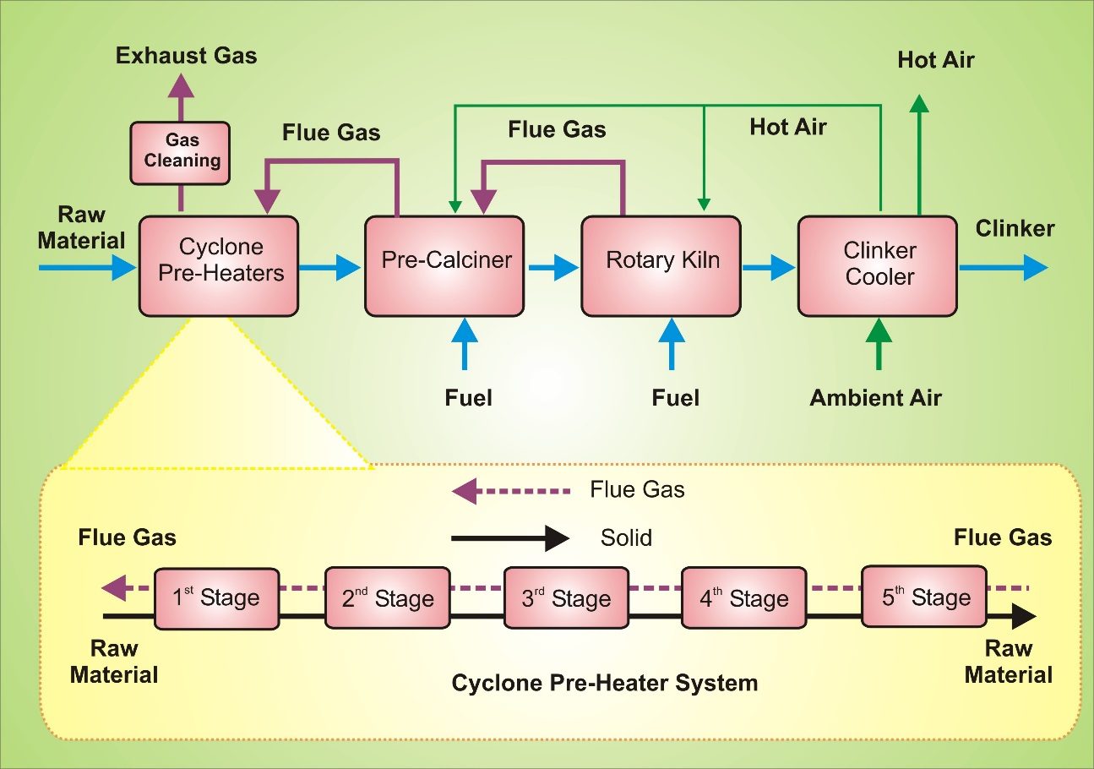

Figure 1: Scenario 1 – Base Case

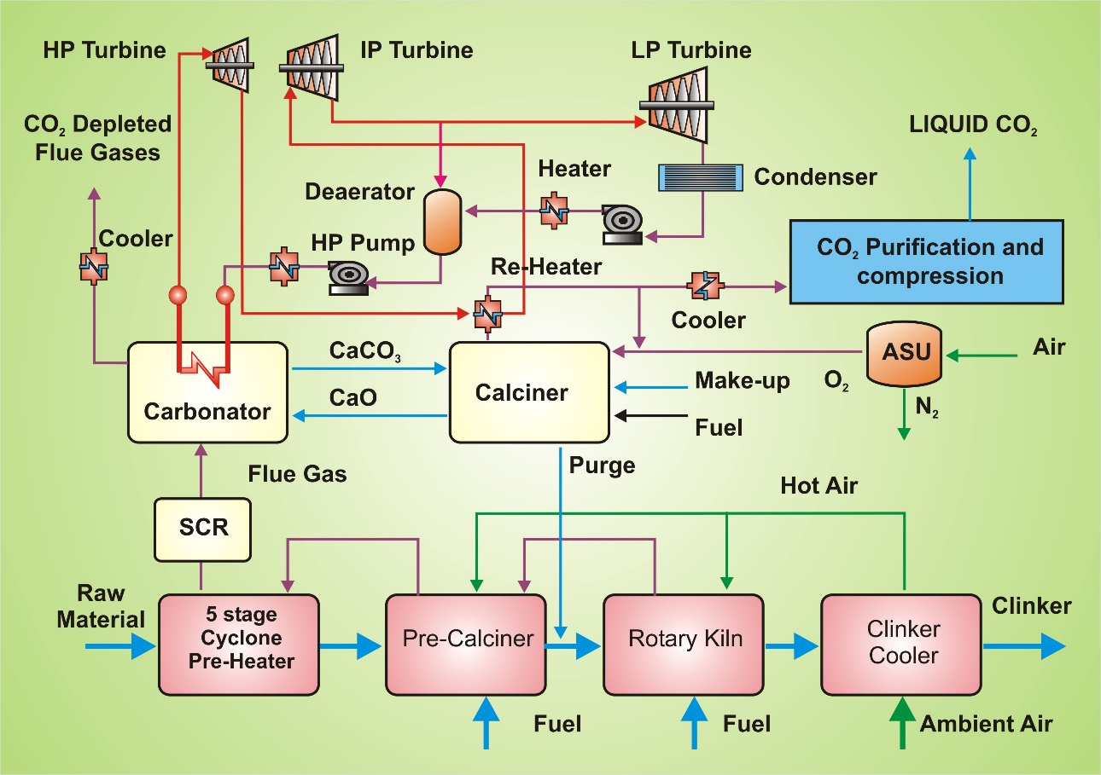

Figure 2: Scenario 2 – CCL integration

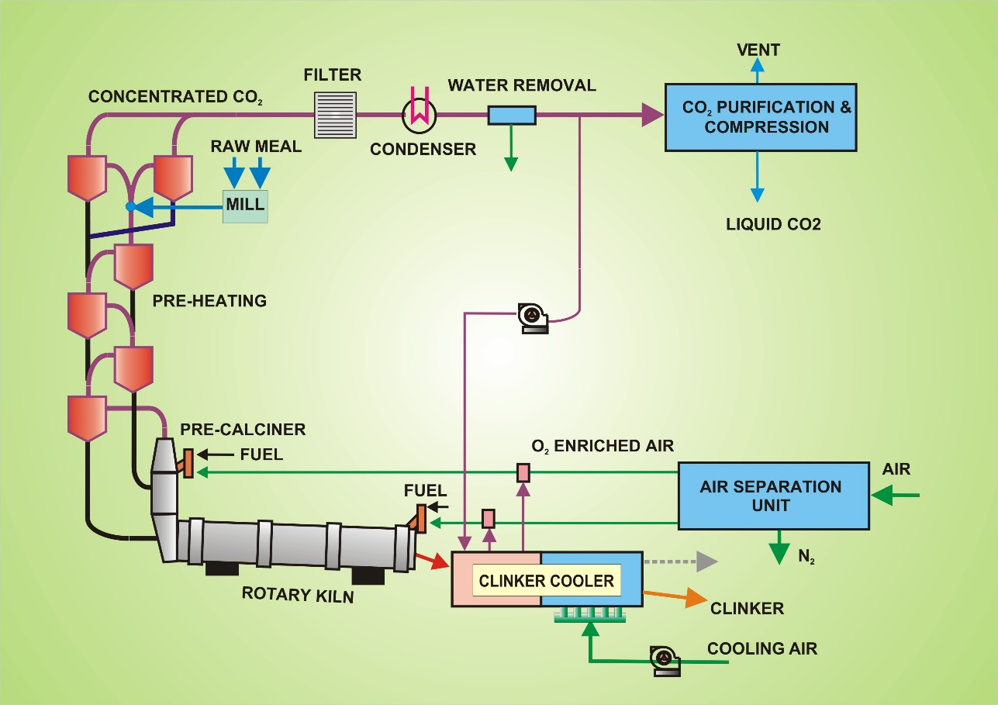

Figure 3: Scenario 3 – Oxy-fuel integration

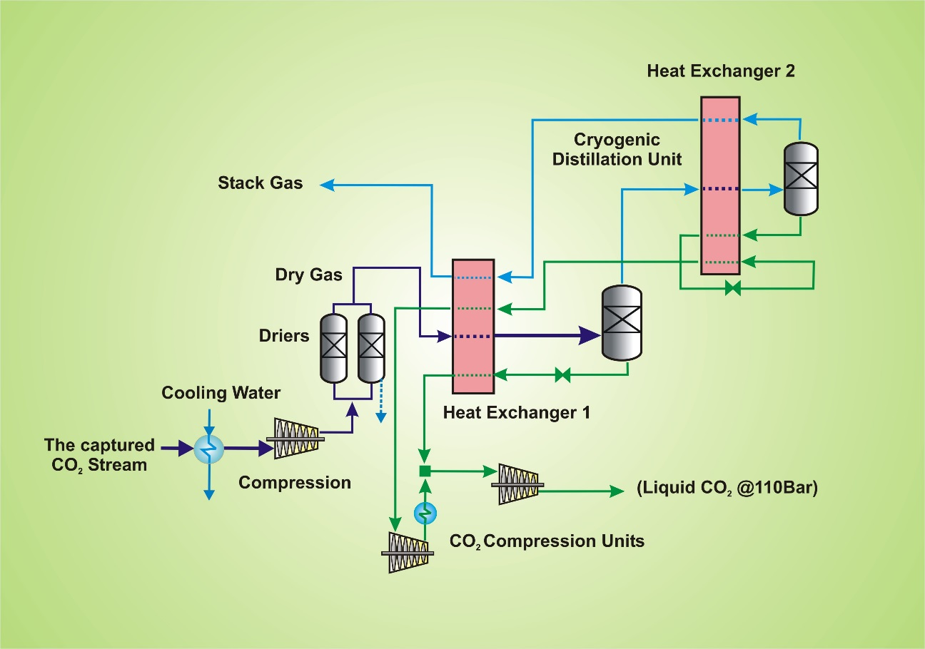

Figure 4 Schematic diagram of the CO2 purification and compression unit

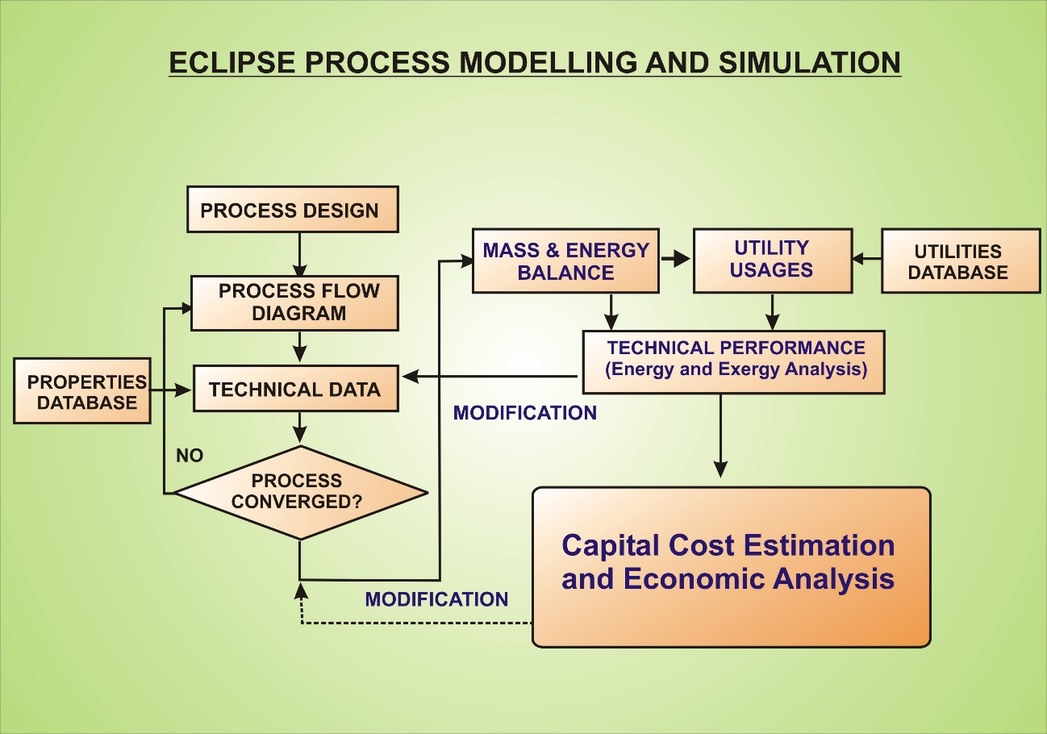

Figure 5 ECLIPSE Process Modelling and Simulation

Figure 6 Specific CO2 emissions avoided vs. Grid electricity CO2 emission factor

Figure 7 SPECCA vs. Grid electricity CO2 emission factor



Figure 8: Comparing Scenario 1 - Base Case, Scenario 2 – CCL and 'Scenario 3 – Oxy-fuel; Method: ReCiPe Midpoint (H) V1.13 / Europe Recipe H / Characterisation



Figure 9: Comparing Scenario 1 - Base Case, Scenario 2 – CCL and 'Scenario 3 – Oxy-fuel; Method: ReCiPe Midpoint (H) V1.13 / Europe Recipe H / Normalisation



Figure 10: Comparing Scenario 1 - Base Case, Scenario 2 - CCL_No Gen and Scenario 3 – Oxy-fuel'; Method: ReCiPe Midpoint (H) V1.13 / Europe Recipe H / Normalisation

Table 1: Coal composition and calorific value

|  |  |  |
| --- | --- | --- |
| Parameter | Units | Values |
| Approximate analysis |  |  |
| Moisture | wt - % | 9.5 |
| Ash | wt - % | 13.5 |
| Lower heating value | MJ∙kg-1 | 25.43 |
| Ultimate analysis | wt - %, (dry and ash free basis) | |
| Carbon |  | 84 |
| Hydrogen |  | 6.7 |
| Nitrogen |  | 1.7 |
| Sulphur |  | 1 |
| Oxygen |  | 6.6 |

Table 2: Technical results

|  |  |  |  |
| --- | --- | --- | --- |
| Main process data | Base Case | CCL integration | Oxy-fuel integration |
| Raw meal consumed (tonne/hr) | 324 | 324 | 324 |
| Coal feed rate (tonne/h, as received) | 28.0 | 91.4 | 30.5 |
| Total thermal input (MW) | 198 | 643 | 215 |
| Clinker production (tonne/hr) | 196 | 226 | 197 |
| Auxiliary power consumption (MWe) | 21.3 | 31.4 | 25.2 |
| ASU power consumption (MWe) | - | 29.6 | 14.4 |
| CO2 purification/compression power (MWe) | - | 44.8 | 28.5 |
| The total power consumption (MWe) | 21.3 | 105.8 | 68.1 |
| On-site power generation (MWe) | - | 179.8 | - |
| Net power generation (MWe) | - | 74.0 | - |
| Specific power consumption (MWh/tClinker) | 0.11 | -0.33 | 0.35 |
| Specific O2 consumption (t O2/t CO2 captured) | - | 0.44 | 0.39 |
| Specific direct heat requirement (GJ/tClinker) | 3.64 | 10.25 | 3.94 |
| Specific indirect heat requirement (i.e. equivalent heat from electricity) (GJ/tClinker) | 0.93 | -2.80 | 2.97 |
| Equivalent specific heat requirement (GJ/tClinker) | 4.57 | 7.45 | 6.91 |
| CO2 captured (t CO2/hr) | - | 334 | 185 |
| CO2 emitted on-site (t CO2/hr) | 179 | 20 | 0 |
| CO2 capture rate of the plant (%) | - | 94 | 100 |
| Specific direct CO2 emissions (kg CO2/tClinker) | 913 | 89 | 0 |
| Specific indirect CO2 emissions (i.e. CO2 from electricity) (kg CO2/tClinker) | 95 | -285 | 301 |
| Equivalent specific CO2 emissions (kg CO2/tClinker) | 1008 | -197 | 301 |
| Equivalent CO2 emissions avoided (kg CO2/tClinker) | - | 1205 | 707 |
| Specific primary energy consumption for CO2 avoidance (GJ/t CO2) | - | 2.39 | 3.31 |

Table 3: LCI

|  |  |  |  |  |
| --- | --- | --- | --- | --- |
| Products, coproducts, avoided products | Scenario 1 - Base Case | Scenario 2 - CCL | Scenario 3 - Oxy | Units |
| *Outputs* |  |  |  |  |
| *Clinker* | *54.44* | *62.78* | *54.72* | *Kg* |
| *CO2 for Processing* | *0.00* | *92.78* | *51.39* | *Kg* |
| *Net Electricity* | *0* | *74* | *0* | *MJ* |
| *Inputs* |  |  |  |  |
| *Coal* | *7.78* | *25.39* | *8.47* | *Kg* |
| *CaCO3* | *71.1* | *86.81* | *71.1* | *Kg* |
| *Electricity* | *21.3* | *0* | *68.1* | *MJ* |
| *Emissions* |  |  |  |  |
| *CO2* | *49.68* | *5.66* | *0.00* | *Kg* |
| *SO2* | *0.053* | *0.018* | *0* | *Kg* |
| *NOX* | *0.033* | *0.033* | *0* | *Kg* |
| *Wastes* |  |  |  |  |
| *Coal Ash* | *0.025* | *0.588* | *0.001* | *kg* |
| *CaCO3* | *0.119* | *0.406* | *0.162* | *kg* |
| *CaO* | *0.001* | *1.811* | *0.001* | *kg* |
| *CaSO4* | *0* | *0.003* | *0.001* | *kg* |
| *SiO2* | *0.196* | *0.196* | *0.011* | *kg* |
| *Al2O3* | *0.03* | *0.001* | *0.003* | *kg* |

Table 4: Impact assessment. ReCiPe Midpoint (H) V1.13 / Europe Recipe H/Characterisation

|  |  |  |  |  |
| --- | --- | --- | --- | --- |
| Impact category | LCA Scenario 1 Base Case | LCA Scenario 2 CCL | LCA Scenario 3 Oxy-Fuel | Unit |
| Climate change | 1222.527 | 135.789 | 246.155 | kg CO2 eq |
| Ozone depletion | 0.000 | 0.000 | 0.000 | kg CFC-11 eq |
| Terrestrial acidification | 1.927 | 0.880 | 1.138 | kg SO2 eq |
| Freshwater eutrophication | 0.185 | 0.251 | 0.298 | kg P eq |
| Marine eutrophication | 0.076 | 0.075 | 0.087 | kg N eq |
| Human toxicity | 116.005 | 182.558 | 184.415 | kg 1,4-DB eq |
| Photochemical oxidant formation | 1.020 | 0.717 | 0.587 | kg NMVOC |
| Particulate matter formation | 0.599 | 0.326 | 0.444 | kg PM10 eq |
| Terrestrial ecotoxicity | 0.003 | 0.000 | 0.007 | kg 1,4-DB eq |
| Freshwater ecotoxicity | 2.938 | 4.565 | 4.695 | kg 1,4-DB eq |
| Marine ecotoxicity | 2.809 | 4.323 | 4.497 | kg 1,4-DB eq |
| Ionising radiation | 26.114 | -70.103 | 79.816 | kBq U235 eq |
| Agricultural land occupation | 11.742 | -6.546 | 26.945 | m2a |
| Urban land occupation | 3.545 | 8.187 | 4.423 | m2a |
| Natural land transformation | 0.021 | 0.026 | 0.034 | m2 |
| Water depletion | 1.007 | -1.762 | 2.667 | m3 |
| Metal depletion | 2.136 | 0.057 | 4.313 | kg Fe eq |
| Fossil depletion | 97.456 | 192.361 | 134.718 | kg oil eq |

Table 5: Climate Change, unit kg CO2 eq

|  |  |  |  |
| --- | --- | --- | --- |
| Process | Scenario 1 Base Case | Scenario 2 CCL | Scenario 3 Oxy-Fuel |
| Clinker - Scenario 1 Base Case | 1096.25 | 0.00 | 0.00 |
| Clinker - Scenario 2 CCL | 0.00 | 90.16 | 0.00 |
| Clinker - Scenario 3 oxy | 0.00 | 0.00 | 0.00 |
| Electricity Input | 52.34 | -157.67 | 166.47 |
| Hard coal Input | 70.08 | 198.34 | 75.91 |
| Hard coal ash Waste | 0.03 | 0.69 | 0.00 |
| Inert Waste | 0.03 | 0.25 | 0.00 |
| Limestone residue Waste | 0.01 | 0.03 | 0.01 |
| Limestone Input | 3.78 | 4.00 | 3.76 |

Table 6: Fossil depletion, unit kg oil eq

|  |  |  |  |
| --- | --- | --- | --- |
| Process | LCA Scenario 1 Base Case | LCA Scenario 2 CCL | LCA Scenario 3 Oxy-Fuel |
| Electricity Input | 13.960 | -42.055 | 44.403 |
| Hard coal Input | 82.326 | 232.979 | 89.169 |
| Hard coal ash Waste | 0.003 | 0.060 | 0.000 |
| Inert Waste | 0.019 | 0.148 | 0.001 |
| Limestone residue Waste | 0.007 | 0.022 | 0.010 |
| Limestone Input | 1.141 | 1.208 | 1.135 |

Acknowledgements

This research work was carried out as part of the FP7 project SCARLET (Scale-up of Calcium Carbonate Looping Technology for Efficient CO2 Capture from Power and Industrial Plants) funded by the European Union (GA608578). (http://www.project-scarlet.eu/.)

# References

[1] E. Benhelal, G. Zahedi, E. Shamsaei and A. Bahadori, “Global strategies and potentials to curb CO2 emissions in cement industry,” Journal of Cleaner Production, vol. 15, pp. 142-161, 2013.

[2] UN, “The Paris Agreement,” United Nations Framework Convention on Climate Change, 2017. [Online]. Available: http://unfccc.int/paris_agreement/items/9485.php.

[3] IEA, “20 years of carbon capture and storage - Accelerating future deployment,” 2016. [Online]. Available: http://www.iea.org/publications/freepublications/publication/20-years-of-carbon-capture-and-storage.html.

[4] A.-M. Cormos and C.-C. Cormos, “Reducing the carbon footprint of cement industry by post-combustion CO2 capture: Techno-economic and environmental assessment of a CCS project in Romania,” Chemical Engineering Research and Design, 2007.

[5] F. Stafford, F. Raupp-Pereira, J. Labrincha and D. Hotza, “Life cycle assessment of the production of cement: A Brazilian case study,” Journal of Cleaner Production, vol. 137, pp. 1293-1299, 2016.

[6] IEA, “Cement Technology Roadmap 2009,” December 2009. [Online]. Available: https://www.iea.org/publications/freepublications/publication/Cement.pdf.

[7] D. Summerbell, D. Khripko, C. Barlow and J. Hesselbach, “Cost and carbon reductions from industrial demand-side management: Study of potential savings at a cement plant,” Applied Energy, vol. 197, pp. 100-113, 2017.

[8] D. García-Gusano, D. Garraín, I. Herrera, H. Cabal and Y. Lechón, “Life Cycle Assessment of applying CO2 post-combustion capture to the Spanish cement production,” Journal of Cleaner Production, vol. 104, pp. 328-338, 2015.

[9] J.-H. Xu, B.-W. Yi and Y. Fan, “A bottom-up optimization model for long-term CO2 emissions reduction pathway in the cement industry: A case study of China,” International Journal of Greenhouse Gas Control, vol. 44, pp. 199-216, 2016.

[10] I. Martínez, G. Grasa, J. Parkkinen, T. Tynjälä and T. Hyppänen, “Review and research needs of Ca-Looping systems modelling for post-combustion CO2 capture applications,” International Journal of Greenhouse Gas Control, vol. 50, pp. 271-304, 2016.

[11] S. Budinis, N. Mac Dowell, S. Krevor, T. Dixon, J. Kemper and A. Hawkes, “Can Carbon Capture and Storage Unlock ‘Unburnable Carbon’?,” Energy Procedia, vol. 114, pp. 7504-7515, 2017.

[12] O. Q. Fernandes Araújo and J. JMedeiros, “Carbon capture and storage technologies: present scenario and drivers of innovation,” Current Opinion in Chemical Engineering, vol. 17, pp. 22-34, 2017.

[13] J. Míguez, J. Porteiro, R. Pérez-Orozco, D. Patiño and S. Rodríguez, “Evolution of CO2 capture technology between 2007 and 2017 through the study of patent activity,” Applied Energy, vol. 211, pp. 1282-1296, 2018.

[14] R. Stanger, T. Wall, R. Spörl, M. Paneru, S. Grathwohl, M. Weidmann, G. Scheffknecht, D. McDonald, K. Myöhänen, J. Ritvanen, S. Rahiala, T. Hyppänen, J. Mletzko, A. Kather and S. Santos, “Oxyfuel combustion for CO2 capture in power plants,” International Journal of Greenhouse Gas Control, vol. 40, pp. 55-125, 2015.

[15] D. Hanak and v. Manovic, “Calcium looping combustion for high-efficiency low-emission power generation,” Journal of Cleaner Production, vol. 161, pp. 245-255, 2017.

[16] A. Abdilahi, M. Mustafa, S. Abujarad and M. Mustapha, “Harnessing flexibility potential of flexible carbon capture power plants for future low carbon power systems: Review,” Renewable and Sustainable Energy Reviews, 2017.

[17] A. Cormos, C. Dinca, L. Petrescu, D. Chisalita, S. Szima and C. Cormos, “Carbon capture and utilisation technologies applied to energy conversion systems and other energy-intensive industrial applications,” Fuel, 2017.

[18] T. Hills, N. Florin and P. Fennell, “Decarbonising the cement sector: A bottom-up model for optimising carbon capture application in the UK,” Journal of Cleaner Production, vol. 139, pp. 1351-1361, 2016.

[19] A. Escudero, S. Espatolero and L. Romeo, “Oxy-combustion power plant integration in an oil refinery to reduce CO2 emissions,” International Journal of Greenhouse Gas Control, vol. 45, pp. 118-129, 2016.

[20] X. Zhang, B. Singh, X. He, T. Gundersen, L. Deng and S. Zhang, “Post-combustion carbon capture technologies: Energetic analysis and life cycle assessment,” International Journal of Greenhouse Gas Control, vol. 27, pp. 289-298, 2014.

[21] L. Giordano, D. Roizard and E. Favre, “Life cycle assessment of post-combustion CO2 capture: A comparison between membrane separation and chemical absorption processes,” International Journal of Greenhouse Gas Control, vol. 68, pp. 146-163, 2018.

[22] F. Stafford, F. Raupp-Pereira, J. Labrincha and D. Hotza, “Life cycle assessment of the production of cement: A Brazilian case study,” Journal of Cleaner Production, vol. 137, pp. 1293-1299, 2016.

[23] D. Song, J. Yang, B. Chen, T. Hayat and A. Alsaedi, “Life-cycle environmental impact analysis of a typical cement production chain,” Applied Energy, vol. 164, pp. 916-923, 2016.

[24] B. Singh, A. Strømman and E. Hertwich, “Life cycle assessment of natural gas combined cycle power plant with post-combustion carbon capture, transport and storage,” International Journal of Greenhouse Gas Control, vol. 5, no. 3, pp. 457-466, 2011.

[25] L. Petrescu, D. Bonalumi, G. Valenti, A. Cormos and C. Cormos, “Life Cycle Assessment for supercritical pulverized coal power plants with post-combustion carbon capture and storage,” Journal of Cleaner Production, vol. 157, pp. 10-21, 2017.

[26] F. Clarens, J. Espí, M. Giraldi and M. Rovira, “Life cycle assessment of CaO looping versus amine-based absorption for capturing CO2 in a subcritical coal power plant,” International Journal of Greenhouse Gas Control, vol. 46, pp. 18-27, 2016.

[27] Scarlet, “Scale-up of Calcium Carbonate Looping Technology for efficient CO2 Capture from Power and Industrial Plants,” 2017. [Online]. Available: http://www.project-scarlet.eu/wordpress/?page_id=70. [Accessed 15 October 2017].

[28] J. Hilz, M. Helbig, M. Haaf, A. Daikeler, J. Ströhle and B. Epple, “Long-term pilot testing of the carbonate looping process in 1 MWth scale,” Fuel, vol. 201, p. 892–899, 2017.

[29] M. Haaf, A. Stroh, J. Hilz, M. Helbig, J. Ströhle and B. Epple, “Process modelling of the calcium looping process and validation,” Energy Procedia, vol. 114, p. 167 – 178, 2017.

[30] J. Hilz, M. Helbig, M. Haaf, A. Daikeler, J. Ströhle and B. Epple, “Investigation of the fuel influence on the carbonate looping process in 1 MWth scale,” Fuel Processing Technology, vol. 169, pp. 170-177, 2018.

[31] A. Stroh, F. Alobaid, M. von Bohnstein and J. E. B. Ströhle, “Numerical CFD simulation of 1 MWth circulating fluidized bed using the coarse grain discrete element method with homogenous drag models and particle size distribution,” Fuel Processing Technology, vol. 169, pp. 84-93, 2018.

[32] M. Zeneli, A. Nikolopoulos, N. Nikolopoulos, P. Grammelis, S. Karellas and E. Kakaras, “Simulation of the reacting flow within a pilot scale calciner by means of a three phase TFM mode,” Fuel Processing Technology, vol. 162, pp. 105-125, 2017.

[33] CCSA, “Storage,” Carbon Capture & Storage Association, 2018. [Online]. Available: www.ccsassociation.org/what-is-ccs/storage/. [Accessed 15 02 2018].

[34] W. Peck, N. Azzolina, J. Ge, N. Bosshart, M. Burton-Kelly, C. Gorecki, A. Gorz, S. Ayash, D. Nakles and L. Melzer, “Quantifying CO2 storage efficiency factors in hydrocarbon reservoirs: A detailed look at CO2 enhanced oil recovery,” International Journal of Greenhouse Gas Control, vol. 69, pp. 41-51, 2018.

[35] N. Azzolina, D. Nakles, C. Gorecki, W. Peck, S. Ayash, L. Melzer and S. Chatterjee, “CO2 storage associated with CO2 enhanced oil recovery: A statistical analysis of historical operations” International Journal of Greenhouse Gas Control, vol. 37, pp. 384-397, 2015.

[36] A. Cormos, C. Dinca, L. Petrescu, D. Chisalita, S. Szima and C. Cormos, “Carbon capture and utilisation technologies applied to energy conversion systems and other energy-intensive industrial applications,” Fuel, 2017.

[37] Lowest Cost Decarbonisation for the UK: Critical Role of CCS, Report of the Parliamentary Advisory Group on CCS, September 2016, www.ccsassociation.org/index.php/download_file/view/1043/508/

[38] D. Leeson, N. Mac Dowell, N. Shah, C. Petit and P. Fennell, “A Techno-economic analysis and systematic review of carbon capture and storage (CCS) applied to the iron and steel, cement, oil refining and pulp and paper industries, as well as other high purity sources,” International Journal of Greenhouse Gas Control, vol. 61, pp. 71-84, 2017.

[39] J. Hilz, M. Helbig, A. Stroh, J. Ströhle, B. Epple, C. Weingärtner and O. Stallmann, “1 MWth pilot testing and scale-up of the carbonate looping process in the SCARLET project,” in 3rd IEAGHG Post Combustion Capture Conference (PCCC3), Regina, Canada, 2015.

[40] Z. Wang, M. Liu, X. Cheng, Y. He, Y. Hu and C. Ma, “Experimental study on oxy-fuel combustion of heavy oil,” International Journal of Hydrogen Energy, vol. 42, no. 31, pp. 20306-20315, 2017.

[41] J. Li, P. Tharakan, D. Macdonald and X. Liang, “Technological, economic and financial prospects of carbon dioxide capture in the cement industry,” Energy Policy, vol. 61, pp. 1377-1387, 2013.

[42] C. Yin and J. Yan, “Oxy-fuel combustion of pulverized fuels: Combustion fundamentals and modeling,” Applied Energy, vol. 162, pp. 742-762, 2016.

[43] K Atsonios, P Grammelis, S Antiohos, N Nikolopoulos, E Kakaras, Integration of calcium looping technology in existing cement plant for CO2 capture: Process modelling and technical considerations, FUEL 153 (2015) 210-223

[44] Vince White, Laura Torrente-Murciano, David Sturgeon and David Chadwick, Purification of oxyfuel-derived CO2, Energy Procedia, Volume 1, Issue 1, (2009), pp. 399-406.

[45] Z. Abbas, T. Mezher, M. Abu-Zahra, Evaluation of CO2 Purification Requirements and the Selection of Processes for Impurities Deep Removal from the CO2 Product Stream, Energy Procedia 37 (2013) pp. 2389 – 2396

[46] Vince White, Rodney Allam and Edwin Miller, Purification of Oxyfuel-Derived CO2 for Sequestration or EOR, http://citeseerx.ist.psu.edu/viewdoc/download?doi=10.1.1.499.2329&rep=rep1&type=pdf

[47] CAESAR Project, “European Best Practice Guidelines for Assessment of CO2 Capture Technologies”, Deliverable 4.9, February 2011. [Online] Available: <http://www.energia.polimi.it/news/D%204_9%20best%20practice%20guide.pdf>

[48] Intergovernmental Panel on Climate Change, Special Report on Carbon Dioxide Capture and Storage (2005), available at <https://www.ipcc.ch/pdf/special-reports/srccs/srccs_wholereport.pdf>

[49] G Sekkappan, PJ Melling, M Anheden G Lindgren, F Kluger, IS Molinero, et al. Oxy-fuel technology for CO2 capture from advanced supercritical pulverized fuel plants. In: 8th International conference on greenhouse gas control technologies. Trondheim Norway. Proceedings of GHGT-8; June 2006.

[50] UK Electricity National Grid CO2 Output per Production Type, <http://gridwatch.co.uk/co2-emissions>

[51] IEA Greenhouse Gas R&D Programme (IEA GHG) “CO2 capture in the cement industry”, 2008/3 July 2008, <http://ieaghg.org/docs/General_Docs/Reports/2008-3.pdf>

[52] Ulster University, “ECLIPSE process simulator,” Energy Research Centre, University of Ulster, Coleraine, Copyright 1992.

[53] E. De Lena, M. Spinelli, I Martinez, M Gatti, R. Scaccabarozzi, G Ginti am M Romano, “Process integration study of tail-end Ca-Looping process for CO2 capture in cement plants, International Journal of Greenhouse Gas Control 67 (2017) 71-92.

[54] ISO, BS EN ISO 14044:2006 Environmental management. Life cycle assessment. Requirements and guidelines, BSI, 2006.

[55] H. Baumann and A. Tillman, The Hitch Hikers Guide to LCA, 1 ed., Studentlitteratur AB, 2004.

[56] B. Weidema, “ISO system expansion = substitution,” LCA Consultants, 22 09 2014. [Online]. Available: <https://lca-net.com/blog/iso-system-expansion-substitution/>.

[57] M. Goedkoop, m. Oele, J. Leijting, T. Ponsioen and E. Meijer, “Introduction to LCA with SimaPro,” PRé, Jan 2016. [Online]. Available: <https://www.pre-sustainability.com/download/SimaPro8IntroductionToLCA.pdf>.

[58] E. Brilhuis-Meijer, “Consider Your Audience When Doing Impact Assessment,” 24 March 2014. [Online]. Available: <https://www.pre-sustainability.com/consider-your-audience-when-doing-lca>.

[59] T. Ponsioen, “Normalisation: New Developments in Normalisation Sets,” PRé, 21 July 2014. [Online]. Available: <https://www.pre-sustainability.com/the-normalisation-step-in-lcia>.

[60] ReCiPe, “Normalisation,” ReCiPe, [Online]. Available: <http://www.lcia-recipe.net/normalisation>

[61] T. Hurst, T. Cockerill and N. Florin, “Life cycle green house gas assessment of a coal-fired power station with calcium looping CO2 capture and offshore geological storage,” Society of Chemistry, vol. 5, no. 5, pp. 7132-5692, 2012.