ACCEPTED VERSION
A Near-isothermal Expander for Isothermal Compressed Air Energy Storage System

Xinjing Zhang^{a,b}, Yujie Xu^{a,b}, Xuezhi Zhouª, Yi Zhang^{a,b}, Wen Li^{a,b}, Zhitao Zuo^{a,b}, Huan Guoª, Ye Huang^{c}, Haisheng Chen^{a,b*}

ªInstitute of Engineering Thermophysics, Chinese Academy of Sciences, 100190 Beijing, China
^{b} University of Chinese Academy of Sciences, 100190 Beijing, China
^{c}School of the Built Environment, University of Ulster, Newtownabbey BT37 0QB, UK
*Corresponding author, chen_hs@iet.cn

Abstract
Compressed air energy storage technology is considered as a promising method to improve the reliability and efficiency of the electricity transmission and distribution, especially with high penetration of renewable energy. Being a vital component, the expander takes an important role in compressed air energy storage operation. The specific work of an expander can be improved through an isothermal expansion compared with the adiabatic expansion process due to a nearly constant temperature which enables the expander to operate with a high pressure ratio. In this study, a specific reciprocating expander with a high pressure ratio was developed and its adiabatic expansion characteristics were measured. Numerical modelling was performed to simulate adiabatic expansion. This model was also validated by experimental results. Based on these findings, we propose a quasi-isothermal expansion process using water injection into the expander cylinder. Modelling was also extended to simulate the quasi-isothermal process by introducing water-air direct heat transfer equations. Simulation results showed that when spraying tiny water droplets into the cylinder, the specific work generated was improved by 15.7% compared with that of the adiabatic expansion under the same air mass flowrate, whilst the temperature difference was only about 10% of that of the adiabatic process, and cylinder height was decreased by 8.7%. The influence of water/air mass flowrate ratio and the inlet temperature on the expander performance was also studied.

Keywords: compressed air energy storage; isothermal expander; experiment and simulation; specific work; high pressure ratio

- Introduction
As clean energy is vital to the mission of mitigating climate change and air pullion, the business case for clean energy is growing, and the trend toward a cleaner power sector is supported by beneficial relationships between economies and emissions, born out in relationship statistics (economies grow, emissions fall), private-sector emissions reductions, and market forces in the power sector and global momentum on emission-reducing technologies [1]. Renewable energy sources (e.g. solar and wind) are vitally important alternatives for clean, affordable, and reliable energy paradigms. The cost of electricity generated from renewables fell dramatically between 2008 and 2015: down 41% for wind, 54% for rooftop solar photovoltaic (PV) installations, and 64% for utility-scale PV [1]. Global capital investment in these clean energy resources was twice as much as that of fossil fuels in 2015 [1, 2].
The mismatch between an intermittent electricity supply and demand over multiple time and energy scales necessitates energy storage to balance and optimize power flow and generation. Electrical energy storage can play an important role in decarbonizing the electricity sector by offering a new, carbon-free source of operational flexibility, improving the utilization of generation assets and facilitating the integration of variable renewable energy sources [2, 3]. Low-cost fabricated compressed air energy storage (CAES) will be a most promising method to store electricity for medium- and long-term periods [2]. When off-peak electricity is available it can be used to produce compressed air via a series of compressors. Compressed air is then stored in a reservoir. During peak periods the stored compressed air is released to drive expanders to generate electricity [4, 5]. CAES technologies can help accommodate fluctuations in wind generation and decrease transmission line size rather than enlarging lines to match maximum power levels. The first patent for CAES technology was filed by Frazer W. Gay in 1948 [6]. This technology has been developed since the 1970s as a load-following and load-peaking power system. CAES system has an estimated efficiency of 70% with an expected lifetime of about 40 years [7]. Two commercial CAES plants have been constructed in Huntorf, Germany and McIntosh, USA [8]. Other countries such as the UK, Denmark, and the Netherlands have been keen to develop CAES plants as well [9].
Many types of CAES have been studied and developed, including conventional CAES, advanced-adiabatic CAES, liquid air energy storage, isothermal CAES, and so forth [4, 9]. In the ideal isothermal CAES (ICAES) process, the temperature during compression is kept constant while related heat is released. The power required to run the compressor is correspondingly lower than that required to run an adiabatic compressor with the same pressure ratio. During compression, related heat is supplied continuously to ensure expansion at a constant temperature. Thus, the electrical power used to run the compressor during charging can be completely recovered during discharging. The ideal cycle efficiency of ICAES systems can be as high as 100% [4, 10]. In this study, a liquid piston based ICAES is proposed, which can yield a compressive efficiency of 89.0% according to the simulation results [8].
The compressor and expander are the pivotal components of the CAES system [11]. Generally, most gas power cycles perform work by expanding adiabatically and produce less specific work than their isothermal counterparts, which run at constant temperature. Isothermal expansion leads to a high pressure ratio and high power density, improving specific work generation. Meanwhile, lower inlet/outlet air temperature differences result in better performance in low-grade heat applications [12]. If heat is continuously transferred to the working fluid during the expansion process, this results in isothermal expansion or, more accurately, quasi-isothermal expansion, which may be somewhere between the adiabatic and ideal isothermal processes [13]. Compressing and expanding a gas nearly isothermally allows efficiency losses due to temperature deviations to be minimized or eliminated, which can in turn prevent heat transfer loss leading to improved efficiency [14]. An experimental system using condensable gas of R134a was built to investigate energy storage potential and compression/expansion characteristics. The experimental results showed a round trip efficiency of 95.8% was achievable [14]. Cicconardi et al. proposed using many super-heaters to make the expansion gradually approach isothermal conditions in a steam power plant and found that the thermal efficiency can be improved from 38.5% to 49.2% [15]. Kim et al. indicated that multi-stages compression with intercooling and multi-stages expansion with reheating could also transform the adiabatic process into a near-isothermal process. Thus, the exergy losses due to heat transfer were decreased by minimizing the temperature differences between heat exchangers. System efficiency was as high as 71.6% [16]. Woodland et al. [17] carried out theoretical study of the Organic Rankine Cycle (ORC) based on a liquid flooding expander. For ammonia, an improvement of 20% in thermal efficiency could be reached [17]. Underwater/Ocean CAES systems have been investigated and can reach near-isothermal processes with a liquid-piston-based compression cycle to increase the air storage pressure and mitigate thermal loss from high temperature heat exchange and increase the air storage pressure. Both theoretical and experimental studies were conducted. The polytropic index for the compression process was approximately 1.25, and this number decreased as the stroke time was increased [18, 19].
Various methods have been proposed to achieve isothermal/near-isothermal expansion; these methods mainly employ reciprocating or volumetric expanders [20]. In terms of the heat transfer methods, these isothermal expansion methods can be roughly categorized into two groups: expander surface heating (indirect heat transfer) and secondary fluid heating (direct heat transfer) [12]. The first one is a simple approach by heating up the expander surface sufficiently in order to transfer the heat to the fluid during expansion. Theoretical studies have been proposed and conducted. The cylinder surface should be large and certain geometries used to enlarge the heat transfer area, such as tubes and fins. Suggestions have also been made to decrease the rotation speed of the expander in order to increase the heat transfer time for a certain amount of fluid [21-23]. However, practice shows that the heating/cooling effect of this kind of external heating/cooling method is limited [24]. The second type of secondary fluid heating is to inject a certain fluid with high heat capacity to the working fluid in order to recover the temperature drop of expansion. For example, water can be sprayed into the cylinder to be mixed with air. Continuous injection of tiny water droplets with high thermal capacity constrains temperature change to a narrower range. Lemort et al. proposed a flooded scroll expander with R245fa working fluid to approach an isothermal process; the best overall isentropic efficiency of the expander was 66% [25, 26]. Liquid pistons have been proposed and studied, and results indicate that these pistons can raise compression efficiency from 70% to 83% [27]. Porous media inserts have been used in the liquid piston system to improve the heat transfer without the penalty of power density and thermal efficiency of ICAES systems. In compression, the porous inserts increased power density by 39-fold at 95% efficiency and enhanced efficiency by 18% at 100 kW/m³ power density; in expansion, power density was increased three-fold at 89% efficiency and efficiency was increased by 7% at 150 kW/m³ power density [28, 29]. Experiments have also been carried out for reciprocating compressors. Results indicate that injecting water into the compressor cylinder decreases the specific work as the polytropic component is reduced to 1.161 [24, 30-32]. SustainX and LightSail corporations have filed patents for isothermal compression and expansion processes. Their patents indicate that direct heat exchange can achieve rapid isothermal compression and expansion. Inlet pressure can be as high as 20 MPa for single-stage expansion [33, 34]. However, detailed and operation parameters and performance have not been reported.
Our research group has previously developed and measured a novel small expander [35]. This was a reciprocating expander with only single inlet valve for a small-scale CAES prototype system. The outlet was near the Bottom Dead Center (BDC), which was controlled by the piston movement. Fewer movement parts were configured compared with other reciprocating expanders. The expander’s internal flow characteristics and adiabatic performance were investigated, which was reported in reference [35]. Moreover, the working fluid of this type of reciprocating expander can be various such as compressed air, water steam, organic fluids [20, 36-39]. The compressed air can be used to drive the expander for either electricity generation or mechanical power. Prototypes of micro-scale and small-scale CAES systems emerged as the alternatives to the electrical or electrochemistry based energy storage technologies, such as batteries. The reciprocating expanders are appropriate for small-scale CAES systems because it can operate with low flowrate and high pressure as required [20]. The compressed air reciprocating expander can also be designed for the vehicle as the MDI corporation claimed [39]. Small scale power cycles (e.g. steam cycle, ORC) usually utilize volumetric expanders for power generation [37, 38]. A reciprocating expander in a water steam cycle was tested and produced a power output of 2.4kW [37]. The efficiency of an reciprocating expander operated in ORC cycle can be as high as above 60% [38].
Adiabatic modelling was performed to simulate the expander. The model developed was also validated by experimental results. The results showed that the expander operated with high pressure and relatively high aerodynamic efficiency. Building off of this research, in the current study we proposed a quasi-isothermal expander. The near-isothermal process was achieved by spraying water droplets into the cylinder, where direct-contact heat exchange can occur between the gas and the liquid. Compared with previous research, this concept used direct heat transfer was different from liquid pistons in that the operation pressure could be very much higher than that of scroll expanders due to the self-sealing configuration of the expander. It is also highly applicable since the reciprocating expander had been developed and tested. The multi-phase heat exchange process was modelled and simulated. The expander performance was predicted and a comparison study between adiabatic expansion and dynamic air pressure and temperature inside the cylinder was performed. A parameter sensitive analysis was also conducted in terms of water/air mass flowrate ratio and inlet temperature.
- Description of the expander and configuration
A three-stage, single-valve reciprocating expander, as shown in figure 1, was designed and manufactured. It is a small-scale expander of around 10 kW. Compared with other types of small expanders, the proposed expander has advantages such as high operating pressure, fewer moving parts, avoidance of the inlet air leakage, and improved efficiency [35]. A schematic sectional view of the first stage cylinder is presented in figure 2. The working principle is illustrated in figures 3 and 4. There are four processes in the adiabatic cycle: air intake, expansion, exhaust, and compression. When the piston comes near the Top Dead Centre (TDC), the intake valve is opened by a knock-out rod connected to the piston. Then the compressed air flows in, and the intake valve closes when the piston moves downward to a certain position near the TDC. The high-pressure air in the cylinder drives the piston to move downward to the Bottom Dead Centre (BDC), which rotates the crankshaft through the connecting rod to generate power. This is the expansion process for power generation. When the piston moves near the BDC, the cylinder is connected to the outside through exhaust orifices around the BDC, and the expanded air is released. When the piston head returns to a certain distance from the BDC, the orifices are forced to close and the air exhaust process is finished. Afterwards, the piston moves towards the TDC until the intake valve is opened. This is the compression process. The residual air in the cylinder is compressed and then mixed with the high-pressure intake air and this starts the next cycle. The adiabatic process can be upgraded to a quasi-isothermal process through direct heat exchange with a high thermal capacity fluid.
As shown in figure 5, on top of the cylinder there is an annular spraying nozzle along with the intake valve. The nozzle injects atomized water at a constant mass flowrate. During the air intake process, the compressed air flows in, mixes with the water droplets and expands as the piston moves downwards. Meanwhile, the water accumulates on the piston head at a constant flowrate. When the piston comes near the BDC, the expanded air as well as the accumulated water are exhausted into the buffer tank through the outlet orifices and cylinder air pressure further decreases. After that, the remaining air is compressed as the piston moves back to the TDC and, hence, another cycle begins.
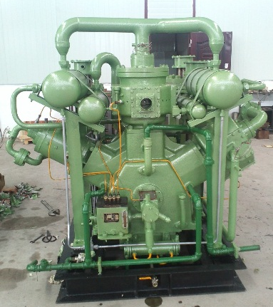  Fig. 1 A 3-stage reciprocating expander | 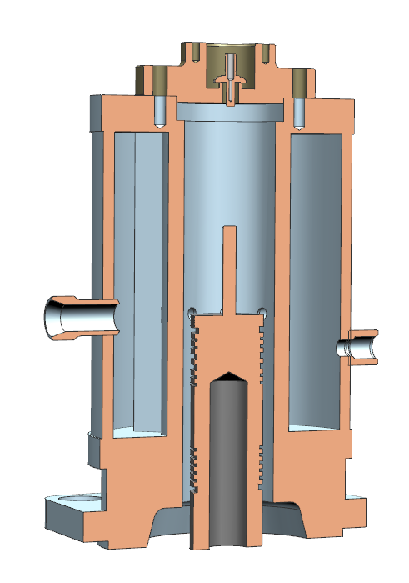  Fig. 2 Sectional view of the first stage cylinder

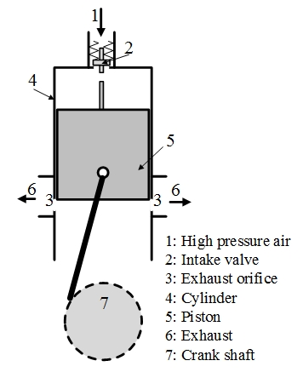  Fig. 3 Schematic diagram of the reciprocating expander | 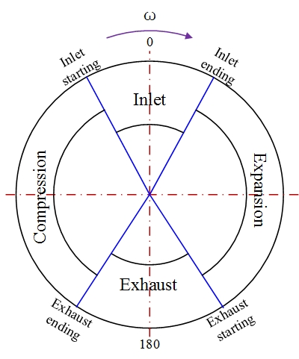  Fig. 4 Phase distribution diagram of the reciprocating expander

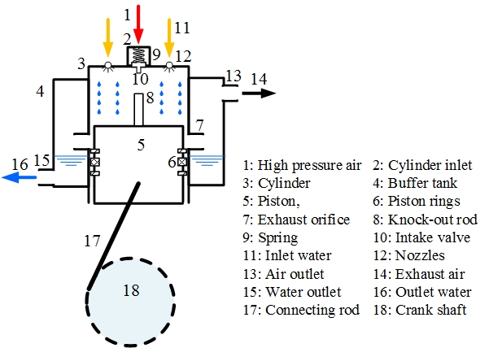
Fig. 5 Schematic diagram of the single valve reciprocating expander
- Methodology
3.1 Experimental setup
The test bench of the fabricated three-stage expander, as shown in Fig. 6, includes the expander, compressor and storage tank, inter-stage heater, pressure/temperature/flowrate sensors (P, T, FR), and the apparatus for controlling speed and inlet pressure. The schematic of the experimental setup is shown in Fig. 7. As illustrated, the air is compressed by the compressor and stored in the storage tank. The stored air pressure is controlled by a valve and heated by a heater. Then it drives the expander for power generation. The air is heated again by heaters before entering cylinders. The temperature sensors were mainly used to measure the steady temperature of inlets/outlets of each stage. High-frequency pressure transducers were installed to measure the dynamic pressure inside the cylinder. Dynamic results were used to validate the modelling of adiabatic expansion.
The expander was connected to a motor through a speed and torque transducer. A converter was introduced and connected to the grid, the motor, and a resistor. The converter was used to control the speed of the motor and also transfer generated electricity to the resistor for consumption. Air pressure and temperature were measured before and after each stage, and a high-frequency pressure transducer was also installed in each cylinder to measure the internal pressure of each stage. The test inlet/outlet pressure of each stage was as follows: 7.03/1.82 MPa for first stage, 1.82/0.51 MPa for second stage and 0.51/0.13MPa for third stage. The measured results of the first stage was analysed, which were utilized to validate the modelling of adiabatic expansion.

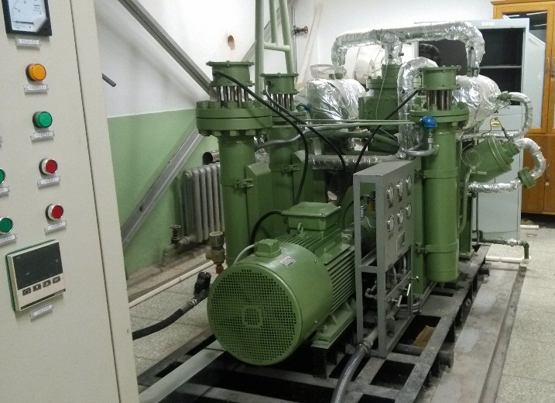
Fig. 6 The expander experimental setup

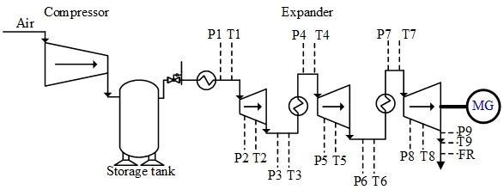
Fig. 7 Schematic diagram of the expander experimental setup
3.2 Modelling of the expander
3.2.1 Modelling of adiabatic expansion process
The modelling process mainly contained two sections: A) the compressed air expansion process and B) the process of water droplet spraying/direct heat exchange with air. The air was assumed to act as an ideal gas and parameters within the cylinder were assumed to be uniform. The inlet/outlet flow process was quasi-steady. While spraying, the water droplets were uniformly distributed in the cylinder as this near-isothermal expander has the same cylinder diameter, same stroke distance, same rotation speed, same air inlet temperature and pressure with the adiabatic expander. The cylinder top clearance is changed to keep the same air mass flowrate. The water/air mass ratio was kept constant in the cylinder, and the mass transfer between water and air through condensation and evaporation was ignored.
The mass balance of air in the cylinder of each cycle was calculated as follows:
(1)
where, the subscript a stands for the air phase, m_{a} is the mass of air in the cylinder, m_{a, E} is the air mass flow through inlet valve, m_{a, A} is the air mass flow through outlet valve, and φ is the crank angle.
Once the pressure difference before and after the inlet/outlet valve and the valve open area were determined, the transient mass flowrate could be calculated by the following equation:
(2)
where the subscript j stands for the inflow/outflow condition, ṁ_{a,j} is the transient mass flow rate through inlet/outlet valve, μ is the gas flow coefficient, A is the open area of the inlet/outlet open area, P_{I} and ρ_{I} are the pressure and density of the air before the valve, and ψ is the flow function which is determined by the air flow state as indicated in a previous study [40].
When , the air flow is subcritical
(3)
When, the air flow is supercritical
(4)
where P_{II} and ρ_{II} are the pressure and density of the air after the valve, k is specific heat ratio.
The air temperature in the cylinder changes along with the crank angle, and the equation is as follows:
(5)
where T_{a} is the air temperature in the cylinder, c_{v} is the air heat capacity at constant volume, Q is the heat exchange through the cylinder walls, Q_{C} is the heat exchange between air and water droplets, W is the mechanical energy generated by the piston, h_{a, E} and h_{a, A} are the enthalpy of the inlet and outlet air, and u_{a} is specific energy of the air.
The mechanical power was calculated as follows:
(6)
where V_{a} is the working volume of the cylinder and P_{a} is the pressure.
The volume change with the crank angle was calculated as:
(7)
where D is the cylinder diameter and S is the piston distance from the TDC to the BDC, λ_{e} is the ratio of connected rod length to crank radius.
The transient pressure inside the cylinder was calculated by the following equation:
(8)
The thermodynamic properties of the ith stage cylinder can be simulated using the above equations.
3.2.2 Modelling of water droplets and heat exchange
Water was utilized to mix with compressed air for direct heat exchange because of its high heat capacity and affordable cost. Since evaporation of the liquid was extremely small, liquid-gas mass diffusion has been ignored in this study.
It was assumed that a single droplet falls at constant terminal velocity. Therefore, the drag and the gravity forces on each droplet are balanced, and the terminal velocity can be calculated with the following equation [13]:
(9)
where, d is droplet diameter, g is acceleration due to gravity, C_{D} is drag coefficient, ρ_{w} is water density, ρ_{a} is air density in the cylinder. As the spraying nozzles were installed in the cylinder head, the minimum and maximum distance for the water droplets can be obtained according to the cylinder configuration. Thus, the mass of water droplets that moved and mixed with the air could be calculated.
There are many correlations of drag coefficients [41, 42]. The following empirical correlations were cited in the calculation.

(10)
(11)
where, Re_{d} is Reynolds number, w is relative velocity of the droplet, which is compared with the average piston velocity, μ_{a} is .
The mass balance of water droplets in the cylinder of each cycle was calculated as:
(12)
where the subscript w stands for the water phase, m_{w} is the mass of water in the cylinder, m_{w,E} is the water mass flow through the spray nozzles, and m_{w,A} is the water mass flow accumulated on the piston surface.
The water temperature in the cylinder changes along with the crank angle, and the equation is:
(13)
where T_{w} is the water temperature in the cylinder, c_{p,w} is the heat capacity of the water, Q_{C} is the heat exchange between air and water droplets, h_{w,E} and h_{w,A} are the enthalpies of the water inflow and water outflow, u_{w} is specific energy of the water.
The heat exchange between the air and water droplets can be calculated as follows [43]:
(14)
where α is the heat transfer coefficient of the air, ω is the angular speed (rad/s), S_{w} is the total surface area of the water droplets exposed to heat transfer, which can be calculated as follows based on the water volume and Sauter Mean Diameter (SMD) of droplets:
(15)
where V_{w} is the total volume of water droplets mixed with the air and d is the average diameter of the water droplets.
The heat transfer coefficient α can be calculated by the following equation [43, 44]:
(16)
where λ is thermal conductivity, and Nu is the Nusselt number.
In order to obtain the heat transfer coefficient between the air and water droplets, the following correlation was applied to the spherical water droplets [10, 45, 46]:
(17)
where the Re_{d} is the Reynolds number and Pr is the Prandtl number.
The adiabatic expansion efficiency is defined as follows:
(18)
where W_{adia} is the indicated work generated by the adiabatic expander and W_{s_adia} is the ideal work generated with constant entropy by the adiabatic expander.
The efficiency of the near-isothermal expander is defined as follows, which is also called isothermality as the ratio of cycle work output to the ideal isothermal work [22, 47]:
(19)
where W_{n_iso} is indicated work generated by the near-isothermal expander, it is calculated by equation (6) under the near-isothermal conditions; W_{n_iso} is the ideal work generated with constant temperature.
When considering the pump power for spraying water, the near-isothermal expander efficiency is defined as follows:
(20)
- Results and discussion
4.1 Model validation
To verify that the models developed were working as expected, model validation was carried out. Based on the first stage of the expander, the cylinder diameter was 65 mm, stroke distance 100 mm, top clearance height 70 mm, and rotation speed 500 rpm. The inlet pressure and temperature were 7.03 MPa and 373 K, while the outlet pressure and temperature were 1.82 MPa and 302.6 K. The validation results showed that the measured and simulated air mass flow rates were 109.25 kg/h and 105.65 kg/h. Both measured and simulated pressure distributions inside the cylinder are shown in Fig. 8. TDC point was assumed to be 0 degrees of crank angle and the BDC point was assumed to be 180 degrees, which was the starting point of the cycle simulation of crank angle. While the. Fig. 8 shows that simulated and experimental results match quite closely. The adiabatic model was validated and it can be further used to analyse the same type of expander with various parameters. As presented above, the near-isothermal model was developed by adding the heat transfer equations into the developed adiabatic model. The heat transfer model was also developed and utilized by many other researchers. The near-isothermal model was proved to be effective for the isothermal simulation. Both adiabatic and near-isothermal expansion processes were studied, analysed and compared in the next section.
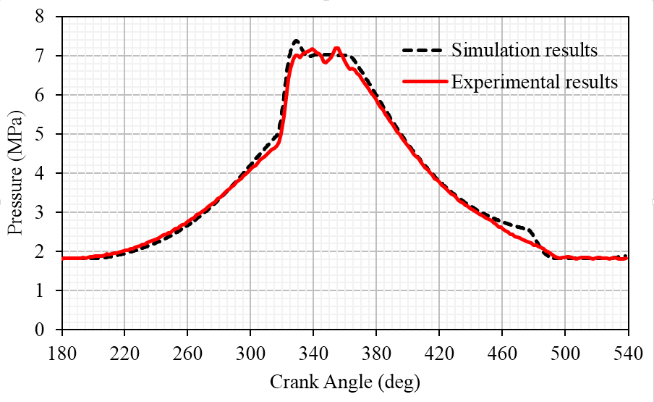
Fig. 8 Comparison of simulated and experimental results
4.2 Quasi-isothermal Expansion Analysis
One advantage of the isothermal expander is that it can be operated at a high pressure ratio through a single stage with a small temperature difference. The pressure ratio was assumed to be 10 in the simulation process. Both adiabatic and near-isothermal expanders were designed and simulated to reveal the relative advantages of the near-isothermal expander. The major parameters of the simulated quasi-isothermal and adiabatic expanders are presented in table 1. Both expanders have the same major parameters including same cylinder diameter, same stroke distance and connecting rod length, same rotation speed, same inlet/outlet pressures, same air inlet temperature, and same air mass flowrate. The main difference of the cylinder structure between the two designs was the top clearance height.
By combining the equations (9), (10), and (11), and choosing average values of the air phase during the near-isothermal expansion process, the Reynolds number ws calculated as 90.9, and drag coefficient C_{D} was 1.2. The Reynolds number less than 200 was within the range of the Ranz-Marshal Correlation (Eq. (17)) [45]. Furthermore, the Prantl number and Biot number were calculated, and the Biot number was smaller than 0.1. Thus, the temperature change over the surface of the droplets can be assumed to be uniform.
Table 1 Main parameters of the adiabatic and quasi-isothermal expanders
 | Adiabatic expansion | Isothermal expansion
Cylinder diameter (mm) | 200 | 200
Inlet pressure (MPa) | 1 | 1
Air Inlet temperature (K) | 393.15 | 393.15
Water Temperature (K) | 393.15 | 393.15
Outlet pressure (MPa) | 0.1 | 0.1
Valve lift (mm) | 5 | 4
Inlet period (degree) | 46.4 | 41.4
Rotation speed (rpm) | 600 | 600
Top clearance height (mm) | 32 | 20.5
Outlet period (degree) | 74.8 | 59.1
Stroke distance (mm) | 100 | 100
Connecting rod length (mm) | 200 | 200
Atmosphere temperature (K) | 298.15 | 298.15
Atmosphere pressure (MPa) | 0.1 | 0.1
Table 2 Comparison of adiabatic and quasi-isothermal expansion processes
 | Adiabatic expansion | Isothermal expansion
Outlet temperature (K) | 215.6 | 375.4
Air mass flowrate (kg/h) | 100.38 | 100.35
Spraying water mass flow (kg/h) | 0 | 100*3
Spraying water droplet diameter (m) | - | 30e-6
Indicated power (kW) | 4.55 | 5.26
Specific work (kJ/kg) | 163.18 | 188.86
Efficiency | 85.7% | 72.5% / 68.5%
According to the results shown in table 2, the air mass flow rates were almost the same for both the adiabatic expansion process and the isothermal expansion process. For the isothermal expansion process, the water mass flowrate was estimated to be 3 times that of the air mass flowrate. Swirl nozzles or pin nozzles can be utilized to spray water droplets [8, 48]. The sprayed water droplet diameter from these nozeels is 30 μm. Compared with the adiabatic expander, the power output of the quasi-isothermal expander was increased by 15.6%, and the specific work output increased approximately 15.7%. The isentropic efficiency of the adiabatic expander is 85.7%, in which the mechanical loss is not considered. The efficiency or isothermality of the near-isothermal expander is 72.5%/68.5% without / consideration of the power consumption of the water pump.
The internal pressure distributions of both quasi-isothermal and adiabatic processes along with the crank angle are shown in Fig. 9, while the stroke distributions (exhaust, compression, inlet, expansion) in one cycle are also labelled in these figures. Both curves were found to be similar. According to equation (8), although the temperature was different between the two processes, the cylinder volume was also different. During the compression process, the pressure of the adiabatic process (P_adiab) was a bit higher, and the pressure of the quasi-isothermal process (P_isoth) was a bit higher at the later expansion section. This indicates that under the quasi-isothermal expansion process, the compression section consumes less power and the expansion section generates more power. Thus, the power output is increased. Fig. 10 shows the derivative of pressure with respect to crank angle as a function of crank angle. It indicates that the most pressure fluctuation occurs during the air inlet period. The air pressure increases quickly as the inlet valve starts to open and decreases quickly after the TDC while the inlet valve starts to close. It also changes much in the expansion process.
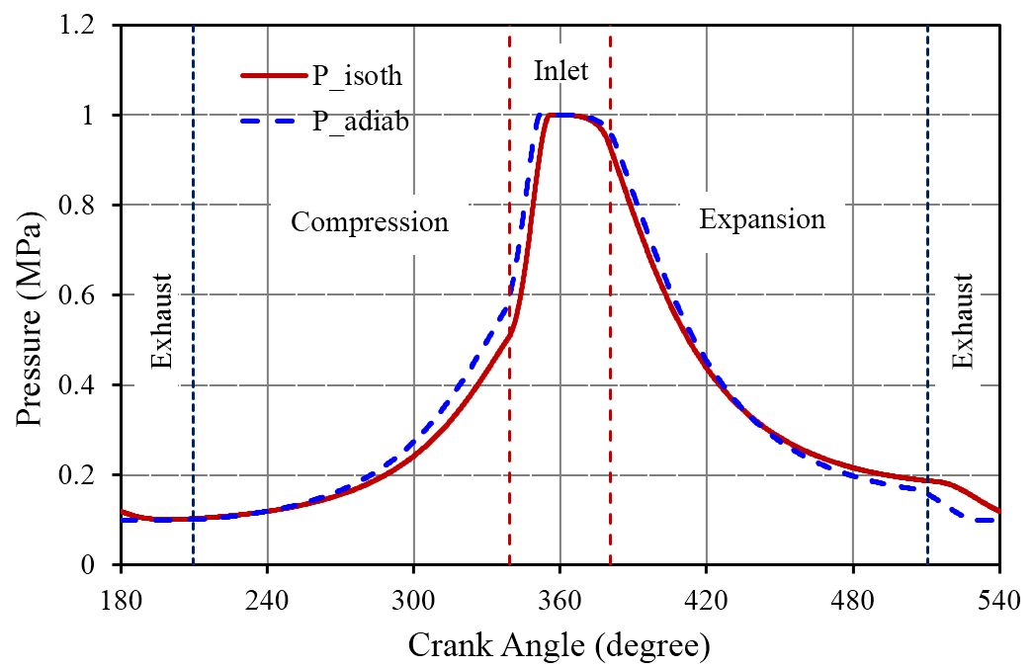
Fig. 9 Simulated internal pressure vs. crank angle
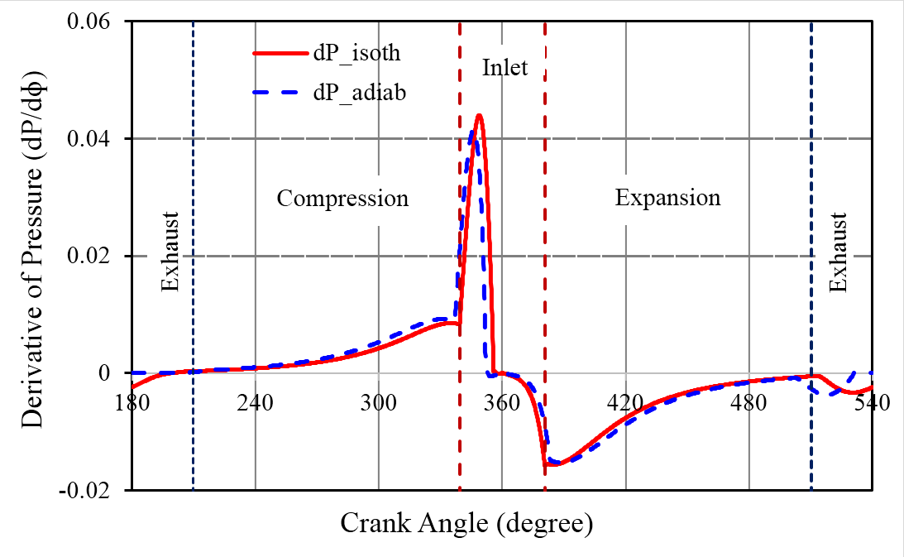
Fig. 10 Simulated derivative of pressure with respect to crank angle vs. crank angle
Fig. 11 shows the temperature distribution along with crank angle of both quasi-isothermal and adiabatic processes. It shows that the inlet/outlet temperature difference of one expander cycle is 17.7 K, which is much smaller than the adiabatic process’s temperature difference of 177.5 K. It can be calculated that the temperature of quasi-isothermal process is only about 10% of the adiabatic process. Fig. 12 shows the derivative of the temperature with respect to crank angle of one cycle. It indicates that the rate of temperature increase is almost zero except during the air intake period. However, during the adiabatic process, the rate of temperature increase changes significantly. For the quasi-isothermal process, the heat capacity of water is much greater than that of the air. Hence, there is relatively sufficient thermal energy from the water to keep the air temperature almost constant. During the air intake period, the high-pressure air runs into the cylinder through the intake valve with a very high speed due to a large pressure difference. Thus, the total air temperature increases, and then decreases quickly as the valve starts to close and the air in the cylinder expands.
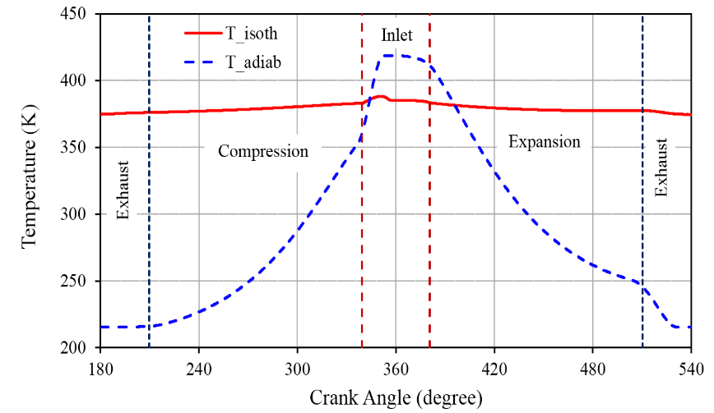
Fig. 11 Simulated internal temperature vs. crank angle
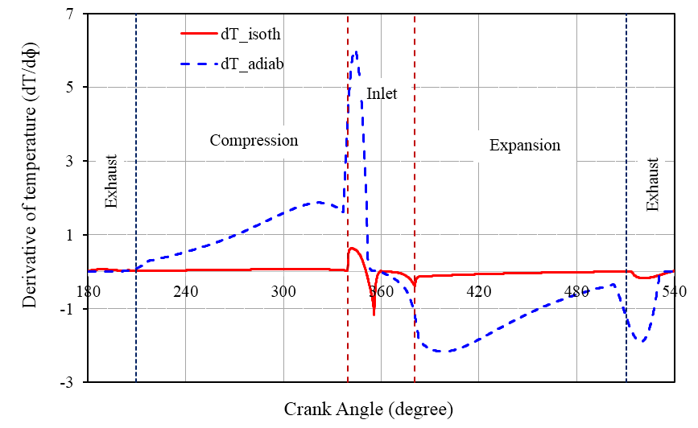
Fig. 12 Simulated derivative of temperature with respect to crank angle vs. crank angle

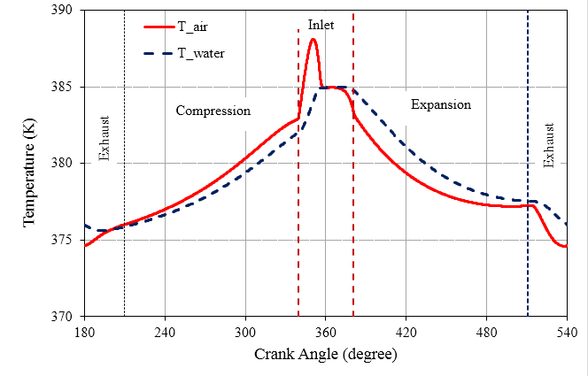
Fig. 13 Simulated air and water temperature vs. crank angle
Fig. 13 shows the temperature distribution of both air and water droplets inside the cylinder in one cycle. During the compression section, air temperature was generally higher than that of the water. During the expansion period, the water droplets’ temperature was generally higher than the air temperature. The volume ratio (maximum cylinder volume to minimum cylinder volume) of this cylinder was about 5.88, which led to a large temperature increase in the compression period without water spraying. The water droplets helped to slow down this increase. After air intake, air expanded and its temperature decreased simultaneously; water droplets helped to slow down this decrease.
Fig. 14 reveals the specific work and inlet/outlet temperature difference under various water/air mass flowrate ratio (in the range of 0.5 to 5) [10]. More specific work was generated through quasi-isothermal expansion. Specific work production increased as the ratio increased, and eventually plateaued. The inlet/outlet temperature difference of quasi-isothermal expansion was much smaller than that of the adiabatic expansion, and the difference tends to plateau as the water/air mass flowrate ratio increases. Fig. 15 shows the temperature distribution along with one cycle with various water/air mass flowrate ratio. All curves had a similar trend, while the temperature differences between inlet and outlet changed significantly. The difference decreased when the water/air mass flowrate ratio (w/a) increased. This means that with more water sprayed into the cylinder, expansion more closely resembles an isothermal process.
Fig. 16 shows the specific work production and inlet/outlet temperature difference as a function of the inlet temperature of both air and water. The water/air mass flowrate ratio of 3. This shows that when the inlet temperature increased, both specific work production and temperature difference increased. The temperature distribution of one cycle under various inlet temperatures is shown in Fig. 17. All curves have a similar trend, and the inlet/outlet temperature differences are fairly small. This is corresponding to the inlet/outlet temperature difference Fig. 16.
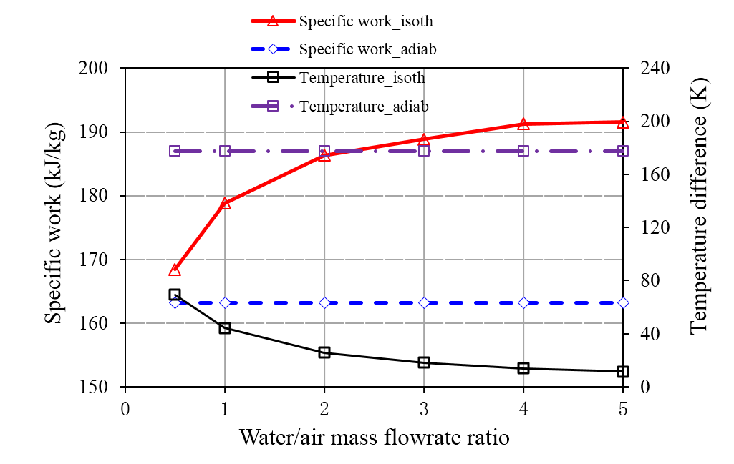
Fig. 14 Simulated specific work and inlet/outlet temperature difference vs. water/air ratio
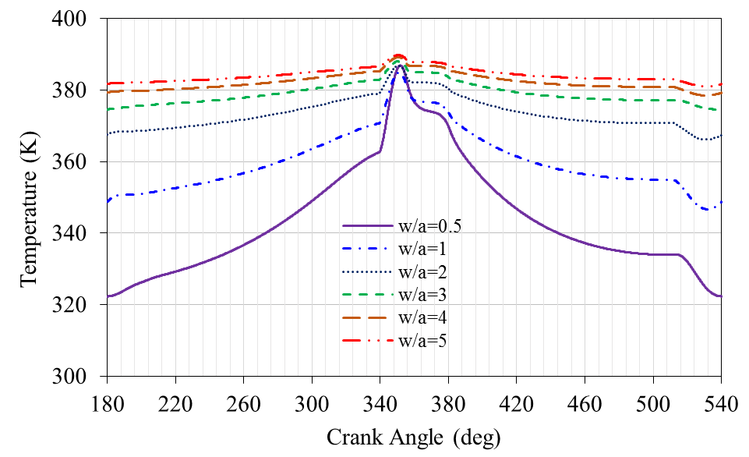
Fig. 15 Simulated temperature distribution vs. water/air ratio
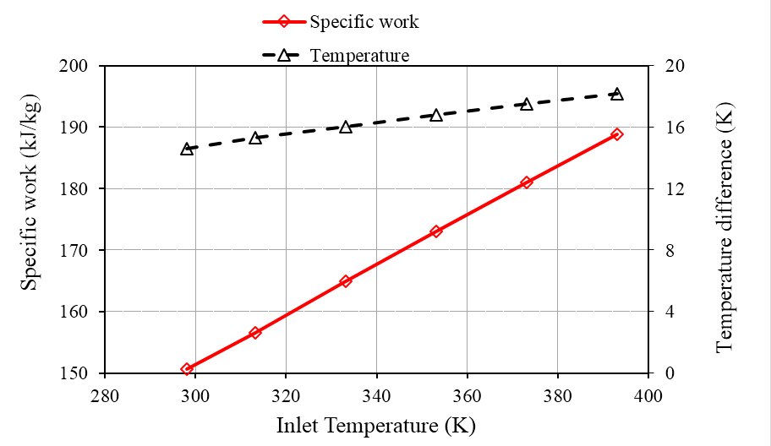
Fig. 16 Simulated specific work and inlet/outlet temperature difference vs. inlet temperature
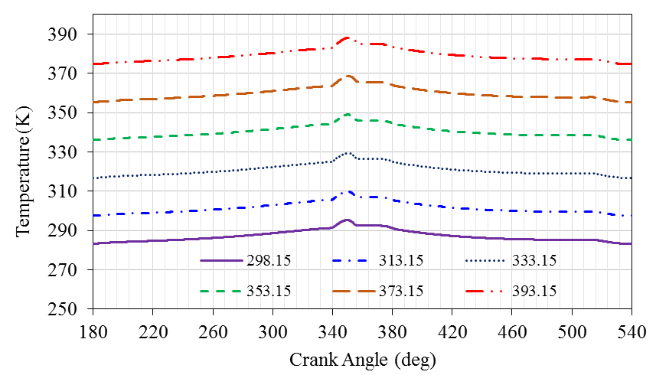
Fig. 17 Simulated temperature distribution vs. inlet temperature
- Conclusion
A novel reciprocating expander was designed for potential application in Isothermal Compressed Air Energy Storage (ICAES). The operating parameters associated with the expander were measured. Both adiabatic and quasi-isothermal expansion processes were simulated based on the model developed. The adiabatic model was validated using experimental results. A quasi-isothermal model was constructed based on the adiabatic modelling by spraying water droplets into the cylinder. It was found that in the quasi-isothermal operation mode, the pressure ratio per stage was markedly increased, and cylinder top clearance was deceased. These results indicate that when the expander operates under quasi-isothermal mode, the cylinder height is reduced by 8.7%, the specific work production is increased by 15.7% and the inlet/outlet temperature difference is only about 10% of that in the adiabatic expansion process. The water/air mass flow ratio can be operated in a large range. Increasing the ratio increased the specific work generation but decreased the temperature difference. Increasing the inlet temperature increased both the specific work generation and inlet/outlet temperature.
Acknowledgements
The authors would like to thank the following organizations for financial support of the work: National Natural Science Foundation of China (NSFC) under grant No. 51676181, National Basic Research Program of China (973 Program) under grant No. 2015CB251302, Beijing Nova Program under grant No. Z171100001117065, and The Frontier Science Research Project of CAS under grant No. QYZDB-SSW-JSC023.
Reference
[1] Obama B. The irreversible momentum of clean energy. Science. 2017;355:126-9.
[2] Chu S, Majumdar A. Opportunities and challenges for a sustainable energy future. Nature. 2012;488:294-303.
[3] de Sisternes FJ, Jenkins JD, Botterud A. The value of energy storage in decarbonizing the electricity sector. Applied Energy. 2016;175:368-79.
[4] Budt M, Wolf D, Span R, Yan J. A review on compressed air energy storage: Basic principles, past milestones and recent developments. Applied Energy. 2016;170:250-68.
[5] Chen H, Cong TN, Yang W, Tan C, Li Y, Ding Y. Progress in electrical energy storage system: A critical review. Progress in Natural Science. 2009;19:291-312.
[6] Gay FW. Means for Storing Fluids for Power Generation. In: Office USP, editor. U. S. A.1948. p. 8.
[7] Aneke M, Wang M. Energy storage technologies and real life applications – A state of the art review. Applied Energy. 2016;179:350-77.
[8] Qin C, Loth E, Li P, Simon T, Ven JVd. Spray-cooling concept for wind-based compressed air energy storage. Journal of Renewable and Sustainable Energy. 2014;6:043125.
[9] Budt M, Wolf D, Span R, Yan J. A review on compressed air energy storage: Basic principles, past milestones and recent developments. Applied Energy. 2016;170:250-68.
[10] Qin C, Loth E. Liquid piston compression efficiency with droplet heat transfer. Applied Energy. 2014;114:539-50.
[11] Zhang X, Chen H, Xu Y, Li W, He F, Guo H, et al. Distributed generation with energy storage systems: A case study. Applied Energy. 2017.
[12] Igobo ON, Davies PA. Review of low-temperature vapour power cycle engines with quasi-isothermal expansion. Energy. 2014;70:22-34.
[13] Odukomaiya A, Abu-Heiba A, Gluesenkamp KR, Abdelaziz O, Jackson RK, Daniel C, et al. Thermal analysis of near-isothermal compressed gas energy storage system. Applied Energy. 2016;179:948-60.
[14] Odukomaiya A, Kokou E, Hussein Z, Abu-Heiba A, Graham S, Momen AM. Near-isothermal-isobaric compressed gas energy storage. Journal of Energy Storage. 2017;12:276-87.
[15] Cicconardi SP, Jannelli E, Spazzafumo G. A thermodynamic cycle with a quasi-isothermal expansion. International Journal of Hydrogen Energy. 1998;23:209-11.
[16] Kim YM, Favrat D. Energy and exergy analysis of a micro-compressed air energy storage and air cycle heating and cooling system. Energy. 2010;35:213-20.
[17] Woodland BJ, Braun JE, Groll EA, Horton WT. Performance Benefits for Organic Rankine Cycles with Flooded Expansion. International Refrigeration and Air Conditioning Conference Purdue, USA: Publications of the Ray W. Herrick Laboratories; 2010.
[18] Park J, Ro PI, He X, Mazzoleni AP. Analysis, Fabrication, and Testing of a Liquid Piston Compressor Prototype for an Ocean Compressed Air Energy Storage (OCAES) System. Marine Technology Society Journal. 2014;48:86-97.
[19] Moradi J, Shahinzadeh H, Khandan A, Moazzami M. A profitability investigation into the collaborative operation of wind and underwater compressed air energy storage units in the spot market. Energy. 2017;141:1779-94.
[20] He W, Wang J. Optimal selection of air expansion machine in Compressed Air Energy Storage: A review. Renewable and Sustainable Energy Reviews. 2018;87:77-95.
[21] Knowlen C, Mattick AT, Bruckner AP, Hertzberg A. High Efficiency Energy Conversion Systems for Liquid Nitrogen Automobiles. SAE International; 1998.
[22] Knowlen C, Williams J, Mattick AT, Deparis H, Hertzberg A. Quasi-Isothermal Expansion Engines for Liquid Nitrogen Automotive Propulsion. SAE International; 1997.
[23] Heidari M, Mortazavi M, Rufer A. Design, modeling and experimental validation of a novel finned reciprocating compressor for Isothermal Compressed Air Energy Storage applications. Energy. 2017;140:1252-66.
[24] Li M. Experimental research of internal water-spray cooling in reciprocating compressor. Fluid Engineering. 1993;21:5.
[25] Bell IH, Lemort V, Groll EA, Braun JE, King GB, Horton WT. Liquid-flooded compression and expansion in scroll machines – Part I: Model development. International Journal of Refrigeration. 2012;35:1878-89.
[26] James NA, Braun JE, Groll EA, Horton WT. Semi-empirical modeling and analysis of oil flooded R410A scroll compressors with liquid injection for use in vapor compression systems. International Journal of Refrigeration. 2016;66:50-63.
[27] Van de Ven JD, Li PY. Liquid piston gas compression. Applied Energy. 2009;86:2183-91.
[28] Zhang C, Yan B, Wieberdink J, Li PY, Van de Ven JD, Loth E, et al. Thermal analysis of a compressor for application to Compressed Air Energy Storage. Applied Thermal Engineering. 2014;73:1402-11.
[29] Yan B, Wieberdink J, Shirazi F, Li PY, Simon TW, Van de Ven JD. Experimental study of heat transfer enhancement in a liquid piston compressor/expander using porous media inserts. Applied Energy. 2015;154:40-50.
[30] Coney MW, Linnemann C, Abdallah HS. A thermodynamic analysis of a novel high efficiency reciprocating internal combustion engine—the isoengine. Energy. 2004;29:2585-600.
[31] Jacobs GG, Liebenberg L. The influence of timed coolant injection on compressor efficiency. Sustainable Energy Technologies and Assessments. 2016;18:175-89.
[32] Coney MW, Stephenson P, Malmgren A, Linnemann C, Morgan RE, Richards RA, et al. Development of a Reciprocating Compressor Using Water Injection to Achieve Quasi-Isothermal Compression. International Compressor Engineering Conference. Purdue University: Purdue University; 2002.
[33] Bollinger BR. System and method for rapid isothermal gas expansion and compression for energy storage. In: States U, editor. United States: SustainX, Inc., West Lebanon, NH (US); 2010. p. 18.
[34] Fone DA, Crane SE, Berlin EP. Compressed air energy storage system utilizing two-phase flow to facilitate heat exchange. In: States U, editor. Unitted States: LightSail Energy, Inc; 2011. p. 63.
[35] Zhang X, Xu Y, Xu J, Xue H, Chen H. Study of a single-valve reciprocating expander. Journal of the Energy Institute. 2016;89:400-13.
[36] Marvania D, Subudhi S. A comprehensive review on compressed air powered engine. Renewable and Sustainable Energy Reviews. 2017;70:1119-30.
[37] Dellicompagni P, Saravia L, Altamirano M, Franco J. Simulation and testing of a solar reciprocating steam engine. Energy. 2018.
[38] Rahbar K, Mahmoud S, Al-Dadah RK, Moazami N, Mirhadizadeh SA. Review of organic Rankine cycle for small-scale applications. Energy Conversion and Management. 2017;134:135-55.
[39] Wasbari F, Bakar RA, Gan LM, Tahir MM, Yusof AA. A review of compressed-air hybrid technology in vehicle system. Renewable and Sustainable Energy Reviews. 2017;67:935-53.
[40] Zhang X, Xue H, Xu Y, Chen H, Tan C. An investigation of an uninterruptible power supply (UPS) based on supercapacitor and liquid nitrogen hybridization system. Energy Conversion and Management. 2014;85:784-92.
[41] Béguin C, Étienne S, Pettigrew MJ. Effect of dispersed phase fraction on the drag coefficient of a droplet or a bubble in an idealized two-phase flow. European Journal of Mechanics - B/Fluids. 2017;65:339-49.
[42] Kelbaliyev G, Ceylan K. DEVELOPMENT OF NEW EMPIRICAL EQUATIONS FOR ESTIMATION OF DRAG COEFFICIENT, SHAPE DEFORMATION, AND RISING VELOCITY OF GAS BUBBLES OR LIQUID DROPS. Chemical Engineering Communications. 2007;194:1623-37.
[43] Lin S, zhao G. Thermodynamical research of reciprocating compressor spraying water inside for colling. Journal of Engineering Thermophysics. 1987;8:3.
[44] Sirignano WA. Fluid Dynamics and Transport of Droplets and Sprays. New York: CAMBRIDGE UNIVERSITY PRESS; 2010.
[45] Ranz WE, Marshall WR. Evaporation from drops: Part 1. Chemical Engineering Progress. 1952;48:141-6.
[46] Yuen MC, Chen LW. Heat-transfer measurements of evaporating liquid droplets. International Journal of Heat and Mass Transfer. 1978;21:537-42.
[47] Chen H, Ding Y, Li Y, Zhang X, Tan C. Air fuelled zero emission road transportation: A comparative study. Applied Energy. 2011;88:337-42.
[48] Chaker MA. Key Parameters for the Performance of Impaction-Pin Nozzles Used in Inlet Fogging of Gas Turbine Engines. Journal of Engineering for Gas Turbines and Power. 2006;129:473-7.

Nomenclature
Symbols | Concepts | Units
A | open area of the inlet/outlet valve | m²
BDC | bottom dead center
c_{p} | specific heat at constant pressure | kJ/(kgk)
c_{v} | specific heat at constant volume | kJ/(kgk)
CAES | compressed air energy storage
C_{D} | drag coefficient
d | water droplet diameter | m
D | cylinder diameter | m
g | acceleration | m/s²
h | specific enthalpy | kJ/kg
ICAES | isothermal compressed air energy storage
m_{a} | mass of air | kg/s
m_{w} | mass of water | kg/s
Nu | Nusselt number
P | pressure | Pa
Pr | Prandtl number
Q | heat exchange through the cylinder walls | kJ
Q_{c} | transferred heat between water and air | kJ
S | stroke distance | m
S_{w} | water droplets surface area | m²
T | temperature | K
TDC | top dead center
t | time | s
u | specific internal energy | kJ/kg
V | volume | m³
v | velocity | m/s
w | velocity | m/s
W | mechanical energy | kJ
W_{adia} | Work generation of adiabatic expansion | kJ
W_{s_adia} | Ideal work generation of adiabatic expansion | kJ
W_{n_iso} | Work generation of near-isothermal expansion | kJ
W_{iso} | Ideal work generation of isothermal expansion | kJ
W_{pump} | Work consumption of water pump | kJ
Greek Symbols
α | heat transfer coefficient
η_{adia} | Isentropic efficiency
η_{isoth} | isothermal efficiency
η_{isoth2} | isothermal efficiency considering pump power consumption
κ | specific heat ratio
λ_{e} | ratio of connected rod length to crank radius
λ | thermal conductivity | W/(m·K)
μ | gas flow coefficient
μ_{a} | dynamic viscosity of the air | Pa·s
ρ | density | kg/m³
φ | crank angle | rad
ω | angular speed | rad/s
ψ | flow function
Subscripts
a | air
A | outlet for air phase, accumulated water on the piston for water phase
E | inlet
I | before the inlet/outlet valve
II | after the inlet/outlet valve
out | outlet
pump | pump
w | water

