Space Craft Application 2015 Michael Moore

Flow 2013
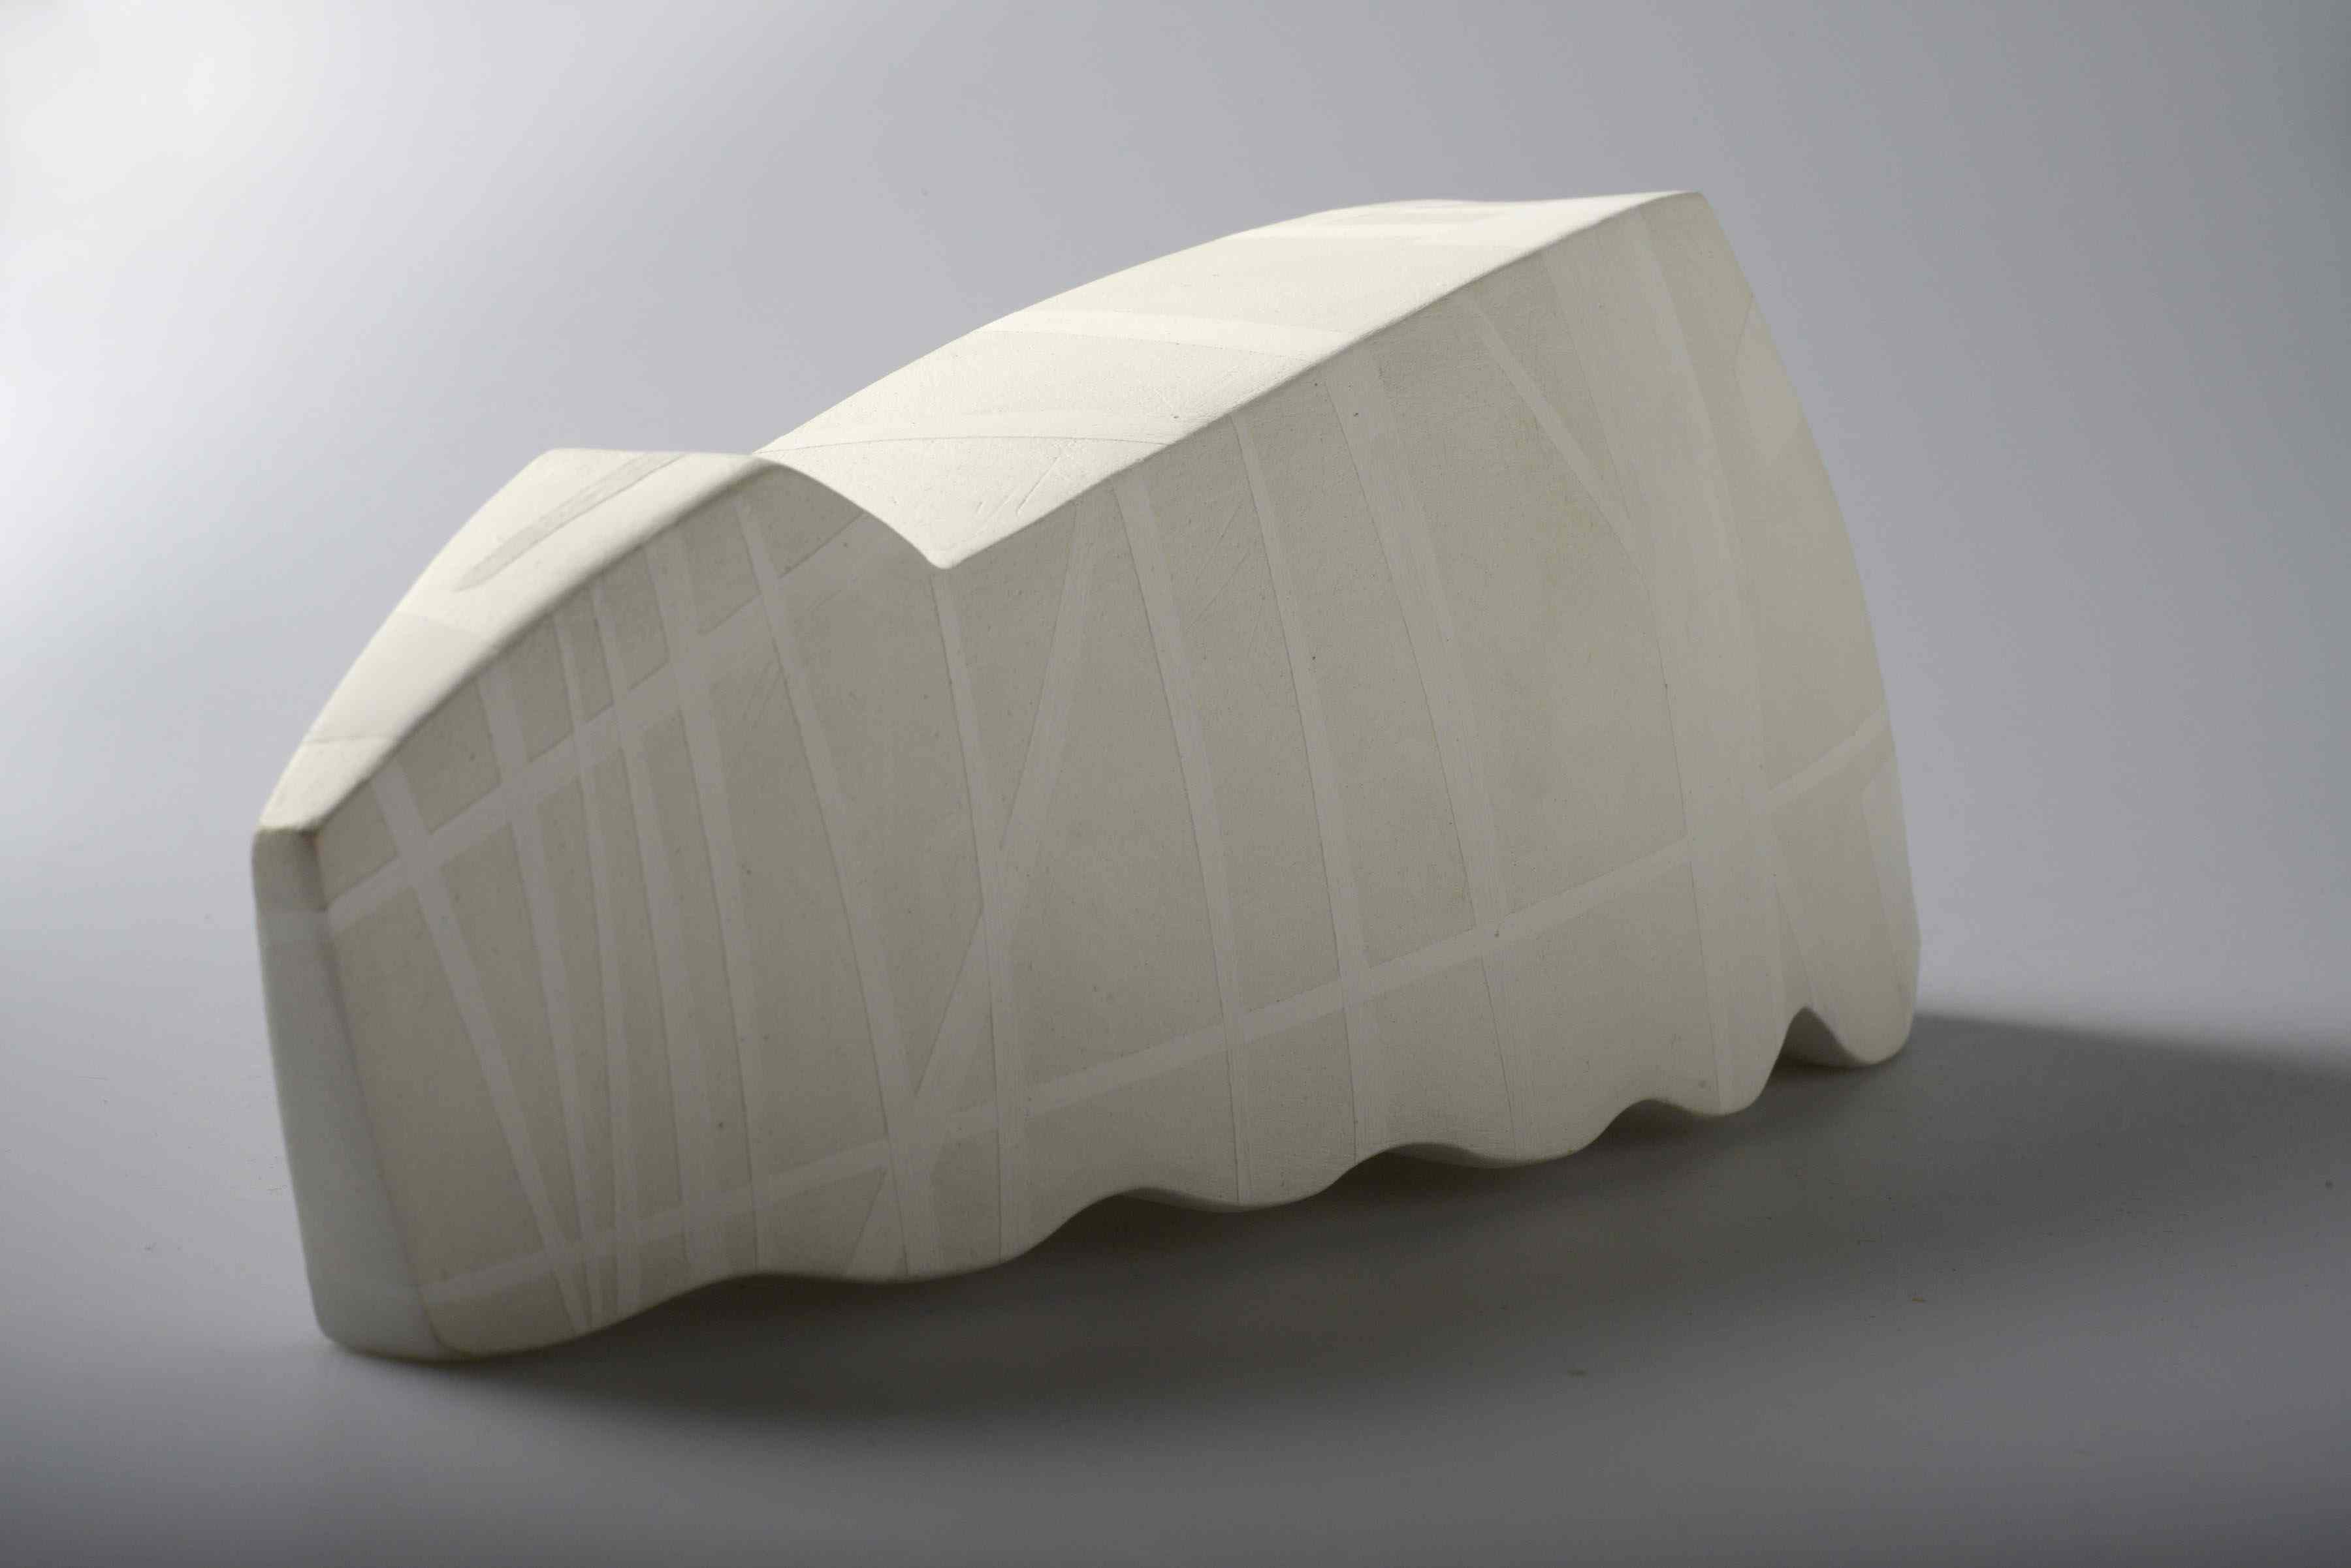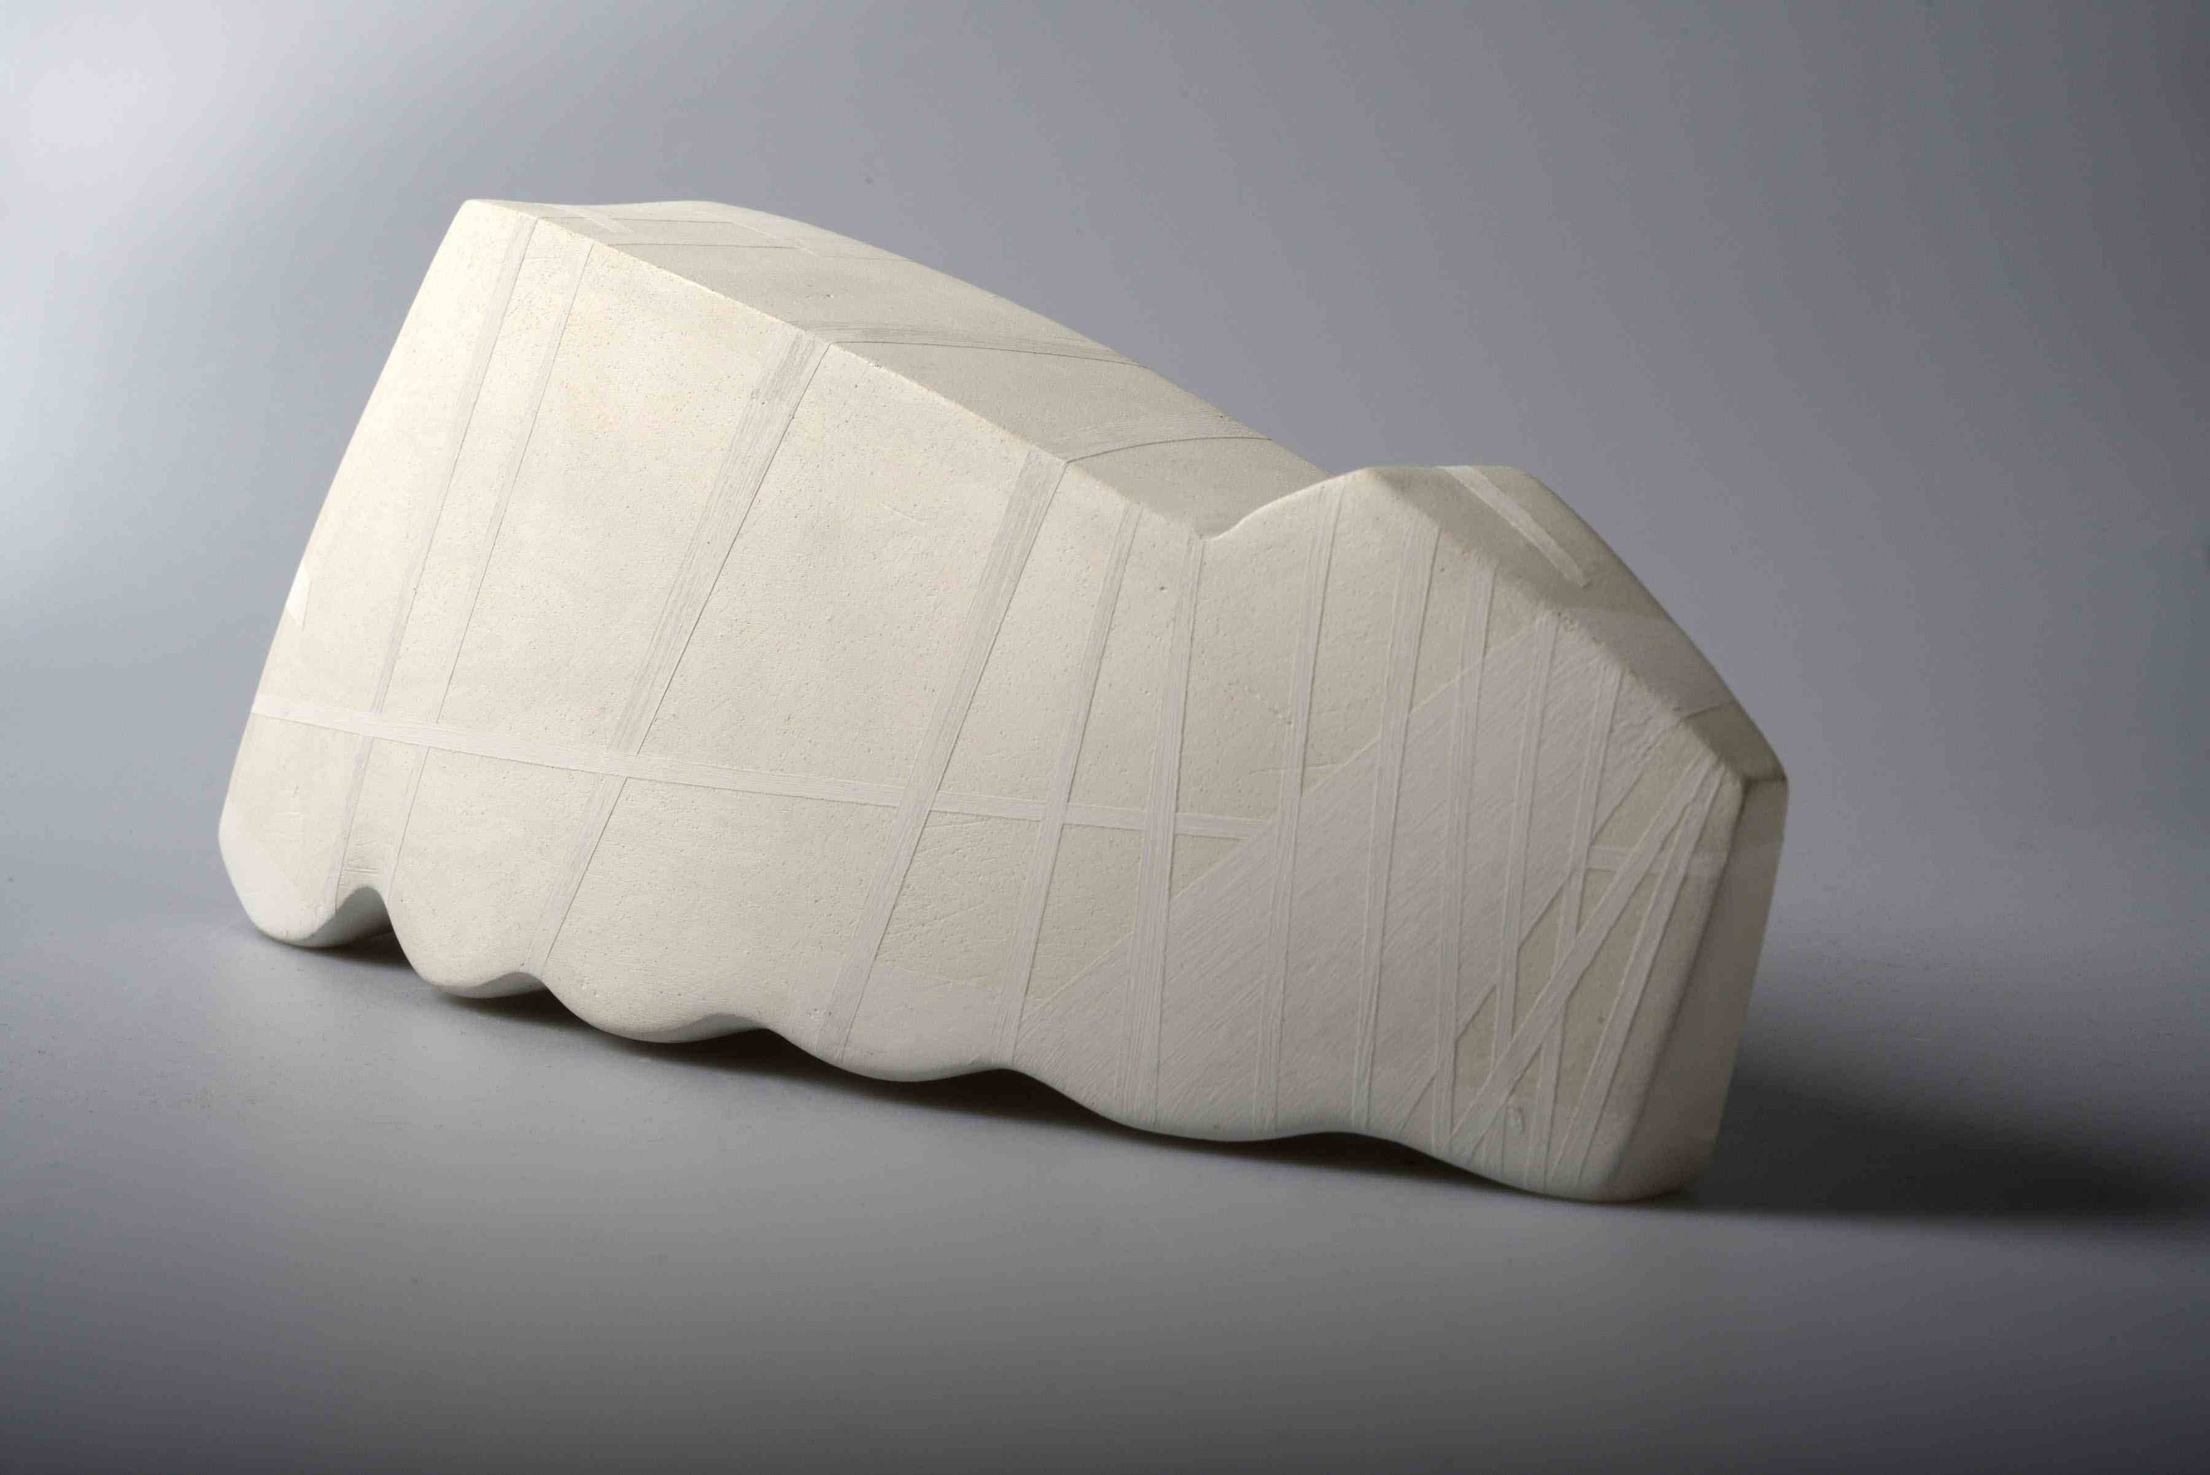
H19 xw33 xd18cm. Hand Built Stoneware. Under glaze decoration.

Yingge Tower 2014
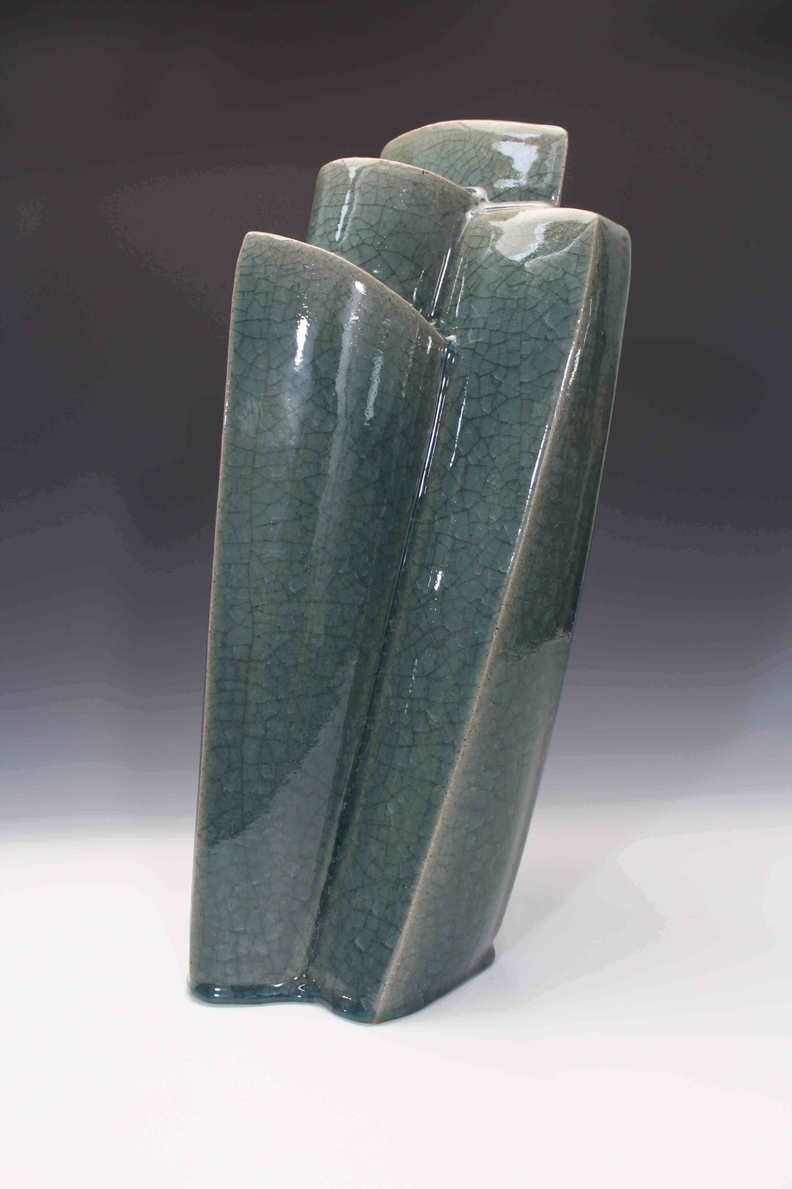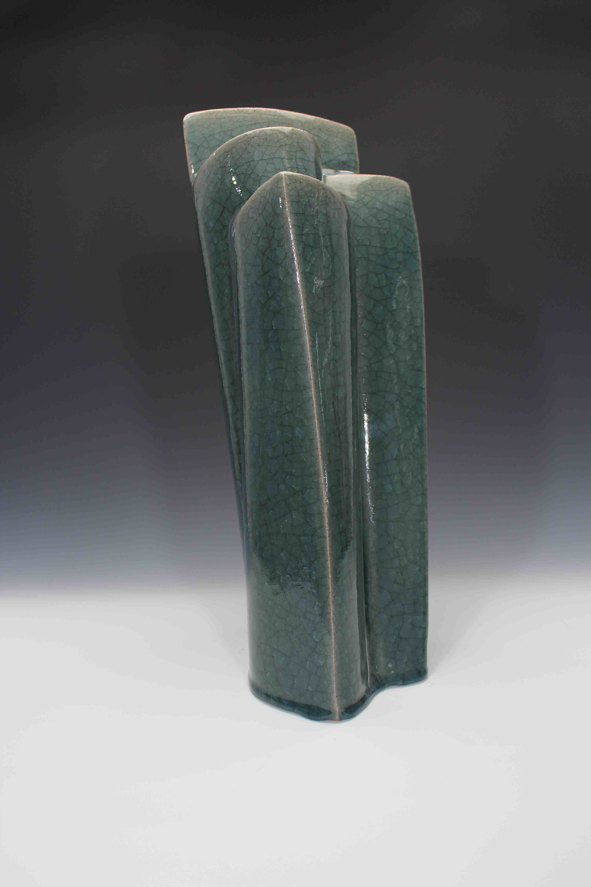
H54 xw22 xd23cm. Hand Built Stoneware. Celadon Glazed.

Trinity Series 3
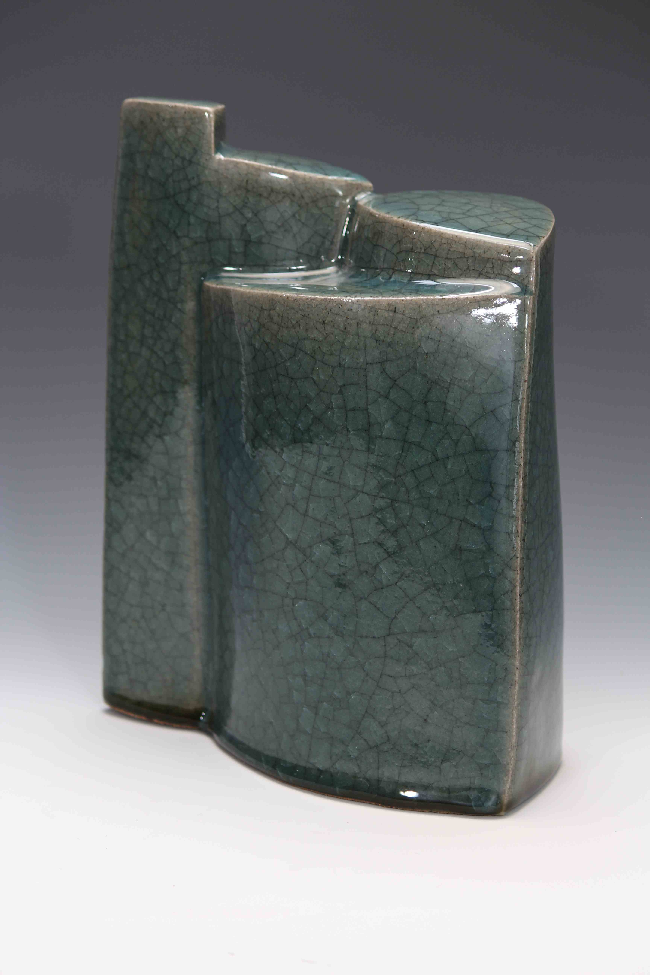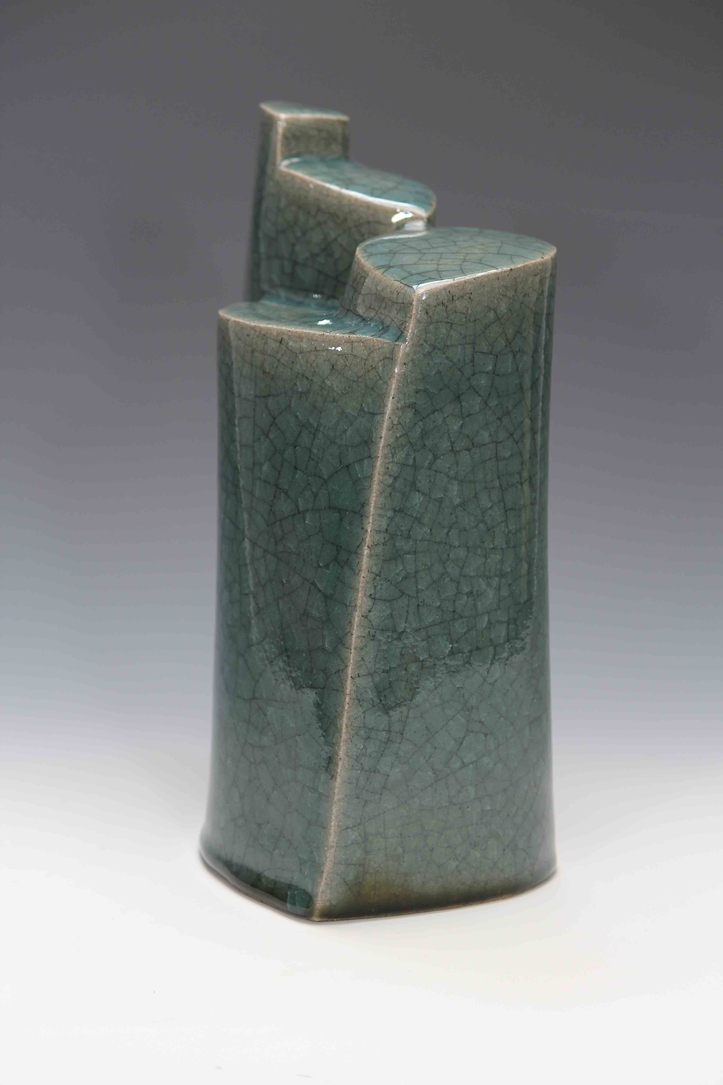
H54 xw22 xd23cm. Hand Built Stoneware. Celadon Glazed.

