“I can say this with absolute certainty. I was there.”

Sue Morris Greg McLaughlin Stephen Baker

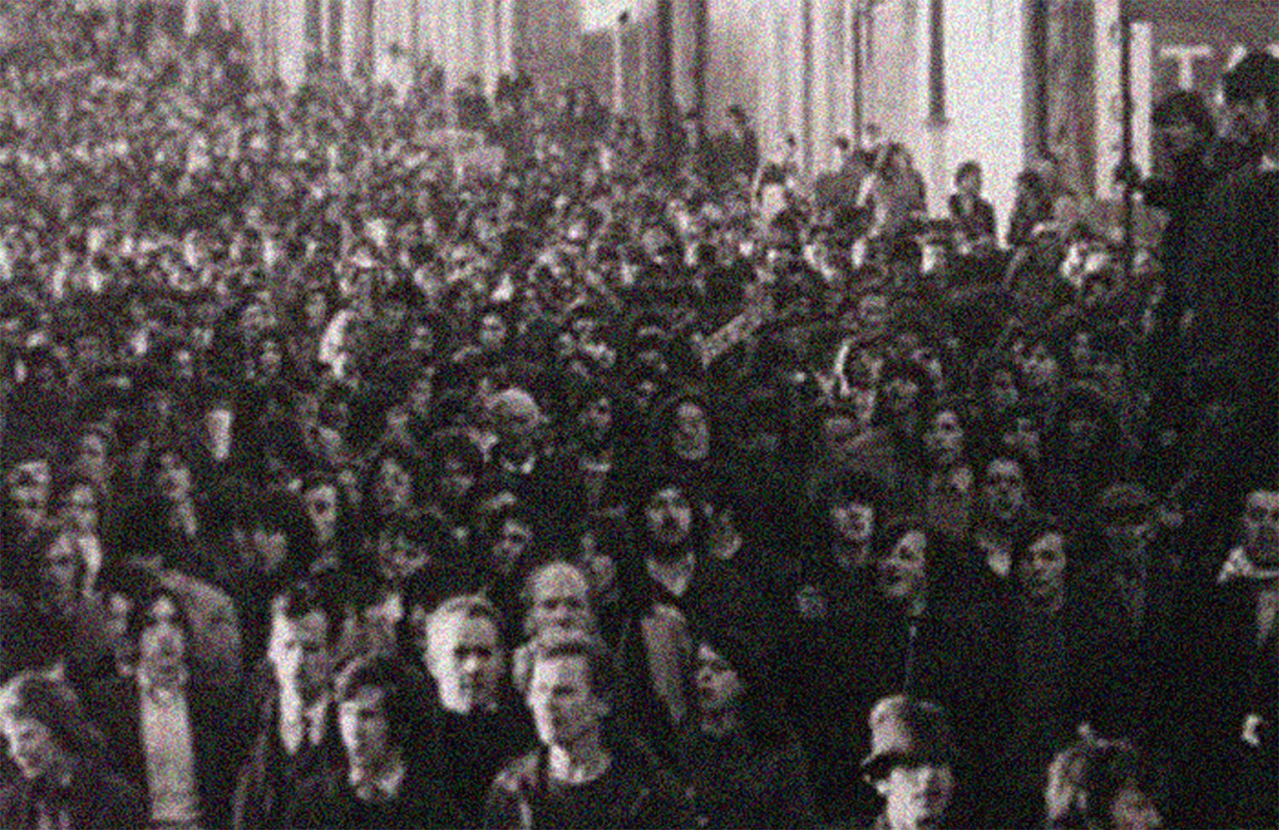

4 March - 23 March
The Crescent Arts Centre
2 – 4 University Road, Belfast BT7 1NJ
Opening reception: 7pm Thursday 6 March

Shortlisted for EVA International, Ireland’s Biennial of Visual Art, Limerick, 2014, this multimedia installation explores the conflict between first-hand, eyewitness testimony to state violence and the noise of distraction and distortion: i.e. official/unofficial propaganda, media reporting and the casual, domestic consumption of media messages. The installation makes specific reference to Bloody Sunday in Derry, 1972, the miners’ strike in Britain, 1984, and the Hillsborough football stadium disaster in Sheffield, 1989, major events that still resonate today.

Gallery 1: ‘This is my statement and it is correct.’*
The stillness and solitude of the eyewitness. With notebooks, files and stationery, this is not an act of passive consumption. It is not the whole truth but it is an act of integrity. It is an act of remembering and forgetting. It is an act of doing, an act of making and an act of asserting the facts of what one has seen.

*This is the opening line of a statement made by an eyewitness to Bloody Sunday to the Northern Ireland Civil Rights Association, one of more than 500 submitted to the Widgery Tribunal but largely rejected as evidence. (see Eyewitness Bloody Sunday, edited by Don Mullan and John Scally, Dublin: Wolfhound Press, 1997; p.115).

Gallery 2: What is force?
A montage of images from Bloody Sunday, the Miners’ Strike and the Hillsborough Football Stadium Disaster are projected in a continuous loop on opposite walls. The images speak of the deliberation, the manipulation and the noise that disrupt original representation.

Gallery 3: Noise
The casual consumption of news and eyewitness testimony is situated in the everyday, domestic setting of the kitchen and alludes to the public/private oppositions and contradictions that the stated events provoked both for those directly involved and those who received information about the events in highly mediated contexts.

Acknowledgements
Many thanks to the following for their invaluable help: Oliver Quinn, Keith Acheson and Megan Boyd at the Crescent Arts Centre; Mervyn McKay, Martin McLoone, Colm Murphy and Daniel Jewesbury at the University of Ulster; Aisling Davis, Lisa Marie Giblin, Emer O’Toole and Ryan Connolly.

About the exhibitors
Sue Morris is a contemporary visual artist from London and has practised in Ireland since 1992. She has exhibited in Ireland, the UK, the USA and, most recently in Vienna as part of the International Cultural Programme for Ireland’s Presidency of the EU.

Greg McLaughlin, from Derry, and Stephen Baker, from Belfast, are lecturers in media at the University of Ulster Coleraine. They are authors of The Propaganda of Peace: The role of media and culture in the Northern Ireland peace process (Intellect Books, 2010) and The British Media and Bloody Sunday, which will be published by Intellect Books in May/June 2014.

