Simple tool to prioritize access to bariatric surgery for people living with obesity during the COVID-19 pandemic

Samarasinghe et al.

S. Samarasinghe¹ *, A. Sudlow², G. K. Dimitriadis³, A. R. Ahmed⁴, S. Purkayastha⁴, C. Tsironis⁴, S. Hakky⁴, K. Moorthy⁴, S. J. B. Aylwin³, S. Panagiotopoulos⁵, S. El-Hassani⁶, A. G. Patel5, H. Chahal¹, S. Hameed¹, C. W. le Roux⁷, D. J. Pournaras² and A. D. Miras¹

1. Department of Metabolism, Digestion and Reproduction, Imperial College London, London, UK
2. Department of Surgery, Southmead Hospital, North Bristol NHS Trust, Bristol, UK
3. Department of Endocrinology Centre for Obesity Management, King’s College Hospital NHS Foundation Trust, London, UK
4. Department of Surgery, Imperial College London, London, UK
5. Department of Minimal Access Surgery, King's College Hospital NHS Foundation Trust, London, UK
6. Minimal Access and Bariatric Unit, Princess Royal University Hospital, King's College Hospital NHS Foundation Trust, London, UK 7. Diabetes Complications Research Centre, University College Dublin, Dublin, Ireland
Correspondence to: Department of Metabolism, Digestion and Reproduction, Imperial College London, South Kensington Campus, London SW7 2AZ, UK (e-mail: Suhaniya.samarasinghe@nhs.net)

Dear Editor

The Federation of Surgical Specialty Associations (FSSA) is a multidisciplinary group comprised of 10 different surgical specialties including the Royal College of Surgeons. Their primary mandate is to produce a coordinated overview of surgical policies for all major surgical societies in the UK and Ireland, and they have published guide‐ lines on surgical prioritization during the COVID-19 pandemic. Given the unprecedented challenges faced within hospitals, requiring major reorganization of services at a time of resource limitation, the aim of these guidelines was to facilitate multidisciplinary team (MDT) review across all surgical specialties of current waiting lists in order to prioritize patients based on indication for surgery, potential consequences of delayed treatment, and presence of com‐
plications^{1,2}.

This approach could also apply in the context of obesity, a disease recognized to cause severe morbidity and high mortality. This opens up the question as to what metrics should be used to conduct this stratification in a practical, fair, and reproducible manner.

The use of traditional anthropometric models such as BMI is widely recognized as inadequate with regard to determining the severity of disease, and therefore largely unhelpful in the clinical decision-making process³. In contrast, the Edmonton Obesity Scoring System (EOSS) is a well established stratification system that has been shown to be strongly predictive of mortality, irrespective of BMI, illustrating its usefulness to assess risk associated with obesity and prognosis⁴. One of the main advantages of using EOSS is that it provides a more complete assessment of the burden of disease in individual patients, with staging based on the presence of functional, physical and mental health
complications of obesity⁵.
The aim of this study was to investigate whether EOSS can be used by multidisciplinary teams as a practical tool to stratify patients with obesity according to their clinical need for surgery.

Four tertiary care centres in the UK and Ireland participated in this project. All patients had already been discussed by the MDT and approved for surgery. Patient notes were reviewed, assessing according to criteria for the EOSS and FSSA prioritization system by two members of the obesity MDT. The reviewers, most commonly an obesity physician and an obesity surgeon, had to reach consensus before a score was assigned. Comparison was drawn between relevant EOSS and FSSA priority (P) categories, whereby those with EOSS 0 or 1 were considered to be equivalent to FSSA P4, EOSS 2 to FSSA P3, and EOSS 3 to FSSA P2. FSSA category 1 was not included as the aim was to evaluate the use of prioritization for elective patients.

A total of 847 patients were assessed. Just over half of patients assessed were assigned 53.8 per cent to EOSS 2, representing those with established obesity-related co-morbidity, and 32.9 per cent to EOSS 1 with risk factors for obesity-related co-morbidity, whereas 7.5 per cent were EOSS 3 with evidence of end-organ failure (Fig. 1).

It was demonstrated that the EOSS is a practical tool that can be used by MDTs to assess patients rapidly, deter‐ mining the urgency for surgery according to the FSSA categorization. Within an MDT, its use ensures that patients can be fairly and reproducibly prioritized for obesity surgery.

It is argued that patients with significant end-organ damage as a result of obesity should be classified as category FSSA category 3. Patients in this category would be prioritized to undergo surgery in less than 3 months, giving these procedures the same urgency as elective abdominal aortic aneurysm repair, colectomy for colitis refractory to medical treatment, and surgery for non-invasive bladder cancer.

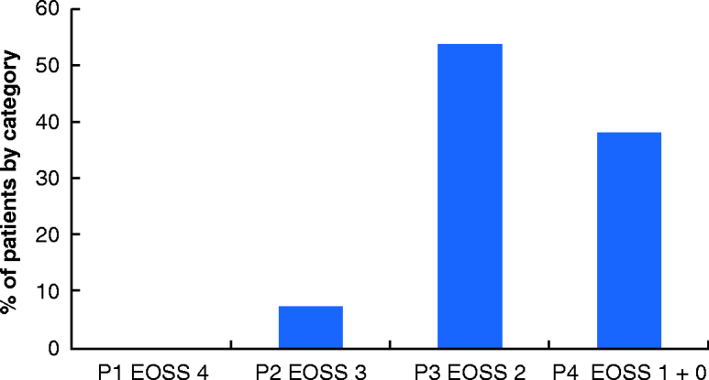

Fig. 1 Proportion of patients in Edmonton Obesity Scoring System categories
Edmonton Obesity Staging Score (EOSS) 0: No apparent risk factors, physical symptoms, psychopathology, functional limitations and/or impairment of well-being related to obesity. EOSS 1: Presence of obesity-related subclinical risk factors, mild physical symptoms, mild psychopathology, mild functional limitation and/or mild impairment of well-being. EOSS 2: Presence of established obesity-related chronic disease, moderate limitations in activities of daily living and/or well-being. EOSS 3: Established end-organ damage such as myocardial infarction, heart failure, stroke, significant psychopathology, significant functional limitation and/or impairment of well-being. EOSS 4: Severe (potentially end-stage) disabilities from obesity-related chronic diseases, severe disabling psychopathology, severe functional limitations and/or severe impairment of well-being. Priority (P) level 1a, emergency procedure to be performed in less than 24 h; 1b, procedure to be performed in less than 72 h; 2, procedure to be performed in less than 1 month; 3, procedure to be performed in less than 3 months; 4, procedure to be performed in more than 3 months.

This approach could continue to be used after the pandemic to maximize the efficiency of public healthcare systems.

Acknowledgements
S.S., A.S., D.J.P. and A.D.M. contributed equally to this publication.
Patients included in the analysis from King’s College Hospital were from the waiting lists of A. Patel and S. Panagiotopoulos.

Disclosure: The authors declare no conflict of interest.

References
1. British Obesity and Metabolic Surgery Society. Reintroducing Safe Bariatric Surgery; 2020. https:// www.bomss.org.uk/wp-content/uploads/2020/06/BOMSS-Restarting-Bariatric-Surgery-in-the-COVID-Era-Guide‐ lines_May-2020.pdf (accessed ???) [AQ6]
2. Morven A, Mahawar K, Blackwell S, Catena F, Chand M, DameN et al.: PRODUCE study. COVID-19 research priorities in surgery (PRODUCE study): a modified Delphi process. Br J Surg 2020; 107:e538–e540
3. Pories WJ, Dohm LG, Mansfield CJ. Beyond the BMI: the search for better guidelines for bariatric surgery. Obesi‐ ty 2010;18:865–871
4. Padwal RSllison DB, Sharma AM. Using the Edmonton Obesity Staging System to predict mortality in a popula‐ tion-representative cohort of people with overweight and obesity. CMAJ 2011;183:E1059–E1066
5. Sharma AM, Kushner RF. A proposed clinical staging system for obesity. Int J Obes 2009;33:289–295

